GPP-GP communication as reported by GPPs participants
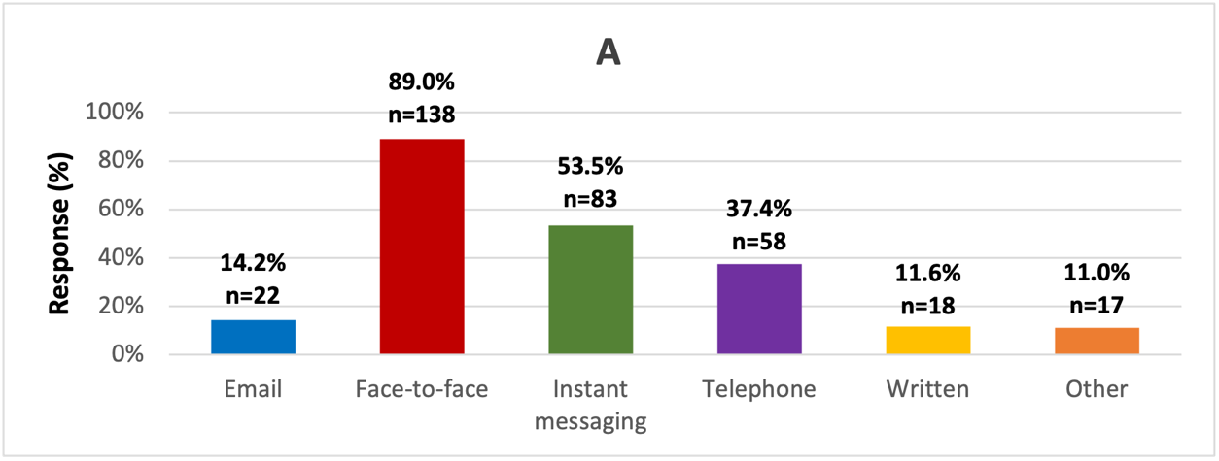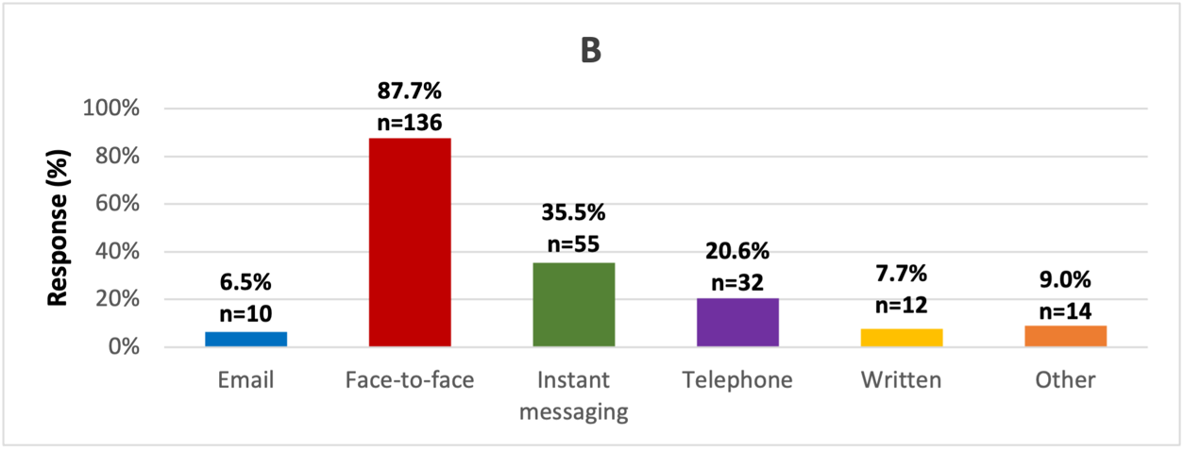
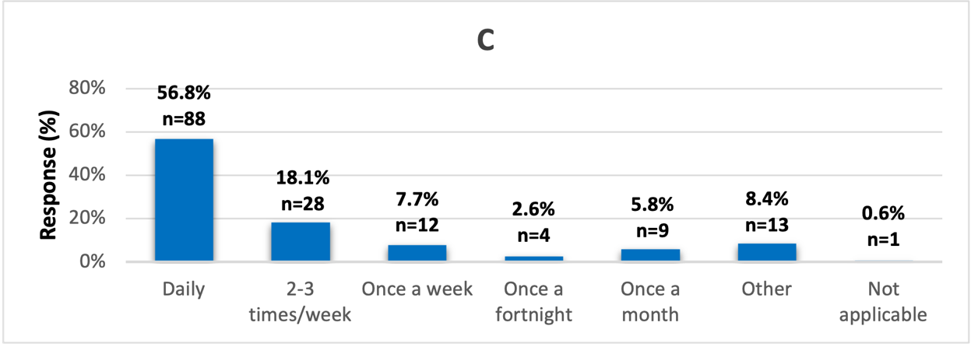
Figure A. The most common method(s) of communication between GPPs and GPs
Figure B. The most preferred method(s) of communication between GPPs and GPs
Figure C. Frequency of face-to-face meetings between GPPs and GPs

GPP-Community pharmacist communication as reported by GPPs participants
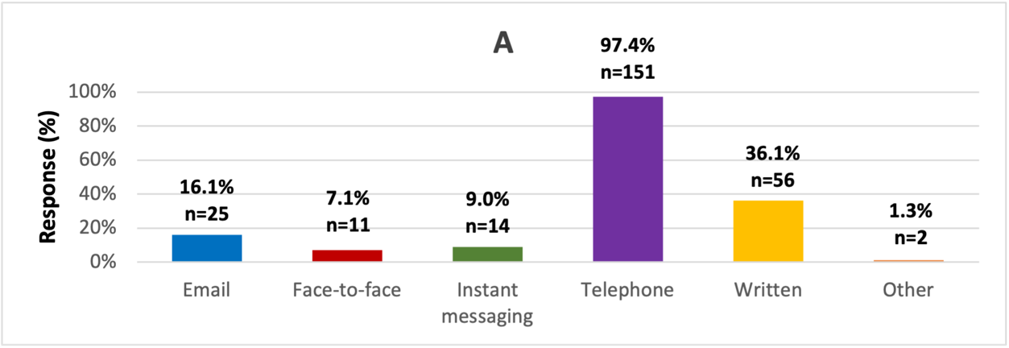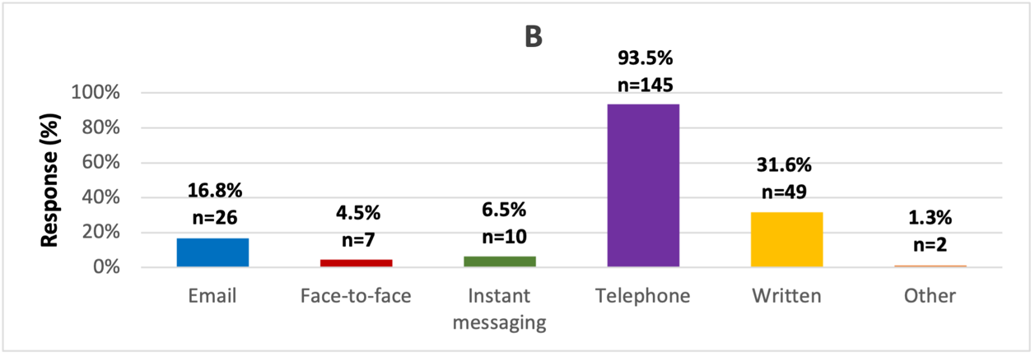
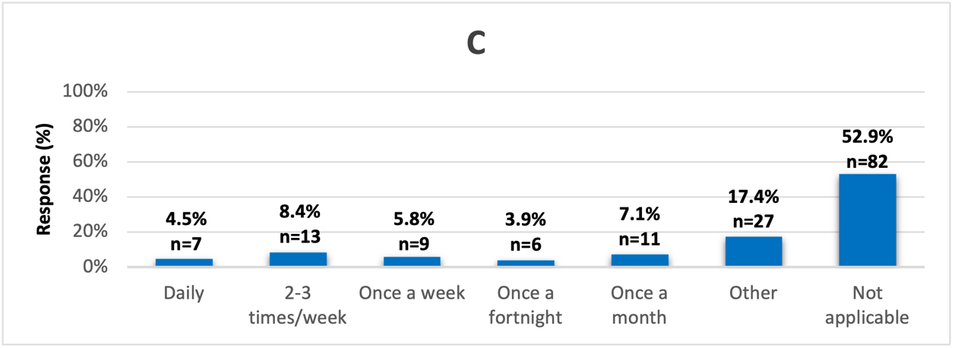
Figure A. The most common method(s) of communication between GPPs and community pharmacists
Figure B. The most preferred method(s) of communication between GPPs and community pharmacists
Figure C. Frequency of face-to-face meetings between GPPs and community pharmacists

GPP-Health and social care professionals communication as reported by GPPs participants
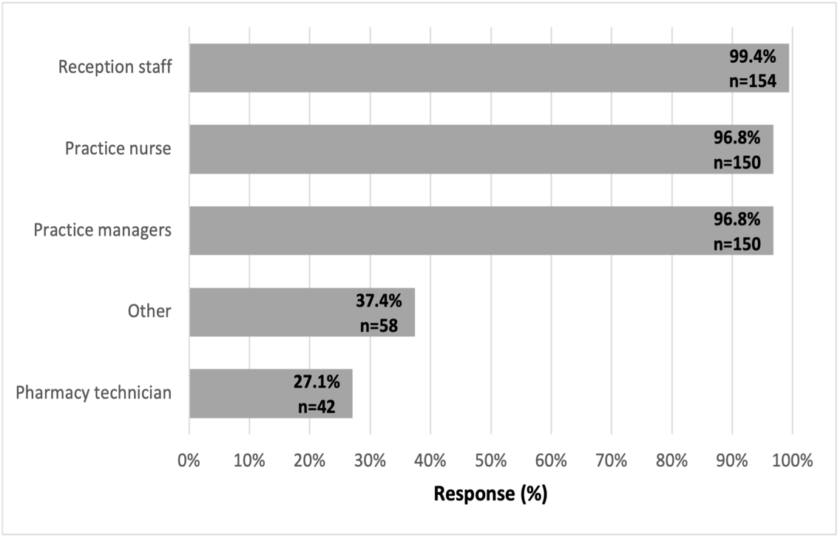
Figure A. GPP communication with other health and social care professionals

GPP-Patient communication as reported by GPPs participants
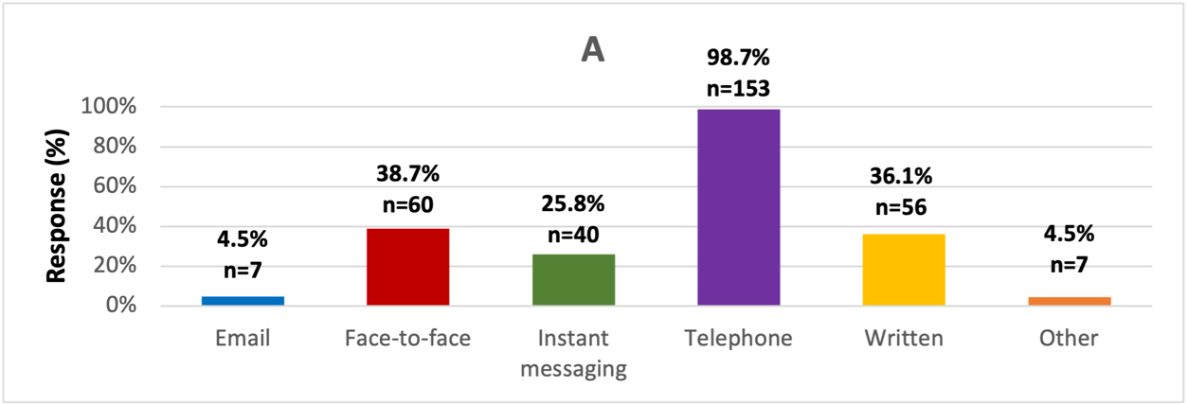
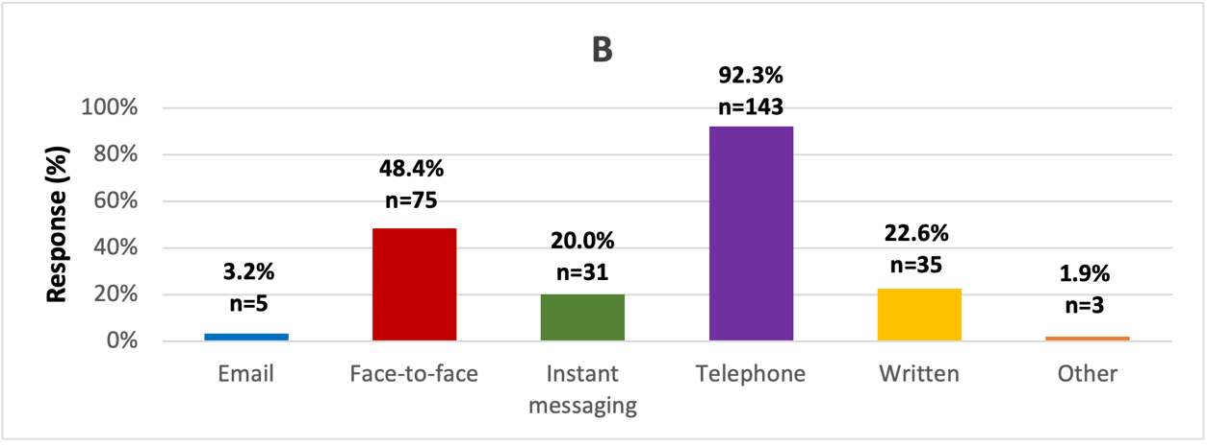
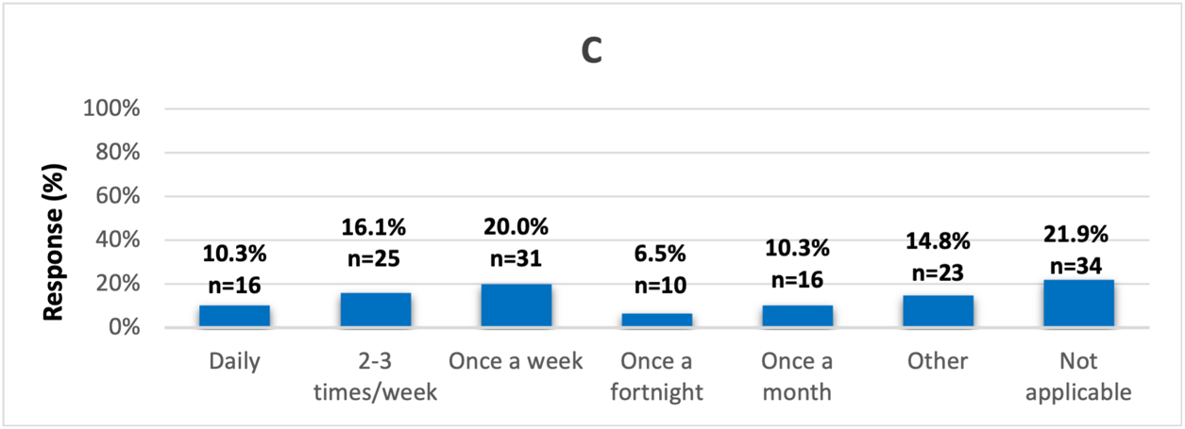
Figure A. The most common method(s) of communication between GPPs and patients
Figure B. The most preferred method(s) of communication between GPPs and patients
Figure C. Frequency of face-to-face meetings between GPPs and patients

