Supplementary information
Postbiotics from Saccharomyces cerevisiae fermentation stabilize microbiota in rumen liquid digesta during grain-based subacute ruminal acidosis (SARA) in lactating dairy cows
Junfei Guo¹, Jan C. Plaizier^{1,*}, Zhengxiao Zhang^{1,†}, Leluo Guan², Ilkyu Yoon³, and Ehsan Khafipour^{1,‡,*}

Additional file 1. Effects of treatment and stage of SARA induction on alpha-diversity of rumen liquid microbiome
Item | Treatment¹ | Stage² |  |  |  |  |  |  |  |  |  |  |  | SEM | P-value³
Item | Treatment¹ | wk -4 | wk -1 | wk 1 | wk 3 | wk 4  Pre-SARA1 | wk 5  SARA1/1 | wk 5  SARA1/2 | wk 7  Post-SARA1 | wk 8  SARA2/1 | wk 8  SARA2/2 | wk 10  Post-SARA2 | wk 12  Post-SARA2 | SEM | Treat | Stage | Int⁴
Shannon’s diversity | Control | 8.78ª | 8.77ª | 8.54ª | 8.64ª | 8.53ª | 7.33^{b} | 7.05^{b} | 8.52ª | 6.95^{b} | 6.41^{b} | 8.56ª | 8.52ª | 0.11 | 0.62 | <0.0001 | 0.03
Shannon’s diversity | SCFPa | 8.58ª | 8.71ª | 8.08^{bc} | 8.80ª | 8.76ª | 6.52^{d} | 6.68^{d} | 8.60ª | 6.32^{d} | 6.73^{d} | 8.53^{ab} | 7.92^{c} | 0.11 | 0.62 | <0.0001 | 0.03
Shannon’s diversity | SCFPb-1X | 8.71^{ab} | 8.66^{ab} | 8.82ª | 8.08^{bc} | 8.60^{ab} | 6.55^{d} | 7.17^{cd} | 7.77^{c} | 6.50^{d} | 6.57^{d} | 8.04^{c} | 8.65^{ab} | 0.12 | 0.62 | <0.0001 | 0.03
Shannon’s diversity | SCFPb-2X | 8.49ª | 8.50ª | 8.29^{ab} | 8.55ª | 8.43ª | 7.71^{bc} | 7.26^{c} | 8.43ª | 7.27^{c} | 7.21^{c} | 8.68ª | 8.65ª | 0.12 | 0.62 | <0.0001 | 0.03
Pielou’s Evenness | Control | 0.92ª | 0.92ª | 0.90ª | 0.89ª | 0.90ª | 0.82^{bY} | 0.81^{b} | 0.91^{ax} | 0.80^{b} | 0.77^{b} | 0.91^{ax} | 0.91^{aX} | 0.01 | 0.13 | <0.0001 | 0.01
Pielou’s Evenness | SCFPa | 0.90ª | 0.92ª | 0.88ª | 0.93ª | 0.92ª | 0.77^{by} | 0.80^{b} | 0.91^{ax} | 0.75^{by} | 0.80^{b} | 0.91^{ax} | 0.86^{ayY} | 0.01 | 0.13 | <0.0001 | 0.01
Pielou’s Evenness | SCFPb-1X | 0.91ª | 0.91ª | 0.91ª | 0.86^{bc} | 0.90^{ab} | 0.78^{dy} | 0.83^{cd} | 0.86^{cy} | 0.79^{d} | 0.80^{d} | 0.87^{bcy} | 0.91^{aX} | 0.01 | 0.13 | <0.0001 | 0.01
Pielou’s Evenness | SCFPb-2X | 0.91ª | 0.90^{ab} | 0.91ª | 0.91ª | 0.91ª | 0.88^{bcxX} | 0.83^{d} | 0.91^{ax} | 0.83^{cdx} | 0.81^{d} | 0.91^{ax} | 0.92^{ax} | 0.01 | 0.13 | <0.0001 | 0.01
Faith’s Phylogenetic diversity | Control | 122.97^{ab} | 125.06^{ab} | 116.30^{ab} | 130.62ª | 116.76^{b} | 76.74^{c} | 71.70^{c} | 110.09^{b} | 71.94^{c} | 59.83^{c} | 111.43^{b} | 111.75^{b} | 3.92 | 0.54 | <0.0001 | 0.08
Faith’s Phylogenetic diversity | SCFPa | 117.16ª | 117.47ª | 99.66^{b} | 121.58ª | 116.57ª | 64.05^{c} | 62.83^{c} | 109.90^{ab} | 62.82^{c} | 66.75^{c} | 111.65^{ab} | 98.69^{b} | 3.94 | 0.54 | <0.0001 | 0.08
Faith’s Phylogenetic diversity | SCFPb-1X | 120.02^{ab} | 120.06^{ab} | 127.16ª | 114.91^{ab} | 119.27^{ab} | 63.53^{d} | 72.29^{d} | 95.70^{c} | 59.28^{d} | 59.50^{d} | 105.34^{bc} | 114.64^{ab} | 4.12 | 0.54 | <0.0001 | 0.08
Faith’s Phylogenetic diversity | SCFPb-2X | 109.99ª | 117.54ª | 98.69^{ac} | 113.09ª | 101.63ª | 78.00^{b} | 77.33^{b} | 102.72ª | 69.48^{b} | 79.06^{bc} | 117.99ª | 111.23ª | 4.13 | 0.54 | <0.0001 | 0.08
Observed features | Control | 757.39^{ab} | 768.50^{ab} | 727.87^{ab} | 832.10ª | 732.62^{ab} | 489.62^{c} | 426.76^{c} | 658.37^{b} | 428.00^{c} | 333.13^{c} | 691.37^{ab} | 678.25^{b} | 36.60 | 0.61 | <0.0001 | 0.11
Observed features | SCFPa | 729.87ª | 714.01ª | 587.87ª | 698.21ª | 732.12ª | 398.83^{b} | 357.00^{b} | 695.62ª | 367.12^{b} | 388.50^{b} | 743.25ª | 579.50ª | 36.83 | 0.61 | <0.0001 | 0.11
Observed features | SCFPb-1X | 750.01ª | 734.44ª | 817.01ª | 701.13^{ab} | 740.72ª | 382.72^{d} | 448.44^{cd} | 569.29^{bc} | 334.86^{d} | 330.15^{d} | 603.15^{abc} | 728.57ª | 38.92 | 0.61 | <0.0001 | 0.11
Observed features | SCFPb-2X | 648.44^{ab} | 723.58ª | 584.15^{bcd} | 685.04ª | 624.86^{ab} | 481.86^{cd} | 486.86^{bcd} | 621.29^{abc} | 442.72^{d} | 481.15^{cd} | 730.72ª | 674.56ª | 39.04 | 0.61 | <0.0001 | 0.11
^{a-d}Means in a row with different superscripts among Stages are different (P < 0.05).
^{x,y}Means in a column with different superscripts among treatments are different (P < 0.05).
^{X,Y}Means in a column with different superscripts among treatments are tended to be different (0.5 ≤ P < 0.1).
¹Treatment: Control = 140 g/d ground corn; SCFPa = 14 g/d Diamond V Original XPC mixed with 126 g/d ground corn; SCFPb-1X = 19 g/d NutriTek mixed with 121 g/d ground corn; SCFPb-2X = 38 g/d NutriTek mixed with 102 g/d ground corn.
²Stage: SARA was induced during wk 5 (SARA1) and wk 8 (SARA2) after parturition. Rumen samples were taken on d 2 (SARA1/1, SARA1/2) and d 5 (SARA2/1, SARA2/2) during each SARA week. Wk 4 was considered as Pre-SARA1, wk 7 as Post-SARA1, and wk 10 and 12 as Post-SARA2.
³Statistical analyses were conducted on log₁₀-transformed data for Faith’s Phylogenetic diversity, original data for Chao1 and Box-cox data for the rest. Presented means are original values prior to transformation.
⁴Int: Interaction effect of treatment and stage.

Additional file 2. Longitudinal shifts in Proteobacteria and Tenericutes proportions in rumen liquid microbiota. Metagenomic Longitudinal Differential Abundance (MetaLonDA) was used to assess the longitudinal changes in rumen liquid microbial communities as lactation progressed. The OTU table was normalized using cumulative sum scaling (CSS) transformation. The longitudinal profiles in each group were fitted with a negative binomial smoothing spline. The blue color represents control and red color represents SCFPb-2X group. The significant time intervals were identified when P < 0.05 after multiple testing corrections using Benjamini-Hochberg False Discover Rate (FDR) estimation. a. Proteobacteria proportion in control vs. SCFPb-2X. b. Tenericutes. proportion in control vs. SCFPb-2X groups. The study was started from 4 weeks before until 12 weeks after parturition. SARA challenges were conducted on wk 5 and wk 8 and rumen samples were taken weekly but twice during SARA weeks (SARA1/1, SARA1/2, SARA2/1, SARA2/2).

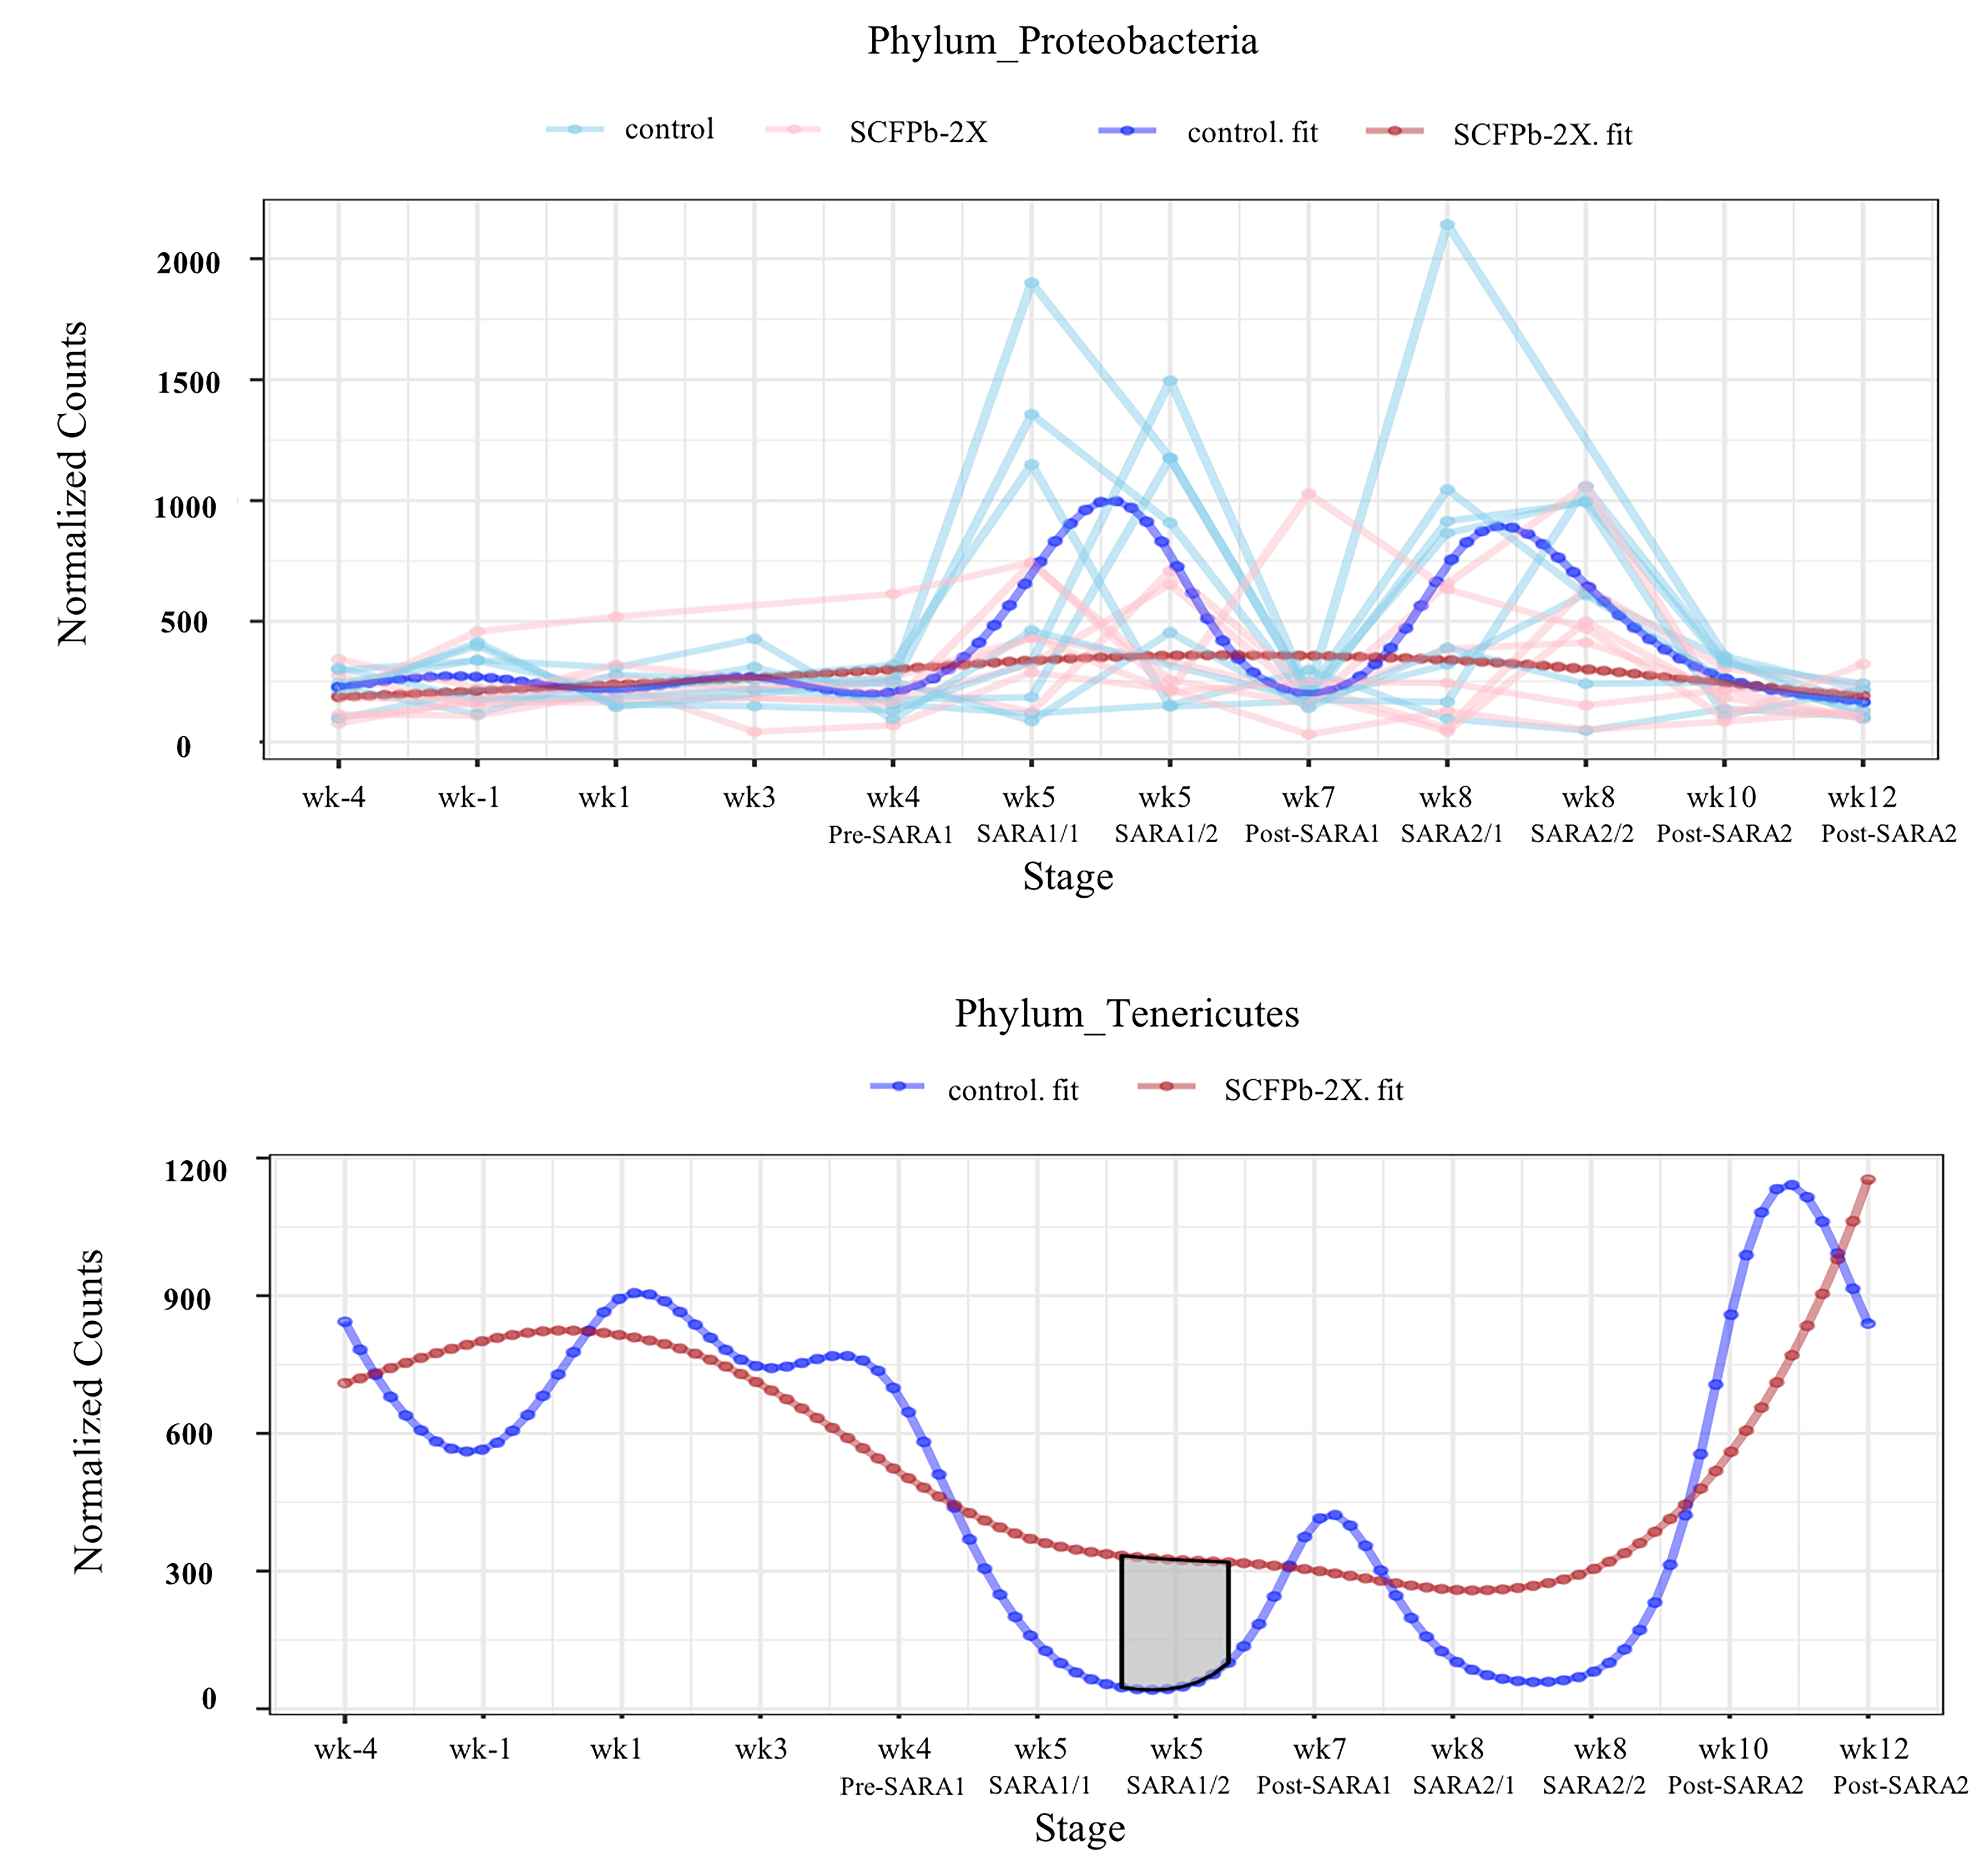

Additional file 3. Concepts of stability, robustness, and resilience of rumen liquid microbiota. Longitudinal shifts in the proportion of phylum Firmicutes in Control and SCFPb2X as example for explanation of a. stability, b. robustness, and c. resilience concepts. Stability is defined as day-to-day variation in microbiome. Robustness explains the capacity of microbiome to resist changes that are forced by stressors, e.g., a metabolic challenge such as SARA. Resilience describes the capacity and the time it takes for the microbiome to return to equilibrium (if at all) after it has been pushed away from the equilibrium by the stressors, e.g., recovery after a metabolic challenge such as SARA.

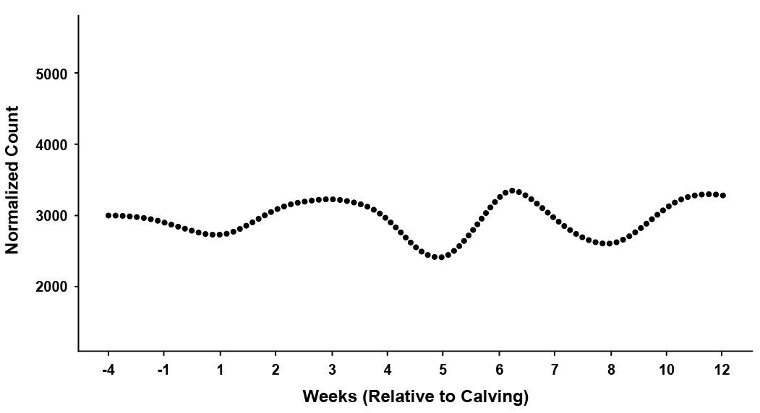
.

Firmicutes proportion
Weeks post-calving
Control
SARA1
SARA2
1st week
post-calving
SCFPb-2X
-4
0
5
8
12
1
3
2
4
6
7
9
10
STABILITY

Firmicutes proportion
SCFPb-2X

Weeks post-calving
Control
SARA1
SARA2
1st week
post-calving
-4
0
5
8
12
1
3
2
4
6
7
9
10
STABILITY
ROBUSTNESS
ROBUSTNESS
ROBUSTNESS

Firmicutes proportion
Weeks post-calving
Control
SARA1
SARA2
1st week
post-calving
-4
0
5
8
12
1
3
2
4
6
7
9
10
STABILITY
RESILIENCE
SCFPb-2X

Additional file 4. Differences in predicted microbial metabolic pathways between nonSARA (Pre-SARA1, Post-SARA1 and Post-SARA2) and SARA (SARA1/1, SARA1/2, SARA2/1, SARA2/2) stages in control group. Functionalities of rumen liquid microbiome were predicted by CowPi and the results were analyzed by STAMP following log transformation and False Discovery Rate (FDR) correction. Significant differences were considered as P < 0.05.

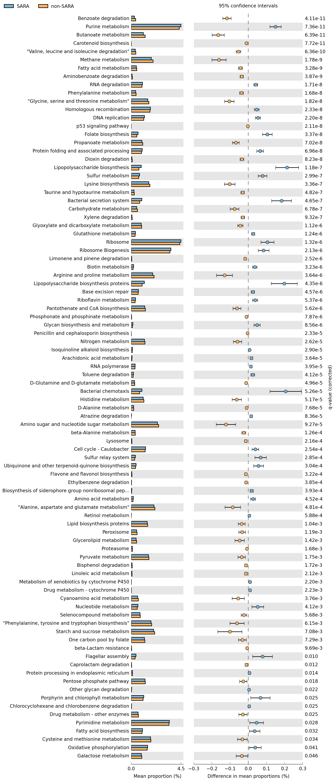

Additional file 5. Differences in predicted microbial metabolic pathways between nonSARA (Pre-SARA1, Post-SARA1 and Post-SARA2) and SARA (SARA1/1, SARA1/2, SARA2/1, SARA2/2) stages in SCFPb-2X group. Functionalities of rumen liquid microbiome were predicted by CowPi and the results were analyzed by STAMP following log transformation and False Discovery Rate (FDR) correction. Significant differences were considered as P < 0.05.
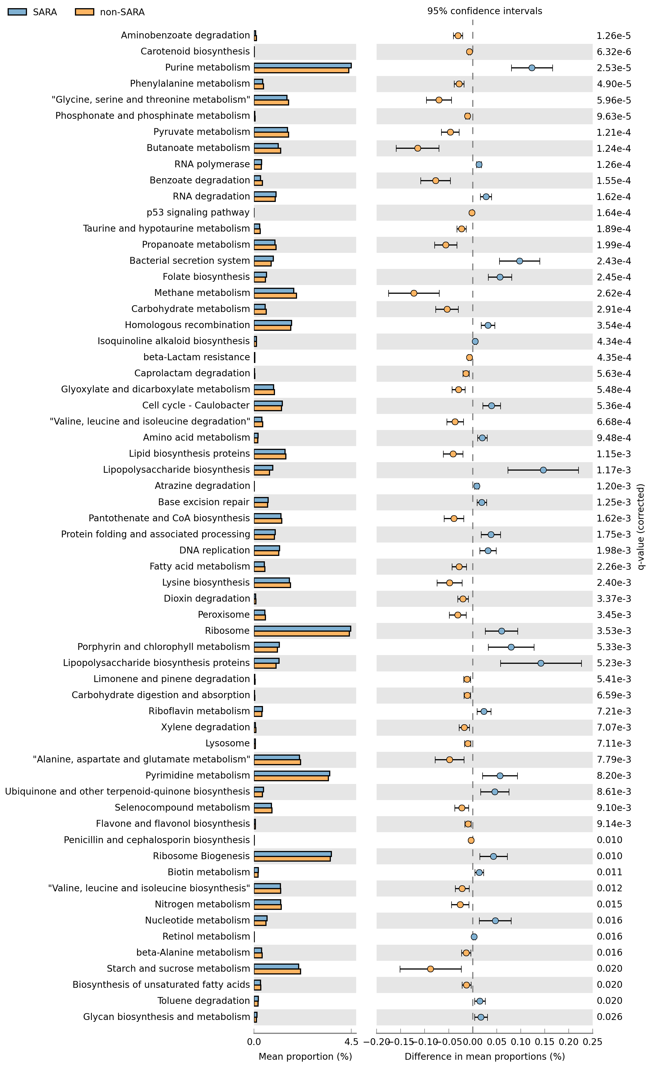
Additional file 6. Differences in predicted microbial metabolic pathways between nonSARA (Pre-SARA1, Post-SARA1 and Post-SARA2) and SARA (SARA1/1, SARA1/2, SARA2/1, SARA2/2) stages in SCFPb-1X group. Functionalities of rumen liquid microbiome were predicted by CowPi and the results were analyzed by STAMP following log transformation and False Discovery Rate (FDR) correction. Significant differences were considered as P < 0.05.

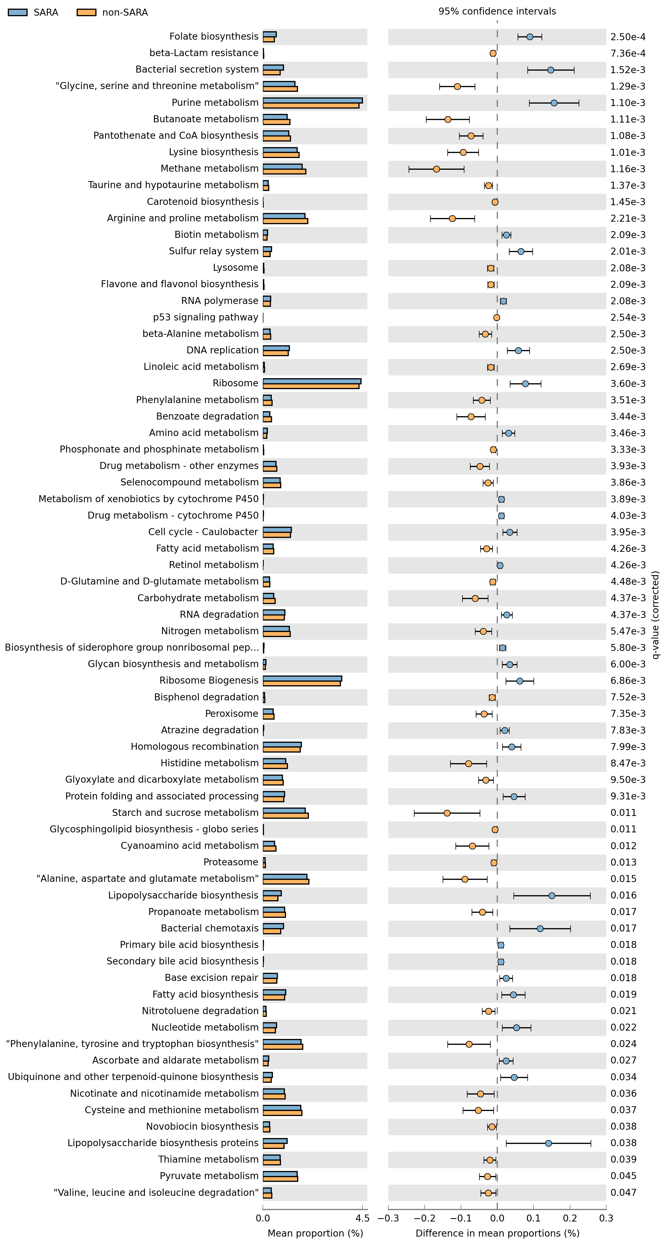
Additional file 7. Differences in predicted microbial metabolic pathways between nonSARA (Pre-SARA1, Post-SARA1 and Post-SARA2) and SARA (SARA1/1, SARA1/2, SARA2/1, SARA2/2) stages in SCFPa group. Functionalities of rumen liquid microbiome were predicted by CowPi and the results were analyzed by STAMP following log transformation and False Discovery Rate (FDR) correction. Significant differences were considered as P < 0.05.

