Table 1. The impact of micronutrient supplementation on the average yield of potatoes and sugar beets (measured in kg per hectare) is being assessed.
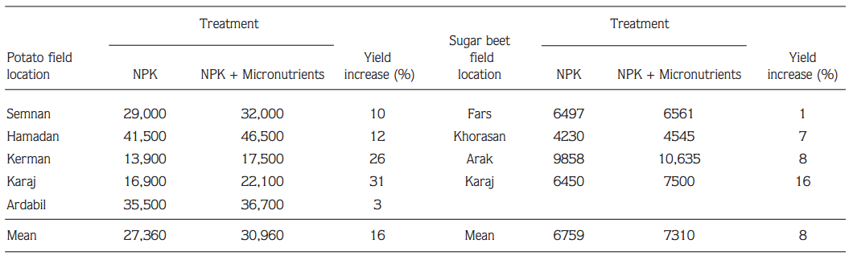
Sources: (Malakouti, 2008)

Table 2.The impact of adding secondary and micronutrients on cereal yield in different African nations 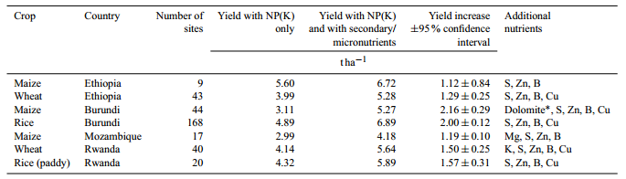
Source: (IFDC, 2012)

Table 3.The impact of lime, a combination of fertilizers, and compost on the thousand seed weight, harvest index, grain yield, straw yield, biological yield, and straw yield of barley were investigated in Wolmera district, West Showa, Ethiopia.
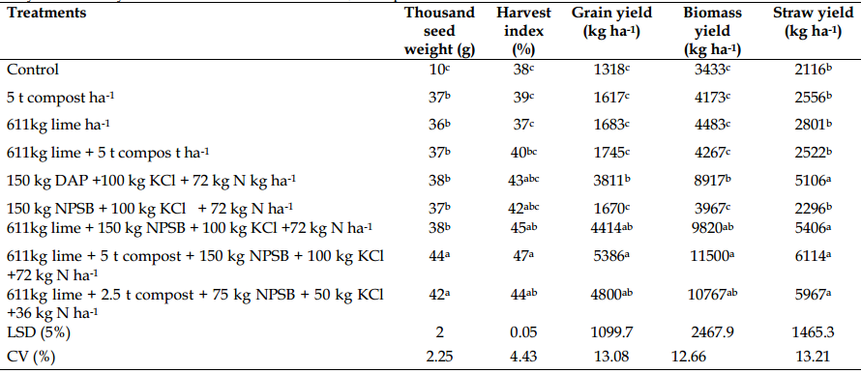
Source: (Woubsh et al., 2017)
Means within a column followed by the same letter are not significantly different at 5% probability level.

Table 4. Response of teff to application of different fertilizers

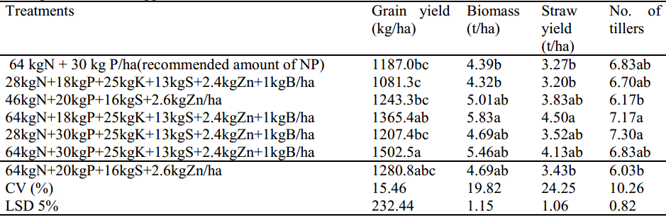
Source: Ayalew and Habte, 2017
Means within a column followed by the same letter are not significantly different at 5% probability level.
Table 5. Evaluating teff production involves examining partial budgets, marginal rates of return, and conducting dominance analysis on fertilizers.
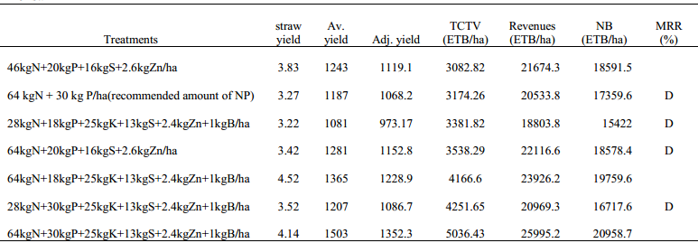
Source: (Ayalew and Habte, 2017)
Yield adjustment=10%, Field price of teff = 18/kg, MRR= marginal rate of return, MARR=100%, BF= blended fertilizer, Av.yield= average yield, Adj.yield=adjusted yield, TCTV= total cost that vary, NB=net benefit, D= dominated treatments, ETB=Ethiopian Birr

Table 6.The effect of balanced fertilization on grain yield (kg /ha) and thousand kernel weight index
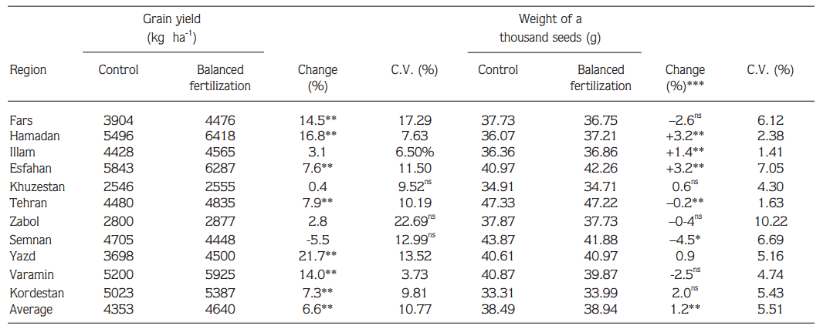
Source: (Malakouti, 2008)
*Significant differences at the 5% level. **Significant differences at the 1% level. ***The main cause of the decrease in the thousand kernel weight index in the field studies was the existence of some growth-limiting factors in some of the provinces, such as soil salinity.
ns: no significant differences between treatments.

Table 7. Amount of micronutrients removed by major intensified production systems in Indi
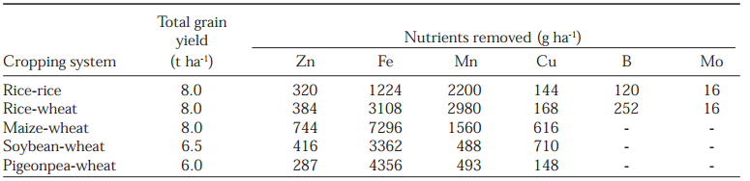
Source: Takkar, 1996 cited by Reg et al. (2005)
Table 8. Shoot dry weight, grain yield, number of panicles, grain harvest index (GHI), (across two Zn levels) and Zn harvest index (ZnHI) of 10 upland rice genotypes
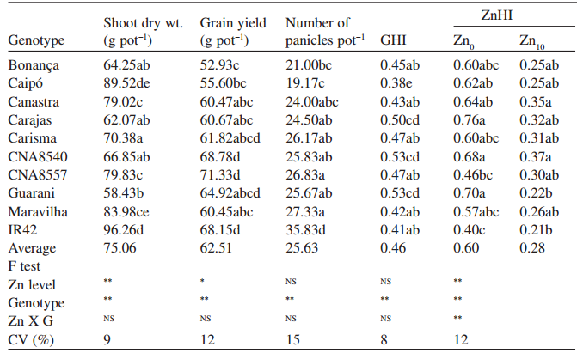
Source: (Alloway, 2008)
*, **, NS Significant at the 5%, 1% probability levels and non-significant, respectively Means in the same column followed by the same letter are not statistically different at the 5% probability level by the Tukey’s test. Several application methods are used for the correction of micronutrient deficiency. The most frequent method is the broadcast application of micronutrient onto soil. Irrespective of the methods used, application of Zn very significantly enhanced grain yield and shoot biomass. The highest increases in grain yield were found with soil, soil + leaf or seed + leaf application methods (fig 2).

