Single-cell exploration of active microbiota in solubilizing fixed phosphorus in soils
Hong-Zhe Li^{1, 2}, JingJing Peng³, Kai Yang^{1,2}, Yi-Yue Zhang^{1, 2}, Qing-Lin Chen¹, Yong-Guan Zhu^{4*} and Li Cui^{1, 2*}
¹ Key Lab of Urban Environment and Health, Institute of Urban Environment, Chinese Academy of Sciences, Xiamen, 361021, China
² Fujian Key Laboratory of Watershed Ecology, Institute of Urban Environment, Chinese Academy of Sciences, Xiamen, 361021, China
³ China Agriculture University, Beijing, 100091, China
⁴ Research Center for Eco-Environmental Sciences Chinese Academy of Sciences, Beijing, 100085, China
*Corresponding author at: Key Laboratory of Urban Environment and Health, Institute of Urban Environment, Chinese Academy of Sciences, 1799 Jimei Road, Xiamen 361021, China. Research Center for Eco-Environmental Sciences Chinese Academy of Sciences, Beijing, 100085, China.
Email: lcui@iue.ac.cn, ygzhu@rcees.ac.cn.

Change of soil microbial communities and potential P solubilization functional proﬁling
After performing quality control, we obtained a total of 1,167,509 sequences from 27 soil samples. We then used co-occurrence network analysis to investigate the effect of long-term fertilization on bacterial community associations (Figure S7a). Our analysis revealed that long-term inorganic fertilizer application increased the average clustering coefficient, a topological parameter that reflects the complexity of the bacterial community, by 0.160. We also observed more edges in the IF-treated samples, indicating that the bacterial community associations were more tightly connected in these samples. Conversely, CF decreased the average clustering coefficient by 0.016, as well as the number of edges. To further investigate the effect of long-term fertilization on the profile of soil PSB, the bacteria presented in Figure S7b were reported with P solubilization function. Our results showed that soil type could alter the effects of fertilizer application on potential PSB. These results were consistent with the differences in PSB communities observed through single-cell Raman detection, indicating significant differences in PSB composition among different soils.

Table S1 The concentrations of soil Olsen P before and after soil washing.
Soil site | Fertilization treatment | Before soil washing (mg kg⁻¹) | After soil washing (mg kg⁻¹)
DH | CK | 14.02 ± 1.37 | 1.16 ± 0.68
DH | IF | 15.60 ± 0.54 | 0.73 ± 0.45
DH | CF | 21.36 ± 14.12 | 1.10 ± 0.31
DZ | CK | 9.17 ± 0.40 | 0.69 ± 0.32
DZ | IF | 14.53 ± 1.92 | 0.82 ±0.61
DZ | CF | 58.29 ± 8.61 | 0.85 ± 0.36
QY | CK | 1.13 ± 0.36 | 0.82 ± 0.21
QY | IF | 33.54 ± 6.78 | 0.56 ± 0.18
QY | CF | 105.83 ± 5.88 | 0.62 ± 0.49

Table S2 The information of fertilization in different sampling sites.
Sampling site | Soil type | Fertilization duration | Fertilization treatment | Organic fertilizer  (t·hm⁻²) | Chemical fertilizer  (kg·hm⁻²)
 |  |  |  |  | N | P₂O₅ | K₂O
DH | Paddy soil | 10 years | CK | 0 | 0 | 0 | 0
DH | Paddy soil | 10 years | IF | 0 | 178 | 54 | 146
DH | Paddy soil | 10 years | CF | 20 | 178 | 54 | 146
DZ | Fluvo-aquic soil | 12 years | CK | 0 | 0 | 0 | 0
DZ | Fluvo-aquic soil | 12 years | IF | 0 | 130 | 600 | 240
DZ | Fluvo-aquic soil | 12 years | CF | 36 | 65 | 600 | 240
QY | Red soil | 40 years | CK | 0 | 0 | 0 | 0
QY | Red soil | 40 years | IF | 0 | 150 | 33 | 62
QY | Red soil | 40 years | CF | 30 | 150 | 33 | 62

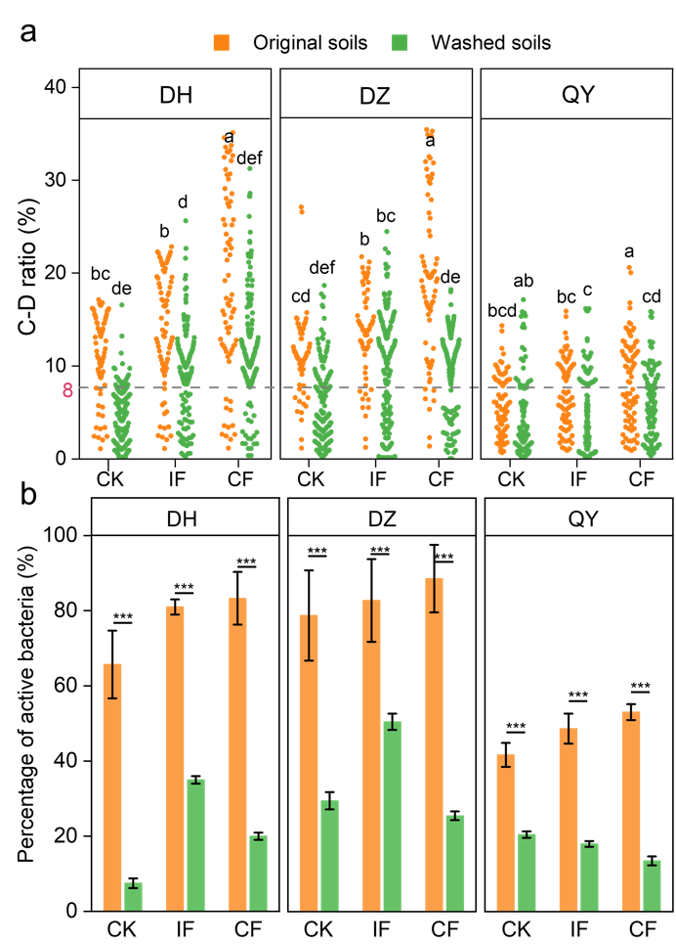
Figure S1 (a) C-D ratio of bacteria from original and washed soils from DH, DZ, and QY. Different letters represent significant differences, P <0.05. The grey dotted line represents the threshold value in distinguishing active and non-active bacteria. (b) The percentage of active bacteria from original and washed soils from DH, DZ, and QY. ***, P < 0.005.

Figure S2 Percentage of PSB against bacteria counts in DZ, DH, and QY soils under different long-term fertilization. The red lines represent the threshold value of Raman detection depth.

Figure S3 Correlation between concentrations of Olsen P and percentage of PSB (a-c), PSB activity (d-f), and P solubilization efficiency (g-i) from DZ, DH soils without (a, d, g) and with (b, e, h) organic fertilization and QY (c, f, i) soils.

Figure S4 Correlation between concentrations of dissolved organic carbon and percentage of PSB from DZ, DH soils without (a) and with (b) organic fertilization and QY (c) soils.

Figure S5 Heatmap showed the detection of functional genes encoding pyruvate metabolism, pentose phosphate pathway, oxidative phosphorylation, purine metabolism, and pyrimidine metabolism.

Figure S6 P acquisition from organic phosphorus substrates ordered by recalcitrance in sorted H-PSB from DZ soils. The numbers represent the EC numbers associated with the P transformation process.

Figure S7 The effects of long-term fertilization on soil bacterial communities. (a) Network analysis revealing the effect of long-term fertilization on bacterial co-occurrence pattern at the family level. (b) Relative abundance of typical PSB at the family level. One-way ANOVA was used to test the significance between IF and CK, CF treatments, *P < 0.05, **P < 0.01, ***P < 0.005; ns represents no significant difference.

