Appendix A. Result of the quantum-chemical calculations
1. Glycine (Gly), see also https://pubchem.ncbi.nlm.nih.gov/compound/Glycine
pK_{a1} 2.34,  pK_{a2} 9.60  logP –3.21 | 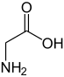  Aminoacid form | 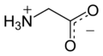  Zwitterionic form
Method | Ab initio 6-31G** | PM3
  CCDC 1515323,  zwitterionic form | 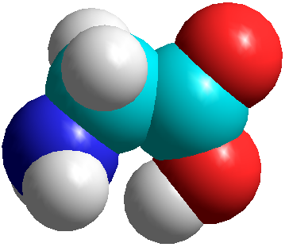  Start from the CCDC geometry,  final aminoacid form | 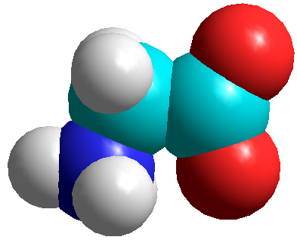  Start from the CCDC geometry,  final zwitterionic form, E⁰ = -892
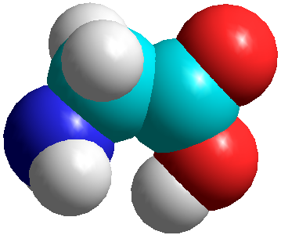
Start form the ab initio geometry,
final aminoacid form, E⁰ = -925
Electrostatic potential/ea₀⁻¹  positive (higher) –blue  negative (lower) –red | 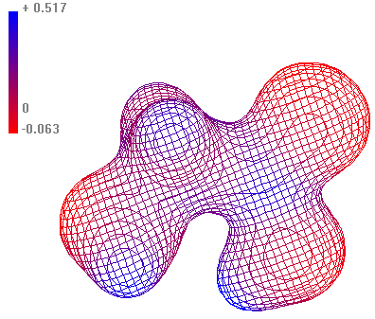  Contour 0.05 | 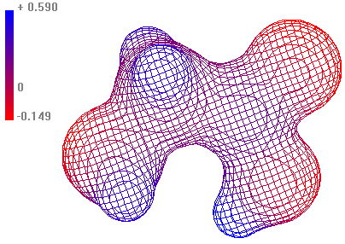  Contour 0.05
Charge density/ea₀⁻³ | 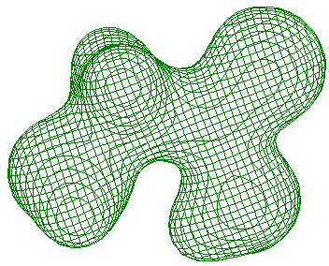  Contour 0.05 | 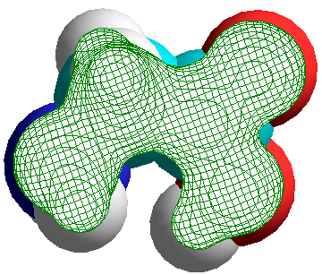  Contour 0.05
HOMO/eV (kcal mol⁻¹) | -10.87, -250 | -10.23, -236
LUMO/ev (kcal mol⁻¹) | 4.98, 114 | 0.85, 20
E⁺/kcal mol⁻¹ hereafter | -177273 | -697
E⁰ (optimized geometry) | -177481 | -925
E⁻ | -177367 | -890
E_{i}(ΔSCF) | 208 | 228
E_{g}(ΔSCF) | 114 | 35
E⁺(MP2) | -177755
E⁰(MP2) | -177993
E⁻(MP2) | -177900
E_{i}(MP2) | 238
E_{g}(MP2) | 93
Dipole moment /debye | 4.56 | 3.43
Polarizability volume /Å³ | 30.0 | 27.1
Surface area /Å² | 210 | 213
Volume /Å³ | 274 | 278
1 eV = 23.0605423 kcal mol⁻¹
2. l-alanine (Ala), see also https://pubchem.ncbi.nlm.nih.gov/compound/Alanine
pK_{a1} 2.34,  pK_{a2} 9.69  logP –2.85 | 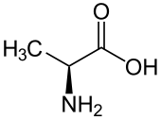  Aminoacid form | 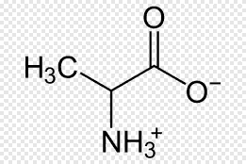  Zwitterionic form
Method | Ab initio 6-31G** | PM3
  CCDC 756486,  zwitterionic form | 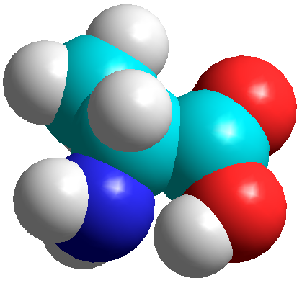  Start from the CCDC geometry,  final aminoacid form | 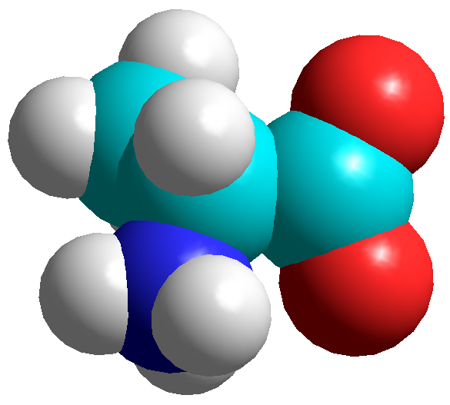  Start from the CCDC geometry,  final zwitterionic form, E⁰ = -1176
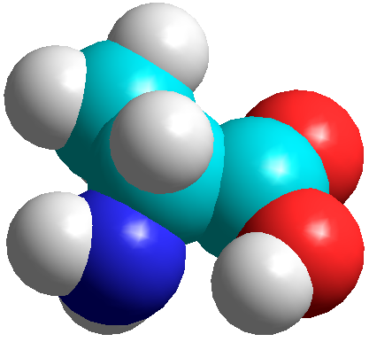
Start from the ab initio geometry,
final aminoacid form, E⁰ = -1209
Electrostatic potential/ea₀⁻¹  positive (higher) –blue  negative (lower) –red | 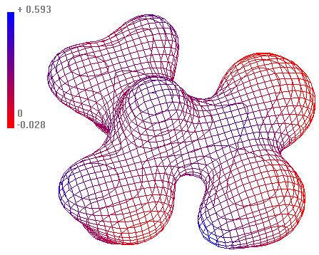  Contour 0.05 | 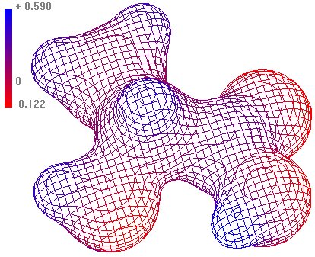  Contour 0.05
Charge density/ea₀⁻³ | 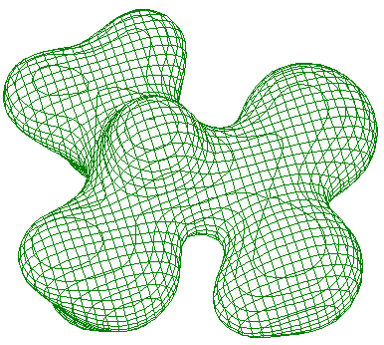  Contour 0.05 | 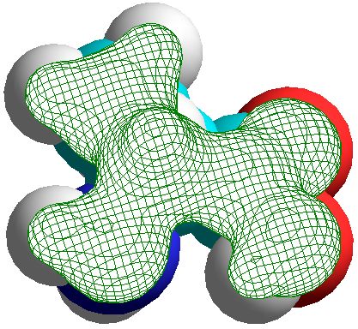  Contour 0.05
HOMO/eV, kcal mol⁻¹ | -11.27, -260 | -10.40, -240
LUMO/eV, kcal mol⁻¹ | 4.73, 109 | 1.06, 24
E⁺/kcal mol⁻¹ hereafter | -201768 | -980
E⁰ (optimized geometry) | -201985 | -1209
E⁻ | -201894 | -1186
E_{i}(ΔSCF) | 217 | 229
E_{g}(ΔSCF) | 91 | 23
E⁺(MP2) | -202355
E₀(MP2) | -202593
E⁻(MP2) | -202505
E_{i}(MP2) | 238
E_{g}(MP2) | 88
Dipole moment /debye | 5.48 | 4.37
Polarizability volume /Å³ | 40.1 | 33.6
Surface area /Å² | 236 | 243
Volume /Å³ | 323 | 330

3. l-asparagine (Asn), see also https://pubchem.ncbi.nlm.nih.gov/compound/Asparagine
pK_{a1} 2.02,  pK_{a2} 8.80,  logP –3.82 | 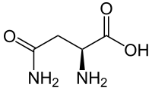  Aminoacid form | 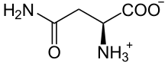  Zwitterionic form
Method | Ab initio 6-31G** | PM3
  CCDC 1103698,  zwitterionic form | 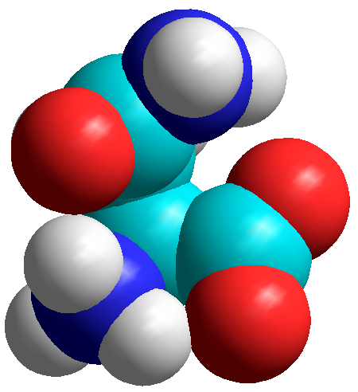  Start from the CCDC geometry,  final hydrogen bond form | 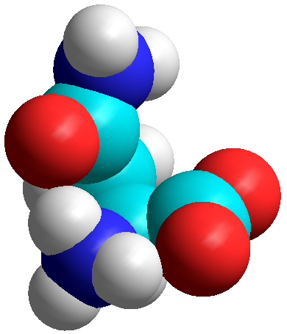  Start from the CCDC geometry,  final hydrogen bond, E⁰ = -1617.67
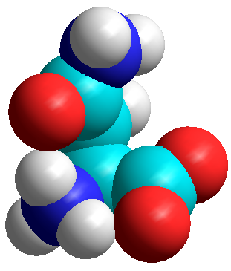
Start from the ab initio geometry,
final hydrogen bond, E⁰ = -1617.67
Electrostatic potential/ea₀⁻¹  positive (higher) –blue  negative (lower) –red | 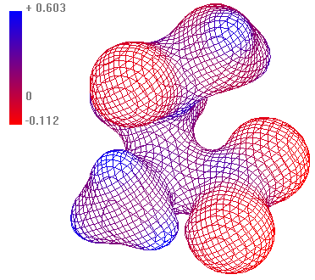  Contour 0.05 | 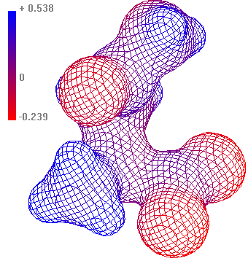  Contour 0.05
Charge density/ea₀⁻³ | 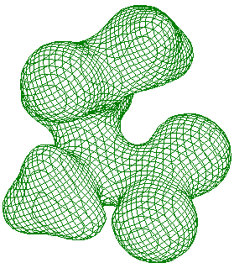  Contour 0.05 | 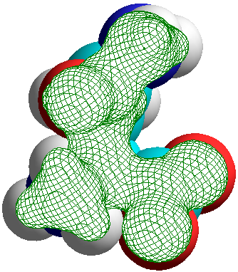  Contour 0.05
HOMO/eV, kcal mol⁻¹ | -10.45, -241 | -9.53, -220
LUMO/eV, kcal mol⁻¹ | 4.16, 95.9 | 0.06, 1.38
E⁺/kcal mol⁻¹ hereafter | -307086 | -1414.3
E₀ (optimized geometry) | -307259 | -1617.6
E⁻ | -307185 | -1626.3
E_{i}(ΔSCF) | 173 | 203
E_{g}(ΔSCF) | 74 | -8.7
E⁺(MP2) | -307968
E₀(MP2) | -308173
E⁻(MP2) | -308100
E_{i}(MP2) | 205
E_{g}(MP2) | 73
Dipole moment/debye | 6.68 | 7.72
Polarizability volume /Å³ | 55.3 | 54.1
Surface area, grid method/Å² | 273.25 | 283.09
Volume /Å³ | 395.75 | 408.30

4. Cysteine (Cys), see also https://pubchem.ncbi.nlm.nih.gov/compound/Cysteine
pK_{a1} 1.71,  pK_{a2} 8.33,  pK_{a3} 10.78(SH)  logP –2.49 | 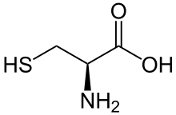  Aminoacid form | 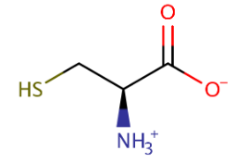  Zwitterionic form
Method | Ab initio 6-31G** | PM3
  CCDC 138062,  zwitterionic form | 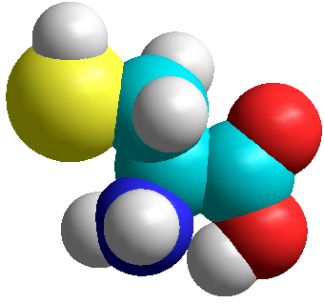  Start from the CCDC geometry,  final aminoacid form | Start from the CCDC geometry,  final: split CO₂
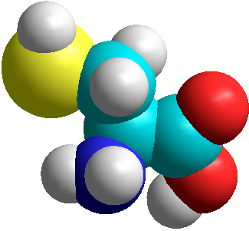
Start form the ab initio geometry,
final aminoacid form, E⁰ = -1264.1
Electrostatic potential/ea₀⁻¹  positive (higher) –blue  negative (lower) –red | 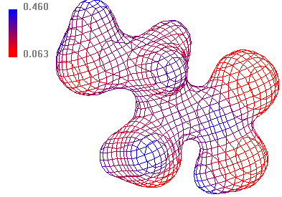  Contour 0.05 | 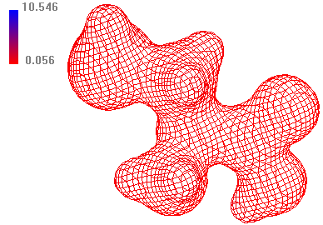  Contour 0.05
Charge density/ea₀⁻³ | 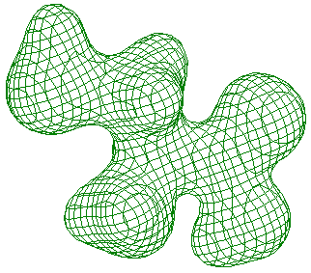  Contour 0.05 | 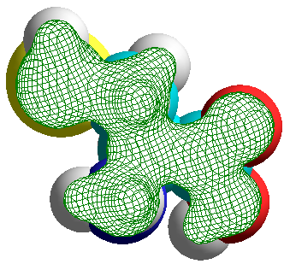  Contour 0.05
HOMO/eV, kcal mol⁻¹ | -9.70, -223 | -10.11, -233
LUMO/eV, kcal mol⁻¹ | -0.27, -6.22 | 4.12, 95
E⁺/kcal mol⁻¹ hereafter | -451218 | -1047.5
E⁰ (optimized geometry) | -451425 | -1264.1
E⁻ | -451342 | -1278.7
E_{i}(ΔSCF) | 207 | 217
E_{g}(ΔSCF) | 83 | -14.6
E⁺(MP2) | -451876
E⁰(MP2) | -452116
E⁻(MP2) | -452037
E_{i}(MP2) | 240
E_{g}(MP2) | 79
Dipole moment /debye | 3.79 | 3.11
Polarizability volume /Å³ | 54.5 | 45.2
Surface area /Å² | 269 | 272
Volume /Å³ | 378 | 385

5. Glutamic acid (Glu), see also https://pubchem.ncbi.nlm.nih.gov/compound/Glutamicacid
pK_{a1} 2.19,  pK_{a2} 4.25,  pK_{a3} 9.67  logP –3.69 | 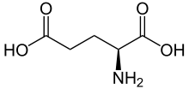  Aminoacid form | 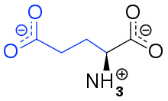  Zwitterionic form
Method | Ab initio 6-31G** | PM3
  CCDC 1877128  Zwitterionic form | 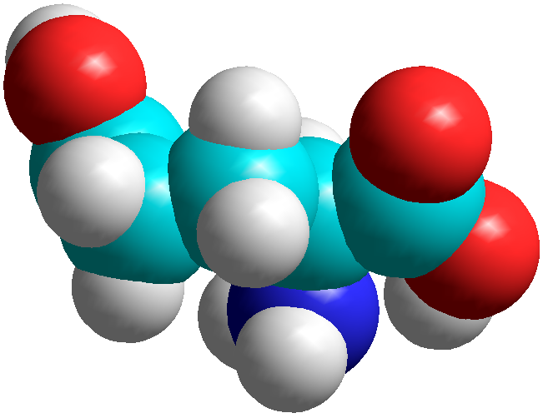  Start from the CCDC geometry,  final aminoacid form | 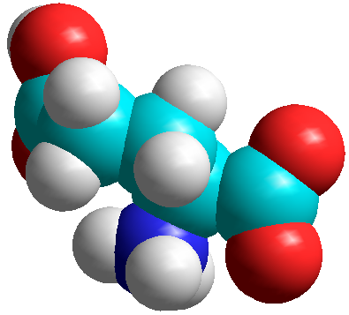  Start from the CCDC geometry,  final zwitterionic form, E⁰ = -1618
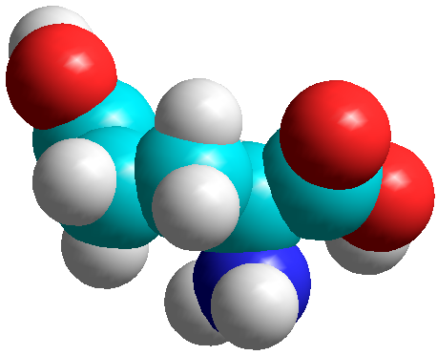
Start from the ab initio geometry,
final aminoacid form, E⁰ = -1866
Electrostatic potential/ea₀⁻¹  positive (higher) –blue  negative (lower) –red | 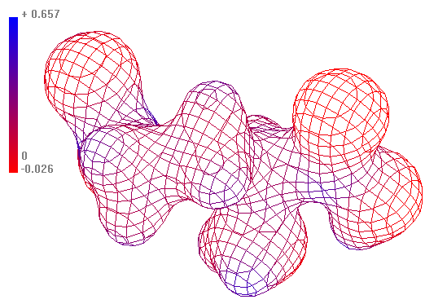  Contour 0.05 | 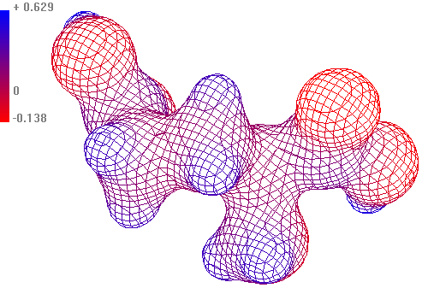  Contour 0.05
Charge density/ea₀⁻³ | 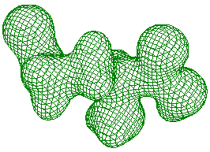  Contour 0.05 | 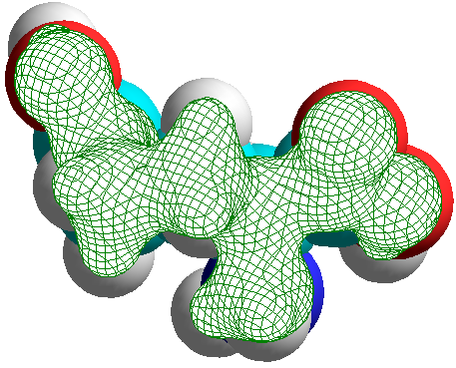  Contour 0.05
HOMO/eV, kcal mol⁻¹ | -11.23, -259 | -10.42, -240
LUMO/eV, kcal mol⁻¹ | 4.42, 102 | 0.53, 12.2
E⁺/kcal mol⁻¹ hereafter | -344014 | -1637
E⁰ (optimized geometry) | -344216 | -1866
E⁻ | -344127 | -1862
E_{i}(ΔSCF) | 202
E_{g}(ΔSCF) | 89
E⁺(MP2) | -344985
E⁰(MP2) | -345220
E⁻(MP2) | -345134
E_{i}(MP2) | 235
E_{g}(MP2) | 86
Dipole moment/debye | 4.81 | 4.15
Polarizability volume/Å³ | 61.7 | 53.1
Surface area, grid method/Å² | 301 | 310
Volume /Å³ | 442 | 456

6. Arginine (Arg), see also https://pubchem.ncbi.nlm.nih.gov/compound/Arginine
pK_{a1} 2.18 (carboxyl),  pK_{a2} 9.09 (amino),  pK_{a3} 13.2 (guanidine)  logP –4.20, -1.65 | 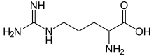  Aminoacid form | 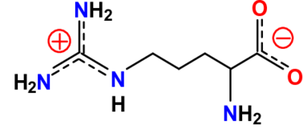  Zwitterionic form
Method | Ab initio 6-31G** | PM3
  CCDC 1578215  Open zwitterionic form  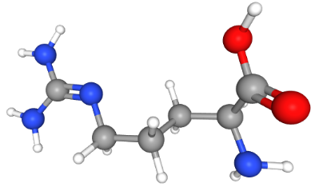  Open aminoacid form | 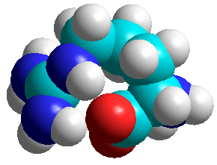  Start from the CCDC geometry,  final wrapped zwitterionic form | 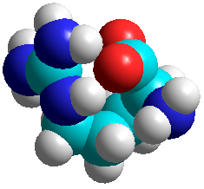  Start from the CCDC form,  final wrapped zwitterionic form,  E⁰ = -2392
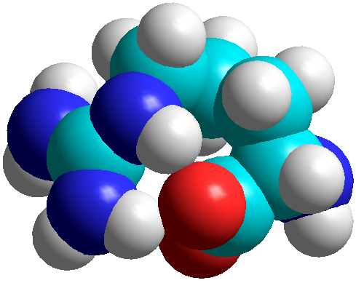
Start from the ab initio geometry,
final wrapped zwitterionic form,
E⁰ = -2393
Electrostatic potential/ea₀⁻¹  positive (higher) –blue  negative (lower) –red | 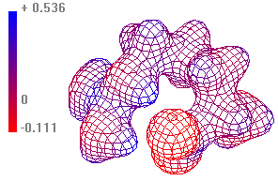  Contour 0.05 | 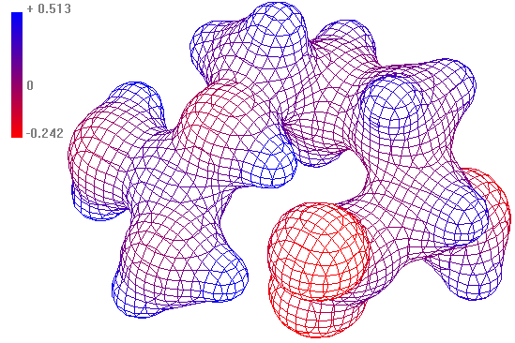  Contour 0.05
Charge density/ea₀⁻³ | 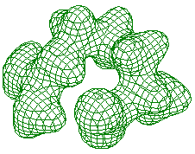  Contour 0.05 | 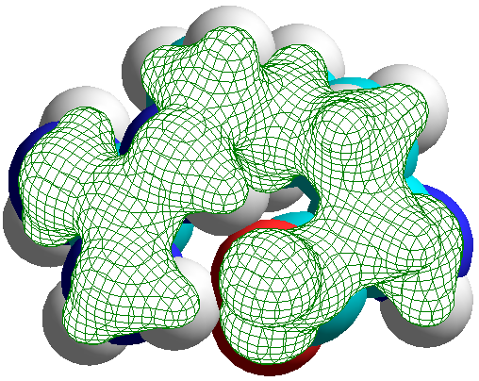  Contour 0.05
HOMO/eV, kcal mol⁻¹ | -9.35, -216 | -8.65, -199
LUMO/eV, kcal mol⁻¹ | 4.37, 101 | -1.04, -24
E⁺/kcal mol⁻¹ hereafter | -378175 | -2203
E⁰ (optimized geometry) | -378340 | -2392
E⁻ | -378250 | -2430
E_{i}(ΔSCF) | 165 | 189
E_{g}(ΔSCF) | 90 | -38
E⁺(MP2) | -379356
E⁰(MP2) | -379543
E⁻(MP2) | -379472
E_{i}(MP2) | 187
E_{g}(MP2) | 71
Dipole moment/debye | 7.27 | 8.08
Polarizability volume/Å³ | 84.8 | 83.0
Surface area, grid method/Å² | 337 | 342
Volume /Å³ | 525 | 532

7. l-phenylalanine (Phe), see also https://pubchem.ncbi.nlm.nih.gov/compound/Phenylalanine
pK_{a1} 1.83,  pK_{a2} 9.13  pK_{a} 1.24,  logP –1.38 | 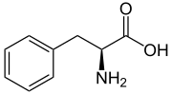  Aminoacid form | 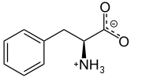  Zwitterionic form
Method | Ab initio 6-31G** | PM3
  CCDC 1532250,  zwitterionic form | 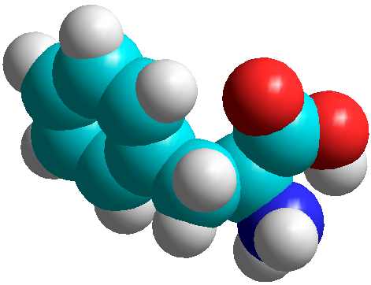  Start from the CCDC geometry,  final aminoacid form | 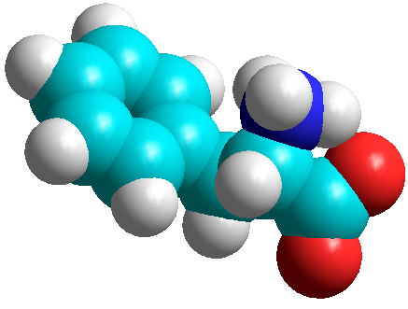  Start from the CCDC geometry,  final zwitterionic form, E⁰ = -2387
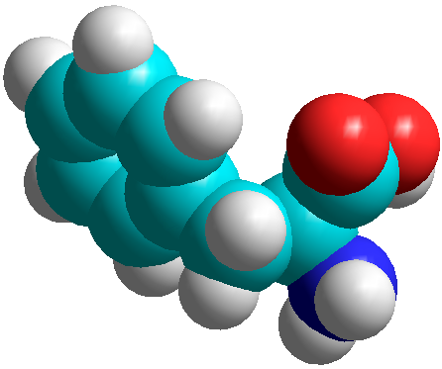
Start from the ab initio geometry,
final aminoacid form, E⁰ = -2413
Electrostatic potential/ea₀⁻¹  positive (higher) –blue  negative (lower) –red | 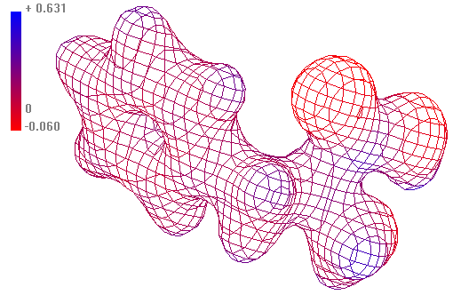  Contour 0.05 | 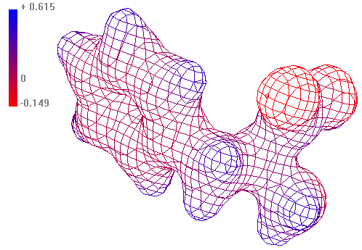  Contour 0.05
Charge density/ea₀⁻³ | 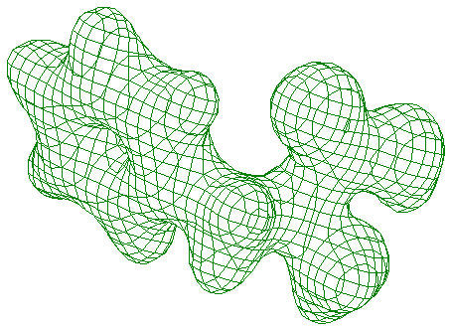  Contour 0.05 | 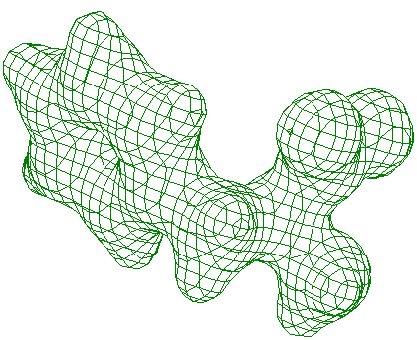  Contour 0.05
HOMO/eV, kcal mol⁻¹ | -8.77, -202 | -9.72, -224
LUMO/eV, kcal mol⁻¹ | 3.90, 90 | 0.10, 2.3
E⁺/kcal mol⁻¹ hereafter | -345856 | -2195
E⁰ (optimized geometry) | -346030 | -2413
E⁻ | -345962 | -2420
E_{i}(ΔSCF) | 174 | 218
E_{g}(ΔSCF) | 68 | -7
E⁺(MP2) | -346940
E⁰(MP2) | -347147
E⁻(MP2) | -347083
E_{i}(MP2) | 207
E_{g}(MP2) | 64
Dipole moment/debye | 4.89 | 4.01
Calc. polarizability volume/Å³ | 93.0 | 79.6
Surface area, grid method/Å² | 347 | 352
Volume /Å³ | 534 | 542

8. l-tyrosine (Tyr), see also https://pubchem.ncbi.nlm.nih.gov/compound/Tyrosine
pK_{i} 2.20, 9.11, 10.07  pK_{a} 2.2, logP –2.26 | 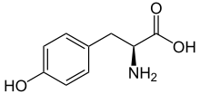  Aminoacid form | 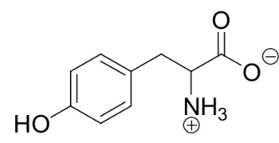  Zwitterionic form
Method | Ab initio 6-31G** | PM3
  CCDC 1208550,  zwitterionic form | 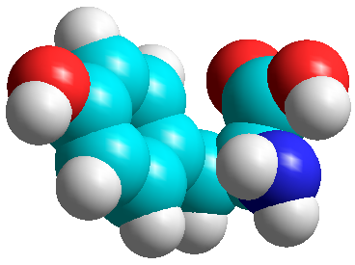  Start from the CCDC geometry,  final aminoacid form | 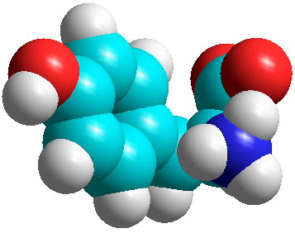  Start from the CCDC geometry,  final zwitterionic form, E⁰ = -2491
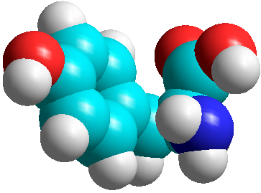 Start from the ab initio geometry,
final aminoacid form, E⁰ = -2518
Electrostatic potential/ea₀⁻¹  positive (higher) –blue  negative (lower) –red | 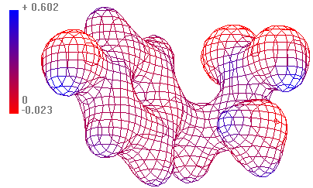  Contour 0.05 | 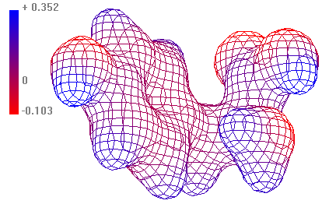  Contour 0.03
Charge density/ea₀⁻³ | 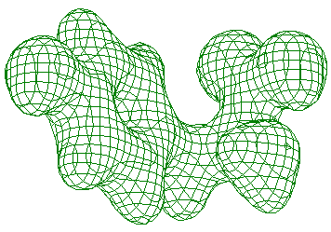  Contour 0.05 | 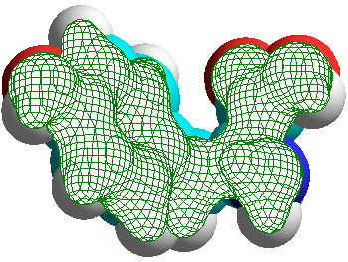  Contour 0.05
HOMO/eV, kcal mol⁻¹ | -8.47, -195 | -9.32, -215
LUMO/eV, kcal mol⁻¹ | 3.58, 83 | 0.02, 0.46
E⁺/kcal mol⁻¹ hereafter | -392841 | -2312
E⁰ (optimized geometry) | -393008 | -2518
E⁻ | -392922 | -2479
E_{i}(ΔSCF) | 167 | 206
E_{g}(ΔSCF) | 86 | 39
E⁺(MP2) | -394038
E⁰(MP2) | -394238
E⁻(MP2) | -394167
E_{i}(MP2) | 200
E_{g}(MP2) | 71
Dipole moment/debye | 6.53 | 5.45
Dipole polarizability volume/Å³ | 96.1 | 85.1
Surface area, grid method/Å² | 351 | 356
Volume /Å³ | 546 | 552
1 eV = 23.0605423 kcal mol⁻¹

9. l-histidine (Hys), see also https://pubchem.ncbi.nlm.nih.gov/compound/Histidine
pK_{a1} 1.78,  pK_{a2} 5.97,  pK_{a3} 8.97,  logP –3.32 | 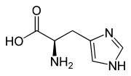  Aminoacid form | 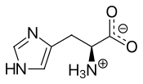  Zwitterionic form
Method | Ab initio 6-31G** | PM3
  CCDC 1889705  Zwitterionic form | 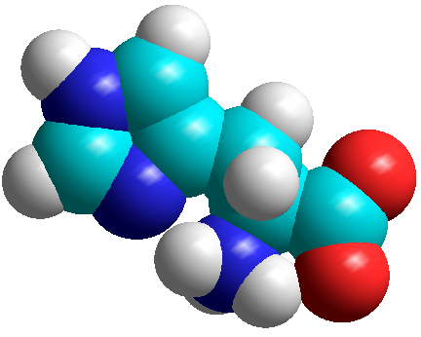  Start form the CCDC geometry  final zwitterionic form | 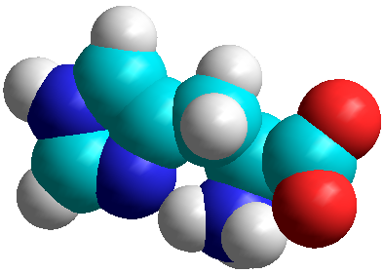  Start from the CCDC geometry  final zwitterionic form, E⁰ = -1994
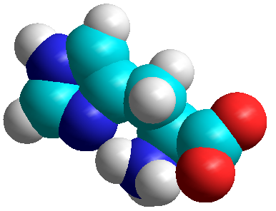
Start from the ab initio geometry
final zwitterionic form, E⁰ = -1994
Electrostatic potential/ea₀⁻¹  positive (higher) –blue  negative (lower) –red | 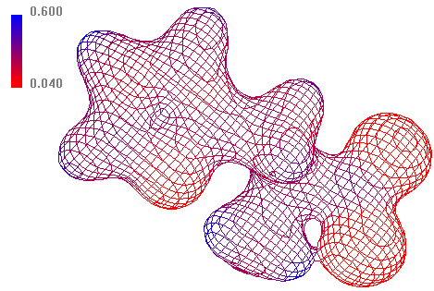  Contour 0.05 | 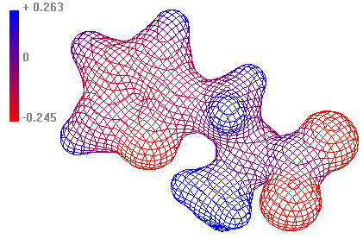  Contour 0.05
Charge density/ea₀⁻³ | 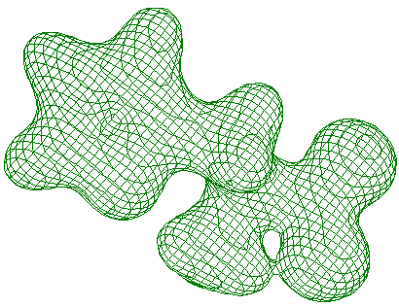  Contour 0.05 | 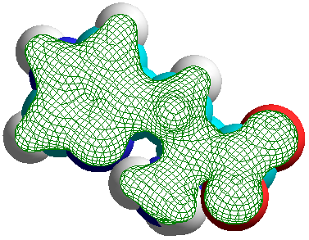  Contour 0.05
HOMO/eV, kcal mol⁻¹ | -9.33, -215 | -8.98, -207
LUMO/eV, kcal mol⁻¹ | 4.40, 101 | -0.22, -5.1
E⁺/kcal mol⁻¹ hereafter | -342138 | -1768
E⁰ (optimized geometry) | -342323 | -1994
E⁻ | -342220 | -1997
E_{i}(ΔSCF) | 185
E_{g}(ΔSCF) | 103
E⁺(MP2) | -343183
E⁰(MP2) | -343399
E⁻(MP2) | -343305
E_{i}(MP2) | 216
E_{g}(MP2) | 94
Dipole moment/debye | 12.99 | 13.68
Calc. polarizability volume/Å³ | 75.6 | 73.2
Surface area, grid method/Å² | 321 | 322
Volume /Å³ | 475 | 481

10. l-tryptophan (Trp), see also https://pubchem.ncbi.nlm.nih.gov/compound/Tryptophan
pK_{a1} 2.38  pK_{a2} 9.39  logP –1.06 | 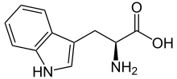  Aminoacid form | 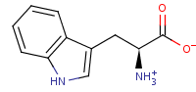  Zwitterionic form
Method | Ab initio 6-31G** | PM3
  CCDC 997182  Zwitterionic form | 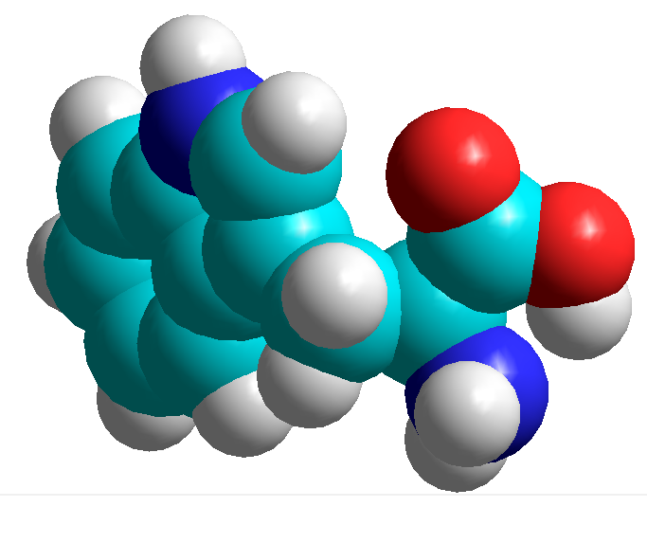  Start form the CCDC geometry,  final aminoacid form | 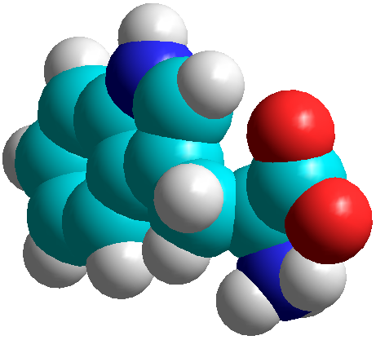  Start from the CCDC geometry,  final zwitterionic form, E⁰ = -2874
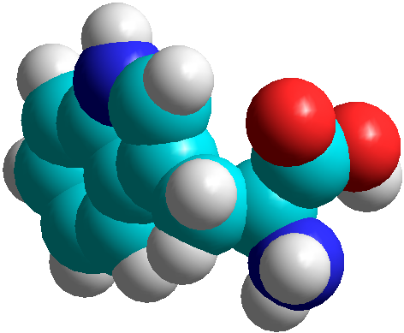
Start from the ab initio geometry,
final aminoacid form, E⁰ = -2902
Electrostatic potential/ea₀⁻¹  positive (higher) –blue  negative (lower) –red | 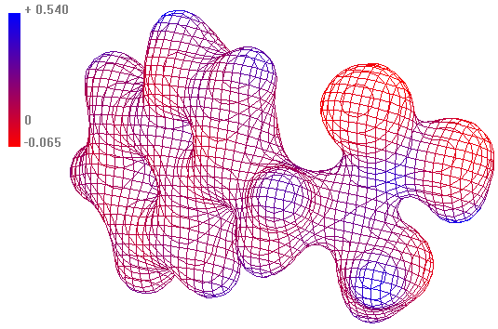  Contour 0.05 | 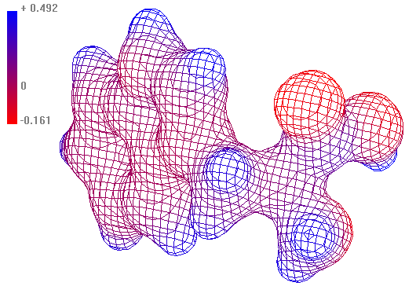  Contour 0.05
Charge density/ea₀⁻³ | 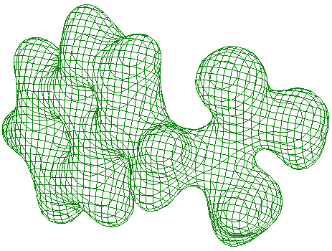  Contour 0.05 | 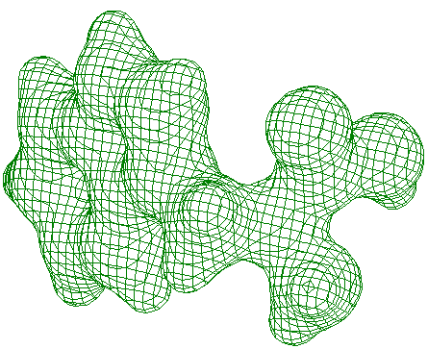  Contour 0.05
HOMO/eV, kcal mol⁻¹ | -7.53, -174 | -8.52, -196
LUMO/eV, kcal mol⁻¹ | 3.66, 84 | -0.06, -1.1
E⁺/kcal mol⁻¹ hereafter | -427940 | -2718
E⁰ (optimized geometry) | -428091 | -2902
E⁻ | -428030 | -2914
E_{i}(ΔSCF) | 151 | 184
E_{g}(ΔSCF) | 61 | -12
E⁺(MP2) | -428877
E⁰(MP2) | -429009
E⁻(MP2) | -428925
E_{i}(MP2) | 132
E_{g}(MP2) | 84
Dipole moment/debye | 2.97 | 2.82
Calc. polarizability volume/Å³ | 117.2 | 107.1
Surface area, grid method/Å² | 389 | 395
Volume /Å³ | 615 | 624

Appendix B.
Results and comments to the multivariate methods

The Cluster Analysis creates groups of observations with similar characteristics. To form the clusters, the procedure began with each observation in a separate group. It then combined the two observations which were closest together to form a new group. After recomputing the distance between the groups, the two groups then closest together were combined.
The Probabilistic Neural Network Classifier (PNN) classifies N observations – cases (o = <1, N>) into one of G groups (g =<1, G>) based on V variables (v =<1, V>). It constructs an estimate of each group’s density function d_{g} at a desired location (X) based on neighboring observations from that group. The estimate is constructed using a “Parzen window” that weights observations from each group according to their distance from the specified location. An input layer with P neurons (entities with manifold connectivities) refers to each variable; a pattern layer with N neurons refers to each selected case (observation); a summation layer is formed of G neurons. The output layer assigns a score to each group by multiplying the estimated density function d_{g} by the prior probability p_{g} and the cost c_{g}, i.e.
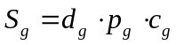
The density function for group g is given by
where σ is the standard deviation of the observed quantity X_{o} from the mean value 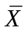 within the group (when o belongs to g; otherwise d_{og} = 0). When the number of observations in the training set that belong to group g, is n_{g}, the estimated density function for group d_{g} at location X is
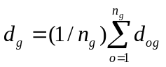
The above occurring prior probability can be set p_{g} = 1/N, and the cost c_{g} can be applied under certain conditions. As an output, the classification table by neural network compares the a priori classified cases with predicted one, including “incorrectly classified” cases. For the latter the highest and the second highest score is displayed thus offering a reclassification.
The Principal Component Analysis creates a small number (c) of linear combinations of the variables {V} which account for most of the variability in the data. This is performed by finding new variables − principal components P_{i} (i = 1,… c) through a linear transformation
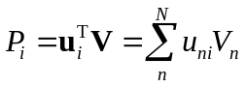
with normalization of coefficients 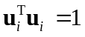. In determining the transformation vectors, covariances are used.
The Pearson product moment correlation coefficient for a pair of variables {x_{i}} and {y_{i}}:
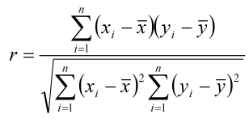

Scatterplot matrix
