Supplementary Material

Qifeng Liu^{1,2} and Yinghong Wang ^{2*}
1. Core Facilities, West China Hospital of Sichuan University, Chengdu 610041, China
2. State Key Laboratory for Bioactive Substances and Functions of Natural Medicines and Beijing Key Laboratory of New Drug Mechanisms and Pharmacological Evaluation Study, Institute of Materia Medica, Chinese Academy of Medical Sciences and Peking Union Medical College, Beijing, China
* Corresponding Author
E-mail addresses: wyh@imm.ac.cn (Y. Wang).

Supporting Information Content Information
Table S1. Evaluation statistics of sampling data.
Table S2. Species that have significantly changed after high-fat diet.
Table S3. Species that have significantly changed after fenofibrate treatment.
Table S4. Results of spearman analysis between KEGG enrichment pathways.
Table S5. Results of spearman analysis between species and KO.
Table S6. Results of spearman analysis between species and AROs.

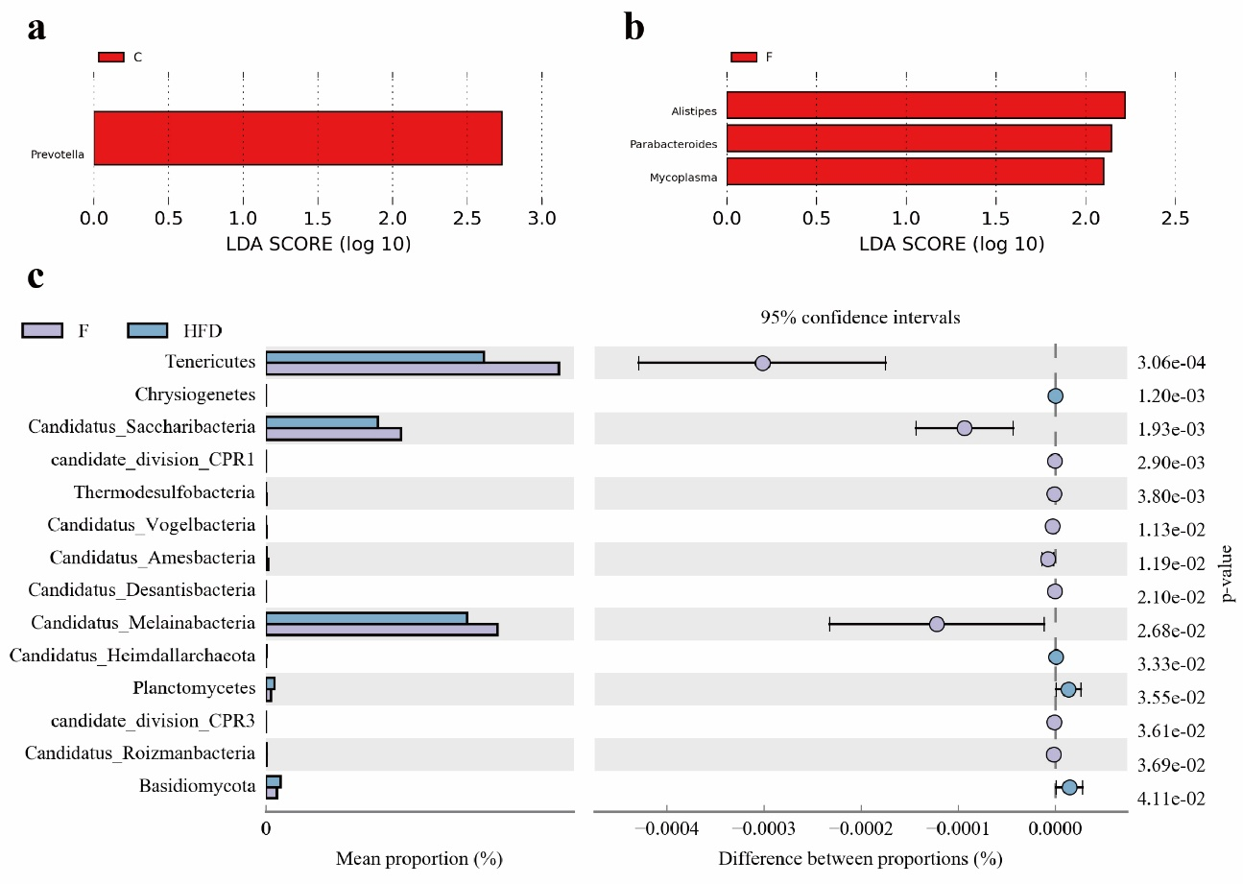
Fig. S1 Changes of gut microbiota between C, F and HFD group. (a) LDA analysis of significantly different genus between C and HFD group (LDA>2.0); (b) LDA analysis of significantly different genus between F and HFD group (LDA>2.0); (c) Significant gut microbial changes between F and HFD groups in phylum level.

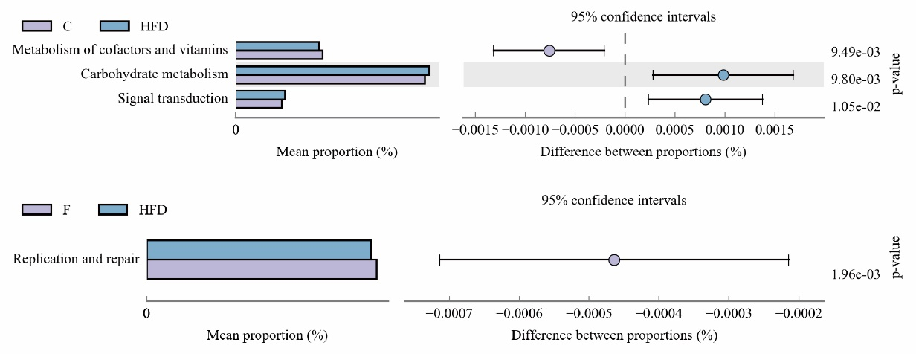
Fig. S2 Significant KEGG pathway changes between C, F and HFD groups in level2.

