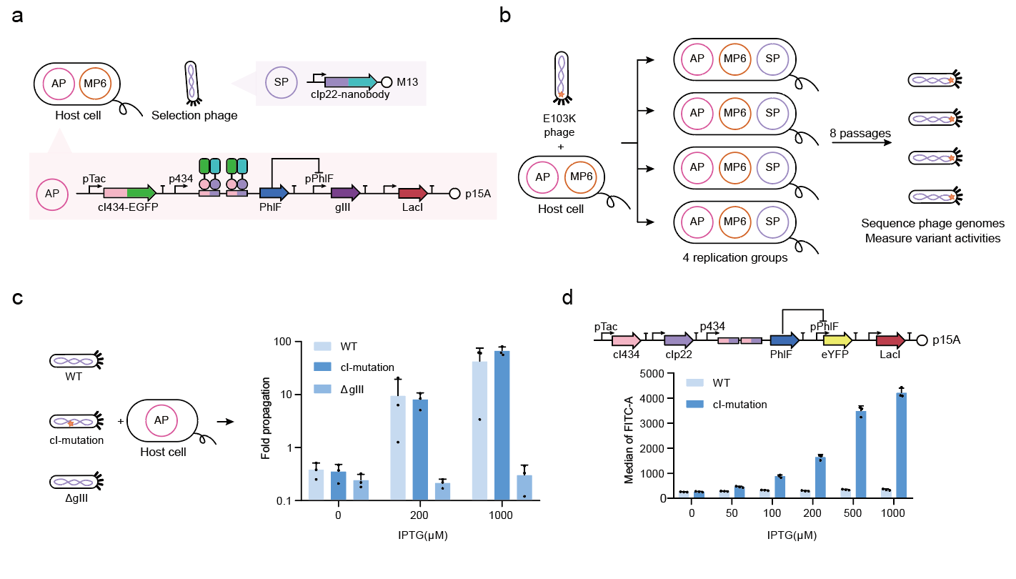
Extended Data Figure 1. PANCE for EGFP-nanobody.
(a) Genetic circuit design of PANCE for EGFP-nanobody. (b) Diagram of PANCE process for EGFP-nanobody. (c) Phage propagation assays of the cI-mutation nanobody compared to WT and ΔgIII. (d) Flow cytometry assays of interaction between the mutated cIp22 and the WT cI434. Concentration of IPTG was 0, 50, 100, 200, 500 and 1000 μM. Data are mean ± SD of three experiments, except for phage titers.

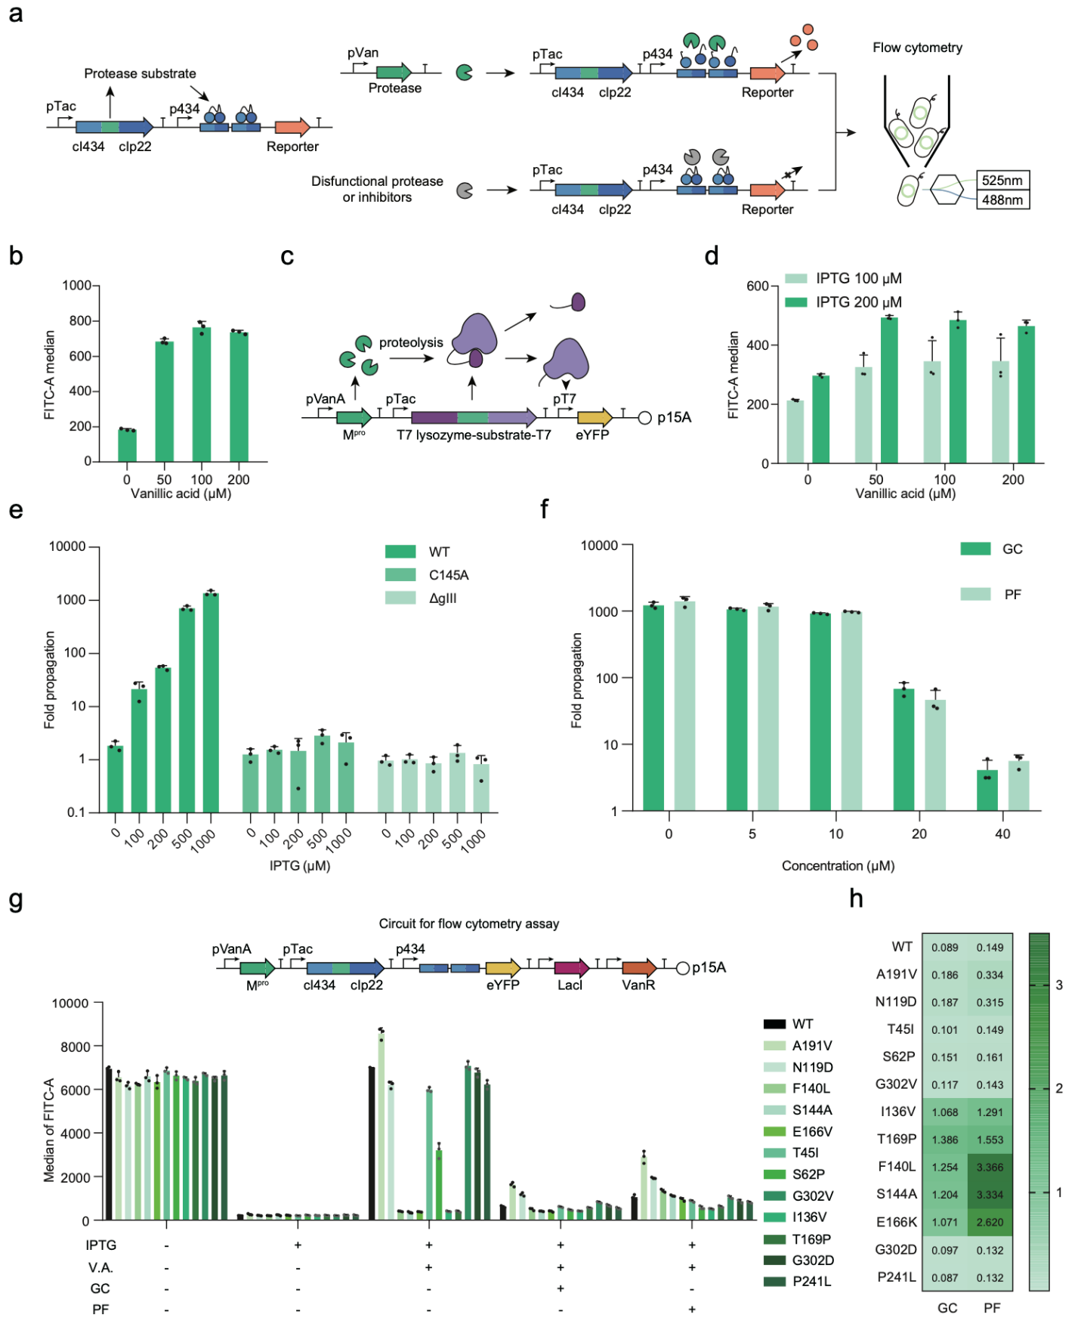
Extended Data Figure 2. The protease activity testing system.
(a) Schematic diagram of reverse two-hybrid protease activity testing system. Matched substrate was used as the linker of the cI repressor pair, and the active protease cut the substrate and rescued the activity of the p434 promoter repressed by the fused cI repressor. Expression of the downstream reporters (fluorescence protein, pIII for phage propagation, etc.) was controlled by the p434 promoter. (b) Flow cytometry assays for HCV protease by the reverse two-hybrid protease activity testing system. Different concentrations of vanillic acid (0, 50, 100, 200 μM) and IPTG (100, 200 μM) were used. (c) Schematic diagram of the T7-based protease activity testing system. T7 lysozyme and T7 polymerase were linked together with a linker carrying the protease substrate. As the protease cut the substrate, released T7 polymerase recognized T7 promoter and expressed the downstream reporter. (d) Flow cytometry assays for M^{pro} by T7-based protease activity system (IPTG=100, 200 μM, Vanillic acid=0, 50, 100, 200 μM). (e) Phage propagation assays for M^{pro} and its variants under different concentrations of IPTG (IPTG = 0, 100, 200, 500, 1000 μM). (f) Phage propagation assays for inhibitors with different concentrations. Inhibitor concentration gradient was set as 0, 5, 10, 20, 40 μM. The concentration of IPTG was set as 1000 μM. (g) Flow cytometry assays for representative M^{pro} variants obtained by EvoScan (IPTG=100 μM, vanillic acid=100 μM, GC376=50 μM, PF-07321332=50 μM). (h) Resistance Index of M^{pro} variants on both inhibitors (50 μM). Concentration of IPTG was 100 μM, and vanillic acid was 100 μM. Data are mean ± SD of three experiments, except for phage titers.
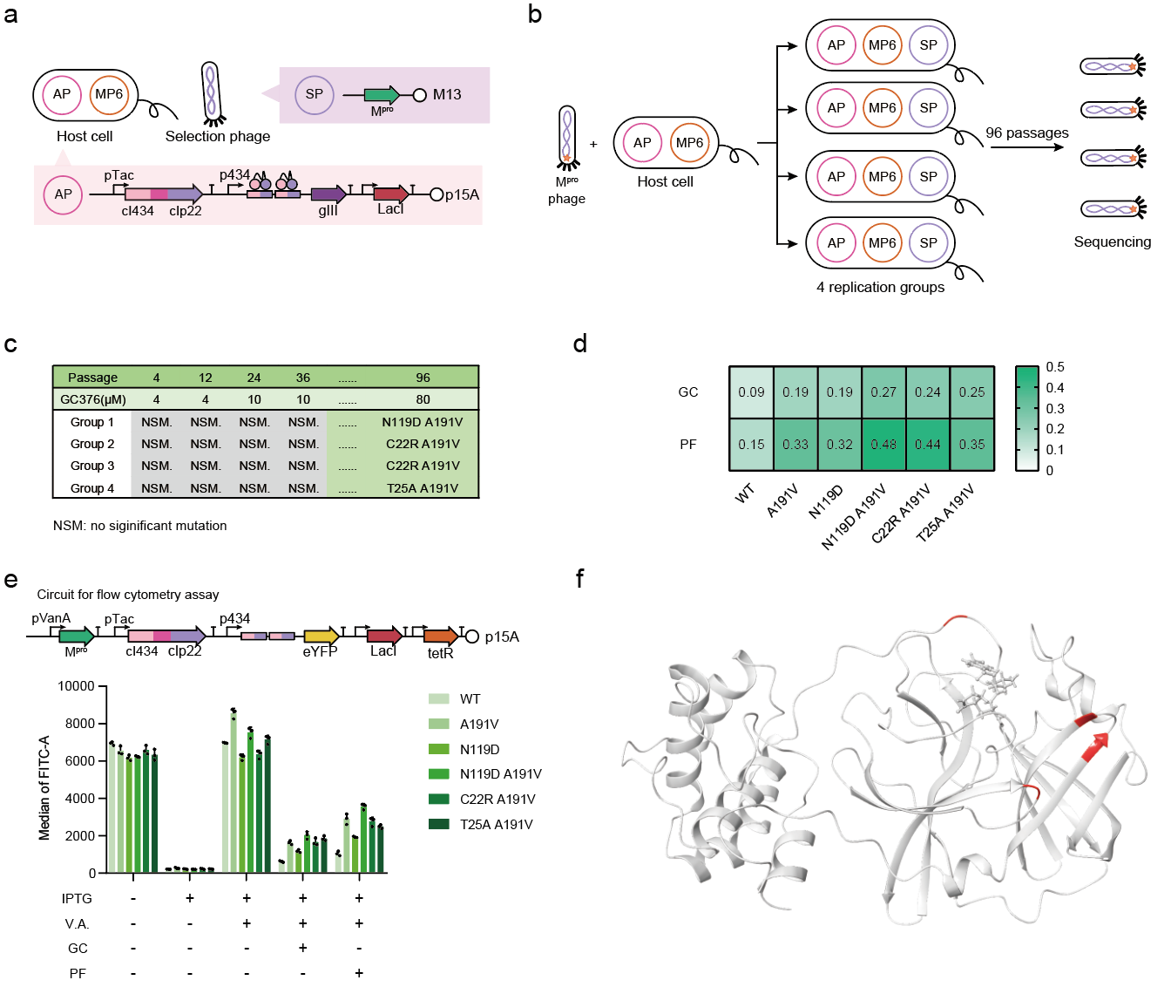
Extended Data Figure 3. PANCE to obtain M^{pro} variants that escape the inhibition of GC376.
(a) Genetic circuit design of PANCE for M^{pro}. (b) Diagram of PANCE process for M^{pro}. 4 replication groups were performed. (c) Evolution results of PANCE after 96 passages. (d) Flow cytometry assays of M^{pro} variants. The A191V and N119D single mutation were also measured and served as control groups. Concentration of IPTG was 100 μM, concentration of vanillic acid was 100 μM, and concentration of GC376 was 50 μM. (e) Resistance Index of variants against GC376 after 96 passages. The A191V and N119D single mutation were also shown as control groups. (f) Mutations from PANCE mapped to the crystal structure of M^{pro} (PDB ID: 7CB7). Data are mean ± SD of three experiments, except for phage titers.

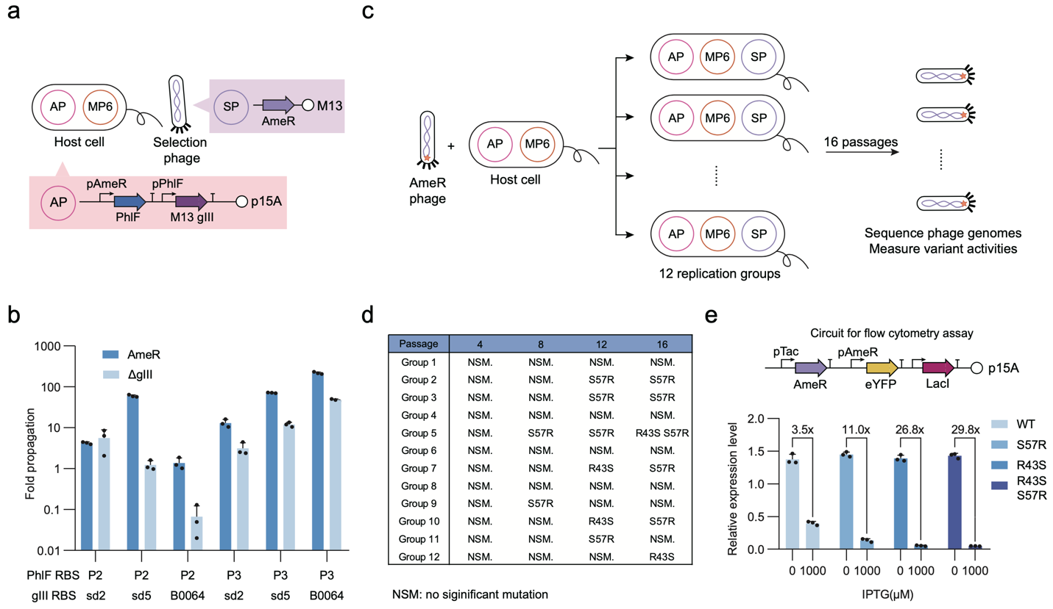
Extended Data Figure 4. PANCE for AmeR evolution.
(a) Genetic circuit design of PANCE for AmeR evolution. (b) Propagation assays of combinatorial AP designs. Different RBS combinations for PhlF and gIII on APs were tested. (c) Workflow of PANCE for AmeR. 12 replication groups were performed. (d) Evolution results of PANCE for AmeR after 16 passages. (e) Flow cytometry assay of variants from PANCE for AmeR. Data are mean ± SD of three experiments, except for phage titers.
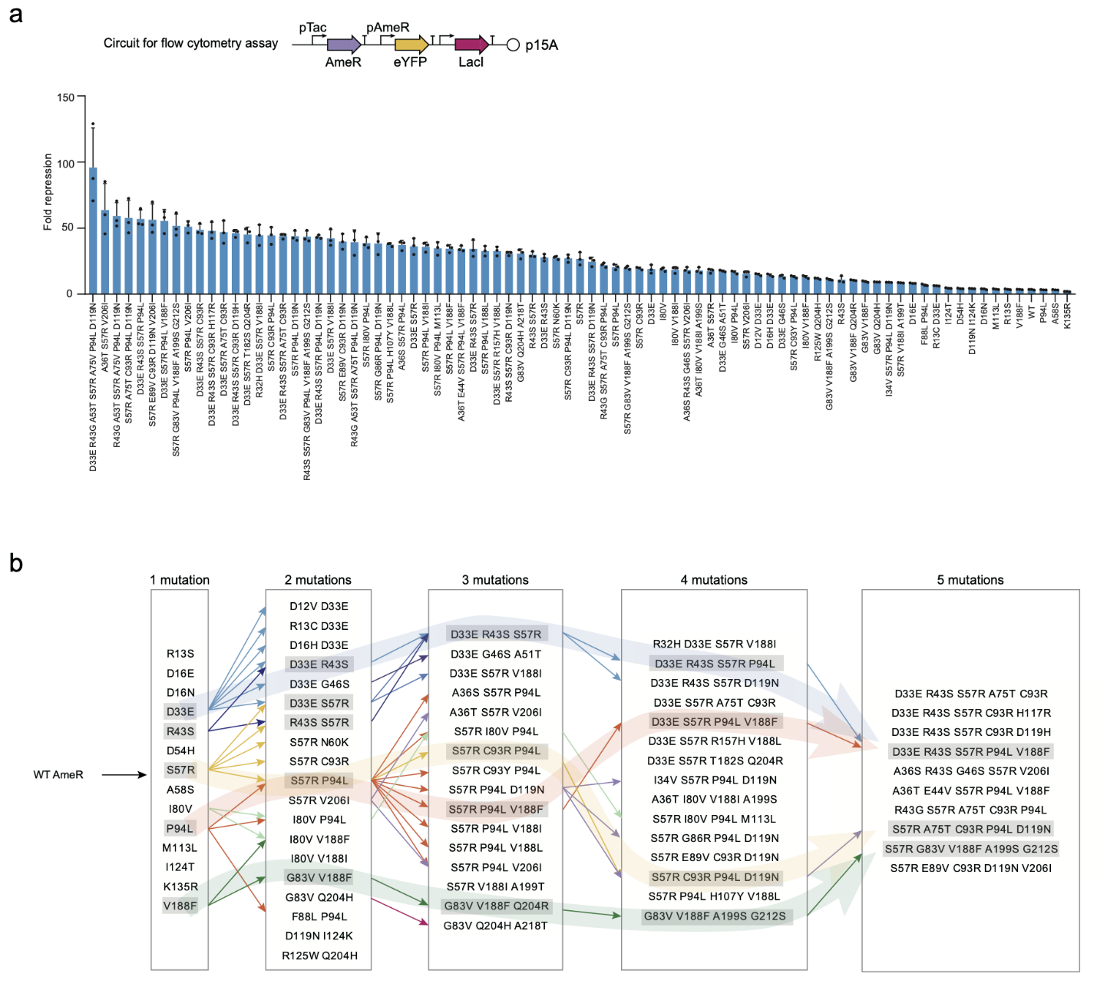
Extended Data Figure 5. AmeR variant activity measurement and evolution path analysis.
(a) Fold repression of 82 AmeR variants from EvoScan. The circuit for flow cytometry assay was shown. (b) Possible evolutionary paths that lead to the same variants with multiple mutations.

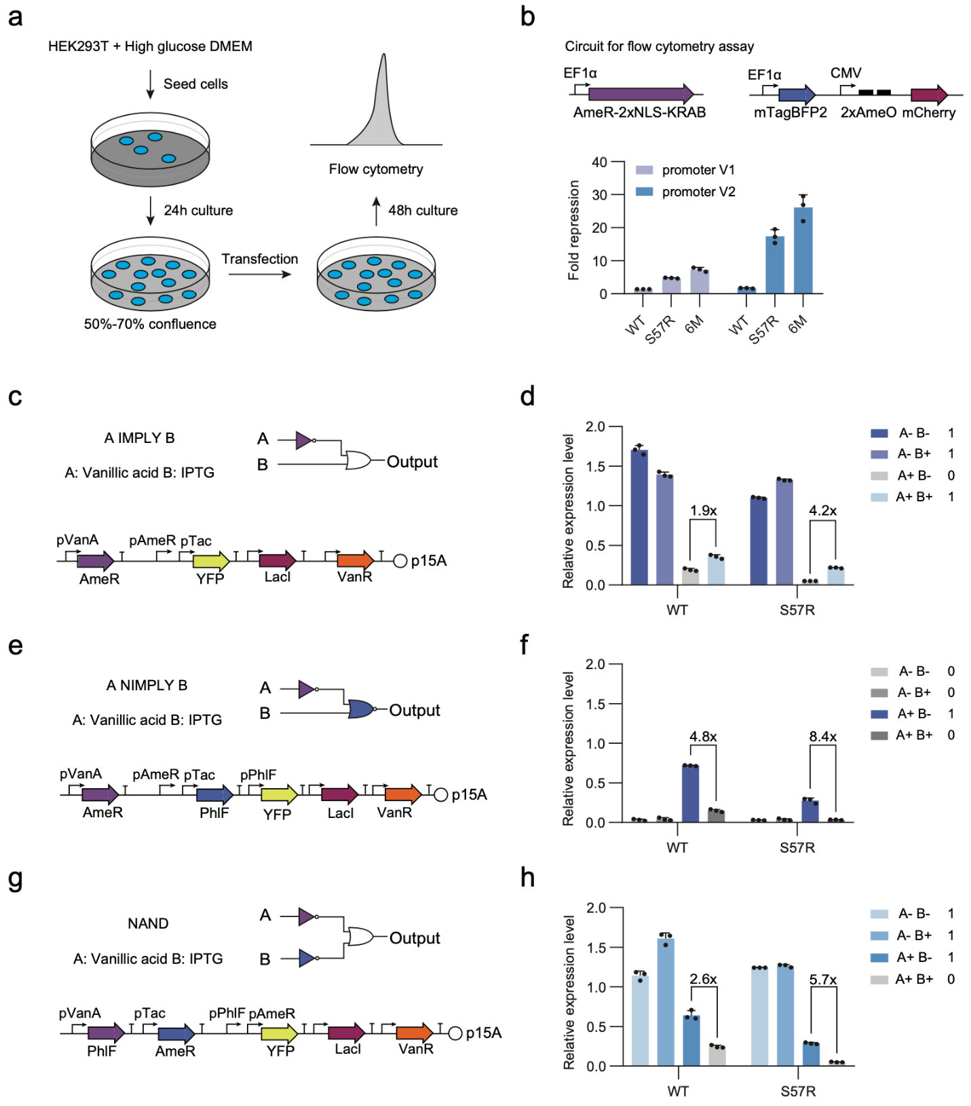
Extended Data Figure 6. Genetic circuit construction with WT AmeR and the S57R variant.
(a) Schematic diagram of AmeR flow cytometry assay in mammalian cell (HEK293T). (b) The genetic circuit for AmeR flow cytometry assay and the results. 6M is the AmeR variant R43G A53T S57R A75V P94L D119N. (c) Genetic circuit design of A IMPLY B. (d) Flow cytometry assay of the genetic circuit A IMPLY B. (e) Genetic circuit design of A NIMPLY B. (f) Flow cytometry assay of the genetic circuit A NIMPLY B. (g) Genetic circuit design of NAND. (h) Flow cytometry assay of the genetic circuit NAND. All circuits in this figure used 100 μM vanillic acid (input A) and 1000 μM IPTG (input B) as input signals. Data are mean ± SD of three experiments, except for phage titers.

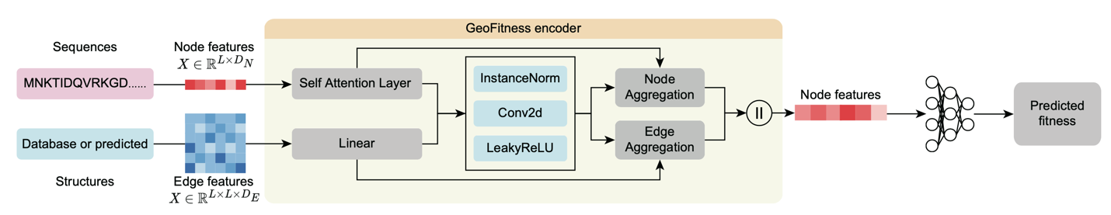
Extended Data Figure 7. Overall algorithm flow of the GeoFitness geometric encoder.
For each protein variant, sequence information was transferred into a 1-dimensional vector, and the structure of the sample collected from PDB or predicted by Alphafold2 was transferred into a 2-dimensional vector. These two inputs were integrated through the geometric encoder block and the output was put into the Multi-Layer Perceptron (MLP) for generation of predicted fitness.

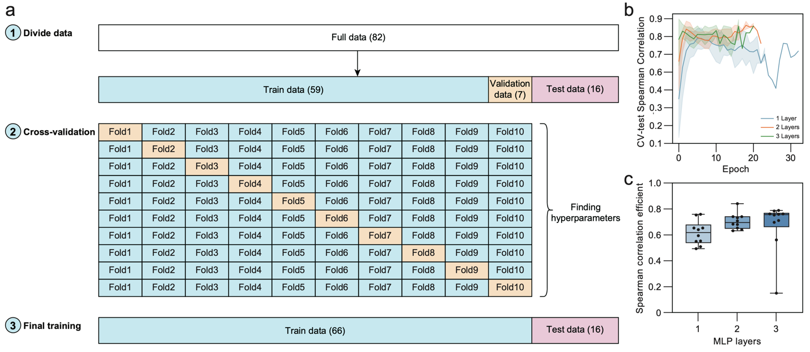
Extended Data Figure 8. Cross-Validation of EvoAI model training
(a) Schematic diagram of the data set in 10-fold cross-validation. (b) CV-test spearman correlation coefficient of different layers during cross-validation. Curves are shown as the mean of 10 groups. (c) Influence of layer number of MLP on 10-fold cross-validation of model training. 2-layer MLP shows the best performance with higher spearman correlation coefficient compared to 1-layer MLP and smaller variance compared to 3-layer MLP. The error bars are shown as standard deviation.

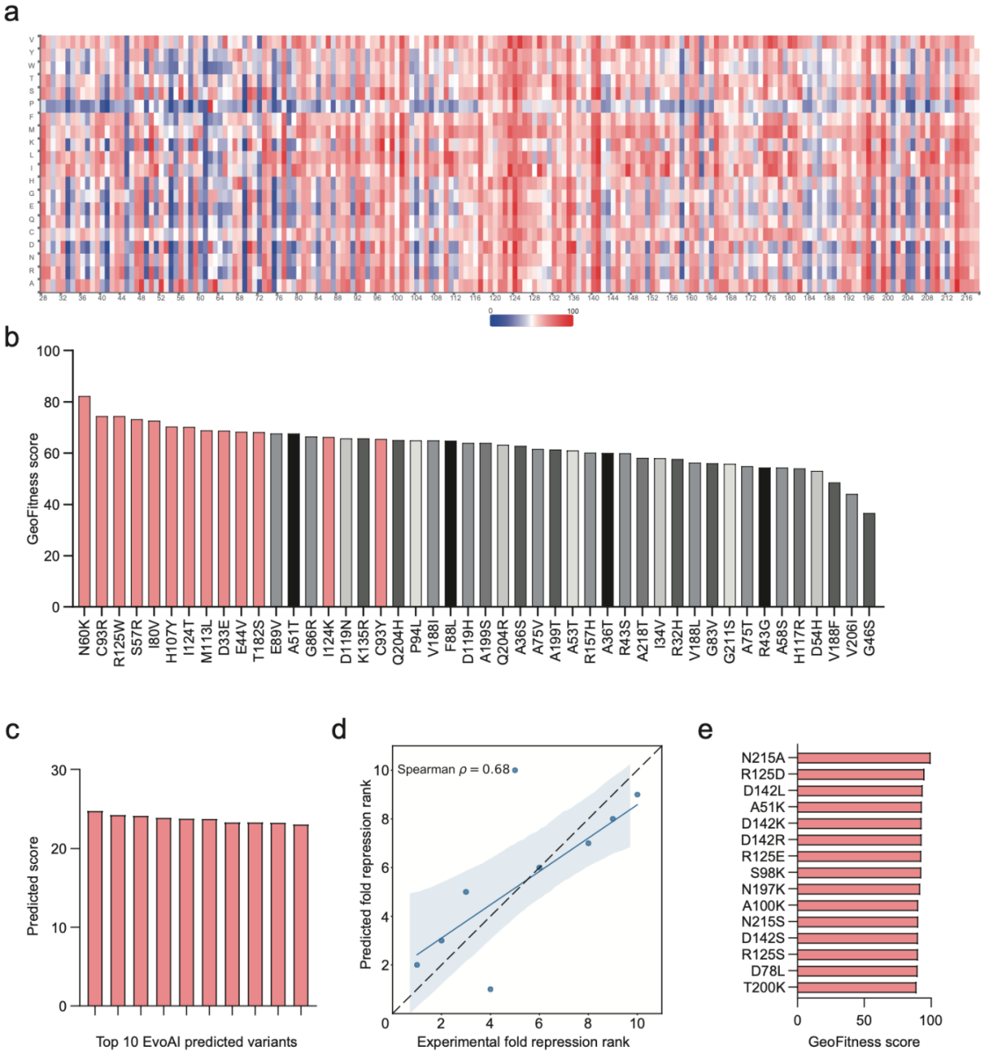
Extended Data Figure 9. GeoFitness values of AmeR mutations.
(a) GeoFitness values of all single site mutations generated by the pre-trained model. The first 28 sites of N-terminal were discarded in prediction because of low confidence. A larger score indicates a higher likelihood that this mutation will improve protein function. (b) GeoFitness value ranking of mutations from all the anchors. The selected top 11 sites (13 mutations in total) were colored in red. (c) Predicted score of the top 10 variants each with a combination of 6 mutations designed by EvoAI. (d) Spearman correlation coefficient of the predicted fold repression rank and the experimental fold repression rank of the top 10 variants. (e) Top 15 mutations with the highest predicted GeoFitness values from all single mutations.

