Supplementary Materials
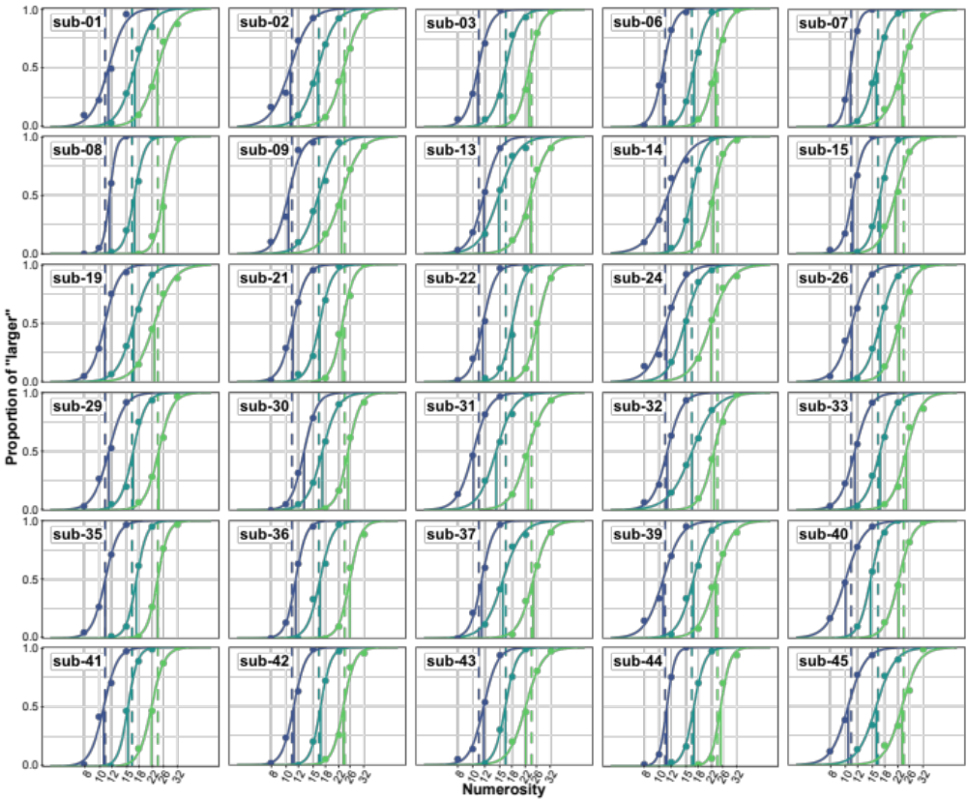
Supplementary Figure 1 | Fitted psychometric functions. Each panel shows the individual behavioral data (colored circles), fitted by psychometric functions. The colored vertical dashed lines indicate the mathematical bisection points, while the vertical solid lines indicate the subjective bisection points. Blue for small, green for medium, light green for large set. The first panel (upper left) is the same data as Fig. 1c.
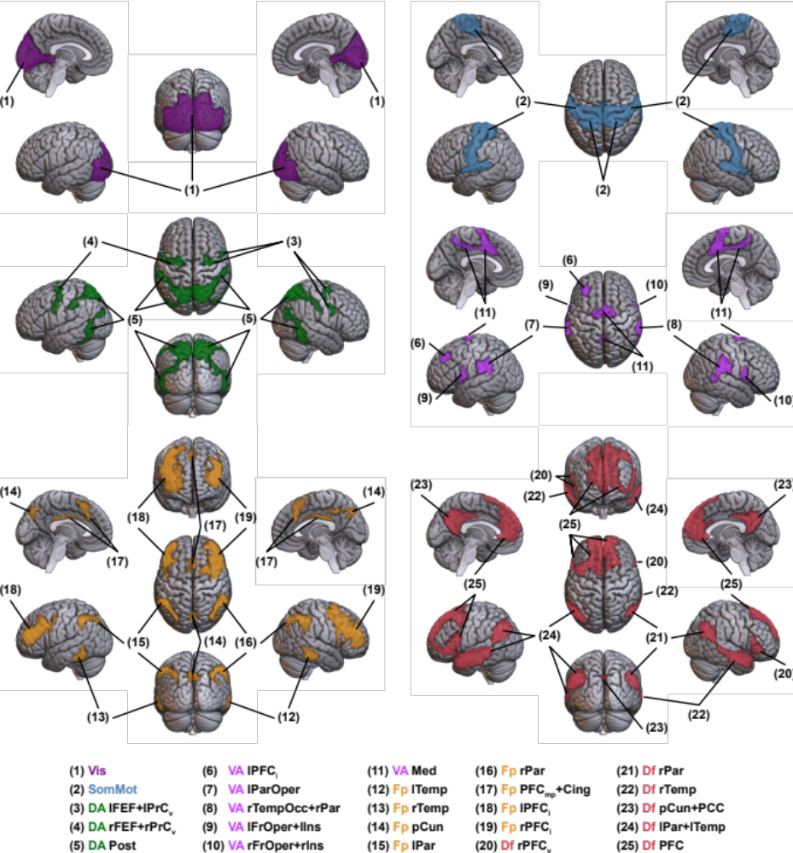
Supplementary Figure 2 | The 25 ROIs. ROIs are shown separately for each functional network in a cortical parcellation: Visual (Vis, purple, upper left), Somatomotor (SomMot, light blue, upper right), Dorsal Attention (DA, green, middle left), Ventral Attention (VA, pink, middle right), Frontoparietal (Fp, orange, lower left), Default (Df, red, lower right). See Table 1 in the main text for the naming rule.
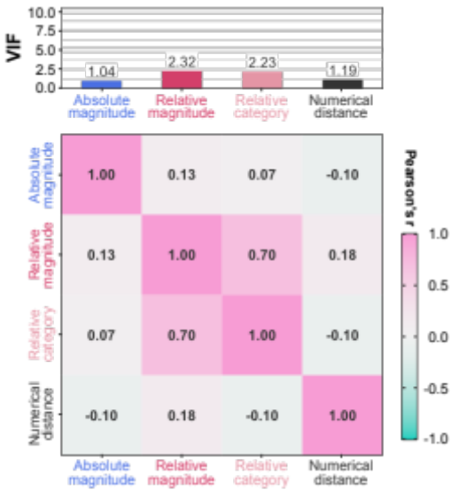
Supplementary Figure 3 | Collinearity across the hypothetical RDMs in representational similarity analysis. The pairwise Pearson’s correlation across the hypothetical RDMs in RSA (bottom) and the variance inflation factor (VIF) for each hypothetical RDM (top).
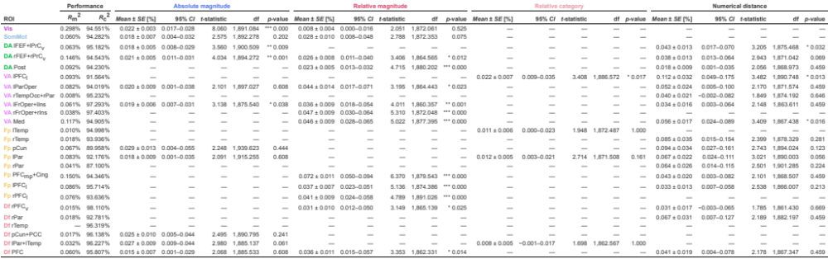
Supplementary Table 1
The coefficients on the fixed effects in the best models in the ROI-based RSA.
The goodness-of-fit and the coefficients on the fixed effects of the best model in each ROI (rows).
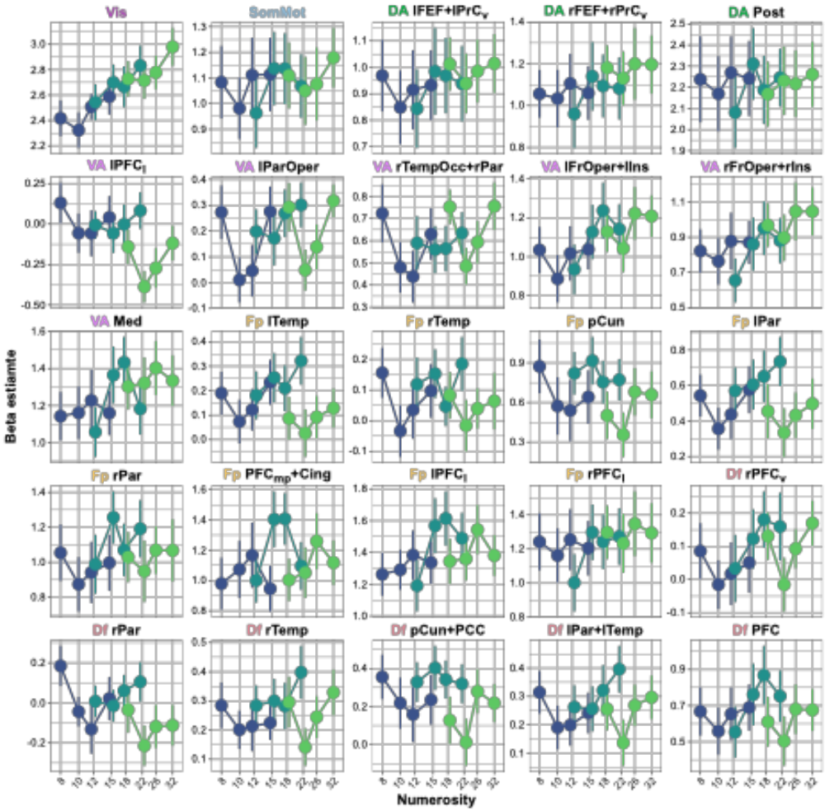
Supplementary Figure 4 | The average activity in each ROI. The beta estimates at each numerical magnitude were averaged across 500 voxels used in the ROI-based classification analysis and RSA. Each data point represents average across participants. Error bar indicates the standard error.
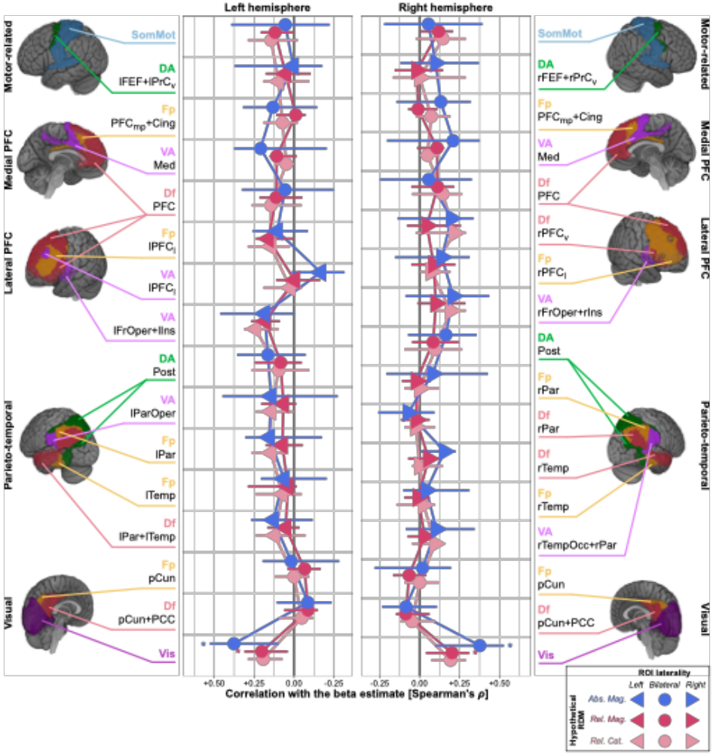
Supplementary Figure 5 | Correlation between the average activity and the stimulus configurations. Spearman’s correlation between the average activity and the stimulus magnitude (x-axis) in all ROIs (y-axis). The results for the left and right hemisphere ROIs are shown in the left and right panels (triangles), respectively. For the bilateral ROIs (circles), which span across both hemispheres, identical data are displayed in both panels to aid interpretation. The colors indicate the stimulus magnitudes, which were also used to define the hypothetical RDMs in the RSA: the absolute magnitude (blue), the relative magnitude (magenta), and the relative category (light magenta). Asterisks denote statistical significance: * p < 0.05, ** p < 0.01, *** p < 0.001 (two-sided Wilcoxon signed-rank test against zero. Holm corrected for multiple comparisons). The data points and error bars indicate the mean and the 95% confidence intervals.

