Supplementary Material
Experimental model is printed on a Picaso 3D printer using ABS plastic. The printing area of the Picaso printer is 200×200×210 mm³, thus, the working model was build of 9 patches replicating the area of 700×700 m². Fig. 1 shows an overall view of experimental model. The location of the extended source of impurity is indicated by a red frame, black color indicates the observation area.
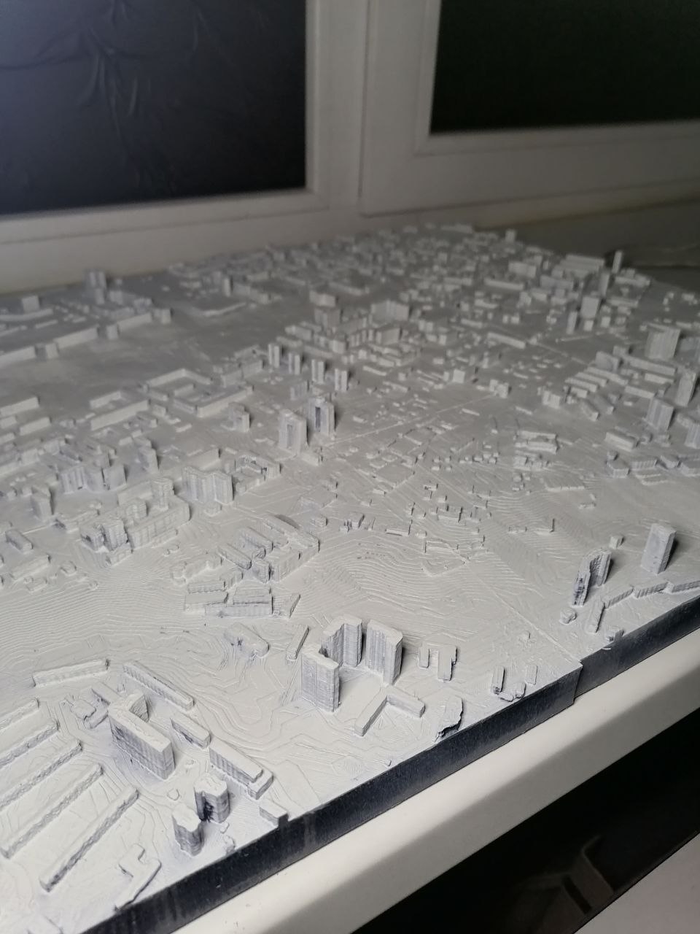 | 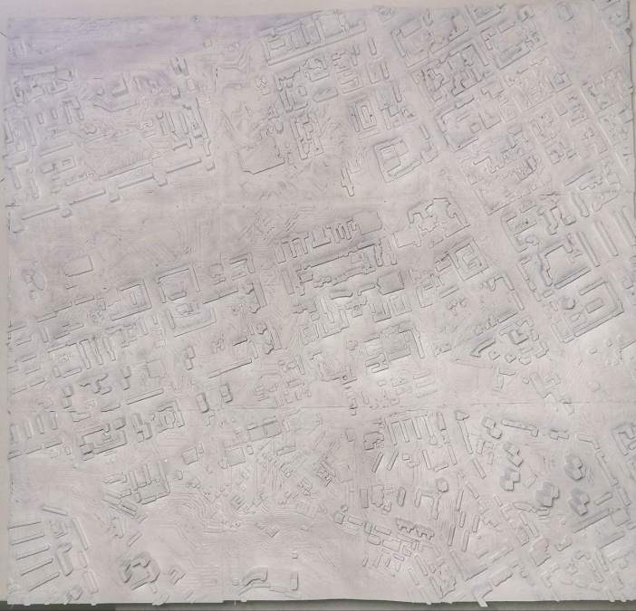
(a) | (b)
Fig. 1 Overall view of experimental model: (a) - volumetric image; (b) - top view

The process of impurity propagation is shown in Fig. 2.
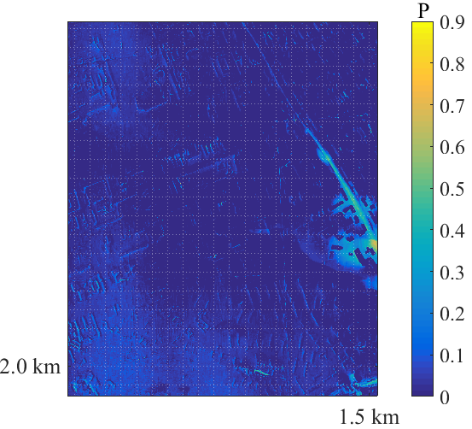 | 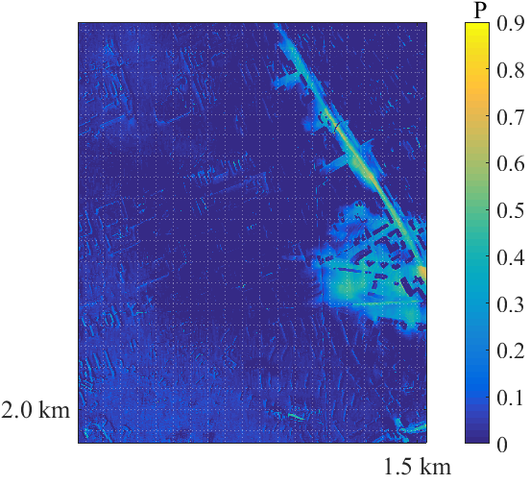
50 s | 100 s
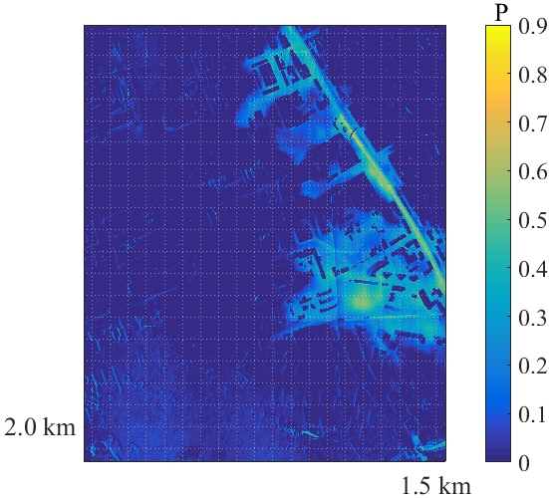 | 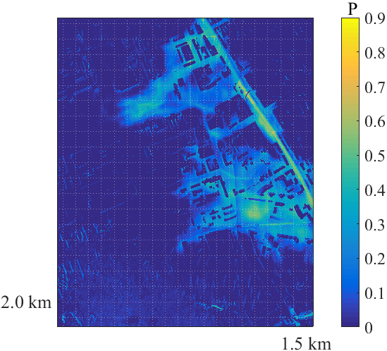
150 s | 200 s
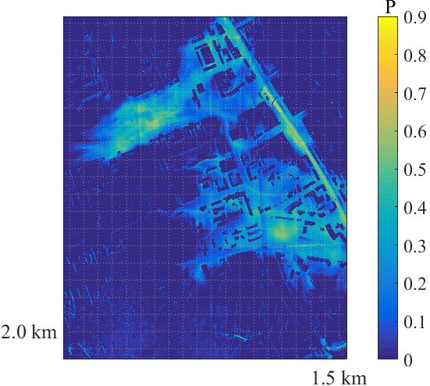 | 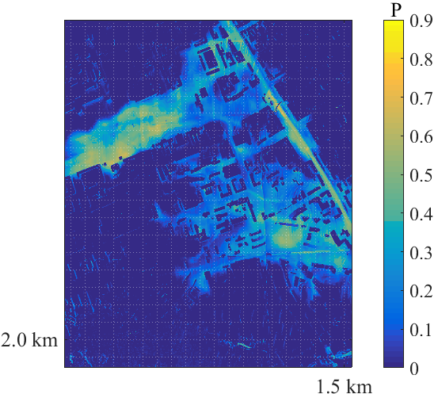
250 s | 300 s
Fig. 2 Visualization of impurity distribution

