Sleep-promotion of probiotics-fermented Gastrodia elata Bl.: Chemical variation and omics exploration
Chao-Qi Zhang ª, Xu-Dong Zhang ª, Yan Wang ª, Yi-Han Liu ª, Cun-Li Zhang ^{a, b, *} and Qiang Zhang ^{a, b, *}
a Shaanxi Key Laboratory of Natural Products & Chemical Biology, College of Chemistry & Pharmacy, Northwest A&F University, Yangling 712100, China
b Key Laboratory of Edible Plant Enzyme R&D and Monitoring, Shaanxi Wuding Biotechnology Co., Ltd., Hanzhong 724400, China
*Correspondence: cunli_zhang@nwsuaf.edu.cn (C.Z.); zhangq@nwsuaf.edu.cn (Q.Z.)
Contents
Omic Features of Fermented Gastrodia elata Blume Sleep-Enhancing Effects in Insomnia Zebrafish 1
Abbreviation List 2
Table S1 Primer Sequences for qRT-PCR 3
Table S2 Profiles of the main chemical components in fermented GE. 4
Table S3 Chemical components that changed significantly between groups before and after fermentation identified by LC-MS 5
Table S4 Enrichment results of the key DMs induced by SFL 6
Table S5 Significantly changed genes in related pathways 7
Table S6 Key driving genes induced by SFL 8
Fig. S1 The number of chemical components significantly increased and decreased among the three groups of WGE, PFL, and SFL 9
Fig. S2 The amount of substances found in ESI positive (pos) and negative (neg) modes 10
Fig. S3 GSEA analysis based on the GO database 11
Fig. S4 GSEA analysis based on the GO database 13

Abbreviation List
DMs, differential metabolites
FC, Fold Change
KEGG, Kyoto Encyclopedia of Genes and Genomes
LC-MS/MS, Liquid Chromatography coupled to tandem Mass Spectrometry
CID, pubchem cid.
PCA, Principal Component Analysis
sPLS-DA, Sparse Partial Least Squares-Discriminant Analysis
GSEA, gene set enrichment analysis
SFL, Secondary fermentation liquid
PTZ, Pentylenetetrazole
G1, Zebrafish group fed with E3 water
G2, Zebrafish group fed with 2.5 mM PTZ
G4, Zebrafish group fed with 80 µg/mL SFL

Table S1 Primer Sequences for qRT-PCR
primer | 5’ to 3’ | length
neurod1-F | CAAGTGTCACAGCAGCTCCCAAG | 23
neurod1-R | TCTTCTTCCTCGTCGTCCTCATCC | 24
msh2-F | AGAACGCCAGTAAGAGCAGCAAAG | 24
msh2-R | CCAAGACGAACACCCACCACAC | 22
rad51c-4F | AGTGATTGACAGCATCGCCTTCC | 23
rad51c-R | CCGCCACTCTGTGTTGTGTAGC | 22
ercc5-F | AGTTGGTGGTTCATTCTGCTGTGG | 24
ercc5-R | TGCGAGTGTTGATGCTGGCTTC | 22
ccl20b-F | CACAAAACTGGACGCAAGAACGAG | 24
ccl20b-R | TGGTGAACATGCTCATCGTCTTCG | 24
msh3-F | GGTTAGCACTCCTTCTCGCACTAC | 24
msh3-R | AATGCCTCCTCCTCCATCTTACCC | 24
recql4-F | AGGCTCTGGTGTCTCTGCTGAAG | 23
recql4-R | CGGCTCGTCTCCTCTCGTCTG | 21
rev3l-F | CTGCTGATGTTCTCAACCGTCTCG | 24
rev3l-R | GCTTTCGCTTCTCTGCCGTCTC | 22
smc5-F | TGTCCAGGTACAGGACACGTGGA | 23
smc5-R | CTTAACACACAGGTTTGGTAATAT | 24
polh-F | TGTGCGTCAGGCTGGAGGTC | 20
polh-R | GTCAGGCTGTCGTTGGTCATCTTC | 24
β-actin-F | CGTGCTGTCTTCCCATCCA | 19
β-actin-R | TCACCAACGTAGCTGTCTTTCTG | 23

Table S2 Profiles of the main chemical components in fermented GE.
Component (μg/mL) | WGE | PFL | SFL
Adenosine | 8.49±0.10c | 11.15±0.09b | 245.72±12.53a
Gastrodin | 122.01±1.38b | 113.97±0.54a | --
4-Hydroxybenzyl alcohol | 21.74±0.13b | 16.19±0.09b | 429.36±13.8a
Parishin A | 64.48±17.95a | 36.99±0.27b | --
Parishin B | 64.1±17.73b | 42.48±0.31b | 185.07±17.72a
Parishin C | 50.82±13.96b | 35.86±0.19b | 147.24±6.18a
Parishin E | 92.14±25.42b | 61.15±0.44b | 265.58±25.41a
Each value is expressed as the mean ± SD (n = 3). Means with different letters within a line are significantly different (P < 0.05).

Table S3 Chemical components that changed significantly between groups before and after fermentation identified by LC-MS
Class |  | CID
superclass | direct_parent | PFL_vs_WGE_dn | PFL_vs_WGE_up | SFL_vs_WGE_dn | SFL_vs_WGE_up
Benzenoids | Phenylacetaldehydes | 998 |  | 998
Benzenoids | Diphenylethers | 5564 |  |  | 5564
Benzenoids | m-Xylenes | 6896 |  | 6896
Lipids and lipid-like molecules | Lineolic acids and derivatives | 3931 |  |  | 3931
Lipids and lipid-like molecules | Very long-chain fatty acids | 11197 |  | 11197
Lipids and lipid-like molecules | Jasmonic acids | 107126 |  | 107126
Lipids and lipid-like molecules | Sesquiterpenoids | 3989419 |  | 3989419
Lipids and lipid-like molecules | Eudesmane, isoeudesmane or cycloeudesmane sesquiterpenoids | 4655876 |  | 4655876
Lipids and lipid-like molecules | Diterpenoids | 10018535/10448477 | 9944781/14239484/  45782962/57509505 | 10018535/  10448477 | 9944781/45782962/  57509505
Nucleosides, nucleotides, and analogues | Purine nucleosides | 60961 |  | 60961
Organic acids and derivatives | Sulfuric acid monoesters | 8778 | 24761 | 8778
Organic acids and derivatives | Alpha amino acids | 9475 |  | 9475 | 247
Organic nitrogen compounds | Cholines | 305 |  | 305
Organic nitrogen compounds | Dialkylarylamines | 949 |  | 949
Organic oxygen compounds | O-glycosyl compounds | 5988 |  | 5988
Organic oxygen compounds | Alkyl-phenylketones | 11092 |  | 11092
Organic oxygen compounds | Polyethylene glycols | 17472 |  | 17472
Organic oxygen compounds | Phenolic glycosides | 115067 |  | 115067
Organoheterocyclic compounds | Nicotinamides | 936 |  | 936
Organoheterocyclic compounds | Indolines | 10328 |  | 10328
Organoheterocyclic compounds | Furanoquinolines | 68085 |  | 68085
Organoheterocyclic compounds | Oxepanes | 4330530 |  | 4330530
Phenylpropanoids and polyketides | 3,4-dihydrocoumarins | 660 |  | 660
Phenylpropanoids and polyketides | 7-hydroxycoumarins | 5281426 |  | 5281426
Phenylpropanoids and polyketides | Isoflavanols | 51136422 |  | 51136422
Benzenoids | Benzoic acid esters |  | 3026 |  | 3026/8346
Benzenoids | Benzophenones |  | 3102 |  | 3102
Benzenoids | Benzenesulfonic acids and derivatives |  | 8485
Benzenoids | Phenylphosphines and derivatives |  | 13097
Lipids and lipid-like molecules | Long-chain fatty acids |  | 985 |  | 985/5281
Lipids and lipid-like molecules | Retinoids |  | 5538 |  | 5538
Lipids and lipid-like molecules | Fatty amides |  | 8214 |  | 8214
Organic nitrogen compounds | 2-arylethylamines |  | 774 |  | 774/3614
Organoheterocyclic compounds | Pyridinecarboxylic acids |  | 938
Organoheterocyclic compounds | Aminopyridines and derivatives |  | 10439 |  | 10439
Organoheterocyclic compounds | Pyrazoles |  | 15073 |  | 15073
Organoheterocyclic compounds | Thiochromenes |  | 79633 |  | 79633
Organoheterocyclic compounds | 2,2-dimethyl-1-benzopyrans |  | 114703
Phenylpropanoids and polyketides | 8-prenylated isoflavanones |  | 10001497
Benzenoids | Benzamides |  |  |  | 231459
Lipids and lipid-like molecules | Medium-chain fatty acids |  |  |  | 2266
Organoheterocyclic compounds | Phthalic anhydrides |  |  |  | 6811
Phenylpropanoids and polyketides | Coumarins and derivatives |  |  |  | 11833
Phenylpropanoids and polyketides | Cinnamic acids |  |  |  | 13245
Phenylpropanoids and polyketides | Stilbenes |  |  |  | 185914

Table S4 Enrichment results of the key DMs induced by SFL
Annotation | in set | set | in background | -lg(p-value)
Regulation of actin cytoskeleton | 1 | 2 | 4 | 2.585249343
Neuroactive ligand-receptor interaction | 1 | 2 | 40 | 1.58779944
alpha-Linolenic acid metabolism | 1 | 2 | 44 | 1.546691026
Glycerophospholipid metabolism | 1 | 2 | 52 | 1.474709459
Biosynthesis of unsaturated fatty acids | 1 | 2 | 69 | 1.353075531
Regulation of actin cytoskeleton | 1 | 2 | 4 | 2.585249343

Table S5 Significantly changed genes in related pathways
# | NCBI ID | Name | # | NCBI ID | Name | # | NCBI ID | Name | # | NCBI ID | Name
 | 100002946 | cxcl8a |  | 30194 | alcama |  | 404275 | helt |  | 563208 | ccl38a.5
 | 100003859 | cxcl8b.3 |  | 30274 | foxg1a |  | 405856 | wrnip1 |  | 565400 | msh3
 | 100004133 | ddb2 |  | 30300 | her2 |  | 406637 | mre11a |  | 565592 | pds5b
 | 100006951 | nrg2a |  | 30301 | her4.2 |  | 406845 | msh2 |  | 565714 | wnt7aa
 | 100148115 | LOC100148115 |  | 30444 | shhb |  | 415151 | rac2 |  | 566632 | med12
 | 100148329 | LOC100148329 |  | 30478 | ascl1b |  | 415158 | cycsb |  | 566749 | smc5
 | 100148840 | wnt7bb |  | 30536 | emx3 |  | 415182 | cyp2aa4 |  | 567383 | recql4
 | 100149066 | her4.4 |  | 30537 | emx2 |  | 445296 | babam1 |  | 567537 | cxcl20
 | 100149863 | LOC100149863 |  | 30549 | fgf3 |  | 447819 | eya2 |  | 568191 | wnt5a
 | 100192217 | ccl20a.3 |  | 30630 | anos1a |  | 447916 | rrh |  | 568326 | ccl35.1
 | 100330921 | si:ch211-103a14.5 |  | 322545 | cyp2x10.2 |  | 449792 | cryba1l2 |  | 569100 | rev3l
 | 100331800 | zmp:0000000545 |  | 324185 | fanci |  | 450081 | rad51c |  | 571301 | ungb
 | 100332599 | ascc3 |  | 325939 | si:dkey-286h2.7 |  | 494577 | cox6c |  | 571943 | lhx4
 | 100332722 | wnt6a |  | 326962 | cox5ab |  | 541336 | zgc:112496 |  | 58118 | bdnf
 | 100334604 | LOC100334604 |  | 326975 | cox4i1 |  | 541371 | en1b |  | 58127 | runx3
 | 100534909 | LOC100534909 |  | 334081 | rnf168 |  | 541386 | xpc |  | 58146 | hey2
 | 100535363 | cox7a2b |  | 335889 | emsy |  | 541440 | cyp2x6 |  | 60632 | wnt3a
 | 100535716 | LOC100535716 |  | 336118 | cox7c |  | 541502 | ercc5 |  | 619245 | draxin
 | 100536999 | ccl38a.3 |  | 336550 | rps3 |  | 550405 | lhx9 |  | 678520 | polh
 | 100537421 | cxcr5 |  | 338225 | crygm4 |  | 550600 | her13 |  | 678586 | rtn4b
 | 100538153 | slx4 |  | 352930 | gli1 |  | 553184 | crybb3 |  | 678653 | unc119b
 | 101883994 | LOC101883994 |  | 359832 | tmtopsa |  | 554101 | cox5aa |  | 751634 | hes2.2
 | 101887128 | mbd4 |  | 359836 | her15.1 |  | 554103 | cox7a2a |  | 790965 | si:dkey-286h2.3
 | 108180207 | LOC108180207 |  | 393578 | ufl1 |  | 554142 | rgrb |  | 791563 | wnt16
 | 114411 | neurog3 |  | 393599 | ddb1 |  | 554361 | lmx1ba |  | 792198 | her4.3
 | 114415 | neurod6b |  | 393930 | bhlhe22 |  | 555610 | mcm9 |  | 794050 | ccl38.1
 | 114418 | crybb1 |  | 394032 | irx2a |  | 556621 | ccl34b.4 |  | 795788 | ccl25b
 | 114435 | neurod2 |  | 402847 | cyp2x7 |  | 558534 | atrip |  | 796252 | cxl34b.11
 | 140613 | her9 |  | 402857 | s1pr4 |  | 559147 | hes2.1 |  | 797669 | ccl39.6
 | 140616 | sox10 |  | 402914 | her12 |  | 559656 | acsl3b |  | 81881 | crx
 | 140618 | tfap2a |  | 402986 | cry-dash |  | 559796 | bhlhe23 |  | 83776 | cry5
 | 140621 | casp3a |  | 403019 | irx1a |  | 561155 | si:ch73-206d17.1
 | 30105 | wnt5b |  | 403064 | atm |  | 562283 | prkdc
 | 30169 | neurod1 |  | 403145 | myd88 |  | 563152 | ccl20b

Table S6 Key driving genes induced by SFL
# | NCBI ID | Name
 | 100151570 | LOC100151570
 | 30169 | neurod1
 | 406845 | msh2
 | 450081 | rad51c
 | 541502 | ercc5
 | 563152 | ccl20b
 | 565400 | msh3
 | 566749 | smc5
 | 567383 | recql4
 | 569100 | rev3l
 | 678520 | polh

Fig. S1 The number of chemical components significantly increased and decreased among the three groups of WGE, PFL, and SFL
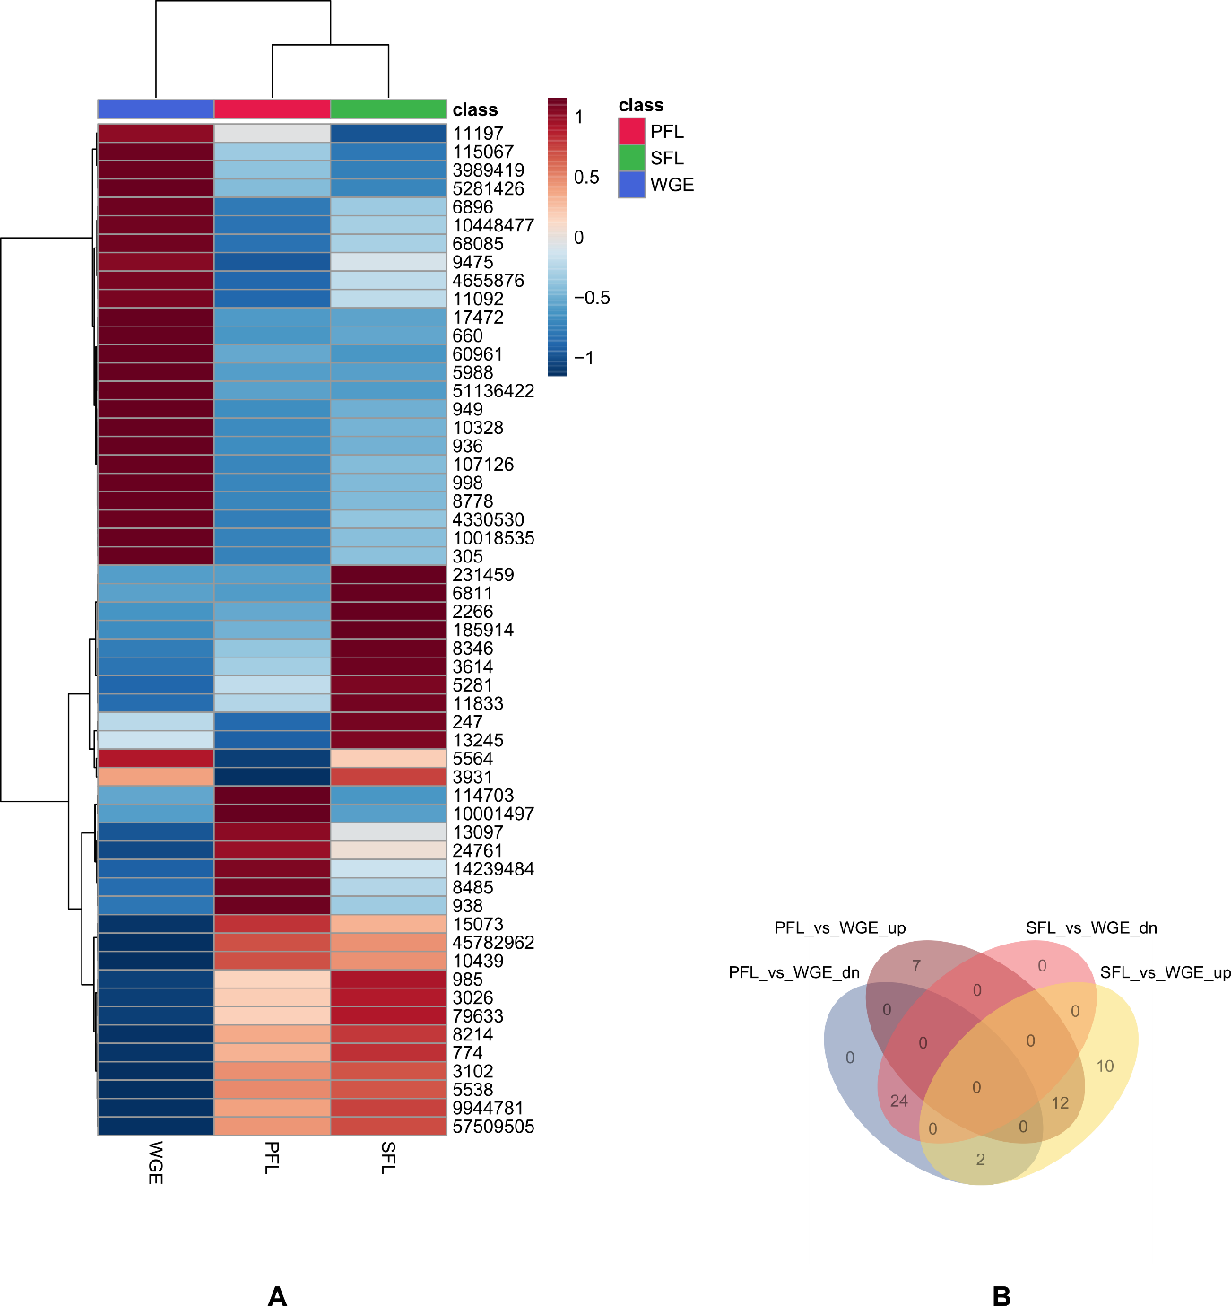

Fig. S2 The amount of substances found in ESI positive (pos) and negative (neg) modes
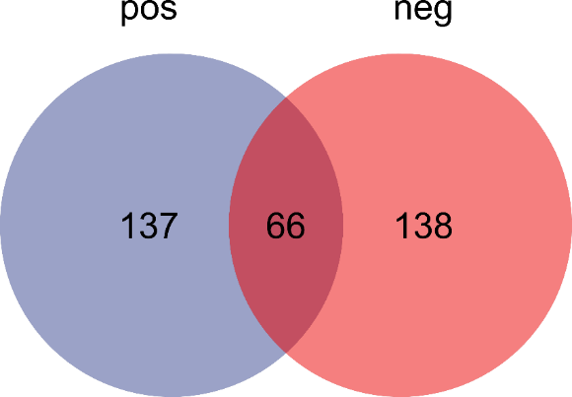

Fig. S3 GSEA analysis based on the GO database

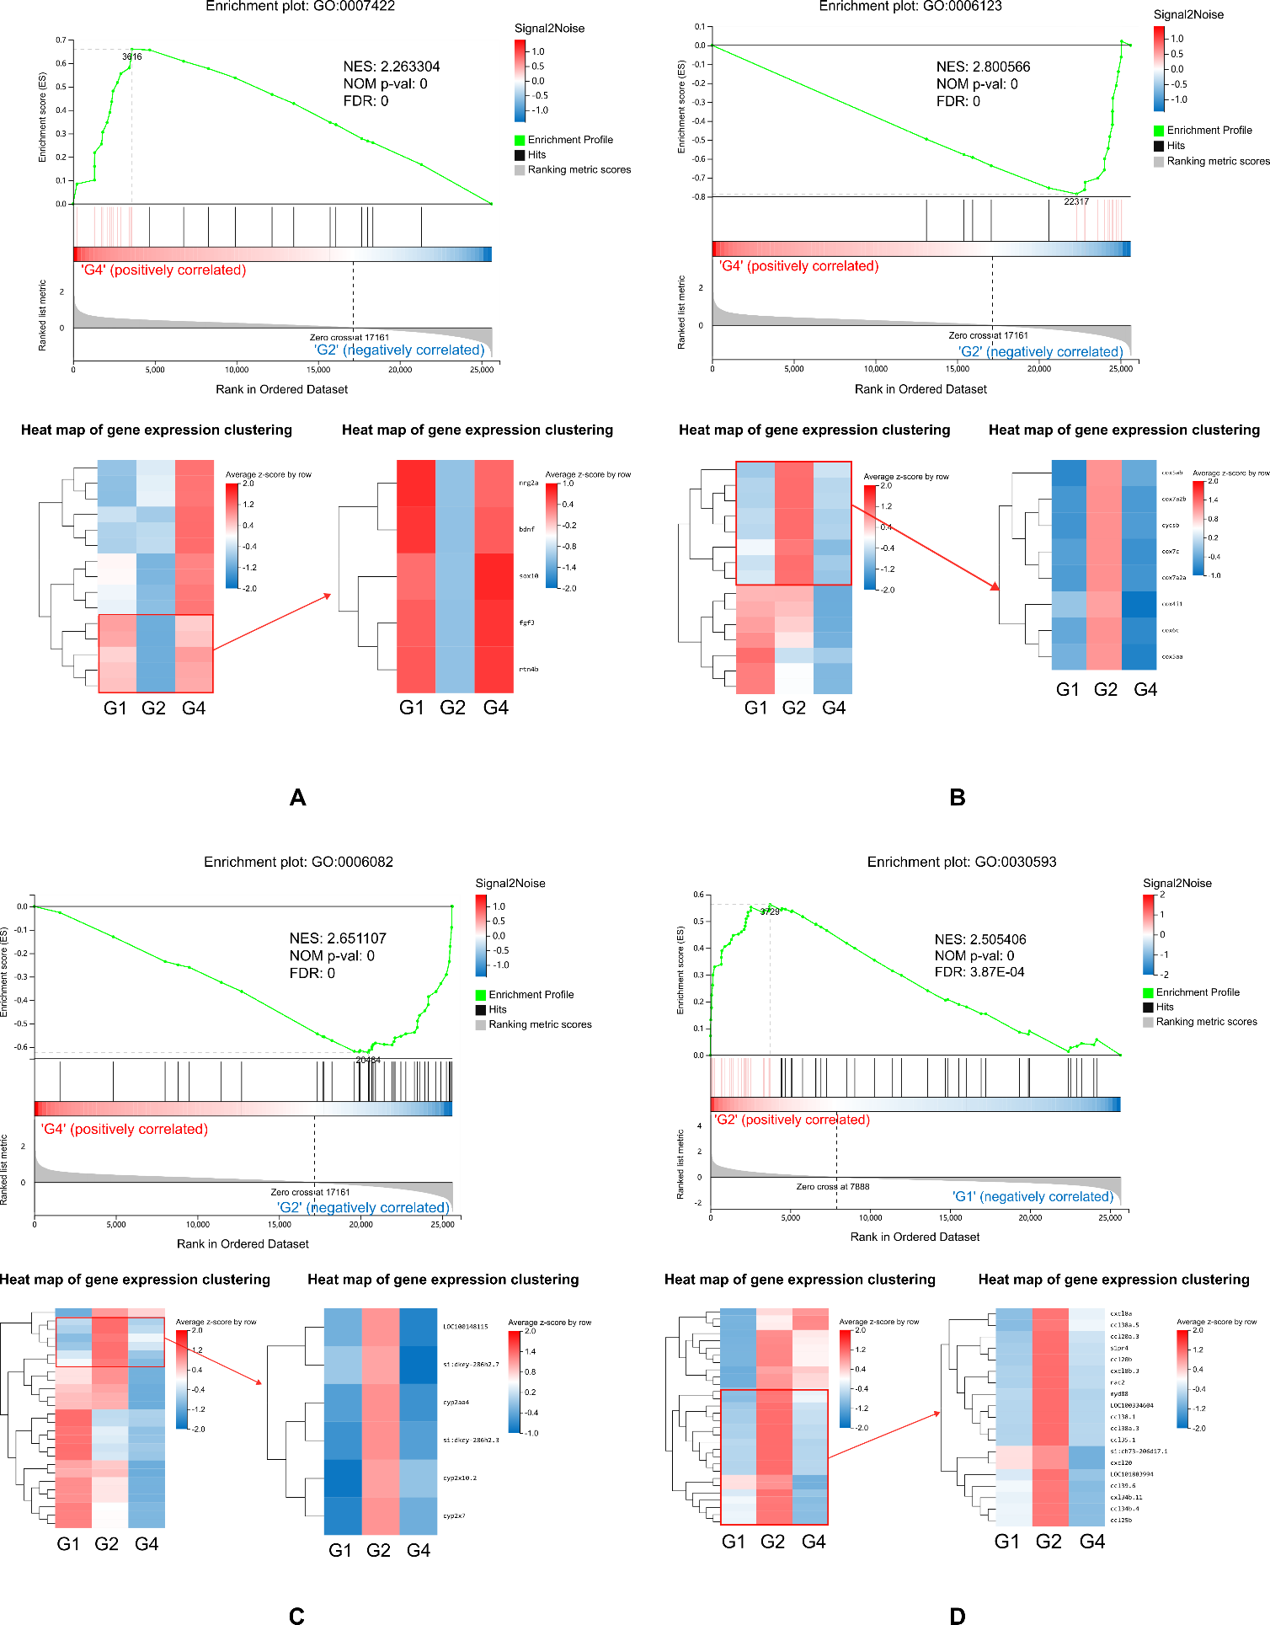

Results of GSEA based on the GO database. GSEA was performed in the G4 and G2 groups and G2 and G1 groups. In a ranked list of all the genes in the RNA-seq dataset, the GSEA algorithm generates an enrichment score that indicates the extent of overrepresentation at the top or bottom of the list of genes included in a gene set. Gene set enrichment at the top of the ranked list is indicated by a positive enrichment score (ES), whereas gene set enrichment at the bottom of the ranked list is indicated by a negative ES. Heatmaps beneath each enrichment plot show the expression heatmap signatures of genes involved in the GSEA analysis, referring to enrichment plots (A) to (D). Z scores were used. Left: the clustering of all genes within the pathway. Most sensitive pathways are highlighted at the right (indicated by a red square in panel 5). High expression is shown in red, and low expression is shown in green. The analysis demonstrates that known (A) peripheral nervous system development, while (B) Negative regulation of mitochondrial electron transport, cytochrome c to oxygen, and (C) Negative regulation of organic acid metabolic process are enriched in G2 groups, for the G4 vs G2 comparison group;(D) neutrophil chemotaxis is enriched in G2 groups.

Fig. S4 GSEA analysis based on the GO database
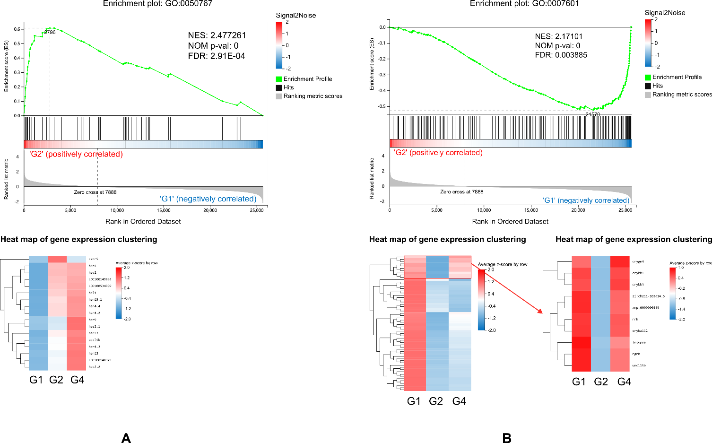

Results of GSEA based on the GO database. GSEA was performed in the G4 and G2 groups and G2 and G1 groups. In a ranked list of all the genes in the RNA-seq dataset, the GSEA algorithm generates an enrichment score that indicates the extent of overrepresentation at the top or bottom of the list of genes included in a gene set. Gene set enrichment at the top of the ranked list is indicated by a positive enrichment score (ES), whereas gene set enrichment at the bottom of the ranked list is indicated by a negative ES. Heatmaps beneath each enrichment plot show the expression heatmap signatures of genes involved in the GSEA analysis, referring to enrichment plots (A) to (B). Z scores were used. Left: the clustering of all genes within the pathway. Most sensitive pathways are highlighted at the right (indicated by a red square in panel 5). High expression is shown in red, and low expression is shown in green. The analysis demonstrates that known (A) regulation of neurogenesis, is enriched in G2 groups, while (B) Negative regulation of visual perception is enriched in G1 groups, for the G2 vs G1 comparison group.

