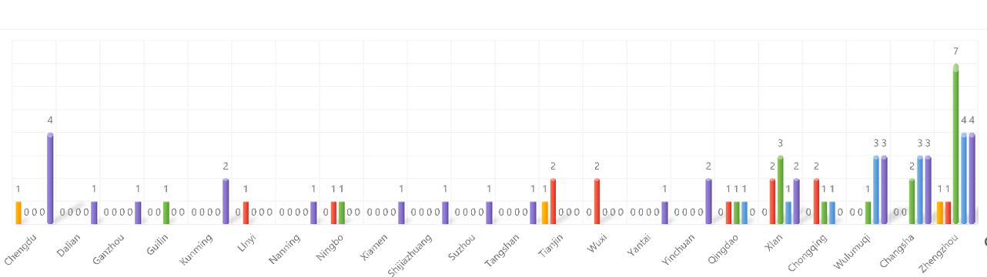 Fig.S1 Cities of PPI Surgery less than 10 cases in 2023 (1-10 month).
Fig.S2 Numbers and provinces of surgeons performed PPI surgury from 2019-2023(1-10m):(a)-(e)Numbers and provinces of surgeons performed PPI surgury from 2019-2023(1-10m)；(f)Total number of surgeons performed PPI surgury from 2019-2023(1-10m) in China.

