Table 2. Univariate regression models for DRI variable.
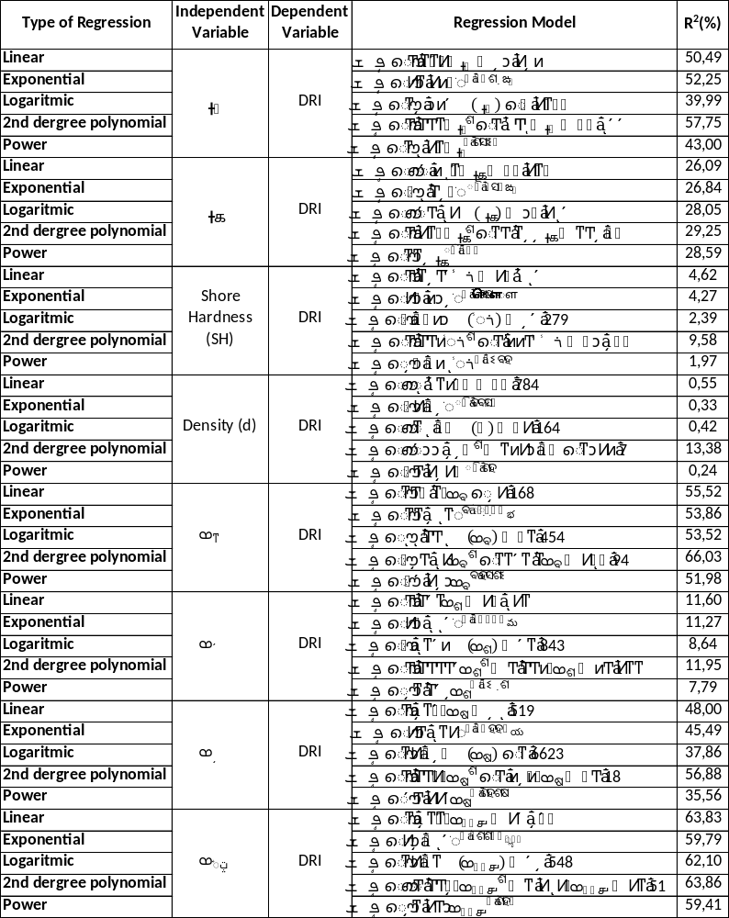
Table 3. Multi-linear regression models on DRI

Table 4. Second Degree Multiple regression models on DRI
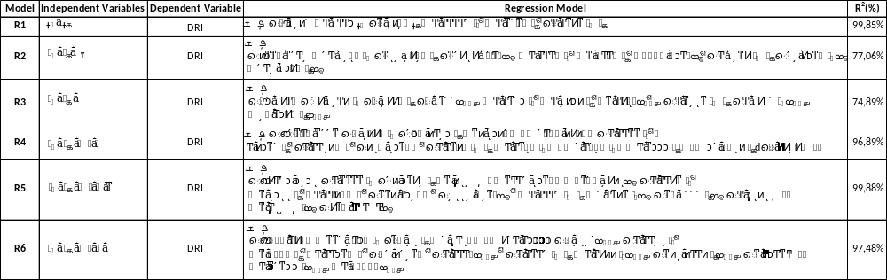
Table 5. Network designs
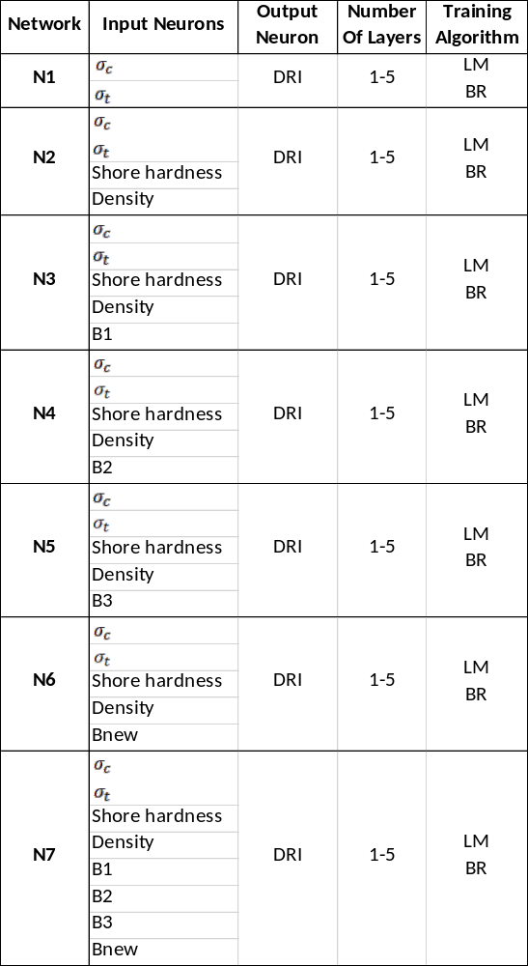

Table 6. ANN analysis results
Network | Input Neurons | Output Neuron | No. of layers | Training Algorithm | R² | Network | Input Neurons | Output Neuron | No. of layers | Training Algorithm | R²
N1 | σ_{c}, σ_{t} | DRI | 1 | LM | 0.8649 | N5 | σ_{c}, σ_{t}, SH, d, B3 | DRI | 1 | LM | 0.9530
 |  |  |  | BR | 0.8958 |  |  |  |  | BR | 0.9326
N1 | σ_{c}, σ_{t} | DRI | 2 | LM | 0.9021 | N5 | σ_{c}, σ_{t}, SH, d, B3 | DRI | 2 | LM | 0.9540
 |  |  |  | BR | 0.9381 |  |  |  |  | BR | 0.9851
N1 | σ_{c}, σ_{t} | DRI | 3 | LM | 0.9767 | N5 | σ_{c}, σ_{t}, SH, d, B3 | DRI | 3 | LM | 0.8919
 |  |  |  | BR | 0.9184 |  |  |  |  | BR | 0.9847
N1 | σ_{c}, σ_{t} | DRI | 4 | LM | 0.9673 | N5 | σ_{c}, σ_{t}, SH, d, B3 | DRI | 4 | LM | 0.9952
 |  |  |  | BR | 0.9267 |  |  |  |  | BR | 0.9126
N1 | σ_{c}, σ_{t} | DRI | 5 | LM | 0.9908 | N5 | σ_{c}, σ_{t}, SH, d, B3 | DRI | 5 | LM | 0.9940
 |  |  |  | BR | 0.9156 |  |  |  |  | BR | 0.8763
N2 | σ_{c}, σ_{t}, SH, d | DRI | 1 | LM | 0.9468 | N6 | σ_{c}, σ_{t}, SH, d, Bnew | DRI | 1 | LM | 0.9237
 |  |  |  | BR | 0.9220 |  |  |  |  | BR | 0.9192
N2 | σ_{c}, σ_{t}, SH, d | DRI | 2 | LM | 0.9675 | N6 | σ_{c}, σ_{t}, SH, d, Bnew | DRI | 2 | LM | 0.9987
 |  |  |  | BR | 0.9737 |  |  |  |  | BR | 0.9853
N2 | σ_{c}, σ_{t}, SH, d | DRI | 3 | LM | 0.9604 | N6 | σ_{c}, σ_{t}, SH, d, Bnew | DRI | 3 | LM | 0.9984
 |  |  |  | BR | 0.9137 |  |  |  |  | BR | 0.9021
N2 | σ_{c}, σ_{t}, SH, d | DRI | 4 | LM | 0.9989 | N6 | σ_{c}, σ_{t}, SH, d, Bnew | DRI | 4 | LM | 0.9774
 |  |  |  | BR | 0.9164 |  |  |  |  | BR | 0.9291
N2 | σ_{c}, σ_{t}, SH, d | DRI | 5 | LM | 0.9886 | N6 | σ_{c}, σ_{t}, SH, d, Bnew | DRI | 5 | LM | 0.9969
 |  |  |  | BR | 0.9195 |  |  |  |  | BR | 0.9623
N3 | σ_{c}, σ_{t}, SH, d, B1 | DRI | 1 | LM | 0.8905 | N7 | σ_{c}, σ_{t}, SH, d, B1, B2, B3, Bnew | DRI | 1 | LM | 0.8814
 |  |  |  | BR | 0.9311 |  |  |  |  | BR | 0.9378
N3 | σ_{c}, σ_{t}, SH, d, B1 | DRI | 2 | LM | 0.9559 | N7 | σ_{c}, σ_{t}, SH, d, B1, B2, B3, Bnew | DRI | 2 | LM | 0.9673
 |  |  |  | BR | 0.9832 |  |  |  |  | BR | 0.9712
N3 | σ_{c}, σ_{t}, SH, d, B1 | DRI | 3 | LM | 0.9934 | N7 | σ_{c}, σ_{t}, SH, d, B1, B2, B3, Bnew | DRI | 3 | LM | 0.9971
 |  |  |  | BR | 0.8971 |  |  |  |  | BR | 0.9129
N3 | σ_{c}, σ_{t}, SH, d, B1 | DRI | 4 | LM | 0.9907 | N7 | σ_{c}, σ_{t}, SH, d, B1, B2, B3, Bnew | DRI | 4 | LM | 0.9320
 |  |  |  | BR | 0.8994 |  |  |  |  | BR | 0.8967
N3 | σ_{c}, σ_{t}, SH, d, B1 | DRI | 5 | LM | 0.9977 | N7 | σ_{c}, σ_{t}, SH, d, B1, B2, B3, Bnew | DRI | 5 | LM | 0.9845
 |  |  |  | BR | 0.9785 |  |  |  |  | BR | 0.9398
N4 | σ_{c}, σ_{t}, SH, d, B2 | DRI | 1 | LM | 0.9622
 |  |  |  | BR | 0.9280
N4 | σ_{c}, σ_{t}, SH, d, B2 | DRI | 2 | LM | 0.9579
 |  |  |  | BR | 0.9615
N4 | σ_{c}, σ_{t}, SH, d, B2 | DRI | 3 | LM | 0.9650
 |  |  |  | BR | 0.9002
N4 | σ_{c}, σ_{t}, SH, d, B2 | DRI | 4 | LM | 0.9942
 |  |  |  | BR | 0.9746
N4 | σ_{c}, σ_{t}, SH, d, B2 | DRI | 5 | LM | 0.9998
 |  |  |  | BR | 0.9996

