Supporting Information for
X-ray Electron Pair Distribution Functions for Validating Experimental and Theoretical Electron Densities of Materials

Kazutaka Sonobe¹, Satoshi Tominaka¹*, and Akihiko Machida²

¹Center for Basic Research on Materials, National Institute for Materials Science (NIMS), 1-1 Namiki, Tsukuba, Ibaraki 305-0044, Japan
²Synchrotron Radiation Research Center, National Institutes for Quantum Science and Technology (QST), SPring-8, 1-1-1 Kouto, Sayo, Hyogo 679-5148, Japan

*Satoshi Tominaka
E-mail: TOMINAKA.Satoshi@nims.go.jp

This file includes:

Supporting text
- Extraction of EPDF from 2D detector
- Theoretical derivation of experimental EPDFs
- Polarisation correction for Compton and elastic scattering intensity
- Numerical processing of derivation of observed EPDFs
- Algorithms for simulating EPDFs via MC sampling
Figures S1–S6
Table S1
SI References

Supporting Information Text
- Extraction of EPDF from two-dimensional (2D) detector

The scattering intensity from the objective material ($I_{total}$) is obtained by subtracting the X-ray scattering intensity of the air in the capillary ($I_{capillary and air}$) from the measured X-ray scattering intensity ($I_{measured}$):
$$\begin{aligned}I_{total}= I_{measured}-I_{capirally and air}.\#\left(1\right)\end{aligned}$$

The scattering intensity is measured using a 2D X-ray scattering pixel detector:
$$\begin{aligned}I_{total}= \frac{dσ}{d\left[pixel\right]}.\#\left(2\right)\end{aligned}$$

The measured intensity is normalised using the solid-angle correction with the term ${d\left[pixel\right]}/{dΩ}= 1/{\cos^{3}Θ}$ [1]:
$$\begin{aligned}I_{total}^{Ewald}= \left(\frac{dσ}{dΩ}\right)= \left(\frac{dσ}{d\left[pixel\right]}\right)\left(\frac{d\left[pixel\right]}{dΩ}\right)= I_{total} \left(\frac{d\left[pixel\right]}{dΩ}\right).\#\left(3\right)\end{aligned}$$

The scattering intensity ($I_{total}^{Ewald}$) also depends on the X-ray polarisation and the unique X-ray light source. This instrument-dependent factor is eliminated, and the resulting equation is
$$\begin{aligned}I_{total}^{Ewald}= σ_{T}∙P_{all}\left(Θ, φ\right)=\left(\frac{dσ_{elastic}^{non-pol}\left(Q\right)}{dΩ}+\frac{dσ_{Compton}^{non-pol}\left(Q\right)}{dΩ}\right)∙P_{all}\left(Θ, φ\right).\#\left(4\right)\end{aligned}$$

The determination of the polarisation correction function$(P_{all}\left(Θ, φ\right)$) is described in Section D:
$$\begin{aligned}\frac{dσ_{elastic}^{non-pol}\left(Q\right)}{dΩ}=\left({I_{total}}/{P_{all}\left(Θ, φ\right)}\right)-\frac{dσ_{Compton}^{non-pol}\left(Q\right)}{dΩ}.\#\left(5\right)\end{aligned}$$

The term ${dσ_{Compton}^{non-pol}\left(Q\right)}/{dΩ}$ is a constant value with no dependence on the scattering angle $Θ$ or the vector $Q$ (see Section D).
The structure function for the EPDF is processed using the following equation:
$$\begin{aligned}{S\left(Q\right)}_{EPF}= \frac{d}{dQ}\left\{Q\frac{dσ_{elastic}^{non-pol}\left(Q\right)}{dΩ}\right\}.\#\left(6\right)\end{aligned}$$

The EPDF is defined as the cosine Fourier transform of ${S\left(Q\right)}_{EPF}$, as shown below:
$$\begin{aligned}{G\left(r\right)}_{elec}^{elastic}= \int_{Q_{min}}^{Q_{max}}{\frac{d}{dQ}\left\{Q\frac{dσ_{elastic}^{non-pol}\left(Q\right)}{dΩ}\right\}\cos\left(Qr\right)dQ}= \sum_{i j}{ρ\left(r_{i}\right)ρ\left(r_{j}\right)∙δ\left(r-r_{ij}\right)}.\#\left(7\right)\end{aligned}$$

This process is depicted in Figure S1.

- Theoretical derivation of experimental EPDFs

The stochastic representations of X-ray scattering show cross-sections to represent the probabilities of scattering in certain areas. A cross-section is calculated as the square of the scattering amplitude, which, in turn, is given by the atomic scattering factor. The Debye scattering equations (DSEs) represent scattering intensity as the histograms of inter-atomic distance. The overbar represents a complex conjugate. The vectors are indicated in bold, and the symbol ${〈…〉}_{OA}$ denotes the orientation average in powder diffraction:

$$\begin{aligned}\frac{dσ_{elastic}^{non-pol}\left(Q\right)}{dΩ}={〈{\left\|F\right\|}^{2}〉}_{OA}= {〈F∙\overline{F}〉}_{OA}= {〈\sum_{i}{f_{i}\left(Q\right)exp\left(iQr_{i}\right)∙\sum_{j }{\overline{f_{j}\left(Q\right)exp\left(iQr_{j}\right)}}}〉}_{OA} \\ = \sum_{i}{{f_{i}\left(Q\right)}^{2}}+\sum_{i≠j}{f_{i}\left(Q\right)f_{j}\left(Q\right)\frac{\sin\left(Qr_{ij}\right)}{Qr_{ij}}}.\#\left(8\right)\end{aligned}$$

Here, $f_{i}\left(Q\right)$ is the atomic form factor and F represents the total scattering amplitude. Typically, the atomic form factor of a material is approximated as the atomic form factor of its isolated atoms while ignoring the bonded electrons. The DSE can be expressed the total scattering intensity as a correlation function for the atomic configurations where $r_{i}$ represents the atomic positions, and is expressed as
$$\begin{aligned}F= \sum_{i}{f_{i}\left(Q\right)exp\left(iQr_{i}\right)}.\#\left(9\right)\end{aligned}$$

The series expansion in Eq. (9) is conducted at atomic resolutions and the concept can apply to electron resolutions. However, the representations of Eq. (9) have hindered the more detailed series expansion in the DSE from the inter-atomic distance representations into smaller inter-electron distance representations owing to the utilisations of atomic scattering factor. The DSE re-representations as MC samplings without atomic scattering factor can derive the pair distribution functions in electronic resolutions and these re-representations can be realized by reorganizing the stochastic concept of the scattering factors. The stochastic representations of scattering are related to two stochastic concepts: (1) the probability of passing photons in the scattering area and (2) the probability of the number of electrons (or local electron density) in the scattering area. These two stochastic ideas were included in the concept of scattering cross sections in conventional representations but, here, these concepts are included in random samplings of the DSE as MC integrations.
The scattering factor and electron density are connected by Fourier transform. This fundamental relationship assumes many passing of photons at homogeneous and random positions, which makes the probability of the photon path constant in any area of the sample. Hence, the above stochastic concepts (1) have not represented explicitly in conventional representations. However, if this probability is not constant (i.e. if it has a certain distribution), the relationship between the scattering factor and the electron density is rewritten using the probability density function $P(r)$ of the distribution. For homogeneous scattering, $P(r)$ is typically a constant and is ignored:
$$\begin{aligned}f\left(Q\right)= \int_{-∞}^{∞}{ρ\left(r\right)P(r)exp\left(iQr\right)dr}.\#\left(10\right)\end{aligned}$$

When the scattering occurs only at a scattering point $r_{i}$, the probability density function P(r) becomes the Dirac delta function. The term $f_{e i}\left(Q\right)$ represents the scattering factor for $r_{i}$ and can remove the stochastic idea from the scattering factor:
$$\begin{aligned}f_{e i}\left(Q\right)= \int_{-∞}^{∞}{ρ\left(r_{i}\right)δ\left(r\right)exp\left(iQr\right)dr}=ρ\left(r_{i}\right).\#\left(11\right)\end{aligned}$$

The above two probability ideas—the photon path and local electron density—were incorporated by considering the summation symbol in the DSE as MC sampling (Eq. (12)). The elastic collision of X-ray photons and electrons in materials is regarded as random samplings, and the random samplings determine the passing positions of photon and the electron density at the positions. This MC sampling is based on the DSE and expresses the same phenomena as the DSE:
$$\begin{aligned}\frac{dσ_{elastic}^{non-pol}\left(Q\right)}{dΩ}={〈\sum_{i}{f_{e i}\left(Q\right)exp\left(iQr_{i}\right)∙\sum_{j }{\overline{f_{e j}\left(Q\right)exp\left(iQr_{j}\right)}}}〉}_{OA}.\#\left(12\right)\end{aligned}$$

MC sampling demonstrates non-deterministic phenomena using random samplings, which converge to an exact value in large sampling. The actual scattering phenomena in real systems also occur at random positions, which are typically expressed as cross-sections. The MC sampling simulate the randomness explicitly the scattering phenomena at $r_{i}$ instead of using the cross-sections at $r_{i}$. Eq. (13) is obtained by substituting Eq. (11) into Eq. (12):
$$\begin{aligned}\frac{dσ_{elastic}^{non-pol}\left(Q\right)}{dΩ}= {〈\sum_{i j}{ρ\left(r_{i}\right)exp\left(iQr_{i}\right)ρ\left(r_{j}\right)}exp\left(-iQr_{j}\right)〉}_{OA}={〈\sum_{i j}{ρ\left(r_{i}\right)ρ\left(r_{j}\right)exp\left(iQr_{ij}\right)}〉}_{OA}.\#\left(13\right)\end{aligned}$$

Here, $f_{i}\left(Q\right)$ and ${r_{ij}= r}_{i}- r_{j}$ are the scattering factors of the electron density, where the pair distance vectors between their scattering points are labelled as i and j. The observed XRD intensity is averaged using the angle of the pair distance vector $r_{ij}$ because the angle between vector $Q$ and $r_{i}-r_{j}$ is random. The average direction of the pair vectors can be expressed as
$$\begin{aligned}\frac{dσ_{elastic}^{non-pol}\left(Q\right)}{dΩ}= \sum_{i j}{ρ\left(r_{i}\right)ρ\left(r_{j}\right)exp\left(iQr_{ij}\right)}= \sum_{i j}{ρ\left(r_{i}\right)ρ\left(r_{j}\right)\frac{\sin\left(Qr_{ij}\right)}{Qr_{ij}}},\#\left(14\right)\end{aligned}$$

where $r_{ij}= \left|r_{i}-r_{j}\right|$ represents the distance between the scattering points at positions $r_{i}$ and $r_{j}$. The relationship in Eq. (14) is a generalisation of the DSE based on the representations of the electron densities at two scattering points. The term $\frac{\sin\left(Qr_{ij}\right)}{Qr_{ij}}$ in Eq. (14) is changed to $\cos\left(Qr_{ij}\right)$ via amplifications with $Q$ and the differential with respect to $Q$, which affords the following equation:
$$\begin{aligned}{S\left(Q\right)}_{EPDF}= \frac{d}{dQ}\left\{Q\frac{dσ_{elastic}^{non-pol}\left(Q\right)}{dΩ}\right\}= \sum_{i j}{ρ\left(r_{i}\right)ρ\left(r_{j}\right)\cos\left(Qr_{ij}\right).}\#\left(15\right)\end{aligned}$$

Thus, the EPDF is described by the cosine Fourier transform of the structure factor in Eq. (15). The EPDFs are obtained without any prior material parameters, such as the chemical composition, crystal structure, or atomic scattering factor:
$$\begin{aligned}{G\left(r\right)}_{elec}^{elastic}= \int_{Q_{min}}^{Q_{max}}{\frac{d}{dQ}\left\{Q\frac{dσ_{elastic}^{non-pol}\left(Q\right)}{dΩ}\right\}\cos\left(Qr\right)dQ} \\ =\sum_{i j}{ρ\left(r_{i}\right)ρ\left(r_{j}\right)*\left\{\frac{sin\left(Q_{max}\left(r-r_{ij}\right)\right)}{r-r_{ij}}-\frac{sinc\left(Q_{min}\left(r-r_{ij}\right)\right)}{r-r_{ij}}\right\}}.\#\left(16\right)\end{aligned}$$

The second term involving Q_{min} in the brackets in Eq. (16) can be approximated as Eq. (17), similar to a PDF derivation:
$$\begin{aligned}{G\left(r\right)}_{elec}^{elastic}≈\sum_{i j}{ρ\left(r_{i}\right)ρ\left(r_{j}\right)*\frac{sin\left(Q_{max}\left(r-r_{ij}\right)\right)}{r-r_{ij}}} -4πρ_{0}r^{2}.\#\left(17\right)\end{aligned}$$

At the limits of Q_{max} → ∞ and Q_{min} → 0, the electronic radial distribution functions in EPDF analysis can be expressed as
$$\begin{aligned}{R(r)}_{elec}^{elastic}= \sum_{i j}{ρ\left(r_{i}\right)ρ\left(r_{j}\right)∙δ\left(r-r_{ij}\right).}\#\left(18\right)\end{aligned}$$

In incoherent elastic scattering, the $r_{ij}$ term becomes zero in Eq. (14). The contribution of incoherent scattering to the EPDF can be expressed as
$$\begin{aligned}{G(r)}_{elec}^{elastic incoh.}= \sum_{i}{{ρ\left(r_{i}\right)}^{2}\left\{\frac{sin\left(Q_{max}r\right)}{r}-\frac{sin\left(Q_{min}r\right)}{r}\right\}.}\#\left(19\right)\end{aligned}$$

Thus, the contributions from incoherent elastic scattering—expressed as the sine function—are maximised at $r=0$, and the data contaminations occur only at $r=0$.

- Polarisation correction for Compton and elastic scattering intensity

The scattering cross-sections obey the Klein–Nishina (KN) formula under the free electron approximation. The impulse approximation of the scattering intensity ignores the electron reconstructions from the energy transitions induced by Compton scattering, because scattering phenomena are faster than electron reconstructions:
$$\begin{aligned}\left(\frac{dσ}{dΩ}\right) =\frac{3}{16π}σ_{T}{\left(\frac{E}{E_{0}}\right)}^{2}\left(\frac{E_{0}}{E}+\frac{E}{E_{0}}-2\sin^{2}Θ\cos^{2}φ\right). \#\left(20\right)\end{aligned}$$

Here, $E_{0}$ and $E$ represent the X-ray energies before and after scattering, respectively; $σ_{T}$ represents the total scattering cross-section without the polarisation effect; and $Θ$ and $φ$ represent the scattering angle (typically written as $2θ$) and azimuthal angle of the 2D X-ray detector with a counterclockwise geometry, respectively.
When the X-ray energies before and after scattering are the same, the KN formula, including the polarisation effect caused by elastic scattering, can be rewritten as follows:
$$\begin{aligned}\left(\frac{dσ}{dΩ}\right) =\frac{3}{16π}σ_{T}\left(2-2\sin^{2}Θ\cos^{2}φ\right) s.t. \left(\frac{E}{E_{0}}=1\right).\#\left(21\right)\end{aligned}$$

This formula includes the well-known polarisation correction function of elastic scattering ($P$):
$$\begin{aligned}\left(\frac{dσ}{dΩ}\right) =\frac{3}{16π}σ_{T}\left(2-2\sin^{2}Θ\cos^{2}φ\right)= \frac{3}{16π}σ_{T}\left(1{+cos}^{2}Θ-\sin^{2}\left(Θ\right)\cos\left(2φ\right)\right)= \frac{3}{16π}σ_{T}P_{elastic}\left(Θ, φ\right).\#\left(22\right)\end{aligned}$$

The total scattering cross-section without the polarisation effect is obtained by dividing the scattering intensity by $P_{elastic}\left(Θ, φ\right)$, which can be expressed as
$$\begin{aligned}P_{elastic}\left(Θ, φ\right)=1{+cos}^{2}Θ-P\sin^{2}\left(Θ\right)\cos\left(2φ\right).\#\left(23\right)\end{aligned}$$

This correction formula ignores the Compton scattering component of the scattering intensity, which should also be corrected using a polarisation correction function including Compton scattering. However, the conventional correction function value is comparable to our correction value, and the scattering-angle dependence of Compton scattering is removed by the polarisation correction.
The energy transfer in the Compton scattering obeys the following relationship based on conservation of energy and momentum ($p$):
$$\begin{aligned}E =\frac{E_{0}}{1+\frac{E_{0}}{mc^{2}}\left(1-cos\left(Θ\right)\right)}+\frac{\frac{ħ}{m}Qp}{1+\frac{E_{0}}{mc^{2}}\left(1-cos\left(Θ\right)\right)}, \#\left(24\right)\end{aligned}$$

where $m$ and $c$ represent the static mass of an electron and the velocity of the X-ray, respectively. The second term in Eq. (24) describes the Doppler effect of the X-ray due to the movement of electrons and provides the intensity distribution of the Compton scattering, which is known as Compton profile. The intensity ($I$) is expressed as Eq. (25) using momentum distribution $f\left(p\right)$ under the impulse approximation [2]:
$$\begin{aligned}I_{material}=\frac{3}{16π}σ_{T}\int_{-∞}^{∞}{f\left(p\right)\left(\frac{dσ}{dΩ}\right)dp} =\frac{3}{16π}σ_{T}\int_{-∞}^{∞}{f\left(p\right){\left(\frac{E}{E_{0}}\right)}^{2}\left(\frac{E_{0}}{E}+\frac{E}{E_{0}}-2\sin^{2}Θ\cos^{2}φ\right)dp.} \#\left(25\right)\end{aligned}$$

The polarisation correction function including Compton scattering is defined as $P_{all}$, which is an integral of the polarisation correction function.
$$\begin{aligned}P_{all}\left(Θ, φ\right) =\int_{-∞}^{∞}{f\left(p\right){\left(\frac{E}{E_{0}}\right)}^{2}\left(\frac{E_{0}}{E}+\frac{E}{E_{0}}-2\sin^{2}Θ\cos^{2}φ\right)dp} \#\left(26\right)\end{aligned}$$

The shape of the momentum distributions and Compton profile are unique to the material. The derivations for the analytical general solutions of Eq. (26) are difficult; however, the momentum distribution of a material can be described as the distribution of a Fermi gas [3,4] without considering electron–electron and electron–nucleus interactions. The momentum distribution of a Fermi gas obeys the Fermi–Dirac distribution, where $ε_{F}$, $k_{B}$, and $T$ represent the Fermi energy, Boltzmann constant, and temperature, respectively:
$$\begin{aligned}f\left(p\right) =\frac{1}{exp\left(\frac{ε-ε_{F}}{k_{B}T}\right)+1}=\frac{1}{exp\left(\frac{\frac{p^{2}}{2m}-ε_{F}}{k_{B}T}\right)+1}.\#\left(27\right)\end{aligned}$$

Thus, Eq. (26) can be rewritten as follows:
$$\begin{aligned}P_{all}\left(Θ, φ\right) =\int_{-∞}^{∞}{\frac{1}{exp\left(\frac{\frac{p^{2}}{2m}-ε_{F}}{k_{B}T}\right)+1}{\left(\frac{E}{E_{0}}\right)}^{2}\left(\frac{E_{0}}{E}+\frac{E}{E_{0}}-2\sin^{2}Θ\cos^{2}φ\right)dp.} \#\left(28\right)\end{aligned}$$

This integral can be rewritten using energy integrals that are evaluated via the Sommerfeld expansion, which is an approximation method that uses Fermi–Dirac distributions. Additionally, Eq. (24) can be rewritten using the energy of electrons $\left( ε= {p^{2}}/{2m} \right)$, which is expressed in terms of the momentum of electrons $( p=±\sqrt{2mε}$):
$$\begin{aligned}\left\{\begin{matrix}E=E_{+} (p≥0) \\ E=E_{+} (p<0)\end{matrix}\right. s.t. E_{±} =\frac{mc^{2}E_{0}±{ħc}^{2}Q\sqrt{2mε}}{mc^{2}+E_{0}\left(1-cos\left(Θ\right)\right)}.\#\left(29\right)\end{aligned}$$

The integral in Eq. (28) should be evaluated in separate positive and negative integral domains owing to positive and negative integrand functions:

$$\begin{aligned}P_{all}\left(Θ, φ\right) =P_{all+}\left(Θ, φ\right)+P_{all-}\left(Θ, φ\right)= \\ \int_{0}^{∞}{\left(\frac{1}{exp\left(\frac{ε-ε_{F}}{k_{B}T}\right)+1}\right)∙\left\{{X\left(ε\right)}_{+}+{\left({X\left(ε\right)}_{+}\right)}^{3}-2{\left({X\left(ε\right)}_{+}\right)}^{3}\sin^{2}Θ\cos^{2}φ\right\}dp} \\ +\int_{-∞}^{0}{\left(\frac{1}{exp\left(\frac{ε-ε_{F}}{k_{B}T}\right)+1}\right)∙\left\{{X\left(ε\right)}_{+}+{\left({X\left(ε\right)}_{+}\right)}^{3}-2{\left({X\left(ε\right)}_{+}\right)}^{3}\sin^{2}Θ\cos^{2}φ\right\}dp}.\#\left(30\right)\end{aligned}$$

Here, functions ${X\left(ε\right)}_{+}$ and ${X\left(ε\right)}_{-}$ are defined for positive and negative momentum, respectively:
$$\begin{aligned}{X\left(ε\right)}_{+}= \frac{mc^{2}+\frac{{ħc}^{2}Q\sqrt{2m}}{E_{0}}\sqrt{ε}}{mc^{2}+E_{0}\left(1-cos\left(Θ\right)\right)}, {X\left(ε\right)}_{-}= \frac{mc^{2}+\frac{{ħc}^{2}Q\sqrt{2m}}{E_{0}}\sqrt{ε}}{mc^{2}+E_{0}\left(1-cos\left(Θ\right)\right)}.\#\left(31\right)\end{aligned}$$

The integral in Eq. (30) can be replaced with the energy integrals to perform the Sommerfeld expansion, as follows:

$$\begin{aligned}P_{all}\left(Θ, φ\right) =P_{all+}\left(Θ, φ\right)+P_{all-}\left(Θ, φ\right)= \\ \int_{0}^{∞}{\left(\frac{1}{exp\left(\frac{ε-ε_{F}}{k_{B}T}\right)+1}\right)∙\left\{{X\left(ε\right)}_{+}+{\left({X\left(ε\right)}_{+}\right)}^{3}-2{\left({X\left(ε\right)}_{+}\right)}^{3}\sin^{2}Θ\cos^{2}φ\right\}∙\left(\sqrt{\frac{m}{2ε}}\right)dε} \\ +\int_{0}^{∞}{\left(\frac{1}{exp\left(\frac{ε-ε_{F}}{k_{B}T}\right)+1}\right)∙\left\{{X\left(ε\right)}_{+}+{\left({X\left(ε\right)}_{+}\right)}^{3}-2{\left({X\left(ε\right)}_{+}\right)}^{3}\sin^{2}Θ\cos^{2}φ\right\}∙\left(\sqrt{\frac{m}{2ε}}\right)dε}.\#\left(32\right)\end{aligned}$$

The second-order Sommerfeld expansion of $P_{all}\left(Θ, φ\right)$ is as follows:
$$\begin{aligned}P_{all}\left(Θ, φ\right) =2mc^{2}\sqrt{\frac{m}{2}}\left[α+β+γ\right]+O{\left(\frac{k_{B}T}{ε_{F}}\right)}^{4}\#\left(33\right)\end{aligned}$$
$$\begin{aligned}α =\frac{1}{Y\left(Θ\right)}\left\{2\sqrt{ε_{F}}-\frac{{\left(πk_{B}T\right)}^{2}}{12ε_{F}\sqrt{ε_{F}}}\right\}\#\left(34\right)\end{aligned}$$
$$\begin{aligned}β=-\frac{1}{{Y\left(Θ\right)}^{3}}\left\{2mc^{2}\sqrt{ε_{F}}-\frac{{\left(πk_{B}T\right)}^{2}}{12ε_{F}\sqrt{ε_{F}}}+\frac{2}{3}\left(8ε_{F}\sqrt{ε_{F}}+\frac{{\left(πk_{B}T\right)}^{2}}{\sqrt{ε_{F}}}\right)π^{2}\sin^{2}Θ\right\}∙\left({2sin}^{2}Θ\cos^{2}φ\right)\#\left(35\right)\end{aligned}$$
$$\begin{aligned}γ=\frac{mc^{2}}{{Y\left(Θ\right)}^{2}}\left\{mc^{2}\left(2\sqrt{ε_{F}}-\frac{{\left(πk_{B}T\right)}^{2}}{12ε_{F}\sqrt{ε_{F}}}\right)+2\left(8ε_{F}\sqrt{ε_{F}}+\frac{{\left(πk_{B}T\right)}^{2}}{\sqrt{ε_{F}}}\right)π^{2}\sin^{2}Θ\right\}.\#\left(36\right)\end{aligned}$$

The temperature dependence of $P_{all}\left(Θ, φ\right)$ can be ignored owing to the typical inequality of the Fermi energy, i.e. $ε_{F} ≫ k_{B}T$. $α$, $β$, and $γ$ can be approximated as follows:
$$\begin{aligned}α ≈2\sqrt{ε_{F}}\frac{1}{Y\left(Θ\right)}\#\left(37\right)\end{aligned}$$
$$\begin{aligned}β≈-2\sqrt{ε_{F}}\frac{1}{{3∙Y\left(Θ\right)}^{3}}\left(3mc^{2}+8ε_{F}π^{2}\sin^{2}Θ\right)∙\left({2sin}^{2}Θ\cos^{2}φ\right)\#\left(38\right)\end{aligned}$$
$$\begin{aligned}γ≈2\sqrt{ε_{F}}\frac{mc^{2}}{{Y\left(Θ\right)}^{2}}\left\{mc^{2}+{8ε_{F}π}^{2}\sin^{2}Θ\right\}.\#\left(39\right)\end{aligned}$$

Therefore, $P_{all}\left(Θ, φ\right)$ can also be approximated:
$$\begin{aligned}P_{all}\left(Θ, φ\right)≈constant∙\left\{\frac{1}{Y\left(Θ\right)}+\frac{mc^{2}}{{Y\left(Θ\right)}^{3}}\left\{mc^{2}+{8ε_{F}π}^{2}\sin^{2}Θ\right\}-\frac{1}{{3∙Y\left(Θ\right)}^{3}}\left(3mc^{2}+8ε_{F}π^{2}\sin^{2}Θ\right)∙\left({2sin}^{2}Θ\cos^{2}φ\right)\right\}.\#\left(40\right)\end{aligned}$$

Here, $constant$ and $Y\left(Θ\right)$ are defined as follows:
$$\begin{aligned}constant=2\sqrt{2}mc^{2}\sqrt{mε_{F}}\#\left(41\right)\end{aligned}$$
$$\begin{aligned}Y\left(Θ\right)=mc^{2}+E_{0}\left(1-cos\left(Θ\right)\right).\#\left(42\right)\end{aligned}$$

The shape of the Compton profile slightly influences the X-ray scattering data when the Compton profile of an objective material is approximated to the profile of a Fermi gas. Furthermore, the Fermi energy dependence for Eq. (40) can be ignored owing to the inequality $mc^{2} \left(\sim 511 keV\right)≫{8ε_{F}π}^{2}\sin^{2}Θ (<c.a. 0.789 keV (ε_{F}=10 eV))$:
$$\begin{aligned}P_{all}\left(Θ, φ\right)≈constant∙\left\{\frac{1}{Y\left(Θ\right)}+\frac{{\left(mc^{2}\right)}^{2}}{{Y\left(Θ\right)}^{3}}-\frac{mc^{2}}{{Y\left(Θ\right)}^{2}}∙\left({2sin}^{2}Θ\cos^{2}φ\right)\right\}.\#\left(43\right)\end{aligned}$$

This formula can be expressed in terms of $P$, similar to the case with $P_{elastic}\left(Θ, φ\right)$:

$$\begin{aligned}P_{all}\left(Θ, φ\right)∝\frac{1}{mc^{2}+E_{0}\left(1-cos\left(Θ\right)\right)}+\frac{{\left(mc^{2}\right)}^{2}}{{\left\{mc^{2}+E_{0}\left(1-cos\left(Θ\right)\right)\right\}}^{3}}-\frac{mc^{2}∙\sin^{2}Θ\left(P∙\cos\left(2φ\right)+1\right)}{{\left\{mc^{2}+E_{0}\left(1-cos\left(Θ\right)\right)\right\}}^{2}}.\#\left(44\right)\end{aligned}$$

However, $P_{elastic}\left(Θ, φ\right)$ and $P_{all}\left(Θ, φ\right)$ are almost comparable except for $constant$. In practical applications, $P_{elastic}\left(Θ, φ\right)$ and $P_{all}\left(Θ, φ\right)$ are the same, and the conventional $P_{elastic}\left(Θ, φ\right)$ remains valid as the polarisation correction function.
The Compton scattering component after removing the angle dependence in the polarisation term then becomes $σ_{Compton}$:
$$\begin{aligned}{I_{total}^{Ewald}}/{P_{all}\left(Θ, φ\right)} =\frac{dσ_{T}}{dΩ} =\frac{dσ_{elastic}^{non-pol}\left(Q\right)}{dΩ}+\frac{dσ_{Compton}^{non-pol}\left(Q\right)}{dΩ}.\#\left(45\right)\end{aligned}$$

Compton scattering is incoherent scattering, which makes $dσ_{Compton}/dΩ$ constant owing to the absence of a phase difference in the time and space correlations [5]. $dσ_{Compton}/dΩ$ is included in the constant offset in the scattering data to obtain the non-continuous point in EPDF at $r=0$ with an incoherent component of elastic scattering. The non-continuous point contaminates EPDF data owing to the Gibbs phenomena in the cosine Fourier transform of structure functions. Hence, $dσ_{Compton}/dΩ$ is adjusted and removed for suppressing the Gibbs phenomena in the EPDF.
This entire process is illustrated in Figure S2.

- Numerical processing of derivation of observed EPDFs

This expansion of the EPDF involves difficulties in numerical differentiation. Denoising treatment of the scattering data can improve these numerical problems. Hence, the 2D scattering data were denoised using kernel density estimation to obtain high-resolution scattering data. The structural functions were obtained using the five-order finite central difference of the scattering data. The scattering data were amplified by the Q value using Eq. (18), and numerical differences were processed. The numerical accuracy of the difference can be improved by increasing the order of the finite central difference because the Q interval is limited by the observed Q interval in the flat-panel X-ray detector. The EPDF can be obtained using the cosine Fourier transform of the structural functions.

- Algorithm for simulating EPDFs via MC sampling

The EPDFs were simulated via MC sampling of the electron density three-dimensional (3D)-grid data in the Gaussian cube format. The grid data were constructed from multimodal distributions corresponding to an atomic electron density coordination. MC sampling was conducted via random sampling for the homogeneous evaluation of the electron density pairs in unit cells.
The simulated EPDF was a histogram of the pair distribution functions of grid electron density pairs. The intensity of the histograms is the total sum of the intensity of the electron–electron pairs whose distance fits within the range of the histogram bins (Fig. S2). This sum is a sextuple integral of $r_{i}$ and $r_{j}$, which is efficiently evaluated using MC integrations. This numerical evaluation using Eq. (18) corresponds to the experimental EPDF within the limits of Q_{min} → 0 and Q_{max} → ∞:
$$\begin{aligned}R_{sim.}^{EPF}\left(r\right)= \sum_{i j}{ρ\left(r_{i}\right)ρ\left(r_{j}\right)}*δ\left(r-r_{ij}\right).\#\left(46\right)\end{aligned}$$

The details of the algorithms are shown as a flowchart in Extended Data Fig. 1. The simulation processes were conducted by considering the periodic boundary conditions (PBCs) of any dimension. The process included five steps with one loop (Fig. S2). The simulations were accelerated using the single instruction, multiple data (SIMD) and message passing interface (MPI) processes.
The following processes are outlined in the algorithm flowchart in Extended Data Fig. 1.

Process 1: Calculation of the translation vectors within PBCs
A simulation that considers the PBC can efficiently compile EPDF histograms. The translational symmetry in the PBC corresponds to the electron density between a grid point and its translation. The histogram calculations are conducted for all positions generated by translational symmetry operations one sampling of a grid point. The using translational symmetry accelerates the numerical process of constructing histograms for distance of electrons without explicitly allocating the memory for supercell grid, as in Processes 2 and 3. The translation vector can be expressed as:
$$\begin{aligned}r_{Trans}= na + mb + lc,\#\left(47\right)\end{aligned}$$

where a, b, and c are the lattice vectors and n, m, and l are integers. All translation vectors were determined by the valid values of n, m, and l within the maximum simulation distance r_{Max}. The following translation vectors were selected:
$$\begin{aligned}\left|\left|r_{Trans}\right|\right|≤ \left|\left|r_{Max}\right|\right|,\#\left(48\right)\end{aligned}$$

where ||…|| represents the l² norm. Consequently, this constructed set of valid translation vectors is indexed as n, m, and l.

Process 2: Random pair selection
The pair of electron densities was randomly selected in one MC sampling step. Two data values whose indices were determined by a random number generator were loaded from a 3D array of the electron density mesh data. Their positions in the crystallographic cell were stored to calculate the pair distance. Hence, this process was used to determine the values of $ρ\left(r_{i}\right)$, $ρ\left(r_{j}\right)$, $r_{i}$, and $r_{j}$, where $r_{i}$ and $r_{j}$ represent the 3D-array data of the crystallographic positions as vectors.

Process 3: Calculated pair multiplication
The intensity of a pair was calculated by multiplying $ρ\left(r_{i}\right) times ρ\left(r_{j}\right)$.

Process 4: Selection of bins for the pair within the PBCs
The bin indexed at x was selected when Eq. (49) was true, where the distance $r_{x}^{bin}$ is the minimum value in the bin. The bin was positioned at $(r_{x+1}^{bin}+ r_{x}^{bin})/2$:
$$\begin{aligned}r_{x}^{bin}≤ r<r_{x+1}^{bin}.\#\left(49\right)\end{aligned}$$

The distance in the abovementioned process was calculated by considering the PBCs as the l² norms of the distance vector $r_{i}-r_{j}$ and translation vectors r_{Trans}. This process selected a set of bins according to the number of translation vectors:
$$\begin{aligned}r=|\left|r_{i}-r_{j}+ r_{Trans}\right||.\#\left(50\right)\end{aligned}$$

Process 5: Addition of the pair intensity to the histogram bins
The calculated intensity of the electron density pair in Section 6 was incremented by the set of histogram bins selected in Section 7. The iterations in the MC samplings independently integrated the intensity in each bin.
The Q_{min} term in Eq. (19) was obtained by curve fitting the quadratic function for the electronic radial distribution function from the MC samplings. Curve fitting was conducted by optimising the module in the SciPy Python library.
The atomic displacement of the thermal effect was considered as the time average of the electron density. The time-averaged electron density was obtained from the overlayed electron density grid data of each time snapshot in ab initio molecular dynamics, such as Born–Oppenheimer (BO) molecular dynamics, or exact path integral dynamics without BO approximations. The smearing of the EPDF via convolution of the Gaussian function accounted for the thermal effect in the same way as the atomic PDF, but the electron reconstructions via atomic vibrations were ignored in simple Gaussian smearing. However, the EPDF analysis considered the shape of the electron density at each snapshot rather than atomic positions. The smearing treatment was deliberately not used for the electron density analysis. Instead, the simulations in this study were based on approximations, where the main EPDF component was regarded as the static EPDF without considering reconstructions of the electron density via atomic vibrations due to the thermal effect. This component should be investigated in the future.

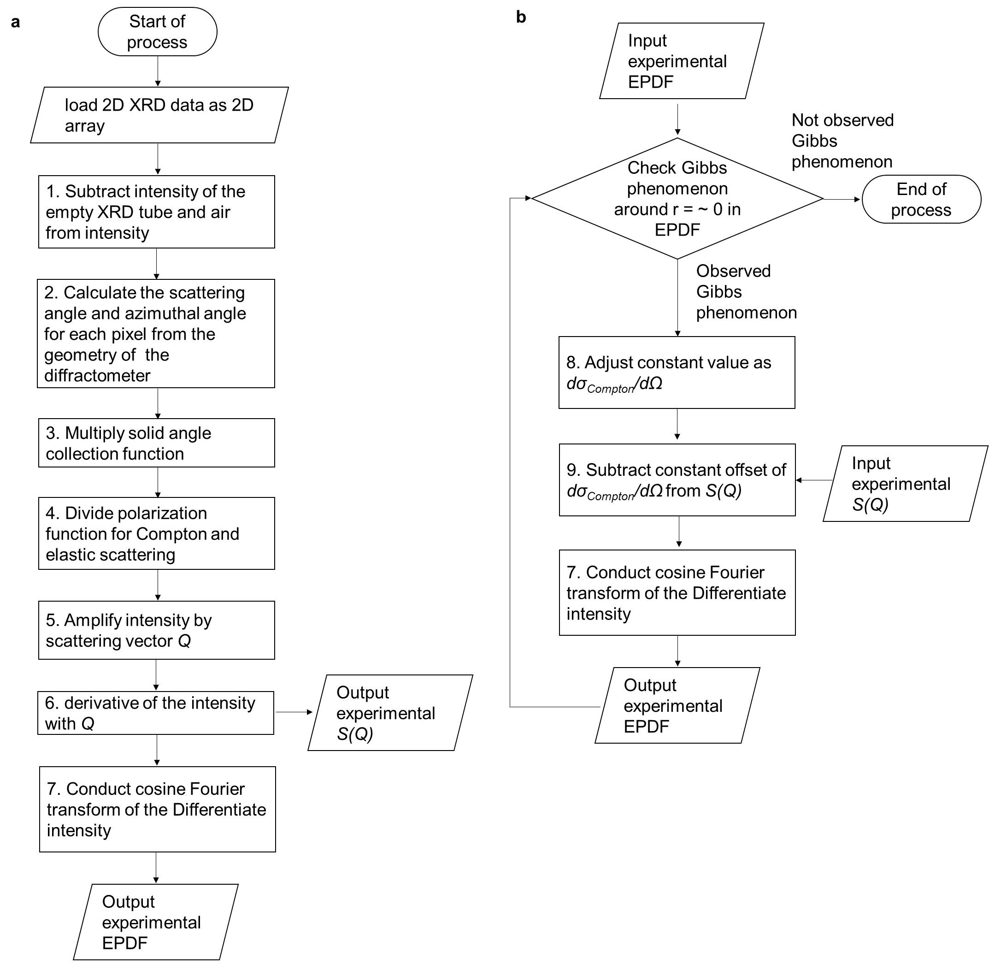

Fig. S1. Flowchart for the determination of the EPDF from 2D X-ray scattering data. (a) Generation of the structure functions for the EPDF. Processes 1–3 are conventional procedures for obtaining scattering data from a 2D XRD image, process 4 is the intensity correction based on Eq. (44), and Processes 5 and 6 convert the intensity into the structure function of the EPDF based on Eq. (15). The structure function is shown in Fig. 2d. Process 7 transforms the structure function into the EPDF. In the case of the Gibbs phenomena at $r=\sim 0$ in the EPDF, the EPDF is corrected using the flowchart in shown in (b). (b) Removing the Compton scattering component (see Fig. S5) and adjusting the constant offset $dσ_{Compton}/dΩ$.
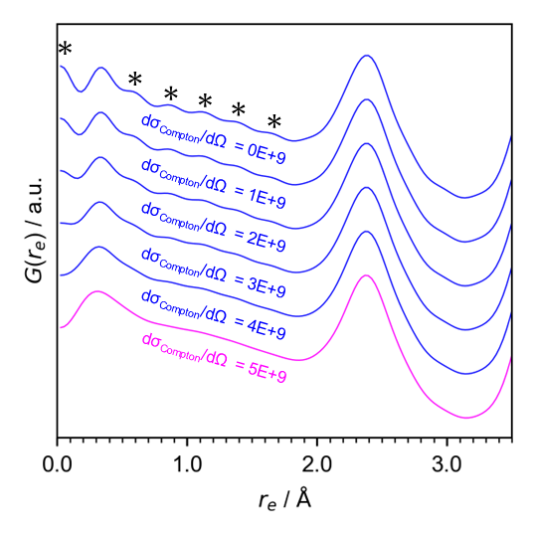

Fig. S2. Processing demonstrations of the subtraction of the Compton scattering in experimental EPDF generation for silicon. The ripples induced by the Gibbs phenomena are marked by asterisks. The values of $dσ_{Compton}/dΩ$ indicate the offset intensity subtracted from the structure functions before the Fourier transform.

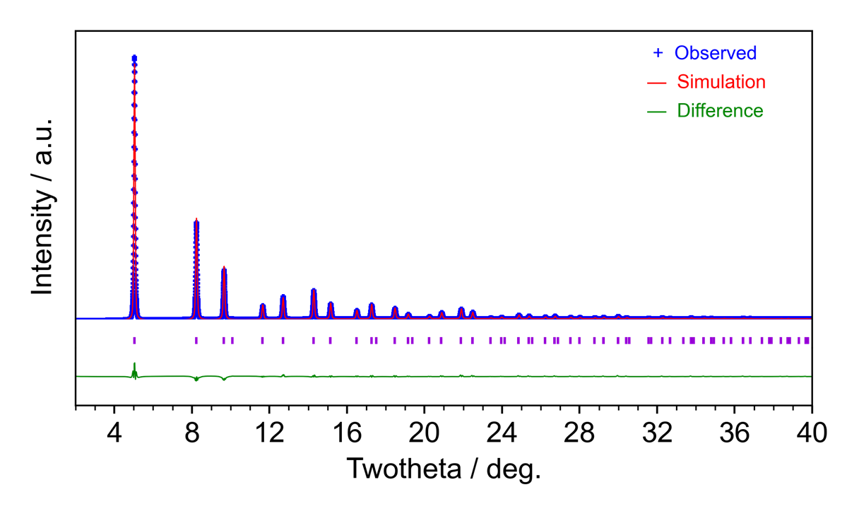
Fig. S3. Rietveld analysis of diamond to obtain a structural model for EPDF analysis. The refinement was conducted using the crystallographic model (space group: Fd$\overline{3}$m, a = 3.569, R_{wp} = 6.801).

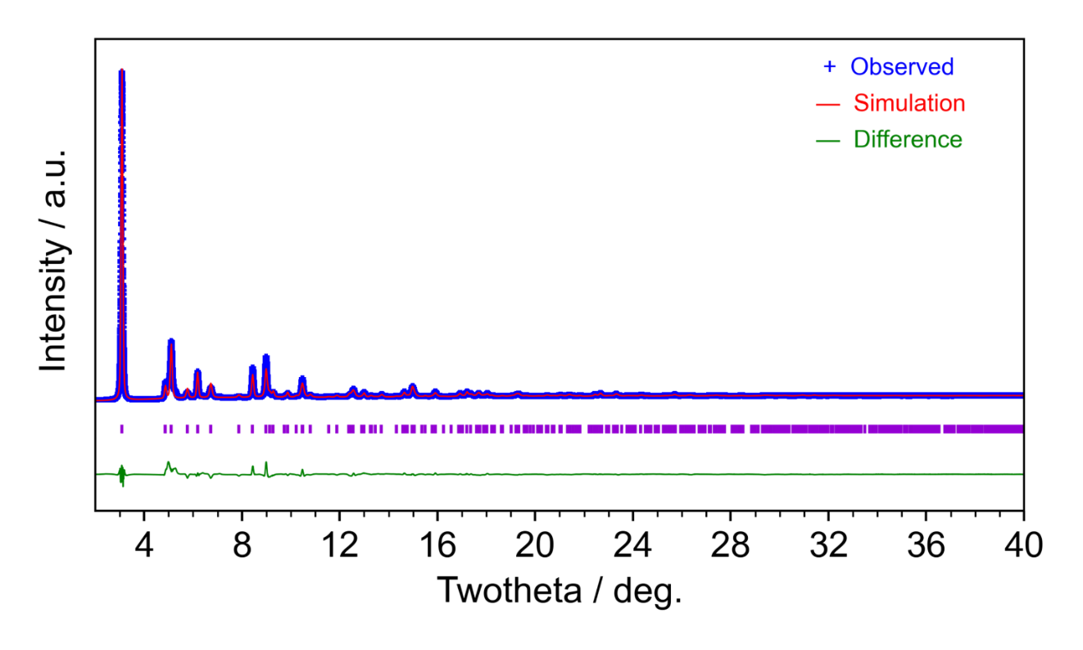
Fig. S4. Rietveld analysis of graphite to obtain a structural model for EPDF analysis. The refinement was conducted using the crystallographic model (space group: P6₃/mmc, a = 2.461, b = 6.713, R_{wp} = 8.412). The slight variation at approximately 5° is attributed to an AA-type stacking fault in the AB stacking graphite layer.
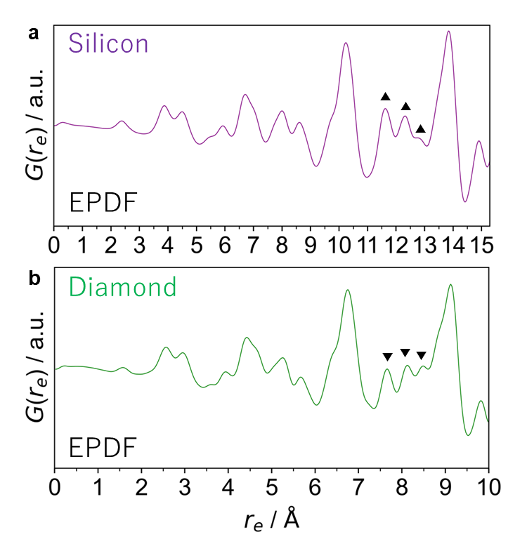
Fig. S5. Experimental EPDF data of (a) silicon and (b) diamond. Their different peak shapes suggest a difference in their electron densities. Their different EPDFs are also observed over a long range (beyond the bond radius), as denoted by triangles and inverse triangles.

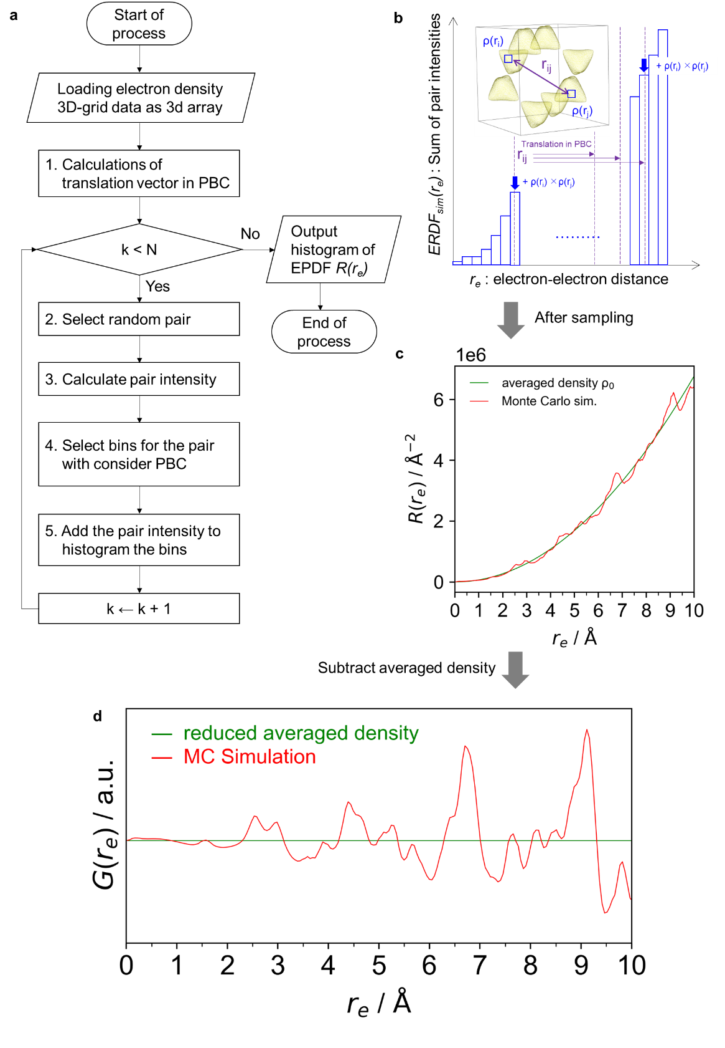

Fig. S6. Flowchart for the EPDF simulations via MC sampling. (a) Flowchart of the EPDF MC simulation algorithm. The process numbers in the loop section correspond to the processes described in Section E. (b) Illustrations of the MC sampling algorithms. (c) Raw MC simulation data (red line) sampled from the electron density map of the diamond obtained from CCSD calculations. The green lines indicate the EPDF data attributed to the small-angle scattering term in Eq. (7). (d) Data obtained after the subtraction of the contributions of the small-angle scattering term from the MC simulation.

Table S1. Analytical approaches for the X-ray scattering and diffraction analysis.

Data type | Atomic position analysis | Electron density analysis
Bragg peaks  (reciprocal space analysis) | Rietveld refinement | Maximum entropy method,  quantum crystallography
Total scattering intensities  (real space analysis) | Atomic PDF analysis | Electronic PDF analysis

SI References
1. Bob, B., H. X‐Ray Detectors. in Two‐dimensional X‐ray Diffraction 87–140 (Wiley, 2018). doi:10.1002/9781119356080.ch4.
2. Qiao, C.-K., Wei, J.-W. & Chen, L. An Overview of the Compton Scattering Calculation. Crystals 11, 525 (2021).
3. Epstein, I. R. Compton scattering and the chemistry of momentum space. Acc. Chem. Res. 6, 145–152 (1973).
4. Hämäläinen, K. et al. Free electron gas under high pressure. Phys. Rev. B 62, R735–R738 (2000).
5. Van Hove, L. Correlations in Space and Time and Born Approximation Scattering in Systems of Interacting Particles. Phys. Rev. 95, 249–262 (1954).

