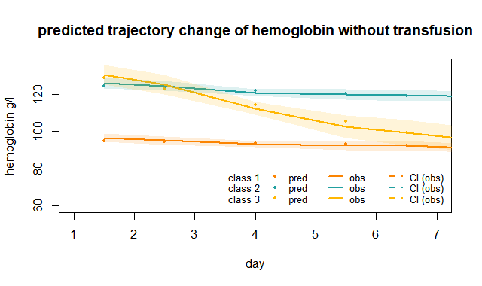

Fig. S1 Hemoglobin trajectory patterns in septic patients without transfusion during the first 7 days after ICU admission

Table S1. Hazard ratio (HR) for risks of clinical outcomes by the 3 subgroups of different hemoglobin trajectory patterns in septic patients without transfusion
Clinical outcome | Subgroups | Events[n(%)] | Un-adjusted HR(95%CI) | P | Adjusted HR(95%CI) | P
Primary outcome
Hospital mortality
 | class1 | 84（25.3%） | 1 |  | 1
 | class2 | 55(23.8%） | 1.29(1.31-1.48) | 0.0001 | 2.44(2.03-2.92) | <0.0001
 | class3 | 24（55.8%） | 4.28(3.50-5.23) | <0.0001 | 3.02(2.57-3.53) | <0.0001
Secondary outcome
Organ dysfunction
 | class1 | 24(7.22%) | 1 |  | 1
 | class2 | 24(10.39%) | 1.13(0.89-1.45) | 0.314 | 1.44(1.09-1.89) | 0.0097
 | class3 | 9(20.93%) | 3.90(2.67-5.69) | <0.0001 | 2.98(1.86(4.78 | <0.0001

