Supporting information
Revisiting the absolute green synthesis of MFI zeolite and derived metal-acid bifunctional catalyst

Wenqi Xu, Hongqing Li, Mengxuan Zhu, Rui Wang, Heng Jiang, Changzi Jin*
School of Petrochemical Engineering, Liaoning Petrochemical University, Fushun, 113001, China
E-mail address: jin_chz@163.com (Changzi Jin)

Figure S1 XRD pattern of as-synthesized products prepared from Al-free starting materials. Synthesis condition: Na₂O/SiO₂=0.072, H₂O/SiO₂=2.0, 170 ºC, 24h.

Table S1 Crystallization of ZSM-5 zeolite under different conditions

Na₂O/SiO₂ | SiO₂/Al₂O₃ | SiO₂/H₂O | t/h | T/℃ | Relative crystallinity
0.036 | 40 | 1：2 | 24 | 170 | -
0.072 | 40 | 1：2 | 24 | 170 | 10%
0.108 | 40 | 1：2 | 24 | 170 | 54%
0.144 | 40 | 1：2 | 24 | 170 | 23%
0.072 | 40 | - | 24 | 170 | -
0.072 | 40 | 1：1 | 24 | 170 | 48%
0.072 | 40 | 1：3 | 24 | 170 | 86%
0.072 | 40 | 1：4 | 24 | 170 | 93%
0.072 | 30 | 1：2 | 24 | 170 | 95%
0.072 | 50 | 1：2 | 24 | 170 | 52%
0.072 | 60 | 1：2 | 24 | 170 | 33%
0.072 | 100 | 1：2 | 24 | 170 | 52%
0.072 | - | 1：2 | 24 | 170 | 26%
0.072 | 40 | 1：2 | 24 | 150 | -
0.072 | 40 | 1：2 | 12 | 170 | -
0.072 | 40 | 1：2 | 18 | 170 | 61%
0.072 | 40 | 1：2 | 48 | 170 | 88%
0.072 | - | 1：2 | 24 | 170 | 30%
0.072 | - | 1：2 | 72 | 170 | -
0.072 | 60 | 1：2 | 24 | 170 | 88%

Figure S2 XRD pattern of as-synthesized products prepared from different Na and Al precursors.
Synthesis condition: SiO₂/Al₂O₃ =40, Na₂O/SiO₂=0.072, H₂O/SiO₂=2.0, 170 ºC, 24h.

Figure S3 XRD pattern of as-synthesized products prepared by addition of ethanol.
Synthesis condition: SiO₂/Al₂O₃ =40, Na₂O/SiO₂=0.072, ethanol/SiO₂=2.0, 170 ºC, 24h.

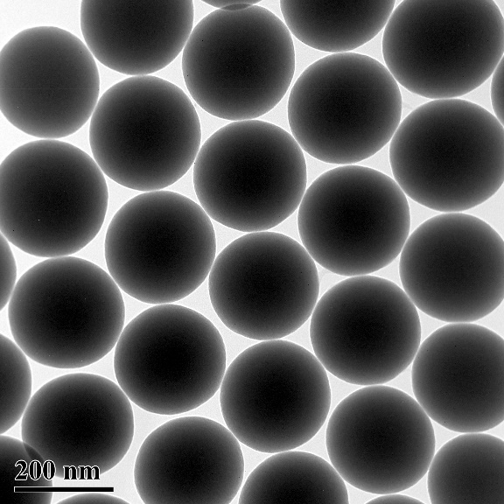
Figure S4 TEM image of Stӧber SiO₂ sphere.

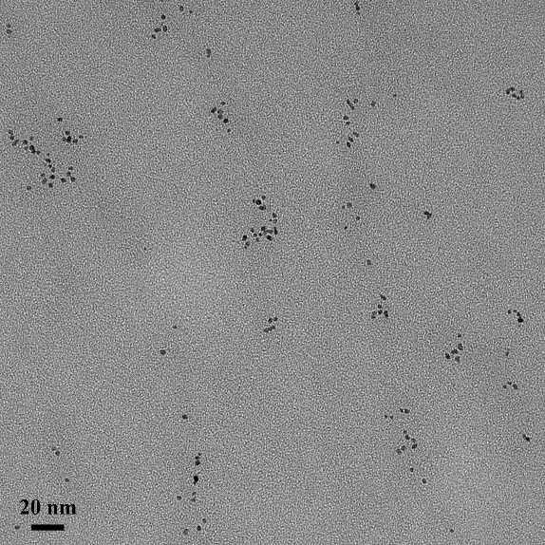
Figure S5 TEM image of PVP-protected Pt nanoparticles.

Figure S6 XRD pattern of as-synthesized products prepared with Stӧber SiO₂ sphere by addition of Pt nanoparticles.

Table S2 Detailed products distribution for hydroisomerization of n-heptane over Pt@SiO₂ and Pt/SiO₂ at 240 ºC
Selectivity (C mol%) |  | Pt@SiO₂ | Pt/SiO₂
Isomers | 2-Methyl Hexane | 33.11 | 12.09
Isomers | 3-Methyl Hexane | 24.85 | 11.39
Isomers | 3-Ethyl Pentane | 0.50 | 0.40
Isomers | 2, 2-Dimethylpentane | 0.03 | 0.01
Isomers | 2, 4-Dimethylpentane | 0.87 | 0.31
Isomers | 3, 3-Dimethylpentane | <0.01 | 0.01
Cracking | Methane | <0.01 | <0.01
Cracking | Ethane | <0.01 | 0.01
Cracking | Propane | 15.21 | 24.71
Cracking | Iso-Butane | 22.99 | 36.70
Cracking | Butane | 0.27 | 1.42
Cracking | Pentane | 0.36 | 1.48
Cracking | 2-Methyl Pentane | 0.13 | 0.32
Cracking | 3-Methyl Pentane | 0.05 | 0.17
Cracking | Hexane | 0.32 | 1.17
Others | Methyl Cyclohexane | 0.46 | 0.75
Others | Ethyl Cyclopentane | 0.29 | 0.74
Others | Toluene | <0.01 | 0.03
Others | Unkown components | 0.54 | 8.28

