Table 1: Details of Indian chrysanthemum cultivars, parentage and flower color used in this study
Sr. No. | Name | Parentage | Color | Flower | Sr. No. | Name | Parentage | Color | Flower
1 | A joy | UK | Pink | 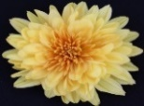  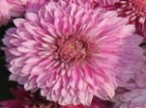  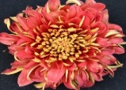  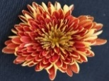  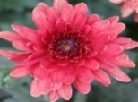  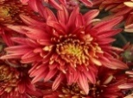  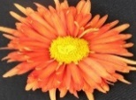  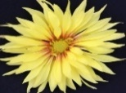  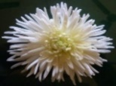  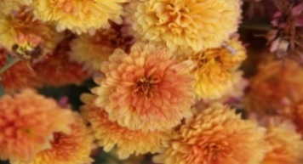  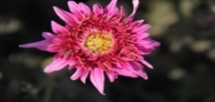  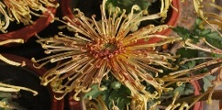  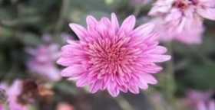  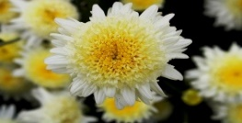  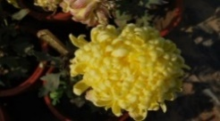  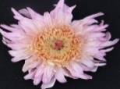  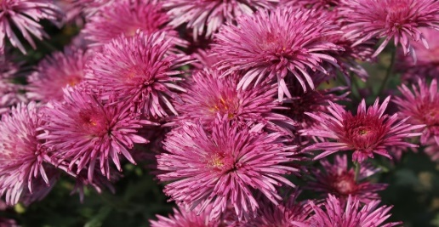  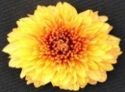  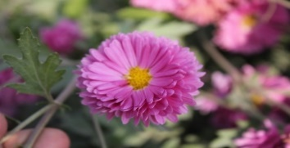  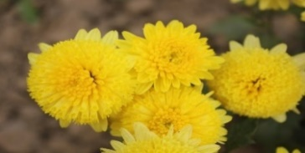  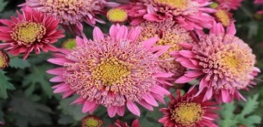  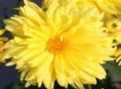 | 12 | Diamond Jubilee | UK | Yellow Orange
2 | Bidhan Agnidev | UK | Red |  | 13 | HYDC 42 | LC | Pink
3 | Bidhan Agnisikha | OSB 52 | Red |  | 14 | HYDC 56 | STW | White
4 | Bidhan Gold | MBJ | Yellow |  | 15 | Koka Kinjan | UK | Yellow
5 | Bidhan Lalima | OPS | Red |  | 16 | Mahatma Gandhi | UK | Pink
6 | Bidhan Monami | OPS | Red |  | 17 | Mauve Sarah | UK | Pink
7 | Bidhan Protima | OPS | Red |  | 18 | Mini Jessie | UK | Orange
8 | Bidhan Purna | OSB 52 | Yellow |  | 19 | PAU B-43 | UK | Pink
9 | Bidhan Rajat | OSB 52 | White |  | 20 | Punjab Anuradha | UK | Yellow
10 | Bidhan Sabita | UK | Orange |  | 21 | Silk Brocade | UK | Pink
11 | Big Violet | UK | Purple |  | 22 | Vasantika | UK | Yellow
UK-Unknown; OPS-OP selection; OBC 52-Open Selection of BCC 52; MBJ-Mutant of Bidhan Jayanti; LC-Local Collection; STW-Selection from cv. Terry White

Table 2: Linear correlation coefficients (r) between different phytochemicals in flowers of chrysanthemum cultivars obtained by Pearson’s analysis
 | Anthocyanin | Flavonoids | Phenols | Antioxidants | Alkaloids | Tannins | Carotenoids | Saponins
Anthocyanin | 1 | 0.099621 | 0.21677 | 0.44062 | -0.36834 | -0.09726 | -0.1633 | 0
Flavonoids | 0.099621 | 1 | 0.10923 | 0.27565 | -0.08489 | 0.16941 | 0.098597 | 0.27772
Phenols | 0.21677 | 0.10923 | 1 | 0.40238 | -0.17235 | 0.45721 | 0.20175 | 0.15899
Antioxidants | 0.44062 | 0.27565 | 0.40238 | 1 | 0 | 0.4367 | 0.19206 | 0.26019
Alkaloids | -0.36834 | -0.08489 | -0.17235 | 0 | 1 | 0.077179 | 0.25386 | 0.29952
Tannins | -0.09726 | 0.16941 | 0.45721 | 0.4367 | 0.077179 | 1 | 0.49668 | 0.40205
Carotenoids | -0.1633 | 0.098597 | 0.20175 | 0.19206 | 0.25386 | 0.49668 | 1 | 0.58365
Saponins | 0 | 0.27772 | 0.15899 | 0.26019 | 0.29952 | 0.40205 | 0.58365 | 1

