Supplementary materials
Table S1. Leven tests for the homogeneity of variance on ChP and LVEN volume.
 | ChP volume |  |  |  |  | LVEN volume
 | Levene | df1 | df2 | Sig. |  | Levene | df1 | df2 | Sig.
Mean | 1.562 | 4 | 801 | .183 |  | 3.125 | 4 | 801 | .015
Median | 1.535 | 4 | 801 | .190 |  | 2.405 | 4 | 801 | .048
Median & Adj df | 1.535 | 4 | 783 | .190 |  | 2.405 | 4 | 767 | .048
trimmed mean | 1.562 | 4 | 801 | .182 |  | 2.922 | 4 | 801 | .020

Table S2: Normality tests of ChP and LVEN volume by Shapiro-Wilk test.
Group | ChP volume |  |  |  | LVEN volume
Group | Statistic | df | Sig. |  | Statistic | df | Sig.
CN | .993 | 156 | .634 |  | .911 | 156 | .000
SMC | .988 | 95 | .513 |  | .829 | 95 | .000
EMCI | .994 | 272 | .410 |  | .914 | 272 | .000
LMCI | .992 | 155 | .571 |  | .922 | 155 | .000
AD | .995 | 128 | .906 |  | .910 | 128 | .000

Table S3. Tukey Post Hoc for pairwise means comparisons for ChP volumes after ANOVA test.
Group 1 | Group 2 | Mean Difference (I-J) | Std. Error | Sig. | 95% Confidence Interval
 |  |  |  |  | Lower Bound | Upper Bound
CN | SMC | -45.37989 | 49.36495 | .889 | -180.3437 | 89.5839
CN | EMCI | -68.58984 | 38.09615 | .374 | -172.7448 | 35.5651
CN | LMCI | -140.48346* | 43.01877 | .010 | -258.0968 | -22.8701
CN | AD | -216.26723* | 45.23742 | .000 | -339.9464 | -92.5881
SMC | CN | 45.37989 | 49.36495 | .889 | -89.5839 | 180.3437
SMC | EMCI | -23.20995 | 45.20565 | .986 | -146.8023 | 100.3824
SMC | LMCI | -95.10357 | 49.42519 | .305 | -230.2321 | 40.0250
SMC | AD | -170.88734* | 51.36788 | .008 | -311.3272 | -30.4475
EMCI | CN | 68.58984 | 38.09615 | .374 | -35.5651 | 172.7448
EMCI | SMC | 23.20995 | 45.20565 | .986 | -100.3824 | 146.8023
EMCI | LMCI | -71.89362 | 38.17417 | .327 | -176.2618 | 32.4746
EMCI | AD | -147.67739* | 40.65805 | .003 | -258.8365 | -36.5182
LMCI | CN | 140.48346* | 43.01877 | .010 | 22.8701 | 258.0968
LMCI | SMC | 95.10357 | 49.42519 | .305 | -40.0250 | 230.2321
LMCI | EMCI | 71.89362 | 38.17417 | .327 | -32.4746 | 176.2618
LMCI | AD | -75.78377 | 45.30315 | .451 | -199.6426 | 48.0751
AD | CN | 216.26723* | 45.23742 | .000 | 92.5881 | 339.9464
AD | SMC | 170.88734* | 51.36788 | .008 | 30.4475 | 311.3272
AD | EMCI | 147.67739* | 40.65805 | .003 | 36.5182 | 258.8365
AD | LMCI | 75.78377 | 45.30315 | .451 | -48.0751 | 199.6426
* The mean difference is significant at the 0.05 level.

Table S4. Post Hoc multiple comparisons of LVEN volume after non-parametric independent-samples Kruskal-Wallis test is significant.
Group 1- Group 2 | Test Statistic | Std. Error | Std. Test Statistic | Sig. | Adj. Sig.
SMC-CN | 8.502 | 30.299 | .281 | .779 | 1.000
SMC-EMCI | -25.715 | 27.746 | -.927 | .354 | 1.000
SMC-LMCI | -83.783 | 30.336 | -2.762 | .006 | .057
SMC-AD | -177.016 | 31.528 | -5.615 | .000 | .000
CN-EMCI | -17.212 | 23.382 | -.736 | .462 | 1.000
CN-LMCI | -75.280 | 26.404 | -2.851 | .004 | .044
CN-AD | -168.514 | 27.766 | -6.069 | .000 | .000
EMCI-LMCI | -58.068 | 23.430 | -2.478 | .013 | .132
EMCI-AD | -151.301 | 24.955 | -6.063 | .000 | .000
LMCI-AD | -93.233 | 27.806 | -3.353 | .001 | .008

Table S5. Leven tests for the homogeneity of variance on relative perfusion.
 | Levene Statistic | df1 | df2 | Sig.
Mean | .860 | 2 | 142 | .425
Median | .498 | 2 | 142 | .609
Median & Adj df | .498 | 2 | 139.540 | .609
Trimmed mean | .878 | 2 | 142 | .418

Table S6: Normality test of relative perfusion by Shapiro-Wilk test.
Group | Statistic | df | Sig.
CN | .911 | 88 | .000
MCI | .963 | 36 | .264
AD | .931 | 21 | .142

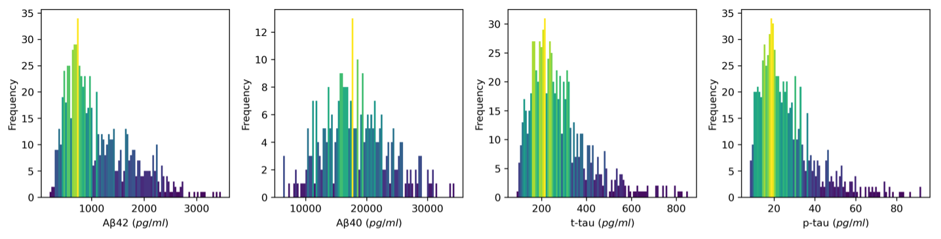
Figure S1. Histogram of proteins level for Aβ42, Aβ40, t-tau, and p-tau.

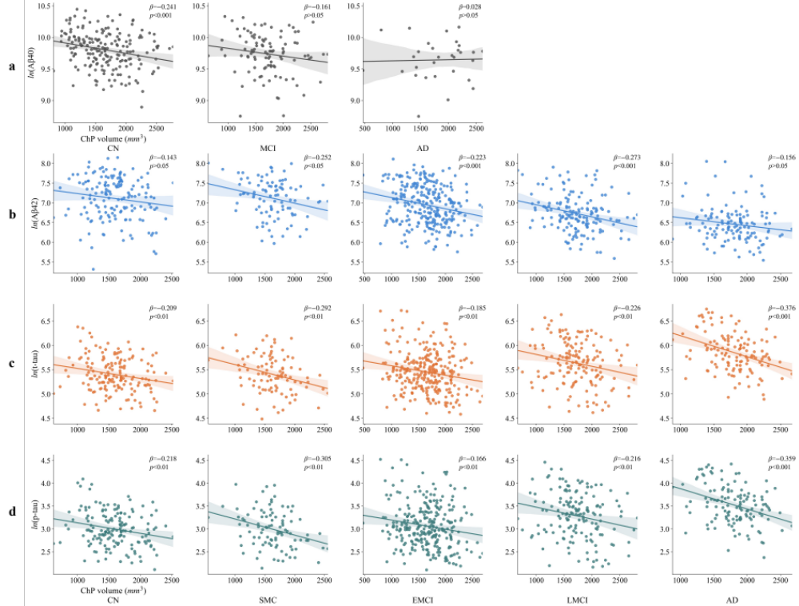
Figure S2. The fitted linear relationship between the protein level and ChP volume for each study group. β is the standardized regression coefficient.

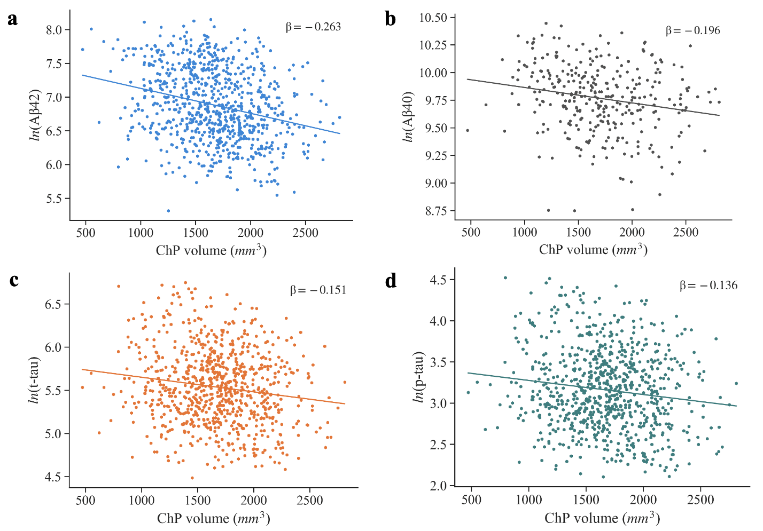
Figure S3. The fitted linear relationship between the protein level and ChP volume. β is the standardized regression coefficient.

