Supplementary Figures
Supplementary figure 1 The patient selection process. 324 novel DLBCL patients were finally enrolled in this study. 164 patients had progressed or recurrence disease, while 160 patients didn’t at the data cutoff date of April 28th, 2023.

Supplementary figure 2 Patients characteristics. This overview includes the clinical characteristics, IHC and FISH results. While each column represents one case, each line represents a specific analysis.

Supplementary figure 3 Univariable analysis for PFS and OS in two groups of novel DLBCL receiving R-CHOP/R-CHOP like regimens. PFS, progress free survival; OS, overall survival; HR, hazard ratios; CI, confidence interval.

Supplementary figure 4 Patient disposition and genetic landscape of IRF4^{mut} DLBCL patients in our cohort.

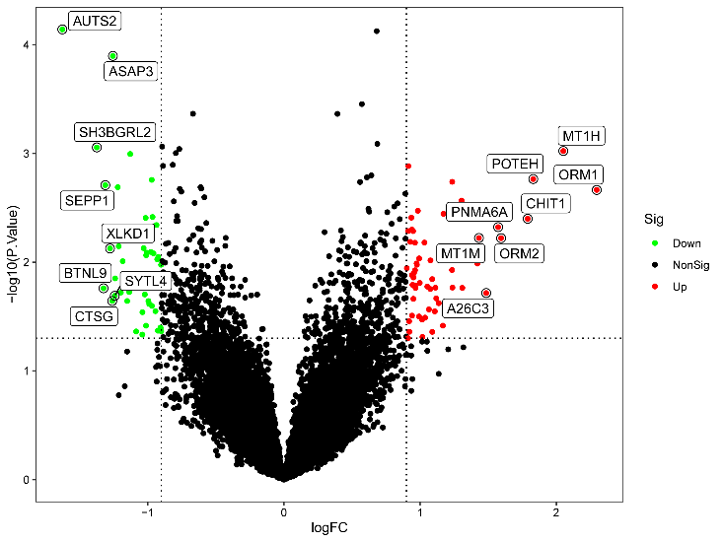
B
Supplementary figure 5 (A)IRF4 RNA expression in IRF4 mutation and wildtype group. (B)Volcano map of DEGs in GSE181063 (p＜0.05, |logFC |＞0.9). A total of 63 up-regulated (red) and 46 down-regulated (green) DEGs were identified between the IRF4 mutation and wildtype group.

