Supplementary methods

Flow cytometry
Cells were analysed and sorted by flow cytometer Calibur or Aria 2 (BD Bioscience). Data were analysed with FlowJo software (Tree Star). The following antibodies were used for staining of the cells: CD31 (MEC13.3), CD41 (MWReg30), CD45 (30-F11), c-Kit (2B8), CD201 (eBio 1560), CD45.1 (A20), CD45.2 (104), Ter119 (TER-119), VE-cadherin (eBioBV13), Sca-1 (D7), Ki67 (SolA15), 7-amino-actinomycin D (7-AAD) and Streptavidin APC-eFluor 780. All monoclonal antibodies and 7-AAD were purchased from eBioscience, except for CD31 and CD41 from BD Pharmingen, and CD150 and VE-cadherin from BioLegend. For single-cell sorting, rainbow beads were used to confirm that exactly one single cell was sorted into each well.

qPCR
After sorting 100 cells straight into the cell lysis buffer, the previously described procedures for reverse transcription and cDNA amplification were carried out¹. qRT–PCR was performed on LightCycler® 480 II system (Roche Diagnostics). The sequences of primers were: 47S pre-rRNA (5’ETS amplicons): ACACGCTGTCCTTTCCCTATTA (sense), CCCAAGCCAGTAAAAAGAATAGG (anti-sense); β-actin: GTAAAGACCTCTATGCCAACAC (sense), ATGATCTTGATCTTCATGGTGCTA (anti-sense).

OP9-DL1 co-culture
FACS-sorted cells were co-cultured with OP9-DL1 stromal cells in 24-well plate, containing α-MEM (Gibco), 10% fetal bovine serum (Hyclone), and cytokines (100 ng/mL SCF, 100 ng/mL Flt3 ligand, and 100 ng/mL IL-3, PeproTech) in the presence or absence of 50 nM CX-5461 (MCE, HY-13323). After 6 days of co-culture, cells in each well were harvested for flow cytometry analysis and transplantation. For hematopoietic and endothelial potential assay, FACS-sorted cells were plated on the OP9-DL1 stromal cells in IMDM (Hyclone) containing 15% fetal bovine serum (Hyclone), 1% bovine serum albumin (Sigma), 10 μg/mL insulin (Macgene), 200 μg/mL transferrin (Sigma), 5.5 × 10⁻⁵ mol/L 2-mercaptoethanol (Gibco), and cytokines (100 ng/mL rhVEGF-165 and 50 ng/mL SCF, PeproTech)². After 6 days of co-culture, cells were fixed for 30 minutes in 2% paraformaldehyde and stained with CD45 antibody (BD Biosciences) to assess the generation of hematopoietic progeny. Following conventional protocols, CD31 (BD Pharmingen, MEC13.3) immunohistochemical staining was carried out, and the formation of CD31-positive tubules in the wells was regarded as indicative of endothelial potential.
Cell cycle detection
For cell cycle analysis by Hoechst/Ki67 staining, cells were fixed using Fixation and Permeabilization Solution (BD, 554722). After surface marker antibodies staining, anti-Ki67 (eBioscience, SolA15) and Hoechst 33342 (BD, 561908) staining were performed following standard protocol.

Principal component analysis and dimensionality reduction
The Seurat R package (v4.9)³ was employed to analyze the scRNA-seq data, facilitating the identification of highly variable genes (HVGs) and differentially expressed genes (DEGs), as well as dimensionality reduction via PCA or t-SNE, unsupervised clustering, among other analyses. The standard analytical workflow was succinctly outlined here. First, genes expressed in at least three individual cells were retained. Subsequently, the ‘FindVariableGenes’ function was engaged to pinpoint genes with significant variability based on log-transformed expression values, specifically log2(TPM/10+1). Genes manifesting an average expression value exceeding 1 and yet below 8, and a dispersion metric beyond 1, were recognized as highly variable genes (HVGs). Furthermore, to investigate whether RiBi can serve as a discriminative biomarker for the various developmental stages of HSC, we directly utilized a collection of 529 RiBi-related genes, as well as a set of 529 genes selected at random, as HVGs for the ensuing principal component analysis (PCA). Subsequently, the Elbow method was employed to determine the most significant principal components (PCs) that are informative for the forthcoming dimensionality reduction using t-SNE and for the subsequent graph-based clustering analysis⁴.

GSVA analysis
Gene Set Variation Analysis (GSVA)⁵ facilitates the transformation of gene-level expression profiles pertaining to gene sets associated with KEGG pathways⁶ into an enrichment score profile of corresponding biological processes. The ssGSEA⁷ method was employed to estimate the gene set enrichment score for each cell. A two-sample Wilcoxon test was utilized to assess differential enrichment across two populations, with corrected P values below 0.05 deemed statistically significant.

Correlation analysis
The average expression of the focused gene set was calculated for each cell. The relevant developmental cell populations of interest were then selected for computing the Pearson correlation coefficient.

Cell cycle analysis
The method similar to that of Tirosh et al.⁸ was employed for categorizing the cell cycle stages. Specifically, the average gene expression for the 43 G1/S⁹ and 54 G2/M¹⁰ genes was calculated in each cell, which was used to G1/S and G2/M score. These scores were then used to approximate the cell cycle stage based on their distribution. Cells with both G1/S and G2/M scores below 3.5 were categorized as "G0" phase, whereas scores exceeding this threshold indicated a proliferative condition. Within the subset of proliferative cells, those with G2/M scores surpassing their G1/S equivalents were classified as being in the "G2/M" phase. Conversely, if the G1/S score trumped that of G2/M and the latter was below 3.5, the cells were assigned to the "G1" phase. Should the G2/M score meet or exceed 3.5, the cell was subsequently labeled as being in the "S" phase.

Footprint analysis
The HINT¹¹ software was utilized for ATAC-seq footprint analysis, leveraging a Hidden Markov Model (HMM) framework. Concisely, footprints were delineated within regions of chromatin accessibility, identified as peaks by MACS2 v2.2.6^{12, 13} within merged replicates for each sample. These footprints were subsequently aligned with TF motifs from the JASPAR database. HINT-differential was used to evaluate the differential activity for each TF between two cell populations.

Reference
1. Gao S, et al. Publisher Correction: Tracing the temporal-spatial transcriptome landscapes of the human fetal digestive tract using single-cell RNA-sequencing. Nat Cell Biol 20, 1227 (2018).
2. Hou S, et al. Embryonic endothelial evolution towards first hematopoietic stem cells revealed by single-cell transcriptomic and functional analyses. Cell Res 30, 376-392 (2020).
3. Hao Y, et al. Integrated analysis of multimodal single-cell data. Cell 184, 3573-3587 e3529 (2021).
4. Levine JH, et al. Data-Driven Phenotypic Dissection of AML Reveals Progenitor-like Cells that Correlate with Prognosis. Cell 162, 184-197 (2015).
5. Hanzelmann S, Castelo R, Guinney J. GSVA: gene set variation analysis for microarray and RNA-seq data. BMC Bioinformatics 14, 7 (2013).
6. Kanehisa M, Furumichi M, Tanabe M, Sato Y, Morishima K. KEGG: new perspectives on genomes, pathways, diseases and drugs. Nucleic Acids Res 45, D353-D361 (2017).
7. Barbie DA, et al. Systematic RNA interference reveals that oncogenic KRAS-driven cancers require TBK1. Nature 462, 108-112 (2009).
8. Tirosh I, et al. Single-cell RNA-seq supports a developmental hierarchy in human oligodendroglioma. Nature 539, 309-313 (2016).
9. Macosko EZ, et al. Highly Parallel Genome-wide Expression Profiling of Individual Cells Using Nanoliter Droplets. Cell 161, 1202-1214 (2015).
10. Tirosh I, et al. Dissecting the multicellular ecosystem of metastatic melanoma by single-cell RNA-seq. Science 352, 189-196 (2016).
11. Li Z, Schulz MH, Look T, Begemann M, Zenke M, Costa IG. Identification of transcription factor binding sites using ATAC-seq. Genome Biol 20, 45 (2019).
12. Zhang Y, et al. Model-based analysis of ChIP-Seq (MACS). Genome Biol 9, R137 (2008).
13. Liu T. Use model-based Analysis of ChIP-Seq (MACS) to analyze short reads generated by sequencing protein-DNA interactions in embryonic stem cells. Methods Mol Biol 1150, 81-95 (2014).

Supplementary Figures
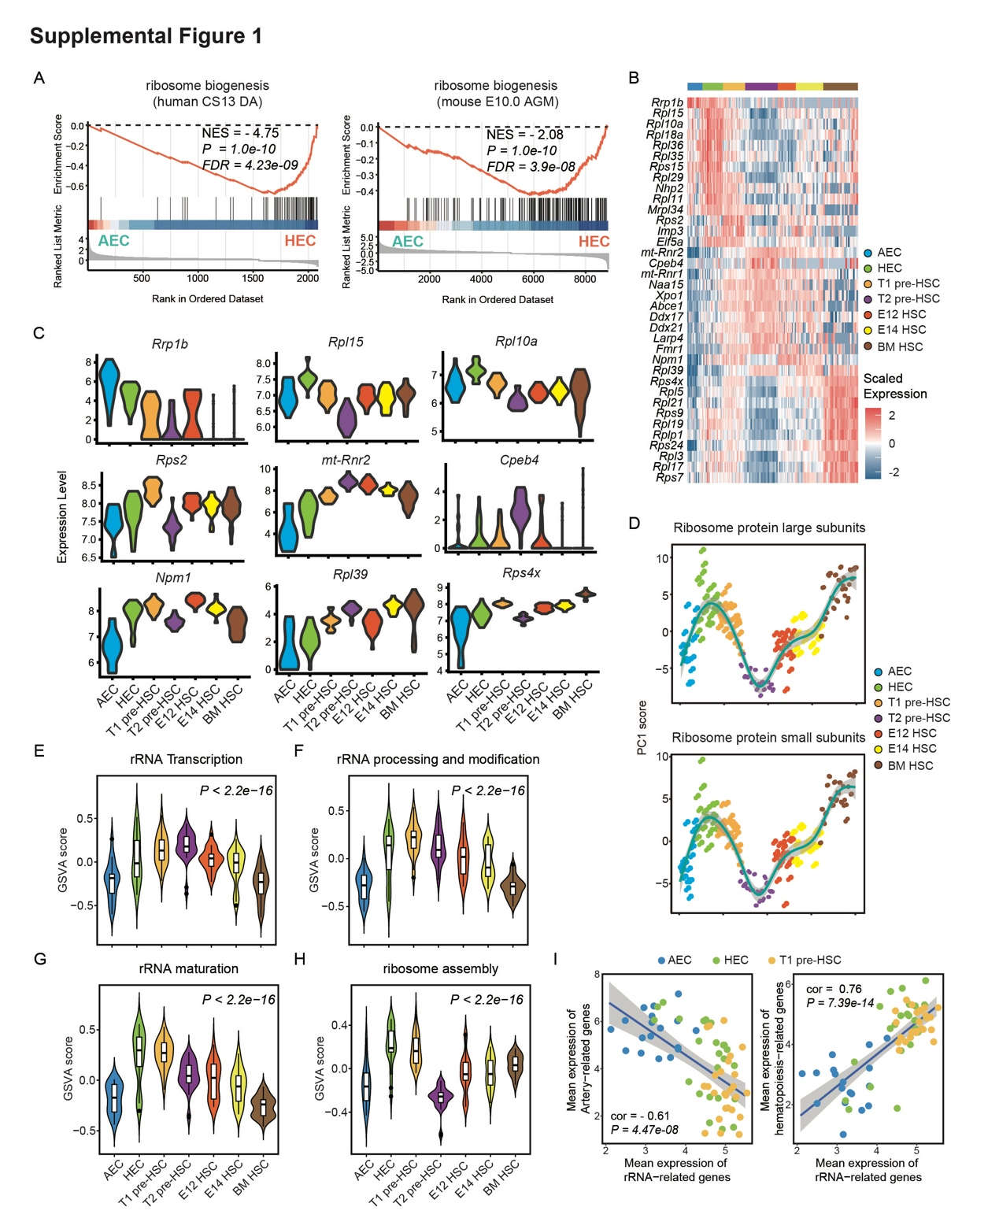
Supplemental Figure 1. The dynamic changes of RiBi during HSC development.
A. Gene Set Enrichment Analysis (GSEA) of ribosome biogenesis (GO:0042254) process between AECs and HECs in human (left) and mouse (right). DA, dorsal aorta; AGM, aorta-gonad-mesonephros. The nominal p-value and normalized enrichment score (NES) are provided to indicate the statistical significance and strength of the enrichment, respectively. Nominal P value, empirical phenotype-based permutation test (P < 0.05, FDR < 0.25).
B. Heatmap depicting relative expression of RiBi-related signature genes, distinguished by their significantly higher expression (adjusted P < 0.01, fold change > 1.5) within each cluster versus other clusters, across defined cell populations.
C. Violin plots showing the expression levels of indicated genes defined as log₂(TPM+1).
D. Scatter plots displaying the change of ribosomal large/small subunits via PC1 scores, aligned with average expression for correct direction, and include loess-fit curves with 95% confidence intervals.
E-H. Violin plots illustrating the GSVA score of ‘rRNA transcription’ (E), ‘rRNA processing and modification’ (F), ‘rRNA maturation’ (G) and ‘ribosome assembly’ (H) during HSC development, with statistical significance assessed via the Kolmogorov-Smirnov test across seven cell clusters.
I. Correlation between artery/hematopoiesis signature genes and rRNA-related genes, color-coded by cell clusters, with a blue linear fit line and gray confidence interval shading. The Pearson correlation coefficient is utilized to assess the correlation between the two. Absolute value of correlation coefficient greater than 0.5 and P value less than 0.05 is considered indicative of a strong correlation.

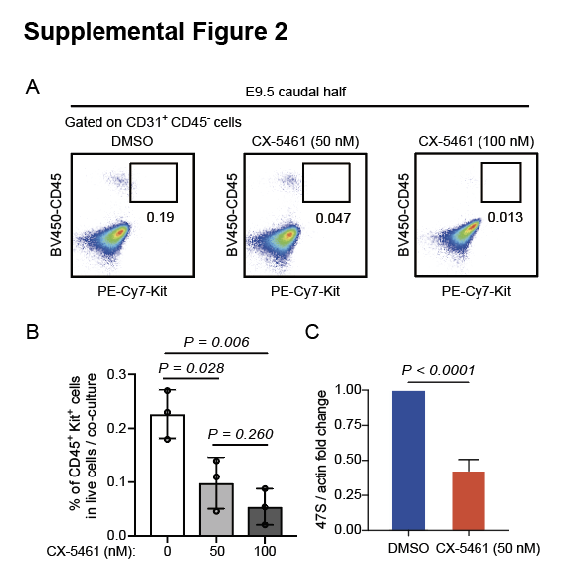
Supplemental Figure 2. CX-5461 is used to inhibit RiBi.
A. Representative ﬂow cytometric analysis of the progenies of 100 CD31⁺CD45⁻ cells from E9.5 caudal half regions co-culture after treatment with increasing concentrations of CX-5461.
B. Quantiﬁcation of the frequency of CD45⁺ Kit⁺ cells in the derivatives of the co-culture from A. Data are collected from three independent experiments. Data are represented as mean ± SD and analyzed by unpaired two-tailed Student’s t-test.
C. qRT-PCR detecting the expression level of 47S pre-rRNA in sorted CD31⁺CD45⁻ cells in E9.5 caudal half regions with the treatment of CX-5461. Data are collected from three independent experiments, and statistical differences were assessed using an unpaired two-tailed Student’s t-test.
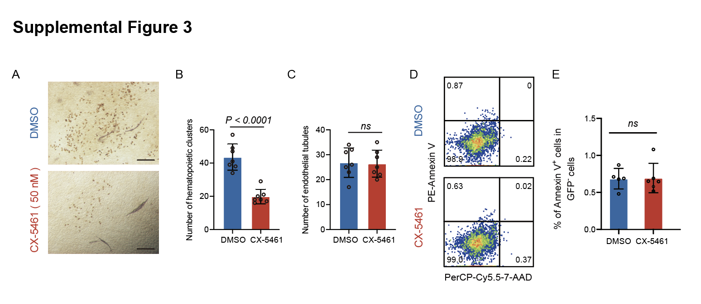
Supplemental Figure 3. RiBi deficiency selectively affects the function of HECs.
A. Representative CD31 and CD45 immunostaining on the cultures of 100 HECs from E10.0 caudal half regions after treatment with CX-5461. Data are from three independent experiments. Scale bars, 100 μm.
B, C. Quantiﬁcation of the number of hematopoietic clusters (B) and endothelial tubes (C). Data are represented as mean ± SD and analyzed by unpaired two-tailed Student’s t-test.
D. Representative ﬂow cytometric analysis of CD31⁺CD45⁻ cell apoptosis after CX-5461 treatment.
E. Quantiﬁcation of the frequency of apoptotic cells in CD45⁺ Kit⁺ cells treated with DMSO (n = 5), 50 nM CX-5461 (n = 6). Data are represented as mean ± SD and analyzed by unpaired two-tailed Student’s t-test.

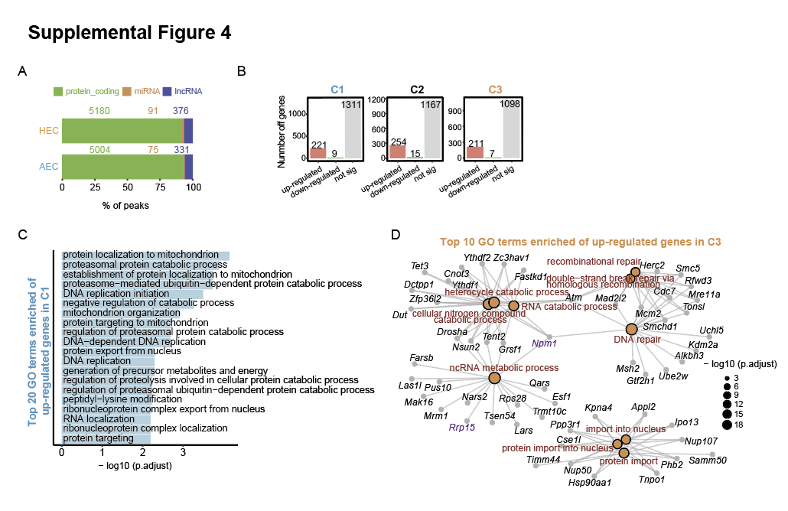
Supplemental Figure 4. Runx1 pre-binds RiBi-related genes locus and mediated their expression.
A. Bar plots displaying the annotation of the Runx1-binding peaks identified by ChIP-seq data.
B. Quantification of the number of DEGs in C1, C2, and C3.
C. Top 20 enriched Gene Ontology biological process (GO: BP) terms by using up-regulated genes in C1.
D. Network showing top 10 enriched GO terms associated with corresponding genes, generated using up-regulated genes in C3.

