Supplementary files
Table S1 2
Table S2 4
Table S3 5
Table S4 6
Table S5 9
Figure S1 10

Table S1. Metrics for Measurement and Quantitative Assessment of Life’s Essential 8
Domain | Metric | Method of measurement | Quantification of Life’s Essential 8 metric: adults
Health behaviors | Diet | Self-reported daily intake of a DASH-style eating pattern | Points Quantile  100 ≥95th percentile (top/ideal diet)  80 75th–94th percentile  50 50th–74th percentile  25 25th–49th percentile  0 1st–24th percentile (bottom/ least ideal quartile)
Health behaviors | PA | Self-reported minutes of moderate or vigorous PA per week | Points Minutes  100 ≥150  90 120–149  80 90–119  60 60–89  40 30–59  20 1–29  0 0
Health behaviors | Nicotine exposure | Self-reported use of cigarettes or inhaled NDS | Points Status  100 Never smoker  75 Former smoker, quit ≥5 y  50 Former smoker, quit 1–<5 y  25 Former smoker, quit <1 y, or currently using inhaled NDS  0 Current smoker  Subtract 20 points (unless score is 0) for living with active indoor smoker in home
Health behaviors | Sleep health | Self-reported average hours of sleep per night | Points Level  100 7–<9  90 9–<10  70 6–<7  40 5–<6 or ≥10  20 4–<5  0 <4
Health factors | BMI | Body weight (kilograms) divided by height squared (meters squared) | Points Level  100 <25  70 25.0–29.9  30 30.0–34.9  15 35.0–39.9  0 ≥40.0
Health factors | Blood lipids | Plasma total and HDL cholesterol with calculation of non–HDL cholesterol | Points Level  100 <130  60 130–159  40 160–189  20 190–219  0 ≥220  If drug-treated level, subtract 20 points
Health factors | Blood glucose | HbA1c | Points Level  100 No history of diabetes and HbA1c <5.7  60 No diabetes and HbA1c 5.7–6.4 (prediabetes)  40 Diabetes with HbA1c <7.0  30 Diabetes with HbA1c 7.0–7.9  20 Diabetes with HbA1c 8.0–8.9  10 Diabetes with Hb A1c 9.0–9.9  0 Diabetes with HbA1c ≥10.0
Health factors | BP | Appropriately measured systolic and diastolic BPs | Points Level  100 <120/<80 (optimal)  75 120–129/<80 (elevated)  50 130–139 or 80–89 (stage 1 hypertension)  25 140–159 or 90–99  0 ≥160 or ≥100  Subtract 20 points if treated level

Table S2. Beta coefficients and 95% confidence intervals of Life’s Essential 8 for CERAD: Trial1-3
 | CERAD: Trial 1 Score |  |  | CERAD: Trial 2 Score |  |  | CERAD: Trial 3 Score
Characteristic | Beta | 95% CI1 | p-value | Beta | 95% CI1 | p-value | Beta | 95% CI1 | p-value
Life’s Essential 8
No-adjusted | 0.01 | 0.01, 0.02 | <0.001 | 0.02 | 0.01, 0.02 | <0.001 | 0.01 | 0.01, 0.02 | <0.001
Age-adjusted | 0.01 | 0.01, 0.02 | <0.001 | 0.02 | 0.01, 0.02 | <0.001 | 0.01 | 0.01, 0.02 | <0.001
Fully adjusted² | 0 | 0.00, 0.01 | 0.3 | 0.01 | 0.00, 0.02 | 0.024 | 0.01 | 0.00, 0.01 | 0.019
CVH status (Based on Life’s Essential 8)
No adjusted
Low CVH (0-49 points) | — | — |  | — | — |  | — | —
Moderate CVH (50-79 points) | 0.25 | -0.01, 0.52 | 0.061 | 0.15 | -0.08, 0.38 | 0.2 | 0.19 | -0.03, 0.41 | 0.09
High CVH (80-100 points) | 0.56 | 0.25, 0.86 | <0.001 | 0.71 | 0.35, 1.1 | <0.001 | 0.68 | 0.39, 0.96 | <0.001
Age-adjusted
Low CVH (0-49 points) | — | — |  | — | — |  | — | —
Moderate CVH (50-79 points) | 0.35 | 0.11, 0.60 | 0.006 | 0.26 | 0.06, 0.46 | 0.013 | 0.29 | 0.08, 0.50 | 0.009
High CVH (80-100 points) | 0.64 | 0.33, 0.95 | <0.001 | 0.8 | 0.44, 1.2 | <0.001 | 0.75 | 0.47, 1.0 | <0.001
Fully adjusted²
Low CVH (0-49 points) | — | — |  | — | — |  | — | —
Moderate CVH (50-79 points) | 0.14 | -0.14, 0.41 | 0.3 | 0.07 | -0.17, 0.30 | 0.6 | 0.12 | -0.11, 0.36 | 0.3
High CVH (80-100 points) | 0.2 | -0.14, 0.55 | 0.2 | 0.43 | 0.02, 0.85 | 0.04 | 0.44 | 0.13, 0.75 | 0.008
¹CI = Confidence Interval; CVH, cardiovascular health; CERAD, Consortium to Establish a Registry for Alzheimer’s Disease.
2Fully adjusted: adjusted for age, sex, race, education level, ratio of family income to poverty and alcohol consumption.

Table S3. Beta coefficients and 95% confidence intervals of health behaviors and health factors for CERAD: Trial1-3
Characteristic | CERAD: Trial 1 Score |  |  | CERAD: Trial 2 Score |  |  | CERAD: Trial 3 Score
 | Beta | 95% CI1 | p-value | Beta | 95% CI1 | p-value | Beta | 95% CI1 | p-value
Health behaviors
No adjusted | 0.01 | 0.01, 0.02 | <0.001 | 0.01 | 0.01, 0.02 | <0.001 | 0.01 | 0.00, 0.01 | 0.003
Age-adjusted | 0.01 | 0.01, 0.02 | <0.001 | 0.01 | 0.01, 0.02 | <0.001 | 0.01 | 0.00, 0.01 | 0.002
Fully adjusted² | 0 | 0.00, 0.01 | 0.08 | 0 | 0.00, 0.01 | 0.083 | 0 | 0.00, 0.01 | 0.2
Health factors
No adjusted | 0 | 0.00, 0.01 | 0.2 | 0.01 | 0.00, 0.01 | 0.012 | 0.01 | 0.00, 0.01 | 0.008
Age-adjusted | 0 | 0.00, 0.01 | 0.1 | 0.01 | 0.00, 0.01 | 0.003 | 0.01 | 0.00, 0.01 | 0.002
Fully adjusted² | 0 | -0.01, 0.01 | >0.9 | 0 | 0.00, 0.01 | 0.073 | 0 | 0.00, 0.01 | 0.045
¹CI = Confidence Interval; ²Fully adjusted: adjusted for age, sex, race, education level, ratio of family income to poverty and alcohol consumption.

Table S4. Beta coefficients and 95% confidence intervals of Life’s Essential 8 metric for cognitive function scores
 | CERAD: Delayed Recall Score |  |  | CERAD: Trial 1 Score |  |  | CERAD: Trial 2 Score |  |  | CERAD: Trial 3 Score |  |  | CERAD: Total Score (3 Recall trials) |  |  | Animal Fluency: Total Score |  |  | Digit Symbol: Score
Life’s Essential 8 metric | Beta | 95% CI¹ | p-value | Beta | 95% CI¹ | p-value | Beta | 95% CI¹ | p-value | Beta | 95% CI¹ | p-value | Beta | 95% CI¹ | p-value | Beta | 95% CI¹ | p-value | Beta | 95% CI¹ | p-value
Diet
No adjusted | 0.01 | 0.00, 0.02 | 0.2 | 0.01 | 0.00, 0.02 | 0.01 | 0.01 | 0.00, 0.02 | 0.008 | 0.01 | 0.00, 0.01 | 0.025 | 0.03 | 0.01, 0.05 | 0.005 | 0.04 | 0.01, 0.07 | 0.021 | 0.06 | -0.02, 0.15 | 0.12
Age-adjusted | 0.01 | 0.00, 0.02 | 0.012 | 0.02 | 0.01, 0.02 | <0.001 | 0.02 | 0.01, 0.03 | <0.001 | 0.01 | 0.01, 0.02 | 0.001 | 0.04 | 0.02, 0.06 | <0.001 | 0.05 | 0.02, 0.08 | 0.001 | 0.12 | 0.05, 0.19 | 0.002
Fully adjusted² | 0.01 | 0.00, 0.02 | 0.15 | 0.01 | 0.00, 0.02 | 0.008 | 0.01 | 0.00, 0.02 | 0.008 | 0.01 | 0.00, 0.01 | 0.015 | 0.03 | 0.01, 0.05 | 0.002 | 0.04 | 0.01, 0.07 | 0.007 | 0.04 | -0.02, 0.10 | 0.2
Physical activity
No adjusted | 0 | 0.00, 0.01 | <0.001 | 0 | 0.00, 0.00 | <0.001 | 0 | 0.00, 0.00 | <0.001 | 0 | 0.00, 0.00 | 0.002 | 0.01 | 0.00, 0.01 | <0.001 | 0.02 | 0.02, 0.03 | <0.001 | 0.07 | 0.05, 0.09 | <0.001
Age-adjusted | 0 | 0.00, 0.00 | 0.02 | 0 | 0.00, 0.00 | 0.032 | 0 | 0.00, 0.00 | 0.037 | 0 | 0.00, 0.00 | 0.034 | 0.01 | 0.00, 0.01 | 0.011 | 0.02 | 0.01, 0.03 | <0.001 | 0.06 | 0.04, 0.08 | <0.001
Fully adjusted² | 0 | 0.00, 0.00 | 0.1 | 0 | 0.00, 0.00 | 0.3 | 0 | 0.00, 0.00 | 0.3 | 0 | 0.00, 0.00 | 0.2 | 0 | 0.00, 0.01 | 0.2 | 0.01 | 0.01, 0.02 | 0.001 | 0.03 | 0.01, 0.05 | 0.001
Nicotine exposure
No adjusted | 0 | 0.00, 0.00 | 0.7 | 0 | 0.00, 0.01 | 0.4 | 0 | 0.00, 0.00 | 0.3 | 0 | 0.00, 0.00 | 0.8 | 0 | -0.01, 0.01 | 0.5 | 0.01 | -0.01, 0.02 | 0.3 | 0.05 | 0.01, 0.08 | 0.01
Age-adjusted | 0 | 0.00, 0.01 | 0.032 | 0 | 0.00, 0.01 | 0.04 | 0 | 0.00, 0.01 | 0.012 | 0 | 0.00, 0.00 | 0.3 | 0.01 | 0.00, 0.02 | 0.028 | 0.01 | 0.00, 0.03 | 0.024 | 0.08 | 0.04, 0.11 | <0.001
Fully adjusted² | 0 | 0.00, 0.00 | 0.9 | 0 | 0.00, 0.00 | >0.9 | 0 | 0.00, 0.00 | 0.8 | 0 | 0.00, 0.00 | 0.3 | 0 | -0.01, 0.01 | 0.8 | 0.01 | 0.00, 0.02 | 0.2 | 0.04 | 0.00, 0.07 | 0.03
Sleep duration
No adjusted | 0 | 0.00, 0.01 | 0.6 | 0 | 0.00, 0.01 | 0.041 | 0 | 0.00, 0.01 | 0.039 | 0 | 0.00, 0.01 | 0.2 | 0.01 | 0.00, 0.02 | 0.037 | 0.02 | 0.01, 0.04 | <0.001 | 0.07 | 0.02, 0.11 | 0.005
Age-adjusted | 0 | 0.00, 0.01 | 0.4 | 0 | 0.00, 0.01 | 0.015 | 0 | 0.00, 0.01 | 0.018 | 0 | 0.00, 0.01 | 0.076 | 0.01 | 0.00, 0.02 | 0.009 | 0.03 | 0.01, 0.04 | <0.001 | 0.07 | 0.03, 0.11 | 0.001
Fully adjusted² | 0 | -0.01, 0.01 | >0.9 | 0 | 0.00, 0.01 | 0.2 | 0 | 0.00, 0.01 | 0.2 | 0 | 0.00, 0.00 | 0.6 | 0 | 0.00, 0.01 | 0.2 | 0.01 | 0.00, 0.02 | 0.2 | 0 | -0.03, 0.03 | 0.9
BMI
No adjusted | 0 | -0.01,0.00 | 0.2 | 0 | 0.00, 0.00 | 0.2 | 0 | 0.00, 0.00 | 0.9 | 0 | 0.00, 0.00 | >0.9 | 0 | -0.01,0.01 | 0.6 | 0 | -0.01,0.01 | >0.9 | 0 | -0.04,0.04 | 0.9
Age-adjusted | 0 | 0.00, 0.00 | 0.9 | 0 | 0.00, 0.00 | 0.9 | 0 | 0.00, 0.01 | 0.3 | 0 | 0.00, 0.00 | 0.2 | 0 | 0.00, 0.01 | 0.4 | 0.01 | -0.01, 0.02 | 0.3 | 0.03 | -0.01, 0.07 | 0.13
Fully adjusted² | 0 | -0.01, 0.00 | 0.6 | 0 | 0.00, 0.00 | 0.5 | 0 | 0.00, 0.00 | 0.5 | 0 | 0.00, 0.00 | 0.5 | 0 | -0.01, 0.01 | 0.8 | 0 | -0.01, 0.01 | 0.9 | 0 | -0.03, 0.02 | 0.8
Blood pressure
No adjusted | 0.01 | 0.01, 0.01 | <0.001 | 0.01 | 0.00, 0.01 | <0.001 | 0.01 | 0.00, 0.01 | <0.001 | 0.01 | 0.00, 0.01 | <0.001 | 0.02 | 0.01, 0.03 | <0.001 | 0.03 | 0.02, 0.03 | <0.001 | 0.08 | 0.05, 0.10 | <0.001
Age-adjusted | 0 | 0.00, 0.01 | 0.012 | 0 | 0.00, 0.01 | 0.027 | 0 | 0.00, 0.01 | 0.014 | 0 | 0.00, 0.01 | 0.002 | 0.01 | 0.00, 0.02 | 0.005 | 0.02 | 0.01, 0.03 | <0.001 | 0.04 | 0.02, 0.07 | 0.003
Fully adjusted² | 0 | 0.00, 0.01 | 0.055 | 0 | 0.00, 0.01 | 0.14 | 0 | 0.00, 0.01 | 0.088 | 0 | 0.00, 0.01 | 0.016 | 0.01 | 0.00, 0.02 | 0.04 | 0.01 | 0.00, 0.02 | 0.016 | 0.01 | -0.01, 0.04 | 0.2
Blood glucose
No adjusted | 0.01 | 0.01, 0.01 | <0.001 | 0 | 0.00, 0.01 | 0.005 | 0.01 | 0.00, 0.01 | 0.001 | 0.01 | 0.00, 0.01 | 0.002 | 0.02 | 0.01, 0.03 | <0.001 | 0.03 | 0.01, 0.05 | 0.002 | 0.13 | 0.08, 0.19 | <0.001
Age-adjusted | 0.01 | 0.00, 0.01 | <0.001 | 0 | 0.00, 0.01 | 0.011 | 0.01 | 0.00, 0.01 | 0.003 | 0.01 | 0.00, 0.01 | 0.007 | 0.02 | 0.01, 0.03 | 0.002 | 0.03 | 0.01, 0.04 | 0.002 | 0.12 | 0.07, 0.17 | <0.001
Fully adjusted² | 0 | 0.00, 0.01 | 0.019 | 0 | 0.00, 0.00 | >0.9 | 0 | 0.00, 0.01 | 0.089 | 0 | 0.00, 0.01 | 0.14 | 0.01 | 0.00, 0.01 | 0.2 | 0 | -0.01, 0.02 | 0.5 | 0.04 | 0.01, 0.08 | 0.023
Non-HDL cholesterol
No adjusted | -0.01 | -0.01, 0.00 | <0.001 | 0 | -0.01,0.00 | 0.006 | 0 | -0.01,0.00 | 0.003 | 0 | -0.010.00 | 0.02 | -0.01 | -0.02, -0.01 | 0.002 | -0.02 | -0.03, -0.01 | 0.005 | -0.06 | -0.09, -0.03 | <0.001
Age-adjusted | 0 | -0.01, 0.00 | 0.048 | 0 | -0.01,0.00 | 0.13 | 0 | 0.00, 0.00 | 0.12 | 0 | -0.01,0.00 | 0.2 | -0.01 | -0.02, 0.00 | 0.088 | -0.01 | -0.02, 0.00 | 0.063 | -0.03 | -0.05, -0.01 | 0.016
Fully adjusted² | 0 | 0.00, 0.00 | 0.2 | 0 | 0.00, 0.00 | 0.2 | 0 | 0.00, 0.00 | 0.3 | 0 | 0.00, 0.00 | 0.4 | 0 | -0.01, 0.00 | 0.2 | -0.01 | -0.02, 0.00 | 0.047 | -0.02 | -0.04, 0.00 | 0.047
¹CI = Confidence Interval; ²Fully adjusted: adjusted for age, sex, race, education level, ratio of family income to poverty and alcohol consumption.

Table S5. Beta coefficients and 95% confidence intervals of Life’s Essential 8 for CERAD: Trial1-3 by sex and age
 |  | CERAD: Trial 1 Score |  |  | CERAD: Trial 2 Score |  |  | CERAD: Trial 3 Score
Subgroup | Category | Beta | 95% CI¹ | p-value | Beta | 95% CI¹ | p-value | Beta | 95% CI¹ | p-value
Sex
Male | No-adjusted | 0.01 | 0.00, 0.02 | 0.046 | 0.01 | 0.00, 0.02 | 0.051 | 0.01 | 0.00, 0.02 | 0.044
 | Age-adjusted | 0.01 | 0.00, 0.02 | 0.007 | 0.01 | 0.01, 0.02 | 0.003 | 0.01 | 0.00, 0.02 | 0.006
 | Fully-adjusted² | 0.01 | -0.01, 0.02 | 0.3 | 0.01 | 0.00, 0.02 | 0.2 | 0.01 | 0.00, 0.01 | 0.3
Female | No-adjusted | 0.01 | 0.00, 0.02 | 0.007 | 0.02 | 0.01, 0.03 | <0.001 | 0.02 | 0.01, 0.03 | <0.001
 | Age-adjusted | 0.01 | 0.00, 0.02 | 0.008 | 0.02 | 0.01, 0.03 | <0.001 | 0.02 | 0.01, 0.03 | <0.001
 | Fully-adjusted² | 0 | -0.01, 0.01 | 0.6 | 0.01 | 0.00, 0.02 | 0.014 | 0.01 | 0.00, 0.02 | 0.023
Age
60-69 years | No-adjusted | 0.01 | 0.01, 0.02 | 0.001 | 0.02 | 0.01, 0.03 | <0.001 | 0.01 | 0.01, 0.02 | <0.001
 | Fully-adjusted³ | 0 | 0.00, 0.01 | 0.4 | 0.01 | 0.00, 0.02 | 0.093 | 0.01 | 0.00, 0.01 | 0.2
70-79 years | No-adjusted | 0.01 | 0.00, 0.03 | 0.038 | 0.01 | 0.00, 0.03 | 0.031 | 0.01 | 0.00, 0.03 | 0.14
 | Fully-adjusted³ | 0.01 | -0.01, 0.02 | 0.3 | 0.01 | -0.01, 0.03 | 0.2 | 0.01 | -0.01, 0.03 | 0.2
80+ years | No-adjusted | 0 | -0.01, 0.02 | 0.6 | 0.01 | 0.00, 0.03 | 0.07 | 0.02 | 0.00, 0.04 | 0.11
 | Fully-adjusted³ | 0 | -0.02, 0.01 | 0.6 | 0.01 | 0.00, 0.03 | 0.2 | 0.01 | -0.01, 0.03 | 0.3
1CI = Confidence Interval; 2Fully adjusted: adjusted for age, race, education level, ratio of family income to poverty and alcohol consumption; 3Fully adjusted: adjusted for sex, race, education level, ratio of family income to poverty and alcohol consumption.

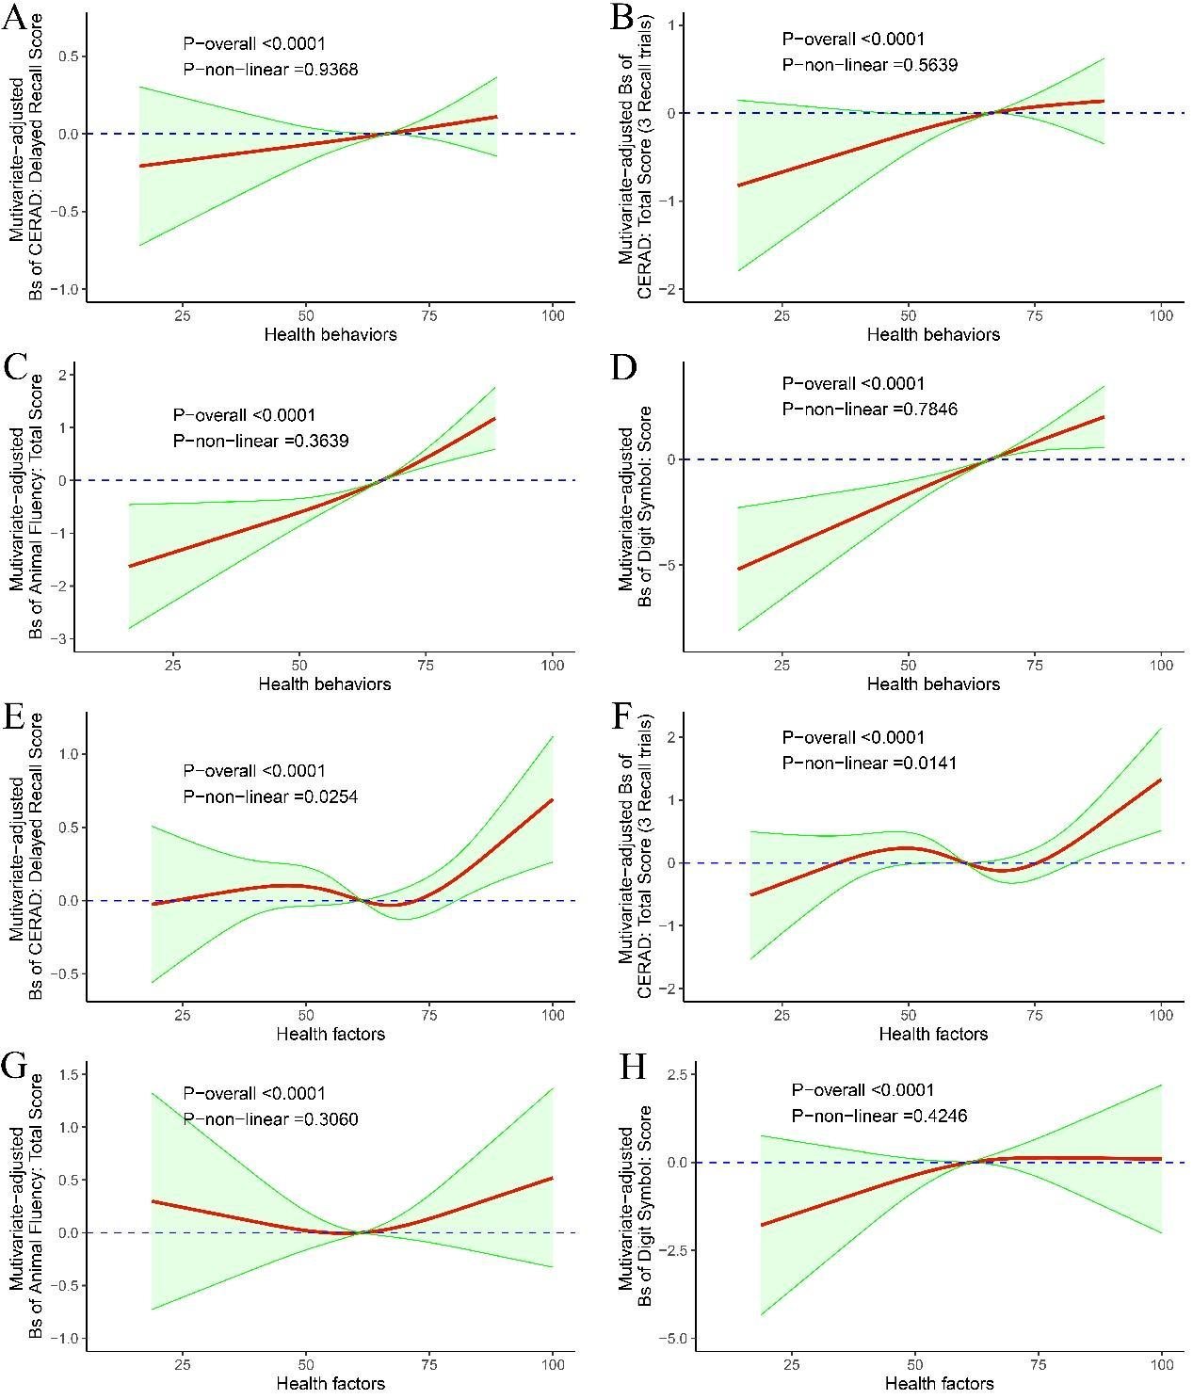
Figure S1 Dose-response relationship of Health behavior (A-D) and Health factor (E-H) with various domains of cognitive function (A, E: CERAD: Delayed Recall Score, B, F: CERAD: Total Score (3 Recall trials), C, G: Animal Fluency: Total Score, D, H: Digit Symbol: Score). Model is adjusted for age, sex, race, education level, ratio of family income to poverty and alcohol consumption.

