Supporting Information
Comprehensive Nontargeted Analysis of Fluorosurfactant Byproducts and Reaction Products in Wastewater from Semiconductor Manufacturing
Submitted to
Sustainable Environment Research
Submitted by
Yi-Ju Chen^{1,2}, Jheng-Sian Yang ², Angela Yu-Chen Lin^{2*}
1 National Environmental Research Academy, Ministry of Environment, Taoyuan City, 320, Taiwan
2 Graduate Institute of Environmental Engineering, National Taiwan University, Taipei City, 106, Taiwan
*Corresponding author. yuchenlin@ntu.edu.tw, Tel: +886-2-3366438

Sample pretreatment
For the non-target analysis, water samples were subjected to solid-phase extraction using an Oasis WAX cartridge, which features a combination of weak anion-exchange and reversed-phase sorbents to enhance water sample condensation. Prior to loading, 200 milliliters of water were adjusted to a pH below 3 with formic acid. The cartridge was pre-conditioned with 6 mL of 2% NH₄OH in methanol, followed by 6 mL of methanol and 6 mL of water. Subsequently, the cartridge was treated with 3 mL of 0.1% formic acid in water, which flowed through the cartridge. After loading the water sample and washing the cartridge with 3 mL of 0.1% formic acid in water and 3 mL of pure water, the cartridge was dried for 15 minutes. The WAX cartridge was then eluted with 6 mL of methanol for neutral PFAS and 6 mL of 2% NH₄OH in methanol for acidic PFAS. The eluents were combined and concentrated to near dryness under nitrogen in a water bath at 50°C. The resulting extract was reconstituted with 500 μL of methanol and filtered through a 0.22 μm nylon filter before being added to reagent water at a methanol/water ratio of 3:7 (vol/vol). The prepared samples were stored at -20°C before Q-Exactive MS analysis.

Table S1: List of native PFAS standards from Wellington Laboratories, Canada
Compound | Abbreviation
Perfluoro-n-butanoic acid | PFBA
Perfluoro-n-pentanoic acid | PFPeA
Perfluoro-n-hexanoic acid | PFHxA
Perfluoro-n-heptanoic acid | PFHpA
Perfluoro-n-octanoic acid | PFOA
Perfluoro-n-nonanoic acid | PFNA
Perfluoro-n-decanoic acid | PFDA
Perfluoro-n-undecanoic acid | PFUdA
Perfluoro-n-dodecanoic acid | PFDoA
Perfluoro-n-tridecanoic acid | PFTrDA
Perfluoro-n-tetradecanoic acid | PFTeDA
Perfluoro-1-octanesulfonamide | FOSA
N-methylperfluoro-1-octanesulfonamidoacetic acid | N-MeFOSAA
N-ethylperfluoro-1-octanesulfonamidoacetic acid | N-EtFOSAA
Potassium perfluoro-1-butanesulfonate | L-PFBS
Sodium perfluoro-1-pentanesulfonate | L-PFPeS
Potassium perfluorohexanesulfonate | PFHxSK: linear isomer  PFHxSK: branched isomers
Sodium perfluoro-1-heptanesulfonate | L-PFHpS
Potassium perfluorooctanesulfonate | PFOSK: linear isomer  PFOSK: branched isomers
Sodium perfluoro-1-nonanesulfonate | L-PFNS
Sodium perfluoro-1-decanesulfonate | L-PFDS
Sodium 1H,1H,2H,2H-perfluoro-1-hexanesulfonate | 4:2 FTSA
Sodium 1H,1H,2H,2H-perfluoro-1-octanesulfonate | 6:2 FTSA
Sodium 1H,1H,2H,2H-perfluoro-1-decanesulfonate | 8:2 FTSA
Potassium 9-chlorohexadecafluoro-3-oxanonane-1-sulfonate | 9Cl-PF3ONS
N-Methylperfluorooctanesulfonamide | Me-FOSA
2-(N-Methylperfluorooctanesulfonamido)ethanol | Me-FOSE
N-Ethylperfluorooctanesulfonamide | Et-FOSA
2-(N-Ethylperfluorooctanesulfonamido)ethanol | Et-FOSE

Table S2: List of authentic standards used for confirming identified PFAS
Compound | Abbreviation | Purity | Supplier
Trifluoroacetic acid | TFA | 99.5% | Alfa Aesar
Pentafluoropropionic acid | PFPrA | 99.4% | Sigma Aldrich
Trifluoromethanesulfonic acid | TFMS | 99.7% | Thermo Fisher
Perfluorobutanesulfinic acid | PFBSi | 100% | Synquest Laboratories, USA
Perfluorobutylsulfonamide | FBSA | 98.4% | Toronto Research Chemicals, Canada
1,2,2,3,3,4,4,4-Nonafluoro-N-(2-hydroxyethyl)-1-butanesulfonamide | FBSE | 98% | Toronto Research Chemicals, Canada
N,N-Bis(2-hydroxyethyl)perfluorobutanesulfonamide | FBSEE diol | 98% | Synquest Laboratories, USA
N-perfluorobutanesulfonyl glycine | FBSAA | 50 mg/L | Chiron AS
N-(Methyl)nonafluorobutanesulfonamide | MeFBSA | 97% | A2B Chem LLC
Nonafluoro-N-(2-hydroxyethyl)-N-methyl-1-butanesulfonamide | MeFBSE | 97% | Toronto Research Chemicals
Perfluorobutanesulfonylamide(N-methyl)acetate | MeFBSAA | 97% | APOLLO scientific supporting discovery

Table S3 Details on the LC‒MS/MS (Thermo Q Exactive, QE) instrumental method for nontarget analysis
LC system | Thermo Scientific Dionex UltiMate 3000
Autosampler | Thermo Scientific Accela autosampler
Separation column | ACQUITY UPLC HSS T3, 1.8 µm, 2.1 mm × 100 mm
Column oven Temperature | 30 °C
Mobile phases | A: 5mM ammonia acetate in H₂O  B: 5mM ammonia acetate in MeOH
Flow rate | 0.3 mL/min
Chromatographic gradient for nontarget analysis | Time (min) | A (%) |  | B (%)
Chromatographic gradient for nontarget analysis | 0 | 98 |  | 2
Chromatographic gradient for nontarget analysis | 1.0 | 65 |  | 35
Chromatographic gradient for nontarget analysis | 24.0 | 50 |  | 50
Chromatographic gradient for nontarget analysis | 88.0 | 20 |  | 80
Chromatographic gradient for nontarget analysis | 89.0 | 0 |  | 100
Chromatographic gradient for nontarget analysis | 96.0 | 0 |  | 100
Chromatographic gradient for nontarget analysis | 98.0 | 98 |  | 2
Chromatographic gradient for nontarget analysis | 103.0 | 98 |  | 2
Chromatographic gradient for quantitative and semi- quantitative analysis | Time (min) | A (%) |  | B (%)
 | 0 | 98 |  | 2
 | 1.0 | 65 |  | 35
 | 10.0 | 50 |  | 50
 | 25.0 | 20 |  | 80
 | 26.5 | 0 |  | 100
 | 30.5 | 0 |  | 100
 | 32.0 | 98 |  | 2
 | 36.0 | 98 |  | 2
Injection volume | 50-100 μL for nontarget analysis
Source parameter | Mode |  | Electrospray (ESI)
Source parameter | Polarity |  | Negative
Source parameter | In-source CID (eV) |  | 0
Source parameter | Sheath gas flow rate |  | 35
Source parameter | Aux gas flow rate |  | 8
Source parameter | Sweep gas flow rate |  | 1
Source parameter | Spray voltage |  | 300
Source parameter | Capillary temp. |  | 320
Source parameter | S-Lens RF level |  | 50
Source parameter | Heater temp. |  | 350
Acquisition mode | Full MS / ddMS2 (TopN)
Full MS | Resolution |  | 7000
Full MS | AGC target |  | 3e6
Full MS | Scan range (m/z) |  | 77 to 1155
dd-MS² | Resolution |  | 17,500
dd-MS² | AGC target |  | 1e5
dd-MS² | Loop count |  | 20
dd-MS² | MSX count |  | 1
dd-MS² | Top N |  | 20
dd-MS² | Isolation window (m/z) |  | 0.7
dd-MS² | (N)CE / stepped (N)CE |  | nce: 15, 60
dd-MS² | Dynamic exclusion |  | 10.0 s
Mass Calibration¹ | Acetic acid (CH₂COO⁻) |  | 59.01385
Mass Calibration¹ | Sodium dodecyl sulfate (C₁₂H₂₅SO₄⁻) |  | 265.14790
Mass Calibration¹ | Taurocholic acid (C₂₆H₄₄NO₇S⁻) |  | 514.28440
¹Mass calibration was performed before every analysis. Acetic acid was included in the calibration to improve the mass accuracy of low mass calibration
Table S4 Specifications for the nontarget workflow nodes from Compound Discoverer 3.3 Software
Node | Setting | Description | Criteria/Specification
Search ChemSpider | Search Setting | Database(s) | Alfa Chemistry; ECHA; EPA DSSTox; EPA Toxcast; KEGG; PubMed; Sigma-Aldrich; Toxin, Toxin-Target Database
 |  | Mass Tolerance | 5 ppm
 |  | Search Mode | By Formula or Mass
Search mzCloud | General Setting | Library | Autoprocessed; Reference
 | DDA Search | Identify Search | HighChem HighRes
 |  | Match Activation Energy | Match with Tolerance
 |  | Activation Energy Tolerance | 20
 |  | Similarity Search | None
Search Neutral losses | General Setting | Neutral Losses | - Carboxylic acid: CH₂CO₂ (58.01); CO₂ (43.99); CO₂HF (64.00);  - Sulfonic acid: CO₂(HF)₄ (124.01); HF (20.01);  - Miscellaneous FASAs and FASEs: SO₃; CONH;  - Others: C₂H₄O (44.03); CH₃OH (32.03); H₂O (18.01)
 |  | High Acc. Mass Tolerance | 2.5 mmu
 |  | Low Acc. Mass Tolerance | 0.5 Da
Predict Compositions | Prediction Settings | Mass Tolerance | 5 ppm
 |  | Max. Element Counts | C90 H190 Br5 Cl4 F30 N10 O38 P5 S10
 | Pattern Matching | S/N Threshold | 3
 | Fragment Matching | Mass Tolerance | 10 ppm
Compound Class Scoring | General Setting | Compound Class | - Polar functional head: CO₂F–, SO₂–, SO₂H–, SO₂F–, SO₃–, SO₃F–, SO₃H–. NSO₂⁻, O₂SNCH₂–, O₂SNC₂H₄O–, O₂SNC₃H₆O–, O₂SNC₄H₈O₂–  - Fluoroalkyl chain: CF₃–, CF₃O–, C₂F₃–, C₂F₅–, C₂F₅O–, C₃F₅–, C₃F₇–, C₄F₇O–, C₄F₇–, C₄F₉–, C₅F₉–, C₅F₁₁–, C₆F₁₃–, C₈F₁₇–
 |  | S/N Threshold | 50
 |  | High Acc. Mass Tolerance | 20 ppm
 |  | Low Acc. Mass Tolerance | 20 ppm
Assign Compound annotations | General Setting | Mass Tolerance | 5 ppm
 | Data Sources | Data Source#1 | mzCloud Search
 |  | Data Source#2 | mzVault Search
 |  | Data Source#3 | Predicted Compositions
 |  | Data Source#4 | MassList Search
 |  | Data Source#5 | ChemSpider Search

Table S5 List of identified PFAS with Formula and chemical structure
Sub-class | Chemical name | Abbreviation | Formula | Precursor ion | Structure
1a | 1,1,2,2,3,3,4,4,4-nonafluorobutane-1-sulfonamide | FBSA | C₄H₂F₉NO₂S | [M-H]– | 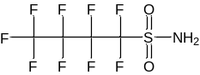
1b | 1,1,2,2,3,3,4,4-octafluorobutane-1-sulfonamide | H-FBSA | C₄H₃F₈NO₂S | [M-H]– | 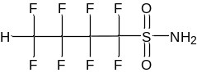
1c | 1,1,2,2,3,3-hexafluoro-3-(trifluoromethoxy)propane-1-sulfonamide  1,1,2,2-tetrafluoro-2-(pentafluoroethoxy)ethane-1-sulfonamide | E-FBSA | C₄H₂F₉NO₃S | [M-H]– | 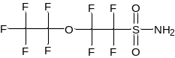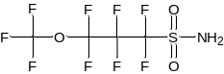
1d | (1,1,2,2,3,3,4,4,4-nonafluorobutane-1-sulfonyl)sulfamic acid | FBSA-SO₃H | C₄HF₉S₂O₅N | [M-H]– | 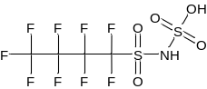
1e | N-carbamoyl-1,1,2,2,3,3,4,4,4-nonafluorobutane-1-sulfonamide | FBSA-Am | C₅H₃F₉N₂O₃S | [M-H]– | 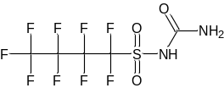
1f | 2-(1,1,2,2,3,3,4,4,4-nonafluorobutane-1-sulfonamido)acetamide | FBSA-MeAm | C₆H₅F₉N₂O₃S | [M-H]– | 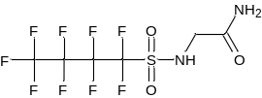
1g | 1,1,2,2,3,3,4,4,4-nonafluoro-N-(nitromethyl)butane-1-sulfonamide | FBSA-MeNO₂ | C₅H₃F₉N₂O₄S | [M-H]– | 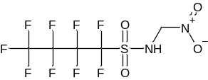
1h | 1,1,2,2,3,3,4,4,4-nonafluoro-N-(3-nitropropyl)butane-1-sulfonamide | FBSA-PrNO₂ | C₇H₇F₉N₂O₄S | [M-H]– | 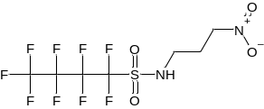
1i | N-(diazenylmethyl)-1,1,2,2,3,3,4,4,4-nonafluorobutane-1-sulfonamide | FBSA-diazene | C₅H₄F₉N₃O₂S | [M-H]– | 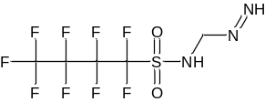
1j | 1,1,2,2,3,3,4,4,4-nonafluoro-N-methylbutane-1-sulfonamide | MeFBSA | C₅H₄F₉NO₂S | [M-H]– | 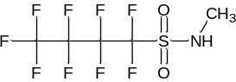
2a | 1,1,2,2,2-pentafluoro-N-(2-hydroxyethyl)ethane-1-sulfonamide | FEtSE | C₄H₆F₅NO₃S | [M-H]– | 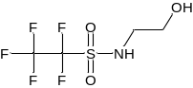
 | 1,1,2,2,3,3,3-heptafluoro-N-(2-hydroxyethyl)propane-1-sulfonamide | FPrSE | C₅H₆F₇NO₃S | [M-H]– | 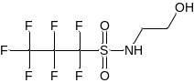
 | 1,1,2,2,3,3,4,4,4-nonafluoro-N-(2-hydroxyethyl)butane-1-sulfonamide | FBSE | C6H6F9NO₃S | [M-H]– | 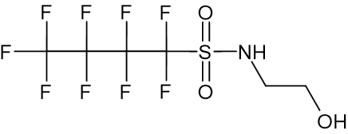
2b | 1,1,2,2,3,3,4,4-octafluoro-N-(2-hydroxyethyl)butane-1-sulfonamide | H-FBSE | C6H7F8NO₃S | [M-H]– | 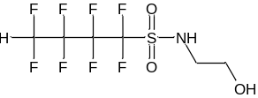
2c | 1,1,2,2,3,3-hexafluoro-N-(2-hydroxyethyl)-3-(trifluoromethoxy)propane-1-sulfonamide  1,1-difluoro-1-(heptafluoropropoxy)-N-(2-hydroxyethyl)methanesulfonamide  1,1,2,2-tetrafluoro-N-(2-hydroxyethyl)-2-(pentafluoroethoxy)ethane-1-sulfonamide | E-FBSE | C₆H₆F₉NO₄S | [M-H]– | 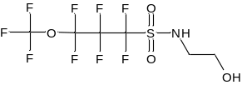  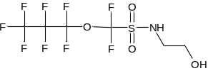  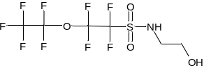
2d | 1,1,2,2-tetrafluoro-N-(2-hydroxyethyl)-2-(pentafluoroethoxy)ethane-1-sulfonamide | H-E-FBSE | C₆H₇F₈NO₄S | [M-H]– | 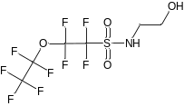
2e | 1,1,2,2,3,4,4-heptafluoro-N-(2-hydroxyethyl)but-3-ene-1-sulfonamide | U-FBSE | C₆H₆F₇NO₃S | [M-H]– | 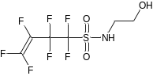
2f | 1,1-difluoro-N-(2-hydroxyethyl)-1-[(1,1,2,3,3-pentafluoroprop-2-en-1-yl)oxy]methanesulfonamide | U-E-FBSE | C₆H₆F₇NO₄S | [M-H]– | 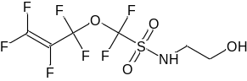
2g | (2-hydroxyethyl)(1,1,2,2,3,3,4,4-octafluorobutane-1-sulfonyl)sulfamic acid | FBSE-SO₃H | C₆H₆F₉NO₆S₂ | [M-H]– | 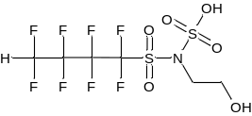
2h | N-carbamoyl-1,1,2,2,3,3,4,4,4-nonafluoro-N-(2-hydroxyethyl)butane-1-sulfonamide | FBSE-Am | C₇H₇F₉N₂O₄S | [M-H]– | 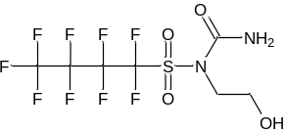
2i | 1,1,2,2,3,3,4,4,4-nonafluoro-N-(2-hydroxyethyl)-N-methylbutane-1-sulfonamide | MeFBSE | C7H8F9O3SN | [M-H]– | 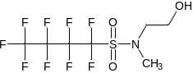
3a | 1,1,2,2,3,3,4,4,4-nonafluoro-N,N-bis(2-hydroxyethyl)butane-1-sulfonamide | FBSEE diol | C₈H₁₀F₉NO₄S₂ | [M-H]–  [M+CH₃COO]–  [M+HCOO]–  [2M-H]– | 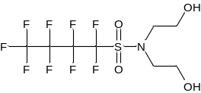
3b | 1,1,2,2,3,3,4,4-octafluoro-N,N-bis(2-hydroxyethyl)butane-1-sulfonamide | H-FBSEE diol | C₈H₁₁F₈NO₄S | [M+CH₃COO]– | 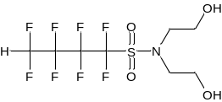
4a | (1,1,2,2,3,3,4,4,4-nonafluorobutane-1-sulfonamido)acetic acid  N-(2,2-dihydroxyethen-1-yl)-1,1,2,2,3,3,4,4,4-nonafluorobutane-1-sulfonamide  2-hydroxy-N-(1,1,2,2,3,3,4,4,4-nonafluorobutane-1-sulfonyl)acetamide | FBSAA | C6H4F9NO4S | [M-H]– | 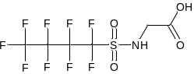  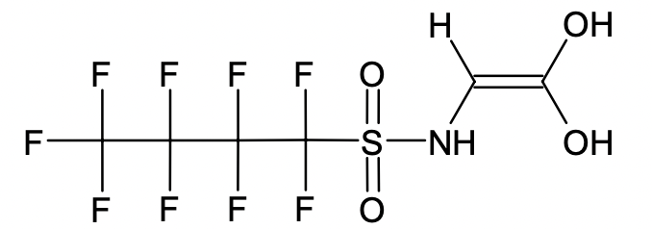  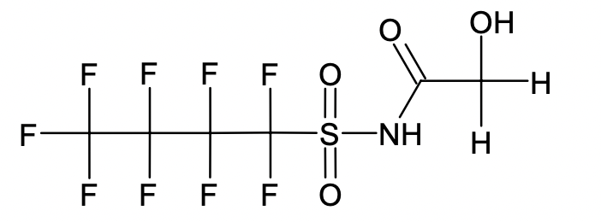
4b | [(1,1,2,2,3,3,4,4-octafluorobutane-1-sulfonyl)amino]acetic acid | H-FBSAA | C6H5F8NO4S | [M-H]– | 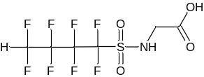
4c | [1,1,2,2,3,3-hexafluoro-3-(trifluoromethoxy)propane-1-sulfonamido]acetic acid  [1,1,2,2-tetrafluoro-2-(pentafluoroethoxy)ethanesulfonamido]acetic acid | E-FBSAA | C6H4F9NO5S | [M-H]– | 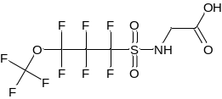  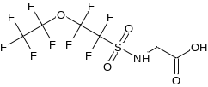
4d | [methyl(1,1,2,2,3,3,4,4,4-nonafluorobutane-1-sulfonyl)amino]acetic acid | N-MeFBSAA | C7H6F9NO4S | [M-H]– | 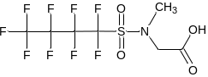
4e | 3-[(1,1,2,2,3,3,4,4,4-nonafluorobutane-1-sulfonyl)amino]propanoic acid | N-FBSPrA | C7H6F9NO4S | [M-H]– | 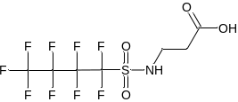  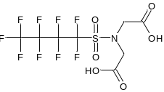
5a | 2,2'-[(1,1,2,2,3,3,4,4,4-nonafluorobutane-1-sulfonyl)azanediyl]diacetic acid | FBSEE diacid | C8H6F9NO6S | [M-H]–
6a | [(2-hydroxyethyl)(1,1,2,2,3,3,4,4,4-nonafluorobutane-1-sulfonyl)amino]acetic acid | FBSEE mono-ol monoacid | C8H8F9NO5S | [M-H]– | 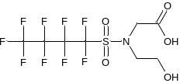
7 | 1,1,2,2,3,3,4,4,4-nonafluoro-N-(2-oxoethyl)butane-1-sulfonamide  1,1,2,2,3,3,4,4,4-nonafluoro-N-[(E)-2-hydroxyethen-1-yl]butane-1-sulfonamide | FBSAcAL | C6H4F9NO3S | [M-H]– | 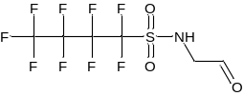  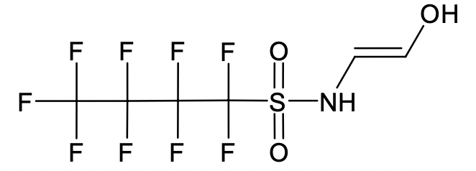
8a | N-(2,2-dihydroxyethyl)-1,1,2,2,3,3,4,4,4-nonafluorobutane-1-sulfonamide | FBSAcAL hydrate | C6H6F9NO4S | [M-H]– | 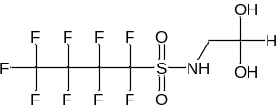
8b | 1,1,2,2,3,3,4,4,4-nonafluoro-N-(2-hydroxy-2-methoxyethyl)butane-1-sulfonamide | FBSAcAL  hemiacetal | C7H8F9NO4S | [M-H]– | 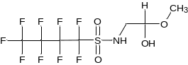
9a | trifluoroacetic acid | TFA | C₂HF₃O₂ | [M-H]– | 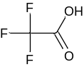
 | pentafluoropropanoic acid | PFPrA | C₃HF₅O₂ | [M-H]– | 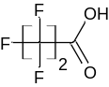
 | heptafluorobutanoic acid | PFBA | C₄HF₇O₂ | [M-H]– | 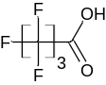
 | nonafluoropentanoic acid | PFPeA | C₅HF₉O₂ | [M-H]– | 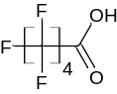
 | undecafluorohexanoic acid | PFHxA | C₆HF₁₁O₂ | [M-H]– | 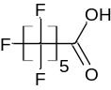
 | tridecafluoroheptanoic acid | PFHpA | C₇HF₁₃O₂ | [M-H]– | 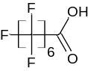
 | pentadecafluorooctanoic acid | PFOA | C₈HF₁₅O₂ | [M-H]– | 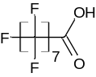
 | heptadecafluorononanoic acid | PFNA | C₉HF₁₇O₂ | [M-H]– | 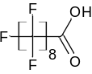
 | nonadecafluorodecanoic acid | PFDA | C₁₀HF₁₉O₂ | [M-H]– | 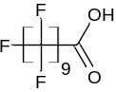
 | henicosafluoroundecanoic acid | PFUdA | C₁₁HF₂₁O₂ | [M-H]– | 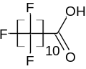
9b | (4E)-2,2,3,3,4,5,6,6,6-nonafluorohex-4-enoic acid | U-PFHxA | C₆HF₉O₂ | [M-H]– | 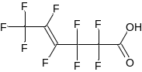
9c | difluoro[(1,2,2-trifluoroethen-1-yl)oxy]acetic acid | U-E-PFBA | C₄HF₅O₃ | [M-H]– | 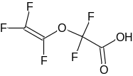  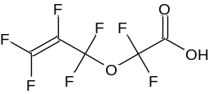
 | difluoro[(1,1,2,3,3-pentafluoroprop-2-en-1-yl)oxy]acetic acid | U-E-PFPeA | C₅HF₇O₃ | [M-H]– | 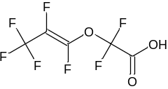
 | difluoro{[(1E)-1,2,3,3,3-pentafluoroprop-1-en-1-yl]oxy}acetic acid | U-E-PFHxA | C₆HF₉O₃ | [M-H]–
9d | 2,2,3,3,4,4-hexafluorobutanoic acid | H-PFBA | C₄H₂F₆O₂ | [M-H]– | 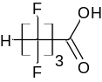
 | 2,2,3,3,4,4,5,5-octafluoropentanoic acid | H-PFPeA | C₅H₂F₈O₂ | [M-H]– | 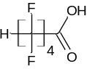
 | 2,2,3,3,4,4,5,5,6,6-decafluorohexanoic acid | H-PFHxA | C₆H₂F₁₀O₂ | [M-H]– | 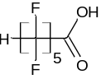
9e | (difluoromethoxy)di(fluoro)acetic acid | H-E-PFPrA | C₃H₂F₄O₃ | [M-H]– | 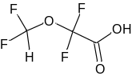
 | difluoro(1,1,2,2-tetrafluoroethoxy)acetic acid | H-E-PFBA | C₄H₂F₆O₃ | [M-H]– | 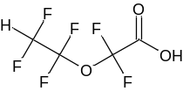
 | 3,3-difluoro-3-(trifluoromethoxy)propanoic acid | H₂-E-PFBA | C₄H₃F₅O₃ | [M-H]– | 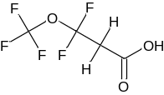
9f | difluoro(trifluoromethoxy)acetic acid | E- PFPrA | C₃HF₅O₃ | [M-H]– | 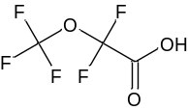
 | difluoro(pentafluoroethoxy)acetic acid | E- PFBA | C₄HF₇O₃ | [M-H]– | 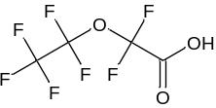
 | 2,2,3,3,4,4-hexafluoro-4-(trifluoromethoxy)butanoic acid | E- PFPeA | C₅HF₉O₃ | [M-H]– | 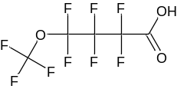
10a | difluoropropanedioic acid | PFdiCA(C3) | C₃H₂F₂O₄ | [M-H]– | 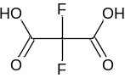
 | tetrafluorobutanedioic acid | PFdiCA(C4) | C₄H₂F₄O₄ | [M-H]– | 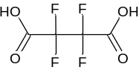
 | hexafluoropentanedioic acid | PFdiCA(C5) | C₅H₂F₆O₄ | [M-H]– | 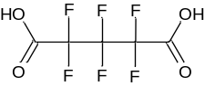
 | octafluorohexanedioic acid | PFdiCA(C6) | C₆H₂F₈O₄ | [M-H]– | 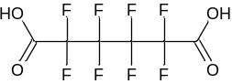
 | decafluoroheptanedioic acid | PFdiCA(C7) | C₇H₂F₁₀O₄ | [M-H]– | 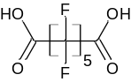
 | dodecafluorooctanedioic acid | PFdiCA(C8) | C₈H₂F₁₀O₄ | [M-H]– | 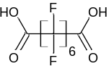
11a | trifluoromethanesulfonic acid | TFMS | CHF₃O₃S | [M-H]– | 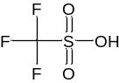
 | nonafluorobutane-1-sulfonic acid | PFBS | C₄HF₉O₃S | [M-H]– | 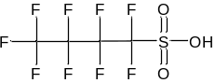
11b | 1,1,2,2-tetrafluoroethane-1-sulfonic acid | H-PFEtS | C₂H₂F₄O₃S | [M-H]– | 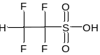
 | 1,1,2,2,3,3-hexafluoropropane-1-sulfonic acid | H-PFPrS | C₃H₂F₆O₃S | [M-H]– | 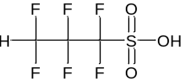
 | 1,1,2,2,3,3,4,4-octafluorobutane-1-sulfonic acid | H-PFBS | C₄H₂F₈O₃S | [M-H]– | 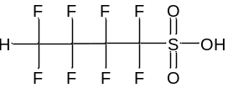
11c | 1,2,2-trifluoro-2-(1,2,2,2-tetrafluoroethoxy)ethane-1-sulfonic acid | H₂-E-PFPrS | C₃H₃F₅O₄S | [M-H]– | 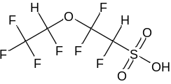
12 | nonafluorobutane-1-sulfinic acid | PFBSi | C₄HF₉O₂S | [M-H]– | 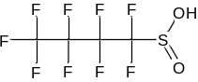

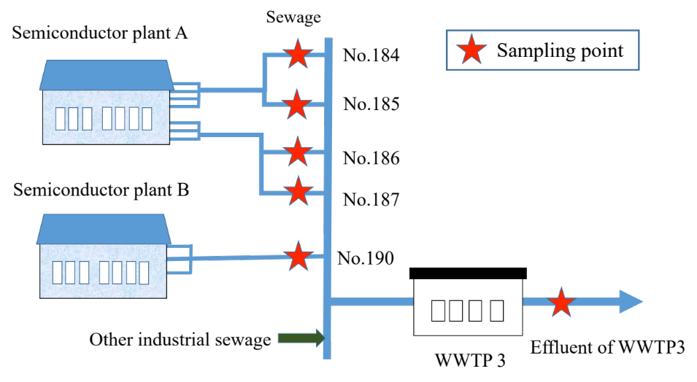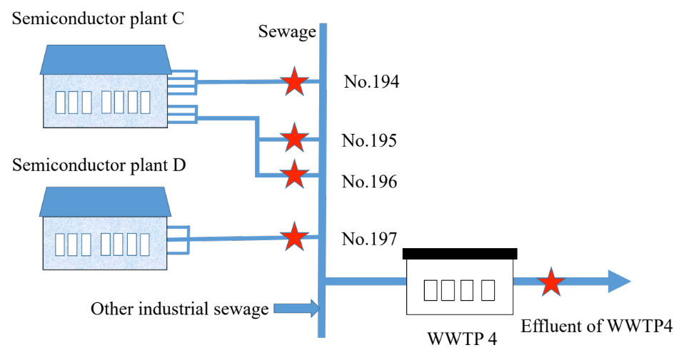
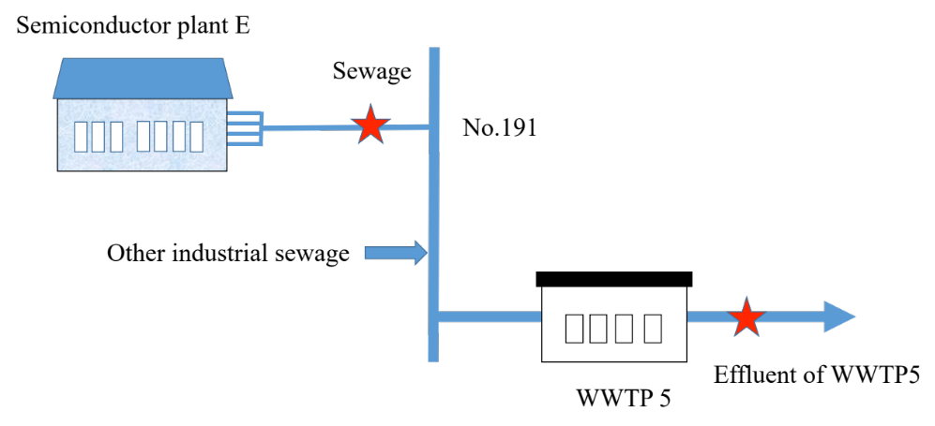
Figure S1 Illustrations include samples numbered 184-187, 190-191, and 194-197 from semiconductor plant pipes, as well as effluent samples WWTP3, WWTP4, and WWTP5 from individual wastewater treatment plants. Sewage was collected downstream of the factory before entering the main wastewater pipe, ensuring attribution to each factory's wastewater. Effluents were collected at discharge points of the wastewater treatment plants, all utilizing the activated sludge process. The maximum discharge capacities (m³/day, CMD) for samples 184, 185, 186, and 187 of Plant A are 4200, 4200, 3475, and 3475 CMD, respectively. Sample 190 from Plant B has a maximum discharge capacity of 9654 CMD. For samples 194, 195, and 196 of Plant C, the maximum discharge capacities are 9519, 4691, and 4691 CMD. Samples 197 from Plant D and 190 from Plant E have maximum discharge capacities of 29,955 and 15,753 CMD, respectively. The maximum discharge capacities for the effluents of WWTP3, WWTP4, and WWTP5 are 16542, 145000, and 24000 CMD. For calculation for the combination of multiple sewage samples from semiconductor plants, the concentration of each sewage was multiplied by the maximum capacity and then divided by the total maximum capacity to determine the concentration to the sewage in the plant. For instance, the concentrations of samples no. 184, no. 185, no. 186 and no. 187 were individually multiplied by their corresponding wastewater maximum capacity and then normalized by the total flow capacity to obtain the final concentration for semiconductor plant A

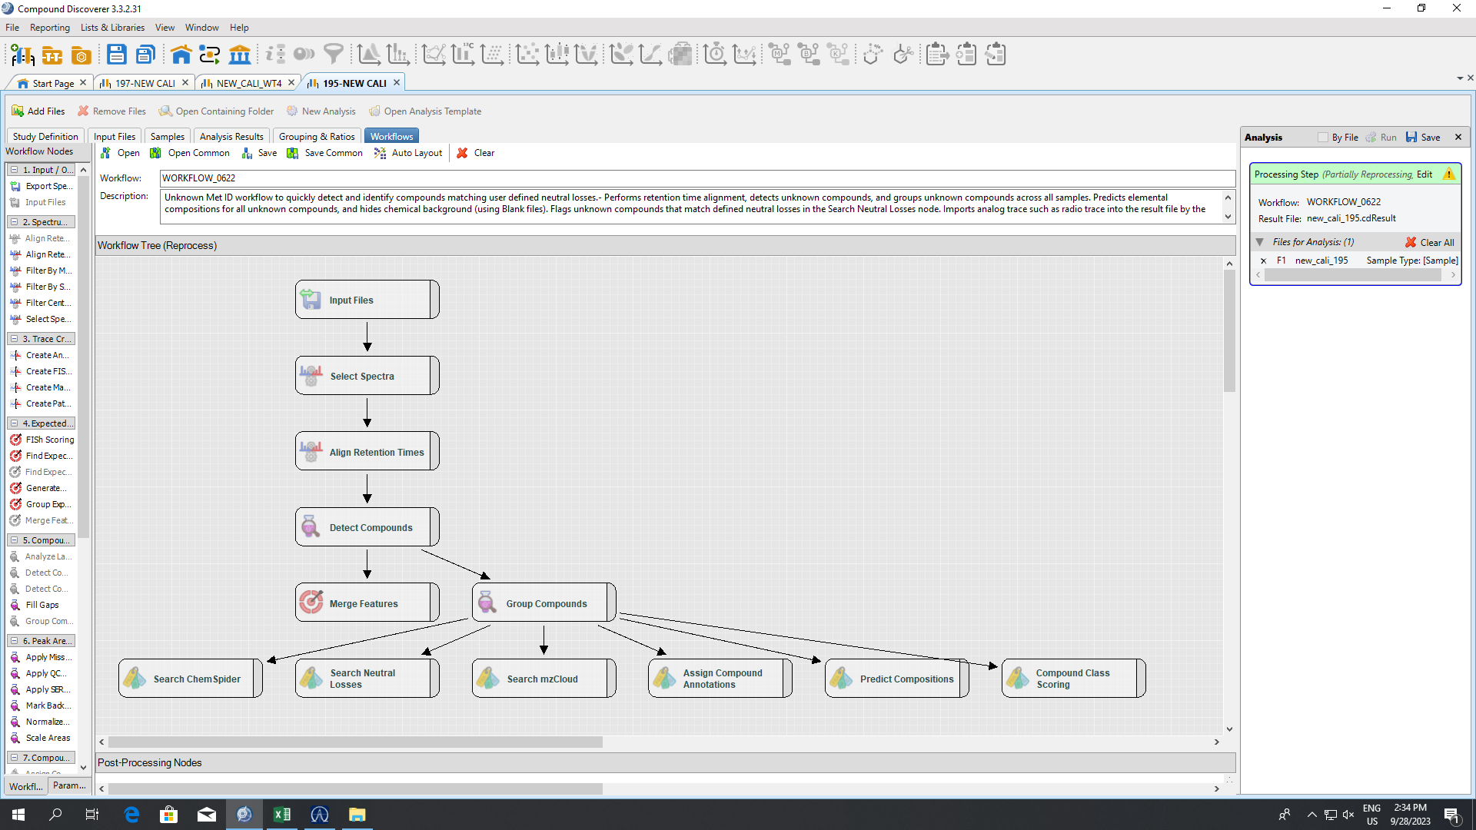
Figure S2 The nontarget analysis workflow in Compound Discoverer 3.3 software outlines key data processing nodes, including Input Files, Select Spectra, Detect Compounds, and Group Compounds. It involves unknown peak identification, integration of information from multiple raw data files, and annotation of unknown compounds in MS1 and MS2 spectral data using various nodes such as Search ChemSpider, Search Neutral Losses, Compound Class Scoring, Search mzCloud, Assign Compound Annotations, and Predict Compositions. The Search Neutral Losses node (MS2) and Compound Class Scoring node (MS2) were used for neutral loss and fragment searching, respectively.

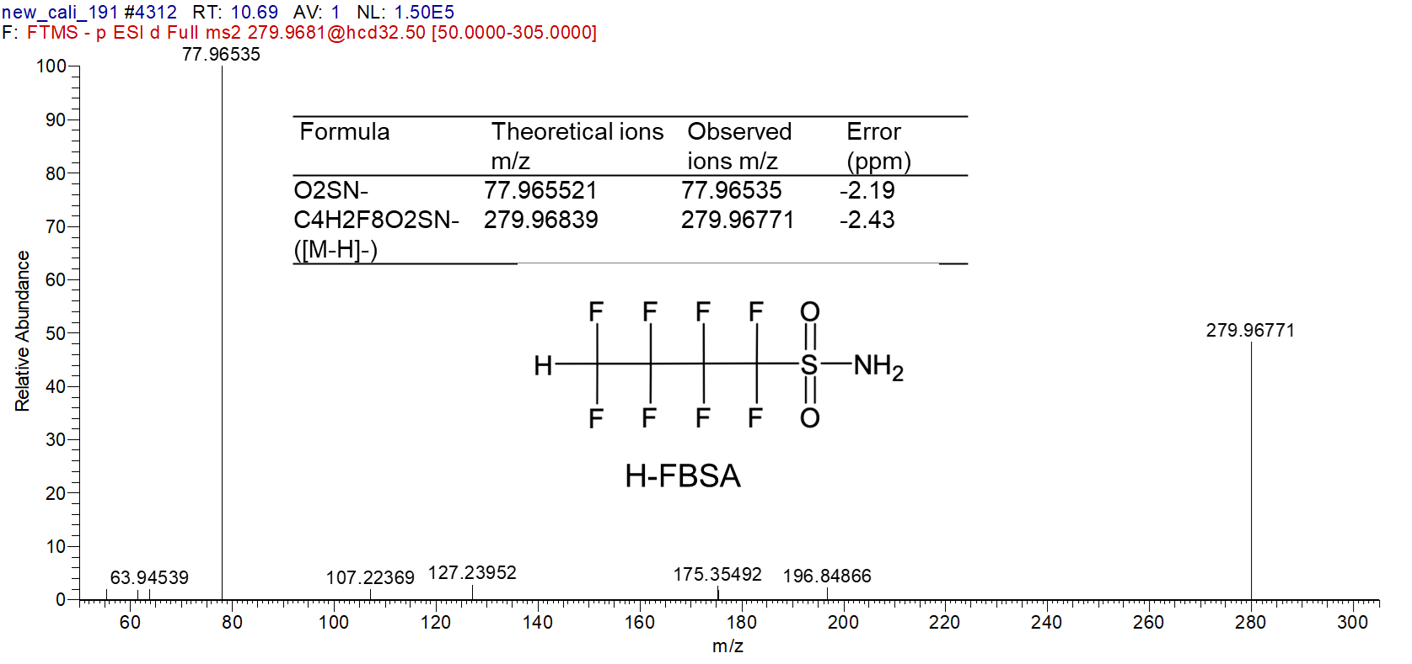
Figure S3 MS2 spectra of H-FBSA.

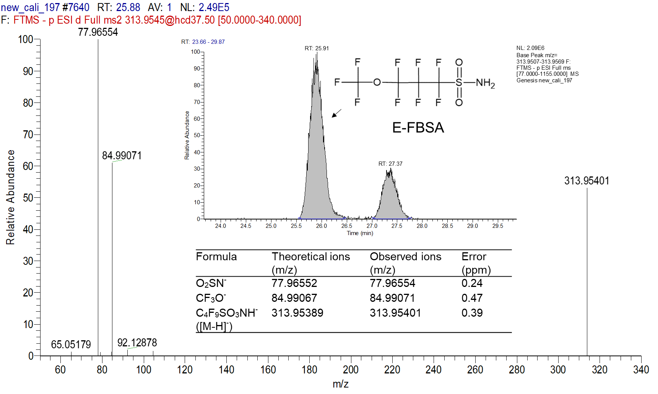
Figure S4a MS2 spectrum of one of the structural isomers of E-FBSA(1). The unique fragmentation of CF₃O⁻ was identified and led to the proposal of the structures of isomers at confidence level 2b.

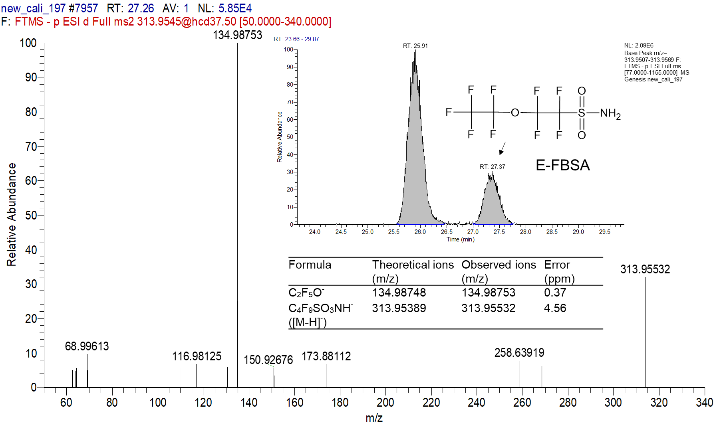
Figure S4b MS2 spectrum of the structural isomer of E-FBSA(2). The unique fragmentation of C₂F₅O⁻ was identified and led to the proposal of the structures of isomers at confidence level 2b. The greater retention time (RT 27.37 min) of E-FBSA was indicative of the increased symmetry of the alkyl structure, which matched the proposed structure.
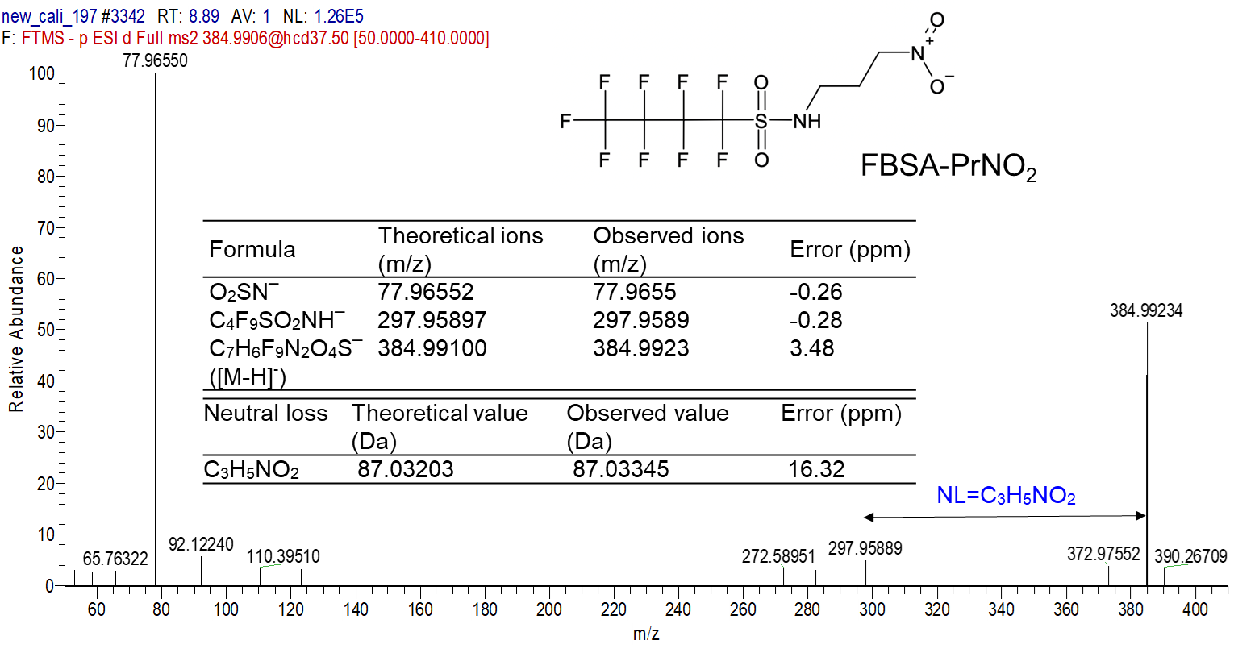
Figure S5 MS2 spectrum of the structural isomer of FBSA-PrNO₂. The unique fragment of SO₂N– and neutral loss of C3H5NO2 was identified and led to the proposal of the structures of isomers at confidence level 3a.
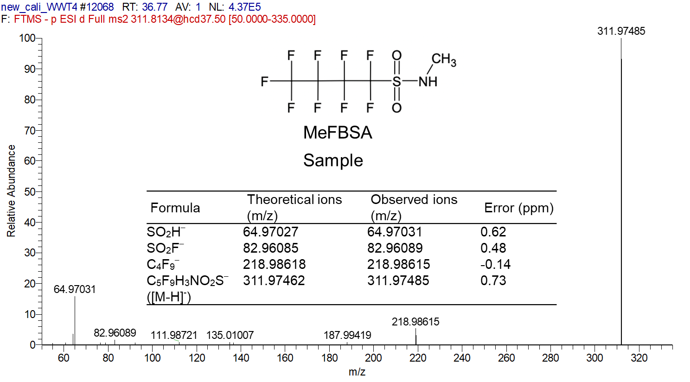
Figure S6a MS2 spectra of MeFBSA from sample WWTP4

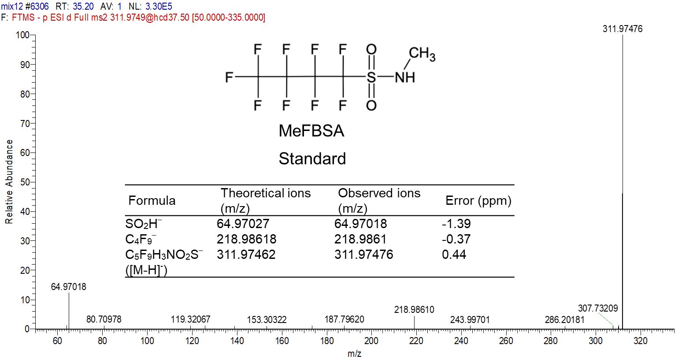
Figure S6b MS2 spectra of MeFBSA from authentic standard.
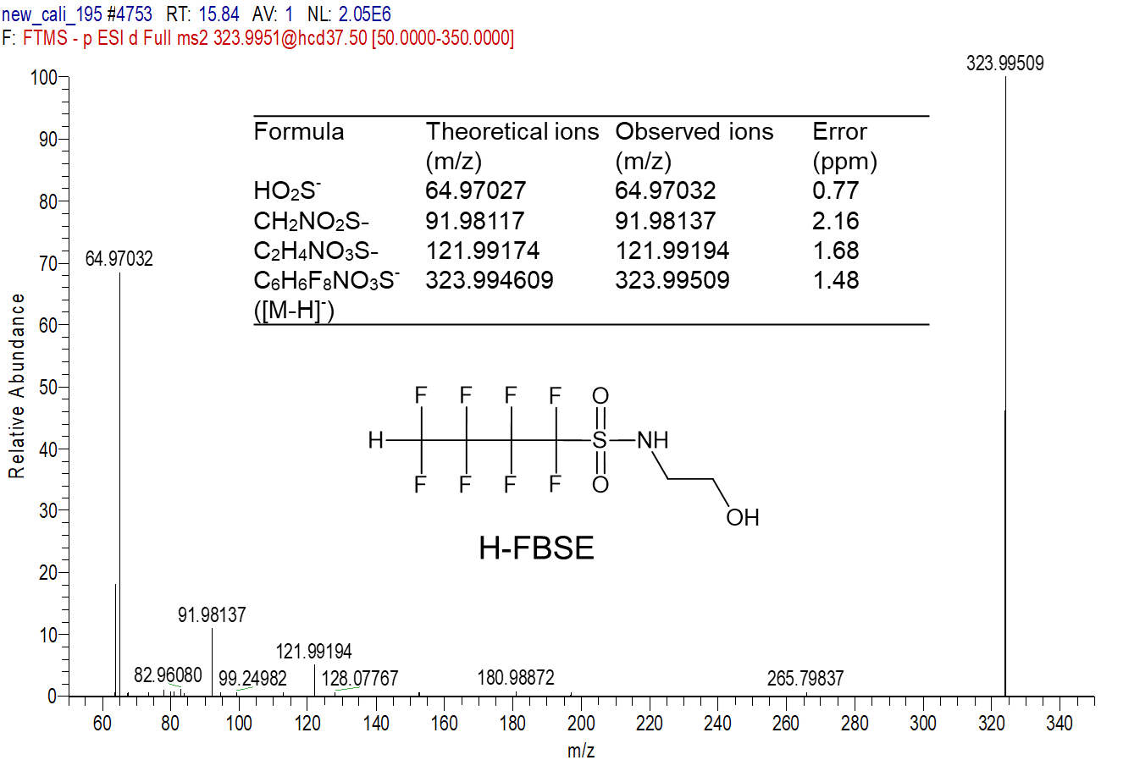
Figure S7 MS2 spectra of H-FBSE. Due to the uncertainty of the position of hydrogen, the CL was set to 3a.
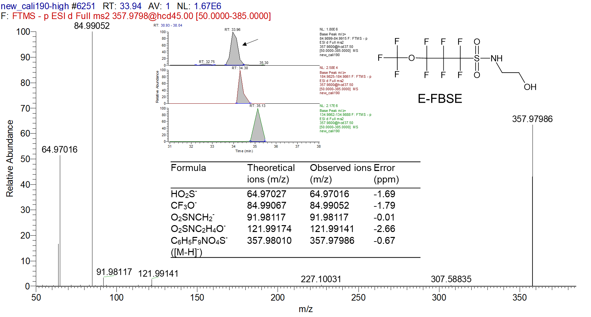
Figure S8a MS2 spectra from one of structural isomers of E-FBSE(1).
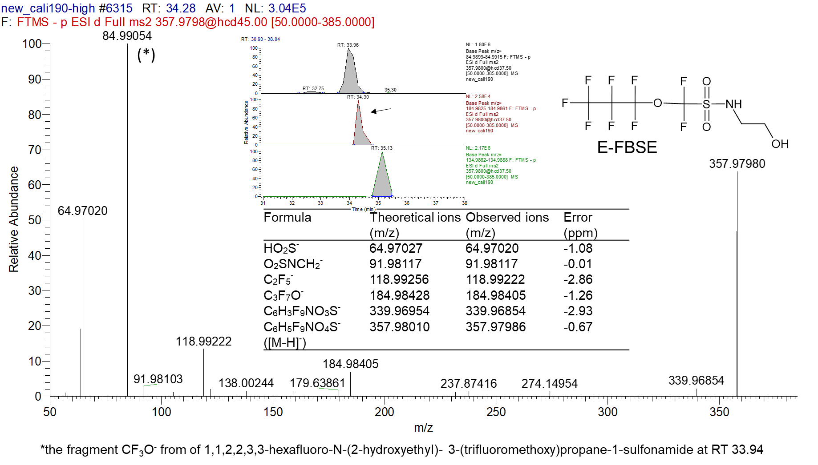
Figure S8b MS2 spectra of one of structural isomers of E-FBSE(2).
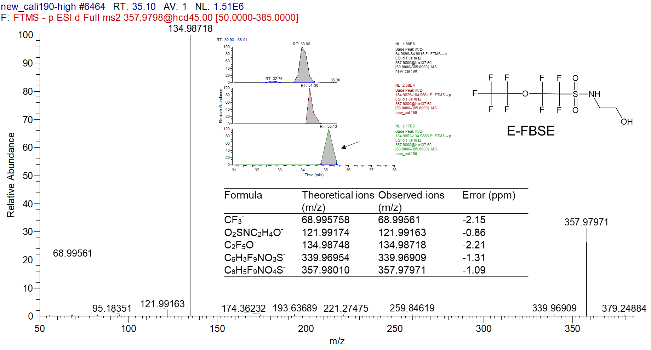

Figure S8c MS2 spectra of one of structural isomers of E-FBSE(3).
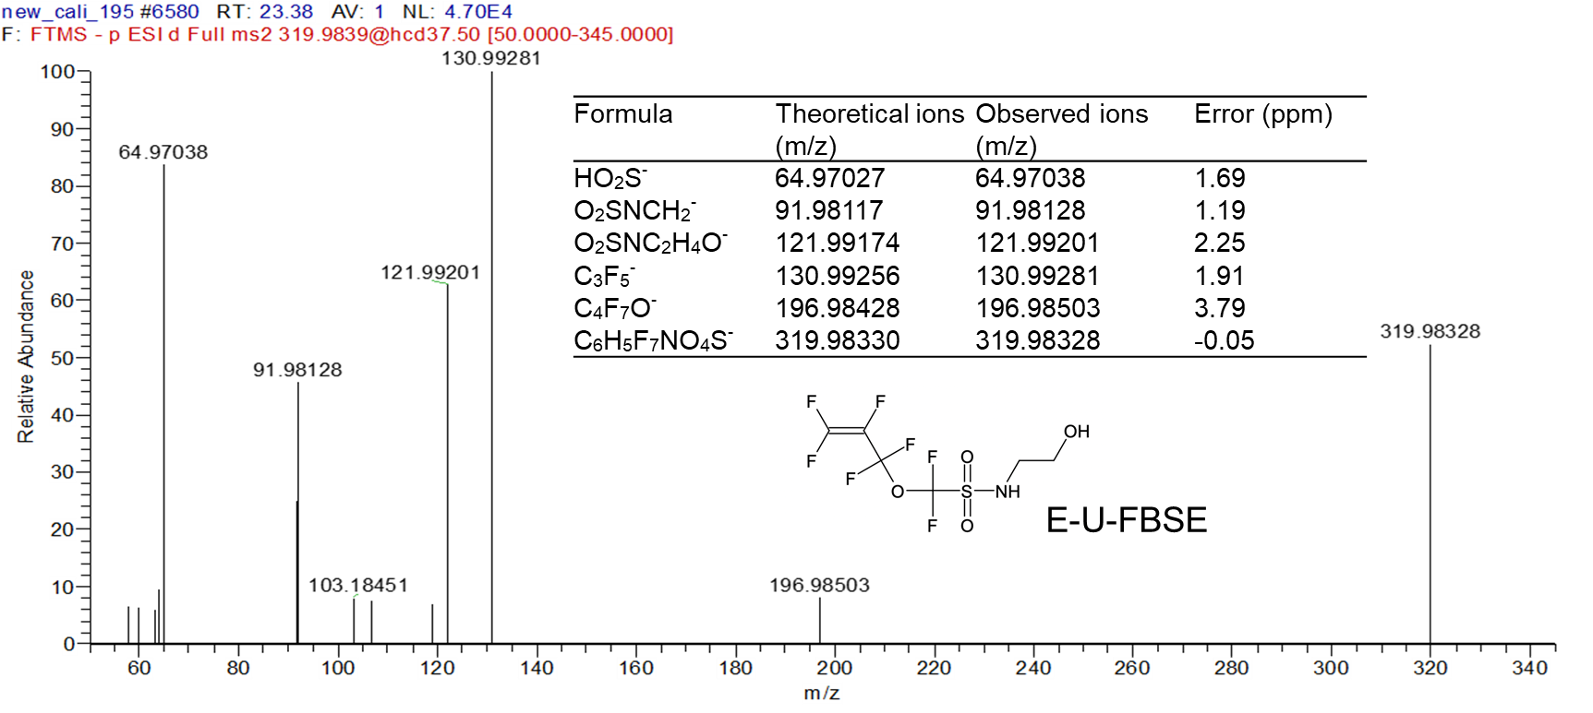
Figure S9 MS2 spectra of E-U-FBSE
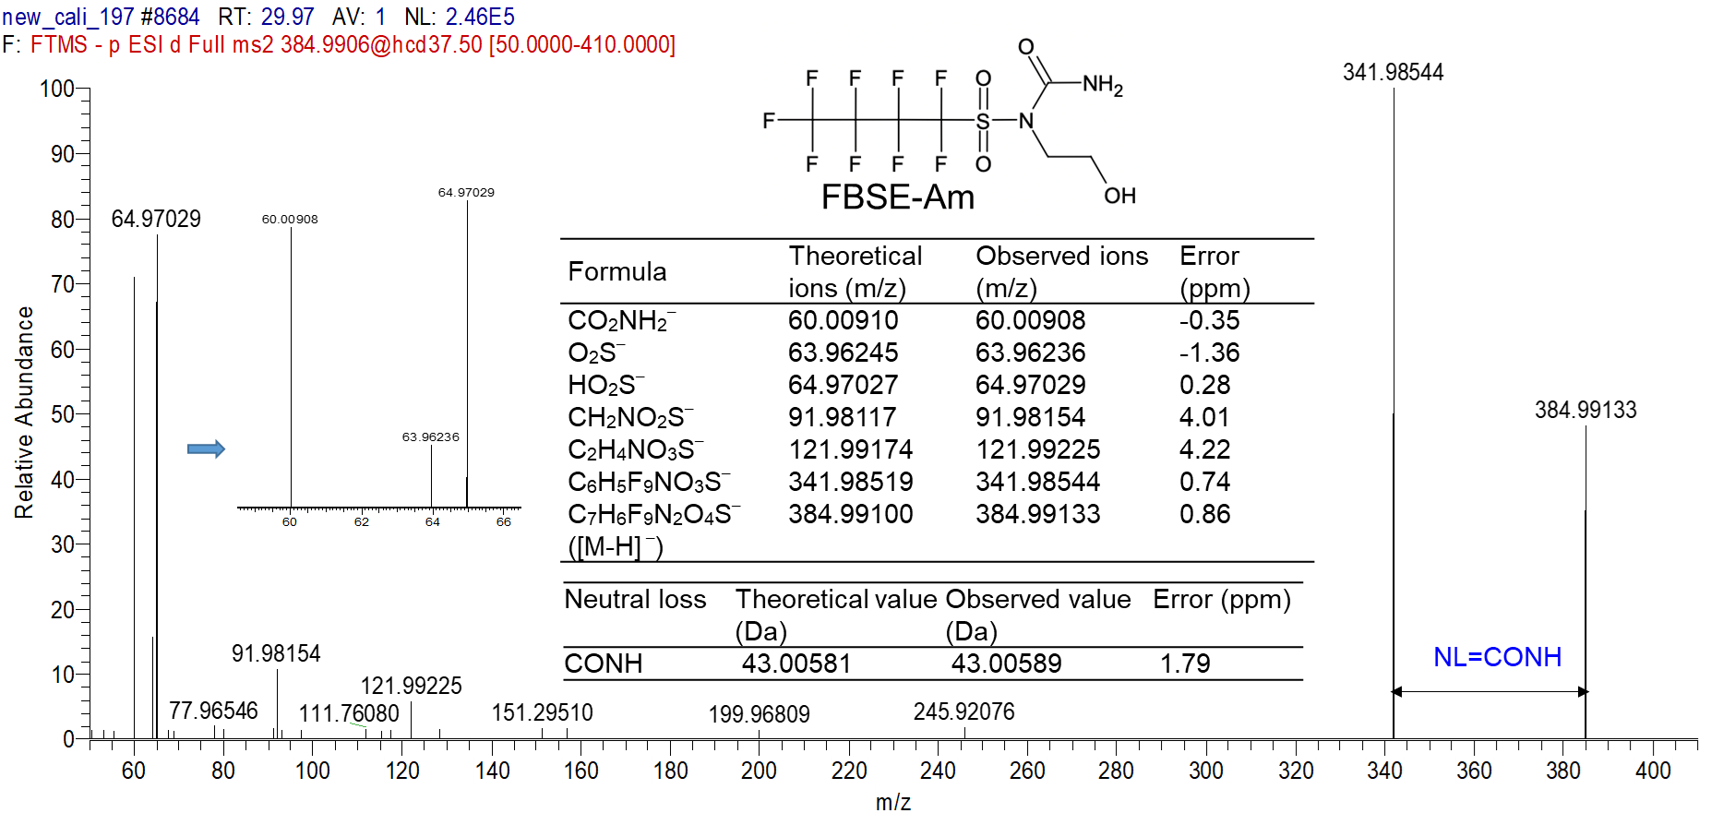
Figure S10 MS2 spectra of FBSE-Am

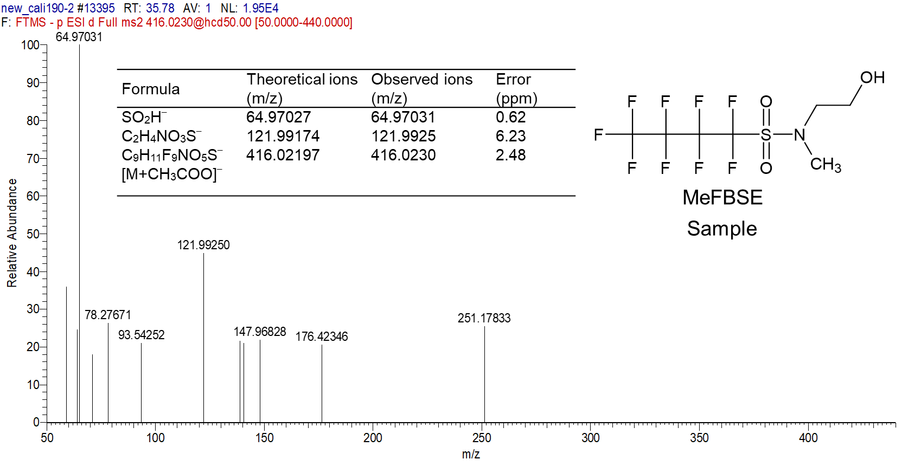
Figure S11a MS2 spectra of MeFBSE from sample no.190

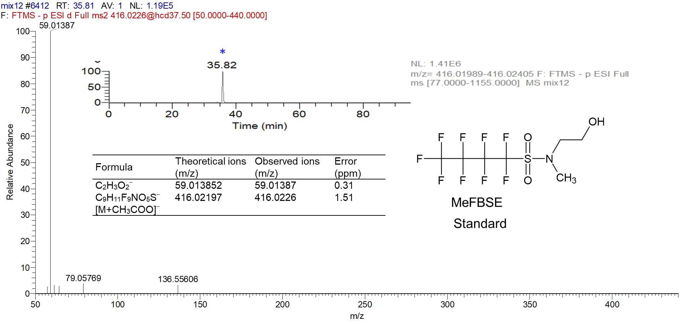
Figure S11b MS2 spectra of MeFBSE from authentic standard

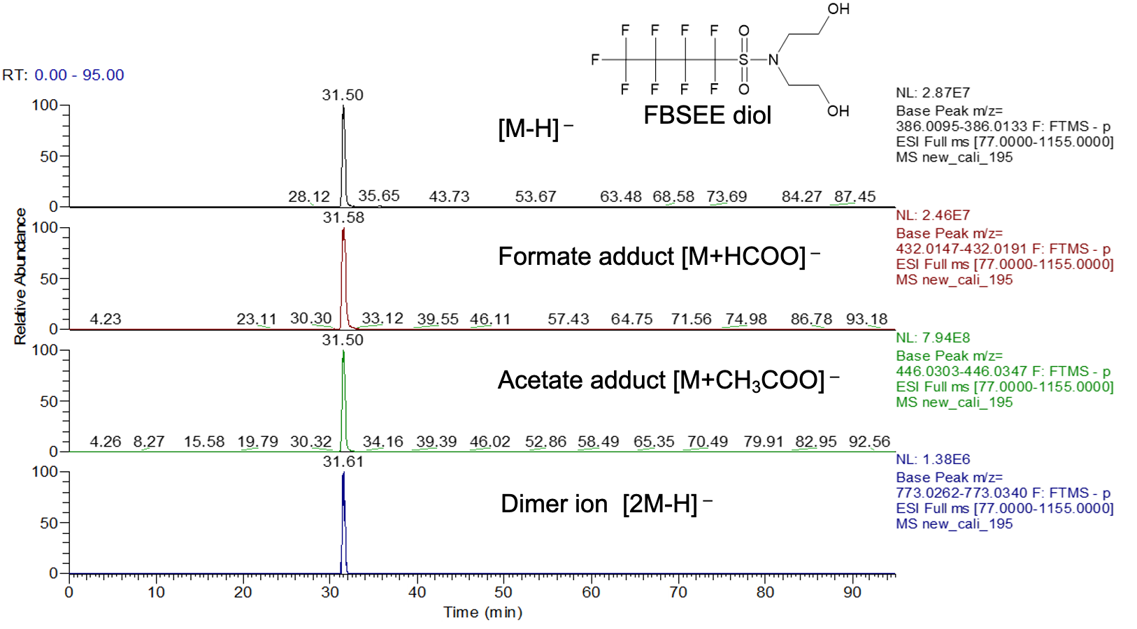
Figure S12 The observations of four adduct ion of FBSEE diol.
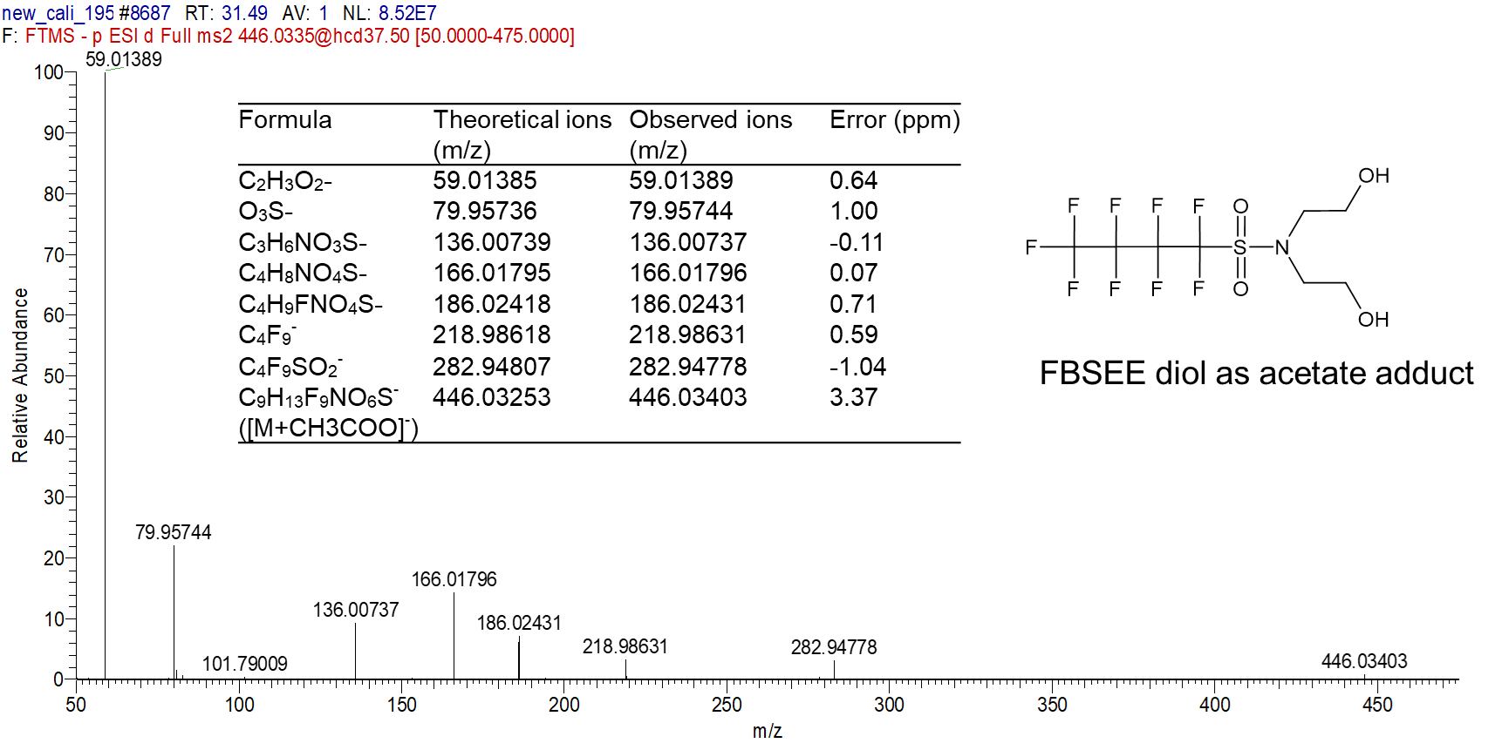
Figure S13a MS2 spectra of FBSEE diol as acetate adduct
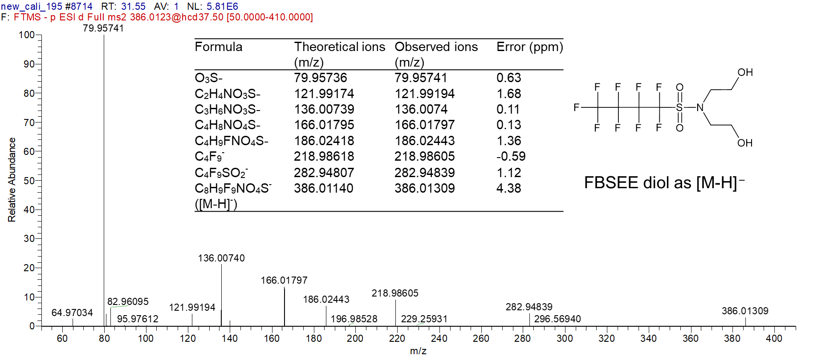
Figure S13b MS2 spectra of FBSEE diol was observed as [M-H]–

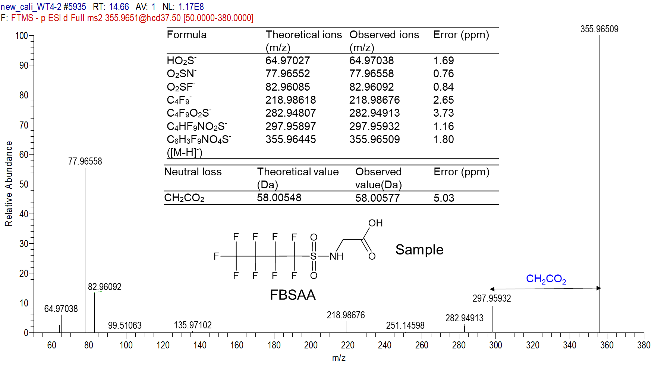
Figure S14a MS2 spectra of FBSAA from sample no. WWTP4
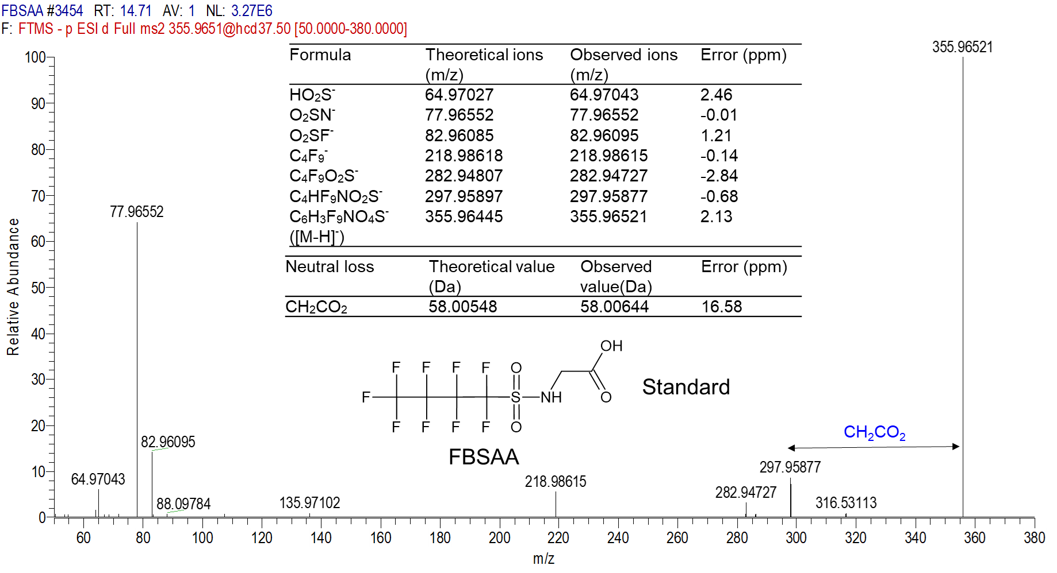
Figure S14b MS2 spectra of FBSAA from authentic standard.

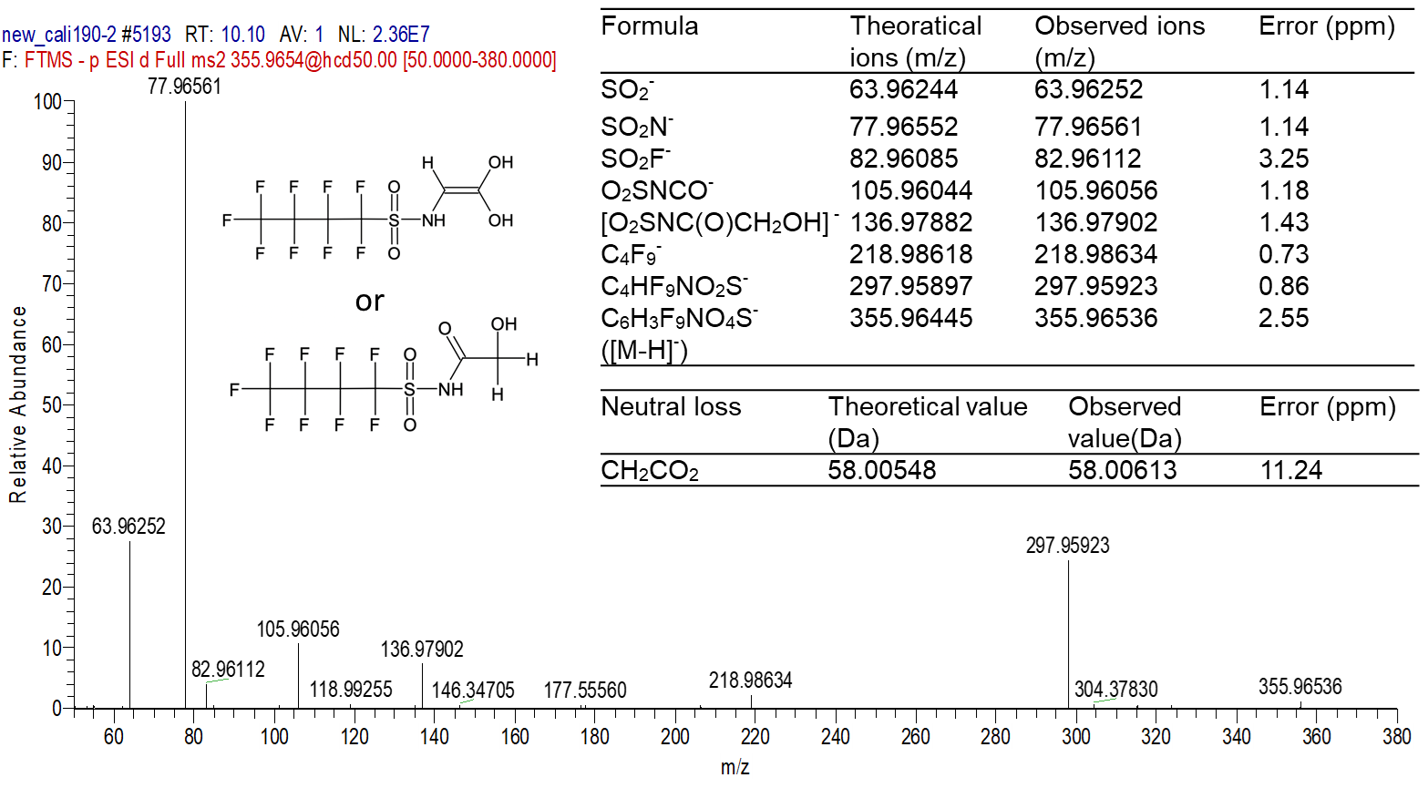
Figure S14b MS2 spectra of a isomer of FBSAA at RT 10.10 min

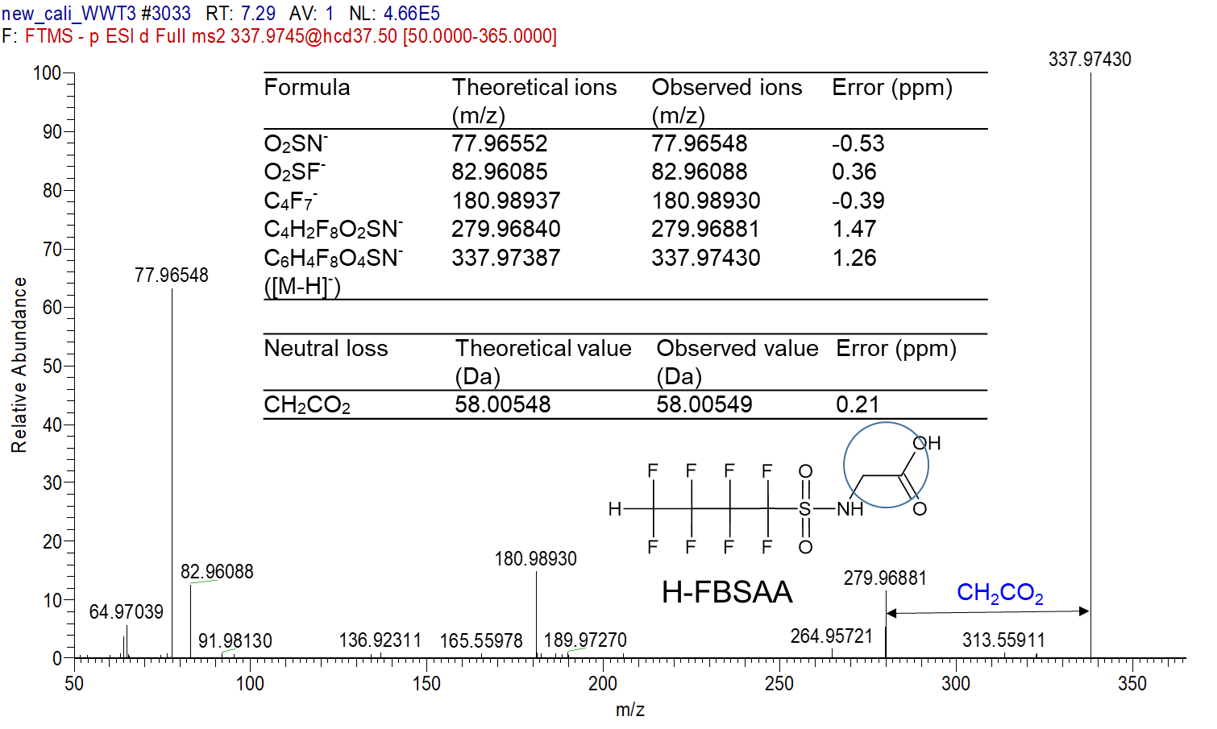
Figure S15 MS2 spectrum of H-FBSAA from sample no. WWTP3. H-FASAAs was identified through the observation of neutral loss of CH₂CO₂ (0.21 ppm), and the molecular ion 337.97387 led to molecular formula C₆H₄F₈NO₄S⁻. Fragments C₄F₇⁻, SO₂N⁻, SO₂F⁻ and C₄H₂F₈O₂SN⁻were detected. The position of the hydrogen was not determined; thus, the structure was set to level 3 confidence. H-FBSAA is reported for the first time.
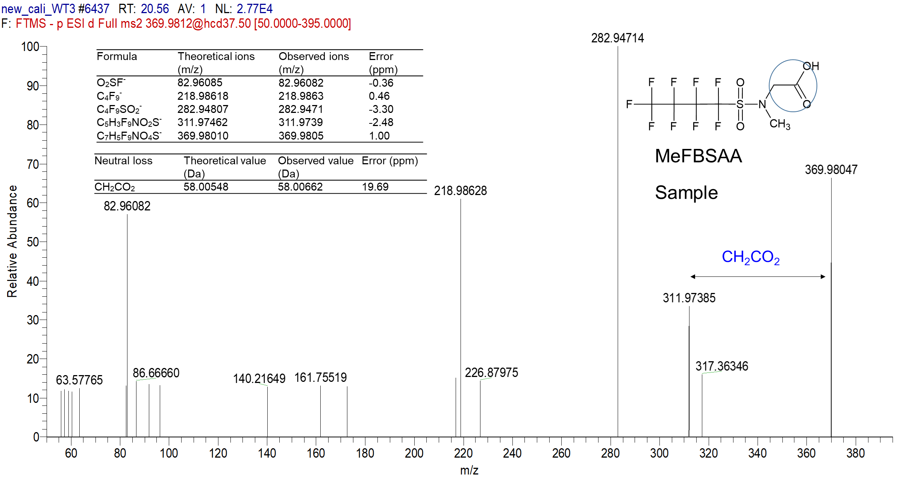
Figure S16a MS2 spectrum of MeFBSAA from sample no. WWTP3.

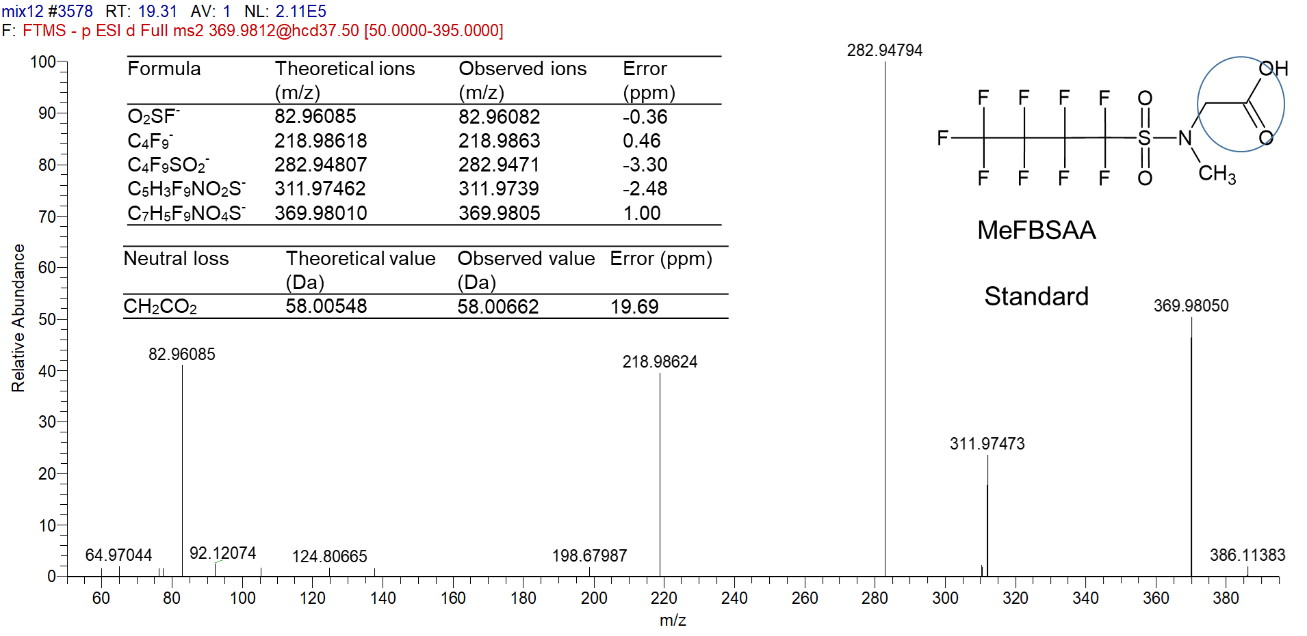
Figure S16b MS2 spectrum of MeFBSAA from authentic standard.

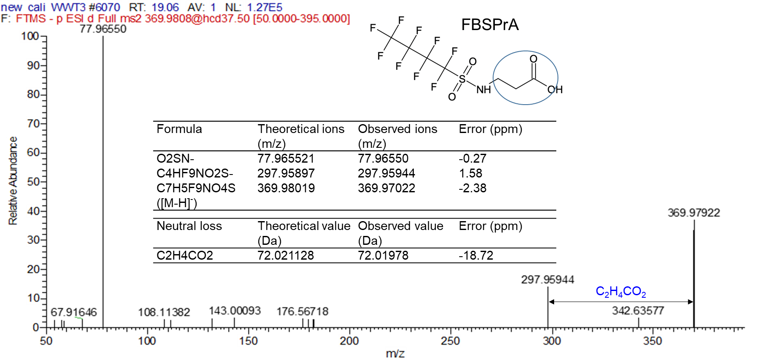
Figure S17 MS2 spectrum of FBSPrA from sample no. WWTP3.

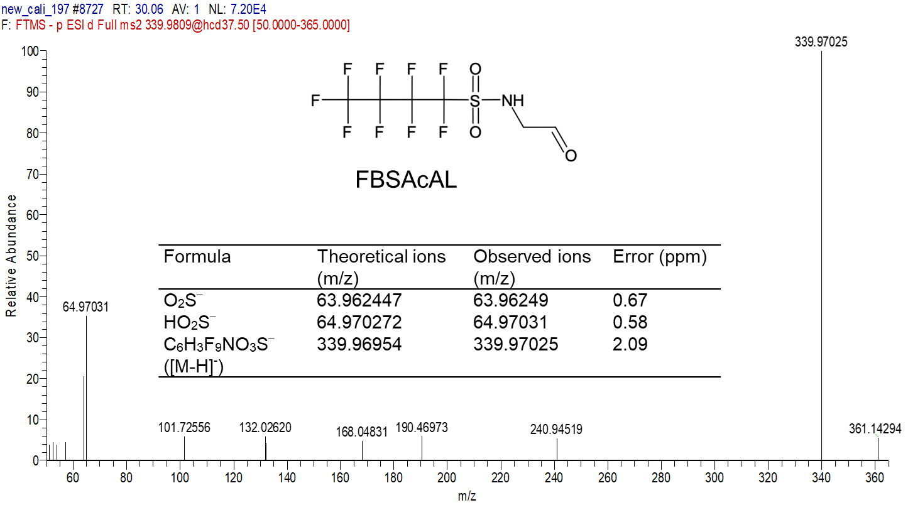
Figure S18 MS2 spectrum of FBSAcAL from sample no. 197.
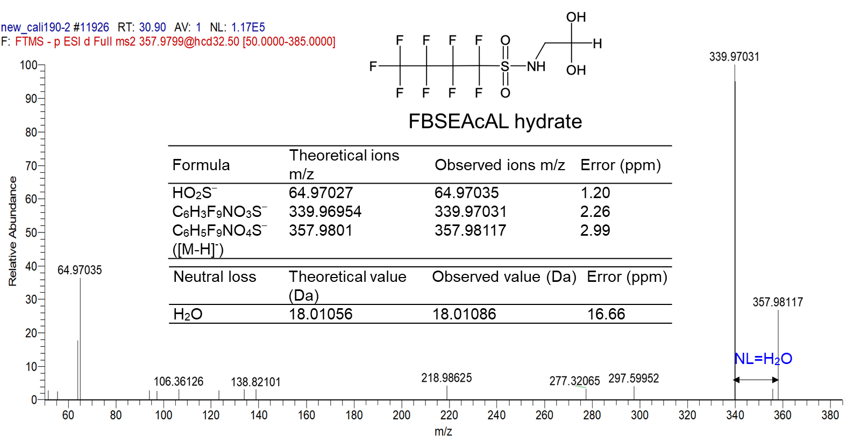
Figure S19 MS2 spectrum of FBSAcAL hydrate from sample no. 190
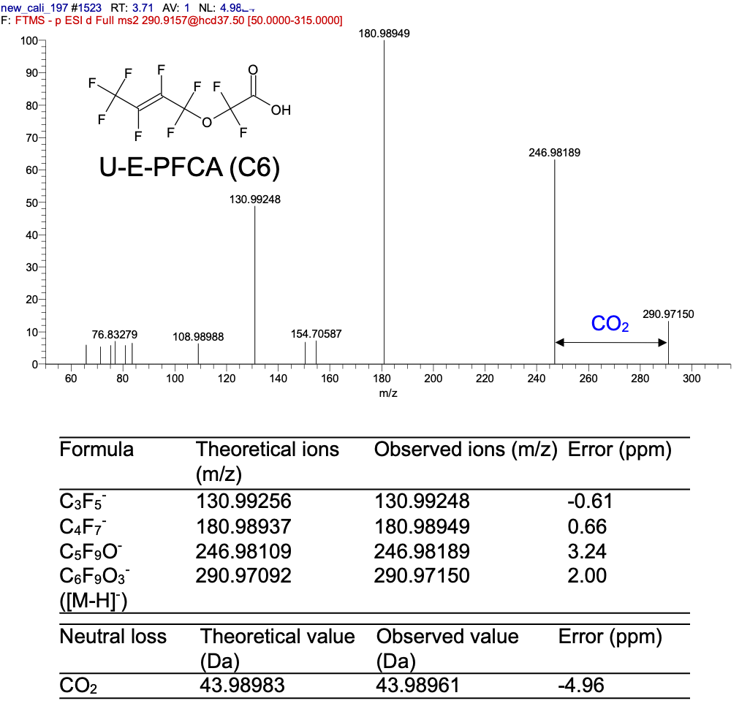
Figure S20 MS2 spectra of U-E-PFCA(C6)

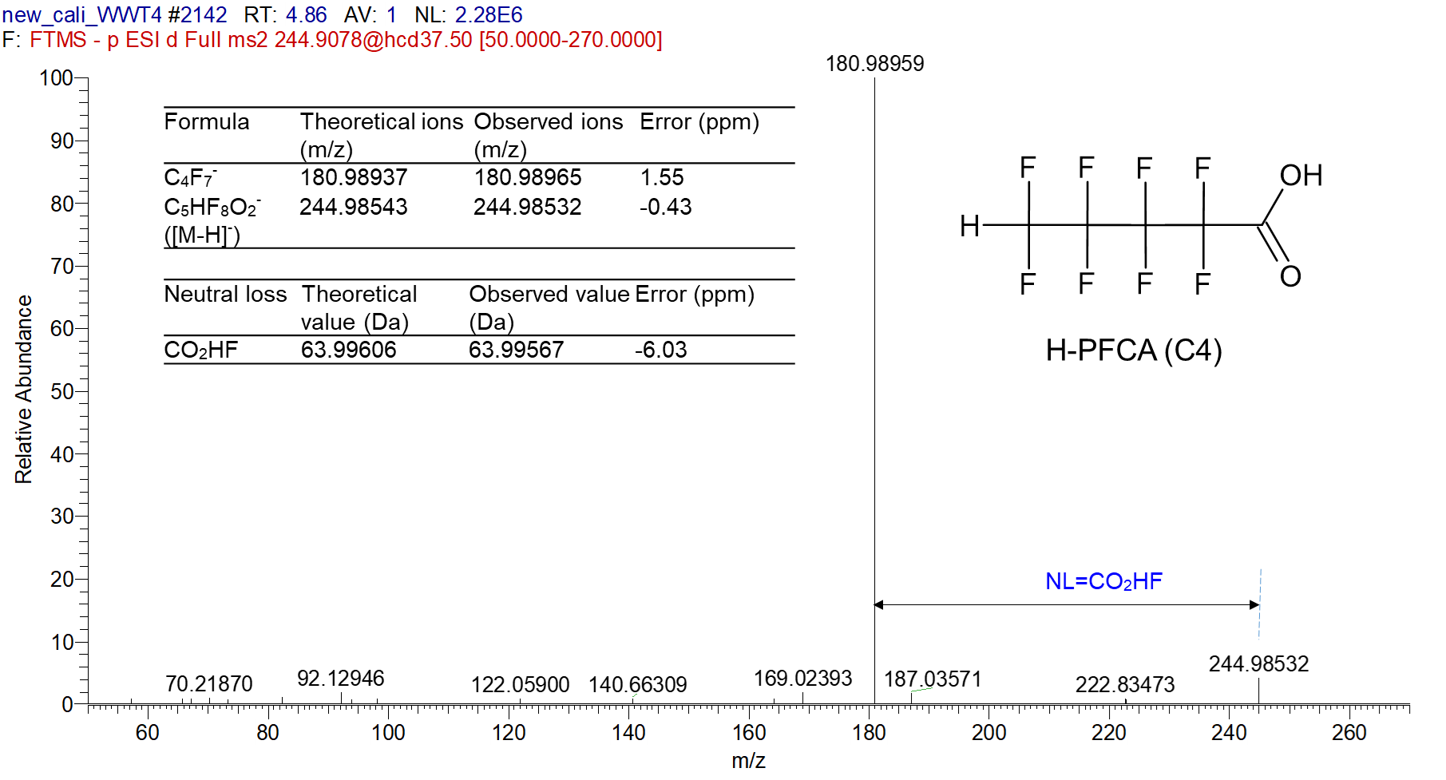
Figure S21 MS2 spectra of H-PFCA(C4). The confident level remained at 3a due to the uncertainty of H position.
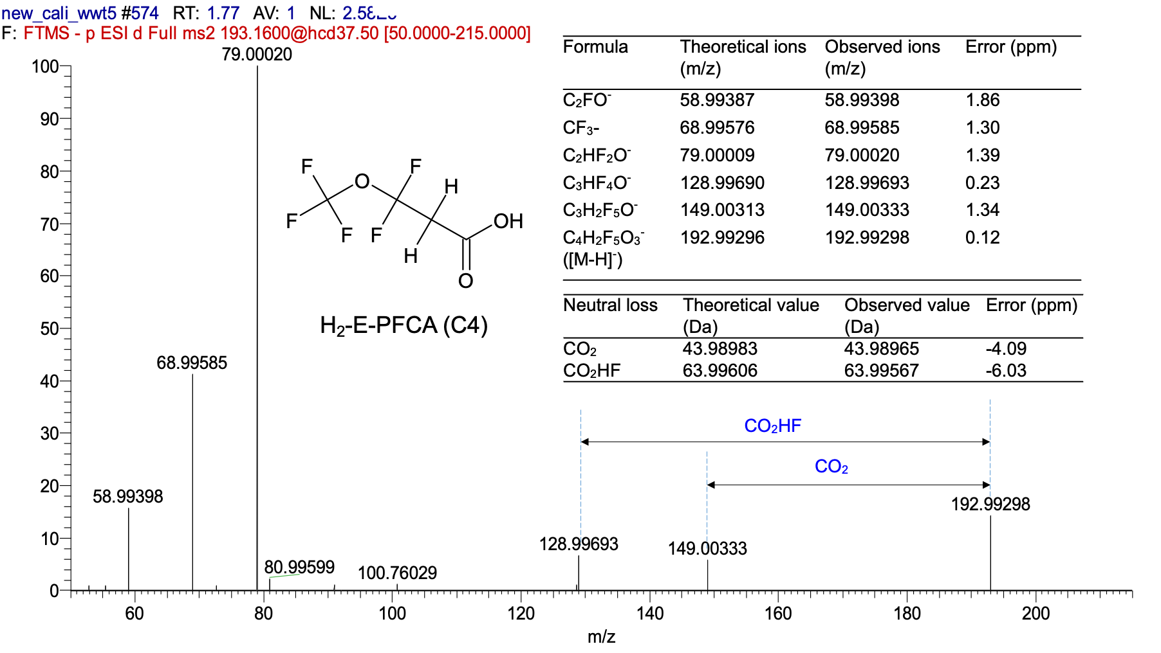
Figure S22 MS2 spectra of H₂-E-PFCA(C4)
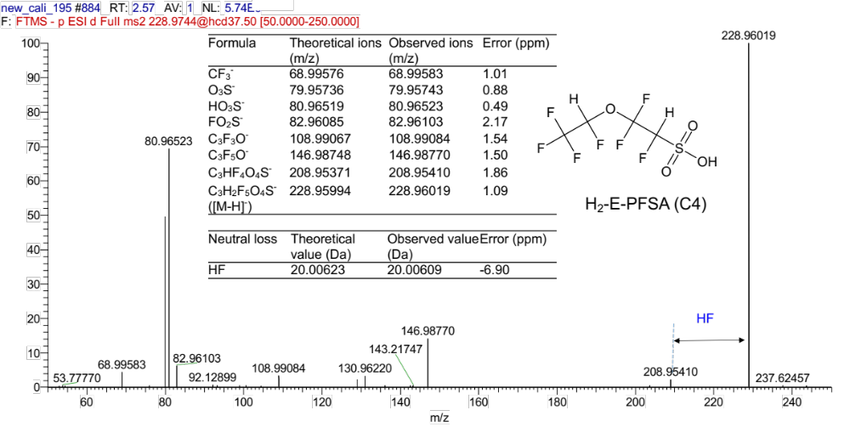
Figure S23 MS2 spectra of E-H₂-PFSA(C4) were identified with fragments SO₃H-, SO₃-, SO₂F-, CF₃-, C₃F₃O-, C₃F₅O- were detected. The substitution of F by hydrogen produce the neutral loss of HF. Due to the uncertainty of the position of H atom, it was set to level 3a

