Supporting Information for

Nanobarcodes with multidimensional optical information beyond diffraction limit
Shihui Wen^{1†}, Yongtao Liu^{1†}, Fan Wang¹, Gungun Lin¹, Jiajia Zhou¹, Bingyang Shi², Yung Doug Suh^{3,4}, Dayong Jin^{1,5}*
¹ Institute for Biomedical Materials & Devices (IBMD), Faculty of Science, University of Technology Sydney, Ultimo, NSW 2007, Australia
² Centre for Motor Neuron Disease Research, Department of Biomedical Sciences Faculty of Medicine and Health Sciences, Macquarie University, Sydney, NSW, 2109 Australia
³ Laboratory for Advanced Molecular Probing, Research Center for Bio Platform Technology, Korea Research Institute of Chemical Technology, Daejeon, South Korea
⁴ School of Chemical Engineering, SungKyunKwan University, Suwon 16419, South Korea
⁵ UTS-SUStech Joint Research Centre for Biomedical Materials & Devices, Southern University of Science and Technology, Shenzhen, Guangdong 518055, P. R. China
*Correspondence to: D. Jin (dayong.jin@uts.edu.au).
† These authors contributed equally to this work.

- Materials and Methods
1.1 Materials
YCl₃·6H₂O (99.99%), YbCl₃·6H₂O (99.99%), ErCl₃·6H₂O (99.99%), TmCl₃·6H₂O (99.99%), NH₄F (>98%), NaOH (>99.9%), KOH (99.9%), Oleic acid (OA, 90%), and 1-octadecene (ODE, 90%) were purchased from Sigma-Aldrich and used as received without further purification.

1.2 Methods

Synthesis of NaYF₄ core nanoparticles. NaYF₄ nanoparticles were synthesized through coprecipitation method. In a typical experiment, 2 mmol YCl₃ were added to a 100 mL flask containing oleic acid (OA, 12 mL) and 1-octadecene (ODE, 30 mL). The mixture was heated to 170 °C under argon for 30 min to obtain a clear solution and then cooled down to about 50 ^{O}C, followed by the addition of 10 mL methanol solution of NH₄F (8 mmol) and NaOH (5 mmol). After stirring for 30 min, the solution was heated to 80 °C under argon for 20 min to remove methanol, and then the solution was further heated to 310 °C for another 90 min. Finally, the reaction solution was cooled down to room temperature, and nanoparticles were precipitated by ethanol and washed with cyclohexane, ethanol and methanol for 3 times to get the NaYF₄ core nanoparticles.
Synthesis of NaYF₄ nanorods. NaYF₄ nanorods was synthesized by longitudinal growth of NaYF₄ shell precursors onto the NaYF₄ core nanoparticles via a successive layer-by-layer hot-injection protocol. Firstly, shell precursors were prepared. 1.5 mmol YCl₃ were added to a 50 mL flask containing 6 mL OA and 15 mL ODE. The mixture was heated to 170 °C under argon for 30 min to obtain a clear solution and then cooled down to about 50 °C , followed by the addition of 12 mL methanol solution of NH₄F (6.0 mmol), NaOH (3.75 mmol) and KOH (3 mmol). After stirring for 30 min, the solution was heated to 80 °C under argon for 30 min to remove methanol, and then the solution was further heated to 150 °C for another 20 min. Finally, the reaction solution was cooled down to room temperature and labelled as NaYF₄ shell precursors.
For the longitudinal growth, 0.2 mmol NaYF₄ core particles were added to a 50 mL flask containing 3.6 mL OA, 9.2 mL ODE, and 40 mg NaOH. The mixture was heated to 170 °C under argon for 30 min, and then the solution was further heated to 310 °C . After that, 0.04 mL of NaYF₄ shell precursors were injected into the reaction mixture and ripened at 310 °C for 1 min followed by the same injection and ripening cycles for different times to get the nanorods with different length. Finally, the reaction solution was cooled down to room temperature and the formed nanorods were purified according to the procedures used for the purification of NaYF₄ core particles.
Characterization Techniques. The morphology of the formed materials was characterized via transmission electron microscopy (TEM) imaging (Philips CM10 TEM with Olympus Sis Megaview G2 Digital Camera) with an operating voltage of 100 kV. The samples were prepared by placing a drop of a dilute suspension of nanocrystals onto copper grids. High-angle annular dark-field (HAADF) scanning transmission electron microscope (STEM) images and corresponding element mapping images were collected with an Talos F200X S/TEM (Thermo Scientific™).
The optical characterization was performed on a commercial microscope (Olympus IX73) equipped with a 3-axis closed loop piezo stage (Nano Nano-LP Series, Mad city labs) and free space design of optics. A schematic drawing of the experimental setup was presented in Scheme S1. A single-mode fiber-coupled 980 nm diode laser (BL976-PAG900, controller CLD1015, Thorlabs; maximum output power 900 mW) was used as the excitation source. After collimation, the excitation beam was transmitted through the first half wave plate (HWP, WPH05M-980, Thorlabs) and polarized beam splitter (PBS, CCM1-PBS252/M, Thorlabs). This allowed precisely adjusting the excitation power by rotating HWP electronically. The vortex phase plate was used to generate a doughnut-shaped point spread function (PSF) at the focal plane. A 4f optical system (L3 and L5) was used to transfer the image plane into the back aperture of the objective lens. The purpose of the second HWP was to control the polarization of excitation beam. After further improving the polarization ratio by a glan Taylor (DGL10, Double Glan-Taylor Polarizer, Thorlabs), the excitation beam was transmitted through a long-pass dichroic mirror (ZT915lpxr, Chroma), then reflected by a second short-pass dichroic mirror (T750spxrxt, Chroma), and focused through a high numerical aperture objective (UPlanSApo, 100×/1.40 oil, Olympus) to the sample slide. The long-pass dichroic mirror was used to combine the 980 nm beam with the 808 nm excitation beam from a polarization-maintaining fiber-coupled diode laser (LU0808M250, 808nm Single Mode Laser Module, Lumics). Another 808 nm excitation laser shared similar beam path as that for the 980 nm laser, in relation to the control of its power and polarization. The quarter-wave plate (QWP, WPQ05M-980/808, Thorlabs) was adopted to transform the excitation beam from linear polarization to circular polarization to obtain optical super-resolution images. Photoluminescence signal from the sample was collected by the same objective, then directed to the detection unit by the second dichroic mirror. Before being coupled into a multi-mode fiber (MMF, M24L02, Thorlabs) for detection, the emission signals went through either a bandpass (BPF, ET805/20M, ET670/50M, ET460/50M, Chroma) or a short pass filter (SPF, FF01-842/SP-25/ FF01-750/SP-25, Semrock) to completely remove the excitation light. A single-photon counting avalanche photodiode (APD, SPCM-AQRH-14-FC, Excelitas) was used for (time-gated) detection, controlled by a Labview program. The MMF could also be connected to a spectrometer (Shamrock 193i Spectrograph, Andor) equipped with an EMCCD detector (iXon Ultra, Andor). Each scanning step was set as 10 nm and pixel dwell times were adjusted to be 3 ms.
To prepare a sample slide, a cover slip was washed with pure ethanol and then Milli-Q water under ultrasonication. 10 μL of the upconversion nanobarcodes (diluted to 0.01 mg/mL in cyclohexane) were dropped onto the surface, which was immediately washed with 500μL cyclohexane twice for optimizing the particle concentration on the slip. After being air-dried, the cover slip was put over a clean glass slide.

- Supplementary Text

2.1 Section I: Calculation the growth rates on different facets of the nanocrystals (Fig. S1-3).
According to our recent report ¹, surfactant ligands of oleic acid molecules (OAH) and oleic cations (OA⁻) preferably bond onto the (001) and (100)/(010) facets of a β-NaYF₄ nanocrystal, respectively. The dynamic roles of OAH and OA⁻ surfactant molecules depend strongly on their synthesis environments and binding strength to the rare earth ions (precursor). The surfactant of OAH has a relatively weak binding energy onto the (001) facet. When the environment becomes unstable, e.g. at increased temperature, OAH will be detached from rare earth ions so that new occupancies will be created for new atoms to be grown into. The surfactant of OA⁻ cations, however, have much stronger binding strength to the rare earth ions and strongly anchor onto the (100)/(010) facets, and effectively terminate the continuous growth even at high temperature. Therefore, under these specific conditions, one-dimensional epitaxial growth should be well under control.
To make one-dimensional epitaxial growth under control, the crystals growth kinetics on different facets were first studied. We employed the layer-by-layer hot injection method, which could make the concentration of the shell precursor relatively consistent during the growth process, to systematically optimize the effect of the concentration of the shell precursors on the facet-selective growth behaviour.
Epitaxial growth with 1.465 μmol/mL NaYF₄ precursors (high concentration). For the longitudinal growth of NaYF₄ with high concentration of the precursors, 0.2 mmol NaYF₄ core particles were added to a 50 mL flask containing 3.6 mL OA, 9.2 mL ODE, and 40 mg NaOH. The mixture was heated to 170 °C under argon for 30 min, and then the solution was further heated to 310 °C . After that, 0.25 mL of NaYF₄ shell precursors were injected into the reaction mixture and ripened at 310 °C for 1 min followed by the same injection and ripening cycles for 16 times to get the nanorods. Finally, the reaction solution was cooled down to room temperature and the formed nanorods were purified according to the procedures used for the purification of NaYF₄ core particles. As shown in fig. S1b, apart from the formed nanorods, there are small nanoparticles formed by precursor self-nucleation. This indicates that the concentration of the precursor is too high to have the controlled epitaxial growth. Therefore, we reduced the precursor concentration to get uniform nanocrystals.
Epitaxial growth with 0.732 μmol/mL NaYF₄ precursors (medium concentration). For the longitudinal growth of NaYF₄ with medium concentration of the precursors, 0.2 mmol NaYF₄ core particles were added to a 50 mL flask containing 3.6 mL OA, 9.2 mL ODE, and 40 mg NaOH. The mixture was heated to 170 °C under argon for 30 min, and then the solution was further heated to 310 °C . After that, 0.125 mL of NaYF₄ shell precursors were injected into the reaction mixture and ripened at 310 °C for 1 min followed by the same injection and ripening cycles for 32 times. Finally, the formed nanorods were purified for TEM characterization. As shown in fig. S2, there were uniform nanorods formed with the medium concentration of the precursors. The length of the nanocrystals increased from 37 nm to 56 nm with injection cycles of 32 times. But, the width of the nanocrystals also increased from 37 nm to 42 nm at the same time. This result indicates that part of the shell precursor could not bind to the preferred (001) facet but grow on the non-preferred one (100/010 facets). Through the calculation, there was 5 nm growth in the transversal direction while there was 19 nm increase in the longitudinal direction. For β-NaYbF4 crystal, the hexagonal cylinder consists of the (001) facets at the ends and identical (100) and (010) facets around the cylinder sides. The Y³⁺ atoms form equilateral triangles with a length of 5.96 Å in the relaxed (001) surface (transversal direction), while rectangles are observed in the (100) and (010) surface with a shorter length of 3.53 Å (longitudinal direction). Therefore, the growth rate along the longitudinal direction is 1.68 atomic layers per min, while that for the transversal direction it is around 0.26 atomic layer per min under the medium precursor concentration.
To get the precise one-dimensional growth, it is better to reduce the amount of the available precursors equal or less than the needed for the (001) facets of the seed nanocrystals. 0.2 mmol NaYF₄ core particles is equal to 2.98x10¹⁴ 37-nm nanocrystals with the requirement of 0.003 mmol NaYF₄ shell precursor for one-layer growth at the (001) facets. As the volume of the reaction solution is around 12.8 mL, the concentration of the shell precursor should be around 0.235 μmol/mL.
Epitaxial growth with 0.235 μmol/mL NaYF₄ precursors (low concentration). For the longitudinal growth of NaYF₄ with low concentration of precursors, 0.2 mmol NaYF₄ core particles were added to a 50 mL flask containing 3.6 mL OA, 9.2 mL ODE, and 40 mg NaOH. The mixture was heated to 170 °C under argon for 30 min, and then the solution was further heated to 310 °C . After that, 0.04 mL of NaYF₄ shell precursors were injected into the reaction mixture and ripened at 310 °C for 1 min followed by the same injection and ripening cycles for 100 times. Finally, the formed nanorods were purified for TEM characterization. As shown in Fig. S3, there were uniform nanorods formed with the low concentration of the precursors. Also, the length of the nanocrystals increased from 37 nm to 72 nm with injection cycles of 100 times, while the width of the nanocrystals is still around 37 nm. Through the calculation, there was 35 nm increase in longitudinal direction with the growth rate around one atomic layer per min. This indicates that the lower shell precursor in the reaction solution makes the one-dimensional growth well in control with the assistant of optimized OA- concentration and reaction temperature. In this case, both the width (depend on the size of the seeds) and length (depend on the injection cycles) of the nanorods could be well in control.

2.2 Section II: One-dimensional growth of NaYF₄ and NaErF₄ onto the NaYF₄ core nanoparticles (Fig. S6).
Heterogeneous upconversion system was frequently employed to tune the emission and excitation wavelengths, the emission intensity and lifetime of the heterogeneous nanocrystals.^{2,3} Also, heterogeneous nanostructures are an idea platform to study the crystals growth behaviors. In this study, we choose Y and Er with significant difference in the atomic number to study the heterogeneous growth under one-dimensional control.
Synthesis of 10-segment NaYF₄-NaErF₄(5nm)-NaYF₄(5nm)-NaErF₄(5nm)-NaYF₄(5nm)-NaErF₄ (5nm). The longitudinal growth of NaYF₄ and NaErF₄ onto the NaYF₄ core nanorods was conducted via a successive layer-by-layer hot-injection protocol. Firstly, both NaYF₄ and NaErF₄ shell precursors were prepared. For NaErF₄ shell precursors preparation, 1.5 mmol ErCl₃ were added to a 50 mL flask containing 6 mL OA and 15 mL ODE. The mixture was heated to 170 °C under argon for 30 min to obtain a clear solution and then cooled down to about 50 ^{O}C, followed by the addition of 12 mL methanol solution of NH₄F (6.0 mmol), NaOH (3.75 mmol) and KOH (3 mmol). After stirring for 30 min, the solution was heated to 80 °C under argon for 30 min to remove methanol, and then the solution was further heated to 150 °C for another 20 min. Finally, the reaction solution was cooled down to room temperature and labelled as NaErF₄ shell precursors.
For the longitudinal growth, 0.2 mmol NaYF₄ core particles were added to a 50 mL flask containing 3.6 mL OA, 9.2 mL ODE, and 40 mg NaOH. The mixture was heated to 170 °C under argon for 30 min, and then the solution was further heated to 310 °C . After that, 0.04 mL of NaYF₄ shell precursors were injected into the reaction mixture and ripened at 310 °C for 1 min followed by the same injection and ripening cycles for 30 times. Then, 0.04 mL of NaErF₄ shell precursors were injected into the reaction mixture and ripened at 310 °C for 1 min followed by the same injection and ripening cycles for another 30 times to get the nanorods with one pairwise NaErF₄ segments. For the synthesis of five pairwise NaYF₄ and NaErF₄ segments (NaYF₄-NaErF₄-NaYF₄-NaErF₄-NaYF₄-NaErF₄) nanorods, the injection process was repeated twice. Finally, the reaction solution was cooled down to room temperature and the formed nanorods were purified according to the procedures used for the purification of NaYF₄ core particles. As shown in fig. S6a, each NaYF₄ and NaErF₄ segment is clearly observed in the high-angle annular dark-field scanning transmission electron microscopy (HAADF-STEM).
Synthesis of 10-segment NaYF₄-NaErF₄(10nm)-NaYF₄(5nm)-NaErF₄(10nm)-NaYF₄(5nm)-NaErF₄(10nm). 0.2 mmol NaYF₄ core particles were added to a 50 mL flask containing 3.6 mL OA, 9.2 mL ODE, and 40 mg NaOH. The mixture was heated to 170 °C under argon for 30 min, and then the solution was further heated to 310 °C. After that, 0.04 mL of NaYF₄ shell precursors were injected into the reaction mixture and ripened at 310 °C for 1 min followed by the same injection and ripening cycles for 30 times. Then, 0.04 mL of NaErF₄ shell precursors were injected into the reaction mixture and ripened at 310 °C for 1 min followed by the same injection and ripening cycles for another 60 times to get the nanorods with one pairwise NaErF₄ segments. For the synthesis of five pairwise NaYF₄ and NaErF₄ segments (NaYF₄-NaErF₄-NaYF₄-NaErF₄-NaYF₄-NaErF₄) nanorods, the injection process was repeated twice. Finally, the reaction solution was cooled down to room temperature and the formed nanorods were purified according to the procedures used for the purification of NaYF₄ core particles.
Synthesis of 18-segment NaYF₄-NaErF₄(5nm)-NaYF₄(5nm)-NaErF₄(5nm)-NaYF₄(5nm)-NaErF₄(5nm). 0.2 mmol NaYF₄ core particles were added to a 50 mL flask containing 3.6 mL OA, 9.2 mL ODE, and 40 mg NaOH. The mixture was heated to 170 °C under argon for 30 min, and then the solution was further heated to 310 °C. After that, 0.04 mL of NaYF₄ shell precursors were injected into the reaction mixture and ripened at 310 °C for 1 min followed by the same injection and ripening cycles for 30 times. Then, 0.04 mL of NaErF₄ shell precursors were injected into the reaction mixture and ripened at 310 °C for 1 min followed by the same injection and ripening cycles for another 30 times to get the nanorods with one pairwise NaErF₄ segments. For the synthesis of nine pairwise NaYF₄ and NaErF₄ segments (NaYF₄-NaErF₄-NaYF₄-NaErF₄-NaYF₄-NaErF₄-NaYF₄-NaErF₄-NaYF₄-NaErF₄) nanorods, the injection process was repeated four times. Finally, the reaction solution was cooled down to room temperature and the formed nanorods were purified according to the procedures used for the purification of NaYF₄ core particles. As shown in fig. S6b, each NaYF₄ and NaErF₄ segment is clearly observed in the high-angle annular dark-field scanning transmission electron microscopy. Also, it is notable that the widths of the nanorods are the same even if the length and the number of the segments are different (Fig. S6c,d), which is indicative of the one-dimensional growth of the heterogeneous nanocrystals.

2.3 Section III: Design and synthesis of optical nanobarcodes with different length (Fig. S8-11).
Following the advantages of the heterogeneous nanocrystal control and the super-resolution imaging, we further fabricate different batches of highly-uniform and distance-tunable nanoscale optical barcodes (fig. S8). By converting the negative contrast images into the positive super-resolution images (fig. S9), the uniformity of five representative kinds of nanobarcodes with the distances of active sections from 76 to 141 nm are summarized, which optical results are highly consistent to the TEM characterizations.
Synthesis of inert NaYF₄ nanorods. Controlled one-dimensional growth of NaYF₄ core nanoparticles was conducted via a successive layer-by-layer hot-injection protocol. 0.2 mmol NaYF₄ core particles were added to a 50 mL flask containing 3.6 mL OA, 9.2 mL ODE, and 40 mg NaOH. The mixture was heated to 170 °C under argon for 30 min, and then the solution was further heated to 310 °C. After that, 0.04 mL of NaYF₄ shell precursors were injected into the reaction mixture and ripened at 310 °C for 1 min followed by the same injection and ripening cycles for different times to get the nanorods with different lengths. Finally, the formed nanorods were purified for TEM characterization. Fig. S8 shows the TEM results of a series of uniform NaYF₄ nanorods with the tunable length (X) from 55 nm to 120 nm.
Synthesis of NaYF₄-NaYF₄:Yb,Tm nanobarcodes with different length. The NaYF₄ nanorods with different lengths were used as the core and added to a 50 mL flask containing 3.6 mL OA, 9.2 mL ODE, and 40 mg NaOH. The mixture was heated to 170 °C under argon for 30 min, and then the solution was further heated to 310 °C. After that, 0.04 mL of NaYF₄:40%Yb,4%Tm shell precursors were injected into the reaction mixture and ripened at 310 °C for 1 min followed by the same injection and ripening cycles for another 110 times to get the nanorods with one pairwise NaYF₄:40%Yb,4%Tm segments. Finally, the reaction solution was cooled down to room temperature, and the formed nanobarcodes were precipitated by ethanol and washed with cyclohexane, ethanol and methanol for 3 times to get the NaYF₄-NaYF₄:40%Yb,4%Tm nanobarcodes with different lengths (Y) from 95 nm to 160 nm. Therefore, the center-to-center distances of the barcodes (Z) are equal to (X+Y)/2 as shown in fig. S8 and these distances are highly consistent to the results of the super-resolution characterizations.
2.4 Section IV: Design and synthesis of colour-based nanobarcodes (Fig. S12).
With well controlled heterogeneous nanostructures, more complexed optical nanopatterns can be achieved by measuring the unique optical properties of upconversion nanorods. Emission wavelength coding (colour coding) is commonly used for the construction of most existing fluorescent tags for optical multiplexing. We first show the formation of heterogeneous nanobarcodes with different emissions through doping of Tm and Er at different positions of the rods, as shown in fig. S12.
Synthesis of color-based nanobarcodes. For color-based nanobarcode fabrication, NaYF₄ nanorods with the length of 85 nm were first synthesized. Then the NaYF₄ nanorods were used as the core and added to a 50 mL flask containing 3.6 mL OA, 9.2 mL ODE, and 40 mg NaOH. The mixture was heated to 170 °C under argon for 30 min, and then the solution was further heated to 310 °C. After that, 0.04 mL of NaYF₄:40%Yb,4%Tm shell precursors were injected into the reaction mixture and ripened at 310 °C for 1 min followed by the same injection and ripening cycles for 110 times to get the nanorods with the NIR-light emitting sections. Then, 0.04 mL of NaYF₄ shell precursors were injected into the reaction mixture and ripened at 310 °C for 1 min followed by the same injection and ripening cycles for 15 times to get the nanorods with the inert sections. Finally, 0.04 mL of NaYF₄:40%Yb,6%Er shell precursors were injected into the reaction mixture and ripened at 310 °C for 1 min followed by the same injection and ripening cycles for 110 times to get the nanorods with the red-light emitting sections.
Characterization of color-based nanobarcodes. The formed nanorods were purified for TEM characterization. As shown in fig. S8a, we can clearly see that the Yb/Tm and Yb/Er co-doped sections through the HAADF-STEM image, which is consistent with our design. As shown in the super-resolution imaging (fig. S12b-c), the optical emissions in different colour channels for different sections could be well resolved with high uniformity.
2.5 Section V: Design and synthesis of excitation-power-based nanobarcodes (Fig. S13-14).
Not only two sections with different doped emitters and emission colours could be decoded, but also the same emitters with same colour but only slightly different doping concentrations could be discerned due to the power-dependent properties of upconversion nanorods.^{4,5} For the first time, we show the formation of heterogeneous nanobarcode with different power-dependent properties through the doping of different concentrations of Tm at different position of the rods, as shown in fig. S13.
Synthesis of excitation-power-based nanobarcodes. For excitation-power-based nanobarcodes fabrication, NaYF₄ nanorods with the length of 85 nm were first synthesized. Then the NaYF₄ nanorods were used as the core and added to a 50 mL flask containing 3.6 mL OA, 9.2 mL ODE, and 40 mg NaOH. The mixture was heated to 170 °C under argon for 30 min, and then the solution was further heated to 310 °C. After that, 0.04 mL of NaYF₄:40%Yb,4%Tm shell precursors were injected into the reaction mixture and ripened at 310 °C for 1 min followed by the same injection and ripening cycles for 110 times. Then, 0.04 mL of NaYF₄ shell precursors were injected into the reaction mixture and ripened at 310 °C for 1 min followed by the same injection and ripening cycles for 15 times to get the nanorods with the inner sections. Finally, 0.04 mL of NaYF₄:40%Yb,10%Tm shell precursors were injected into the reaction mixture and ripened at 310 °C for 1 min followed by the same injection and ripening cycles for 110 times to form the excitation-power-based nanobarcodes.
Characterization of excitation-power-based nanobarcodes. The formed nanorods were purified for TEM characterization. As shown in fig. S13a, the formed nanobarcodes are uniform in size and morphology. Also, the super-resolution images (fig. S13b) indicated the optical emission pattern under different excitation power could be well resolved with high uniformity. Two channels in the excitation power dimension were well consistent with our design and demonstrated the different distances of the doped parts. This result illustrates the potential of this untapped dimension independent of the conventional emission channels for optical multiplexed.
Characterization of lifetime-based nanobarcodes. As the lifetime of the upconversion luminescence is highly depend on the doping concentration of the emitters, the difference in doping concentration could be also used in lifetime-based multiplexing. As shown in fig. S14, we can get the optical emissions with same kinds of dopants (Yb/Tm) at different sections by time-gated super-resolution imaging.
2.6 Section VI: Design and synthesis of excitation-wavelength-based nanobarcodes (Fig. S15).
Controlled energy migration in the core@shell UCNPs systems enables the fine-tuning of both upconversion emission colours and excitation wavelength.^{2,6} Encouragingly, we show here that the excitation wavelength could be used as fourth dimension for the barcode coding. In a very simple design, we have one emission part (Yb/Er), packed closely with Yb/Nd section (fig. S15). Therefore, 980 nm laser could directly excite the emission parts with Yb doping, while 808 nm laser can excite the Nd in Nd/Yb sections followed by the energy transfer and migration to the emission parts (Nd³⁺ → Yb³⁺ → Yb³⁺ → Er³⁺). It should be noted that the super-resolution signals will appear at the absorption parts instead of the emission parts in the energy migration upconversion system. Therefore, we can easily decoding the close packed absorption parts with different excitation wavelengths.
Synthesis of excitation-wavelength-based nanobarcodes. For excitation-wavelength-based nanobarcode fabrication, NaYF₄ nanorods with the length of 120 nm were first synthesized. Then the NaYF₄ nanorods were used as the core and added to a 50 mL flask containing 3.6 mL OA, 9.2 mL ODE, and 40 mg NaOH. The mixture was heated to 170 °C under argon for 30 min, and then the solution was further heated to 310 °C. After that, 0.04 mL of NaYF₄:20%Yb,60%Nd shell precursors were injected into the reaction mixture and ripened at 310 °C for 1 min followed by the same injection and ripening cycles for 30 times. Then, 0.04 mL of NaYF₄:40%Yb,6%Er shell precursors were injected into the reaction mixture and ripened at 310 °C for 1 min followed by the same injection and ripening cycles for 80 times to get the excitation-wavelength-based nanobarcodes.
Characterization of excitation-wavelength-based nanobarcodes. The formed nanorods were purified for TEM characterization. As shown in fig. S15a, the formed nanobarcodes are uniform in size and the morphology. Also, the super-resolution images (fig. S15b) indicated the optical emission patterns under different excitation wavelengths could be well resolved with high uniformity. Two channels in the excitation wavelength dimension were well consistent with our design and demonstrated the different distances of the sensitizer-doped parts. This result illustrates the potential of this untapped dimension independent of the conventional emission channels for optical multiplexed.
2.7 Section VII: Design and synthesis of RGB colors nanobarcodes.
The ability of selective activations of high-dimensional emission diversities from a single nanorod can further create a sub-diffraction-limit RGB-switchable pixel, on demand and in response to the specific excitation wavelength and donut illumination patterns.
Synthesis of RGB colors nanobarcodes. For RGB colors nanobarcode fabrication, NaYF₄:15%Er nanoparticles were first synthesized. Then 0.2 mmol NaYF₄:15%Er nanoparticles were used as the core and added to a 50 mL flask containing 3.6 mL OA, 9.2 mL ODE, and 40 mg NaOH. The mixture was heated to 170 °C under argon for 30 min, and then the solution was further heated to 310 °C. After that, 0.04 mL of NaYF₄ shell precursors were injected into the reaction mixture and ripened at 310 °C for 1 min followed by the same injection and ripening cycles for 240 times. Then, 0.04 mL of NaYF₄:40%Yb,4%Tm shell precursors were injected into the reaction mixture and ripened at 310 °C for 1 min followed by the same injection and ripening cycles for 110 times. Followed, 0.04 mL of NaYF₄ shell precursors were injected into the reaction mixture and ripened at 310 °C for 1 min followed by the same injection and ripening cycles for another 240 times. Finally, 0.04 mL of NaYF₄:30%Yb,2%Er shell precursors were injected into the reaction mixture and ripened at 310 °C for 1 min followed by the same injection and ripening cycles for 110 times to get the RGB barcodes.
2.8 Section VIII: Design and synthesis of multi-dimensional optical nanobarcodes (Fig. S17-18).
As the optical properties of the UCNPs can be described by many features, including colour, intensity, lifetime, and excitation wavelength, each of the features could be viewed as an optical dimension.⁷ Therefore, the multiplexing capability of optical barcodes increases exponentially as multi-dimensional optical information are combined through an integrated approach. For ultrahigh density optical information, multi-dimensional information stiff scaffold capable, highly uniformity, precise-coding ability, orthogonal without cross talk interference between compact part. In our system, heterogeneous upconverter with controlled one-axial nanocrystals growth enables this scaffold for multi-dimensional optical nanobarcode possible. To illustrate this concept, we show the controlled growth of uniform nanoscale barcodes with four dimensional optical signatures close-packed at different positions of the nanorods. The neighbouring zones were separated by ∼2.5 nm, well below the resolution of the super-resolution imaging. With this design, the emitters with different colors, lifetimes, excitation powers and wavelengths could be easily separated even within 10 nm (Fig. S17).
Synthesis of multi-dimensional optical nanobarcodes. For multi-dimensional optical nanobarcodes fabrication, 85 nm NaYF₄ nanorods were first synthesized. Then, these NaYF₄ nanorods were used as the core and added to a 50 mL flask containing 3.6 mL OA, 9.2 mL ODE, and 40 mg NaOH. The mixture was heated to 170 °C under argon for 30 min, and then the solution was further heated to 310 °C. After that, 0.04 mL of NaYF₄:40%Yb,4%Tm shell precursors were injected into the reaction mixture and ripened at 310 °C for 1 min followed by the same injection and ripening cycles for 110 times. Then, 0.04 mL of NaYF₄ shell precursors were injected into the reaction mixture and ripened at 310 °C for 1 min followed by the same injection and ripening cycles for 15 times. After that, 0.04 mL of NaYF₄:40%Yb,10%Tm shell precursors were injected into the reaction mixture and ripened at 310 °C for 1 min followed by the same injection and ripening cycles for another 110 times. Then, 0.04 mL of NaYF₄ shell precursors were injected into the reaction mixture and ripened at 310 °C for 1 min followed by the same injection and ripening cycles for 15 times. Followed, 0.04 mL of NaYF₄:20%Yb,60%Nd shell precursors were injected into the reaction mixture and ripened at 310 °C for 1 min followed by the same injection and ripening cycles for another 30 times. Finally, 0.04 mL of NaYF₄:40%Yb,6%Er shell precursors were injected into the reaction mixture and ripened at 310 °C for 1 min followed by the same injection and ripening cycles for 80 times to get the multi-dimensional optical barcodes.
Characterization of multi-dimensional optical nanobarcodes. The HAADF-STEM image of the formed nanorods shows the well-controlled one-axial layered growth behavior, which is full fill the designed structure. Using the super-resolution imaging, we decoded the signal in 4 selected channels of four optical dimensions separately as shown in fig. S18. The unique patterns of the barcodes in all four dimensions can be clearly resolved. In principle, we could also construct barcodes with varied distance between different codes to enlarge the multiplexing capability of the diffraction-limited barcode system. This multi-dimensional optical coding in will significantly boost our capacity to acquire and process information.

Scheme S1. Scheme of the purpose-built optical measurement setup. OL: Objective lens; M: mirror; FM: flexible mirror; QWP: quarter-wave plate; HWP: half-wave plate; SMF: single-mode fiber; MMF: multi-mode fiber; PBS: polarized beam splitter; VPP: vortex phase plate; DM: dichroic mirror; BPF: band pass filter; SPAD: single-photon avalanche diode; CCD: charge coupled device. L1, L2, L6: collimation and collection lens; L3, L4, L5: 4f optical system lens; The dotted portion is designed for auxiliary confocal with two flexible mirrors to bypass the VPP in the main optical path.

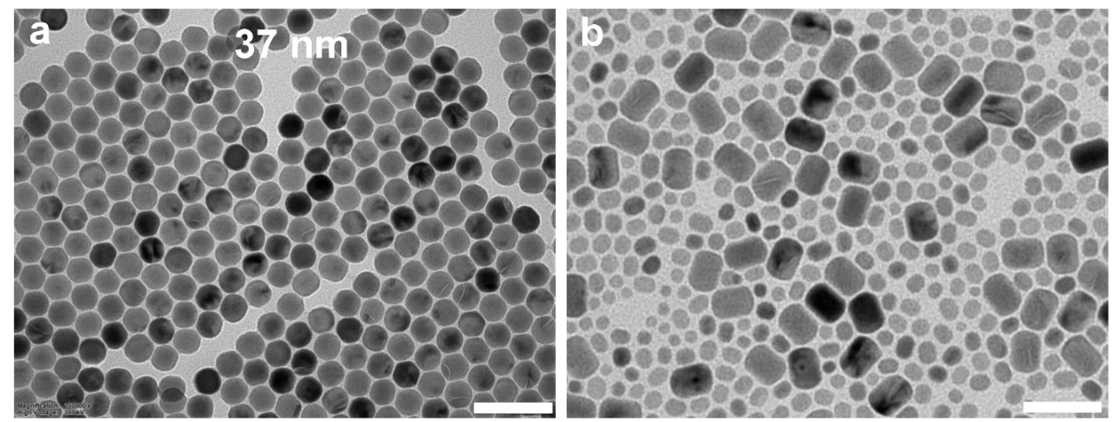
Figure S1. TEM images of NaYF₄ core nanoparticles (a) and NaYF₄ nanorods (b) synthesized using high-concentration shell precursors (1.465 μmol/mL with an injection rate of 0.25 mL/min) for 16 injection cycles, scale bars are 100 nm.

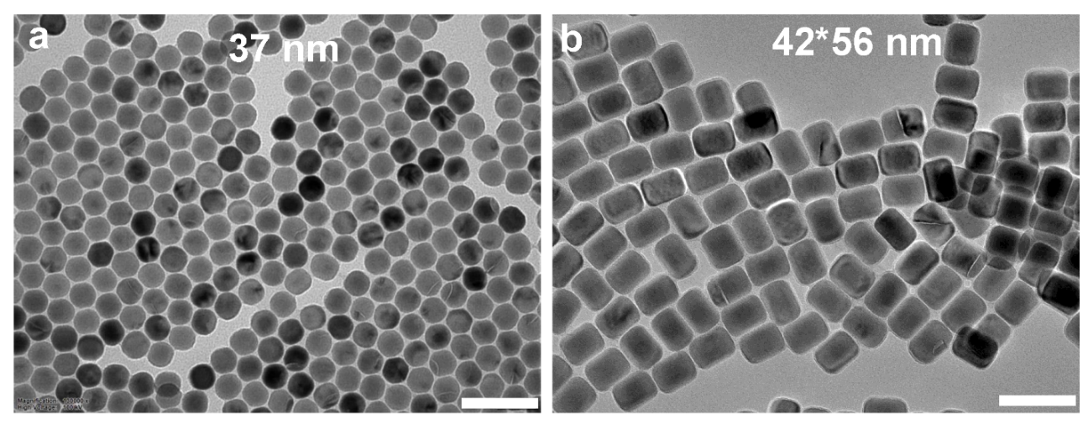
Figure S2. TEM images of NaYF₄ core nanoparticles (a) and NaYF₄ nanorods (b) synthesized using medium-concentration shell precursors (0.732 μmol/mL with an injection rate of 0.125 mL/min) for 32 injection cycles, scale bars are 100 nm.

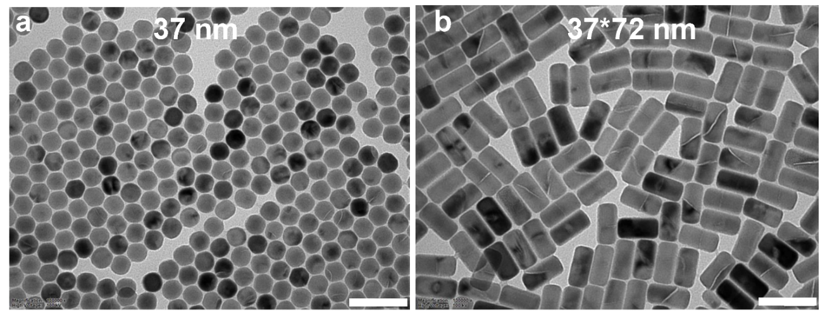
Figure S3. TEM images of NaYF₄ core nanoparticles (a) and NaYF₄ nanorods (b) synthesized using low-concentration shell precursors (0.235 μmol/mL with an injection rate of 0.04 mL/min) for 100 injection cycles, scale bars are 100 nm.

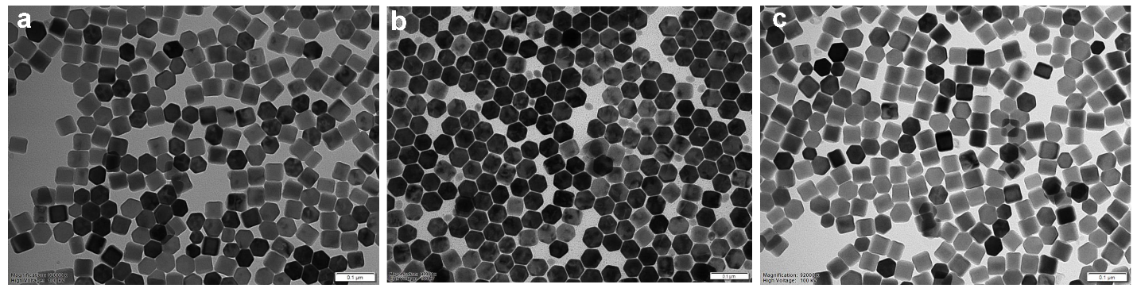
Figure S4. TEM images of heterogeneous NaYF₄-NaErF₄ (a), NaYF₄-NaYbF₄ (b), and NaYF₄-NaTmF₄ (c), nanoplates synthesized using a low ratio of OA-/HOA (1:10) and low concentration of shell precursor (0.235 μmol/mL with an injection rate of 0.04 mL/min), scale bars are 100 nm.

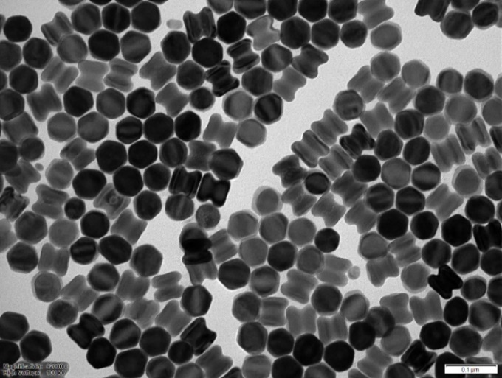
Figure S5. TEM image of heterogeneous NaYF₄-NaNdF₄ nanorods synthesized using a low ratio of OA-/HOA (1:10) and low concentration of shell precursor (0.235 μmol/mL with an injection rate of 0.04 mL/min), scale bar is 100 nm.

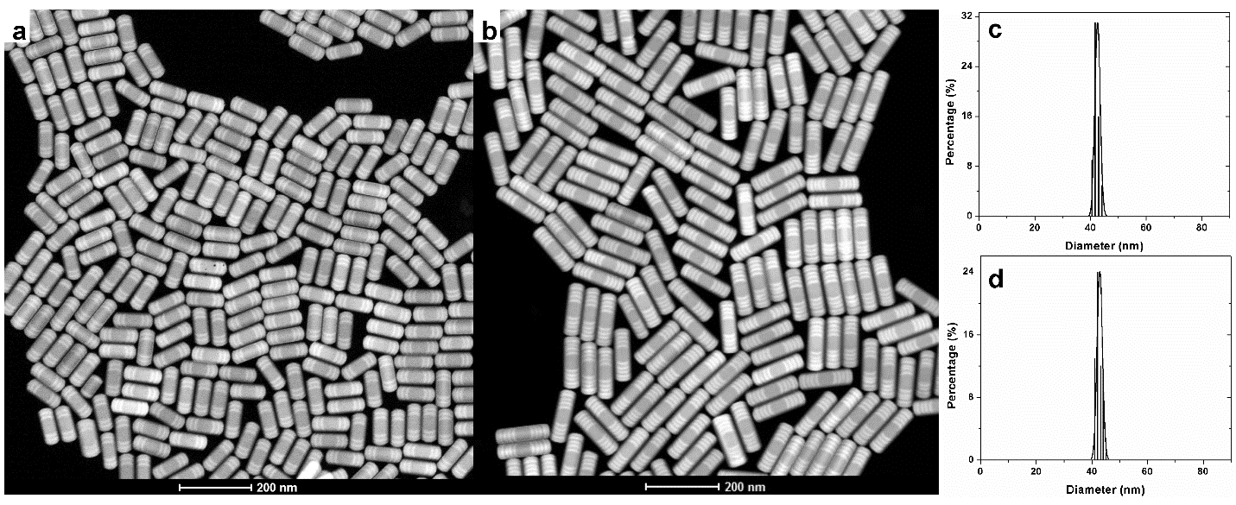
Figure S6. High-angle annular dark-field scanning transmission electron microscopy (HAADF-STEM) images (a,b) and width distribution histograms (c,d) of typical heterogeneous NaYF₄-NaErF₄-NaYF₄-NaErF₄-NaYF₄-NaErF₄ (a,c) and NaYF₄-NaErF₄-NaYF₄-NaErF₄-NaYF₄-NaErF₄-NaYF₄-NaErF₄-NaYF₄-NaErF₄ (b,d) nanorods, scale bars are 200 nm.

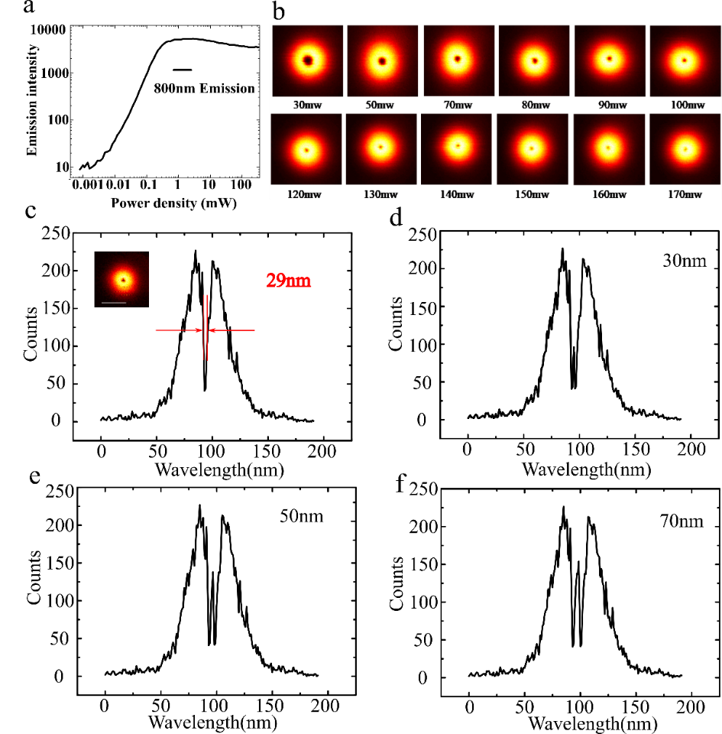
Figure S7. (a) The saturation intensity curve of the 800 nm emissions from single nanoparticles (NaYF₄:40%Yb³⁺,4%Tm³⁺) under 980 nm excitation. (b) Negative images of single particle under different excitation powers. (c) The corresponding cross-section profile in figure b, insert shows the negative-shaped PSF of single nanoparticle under the excitation power of 80 mW. (d-f) Merged PSF with different central shift distance of 30 nm, 50 nm, and 70 nm respectively. Pixel dwells time is 3 ms; all the pixel size is 10 nm. Scale bar is 500 nm.

The FWHM of the PSF with a dip of our optical system is 29 nm, which can be defined as the experiment resolution. In this case, two active parts with distance from 30 to 70 nm has been simulated, where we overlap two experimental PSF. When the distance is 30 nm, the two active segments cannot be well resolved as the intensity of the central spot (spot 2 in Fig. 2c) is only slightly higher than that of the two negative parts (spots 1 and 3 in Fig. 2c). For two parts with a spacing of 50 nm, they can be theoretically resolved.
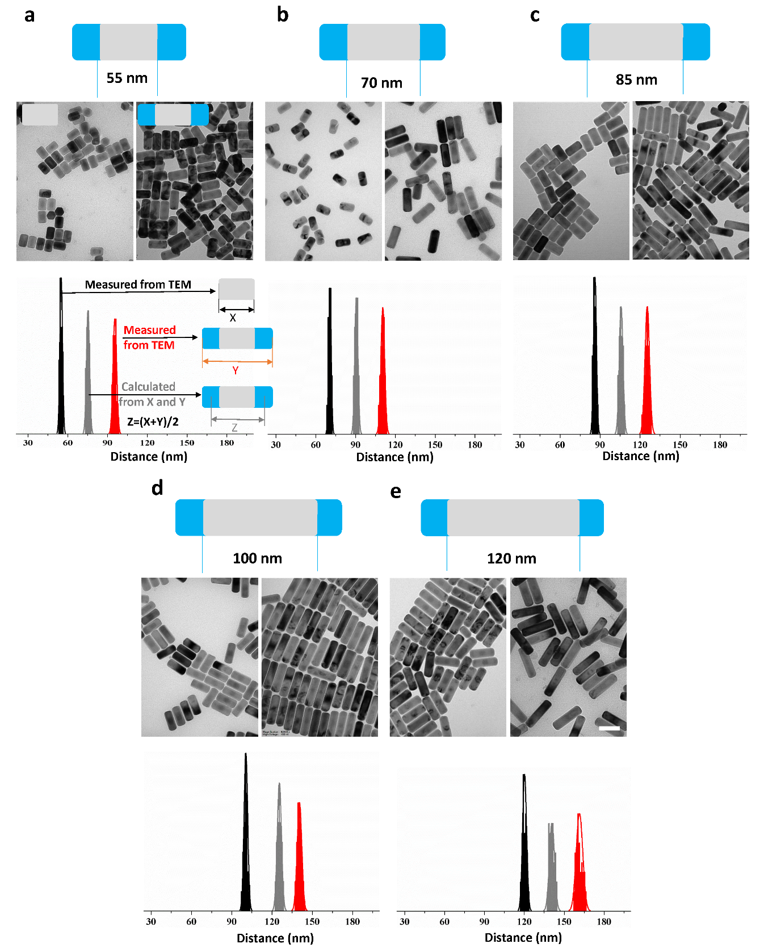
Figure S8. Design structure, TEM images, distance distributions of a series of heterogeneous upconversion nanobarcodes with tunable lengths of the inert section to separate the optically active components on the ends, X represents the distance of the two ends of the inert section, Y represents the distance of the two ends of the actively doped part, Z represents the center-to-center distance of the two actively doped parts, scale bar is 100 nm.

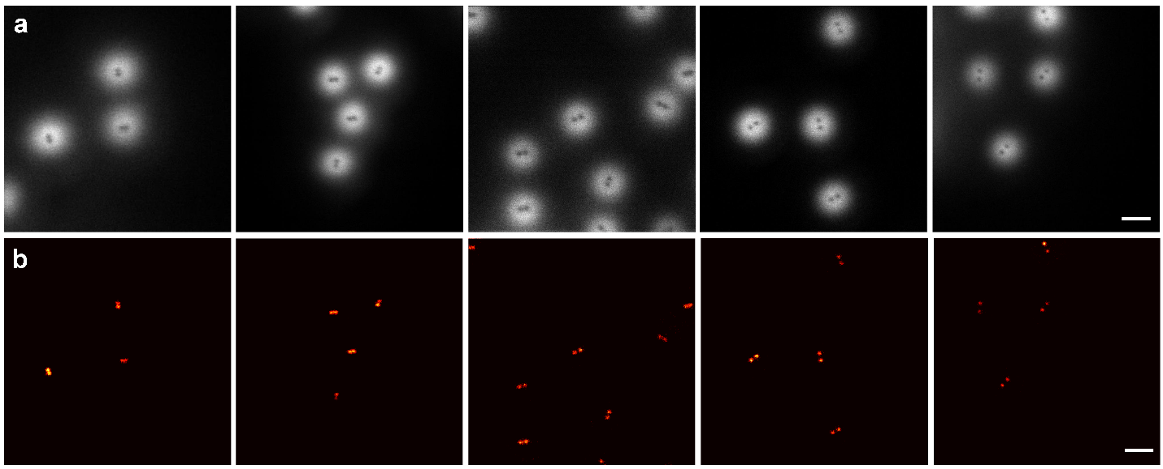
Figure S9. Large-area negative-contrast images (a), and positive super-resolution images (b) of a series of heterogeneous upconversion nanobarcodes corresponding with that in fig. S9 and fig. 2d,e. Scale bars are 500 nm.

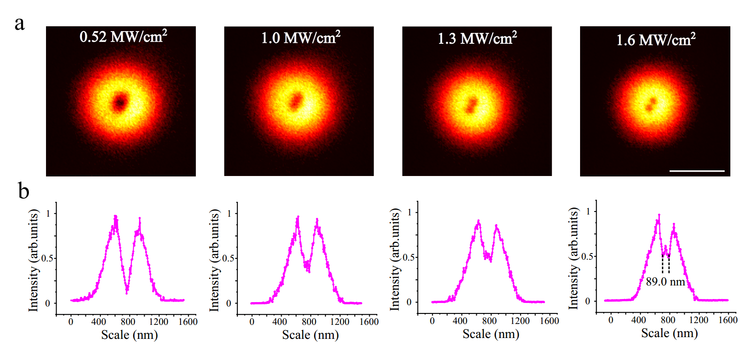

Figure S10. (a) “Negative” images of the cross-section profiles of a single nanobarcode under different excitation powers. (b) Cross-section profiles of upconversion emission of nanobarcodes in a at four different excitation powers. Pixel size, 10 nm. Scale bar is 500 nm, dwell time is 1 ms.

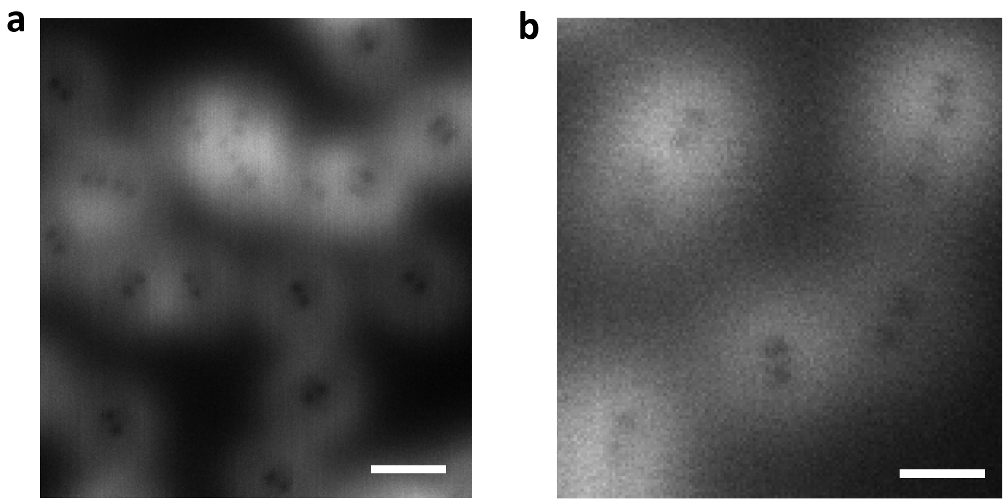

Figure S11. Negative super-resolution images of the high concentration nanobarcodes with the same sample (a) and the mixture of two kinds of nanobarcodes (b). Scale bars in a and b are 400 and 250 nm, respectively.

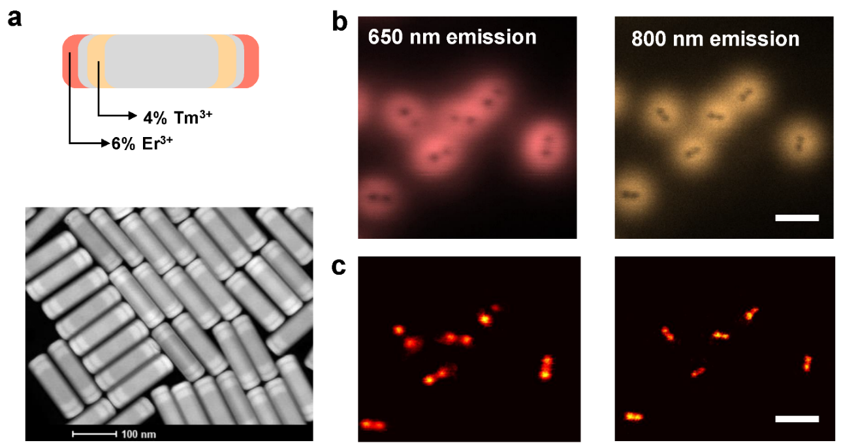

Figure S12. a, Structure design and HAADF-STEM images of heterogeneous nanorods with emitters Tm and Er doped at different positions for colour barcoding. Negative (b) and positive (c) super-resolution images of the fabricated nanobarcodes in different channels of emission wavelength. Scale bars in b and c are 500 nm.

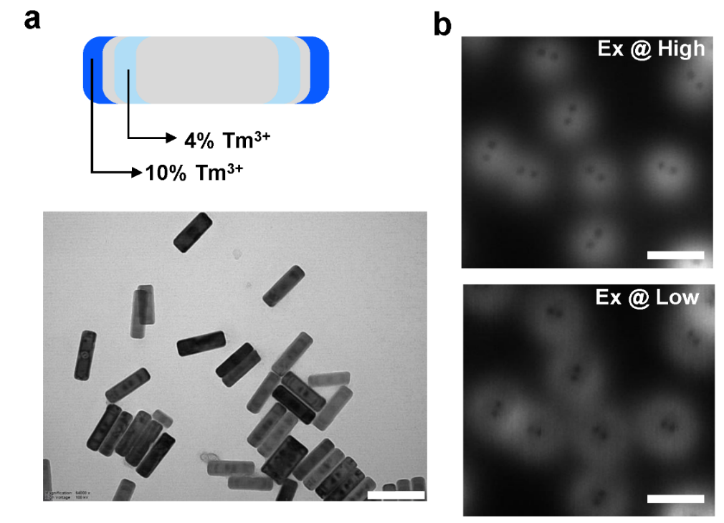
Figure S13. a, Structure design and TEM images of the heterogeneous nanorods with different Tm doping concentrations at different positions for power-dependent barcoding, scale bar is 200 nm. b, Negative super-resolution images of the formed nanobarcodes under different excitation powers, scale bars are 500 nm.

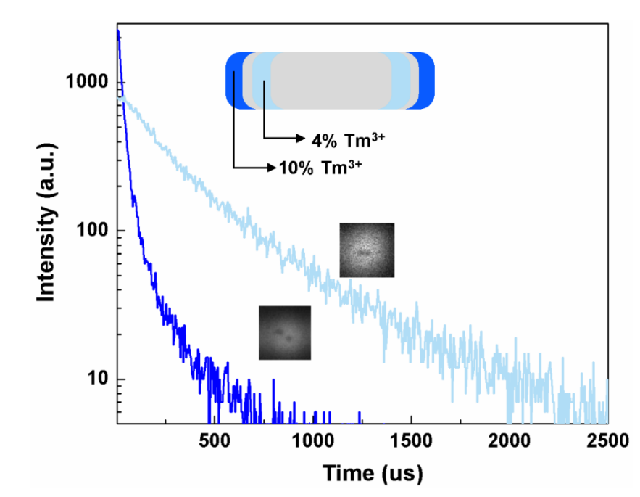
Figure S14. Illustration of time-gated super-resolution images of heterogeneous nanorods with different concentrations (4% and 10%) of Tm under pulsed illumination. Luminescence decay curves at 800 nm shown that 4% Tm doped sample has the much longer lifetime than that from 10% Tm doped sample.

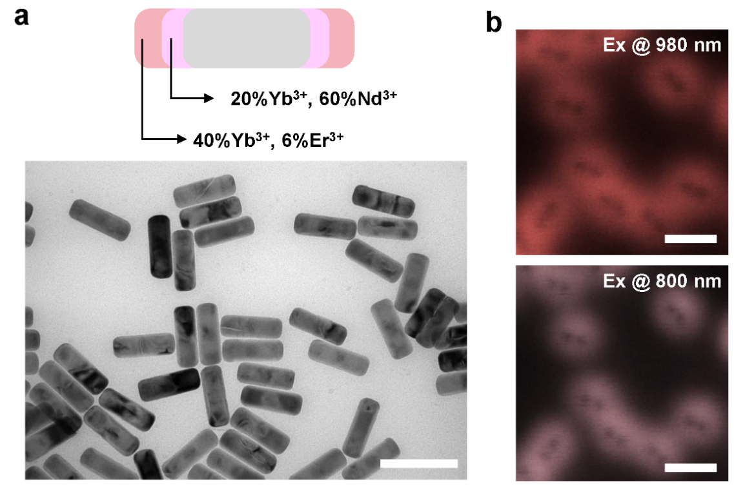
Figure S15. a, Structure design and TEM image of the heterogeneous nanorods with Nd/Yb-Yb/Er doping sections at different positions for excitation-wavelength-dependent barcoding, scale bar is 200 nm. b, Negative super-resolution images of the formed nanobarcodes under different excitation wavelengths, scale bar is 500 nm.

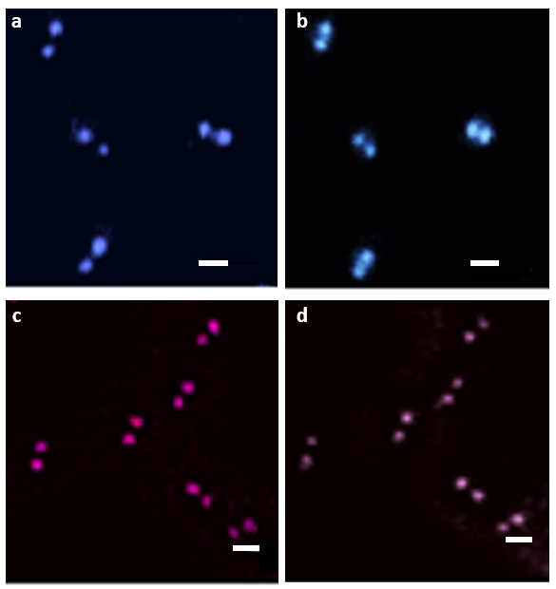

Figure S16. High-resolution images of the functional segments selectively decoded by high power density (a), low power density (b), 980 nm excitation (c) and 808 nm excitation (d). Scale bar are 100 nm. Large area images are shown in figure 3 b and f.

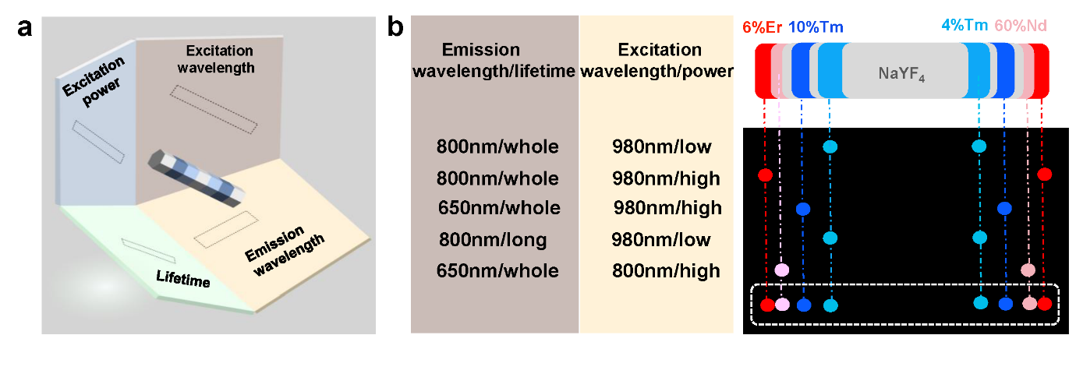
Figure S17. a, The scheme to integrate multiple sub-20nm segments, each contains optical barcodes and patterns from an orthogonal optical dimension. b, The detailed excitation and emission conditions used for resolving different codes of the nanobarcodes in multi-dimensions.

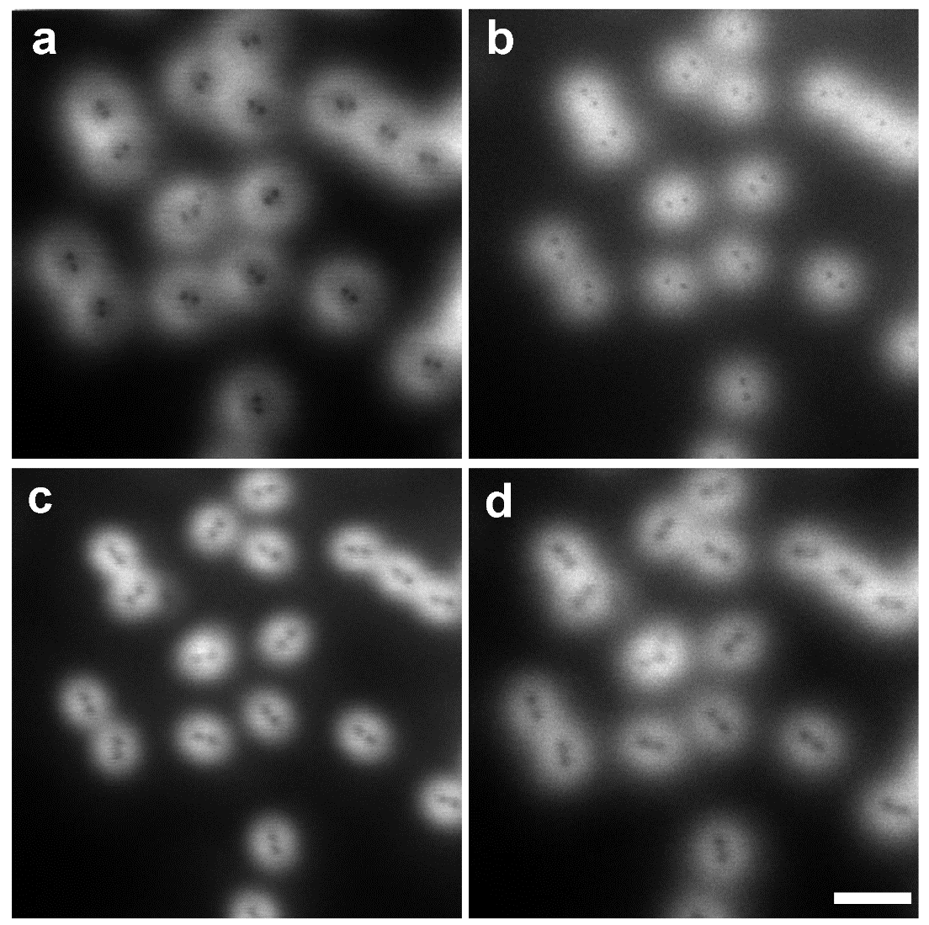

Figure S18. Negative super-resolution images of the nanobarcodes in multidimensions under different imaging conditions, 808 nm emission under 980 nm excitation with low power density (a), 808 nm emission under 980 nm excitation with high power density (b), 650 nm emission under 800 nm excitation (c), and 650 nm emission under 980 nm excitation (d). Scale bar is 500 nm.
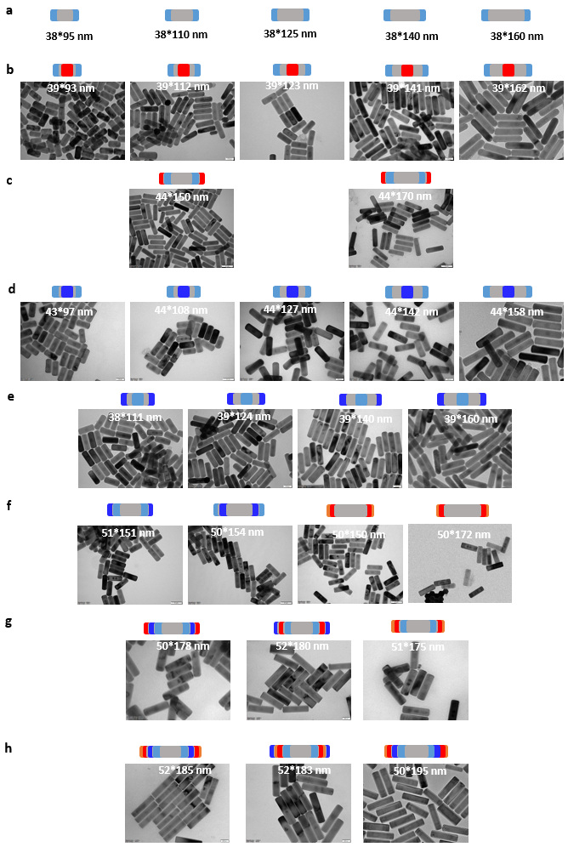
Figure S19. A summary of 31 types of formed nanobarcodes, including 5 types of two-section distance barcodes (a, TEM images are shown in figure S9), 5 types of three-section two-colour distance barcodes (b), 2 types of four-section two-colour distance barcode (c), 9 types of three-section two-excitation-power distance barcodes (d,e), 2 types of four-section two-excitation-power distance barcodes (f), 2 types of four-section two-excitation-wavelength distance barcodes (f), 2 types of six-section two-colour and two-excitation-power distance barcodes, 1 two-colour and two-excitation-wavelength barcodes (g), 3 types of eight-section two-colour, two-excitation-power and two-excitation-wavelength distance barcodes (h).

References

1 Liu, D. et al. Three-dimensional controlled growth of monodisperse sub-50 nm heterogeneous nanocrystals. Nat. Commun. 7, 10254 (2016).
2 Wang, F. & Liu, X. Multicolor Tuning of Lanthanide-Doped Nanoparticles by Single Wavelength Excitation. Acc. Chem. Res. 47, 1378-1385 (2014).
3 Fan, Y. et al. Lifetime-engineered NIR-II nanoparticles unlock multiplexed in vivo imaging. Nature Nanotechnology 13, 941-946 (2018).
4 Wang, F. et al. Microscopic inspection and tracking of single upconversion nanoparticles in living cells. Light Sci. Appl. 7, e18007 (2018).
5 Gargas, D. J. et al. Engineering bright sub-10-nm upconverting nanocrystals for single-molecule imaging. Nat Nano 9, 300-305 (2014).
6 Wang, Y.-F. et al. Nd3+-Sensitized Upconversion Nanophosphors: Efficient In Vivo Bioimaging Probes with Minimized Heating Effect. ACS Nano 7, 7200-7206 (2013).
7 Lin, G., Baker, M. A. B., Hong, M. & Jin, D. The Quest for Optical Multiplexing in Bio-discoveries. Chem 4, 997-1021 (2018).

