Supplementary Information
Internally hollow Cu₂O nanoframes with the abundance of {110} facets achieves triple-win in direct propylene epoxidation
Yueming Qiu ^{1,†}, Yichen Zhang ^{1,†}, Ronghui Zhang ¹, Meng Huang ¹, Kok Bing Tan ^{1,2}, Guowu Zhan ², Gang Fu ^{1,3,*}, Qingbiao Li ^{1,4,*} & Jiale Huang ^{1,*}
¹ Department of Chemical and Biochemical Engineering, College of Chemistry and Chemical Engineering, Xiamen University, Xiamen, Fujian 361005, China
² College of Chemical Engineering, Integrated Nanocatalysts Institute (INCI), Huaqiao University, Xiamen 361021, China
³ State Key Laboratory of Physical Chemistry of Solid Surfaces, Xiamen University, Xiamen, Fujian 361005, China
⁴ College of Ocean Food and Biology Engineering, Jimei University, Xiamen, Fujian 361021, China
† These authors contributed equally to this work: Yueming Qiu and Yichen Zhang.
* Corresponding Authors.
E-mail: gfu@xmu.edu.cn (G. Fu); kelqb@xmu.edu.cn (Q.B. Li); cola@xmu.edu.cn (J.L. Huang)

Table of contents
1. Experimental Section 3
2. Supplementary Figures 9
3. Supplementary Tables 19
4. References 23

1. Experimental Section
1.1 Synthesis of c-Cu₂O. Typically, 0.25 g CuSO₄·5H₂O was dissolved in 40.0 mL deionized water to form a clear solution. Then, 1.0 mL OA and 20.0 mL ethanol were added to the above solution successively under intense agitation. Throughout the 0.8 mol L^{–1} NaOH solution dropping process, the mixture was stirred for 5 min while heating at 100 °C. After that, 30.0 mL glucose solution was added to the above solution and stirred for 60 min. The brick red product was washed with cyclohexane and ethanol for several times, and dried under vacuum at 60 °C overnight.
1.2 Synthesis of o-Cu₂O. o-Cu₂O was synthesized according to the method reported by Hua et al.¹. 0.48 g Cu(NO₃)₂·3H₂O was accurately weighed and dissolved in 20.0 mL deionized water at 55 °C. Then 0.70 g PVP was added into the above solution. After adequately stirring, 6.0 mL 1.0 mol L^{–1} NaOH solution was added dropwise (~195 s), and continued to be mixed for 10 min. The freshly prepared 0.6 mol L^{–1} ascorbic solution was poured at a constant rate for 3.5 min (about 1 drop every 3 seconds), and was kept stirring at 55 °C for 30 min. After centrifugation, the obtained product was washed with ethanol for several times and stored in ethanol solution for future use.
1.3 Synthesis of r-Cu₂O. r-Cu₂O was synthesized according to the method reported by Zhan et al.². First, 0.25g CuSO₄·5H₂O was dissolved in 15.0 mL deionized water and transferred into conical bottle for dequately stirring at 80 °C. Then, the mix solution containing 2.0 mL OA and 5.0 mL ethanol was poured into the about conical bottle and keep stirring for 30 min. After that, 5.0 mL 1.0 mol L^{–1} NaOH solution was added dropwise (~195 s) with 10 min stirring. A fresh glucose solution (2.0 mol L^{–1}) was added to the above solution at the rate about 1 drop every 3 seconds, and the mixture was stirred at 80 °C for 3 h. The obtained product should be washed with ethanol and cyclohexane for several times and stored in ethanol solution for future use.
1.4 Synthesis of d-Cu₂O. First, 0.35g Cu(NO₃)₂·3H₂O was dissolved in 7.0 mL deionized water with ultrasonication for 5 min to obtain clear solution. 104.0 mL deionized water was added to a beaker in a 33 °C water bath. Then, under intense agitation, 7.5 mL of Cu(NO₃)₂ solution was added and 1.31 g SDS was mixed with the about solution. After completely mixed, 3.0 mL 1.0 mol L^{–1} NaOH was added, immediately forming a blue precipitate. Finally, 40.0 mL NH₂OH·HCl solution was quickly injected into the above and the precursor was growing in the water bath for 80 min. The origin product was washed with deionized water and ethanol for several times, and dried under vacuum at 60 °C overnight.
1.5 Synthesis of c-Cu₂O-NF. c-Cu₂O-NF was synthesized according to the liquid reduction method. First, 0.17 g CuCl₂·2H₂O and 0.23 g NaCl were dissolved in 0.0 mL deionized water. After well-mixed, 1.8 mL NaOH solution (1.0 mol L^{–1}) was added into the above solution, and 5.0 mL AA solution (0.1 mol L^{–1}) was added subsequently with intense stirring for 5 minutes. As the reaction progresses, the mixture gradually changes from blue to yellow colors. After 10 min, the product was washed with ethanol for several times, and was dried under vacuum at room temperature overnight.
1.6 Synthesis of o-Cu₂O-NF. In a typical procedure, the Fehling solution consisted of 7.0 g L^{–1} CuSO₄·5H₂O solution, 25.0 g L^{–1} SPTT solution and 4.5 g L^{–1} KOH solution should be prepared first. Then, 0.4 mL PdCl₂ solution (0.027 mol L^{–1}) and 4.0 mL glucose solution (0.25 mol L^{–1}) were added into a mixture of 20.0 mL Fehling solution and 180.0 mL deionized water under stirring. After that, a clarified light blue solution was aged at 75 °C for 3 h, and the o-Cu₂O-NF product was thoroughly washed and dried under vacuum at room temperature overnight.
1.7 Synthesis of d-Cu₂O-NF. d-Cu₂O-NF was synthesized according to the method reported by Lv et al.³. Typically, quantitative Cu(NO₃)₂·3H₂O was dissolved in deionized water with ultrasonication for 3 min to obtain 0.1 mol L^{–1} Cu(NO₃)₂ solution. Next, 7.5 mL of Cu(NO₃)₂ solution and 1.31 g SDS were successively added to 104.0 mL of deionized water with vigorous stirring. After complete dissolution, 3.0 mL NaOH solution (0.1 mol L^{–1}) was added dropwise to formed a blue precipitate of Cu(OH)₂. Then, 42.0 mL of NH₂OH·HCl (0.1 mol L^{–1}) was introduced into the mixture and the blue solution changed yellow quickly. After nanocrystal growth about 2 h, the precursor was washed with a Soxhlet extractor using ethanol as a solvent for 16 h. The obtained product was washed with ethanol and deionized water for several times and dried under vacuum at 50 °C overnight.
1.8 Synthesis of truncated 26-facet polyhedral Cu₂O-1 (t-26-Cu₂O-1). Typically, 2.72 g Cu(CH₃COO)₂ was dissolved in 50.0 mL deionized water with vigorous stirring for 2 min at 70 °C to obtain clear solution. Subsequently, 30.0 mL NaOH solution (3.0 mol L^{–1}) was added dropwise to formed a black precipitate with vigorous stirring for another 5 min. Then, 0.6 g glucose powder was weighed accurately and was introduced into the mixture with stirring. Next, the reaction system was cooled down to room temperature after the black precipitates turned into brownish-red color and then dark-red color. The obtained product was washed with ethanol and deionized water for several times and dried under vacuum at 70 °C overnight.
1.9 Synthesis of truncated 26-facet polyhedral Cu₂O-2 (t-26-Cu₂O-2). The preparation scheme for t-26-Cu₂O-2 is similar to that of t-26-Cu₂O-2, except that the addition quantities of deionized water, NaOH solution (9.0 mol L^{–1}) was 40.0 mL and 10.0 mL. Besides, the time for crystal growth increased to 70 min.
1.10 Computational details. Periodic density functional theory (DFT) calculations were executed utilizing the Vienna Ab Initio Simulation Package (VASP)⁴⁻⁷. The exchange-correlation effects were incorporated through the Perdew-Burke-Ernzerhof (PBE) functional within the generalized gradient approximation (GGA)⁴. Core electron interactions were modeled using pseudo-potentials based on the projector augmented wave (PAW) method^{8,9}, while valence electrons were treated with a plane-wave basis set, employing a cutoff energy of 400 eV. To more accurately capture the electronic characteristics of Cu(I) species, we implemented the DFT+U¹⁰ approach in accordance with Dudarev’s formulation, a widely-accepted method for enhancing electron correlation treatment in transition metal oxides and rare earth metal oxides. A Hubbard U correction (U-J) of 6 eV was applied to the Cu 3d electrons, in line with established methodologies¹¹. The Brillouin zone sampling for all structural models was conducted using the Monkhorst-Pack scheme, adopting a 3×3×1 k-point mesh¹². The optimized lattice parameter for bulk Cu₂O was determined to be 4.24 Å, which was in close agreement with the experimentally reported value of 4.27 Å¹³.
The Cu₂O{111}, Cu₂O{100} and Cu₂O{110} surfaces were modelled by (2×2), (2×3) and (2×2) supercells, respectively, each comprising symmetric slabs with eleven layers for the {111} and {100} surfaces, and seven layers for the {110} surface, separated by a vacuum layer of 15 Å. In the structural relaxation process, the lower four layers of each slab were kept fixed, while the remaining atoms were allowed to be fully optimized. The optimization continued until the Hellman-Feynman forces on the atoms were minimized to below 0.03 eV/Å.
The adsorption energies (ΔE_{ads}) were calculated using Equation (1):
ΔE_{ads} = E_{ad/surf} – E_{surf} - E_{ad} (1)
where E_{ad/surf} was the total energy of the adsorbed system, E_{surf} was the total energy of the clean surface, and E_{ad} was the total energy of the gas-phase adsorbate(s).
Given the known limitations of GGA functionals in accurately describing molecular oxygen in triplet state, we referenced gas-phase H₂O and H₂ to calibrate the total energy of O₂, see Equation (2), analogous to the methodology employed by Nørskov et al.¹⁴. In Equation (2), ΔE_{r} denoted as the reaction heat at 0 K without zero-point energy correction, which can be derived from the experimental atomic energies (AE)¹⁵, see Equation (3). Here, AE(H₂O), AE(H₂) and AE(O₂) denoted the atomic energies of H₂O, H₂ and O₂, respectively. Our calculations showed that the corrected total energy of O₂ should be -9.41 eV.
E (O₂) = 2×E(H₂O) - 2×E(H₂) - ΔE_{r} (2)
ΔE_{r} = 2×AE(H₂O) - 2×AE(H₂) - AE(O₂) (3)

2. Supplementary Figures
Supplementary Fig. 1 | Microscopic characterizations. SEM and TEM images of r-Cu₂O.
Supplementary Fig. 2 | Characterizations of various catalysts. (a) XPS patterns of C of s-Cu₂O, s-Cu₂O-NC and s-Cu₂O-NF. (b) In situ DRIFTS spectra of CO adsorption on the s-Cu₂O, s-Cu₂O-NC and s-Cu₂O-NF at 30 °C.

Supplementary Fig. 3 | Characterizations of various catalysts. The UV-vis spectroscopy for the s-Cu₂O, s-Cu₂O-NC and s-Cu₂O-NF.

Supplementary Fig. 4 | Microscopic characterizations. (a,b) High-angle annular dark-field image of s-Cu₂O-NC and elemental mapping images of O (c) and Cu (d,e).

Supplementary Fig. 5 | Physicochemical properties of various catalysts. (a) N₂ adsorption/desorption isotherms and (b) pore size analysis of all as-prepared Cu₂O nanocatalysts.

Supplementary Fig. 6 | Catalytic performance of propylene epoxidation with O₂. Propylene conversion and product selectivity over (a) t-26-Cu₂O-1 and (b) t-26-Cu₂O-2 at different temperatures. Reaction conditions: C₃H₆: O₂: N₂ = 10: 5: 85 vol.%, GHSV = 36,000 h⁻¹, 50.0 mg catalyst.

Supplementary Fig. 7 | Microscopic characterizations. SEM images of (a) t-26-Cu₂O-1 and (b) t-26-Cu₂O-2.

Supplementary Fig. 8 | Catalytic performance of propylene epoxidation with O₂. Propylene conversion and product selectivity over as-prepared Cu₂O nanocatalysts at 225 °C. Reaction conditions: C₃H₆: O₂: N₂ = 10: 5: 85 vol.%, GHSV = 36,000 h⁻¹, 50.0 mg catalyst.

Supplementary Fig. 9 | Catalytic performance of propylene epoxidation with O₂. Arrhenius plots of propylene epoxidation catalyzed over the s-Cu₂O, s-Cu₂O-NC and s-Cu₂O-NF.

Supplementary Fig. 10 | Catalytic performance of propylene epoxidation with O₂. Stability test of the (a) s-Cu₂O-NF, (b) s-Cu₂O-NC and (c) s-Cu₂O in propylene epoxidation at 175 °C. Reaction conditions: C₃H₆: O₂: N₂ = 10: 5: 85 vol.%, GHSV = 36,000 h⁻¹, 50.0 mg catalyst.

Supplementary Fig. 11 | Characterizations of spent catalysts. (a) Quasi situ XRD, (b) Cu 2p XPS spectra and (c) TEM image of the spent s-Cu₂O-NF catalyst.

Supplementary Fig. 12 | Characterizations of various catalysts. (a) The resistance to charge transfer spectra and (b) Raman pattern of the s-Cu₂O, s-Cu₂O-NC and s-Cu₂O-NF.
Supplementary Fig. 13 | Characterizations of various catalysts. The data split graph of O₂-TPD of the s-Cu₂O, s-Cu₂O-NC and s-Cu₂O-NF.
Supplementary Fig. 14 | Characterizations of various catalysts. The H₂-TPR graph of the s-Cu₂O-NC and s-Cu₂O-NF.
Supplementary Fig. 15 | Reaction mechanism. In situ DRIFTS spectra over s-Cu₂O-NF at different temperatures were recorded after (a) the mix flow of C₃H₆, O₂ and N₂ (10: 5: 85 vol.%) or (b) C₃H₆ adsorption.

Supplementary Fig. 16 | Characterizations of various catalysts. In situ DRIFTS spectra over s-Cu₂O-NF at 150 °C were recorded after the PO adsorption.

3. Supplementary Tables
Supplementary Table 1 | Physicochemical properties test of as-prepared Cu₂O nanocatalysts.
Sample | S_{BET}ª  (m² g⁻¹) | V^{b}  (cm³ g⁻¹)
s-Cu₂O | 0.710 | 0.007
s-Cu₂O-NC | 12.330 | 0.093
s-Cu₂O-NF | 30.382 | 0.114
c-Cu₂O-NF | 10.120 | 0.039
o-Cu₂O-NF | 4.323 | 0.013
d-Cu₂O-NF | 2.728 | 0.025
ª BET surface area; ^{b} t-Plot micropore volume.

Supplementary Table 2 | Assignment of IR bands observed in the DRIFTS spectra.
Wavenumber (cm^{–1}) | Assignment | Ref.
2950, 2980, 3100 | methyl symmetrical C−H vibrations | 2,16
2752, 2815, 2856 | C−H stretching split by Fermi resonance | 17–19
1442, 1473, 1585, 2920 | C₃H₆ molecules adsorbed Cu(I) sites or bridging Cu–O sites | 1,20
2305, 2375 | asymmetric stretching vibration of CO₂ | 1,21,22
1652 | adsorbed C₃H₄O | 20,23,24
1440 | CH₂ bending-vibration | 2,25
1385, 1560 | adsorbed HCOO | 18,20,26
1288 | CH bending-vibration | 1,20,27

Supplementary Table 3 | DFT calculations. Optimized structure of oxygen species and possible intermediates of epoxidation over Cu₂O {111}, {100}, and {110} surfaces.
 | Cu₂O {111} | Cu₂O {100} | Cu₂O {110}
O₂* | 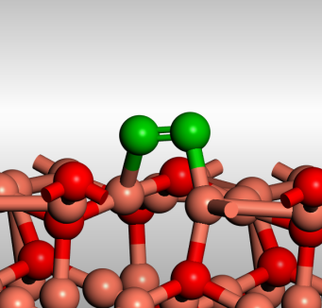 | 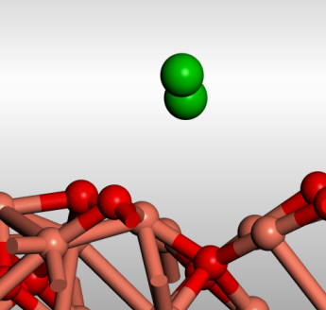 | 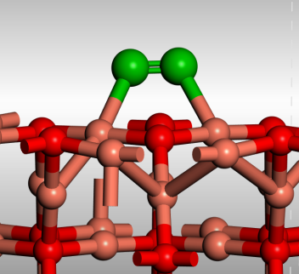
O₂* | ΔE= -1.59 eV  R(O-O)= 1.329 Å  R(O-Cu)= 1.863 Å | ΔE= -0.51 eV  R(O-O)= 1.234 Å  R(O- Cu)= 2.932 Å | ΔE= -0.57 eV  R(O-O)= 1.273 Å  R(O- Cu)= 2.109 Å
INT-1 | 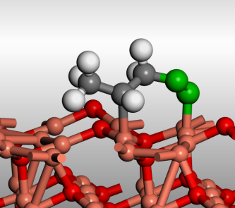 | 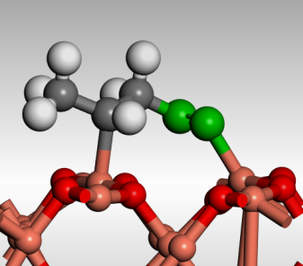 | 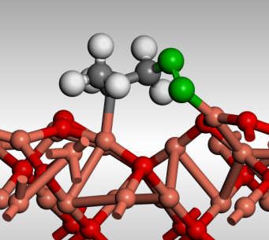
INT-1 | ΔE= -1.63 eV  R(O-Cu)= 1.806 Å  R(C-Cu)= 2.053 Å | ΔE= -0.39 eV  R(O-Cu)= 1.854 Å  R(C-Cu)= 2.150 Å | ΔE= -0.74 eV  R(O-Cu)= 1.921 Å  R(C-Cu)= 2.027 Å
INT-2 | 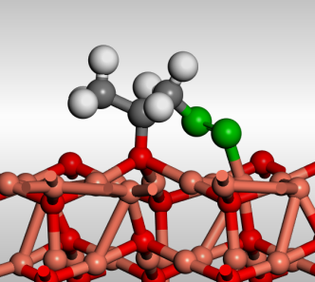 | 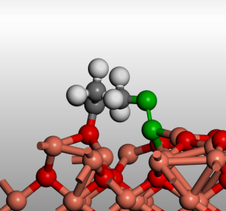 | 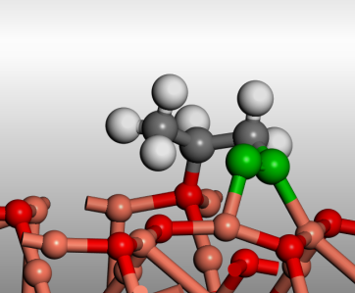
INT-2 | ΔE= -2.89 eV  R(O-Cu)= 1.740 Å  R(C-O_{surf})= 1.470 Å | ΔE= -2.34 eV  R(O-Cu)= 1.927 Å  R(C-O_{surf})= 1.470 Å | ΔE= -1.60 eV  R(O-Cu)= 1.908 Å  R(C-O_{surf})= 1.488 Å
O* | 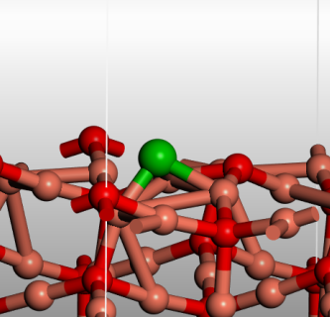 | 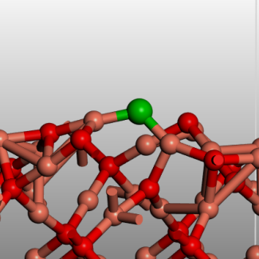 | 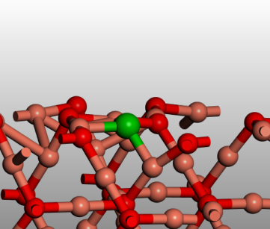
O* | ΔE= -2.75 eV  R(O-Cu)= 1.782 Å | ΔE= -1.46 eV  R(O-Cu)= 1.760 Å | ΔE= -1.92 eV  R(O-Cu)= 1.894 Å

Supplementary References
1. Hua, Q. et al. Crystal-plane-controlled selectivity of Cu₂O catalysts in propylene oxidation with molecular oxygen. Angew. Chem. Int. Ed. 126, 4956–4961 (2014).
2. Zhan, C. et al. Critical roles of doping Cl on Cu₂O nanocrystals for direct epoxidation of propylene by molecular oxygen. J. Am. Chem. Soc. 142, 14134–14141 (2020).
3. Lv, T.-T. et al. Protection of highly active sites on Cu₂O nanocages: an efficient crystalline catalyst for ammonium perchlorate decomposition. CrystEngComm 22, 8214–8220 (2020).
4. Kresse, G. & Hafner, J. Ab initio molecular dynamics for liquid metals. Phys. Rev. B 47, 558–561 (1993).
5. Kresse, G. & Hafner, J. Ab initio molecular-dynamics simulation of the liquid-metal--amorphous-semiconductor transition in germanium. Phys. Rev. B 49, 14251–14269 (1994).
6. Kresse, G. & Furthmüller, J. Efficiency of ab-initio total energy calculations for metals and semiconductors using a plane-wave basis set. Comput. Mater. Sci. 6, 15–50 (1996).
7. Kresse, G. & Furthmüller, J. Efficient iterative schemes for ab initio total-energy calculations using a plane-wave basis set. Phys. Rev. B 54, 11169–11186 (1996).
8. Kresse, G. & Hafner, J. Ab initio molecular dynamics for open-shell transition metals. Phys. Rev. B 48, 13115–13118 (1993).
9. Kresse, G. & Joubert, D. From ultrasoft pseudopotentials to the projector augmented-wave method. Phys. Rev. B 59, 1758–1775 (1999).
10. Dudarev, S. L., Botton, G. A., Savrasov, S. Y., Humphreys, C. J. & Sutton, A. P. Electron-energy-loss spectra and the structural stability of nickel oxide: An LSDA+U study. Phys. Rev. B 57, 1505–1509 (1998).
11. Isseroff, L. Y. & Carter, E. A. Importance of reference Hamiltonians containing exact exchange for accurate one-shot GW calculations of Cu₂O. Phys. Rev. B 85, 235142 (2012).
12. Monkhorst, H. J. & Pack, J. D. Special points for Brillouin-zone integrations. Phys. Rev. B 13, 5188–5192 (1976).
13. Werner, A. & Hochheimer, H. D. High-pressure X-ray study of Cu₂O and Ag₂O. Phys. Rev. B 25, 5929–5934 (1982).
14. Nørskov, J. K. et al. Origin of the overpotential for oxygen reduction at a fuel-cell cathode. J. Phys. Chem. B 108, 17886–17892 (2004).
15. Perdew, J. P., Burke, K. & Ernzerhof, M. Generalized gradient approximation made simple. Phys. Rev. Lett. 77, 3865–3868 (1996).
16. Liang, M., Zhu, X. & Ma, W. The propylene oxide rearrangement catalyzed by the lewis acid sites of ZSM-5 catalyst with controllable surface acidity. Catal. Lett. 149, 942–949 (2019).
17. Li, W. et al. Direct propylene epoxidation with molecular oxygen over cobalt-containing zeolites. J. Am. Chem. Soc. 144, 4260–4268 (2022).
18. Wang, Y., Ma, W., Wang, D. & Zhong, Q. Study on the reaction mechanism of the propylene oxide rearrangement via in situ DRIFTS. Chem. Eng. J. 307, 1047–1054 (2017).
19. Chinnathambi, A. et al. Biosynthesis of TiO₂ nanoparticles by Acalypha indica; photocatalytic degradation of methylene blue. Appl. Nanosci. 13, 383–390 (2023).
20. Xiong, W. et al. Fine cubic Cu₂O nanocrystals as highly selective catalyst for propylene epoxidation with molecular oxygen. Nat. Commun. 12, 5921 (2021).
21. Wang, W.-W. et al. Crystal plane effect of ceria on supported copper oxide cluster catalyst for CO oxidation: Importance of metal–support interaction. ACS Catal. 7, 1313–1329 (2017).
22. Chen, S. et al. Probing surface structures of CeO₂, TiO₂, and Cu₂O nanocrystals with CO and CO₂ chemisorption. J. Phys. Chem. C 120, 21472–21485 (2016).
23. Huang, W. X. & White, J. M. Transition from π-bonded to di-σ metallacyclic propene on O-modified Ag(111). Langmuir 18, 9622–9624 (2002).
24. Finocchio, E., Busca, G., Lorenzelli, V. & Willey, R. J. FTIR studies on the selective oxidation and combustion of light hydrocarbns at metal oxide surfaces. Propane and propene oxidation on MgCr₂O₄. J. Chem. Soc. Faraday Trans. 90, 3347–3356 (1994).
25. Lu, J., Bravo-Suárez, J. J., Haruta, M. & Oyama, S. T. Direct propylene epoxidation over modified Ag/CaCO₃ catalysts. Appl. Catal. Gen. 302, 283–295 (2006).
26. Wang, Y. et al. Exploring the ternary interactions in Cu–ZnO–ZrO₂ catalysts for efficient CO₂ hydrogenation to methanol. Nat. Commun. 10, 1166 (2019).
27. Wang, Q., Zhan, C., Zhou, L., Fu, G. & Xie, Z. Effects of Cl⁻ on Cu₂O nanocubes for direct epoxidation of propylene by molecular oxygen. Catal. Commun. 135, 105897 (2020).

