Country | Code | Population | hap
CANADA | CON | Ontario, Canada | 1,2,7,8,11,13,14,15,21,28,35,36,40,41,43
USA | ARK | Kansas | 2,17
USA | DC | Washington DC | 1,2
USA | DUL | Duluth | 42,44,45,46,47,48
USA | ED |  | 4
USA | FL2 | Florida2 | 2,13,29,31,32
USA | FL3 | Florida3 | 2,20,26
USA | IW | Council Groove | 4
USA | KAN | Kansas2 | 1,2,4,23,26,30
USA | LOU | Louisiana | 2,24,27
USA | MIS | Mississippi | 2,6,22,26
USA | PEL | Misuri | 4,6,9
USA | TAL | Tallahassee | 2,25,37,38,39
JAPAN | FN | Fukuoka | 1,3,12
JAPAN | IM | Iwate | 4,10
JAPAN | KB | Kobe | 2,5,26
JAPAN | KC | Kumamoto | 1,3,33
JAPAN | KG | Kagoshima | 1,3
JAPAN | NAG | Nagasaki, Glover Garden | 2,5,18
JAPAN | ON | Hyogo | 1
JAPAN | SAG | Saga | 5,18,26
JAPAN | SF | Shizuoka | 1,3,,34
JAPAN | TK | Tokio | 1,3
JAPAN | TY | Tochigi | 1,3,13
JAPAN | YA | Yamagoda | 5,18
JAPAN | CER | CER, Otsu | 1,3,9
Table S1.- Haplotype list per populations and countries of COI sequences from C. marmorata samples from Canada (BOLD database) USA, and Japan.

Table S2. Pairwise F_{ST} among C. marmorata populations from USA and Japan based on SNP´s nuclear markers.
 | LAK/ARK | LFL2/FL2 | LMS/MIS | LFL3/LF3 | LC/CER | LS/SAG
LAK/ARK | 0
LFL2/FL2 | 0.05445 | 0
LMS/MIS | 0.05581 | 0.0231 | 0
LFL3/LF3 | 0.07453 | 0.04926 | -0.00299 | 0
LC/CER | 0.20963 | 0.16958 | 0.18394 | 0.11698 | 0
LS/SAG | 0.14432 | 0.08724 | 0.13726 | 0.14103 | 0.05662 | 0

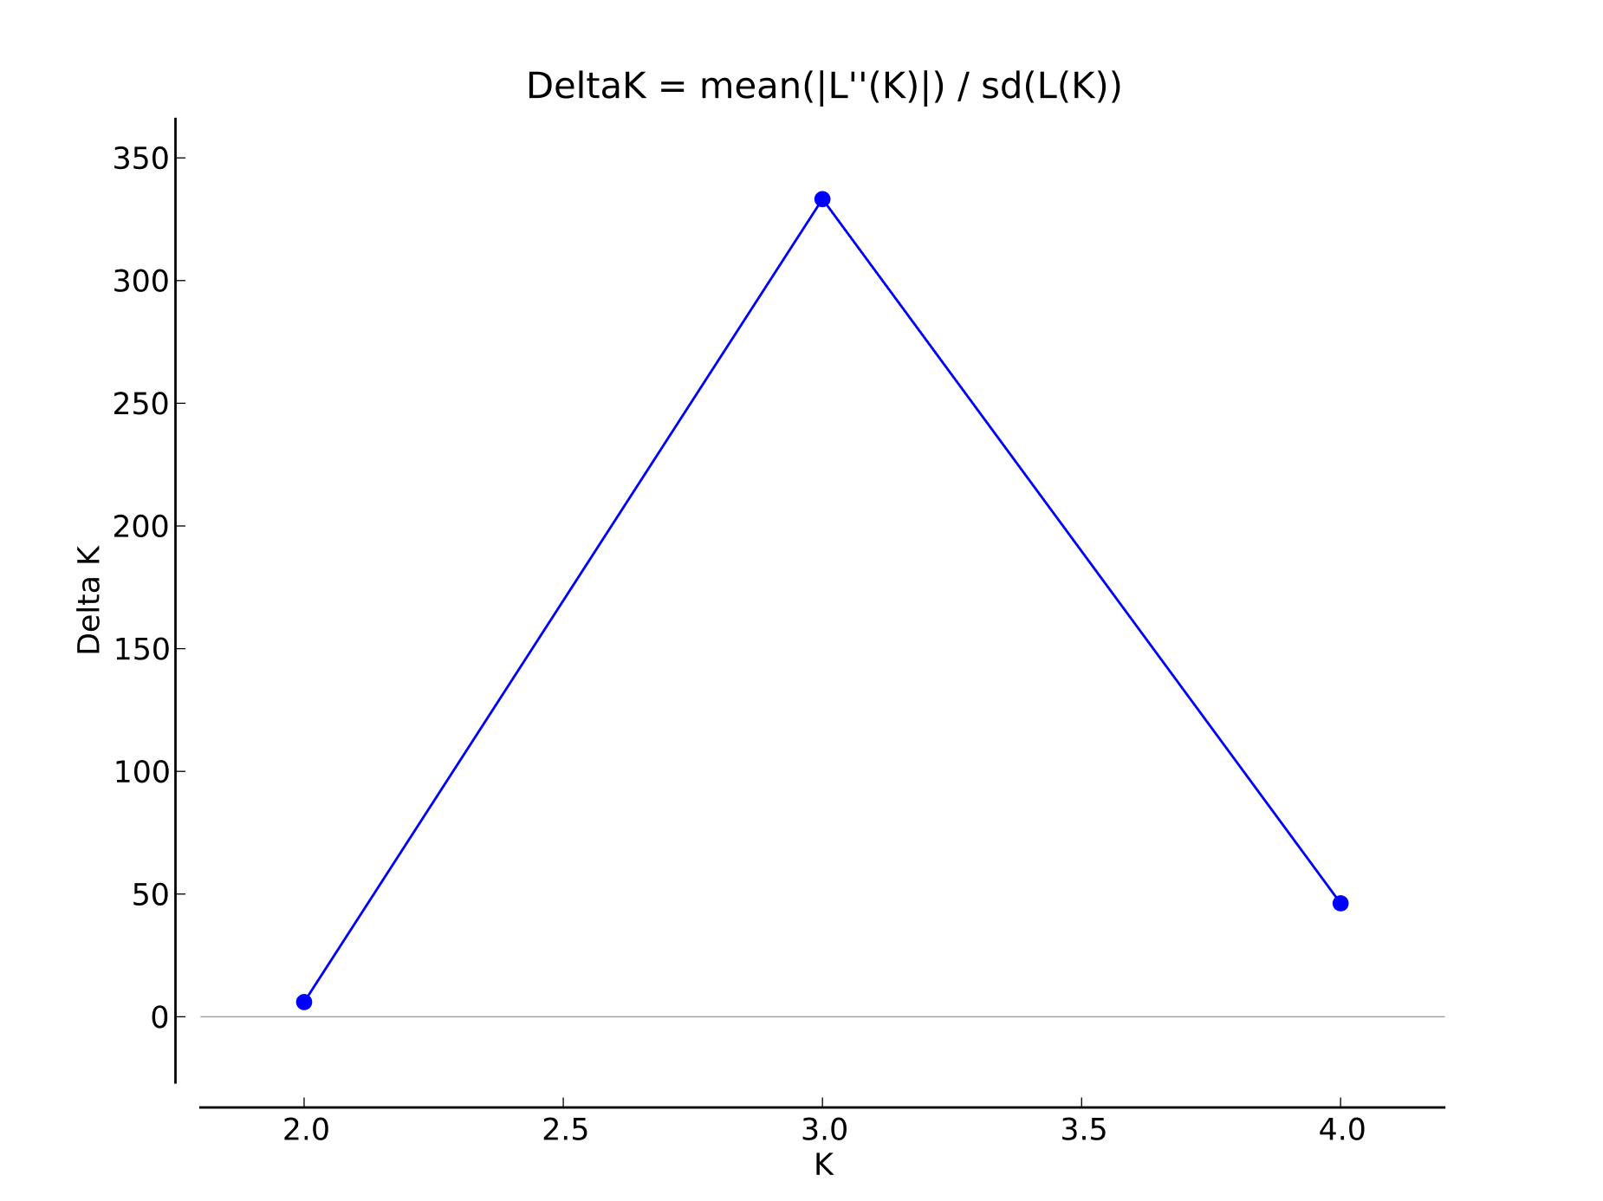
Figure S1.- Values of ∆K and mean Ln P(D) as a function of K from STRUCTURE analysis for Corythucha marmorata COI sequences from native distribution range (i.e., CANADA and USA) and invasive range (JAPAN)

Figure S2.- Cross-entropy graph indicating the optimal number of ancestral populations for K in Corythucha marmorata populations from USA and Japan using the sparse Nonnegative Matrix Factorization (sNMF)

