The association between testosterone, estradiol, estrogen sulfotransferase and idiopathic pulmonary fibrosis: a bidirectional Mendelian randomization study.
Qingying Xu¹, Guangwang Hu¹, Qunying Lin^{123*}, Menghang Wu¹, Kenan Tang¹, Yuyu Zhang¹,Feng Chen¹

- The School of Clinical Medicine, Fujian Medical University, Fuzhou, China
- Department of Respiratory Medicine, Putian Pulmonary Hospital, Putian, China
- Department of Respiratory Medicine, Affiliated Hospital of Putian University, Putian, China

* Corresponding authors:

Table S1 Univariate Mendelian randomization analysis for the effects of Testosterone on IPF risk
Chr | SNP | Pos | EAE | OAE | EAO | OAO | Exposure |  |  | Outcome |  |  | F
 |  |  |  |  |  |  | Beta | Se | p-val | Beta | Se | p-val | F
4 | rs10020067 | 88181491 | A | C | A | C | -0.011 | 0.001 | 3.23E-14 | 0.061 | 0.049 | 0.216 | 57.587
4 | rs10027182 | 148981406 | A | G | A | G | -0.01 | 0.002 | 2.21E-09 | -0.073 | 0.053 | 0.166 | 35.777
2 | rs10195252 | 165513091 | C | T | C | T | 0.009 | 0.001 | 5.78E-10 | 0.03 | 0.048 | 0.528 | 38.394
7 | rs10279715 | 40870935 | G | A | G | A | -0.01 | 0.001 | 2.86E-11 | -0.016 | 0.046 | 0.721 | 44.271
11 | rs111903103 | 118308499 | T | C | T | C | -0.022 | 0.004 | 2.73E-09 | 0.114 | 0.132 | 0.387 | 35.369
1 | rs11240695 | 204158132 | A | C | A | C | 0.012 | 0.002 | 1.43E-12 | 0.002 | 0.055 | 0.966 | 50.148
2 | rs113017476 | 31989359 | A | G | A | G | 0.064 | 0.004 | 4.38E-65 | -0.421 | 0.155 | 0.007 | 290.254
12 | rs113277738 | 51045447 | C | CTA | C | CTA | -0.01 | 0.002 | 1.59E-10 | -0.043 | 0.049 | 0.383 | 40.919
5 | rs11429307 | 55857025 | GT | G | GT | G | -0.011 | 0.002 | 7.27E-09 | 0.038 | 0.067 | 0.573 | 33.461
11 | rs11602347 | 2176852 | G | C | G | C | -0.008 | 0.001 | 2.75E-08 | -0.018 | 0.048 | 0.703 | 30.879
5 | rs11743810 | 137802404 | T | C | T | C | 0.009 | 0.001 | 2.63E-09 | -0.022 | 0.048 | 0.644 | 35.438
6 | rs12196385 | 32025980 | A | G | A | G | -0.019 | 0.003 | 1.13E-13 | 0.145 | 0.1 | 0.147 | 55.133
4 | rs1230155 | 99989259 | A | G | A | G | -0.01 | 0.002 | 1.40E-11 | 0.06 | 0.05 | 0.226 | 45.668
10 | rs12416687 | 104629011 | C | T | C | T | -0.013 | 0.002 | 6.56E-14 | 0.08 | 0.055 | 0.141 | 56.195
15 | rs12592697 | 51525173 | C | T | C | T | -0.012 | 0.002 | 1.05E-14 | 0.028 | 0.048 | 0.561 | 59.801
17 | rs12602834 | 29637308 | A | G | A | G | 0.01 | 0.001 | 4.01E-12 | -0.082 | 0.047 | 0.079 | 48.121
2 | rs1260326 | 27730940 | C | T | C | T | 0.025 | 0.001 | 6.52E-62 | 0.005 | 0.048 | 0.92 | 275.692
5 | rs12658172 | 124205385 | C | G | C | G | -0.012 | 0.002 | 8.21E-10 | 0.038 | 0.063 | 0.552 | 37.711
11 | rs12796488 | 94131557 | A | C | A | C | -0.014 | 0.002 | 1.30E-13 | 0.025 | 0.063 | 0.689 | 54.851
2 | rs13000017 | 51103718 | T | A | T | A | 0.009 | 0.001 | 7.61E-09 | 0.038 | 0.05 | 0.441 | 33.373
3 | rs13067183 | 88241914 | T | C | T | C | -0.013 | 0.002 | 2.29E-10 | 0.035 | 0.06 | 0.557 | 40.201
4 | rs13108218 | 3443931 | G | A | G | A | -0.011 | 0.002 | 2.10E-14 | 0.04 | 0.049 | 0.412 | 58.437
17 | rs1317701 | 47444794 | C | T | C | T | 0.018 | 0.002 | 2.88E-31 | -0.099 | 0.051 | 0.052 | 135.272
8 | rs13251574 | 81872031 | A | G | A | G | 0.011 | 0.002 | 2.47E-09 | -0.004 | 0.056 | 0.945 | 35.559
4 | rs1351623 | 104587977 | T | C | T | C | -0.014 | 0.002 | 2.10E-12 | -0.062 | 0.062 | 0.321 | 49.384
11 | rs1401454 | 16250183 | T | C | T | C | -0.009 | 0.001 | 1.14E-09 | -0.009 | 0.049 | 0.851 | 37.069
8 | rs141238529 | 77886088 | A | G | A | G | -0.009 | 0.002 | 4.89E-08 | -0.013 | 0.049 | 0.786 | 29.761
11 | rs143088266 | 62887418 | TCGC | T | TCGC | T | 0.02 | 0.003 | 2.16E-12 | 0.136 | 0.131 | 0.301 | 49.334
1 | rs1730865 | 107605611 | T | G | T | G | -0.015 | 0.002 | 7.66E-22 | 0.013 | 0.05 | 0.802 | 92.246
11 | rs174530 | 61546592 | G | A | G | A | -0.008 | 0.001 | 3.19E-08 | 0.01 | 0.046 | 0.826 | 30.589
15 | rs17774869 | 64129923 | C | T | C | T | -0.01 | 0.002 | 4.89E-10 | -0.008 | 0.047 | 0.861 | 38.722
17 | rs17886028 | 7582719 | CCTT | C | CCTT | C | -0.037 | 0.002 | 1.82E-56 | -0.138 | 0.091 | 0.127 | 250.711
5 | rs1866385 | 10736569 | C | T | C | T | 0.011 | 0.002 | 4.90E-08 | 0.041 | 0.06 | 0.497 | 29.756
1 | rs193084249 | 26987646 | G | A | G | A | -0.037 | 0.005 | 1.71E-14 | 0.113 | 0.119 | 0.34 | 58.841
6 | rs1933801 | 105365725 | T | C | T | C | 0.014 | 0.002 | 3.35E-19 | -0.017 | 0.049 | 0.734 | 80.22
10 | rs1935 | 64927823 | G | C | G | C | 0.039 | 0.001 | 1.27E-162 | -0.002 | 0.046 | 0.962 | 738.495
11 | rs1994721 | 29204531 | A | G | A | G | -0.013 | 0.002 | 5.96E-11 | 0.001 | 0.062 | 0.986 | 42.833
2 | rs2011425 | 234627608 | G | T | G | T | -0.026 | 0.003 | 1.67E-21 | -0.139 | 0.096 | 0.148 | 90.707
19 | rs202200760 | 17346854 | C | G | C | G | 0.043 | 0.004 | 2.83E-26 | -0.019 | 0.1 | 0.849 | 112.463
3 | rs2342307 | 195942487 | G | A | G | A | -0.01 | 0.002 | 2.38E-11 | -0.025 | 0.048 | 0.594 | 44.63
11 | rs2370798 | 122766070 | C | A | C | A | 0.011 | 0.001 | 1.81E-14 | -0.066 | 0.046 | 0.154 | 58.733
16 | rs2764772 | 20060653 | A | T | A | T | 0.011 | 0.002 | 1.79E-12 | 0.05 | 0.048 | 0.297 | 49.698
14 | rs28929474 | 94844947 | T | C | T | C | 0.052 | 0.005 | 3.76E-24 | -0.11 | 0.174 | 0.526 | 102.774
9 | rs296883 | 86578925 | T | A | T | A | 0.01 | 0.002 | 2.02E-09 | 0.048 | 0.049 | 0.329 | 35.958
8 | rs35783704 | 105966258 | A | G | A | G | 0.014 | 0.002 | 4.03E-09 | 0.179 | 0.062 | 0.004 | 34.609
19 | rs35925598 | 46410216 | A | G | A | G | 0.016 | 0.002 | 2.60E-14 | 0.036 | 0.084 | 0.666 | 58.014
10 | rs36032941 | 5062752 | A | C | A | C | -0.016 | 0.002 | 1.21E-23 | 0.106 | 0.051 | 0.036 | 100.455
2 | rs3827536 | 111920741 | T | G | T | G | 0.011 | 0.001 | 5.19E-13 | -0.072 | 0.046 | 0.114 | 52.132
1 | rs41264945 | 155640115 | T | C | T | C | 0.02 | 0.003 | 1.28E-10 | -0.048 | 0.094 | 0.608 | 41.333
10 | rs4397736 | 4971457 | T | C | T | C | 0.008 | 0.001 | 2.62E-08 | 0.043 | 0.046 | 0.353 | 30.97
5 | rs4431325 | 76461706 | T | C | T | C | 0.018 | 0.003 | 1.11E-08 | 0.038 | 0.085 | 0.657 | 32.63
6 | rs4495279 | 100257668 | A | G | A | G | -0.01 | 0.002 | 3.26E-08 | -0.056 | 0.054 | 0.293 | 30.545
7 | rs45446698 | 99332948 | G | T | G | T | -0.067 | 0.004 | 5.49E-73 | 0.05 | 0.102 | 0.624 | 326.524
4 | rs4632729 | 69946004 | G | A | G | A | -0.014 | 0.001 | 9.24E-23 | -0.039 | 0.046 | 0.401 | 96.431
22 | rs4822983 | 29115066 | T | C | T | C | 0.009 | 0.002 | 3.28E-09 | 0.057 | 0.052 | 0.277 | 35.01
14 | rs4900463 | 100826435 | G | A | G | A | -0.01 | 0.002 | 7.72E-10 | -0.026 | 0.055 | 0.642 | 37.83
15 | rs55707100 | 43820717 | T | C | T | C | -0.033 | 0.005 | 6.11E-13 | 0.127 | 0.314 | 0.687 | 51.81
12 | rs56196860 | 2908330 | A | C | A | C | 0.082 | 0.004 | 2.69E-87 | -0.28 | 0.21 | 0.183 | 392.243
15 | rs56332871 | 96714816 | A | C | A | C | 0.019 | 0.002 | 1.27E-30 | -0.019 | 0.05 | 0.705 | 132.32
19 | rs56709164 | 50053790 | C | T | C | T | 0.018 | 0.003 | 6.63E-11 | -0.122 | 0.119 | 0.304 | 42.625
12 | rs57743625 | 21367633 | A | G | A | G | -0.011 | 0.002 | 1.21E-08 | 0.008 | 0.05 | 0.869 | 32.465
17 | rs58356259 | 8040151 | T | C | T | C | 0.008 | 0.001 | 6.01E-09 | 0.031 | 0.046 | 0.503 | 33.831
20 | rs6073431 | 43040569 | T | C | T | C | 0.011 | 0.001 | 9.22E-13 | 0.003 | 0.046 | 0.954 | 51.004
17 | rs62059833 | 7514544 | T | C | T | C | 0.063 | 0.002 | 1.00E-200 | -0.057 | 0.049 | 0.25 | 1480.758
22 | rs62220604 | 49677464 | A | G | A | G | 0.01 | 0.002 | 4.45E-10 | 0.02 | 0.053 | 0.711 | 38.903
3 | rs62259233 | 41121974 | T | C | T | C | -0.013 | 0.002 | 1.89E-08 | -0.085 | 0.097 | 0.379 | 31.603
13 | rs629042 | 22318506 | C | G | C | G | 0.015 | 0.001 | 3.76E-23 | -0.07 | 0.046 | 0.132 | 98.213
7 | rs6460047 | 73042443 | C | T | C | T | 0.012 | 0.002 | 9.59E-12 | 0.035 | 0.062 | 0.575 | 46.41
12 | rs6486542 | 130952209 | T | C | T | C | -0.008 | 0.001 | 1.05E-08 | 0.102 | 0.049 | 0.036 | 32.755
16 | rs6564890 | 81612541 | T | C | T | C | -0.013 | 0.001 | 5.47E-20 | -0.042 | 0.046 | 0.361 | 83.803
1 | rs6684361 | 101737743 | C | T | C | T | 0.016 | 0.002 | 1.12E-24 | -0.013 | 0.047 | 0.777 | 105.172
3 | rs66956368 | 61279726 | A | T | A | T | -0.011 | 0.002 | 8.81E-11 | -0.015 | 0.05 | 0.758 | 42.069
7 | rs6951286 | 97939222 | C | T | C | T | 0.012 | 0.002 | 3.78E-13 | -0.028 | 0.055 | 0.608 | 52.753
3 | rs696516 | 136067778 | T | G | T | G | -0.01 | 0.002 | 2.57E-09 | -0.044 | 0.062 | 0.477 | 35.483
8 | rs7003319 | 143954747 | C | T | C | T | -0.01 | 0.001 | 2.37E-11 | -0.09 | 0.047 | 0.055 | 44.641
10 | rs7073001 | 67278666 | C | T | C | T | 0.015 | 0.001 | 7.52E-25 | -0.036 | 0.05 | 0.476 | 105.962
15 | rs7183977 | 40377092 | C | T | C | T | 0.011 | 0.002 | 9.03E-14 | -0.039 | 0.048 | 0.408 | 55.566
4 | rs72666817 | 104129141 | A | G | A | G | 0.011 | 0.002 | 3.34E-09 | -0.078 | 0.052 | 0.133 | 34.975
2 | rs72790938 | 43718976 | G | C | G | C | -0.02 | 0.003 | 1.80E-08 | -0.467 | 0.209 | 0.025 | 31.704
2 | rs72790938 | 43718976 | G | C | T | C | -0.02 | 0.003 | 1.80E-08 | -1.064 | 1.308 | 0.416 | 31.704
10 | rs73390639 | 135051149 | G | C | G | C | 0.025 | 0.005 | 2.38E-08 | 0.05 | 0.131 | 0.703 | 31.153
22 | rs738408 | 44324730 | T | C | T | C | 0.016 | 0.002 | 5.12E-19 | -0.027 | 0.055 | 0.62 | 79.383
17 | rs7503751 | 7789542 | A | G | A | G | 0.017 | 0.003 | 5.58E-11 | -0.045 | 0.106 | 0.673 | 42.964
3 | rs7610095 | 152035637 | A | G | A | G | -0.008 | 0.001 | 4.97E-08 | 0.065 | 0.048 | 0.172 | 29.728
4 | rs7679843 | 22028079 | G | C | G | C | 0.015 | 0.003 | 3.60E-09 | -0.121 | 0.092 | 0.187 | 34.827
9 | rs7860122 | 19087429 | G | A | G | A | 0.01 | 0.002 | 3.01E-09 | -0.038 | 0.053 | 0.47 | 35.179
19 | rs79267532 | 49530737 | C | T | C | T | 0.02 | 0.003 | 1.22E-11 | -0.167 | 0.081 | 0.038 | 45.934
18 | rs79384925 | 71938618 | A | C | A | C | -0.018 | 0.002 | 6.02E-17 | -0.01 | 0.063 | 0.87 | 69.971
15 | rs79391862 | 53739426 | C | A | C | A | -0.043 | 0.006 | 3.77E-12 | 0.159 | 0.128 | 0.216 | 48.242
6 | rs794614 | 119284884 | G | A | G | A | -0.015 | 0.002 | 8.53E-17 | 0.064 | 0.063 | 0.305 | 69.282
16 | rs8053548 | 11889059 | C | T | C | T | 0.011 | 0.002 | 2.68E-08 | -0.022 | 0.073 | 0.76 | 30.927
17 | rs8077638 | 1640793 | T | C | T | C | 0.011 | 0.002 | 1.03E-09 | -0.038 | 0.056 | 0.495 | 37.264
19 | rs9304665 | 47602577 | A | T | A | T | -0.01 | 0.002 | 3.68E-09 | 0.029 | 0.051 | 0.565 | 34.785
8 | rs930828 | 38326404 | C | T | C | T | -0.009 | 0.001 | 1.20E-09 | -0.069 | 0.046 | 0.134 | 36.968
6 | rs9394951 | 43350753 | T | C | T | C | 0.011 | 0.001 | 5.43E-15 | 0.103 | 0.047 | 0.029 | 61.099
9 | rs9695757 | 114826645 | G | A | G | A | -0.01 | 0.002 | 2.17E-08 | -0.037 | 0.05 | 0.462 | 31.332
7 | rs9986829 | 15019259 | A | G | A | G | 0.012 | 0.001 | 1.63E-16 | -0.008 | 0.046 | 0.859 | 68.009
SNP: single nucleotide polymorphism; EAE: effect allele exposure; OAE: other allele exposure; EAO: effect allele outcome; OAO: other allele outcome; SE: standard error; F: F value;

Table S2 Univariate Mendelian randomization analysis for the effects of Estradiol on IPF risk
Chr | SNP | Pos | EAE | OAE | EAO | OAO | Exposure |  |  | Outcome |  |  | F
 |  |  |  |  |  |  | Beta | Se | p-val | Beta | Se | p-val | F
4 | rs145292296 | 33255775 | T | C | T | C | -0.239 | 0.047 | 4.56E-07 | -0.068 | 0.115 | 0.555 | 25.440
1 | rs145893930 | 61357446 | C | T | C | T | -0.349 | 0.068 | 3.32E-07 | -0.337 | 0.730 | 0.645 | 26.056
20 | rs16991615 | 5948227 | A | G | A | G | 0.130 | 0.024 | 4.67E-08 | -0.114 | 0.161 | 0.479 | 29.850
7 | rs45446698 | 99332948 | G | T | G | T | -0.206 | 0.030 | 7.62E-12 | 0.050 | 0.102 | 0.624 | 46.861
12 | rs4764934 | 103469376 | T | C | T | C | -0.085 | 0.016 | 6.07E-08 | -0.038 | 0.051 | 0.451 | 29.340
19 | rs734518 | 55832884 | A | G | A | G | -0.065 | 0.012 | 6.38E-08 | -0.004 | 0.046 | 0.931 | 29.245
SNP: single nucleotide polymorphism; EAE: effect allele exposure; OAE: other allele exposure; EAO: effect allele outcome; OAO: other allele outcome; SE: standard error; F: F value;

Table S3 Univariate Mendelian randomization analysis for the effects of Estrogen sulfotransferase on IPF risk
Chr | SNP | Pos | EAE | OAE | EAO | OAO | Exposure |  |  | Outcome |  |  | F
 |  |  |  |  |  |  | Beta | Se | p-val | Beta | Se | p-val | F
19 | rs429358 | 45411941 | C | T | C | T | -0.404 | 0.033 | 2.88E-34 | -0.149 | 0.061 | 0.015 | 148.973
17 | rs704 | 26694861 | A | G | A | G | 0.141 | 0.025 | 8.71E-09 | 0.050 | 0.046 | 0.278 | 33.039
3 | rs73165060 | 165481418 | A | C | A | C | 0.390 | 0.030 | 9.33E-38 | 0.067 | 0.060 | 0.265 | 164.666
SNP: single nucleotide polymorphism; EAE: effect allele exposure; OAE: other allele exposure; EAO: effect allele outcome; OAO: other allele outcome; SE: standard error; F: F value;

Table S4 Univariate Mendelian randomization analysis for the effects of IPF risk on Testosterone
Chr | SNP | Pos | EAE | OAE | EAO | OAO | Exposure |  |  | Outcome |  |  | F
 |  |  |  |  |  |  | Beta | Se | p-val | Beta | Se | p-val | F
11 | rs11246335 | 866133 | A | G | A | G | 0.784 | 0.123 | 1.91E-10 | -0.006 | 0.003 | 0.089 | 40.537
5 | rs145315307 | 168904005 | G | T | G | T | 1.019 | 0.129 | 2.20E-15 | 0.009 | 0.005 | 0.096 | 62.836
11 | rs35705950 | 1241221 | T | G | T | G | 1.605 | 0.085 | 3.88E-80 | 0.001 | 0.002 | 0.781 | 359.073
5 | rs58452381 | 1637795 | A | G | A | G | 1.268 | 0.226 | 2.06E-08 | 0.004 | 0.003 | 0.220 | 31.423
11 | rs72843931 | 1875886 | T | C | T | C | 0.899 | 0.132 | 9.29E-12 | -0.003 | 0.005 | 0.587 | 46.465
5 | rs79479138 | 1238988 | T | C | T | C | 1.037 | 0.186 | 2.59E-08 | 0.012 | 0.006 | 0.028 | 30.990
SNP: single nucleotide polymorphism; EAE: effect allele exposure; OAE: other allele exposure; EAO: effect allele outcome; OAO: other allele outcome; SE: standard error; F: F value;

Table S5 Univariate Mendelian randomization analysis for the effects of IPF risk on Estradiol
Chr | SNP | Pos | EAE | OAE | EAO | OAO | Exposure |  |  | Outcome |  |  | F
 |  |  |  |  |  |  | Beta | Se | p-val | Beta | Se | p-val | F
11 | rs11246335 | 866133 | A | G | A | G | 0.784 | 0.123 | 1.91E-10 | -0.019 | 0.028 | 0.492 | 40.537
5 | rs145315307 | 168904005 | G | T | G | T | 1.019 | 0.129 | 2.20E-15 | 0.057 | 0.043 | 0.186 | 62.836
11 | rs35705950 | 1241221 | T | G | T | G | 1.605 | 0.085 | 3.88E-80 | 0.002 | 0.019 | 0.931 | 359.073
5 | rs58452381 | 1637795 | A | G | A | G | 1.268 | 0.226 | 2.06E-08 | -0.028 | 0.029 | 0.334 | 31.423
11 | rs72843931 | 1875886 | T | C | T | C | 0.899 | 0.132 | 9.29E-12 | 0.031 | 0.044 | 0.479 | 46.465
5 | rs79479138 | 1238988 | T | C | T | C | 1.037 | 0.186 | 2.59E-08 | 0.032 | 0.047 | 0.504 | 30.990
SNP: single nucleotide polymorphism; EAE: effect allele exposure; OAE: other allele exposure; EAO: effect allele outcome; OAO: other allele outcome; SE: standard error; F: F value;

Table S6 Univariate Mendelian randomization analysis for the effects of IPF risk on Estrogen sulfotransferase
Chr | SNP | Pos | EAE | OAE | EAO | OAO | Exposure |  |  | Outcome |  |  | F
 |  |  |  |  |  |  | Beta | Se | p-val | Beta | Se | p-val | F
11 | rs11246335 | 866133 | A | G | A | G | 0.784 | 0.123 | 1.91E-10 | -0.083 | 0.058 | 0.155 | 40.537
5 | rs145315307 | 168904005 | G | T | G | T | 1.019 | 0.129 | 2.20E-15 | -0.050 | 0.086 | 0.562 | 62.836
11 | rs35705950 | 1241221 | T | G | T | G | 1.605 | 0.085 | 3.88E-80 | -0.065 | 0.039 | 0.100 | 359.073
5 | rs58452381 | 1637795 | A | G | A | G | 1.268 | 0.226 | 2.06E-08 | 0.063 | 0.061 | 0.302 | 31.423
11 | rs72843931 | 1875886 | T | C | T | C | 0.899 | 0.132 | 9.29E-12 | 0.059 | 0.085 | 0.490 | 46.465
SNP: single nucleotide polymorphism; EAE: effect allele exposure; OAE: other allele exposure; EAO: effect allele outcome; OAO: other allele outcome; SE: standard error; F: F value;

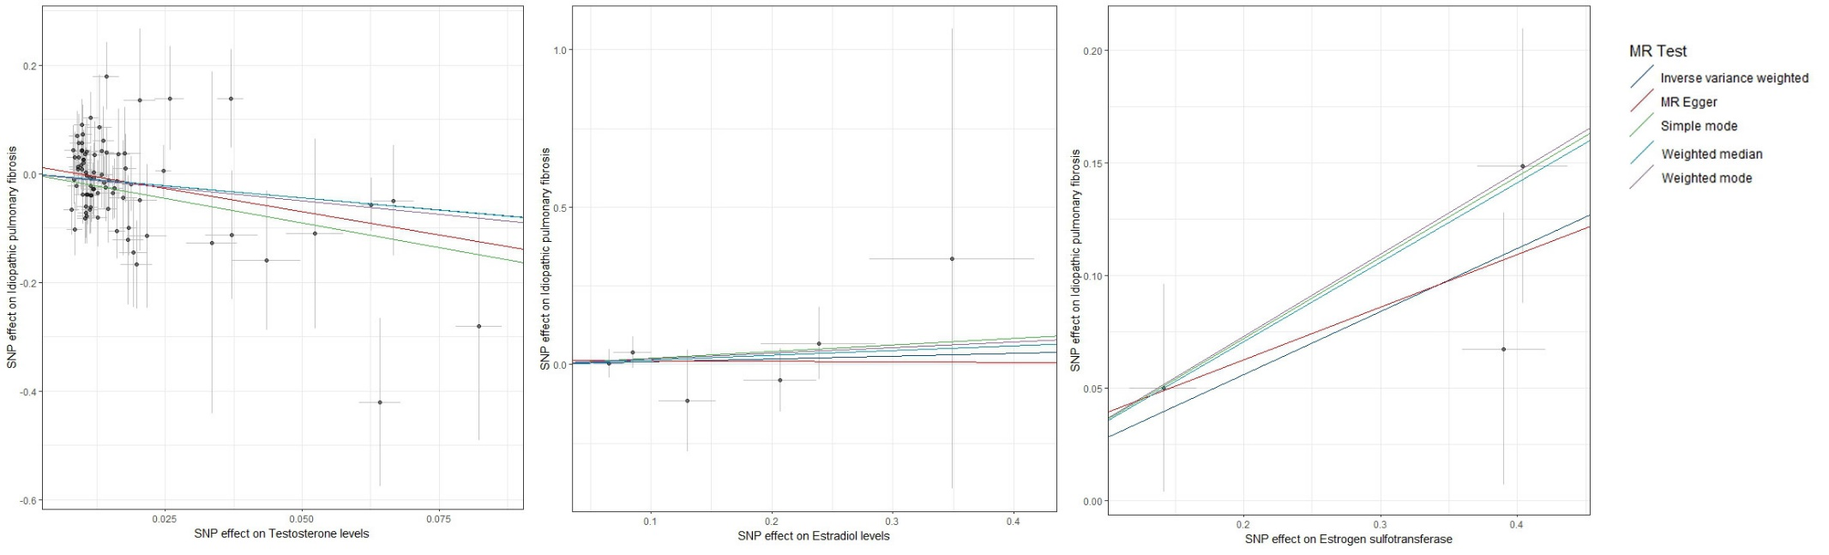
Figure S1 Scatter plots of the causal relationship between Testosterone, Estradiol, Estrogen Sulfotransferase and IPF in turn.

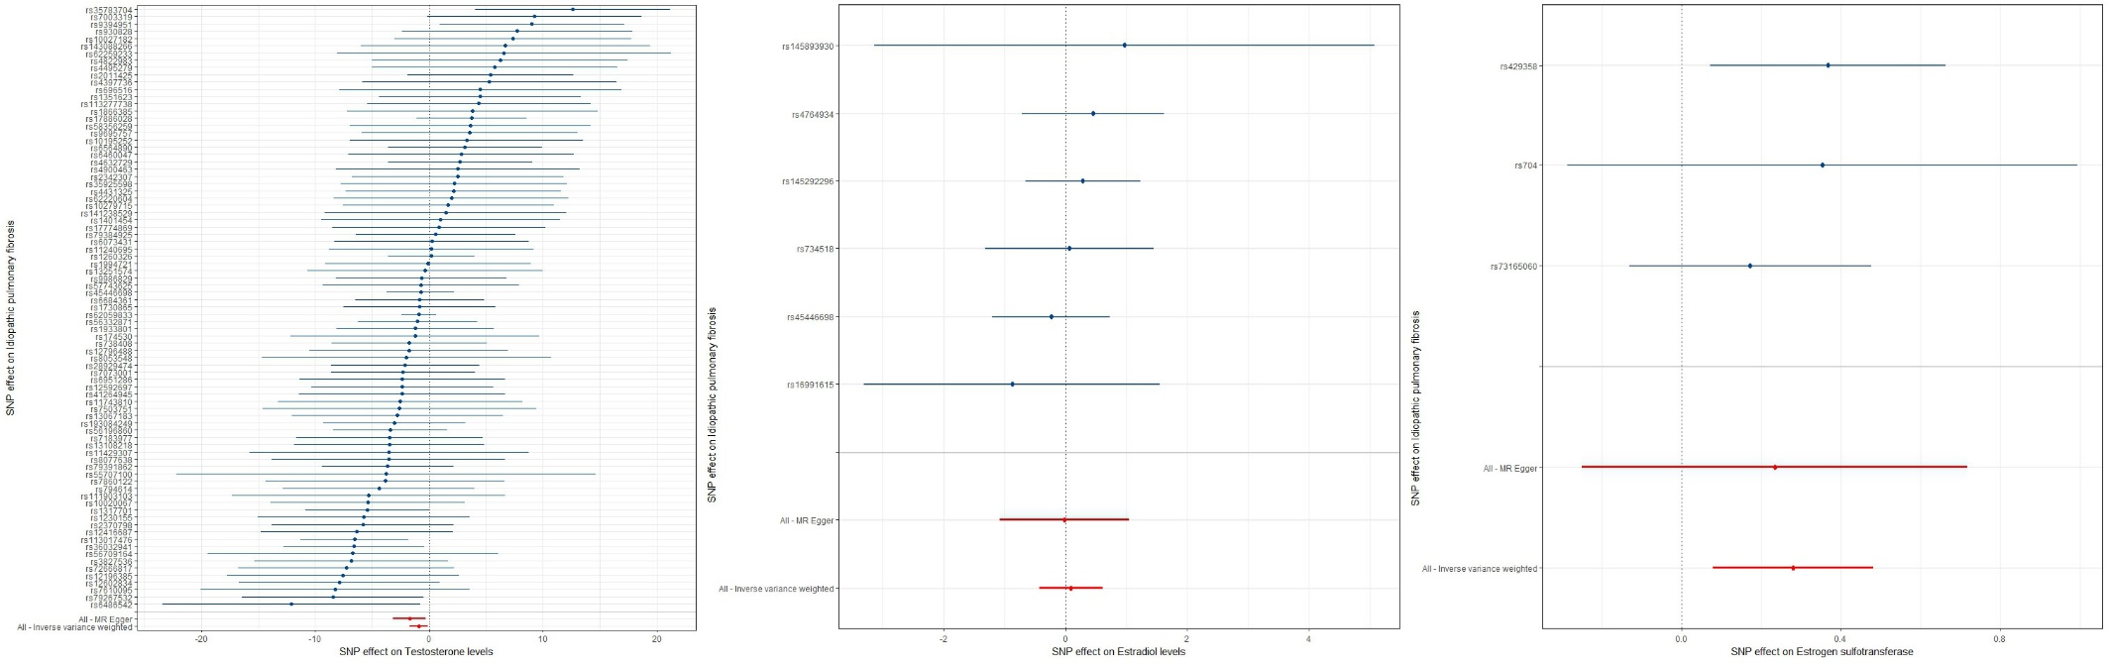
Figure S2 Forest plots of the causal relationship between Testosterone, Estradiol, Estrogen Sulfotransferase and IPF in turn.

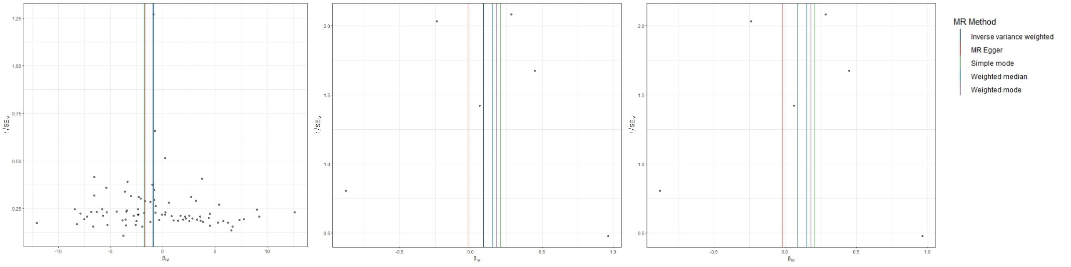
Figure S3 Funnel plots of the causal relationship between Testosterone, Estradiol, Estrogen Sulfotransferase and IPF in turn.

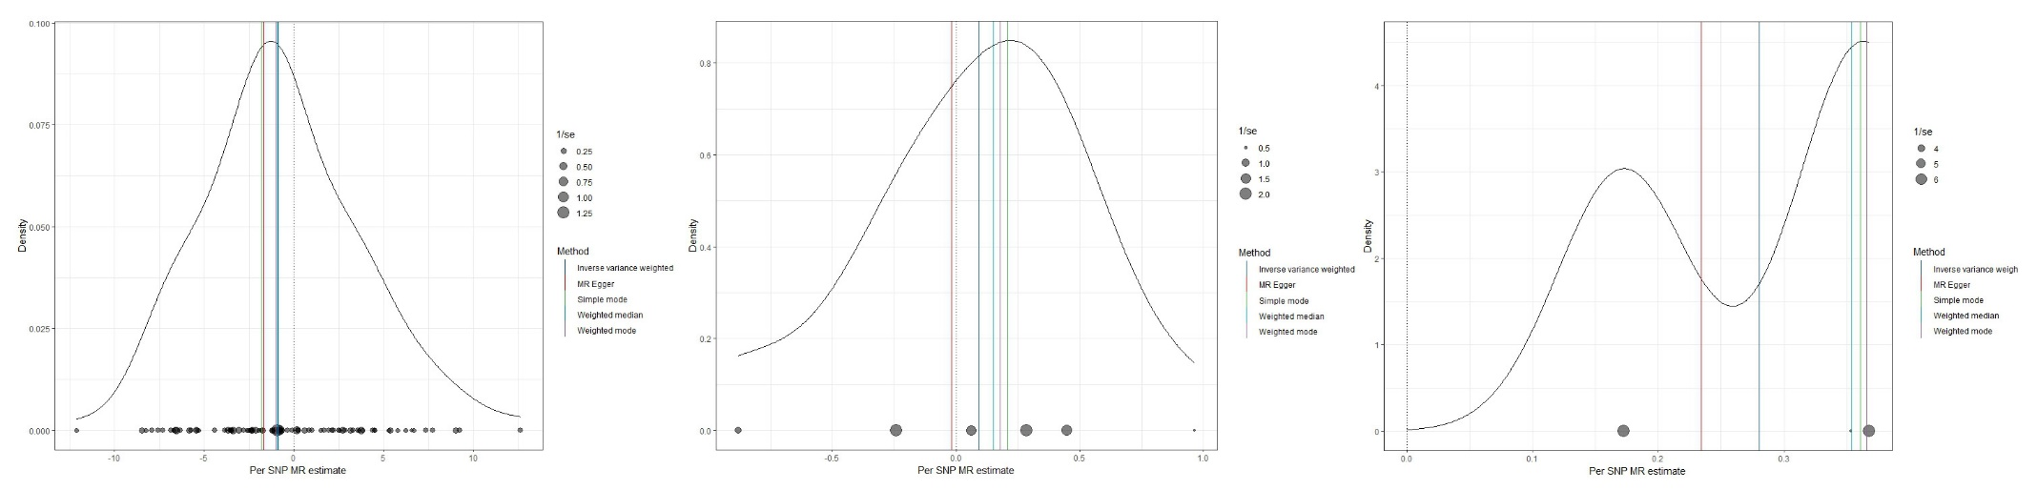
Figure S4 Density plots of the causal relationship between Testosterone, Estradiol, Estrogen Sulfotransferase and IPF in turn.

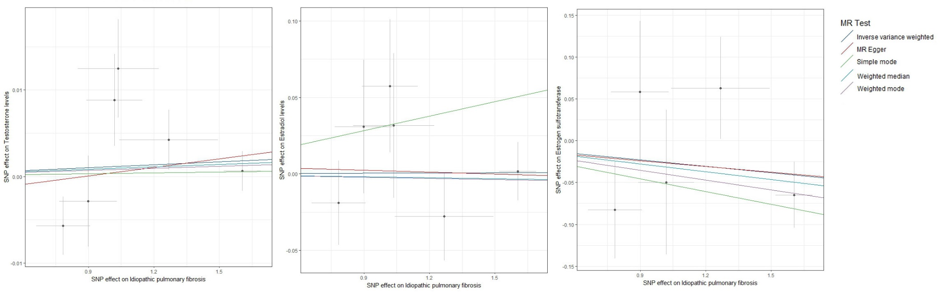
Figure S5 Scatter plots of the causal relationship between IPF in relation to Testosterone, Estradiol, and Estrogen Sulfotransferase in turn.

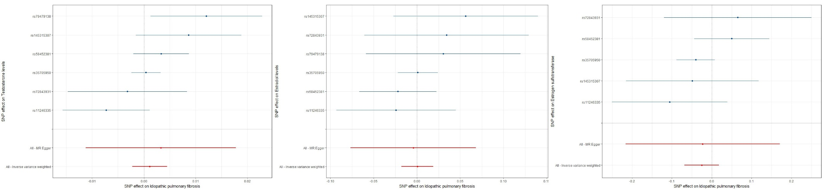
Figure S6 Forest plots of the causal relationship between IPF in relation to Testosterone, Estradiol, and Estrogen Sulfotransferase in turn.

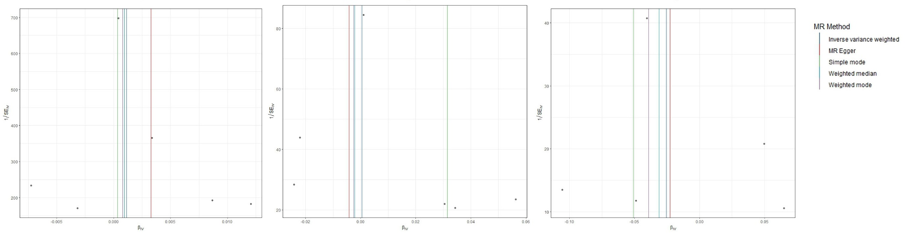
Figure S7 Funnel plots of the causal relationship between IPF in relation to Testosterone, Estradiol, and Estrogen Sulfotransferase in turn.

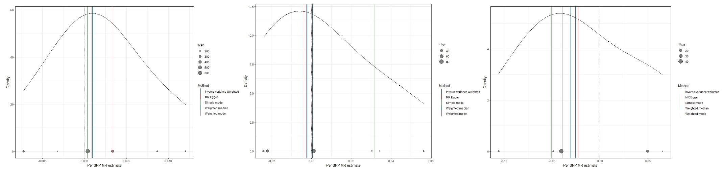
Figure S8 Density plots of the causal relationship between IPF in relation to Testosterone, Estradiol, and Estrogen Sulfotransferase in turn.

