Supplementary:
Efficient estimating and clustering Lithium-ion batteries with a deep-learning approach
Zhongxian Sun¹, Weilin He¹, Dingquan Li², Xin Geng³, Dongchen Yang⁴, Hailong Wang³, Linyu Hu⁵, Haiyan Tu¹, Xin He^{1,3*}
¹ College of Electrical Engineering, Sichuan University, Chengdu, 610065, China
² Peng Cheng Laboratory, Shenzhen, 518055, China
³School of Chemical Engineering, Sichuan University, Chengdu, 610065, China
⁴Faculty of Engineering, Architecture and Information Technology (EAIT), University of Queensland, St Lucia QLD 4072, Australia
⁵School of Microelectronics, Southern University of Science and Technology, Shenzhen, 518055, China

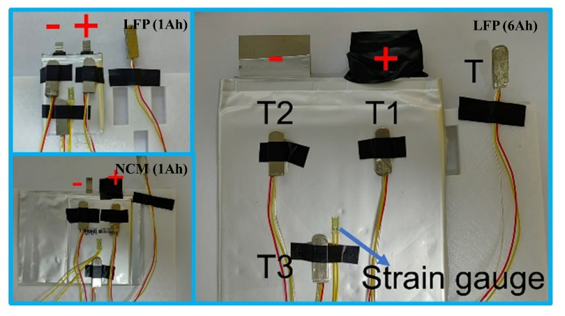
Fig. 1 Position of temperature sensors and strain sensor on battery surface.

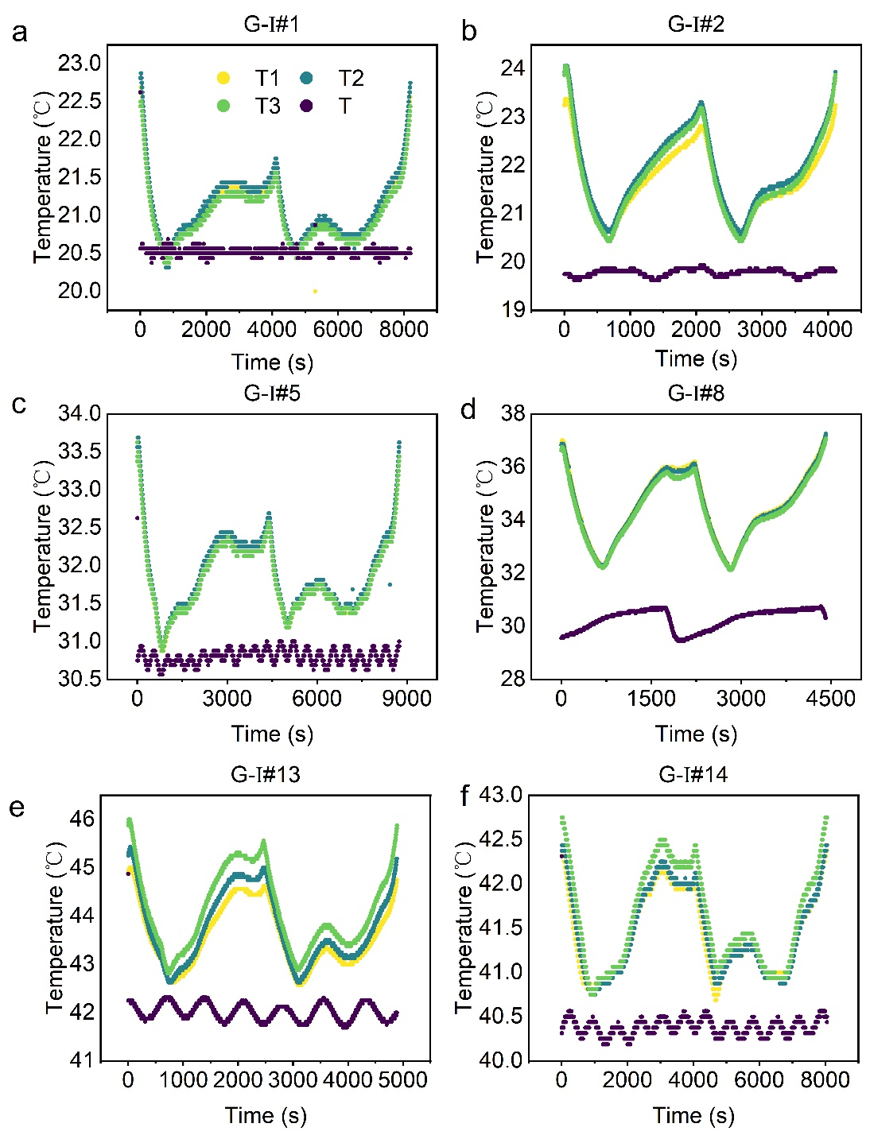
Fig. 2 Variation of T1, T2, T3 and ambient temperature for one cycle from cell G-I#1, G-I#2, G-I#5, G-I#8, G-I#13, G-I#14.
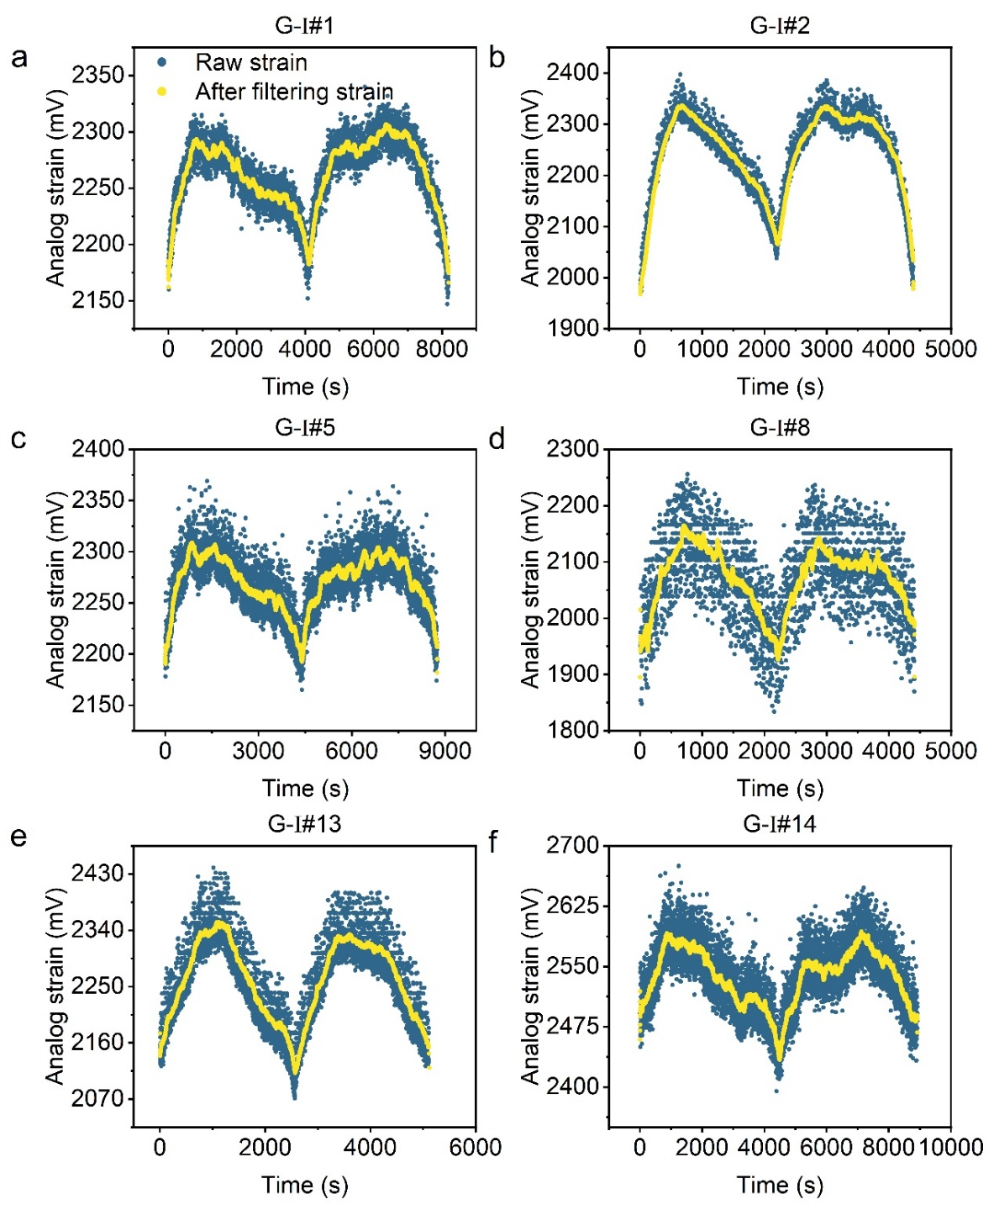
Fig. 3 Variation of analog strain for one cycle from cell G-I#1, G-I#2, G-I#5, G-I#8, G-I#13, G-I#14.
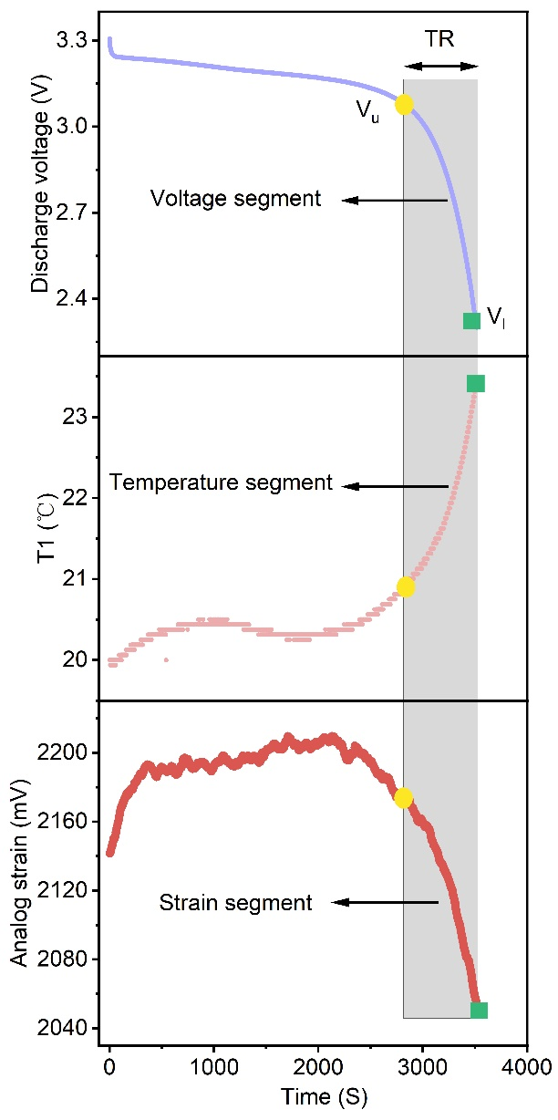
Fig. 4 The voltage, temperature and strain profiles in the voltage threshold from V_{u} to V_{l} segment.

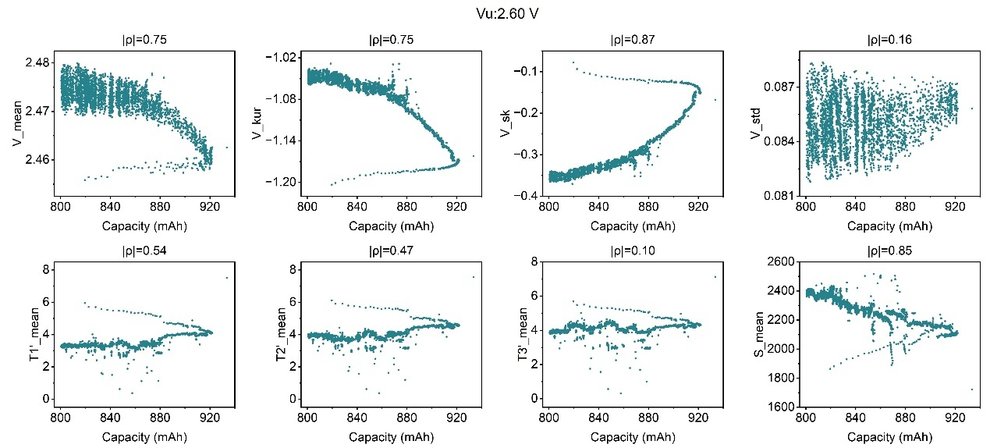
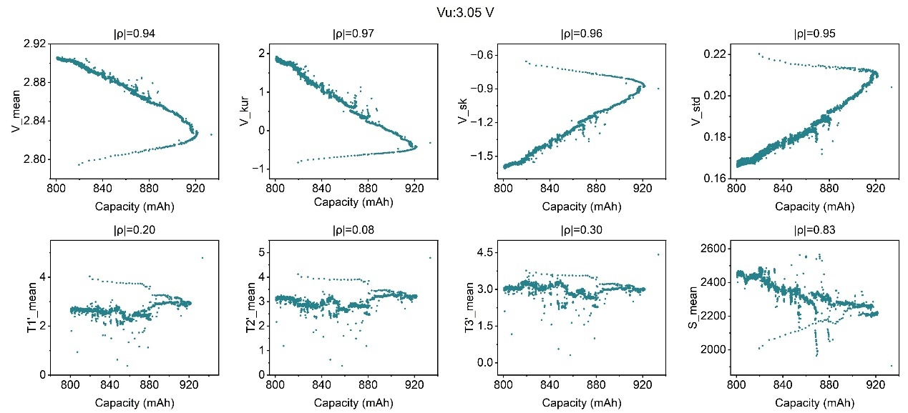
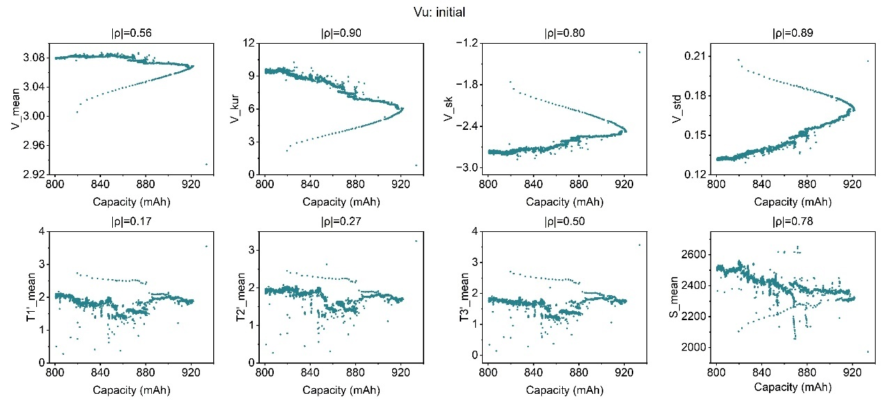
Fig. 5 The visualized correlation between capacity and relevant features and for cell G-I#2.

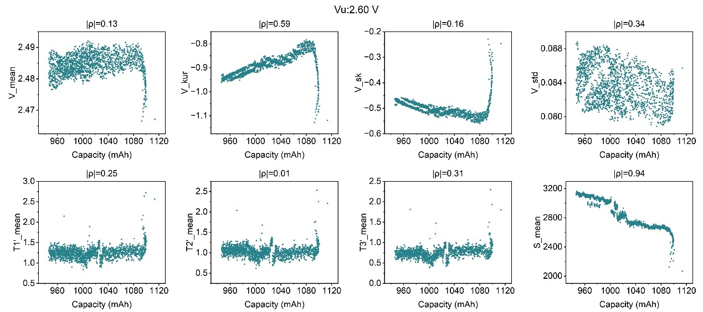
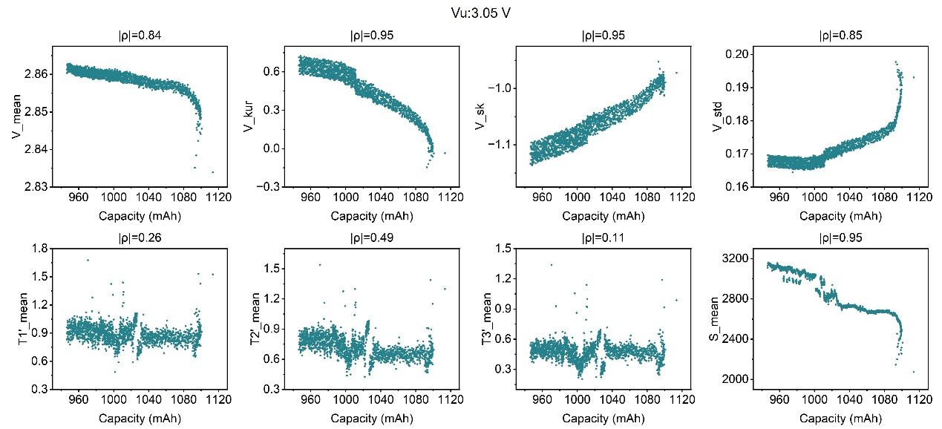
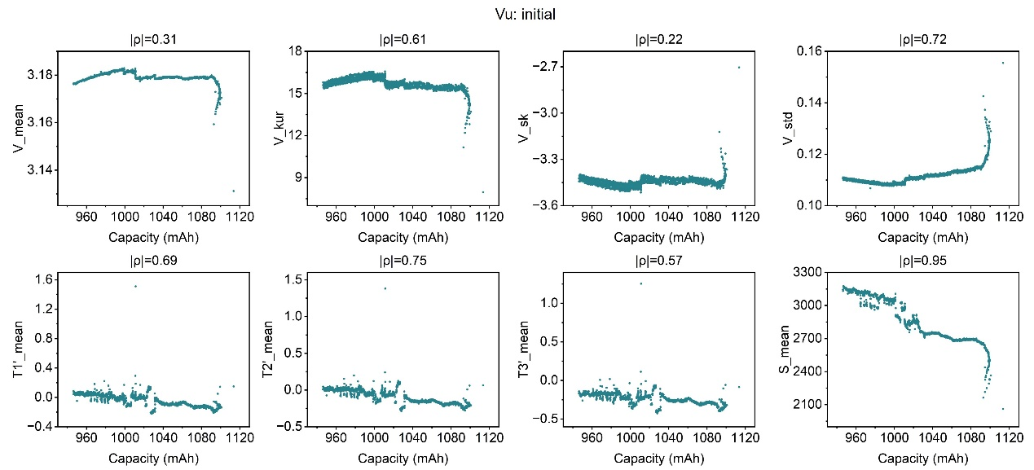
Fig. 6 The visualized correlation between capacity and relevant features and for cell G-I#5.

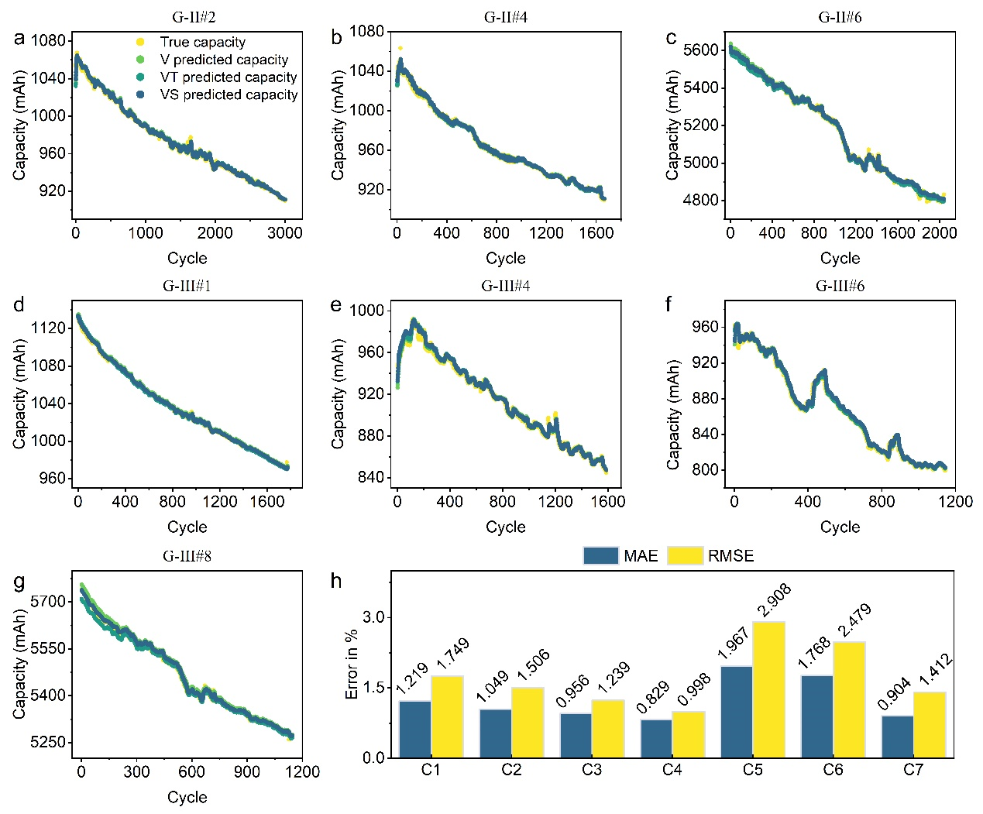
Fig. 7 G-II and G-III datasets (Supplementary Table 2) into seven categories (C) according to current rates, and estimation of the SOH in different categories. a, G-II #1, b, G-II #4, c, G-II #6, d, G-III #1, e, G-III #4, f, G-III #6, g, G-III #9 cells true and estimated capacity curves. h, the mean of MAE and RMSE in different categories using different combined features (V, VT and VS).

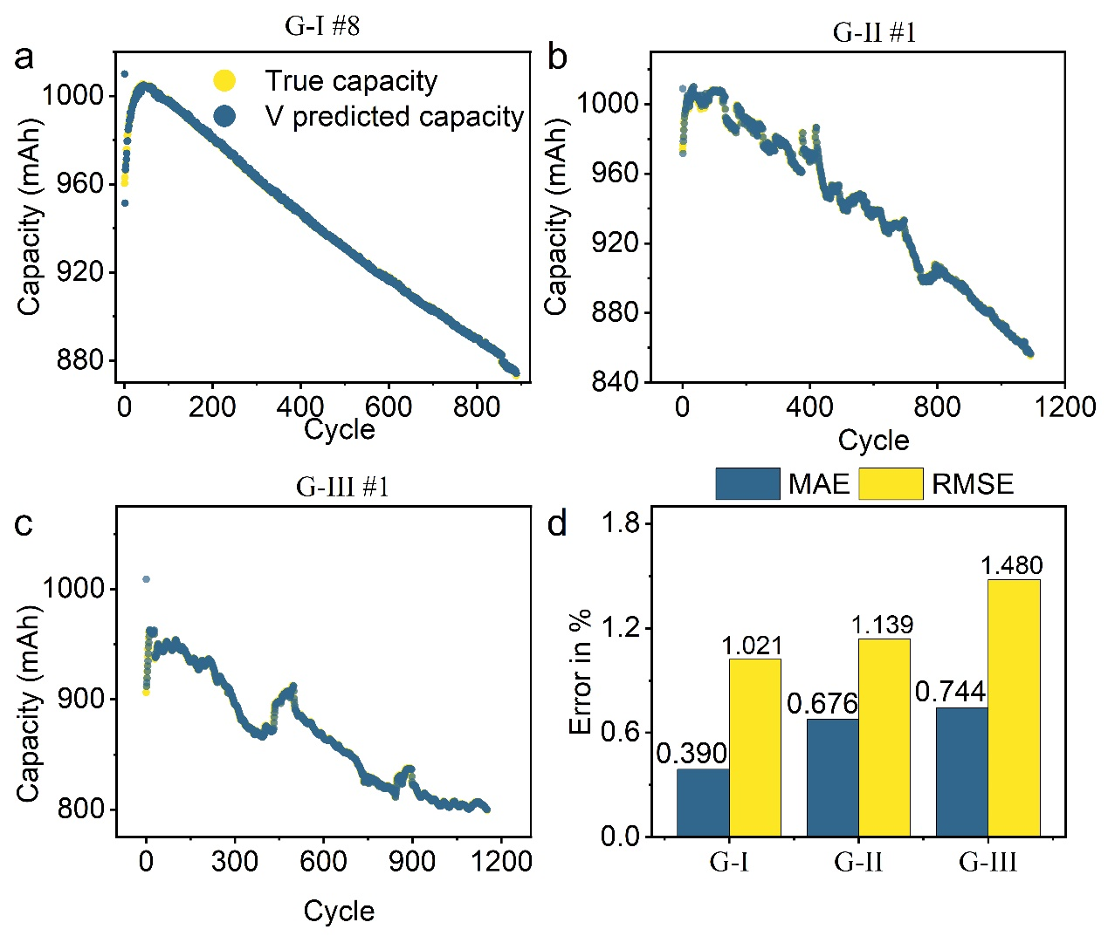
Fig. 8 The SOH estimation with one cycle datasets in the G-I, G-II, G-III as input. a, G-I#8, b, G-II #1, c, and G-III #6 cells true and estimated capacity curves using VS combined feature. d MAE and RMSE in G-I, G-II, G-III datasets using combined feature VS.
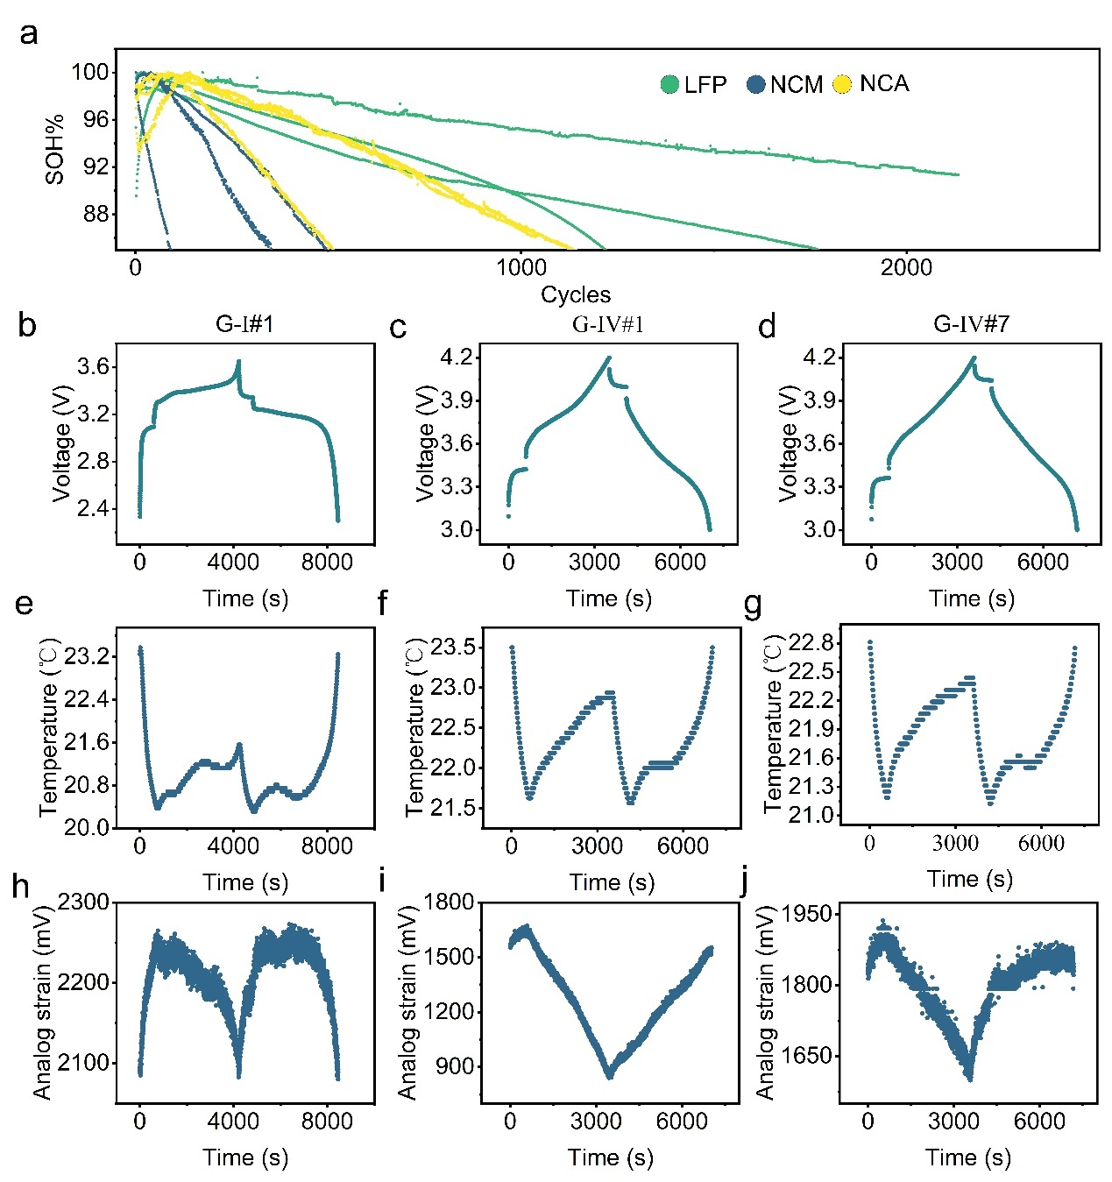
Fig. 9 The electrochemical, thermal and mechanical performance of representative LFP, NCM and NCA cells for transfer learning in our model. a, LFP (G-I#1, G-I#5, G-I#12), NCM (G-IV#1, G-IV#3, G-IV#5) and NCA (G-IV#7, G-IV#9, G-IV#11) capacity fade curve. b, G-I#1, c, G-IV#1, d, and G-IV#7 cells voltage profile in one cycle. e, G-I#1, f, G-IV#1, g, and G-IV#7 cells temperature (T1) profile in one cycle. h, G-I#1, i, G-IV#1, j, and G-IV#7 cells analog strain in one cycle.

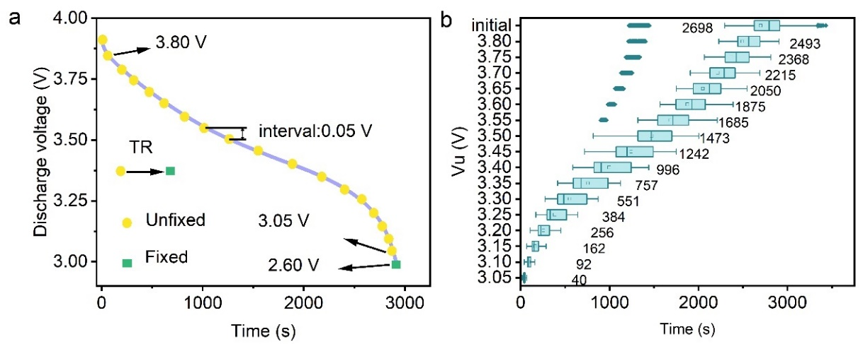
Fig. 10 Setting on threshold voltage acquisition time region for G-IV datasets. a, Design of dynamic voltage threshold in the discharging voltage profile. c, The mean value for length of time within each time region (TR).

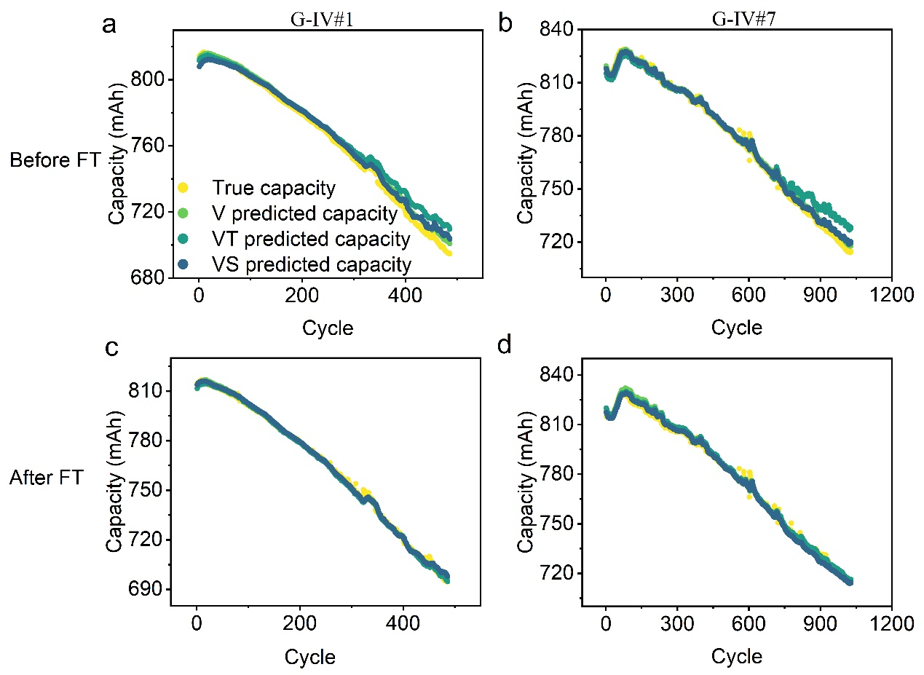
Fig. 11 The performance of SOH estimation for representative cells in G-IV with our models before and after fine-tuning. a, Estimated G-IV#1 and b, G-IV#7 cell SOH before model FT. c, Estimated G-IV#1 and d, G-IV#7 cell SOH after model FT.

Table 1. Overview for the classification of all the sample cells
Datasets | Cell type | Manufacture | Cycling temperature | Current rate(C) | Number of cells
G-I | LFP/Gr (1 Ah) | ShenZhen LiNengPai  Electronics Co.,Ltd | 20  30  40 | 1/1  2/2 | 14
G-I | LFP/Gr (6 Ah) | ShenZhen WeiNeng Electronics Co.,Ltd | 20  30  40 | 1/1  2/2 | 14
G-II | LFP/Gr (1 Ah) | ShenZhen LiNengPai  Electronics Co.,Ltd | Varying room temperature (20~40) | 1/1  2/2 | 10
G-II | LFP/Gr (6 Ah) | ShenZhen WeiNeng Electronics Co.,Ltd | Varying room temperature (20~40) | 1/1  2/2 | 10
G-III | LFP/Gr (1 Ah) | ShenZhen LiNengPai  Electronics Co.,Ltd | Varying room temperature (20~40) | 0.5/0.5  0.5+1/2  4/4 | 10
G-III | LFP/Gr (6 Ah) | ShenZhen WeiNeng Electronics Co.,Ltd | Varying room temperature (20~40) | 0.5/0.5  0.5+1/2  4/4 | 10
G-IV | NCM622/APG (1Ah)  NCA/MCG (1Ah) | Lab-assembled | 20  30  40 | 1/1 | 12

Table 2. Details of each cell, including electrode material, operating conditions, cut-off voltages, sample sizes (cycle number), SOH at the end of cycling.
Cell name | Type and nominal capacity (Ah) | Current Rate (C) | Cycling temperature | cut-off  voltage (V) | Sample size | SOH  (%)
G-I#1 | LFP (1Ah) | 1/1 | 20℃ | 3.65-2.30 | 2134 | 91.3
G-I#2 | LFP (1Ah) | 2/2 | 20℃ | 3.65-2.30 | 3347 | 85.7
G-I#3 | LFP (6Ah) | 1/1 | 20℃ | 3.65-2.30 | 2532 | 85.4
G-I#4 | LFP (6Ah) | 1/1 | 20℃ | 3.65-2.30 | 2630 | 90.0
G-I#5 | LFP (1Ah) | 1/1 | 30℃ | 3.65-2.30 | 1771 | 84.9
G-I#6 | LFP (1Ah) | 1/1 | 30℃ | 3.65-2.30 | 1064 | 85.0
G-I#7 | LFP (1Ah) | 2/2 | 30℃ | 3.65-2.30 | 1841 | 84.9
G-I#8 | LFP (1Ah) | 2/2 | 30℃ | 3.65-2.30 | 894 | 84.9
G-I#9 | LFP (6Ah) | 1/1 | 30℃ | 3.65-2.30 | 2753 | 85.0
G-I#10 | LFP (6Ah) | 1/1 | 30℃ | 3.65-2.30 | 3221 | 85.0
G-I#11 | LFP (6Ah) | 1/1 | 30℃ | 3.65-2.30 | 2696 | 85.6
G-I#12 | LFP (1Ah) | 1/1 | 40℃ | 3.65-2.30 | 1223 | 84.9
G-I#13 | LFP (1Ah) | 2/2 | 40℃ | 3.65-2.30 | 1078 | 84.8
G-I#14 | LFP (6Ah) | 1/1 | 40℃ | 3.65-2.30 | 1515 | 84.9
G-II#1 | LFP (1Ah) | 1/1 | Room | 3.65-2.30 | 1097 | 84.8
G-II#2 | LFP (1Ah) | 1/1 | Room | 3.65-2.30 | 3015 | 85.2
G-II#3 | LFP (1Ah) | 1/1 | Room | 3.65-2.30 | 2015 | 87.0
G-II#4 | LFP (1Ah) | 2/2 | Room | 3.65-2.30 | 1678 | 85.6
G-II#5 | LFP (1Ah) | 2/2 | Room | 3.65-2.30 | 2357 | 84.9
G-II#6 | LFP (6Ah) | 1/1 | Room | 3.65-2.30 | 2053 | 85.0
G-II#7 | LFP (6Ah) | 1/1 | Room | 3.65-2.30 | 2146 | 86.1
G-II#8 | LFP (6Ah) | 1/1 | Room | 3.65-2.30 | 2175 | 85.5
G-II#9 | LFP (6Ah) | 1/1 | Room | 3.65-2.30 | 2244 | 85.2
G-II#10 | LFP (6Ah) | 1/1 | Room | 3.65-2.30 | 2211 | 85.6
G-III#1 | LFP (1Ah) | 0.5/0.5 | Room | 3.65-2.30 | 1787 | 85.6
G-III#2 | LFP (1Ah) | 0.5/0.5 | Room | 3.65-2.30 | 1733 | 86.5
G-III#3 | LFP (1Ah) | 0.5/0.5 | Room | 3.65-2.30 | 1645 | 86.3
G-III#4 | LFP (1Ah) | 0.5+1/2 | Room | 3.30+3.65-2.30 | 1601 | 85.1
G-III#5 | LFP (1Ah) | 0.5+1/2 | Room | 3.30+3.65-2.30 | 1280 | 85.1
G-III#6 | LFP (1Ah) | 4/4 | Room | 3.65-2.30 | 1157 | 77.0
G-III#7 | LFP (1Ah) | 4/4 | Room | 3.65-2.30 | 1093 | 78.3
G-III#8 | LFP (6Ah) | 0.5/0.5 | Room | 3.65-2.30 | 1702 | 84.8
G-III#9 | LFP (6Ah) | 0.5/0.5 | Room | 3.65-2.30 | 2379 | 85.3
G-III#10 | LFP (6Ah) | 0.5/0.5 | Room | 3.65-2.30 | 2441 | 85.1
G-IV#1 | NCM622 (1Ah) | 1/1 | 20℃ | 4.20-3.00 | 500 | 85.0
G-IV#2 | NCM622 (1Ah) | 1/1 | 20℃ | 4.20-3.00 | 592 | 78.8
G-IV#3 | NCM622 (1Ah) | 1/1 | 30℃ | 4.20-3.00 | 350 | 84.9
G-IV#4 | NCM622 (1Ah) | 1/1 | 30℃ | 4.20-3.00 | 545 | 85.8
G-IV#5 | NCM622 (1Ah) | 1/1 | 40℃ | 4.20-3.00 | 97 | 84.9
G-IV#6 | NCM622 (1Ah) | 1/1 | 40℃ | 4.20-3.00 | 96 | 84.3
G-IV#7 | NCA (1Ah) | 1/1 | 20℃ | 4.20-3.00 | 1043 | 87.0
G-IV#8 | NCA (1Ah) | 1/1 | 20℃ | 4.20-3.00 | 960 | 85.4
G-IV#9 | NCA (1Ah) | 1/1 | 30℃ | 4.20-3.00 | 1146 | 84.8
G-IV#10 | NCA (1Ah) | 1/1 | 30℃ | 4.20-3.00 | 722 | 84.7
G-IV#11 | NCA (1Ah) | 1/1 | 40℃ | 4.20-3.00 | 522 | 84.7
G-IV#12 | NCA (1Ah) | 1/1 | 40℃ | 4.20-3.00 | 427 | 85.1
The C rate is calculated base on the nominal capacity.

Table 3. Training and testing dataset for battery SOH estimation with single feature.
Cell name | Dataset
G-I#1 | Testing
G-I#2 | Training
G-I#5 | Training
G-I#6 | Testing
G-I#7 | Training
G-I#8 | Training
G-I#12 | Testing
G-I#13 | Training

Table 4. Sample classification in G-I dataset for K-fold cross-validation
K-fold cross-validation | Test dataset cell name
K1 | G-I#1
K1 | G-I#9
K2 | G-I#2
K2 | G-I#8
K3 | G-I#3
K3 | G-I#10
K4 | G-I#4
K4 | G-I#11
K5 | G-I#5
K5 | G-I#14
K6 | G-I#6
K6 | G-I#12
K7 | G-I#7
K7 | G-I#13

Table 5. Classification for the training and testing dataset in G-I, G-II and G-III into seven categories (C) with sample size.
Group name |  |  | Dataset | Sample size
G-I |  |  | training | 28699
G-II | C 1 | G-II#1 | testing | 6127
G-II | C 1 | G-II#2 | testing | 6127
G-II | C 1 | G-II#3 | testing | 6127
G-II | C 2 | G-II#4 | testing | 4035
G-II | C 2 | G-II#5 | testing | 4035
G-II | C 3 | G-II#6 | testing | 10829
G-II | C 3 | G-II#7 | testing | 10829
G-II | C 3 | G-II#8 | testing | 10829
G-II | C 3 | G-II#9 | testing | 10829
G-II | C 3 | G-II#10 | testing | 10829
G-III | C 4 | G-III#1 | testing | 5165
G-III | C 4 | G-III#2 | testing | 5165
G-III | C 4 | G-III#3 | testing | 5165
G-III | C 5 | G-III#4 | testing | 2881
G-III | C 5 | G-III#5 | testing | 2881
G-III | C 6 | G-III#6 | testing | 2250
G-III | C 6 | G-III#7 | testing | 2250
G-III | C 7 | G-III#8 | testing | 2441
G-III | C 7 | G-III#9 | testing | 2441
G-III | C 7 | G-III#10 | testing | 2441

Table 6 Classification of training and testing dataset in G-I, G-II and G-III dataset.
Cell name |  | Dataset
G-I | G-I #1 | Testing
G-I | G-I #2 | Training
G-I | G-I #3 | Testing
G-I | G-I #4 | Training
G-I | G-I #5 | Training
G-I | G-I #6 | Testing
G-I | G-I #7 | Training
G-I | G-I #8 | Testing
G-I | G-I #9 | Testing
G-I | G-I #10 | Training
G-I | G-I #11 | Training
G-I | G-I #12 | Training
G-I | G-I #13 | Training
G-I | G-I #14 | Training
G-II | G-II #1- | Testing
G-II | G-II #2 | Training
G-II | G-II #3 | Training
G-II | G-II #4 | Testing
G-II | G-II #5 | Training
G-II | G-II #6 | Testing
G-II | G-II #7 | Training
G-II | G-II #8 | Training
G-II | G-II #9 | Testing
G-II | G-II #10 | Training
G-III | G-III #1 | Testing
G-III | G-III #2 | Training
G-III | G-III #3 | Training
G-III | G-III #4 | Testing
G-III | G-III #5 | Training
G-III | G-III #6 | Testing
G-III | G-III #7 | Training
G-III | G-III #8 | Training
G-III | G-III #9 | Testing
G-III | G-III 10 | Training

Table 7. Classification of FT dataset and test dataset in G-IV datasets.
Cell name |  | Dataset | Sample size
G-IV | G-IV#2 | FT | 1233
G-IV | G-IV#4 | FT | 1233
G-IV | G-IV#6 | FT | 1233
G-IV | G-IV#1 | Test | 947
G-IV | G-IV#3 | Test | 947
G-IV | G-IV#5 | Test | 947
G-IV | G-IV#8 | FT | 2109
G-IV | G-IV#10 | FT | 2109
G-IV | G-IV#12 | FT | 2109
G-IV | G-IV#7 | Test | 2711
G-IV | G-IV#11 | Test | 2711
G-IV | G-IV#9 | Test | 2711

Supplementary Note 1.
Datasets
We cycled a total of 46 pouch lithium-ion batteries using the NEWARE test equipment and combined sensors to monitor the thermal and mechanical features of the cycling process, as shown in Fig. 1. The 46 cells are classified into four groups (G-I, G-II, G-III, G-IV) datasets, and the electrochemical test is proceeded by NEWARE Battery Test System (MIHW-200-160CH-B, Shenzhen, China), as shown in Table 1. Temperature sensors are placed in the following positions: T1 locates below the positive plate lug and at around 15% position of the cell, T2 locates below the negative plate lug and at around 15% position of the cell, and T3 locates at half centimeter away from the bottom left corner of strain sensor. The stain sensor is located at the geometric center of each cell. The naming and operating details for each cell are shown in Table 2.
Cell assembling
Laboratory assembled pouch cells were made through drying, liquid injection, encapsulation and formation process. The free-electrolyte pouch cells (Dongguan Detai Energy Co., Ltd) were first dried in a vacuum chamber using 60 °C for over 720 minutes, then 3 ml liquid electrolyte (1 M LiPF₆ in 1:1 (wt%) ethylene carbonate (EC): dimethyl carbonate (DEC) from Duoduo Chemical Co., Ltd.) was injected and encapsulated at 180°C under the pressure of 94 Kpa. After the encapsulation process, the cells were laying-aside for over 600 minutes. 3 formation cycle was performed with the constant charge and discharge current of 0.1C, 30 minutes relaxation in between the charging and discharging process.

Supplementary Note 2. K-fold cross-validation.
14 cells in the G-I dataset were selected to carry out K-fold cross-validation (which was divided into seven folds. Twelve cells used as the train dataset and the remaining cells as the test dataset for each fold. The classification is listed in Table 4.

Supplementary Note 3. SOH prediction with one previous cycle.
We use the combined feature VS to estimate the battery SOH in G-I, G-II and G-III, where the input is dataset from one previous cycle and the output is the capacity of the next cycle. The training and testing datasets are shown in Table 6.

Supplementary Note 4. G-IV dataset extract features.
The V_{l} is fixed at the discharging cutoff voltage (3.00 V), and the V_{u} includes initial discharge voltage and sliding values within a sliding region of 3.05 V - 3.80 V with interval of 0.05 V. Therefore, the TR is determined by V_{u}, the length of each TR for the experimental samples corresponding to G-IV dataset is collected. When V_{u} reaches 3.25 V, it best matches the TR extracting features to train the base model in the G-I dataset. Therefore, the voltage range for extracting features for the G-IV dataset is from 3.00 V to 3.25 V.

