Supplementary Information
Supplementary Methods
Supplementary methods for the point location experiment
Supplementary methods for creation of the cardiac models
Optic scanning of the cardiac models for the reference measurements

Supplementary Figure S1. Diagram of the point location measurement
Supplementary Figure S2. The circular model for the point location measurement
Supplementary Figure S3. Superimposition of volume-rendered and surface images of the circular model
Supplementary Figure S4. Measurement of the circular model
Supplementary Figure S5. Comparison of point location accuracy between MPR and IMVR
Supplementary Figure S6. Image post-processing and segmentation for 3D printing of the cardiac models
Supplementary Figure S7. CT scanning of the cardiac models
Supplementary Figure S8. Normal aortic root geometry to be measured
Supplementary Figure S9. Outer curvature lengths of coronary arteries
Supplementary Figure S10. Direct volume-rendering visualization

Supplementary Table S1. Point location accuracy of IMVR and MPR
Supplementary Table S2. Inter-vertices distance of the polygonal surface mesh
Supplementary Table S3. Results of the measurement of the base tags comprised 5-mm intervals
Supplementary Table S4. Bias and Limit of agreement of Bland-Altman analysis of coronary artery measurements
Supplementary Table S5. Intra-observer reliability of IMVR and CPR
Supplementary Table S6. Inter-observer reliability of IMVR and CPR
Supplementary Table S7. Measurement speeds of IMVR and CPR
Supplementary Table S8. Measurement speed of IMVR and CPR on a trial-by-trial basis

Supplementary Methods
Supplementary methods for the point location experiment
Circular model study design
Supplementary Figure S1 shows a schematic diagram of this study. A circular model was manufactured for the point location accuracy experiment. The model was scanned using computed tomography (CT), and the images were processed for viewing and measurement. The spatial coordinates of all marker-points placed in the multiplanar reformation (MPR) and separately in isosurface measurement on volume-rendered images (IMVR) were calculated by a single observer (K. K., an experienced cardiac surgeon) and compared with the reference data made with optic-scanning measurements by another single-blinded operator (H. F.).

Creation of the circular model
The circular model was designed using computer-aided design (CAD) software (Autodesk Fusion 360 Software, version 2.0.16490), as shown in Supplementary Figure S2. The model was 150 mm in diameter to simulate the cardiovascular anatomical scale. There were 57 small pits for landmarks evenly spaced at 10-mm intervals in circles on the disk surface and one on the tip of a small post. The circular model is constructed of rigid polyoxymethylene plastic.

Image data acquisition and reconstruction of the circular model using a super high-resolution CT scanner
Image data were obtained for all the models on a 160-row multidetector CT scanner (Aquilion Precision, Canon Medical Systems, Otawara, Tochigi, Japan) in a super high-resolution mode with the following data acquisition and reconstruction parameters: tube voltage = 120 kVp, tube current-time product = 75 mAs, reconstruction slice thickness and increments = 0.25 mm, reconstruction field of view = 170 mm, and reconstruction kernel = FC04 (standard).

Image generation for IMVR
The flowchart in Supplementary Figure S3 shows the visualization framework for IMVR. Image generation for IMVR consisted of (1) the optimal window settings (“presets” illustrated in Online Resource 12) for direct volume-rendering, (2) the stepwise surface segmentation using Ziostation2 (Ziosoft Inc., Tokyo, Japan), (3) quality assurance of the segmented surface data in Standard Tessellation Language (STL) format, and (4) the superimposition of volume- and surface-rendered images in Vesalius3D (PS Tech, Amsterdam, the Netherlands). The same steps were followed for the cardiac models. After qualitative image evaluations of several segmented datasets derived from different thresholds, the optimal cutoff values of CT attenuation that presented the best surface image were selected: WL, 250 HU; and WW, 600 HU. The triangular distances of the polygon mesh vertices calculated using MATLAB (MathWorks Inc., Natick, MA, USA) are listed in Supplementary Table S2. Once the optimal window settings were determined, the surface data of the model were generated for the subsequent three-dimensional (3D) measurement analysis.

Display in multiplanar reformatted images
The CT Digital Imaging and Communications in Medicine (DICOM) file of the circular model was imported into Ziostation2. The multiplanar window displayed the three orthogonal planes of the sagittal, coronal, and axial slices.

Measurements on the circular model
To measure 58 landmarks consisting of the centers of 57 pits and tip of the small post using either the MPR or IMVR technique, the observer must initially identify the center of every pit (and the tip of the small post) and then use a “widget” to place marker-points accurately on every landmark. Finally, the image processing system automatically registers the spatial coordinates. All the measurements were performed by a single observer.

IMVR. As illustrated in Supplementary Figure S4, the point location task required rudimentary manipulations of the 3D widget to place marker-points. A “widget” in this context is a software component acting as an intermediary between the input-method (such as a computer mouse) and the image in dataspace [6,7,9]. Various widgets are available for manipulating images, including those for moving or changing the magnification of a 3D image, and in this study, a point-widget served to place marker-points on features of interest; finding an appropriate orientation of the target region required translation and rotation performed with a regular computer mouse. The image magnification was adjusted by pressing the right mouse button and moving the mouse up or down. To place a marker-point, the cursor was placed on the target, and the left mouse button was double-clicked.

MPR. In MPR, the observer identified all landmarks using multiplanar views (Supplementary Fig. S4). The positioning of each marker-point required two sequential actions: translation in the (x, y) plane, followed by translation in the z-direction. If necessary, the observer accessed the volume-rendered image to verify the orientation.

Optic scanning for the reference measurements
The model was scanned using a high-resolution optical 3D scanner (VL-500; Keyence, Osaka, Japan), as shown in Supplementary Figure S2. The operator placed marker-points at the 58 landmarks on the circular model using the point position measurement tool of the VL-500 Series software application (Keyence, Osaka, Japan). Each marker-point was positioned at the specified location using mouse clicks, and the software registered the locations.

Precision analysis
The coordinates of all 58 landmarks on the disk were exported and analyzed using MATLAB. Because the three different data groups had different spatial coordinate systems, a transformation of the MPR and IMVR coordinates was required to place all coordinates into the same frame of reference. A coordinate transformation matrix was calculated using six landmarks: the center point, four outermost points, and the tip of the post. Next, for each of the 52 landmarks (excluding six landmarks for calculating the coordinate transformation matrix), the Euclidean distance between the position measured using MPR and that measured by optical scanning as a reference was calculated. Similarly, the Euclidean distance was measured between the position in IMVR and reference values. Finally, the root mean square distance was calculated from these distances to assess position measurement accuracy.

Supplementary methods for creation of the cardiac models
Cardiac CT image acquisition for 3D printing of the cardiac models
Retrospectively, electrocardiographic-gated cardiac CT scans were acquired using a 320-slice multidetector CT scanner (Aquilion ONE, Canon Medical Systems, Otawara, Japan), with a tube voltage of 120 kVp, tube current-time product of 700 mAs with dose modulation, and slice thickness and increments of 0.5 mm. An intravenous contrast medium (50 ml Omnipaque; GE Healthcare, Princeton, NJ, USA) was administered (3.5 ml/s) through a peripheral intravenous catheter. The imaging data were reconstructed using an institutional standard convolution kernel at a relative point corresponding to 75% of the R-to-R wave interval in the mid-diastolic phase. Pixel spacing was 0.29 × 0.29 mm, with an image matrix of 512 × 512 and a field of view of 150 mm.

Image post-processing and segmentation of CT images for 3D printing
As illustrated in Supplementary Figure S6, CT datasets in DICOM format were transferred to a CT workstation (Ziostation2; Ziosoft Inc., Tokyo, Japan) for image post-processing and segmentation. A semiautomatic approach was used to separate the contrast-enhanced aortic root and coronary artery lumen from the surrounding noncardiac structures. The blood pool in the left ventricular outflow tract, aortic root, proximal part of the ascending aorta, and coronary arteries were manually segmented based on the threshold values determined for each patient to include contrast opacification. The blood pool mask was carefully edited to exclude the left atrium and ventricles. To create a luminal model that closely approximated the shape of the aortic root, the blood pool was extended outward 1 mm from the surface. After extrusion, the blood pool was removed from the aortic walls. The segmented volume masks were saved as STL files and imported into Magics RP software (version 27.0; Materialize, Leuven, Belgium) for further STL processing, including smoothing and correcting discontinuities with mesh errors. A base tag marked at 5-mm intervals for calibration was designed in the CAD software and added to each model by the Boolean modifier in the Magics RP software.

3D printing of the cardiac models
The 3D printed models, shown in Figure 2, were fabricated using Polyjet technology, a multimaterial 3D printer (J826 Prime; Stratasys, Inc. Rehovot, Israel) with a 27-μm printing resolution. For adequate stability in image acquisition by optic and CT scanning, acrylic resin composed of RGD825 VeroUltra™White and FLX935 Agilus30™ (Stratasys, Inc. Rehovot, Israel) materials with rigid and opaque characteristics were used for 3D printing. The printed models were placed in a water bath to remove the support material. After each model was dried, radiopaque markers of 0.3-mm diameter were glued precisely onto the surface. Finally, thin lines were drawn between the markers using a fine mechanical pencil (Staedtler Mars, Nürnberg, Germany). These markers and lines were used as landmarks to ensure that the optical and CT scans identified the same locations.

Optic scanning of the cardiac models for the reference measurements
Scanning protocol
To obtain reference measurements of all the features, all the models were scanned using a high-resolution optical 3D scanner (VL-500; Keyence, Osaka, Japan). The scanner was calibrated before use, using the Keyence’s VL series calibration board (OP-88145, Keyence, Osaka, Japan). For high-definition imaging, the measurement settings were adjusted manually. (1) The stage angle was adjusted such that the section of the target to be measured was vertically below the light emitter/receiver. (2) Multiple scanning modes were used in all directions (rotating the stage by 360°) for composite image capture. (3) The image resolution and magnification were adjusted to the highest settings, in which mode the measurement accuracy and repeatability increase to ± 10 µm and ± 2 µm, respectively. Measurement values were specified using the default standard gauge of the Keyence scanner at normal ambient operating temperature and humidity (https://www.keyence.com/products/measure-sys/3d-scanner/vl/models/vl-500/).

Measurement protocol
The optically scanned image data were measured using the VL-500 Series software application (Keyence, Osaka, Japan), which registers and integrates 3D coordinates in optically scanned 3D images. Two operators (Y.M. and S.T., both experienced cardiac surgeons), blinded to the other feature dimensions, measured all cardiac models three times. When measuring the surfaces of the cardiac models, a specified measurement tool was used: a cross-sectional image was initially extracted, and a line-segment tool that connects multiple points on the displayed cross-sectional image was implemented. The operators were instructed to place the points along the features by mouse click, the profile line appearing with cursor movements, and ending with a double click. The abovementioned procedure resulted in six measurements (three per operator) for each anatomical feature. The maximum and minimum values were removed from the six measurements, and the remaining four measurements were averaged to obtain the reference values.

Supplementary Figure S1. Diagram of the point location measurement
IMVR, isosurface measurement on volume-rendered images; MPR, multiplanar reformation.

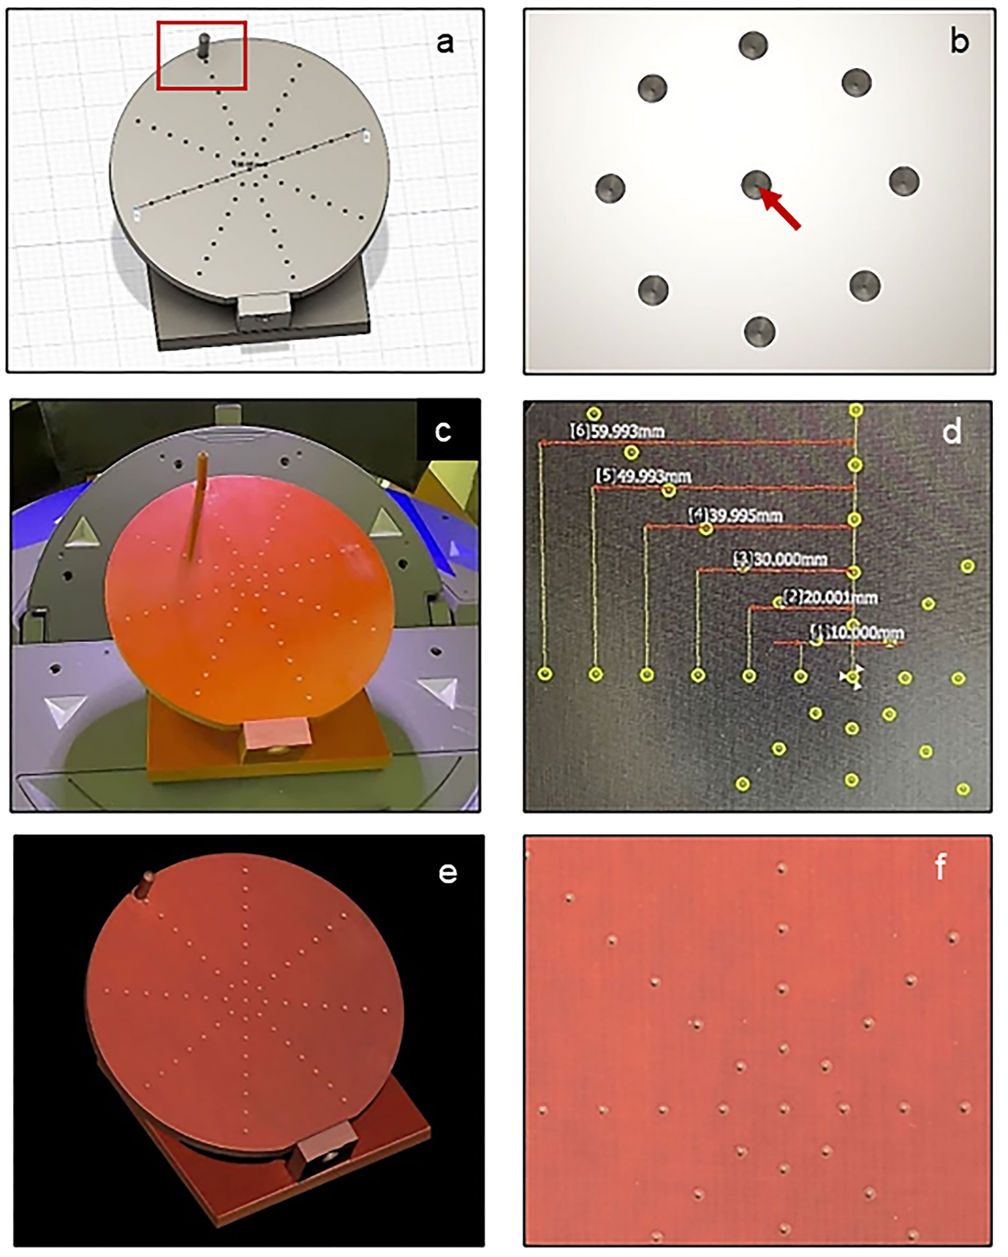
Supplementary Figure S2. The circular model for the point location measurement
(a) Computer-aided design data of the circular model 160-mm in diameter. The model has 57 small pits on its surface and a post (red box). (b) The landmarks for point location (the center of each pit; red arrow) are in a concentric arrangement. (c) The manufactured circular model. (d) A microscopic image of the surface shows evenly spaced landmarks (each pit being < 2 mm in diameter) at 10-mm intervals. (e) An optic-scanned image of the model. (f) Magnified view of the optic-scanned image.
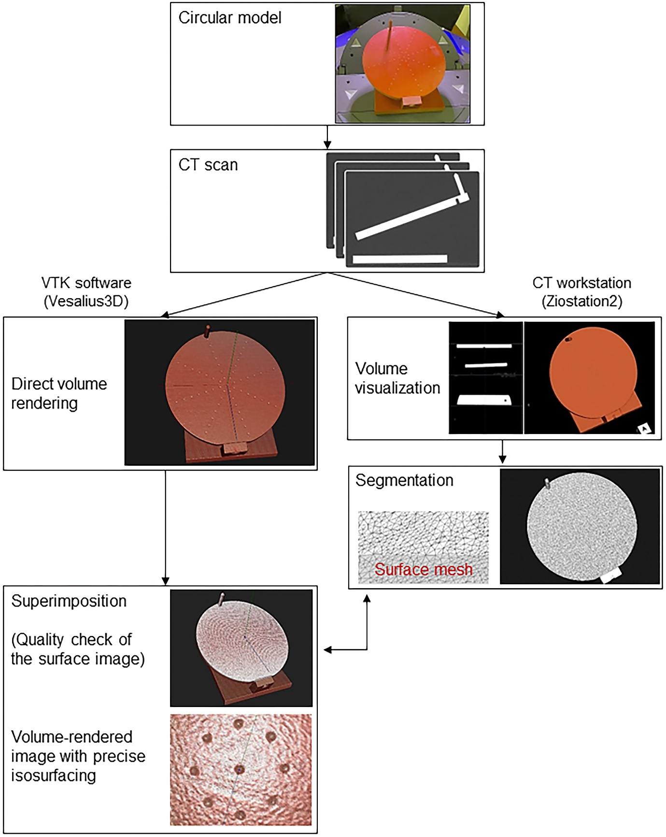 Supplementary Figure S3. Superimposition of volume-rendered and surface images of the circular model
The flowchart shows the visualization framework comprising CT image acquisition, direct volume rendering, surface segmentation, and superimposition of both modes. The segmented surface image is an opaque, monotone-colored, smooth, rasterized polygonal mesh with no artifacts or defects. CT, computed tomography.

Supplementary Figure S4. Measurement of the circular model
In IMVR, the volume-rendered image shows small pits for landmarks on the isosurface of the model (yellow box). Superimposed volume- and surface-rendered images allow the operator to place marker-points merely on the isosurface via mouse clicks (blue cross). In MPR, multiplanar images of the orthogonal planes show landmarks (the center of each pit). IMVR, isosurface measurement on volume-rendered images; MPR, multiplanar reformation.

Supplementary Figure S5. Comparison of point location accuracy between MPR and IMVR
IMVR, isosurface measurement on volume-rendered images; MPR, multiplanar reformation.

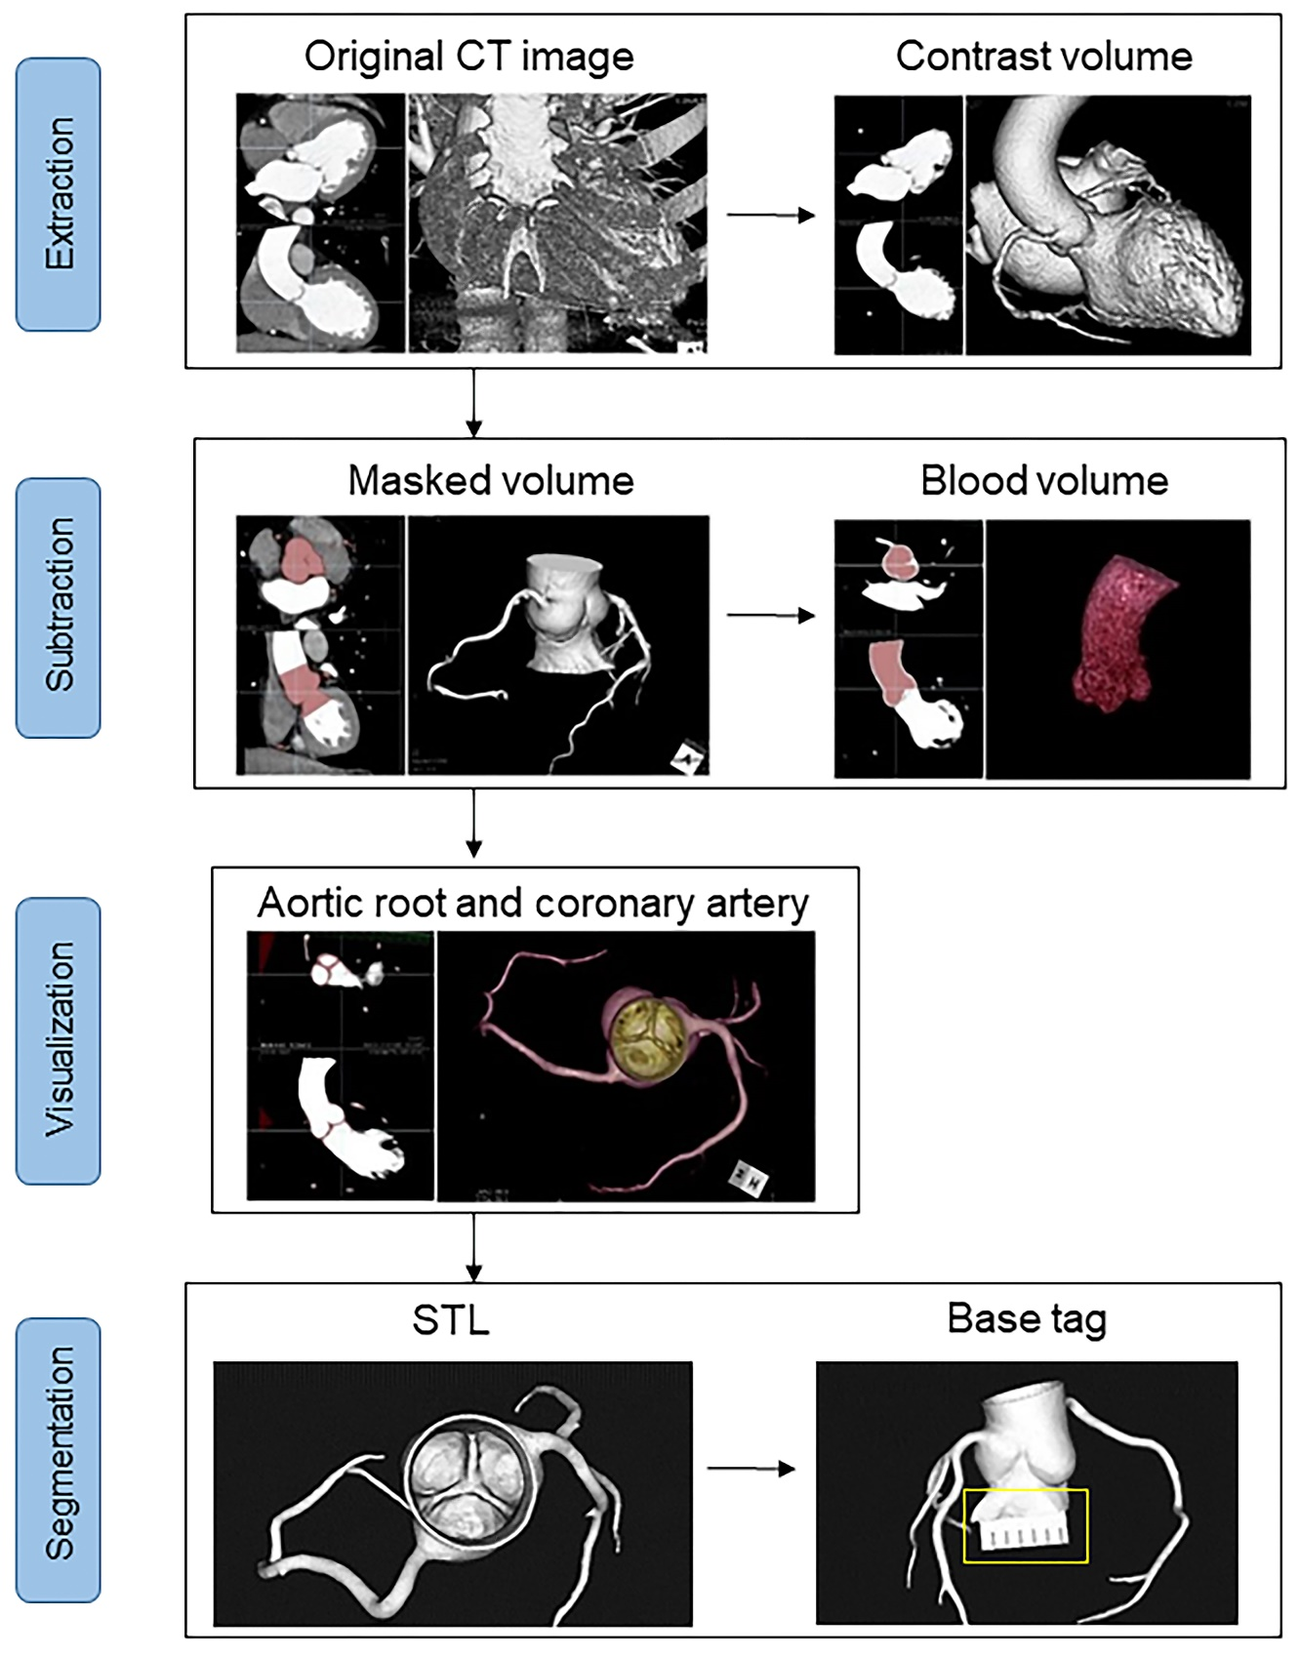
Supplementary Figure S6. Image post-processing and segmentation for 3D printing of the cardiac models Extraction: Cardiac CT datasets were processed to separate the contrast-enhanced volume of the aortic root and coronary artery from the surrounding structures. Subtraction: The blood pool in the aortic root and coronary arteries was manually segmented. The mask of the blood pool was subtracted to leave the aortic wall. Visualization: The luminal aortic root image was created. Segmentation: The segmented mask volume was saved as STL files. A base tag marked at 5-mm intervals (yellow box) was designed and added to the model. 3D, three-dimensional; CT, computed tomography; STL, Standard Tessellation Language.
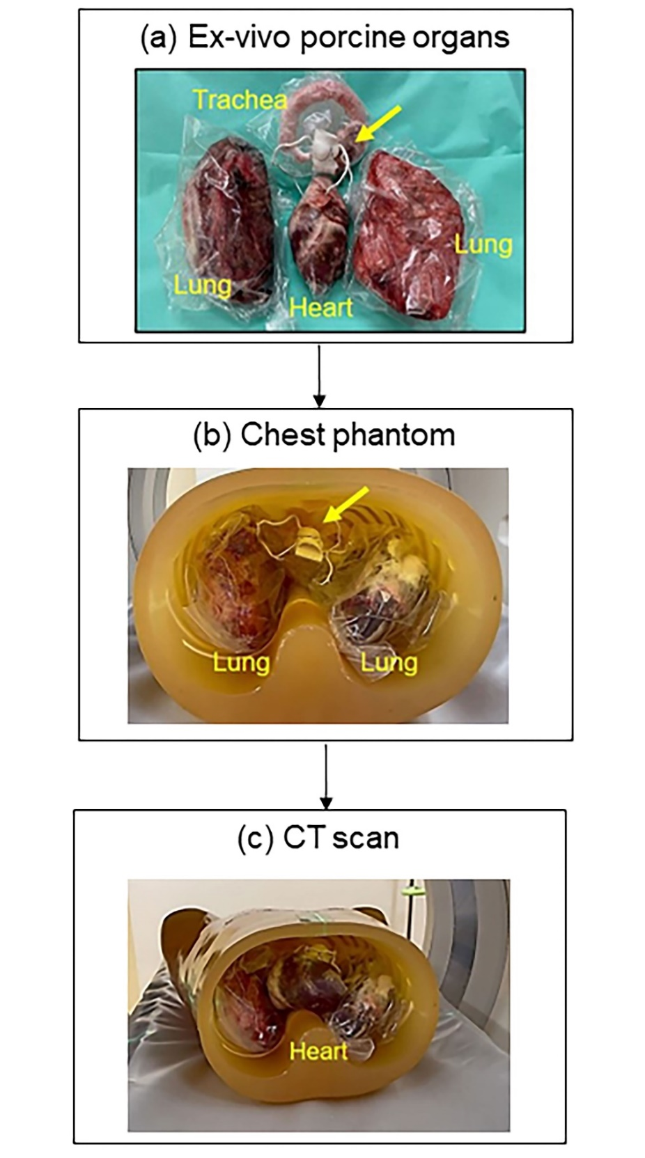
Supplementary Figure S7. CT scanning of the cardiac models
(a) The cardiac model (yellow arrow) was positioned among an ex vivo porcine heart, pair of lungs, and trachea. (b) All were inserted in an anthropomorphic chest phantom. (c) The thoracic phantom model was imaged on a CT scanner. CT, computed tomography.

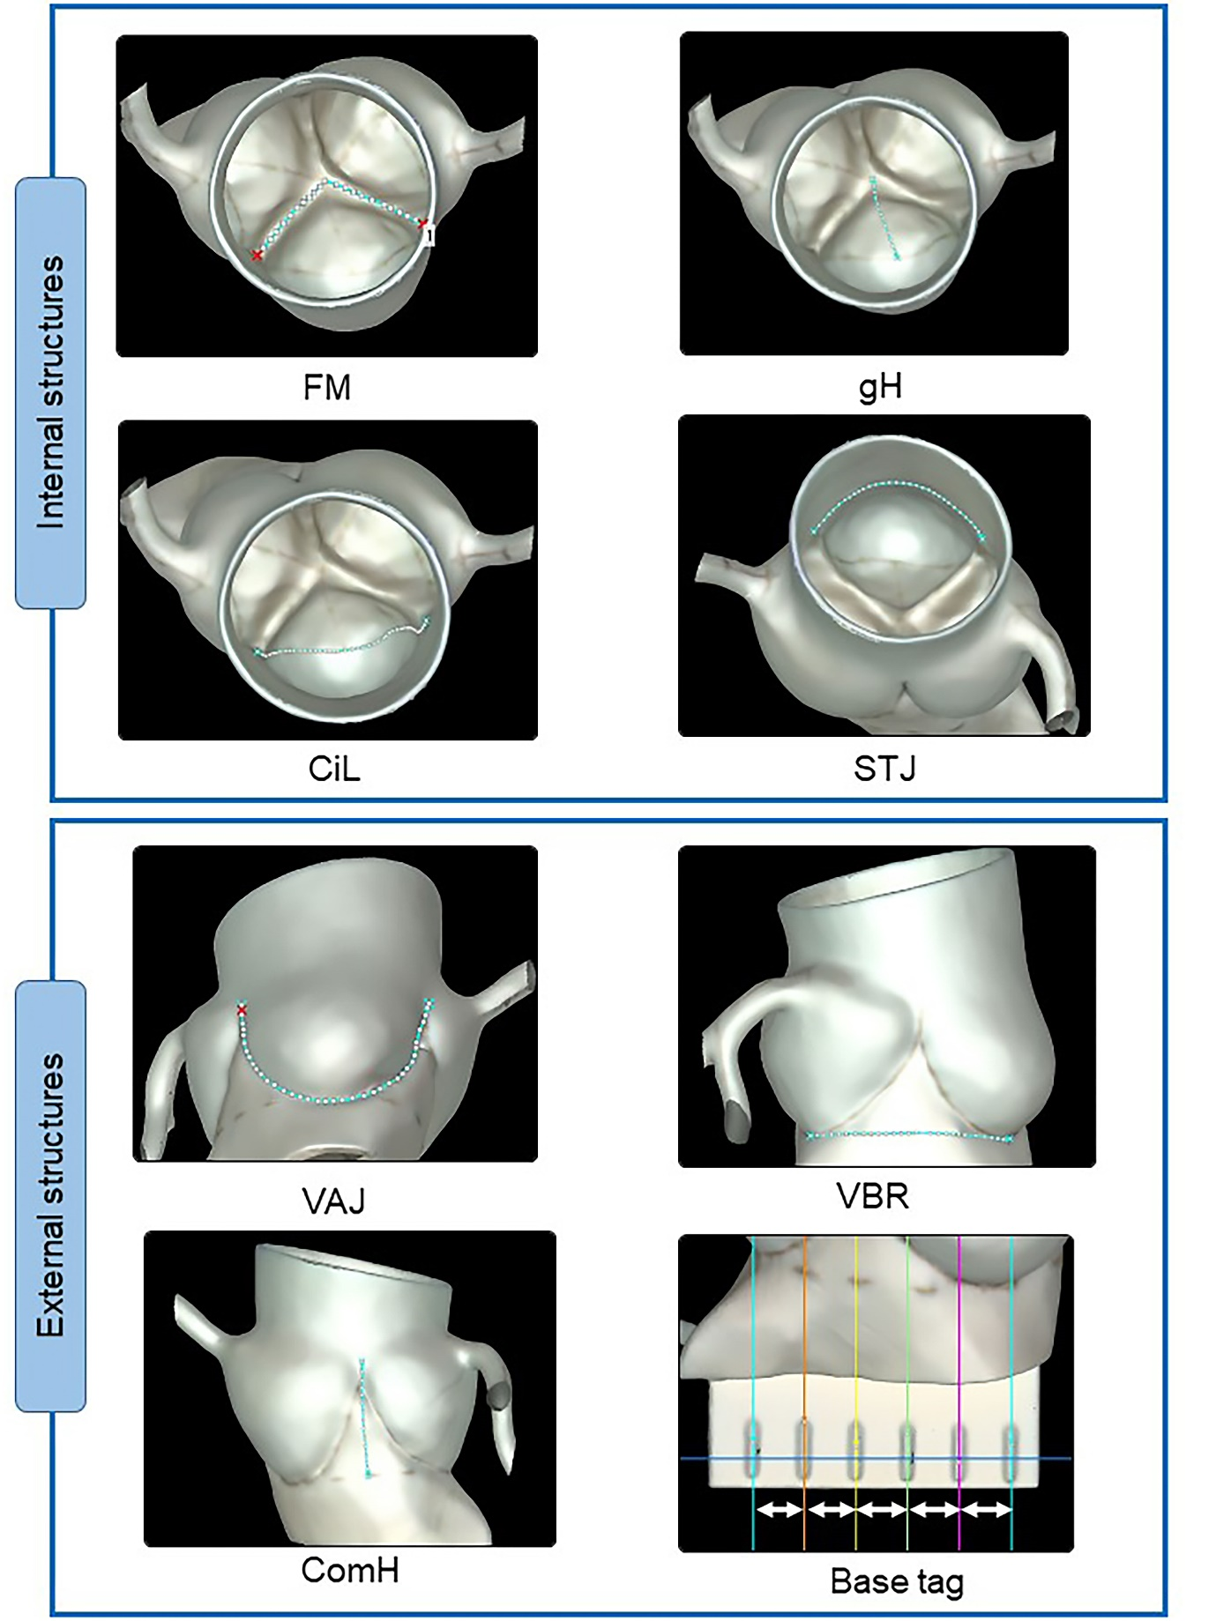
Supplementary Figure S8. Normal aortic root geometry to be measured
Optic-scanned images showing anatomical features composed of (1) internal structures: CiL, cusp insertion length; FM, free margin length; gH, geometric height; STJ, sinotubular junction, and (2) external structures: ComH, commissure height; VAJ, ventricular-arterial junction, and base tag; VBR, virtual basal ring length.
Supplementary Figure S9. Outer curvature lengths of coronary arteries
Optic-scanned images showing segments (yellow arrows) of the three main branches consisting of the LAD and LCX of the LCA and RCA, in accordance with the American Heart Association classification. LAD, left anterior descending; LCA, left coronary artery; LCX, left circumflex; RCA, right coronary artery.
Supplementary Figure S10. Direct volume-rendering visualization
The displayed CT volume data of the circular and cardiac models showed variably transparent monotonically colored 3D images. For volume-rendering visualization, the levels of color and opacity displayed on the voxel histogram were manually adjusted for optimum viewing settings (“presets”), which were saved for later use throughout the evaluations. In cardiac models, the preset consisted of non-overlapping trapezoids, one centered at a higher attenuation and containing a narrow plateau segment. In contrast, the second trapezoid was centered at a lower attenuation with a broader segment. Once optimal visualization was achieved, the presets were used in the subsequent measurement analyses. 3D, three-dimensional; CT, computed tomography.

Supplementary Table S1. Point location accuracy of IMVR and MPR
Method | Number of points | Distance from the reference, mm,  median (minimum, maximum) | RMSD, mm
IMVR | 52 | 0.20 (0.05, 0.37) | 0.22
MPR | 52 | 0.16 (0.02, 0.42) | 0.21
IMVR, isosurface measurement on volume-rendered images; MPR, multiplanar reformation; RMSD, root mean square distance.

Supplementary Table S2. Inter-vertices distance of the polygonal surface mesh
The distance, mm,
median (minimum, maximum)
3D-printed cardiac models
Model 1 | 0.469 (0.038, 1.103)
Model 2 | 0.475 (0.026, 0.944)
Model 3 | 0.397 (0.057, 1.006)
Model 4 | 0.476 (0.096, 0.987)
Model 5 | 0.474 (0.064, 1.012)
Circular model | 0.591 (0.005, 1.582)

Supplementary Table S3. Results of the measurement of the base tags comprised 5-mm intervals
 | Number of  measurements* | Length, mm,  mean (SD) | Deviation†, mm,  median (minimum,  maximum) | RMSD, mm
Optic scan
Observer S.T. | 75 | 5.01 (0.04) | 0.03 (0.00, 0.11) | 0.04
IMVR
Observer #1 | 75 | 5.01 (0.08) | 0.10 (0.00, 0.20) | 0.08
Observer #2 | 75 | 4.97 (0.02) | 0.03 (0.00, 0.08) | 0.04
MPR
Observer #3 | 75 | 5.03 (0.17) | 0.10 (0.00, 0.40) | 0.17
Observer #4 | 75 | 4.95 (0.17) | 0.10 (0.00, 0.40) | 0.17
IMVR, isosurface measurement on volume-rendered images; MPR, multiplanar reformation; RMSD, root mean square deviation; SD, standard deviation. *Numbers derived from three measurement trials. †The deviation from the true value of 5 mm.

Supplementary Table S4. Bias and Limit of agreement of Bland-Altman analysis of coronary artery measurements
 | Number of  measurement  locations | Bias, mm  [95% CI] | Lower LOA, mm  [95% CI] | Upper LOA, mm  [95% CI]
Segments containing a tip
IMVR
Observer #1 | 18 | −0.3 [−0.8, 0.2] | −3.2 [−4.3, −2.5] | 2.6 [1.9, 3.7]
Observer #2 | 18 | −0.4 [−0.7, −0.1] | −1.7 [−2.4, −1.3] | 0.9 [0.5, 1.6]
CPR
Observer #3 | 18 | −0.5 [−3.4, 2.4] | −12.7 [−19.5, −8.6] | 11.7 [7.6, 18.5]
Observer #4 | 18 | −0.9 [−3.7, 2.0] | −13.0 [−19.7, −8.9] | 11.3 [7.1, 18.0]
Segments without a tip
IMVR
Observer #1 | 34 | −0.1 [−0.4, 0.2] | −2.3 [−2.9, −1.8] | 2.0 [1.6, 2.7]
Observer #2 | 34 | −0.1 [−0.2, 0.0] | −0.8 [−1.0, −0.6] | 0.6 [0.5, 0.8]
CPR
Observer #3 | 34 | −0.2 [−1.3, 1.0] | −6.8 [−9.2, −5.1] | 6.5 [4.8, 8.8]
Observer #4 | 34 | −0.3 [−1.5, 0.9] | −7.3 [−9.8, −5.5] | 6.7 [4.9, 9.2]
CI, confidence interval; CPR, curved planar reformation; IMVR, isosurface measurement on volume-rendered images; LOA, limit of agreement.

Supplementary Table S5. Intra-observer reliability of IMVR and CPR
 | ICC(1) [95% CI] | ICC(A,1) [95% CI] | ICC(C,1) [95% CI]
Aortic root
IMVR
Observer #1 | 0.996 [0.995, 0.997] | 0.996 [0.995, 0.997] | 0.996 [0.994, 0.997]
Observer #2 | 1.000 [0.999, 1.000] | 1.000 [0.999, 1.000] | 1.000 [0.999, 1.000]
CPR
Observer #3 | 0.994 [0.992, 0.996] | 0.994 [0.992, 0.996] | 0.994 [0.992, 0.996]
Observer #4 | 0.987 [0.982, 0.991] | 0.987 [0.982, 0.991] | 0.987 [0.982, 0.991]
Coronary artery
IMVR
Observer #1 | 0.997 [0.995, 0.998] | 0.997 [0.995, 0.998] | 0.997 [0.995, 0.998]
Observer #2 | 1.000 [1.000, 1.000] | 1.000 [1.000, 1.000] | 1.000 [1.000, 1.000]
CPR
Observer #3 | 0.998 [0.997, 0.999] | 0.998 [0.997, 0.999] | 0.998 [0.997, 0.999]
Observer #4 | 0.999 [0.998, 0.999] | 0.999 [0.998, 0.999] | 0.999 [0.998, 0.999]
CPR, curved planar reformation; ICC, intra-class coefficient; ICC(1), classical ICC; ICC(A,1), absolute agreement ICC; ICC(C,1), consistency ICC; IMVR, isosurface measurement on volume-rendered images.

Supplementary Table S6. Inter-observer reliability of IMVR and CPR
 | ICC(1) [95% CI] | ICC(A,1) [95% CI] | ICC(C,1) [95% CI]
Aortic root
IMVR
Observers #1 and #2 | 0.995 [0.992, 0.996] | 0.995 [0.992, 0.996] | 0.995 [0.992, 0.997]
CPR
Observers #3 and #4 | 0.979 [0.970, 0.986] | 0.979 [0.970, 0.986] | 0.980 [0.971, 0.986]
Coronary artery
IMVR
Observers #1 and #2 | 0.997 [0.995, 0.998] | 0.997 [0.995, 0.998] | 0.997 [0.995, 0.998]
CPR
Observers #3 and #4 | 0.997 [0.995, 0.998] | 0.997 [0.995, 0.998] | 0.997 [0.996, 0.999]
CPR, curved planar reformation; ICC, intra-class coefficient; ICC(1), classical ICC; ICC(A,1), absolute agreement ICC; ICC(C,1), consistency ICC; IMVR, isosurface measurement on volume-rendered images.

Supplementary Table S7. Measurement speeds of IMVR and CPR
 | Measurement time*, s,  median (Q1, Q3) | Measurement speed, mm/s,  median (Q1, Q3)
Aortic root
IMVR
Observer #1 | 32.0 (26.0, 42.0) | 0.91 (0.67, 1.19)
Observer #2 | 31.0 (19.3, 45.1) | 0.99 (0.87, 1.13)
CPR
Observer #3 | 39.0 (24.0, 68.0) | 0.68 (0.52, 0.94)
Observer #4 | 26.0 (14.0, 34.0) | 1.21 (1.00, 1.52)
Coronary artery
IMVR
Observer #1 | 26.0 (20.0, 35.0) | 1.03 (0.83, 1.34)
Observer #2 | 29.4 (22.1, 41.1) | 0.95 (0.86, 1.07)
CPR
Observer #3 | 66.5 (40.5, 92.5) | 0.46 (0.39, 0.53)
Observer #4 | 26.0 (18.0, 34.0) | 1.07 (0.92, 1.34)
*The measurement time is the time required to complete the measurement of each anatomical feature. CPR, curved planar reformation; IMVR, isosurface measurement on volume-rendered images; Q1, first quartile; Q3, third quartile.

Supplementary Table S8. Measurement speeds of IMVR and CPR on a trial-by-trial basis
 | Measurement time*, s,  median (Q1, Q3) | Measurement speed, mm/s,  median (Q1, Q3)
Aortic root
IMVR
Observer #1
First trial | 38.0 (29.0, 51.0) | 0.80 (0.59, 1.02)
Second trial | 31.0 (26.0, 41.0) | 0.93 (0.73, 1.20)
Third trial | 29.0 (23.0, 37.0) | 1.04 (0.82, 1.25)
Observer #2
First trial | 31.2 (19.6, 45.4) | 0.99 (0.87, 1.09)
Second trial | 31.8 (20.4, 45.1) | 0.98 (0.87, 1.11)
Third trial | 30.2 (18.8, 43.2) | 1.03 (0.88, 1.19)
CPR
Observer #3
First trial | 52.0 (27.0, 74.0) | 0.56 (0.44, 0.82)
Second trial | 39.0 (23.0, 60.0) | 0.72 (0.57, 0.90)
Third trial | 34.0 (21.0, 57.0) | 0.73 (0.60, 1.08)
Observer #4
First trial | 27.0 (15.0, 37.0) | 1.15 (0.98, 1.39)
Second trial | 27.0 (14.0, 34.0) | 1.18 (0.98, 1.50)
Third trial | 24.0 (14.0, 30.0) | 1.32 (1.08, 1.59)
Coronary artery
IMVR
Observer #1
First trial | 31.0 (22.5, 43.5) | 0.88 (0.73, 1.13)
Second trial | 25.0 (20.5, 35.5) | 1.07 (0.83, 1.34)
Third trial | 24.0 (18.5, 33.0) | 1.11 (0.95, 1.49)
Observer #2
First trial | 29.3 (21.0, 39.1) | 0.99 (0.86, 1.08)
Second trial | 29.3 (23.1, 40.4) | 0.95 (0.87, 1.08)
Third trial | 29.6 (21.8, 41.4) | 0.97 (0.86, 1.06)
CPR
Observer #3
First trial | 72.0 (42.5, 96.0) | 0.42 (0.37, 0.51)
Second trial | 59.5 (43.0, 93.5) | 0.46 (0.42, 0.54)
Third trial | 63.5 (39.5, 84.5) | 0.47 (0.39, 0.57)
Observer #4
First trial | 26.0 (18.5, 35.0) | 1.05 (0.94, 1.35)
Second trial | 29.0 (18.5, 34.5) | 1.03 (0.88, 1.34)
Third trial | 24.5 (18.0, 32.0) | 1.12 (0.97, 1.36)
*The measurement time is the time required to complete the measurement of each anatomical feature. CPR, curved planar reformation; IMVR, isosurface measurement on volume-rendered images; Q1, first quartile; Q3, third quartile.

