The Predominance of Bacillus species and non-culturable microaerophilic/anaerobic microflora in the aerobically operated predigester of Nisargruna biogas plant

Running title: Microbiological analysis of predigester flora

Shubhada Nayakª* Sharad Kale^{b}
a Department of Microbiology, Rayat Shikshan Sanstha's Karmaveer Bhaurao Patil College, Vashi Sector 15 A, Vashi, Navi Mumbai 400703, Maharashtra, India
E-mail ID: shubhada009@gmail.com
ORCID ID: 0000-0002-3235-2997

b (Ex) Nuclear Agricultural Biotechnology division, Bhabha Atomic Research Center, Trombay, Mumbai 400084, Maharashtra, India
E-mail: sharadkale@gmail.com
ORCID: https://orcid.org/0000-0002-6664-6707

*Corresponding author:
Dr. Shubhada Nayak
Principal and Associate Professor,
Department of Microbiology,
Rayat Shikshan Sanstha's Karmaveer Bhaurao Patil College, Vashi
Navi Mumbai- 400703
E-mail id: shubhadanayak@kbpcollegevashi.edu.in
Contact: +91-9869845255
Permanent address: B20/0/2, Sector 11, Kendriya Vihar, Kharghar 410210 Maharashtra, India

Table 1 Colony characteristics of cultures isolated from predigester 1
Isolate | Size | Shape | Colour | Margin | Opacity | Elevation | Consistency | Gram nature | Arrangement | Spore characters and position
PI1 | 2mm | Circular | White | Uneven | Opaque | Raised with  central depression | Moist | Gram positive  Rods with parallel sides and rounded ends | Mostly singles, some are in pairs | Bulging elliptical  Central and sub-terminal spores
PI2 | 4mm | Irregular | White | Uneven | Semi-transparent | Raised | Moist | Gram positive thick  Rods | Mostly singles, some are in pairs | Non-bulging, oval, central spores
PI3 | 4mm | Circular | Dirty white | Uneven | Semi-transparent | Raised | Moist | Gram positive thin slender rods | Mostly singles, some are in short chains | Non-bulging, oval, central spores
PI4 | 5mm | Irregular | Water-like | Uneven | Semi-transparent | Flat | Gelatinous | Gram positive medium size rods | Singles | Bulging oval,  Central and sub-terminal spores
PI5 | 6mm | Circular | White | Even | Opaque | Raised | Moist | Gram positive big  Rods with parallel sides and square ends | Very long chains | Non-bulging, large, oval, central spores
PI6 | 3-4mm | Circular | Dirty white | Uneven | Opaque | Flat with raised  Margin | Moist | Gram positive medium size rods | Singles, pairs and bundles | Non-bulging, oval, central spores
PI7 | 5-6mm | Circular | Water-like | Even | Semi-transparent | Flat | Mucoid | Gram positive medium size rods, slightly thick | Singles and pairs | Oval and spherical, small, central and sub-terminal spores
PI8 | 6mm | Circular | Dirty white | Uneven | Semi-transparent | Raised with  central depression | Mucoid | Gram positive long rods with parallel sides | Singles and pairs | Oval, bulging, sub-terminal spores
PI9 | 3mm | Circular | White | Uneven | Opaque | Flat with raised  ring at the center | Sticky | Gram positive medium size rods | Singles | Oval, bulging, sub-terminal spores
PI10 | 6-7mm | Circular | Dirty white | Uneven | Opaque | Raised | Moist | Gram positive long thick rods | Singles and pairs | Oval, big spores [occupy 2/3 of cell] Non-bulging, terminal
PI11 | 5mm | Irregular | Dirty white | Uneven | Opaque | Raised with  central thin area | Moist | Gram positive medium size rods | Singles | Oval, bulging, sub-terminal spores
PI12 | 3-4mm | Circular | Dirty white | Even | Opaque | Convex with  crumpled surface | Moist | Gram positive stumpy rods | Singles | Oval, non-bulging, sub-terminal & central spores
PI13 | 5-6mm | Circular | Yellowish white | Uneven | Opaque | Flat with raised margin | Sticky | Gram positive slender rods | Singles | Oval, non-bulging, & central spores
PI14 | 4mm | Circular | White | Uneven | Opaque | Flat with  raised center margin | Sticky | Gram positive medium size rods | Singles and pairs | Oval, non-bulging, & central spores
PI15 | 4mm | Circular | Dirty white | Uneven | Semi-transparent | Raised with  folds on surface | Sticky | Gram positive medium size rods | Singles | Oval, sub-terminal spores
PI16 | 5mm | Circular | Dirty white | Uneven | Semi-transparent | Flat with  raised center | Sticky | Gram positive slender rods | Singles and pairs | Oval, sub-terminal, bulging spores
PI17 | 6mm | Irregular | Water-like | Uneven | Semi-transparent | Raised | Sticky | Gram positive slender rods | Singles | Oval, non-bulging & small spores
PI18 | 3mm | Circular | White | Uneven | Semi-transparent | Raised with  crumpled surface | Mucoid | Gram positive long rods | Singles | Oval, sub-terminal, bulging spores
PI19 | 3-4mm | Circular | White | Uneven | Semi-transparent | Star shaped folds | Mucoid | Gram positive short rods | Singles | Oval, sub-terminal, bulging spores
PI20 | 4mm | Irregular | Water like | Uneven | Semi-transparent | Convex with folds | Mucoid | Gram positive medium size rods | Singles | Oval, central, bulging spores

Table 2 Colony characteristics of cultures isolated from predigester 2
Isolate | Size ‘mm’ | Shape | Colour | Margin | Opacity | Elevation | Consistency | Gram nature | Arrangement | Spore characters and position
PII1 | 2 | Irregular | Water-like | Uneven | Opaque | Flat with water-like droplets | Moist | Gram positive medium size rods | Mostly singles | Slightly bulging, oval  central spores
PII2 | 5 | Irregular | White | Uneven | Opaque | Flat with wavy margin | Moist | Gram positive medium size thick rods | Mostly singles | Non-bulging, oval, central spores
PII3 | 5 | Circular | Bright white | Uneven | Opaque | Flat with raised center | Moist | Gram positive stumpy rods | Mostly singles, some are in pairs | Non-bulging, oval, central spores
PII4 | 6 | Irregular | Off-white | Uneven | Opaque [shining] | Flat | Moist | Gram positive medium to long rods | Singles, some are in pairs | Bulging oval,  Central spores
PII5 | 6 | Circular | White | Even | Opaque | Flat | Moist | Gram positive long thick rods | Singles | Bulging, large, oval, central spores
PII6 | 6 | Circular | White | Even | Opaque | Flat | Moist | Gram positive very thick rods with parallel sides and flat ends | Singles and short chains | Non-bulging, elliptical, central spores
PII7 | 6 | Circular | White | Even | Opaque | Flat with raised center | Moist | Gram positive thick rods | Singles and chains | Oval, non-bulging and sub-terminal spores
PII8 | 4 | Irregular | Bright white | Uneven | Opaque | Flat with  raised margin | Moist | Gram positive very thin rods | Singles and chains | Circular, on- bulging, sub-terminal spores
PII9 | 4 | Circular | Light yellow | Uneven | Opaque | Flat | Moist | Gram positive long rods | Singles and pairs | Oval, non-bulging, central spores
PII10 | 5 | Irregular | Bright white | Uneven | Opaque | Flat with lots of fold on it | Moist | Gram positive short to medium size rods | Chains and pairs | Oval, bulging, sub-terminal spores
PII11 | 3 | Irregular | Bright white | Uneven | Opaque | High convex [balloon-like] | Moist | Gram positive thin &short rods | Singles and chains | Oval, non-bulging, central spores
PII12 | 7 | Irregular | Dirty white | Even | Opaque | Flat | Moist | Gram positive very thick rods with parallel sides and flat ends | Singles and pairs | Oval, non-bulging, central spores
PII13 | 4 | Circular | Pale Yellow | Even | Semi-transparent | Flat | Moist | Gram positive medium size rods | Singles | Spherical, non-bulging, & central spores
PII14 | 4 | Circular | Lemon Yellow | Even | Opaque | Flat | Moist | Gram positive short rods | Singles and pairs | Oval, non-bulging, & central spores
PII15 | 4 | Irregular | Water-like | Uneven | Semi-transparent | Raised with  folds on surface | Moist | Gram positive medium size rods | Singles | Oval, sub-terminal central spores
PII16 | 3 | Circular | White | Even | Opaque | Low convex | Moist | Gram positive medium size rods | Singles and pairs | Oval, sub-terminal, bulging spores
PII17 | 10 | Circular | White | Uneven | Opaque | Raised | Moist | Gram positive thick rods | Singles and chains | Circular, bulging & sub-terminal spores
PII18 | 15 | Irregular | Dirty white | Uneven | Opaque | Raised | Moist | Gram positive thick rods, parallel sides and rounded ends | Singles | Oval, sub-terminal, bulging spores
PII19 | 15 | Irregular | Dirty white | Uneven | Opaque | Raised with many folds | Moist | Gram positive long, thick rods | Singles | Oval, sub-terminal, slightly bulging spores
PII20 | 15 | Irregular | Dirty white | Uneven | Opaque | Raised with water like droplets | Moist | Gram positive thin medium size rods | Singles [Y,V shaped] | Oval, terminal, bulging spores
PII21 | 3 | Circular | Dirty white | Uneven | Opaque | Convex | Moist | Gram positive thick rods with rounded ends | Chains | Oval, central spores
PII22 | 4 | Circular | Lemon Yellow | Even | Opaque | Flat with raised border | Moist | Gram positive thick rods | Chains | Oval, bulging central spores
PII23 | 4 | Circular | Bright white | Uneven | Opaque | Convex with hollow center | Moist | Gram positive long to medium size rods | Singles | Oval, bulging central spores
PII24 | 5 | Circular | Dirty white | Uneven | Opaque | Convex with many folds | Moist | Gram positive long rods | Singles | Oval, sub-terminal, slightly bulging spores

Table 3 Biochemical tests results of the isolates from predigester1
Culture  No. | Tests |  |  |  |  |  |  |  |  |  |  |  |  | Identification
Culture  No. | A | B | C | D | E | F | G | H | I | J | K | L | M | Identification
PI1 | + | + | - | + | + | - | + | - | + | - | - | 6.35 | + | B. subtilis
PI2 | + | + | + | - | + | - | + | - | + | - | + | 5.55 | - | B. cereus
PI3 | + | + | - | - | + | - | + | - | - | - | - | 5.45 | + | B. pumilus
PI4 | + | + | + | + | + | - | + | - | + | - | - | 5.74 | + | B. licheniformis
PI5 | + | - | + | - | + | - | + | - | - | - | - | 5.14 | + | B. laterosporus
PI6 | + | + | - | + | + | - | - | - | - | - | - | 5.31 | + | B. pumilus
PI7 | + | + | - | + | + | - | + | - | + | - | - | 5.72 | + | B. subtilis
PI8 | + | + | - | + | + | - | + | - | + | - | - | 5.76 | + | B. subtilis
PI9 | + | + | - | + | + | - | + | - | + | - | - | 5.83 | + | B. subtilis
PI10 | + | + | + | - | + | - | + | - | - | - | + | 5.13 | + | B. cereus
PI11 | + | + | - | + | + | - | + | - | + | - | - | 6.10 | + | B. subtilis
PI12 | + | + | - | + | + | - | + | - | + | - | - | 5.98 | - | B. subtilis
PI13 | + | + | - | + | + | - | + | - | - | - | - | 6.35 | + | B. pumilus
PI14 | + | + | - | + | + | - | + | - | + | - | - | 5.98 | + | B. subtilis
PI15 | + | + | - | + | + | - | + | - | + | - | - | 6.10 | + | B. subtilis
PI16 | + | + | - | + | - | - | - | - | - | - | - | 5.39 | + | B. pumilus
PI17 | + | + | - | + | - | - | + | - | - | - | - | 5.43 | + | B. pumilus
PI18 | + | + | - | + | + | - | + | - | + | - | - | 6.31 | + | B. subtilis
PI19 | + | + | - | + | - | - | + | - | + | - | - | 6.16 | + | B. subtilis
PI20 | + | + | - | + | + | - | + | - | + | - | - | 6.09 | + | B. pumilus
Note: + indicates growth/positive result, - indicates no growth/negative result.
A-Catalase test, B-Voges Proskauer test, C- Growth in anaerobic agar, D- Growth at 50°C, E-Growth in 7% NaCl, F- Acid and gas from glucose, G- Nitrate reduction test, H-Parasporal bodies, I- Hydrolysis of starch, J-Growth at 65°C, K-Rod breadth 1μ or more, L-pH in VP broth <6.0, M-Hydrolysis of casein

Table 4 Biochemical tests results of the isolates from predigester 2
Culture No. | Tests |  |  |  |  |  |  |  |  |  |  |  |  | Identification
Culture No. | A | B | C | D | E | F | G | H | I | J | K | L | M | Identification
PII1 | + | + | + | + | + | - | + | - | - | - | - | 5.82 | + | B. licheniformis
PII2 | + | + | - | - | - | - | + | - | + | - | - | 5.85 | + | B. subtilis
PII3 | + | + | - | + | + | - | - | - | + | - | - | 7.88 | - | B. subtilis
PII4 | + | - | - | - | + | - | + | - | + | - | - | 5.20 | + | B.firmus
PII5 | + | + | + | - | + | - | + | + | + | - | + | 5.27 | + | B. thuringenesis
PII6 | + | + | + | - | + | - | + | - | - | - | + | 5.18 | + | B. cereus
PII7 | + | + | + | - | - | - | + | - | - | - | + | 5.33 | + | B. cereus
PII8 | + | + | - | + | + | - | + | - | + | - | - | 5.87 | + | B. subtilis
PII9 | + | + | - | + | + | - | - | - | - | - | - | 5.28 | + | B. pumilus
PII10 | + | + | - | + | + | - | + | - | + | - | - | 7.24 | + | B. subtilis
PII11 | + | + | - | + | + | - | + | - | + | - | - | 6.69 | + | B. subtilis
PII12 | + | + | + | - | + | - | + | - | + | - | + | 5.05 | + | B. cereus
PII13 | + | - | - | - | - | - | - | - | - | - | - | 7.08 | - | B. sphaericus
PII14 | + | + | - | - | + | - | - | - | - | - | - | 6.14 | + | B. pumilus
PII15 | + | + | + | + | + | - | + | - |  | - | - | 6.99 | + | B. licheniformis
PII16 | + | + | - | - | + | - | + | - | + | - | - | 5.89 | - | B. subtilis
PII17 | + | + | + | - | + | - | + | + | - | - | - | 5.33 | + | B. thuringenesis
PII18 | + | + | + | + | - | - | + | + | - | - | + | 5.22 | + | B. thuringenesis
PII19 | + | + | + | + | + | - | + | - | - | - | - | 6.51 | + | B. licheniformis
PII20 | + | + | + | + | + | - | + | - | - | - | - | 5.21 | + | B. licheniformis
PII21 | + | + | - | + | + | - | + | - | + | + | - | 6.47 | + | B. subtilis
PII22 | + | - | - | + | - | - | - | - | + | - | + | 5.31 | + | B. megaterium
PII23 | + | + | - | + | - | - | + | - | + | - | - | 6.13 | + | B. subtilis
PII24 | + | + | - | + | + | - | + | - | + | - | - | 6.05 | + | B. subtilis
Note: + indicates growth/positive result, - indicates no growth/negative result.
A-Catalase test, B-Voges Proskauer test, C- Growth in anaerobic agar, D- Growth at 50°C, E-Growth in 7% NaCl, F- Acid and gas from glucose, G- Nitrate reduction test, H-Parasporal bodies, I- Hydrolysis of starch, J-Growth at 65°C, K-Rod breadth 1μ or more, L-pH in VP broth <6.0, M-Hydrolysis of casein

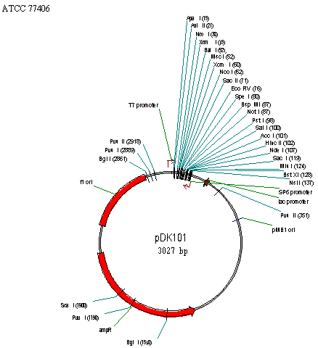
Fig. 1 Genetic map of T/A vector

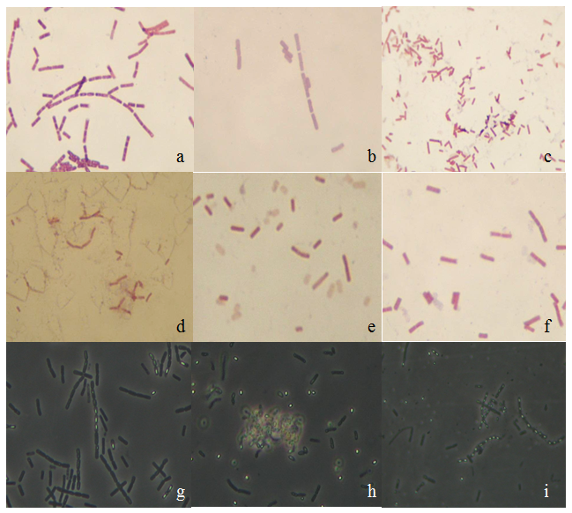
Fig. 2. Gram staining of isolates from predigester (a) B. silvestris (b) B. thuringenesis (c) B. firmus (d) B. licheniformis (e) B pumilus (f) B .cereus and phase contrast micrographs showing spores of (g) B. thuringenesis (h) B. megaterium (i) B. silvestris

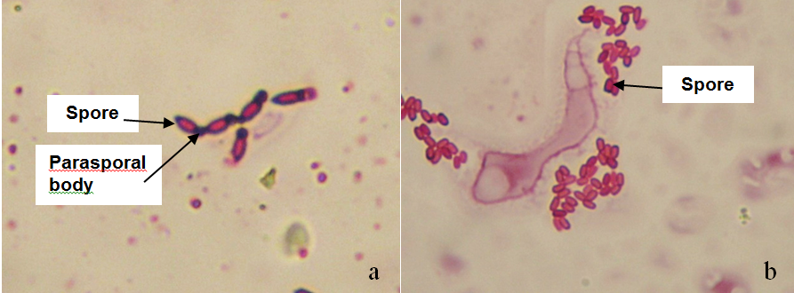
Fig. 3. Ziehl Neelsen staining technique showing (a) parasporal bodies attached to the spores in B. thuringenesis and (b) their absence in B. cereus

