Table 1. BET analyses of synthesized compounds
Sample | Surface area(m²/g)ª | S_{BET Micro} | S_{BET Meso}^{b} | Total pore volume^{c} | Size BJH
HY | 530 | 510 | 50 | 0.39 | 2.45
HY-N-SO₃H | 305 | 140 | 165 | 0.20 | 1.29
ª Calculated by the BET method, ^{b} Calculated by the t-plot method, ^{c} Obtained at a relative pressure of 0.99.

Table 2. Synthesis of different coumarins using HY/NaY/MCM-N-SO₃H as a catalyst
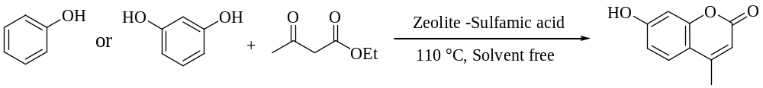
ªEntry | Catalyst (g) | Substrate | Solvent | Time (min) | Mp(◦C) | Yields (%)
1 | HY-N-SO₃H (0.02) | Resorcinol | - | 180 | 157-159 | 49
2 | HY-N-SO₃H (0.04) | Resorcinol | - | 110 | 157-159 | 61
3 | HY-N-SO₃H (0.08) | Resorcinol | - | 45 | 157-159 | 99
4 | HY-N-SO₃H (0.1) | Resorcinol | - | 90 | 157-159 | 97
5 | HY-N-SO₃H (0.08) | Phenol | - | 45 | 83-86 | 72
6 | HY-N-SO₃H (0.08) | Resorcinol | DMF | 45 | 156-158 | 70
7 | HY-N-SO₃H (0.08) | Resorcinol | THF | 45 | 156-158 | 60
8 | HY-N-SO₃H (0.08) | Resorcinol | H₂O | 45 | 156-158 | 75
9 | HY-N-SO₃H (0.08) | Resorcinol | CH₃CN | 45 | 156-158 | 80
10 | NaY (0.08) | Resorcinol | - | 45 | 156-158 | 25
11 | HY (0.08) | Resorcinol | - | 45 | 156-158 | 36
12 | MCM-41 (0.08) | Resorcinol | - | 45 | 156-158 | Trace
13 | NaY-N-SO₃H (0.08) | Resorcinol | - | 45 | 156-159 | 52
14 | NaY-N-SO₃H (0.08) | Phenol | - | 45 | 84-85 | 39
15 | MCM-N-SO₃H | Phenol |  | 45 | 84-85 | 13
16 | MCM-N-SO₃H | Resorcinol |  | 45 | 156-158 | 38
17 | Without catalyst | Phenol, Resorcinol | - | 45 | - | Trace
ª Condition: Catalyst (0.08 g), phenol or resorcinol (1 mmol), ethyl acetoacetate (1 mmol), solvent free, 110 ˚C.
Table 3. Optimization of reaction condition for synthesis of N-Phenyl formamide as the model reaction
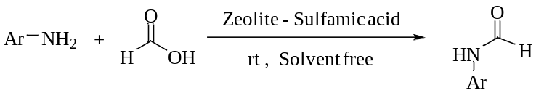
Entry | Catalyst (g) | HCOOH (mmol) | Solvent (1ml) | Time (min) | Yields (%)
1 | HY-N-SO₃H (0.01) | 1.2 | Solvent free | 120 | 10
2 | HY-N-SO₃H (0.015) | 1.2 | Solvent free | 35 | 60
3 | HY-N-SO₃H (0.02) | 1.2 | Solvent free | 9 | 99
4 | HY-N-SO₃H (0.03) | 1.2 | Solvent free | 20 | 98
5 | HY-N-SO₃H (0.02) | 1.5 | Solvent free | 25 | 60
6 | HY-N-SO₃H (0.02) | 1.2 | THF | 8 | 98
7 | HY-N-SO₃H (0.02) | 1.2 | MeCN | 10 | 97
8 | HY-N-SO₃H (0.02) | 1.2 | Ethylacetate | 3 | 99
9 | Without catalyst | 2 | Solvent free | 240 | Trace
10 | NaY(0.02) | 2 | Solvent free | 20 | 5
11 | HY(0.02) | 2 | Solvent free | 20 | 20
12 | MCM-41(0.02) | 2 | Solvent free | 20 | Trace
13 | NaY-N-SO₃H (0.02) | 2 | Solvent free | 20 | 80
14 | MCM-N-SO₃H (0.02) | 2 | Solvent free | 20 | 61

Table 4. Formylation of different amines
Entryª | Substrate | Product | Time (min) | Yields (%)^{b} | Melting point (◦C)
 |  |  |  |  | Found | Reported
1 | 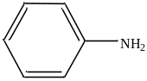 | 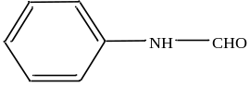 | 9 | 99 | 47-49 | 46-48⁴²
2 | 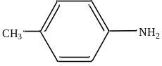 | 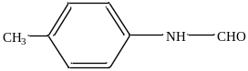 | 9 | 99 | 51-53 | 52-54⁴²
3 | 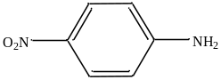 | 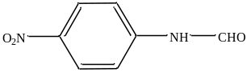 | 60 | 48 | 198-200 | 196-197⁴²
4 | 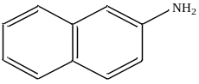 | 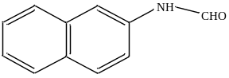 | 7 | 99 | 142-144 | 141-143⁴²
5 | 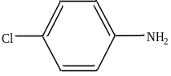 | 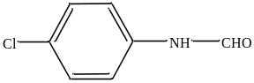 | 35 | 86 | 102-104 | 99-101⁴³
6 | 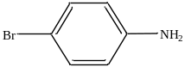 | 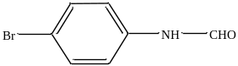 | 40 | 74 | 116-118 | 115-119⁴³
7 | 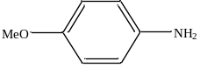 | 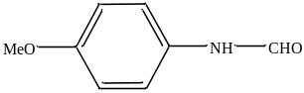 | 60 | 82 | 76-78 | 78-80⁴³
8 | 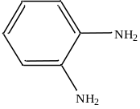 | 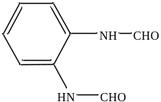 | 47 | 69 | * | New
ª Condition: amine (1 mmol), formic acid (1.2 mmol), catalyst (0.02 g), room temperature, solvent free, ^{b} Isolated yields.
* IR (Cm-1): 3134, 2980, 2823, 2696, 1689, 1589, 1454, 1386, 1240, 1006, 864, 748, 615, 543, 422.
¹H NMR (DMSOd6, δ= ppm): 6.89 (NH, 2 H), 7.20, 7.21 (Ar-H, 2 H), 7.62, 7.65 (Ar-H, 2 H), 8.22 and 8.34 (CHO, 2 H). ¹³C NMR (DMSOd6, δ= ppm): 115.4, 122.5, 137.6, 142.0, and 163.6.
Table 5. Comparison catalytic activity of [HY-N-SO₃H] with other heterogeneous catalyst for preparation of coumarins
Catalyst | Catalyst amount | Time (min) | Temperature (◦C) | Yield (%) | Ref.
Uncatalyzed (solvent) | - | 383 | 78 | 89 | 45
Mesoporous zirconium phosphate (m-ZrP) | 10 wt% | 160 | 150 | 76 | 46
SiO₂/Sulfated (20%) (solvent) | 100 mmol | 240 | 200 | 100 | 47
CNC-AMPD-Pd | 0.5 %mol | 120 | 130 | 94 | 48
Zn_{0.925} Ti_{0.075} O NPs | 10 %mol | 180 | 110 | 76 | 24
Co/SBA-15 | 0.1 %mol | 180 | 110 | 98 | 49
CMK-5-SO₃H | 3 %mol | 20 | 130 | 95 | 50
SnCl₄ grafted on silica gel | 5 %mol | 360 | 60 | 63 | 51
ZrO₂-TiO₂ | 0.050 g | 180 | Room temperature | 97 | 52
[MTMSPIm]Cl@HY-Z (Cu) | 0.18 g | 150 | 130 | 96.5 | 23
Acidic ionic liquid (solvent) | 0.078 g | 120 | 85 | 75 | 53
HY-N-SO₃H | 0.08 g | 45 | 110 | 99 | Present

Table 6. Studying efﬁciency of the present protocol over some reported catalysts to preparation of formamides
Catalyst | Solvent and reagent | Temperature (◦C) | Time(min) | Yield (%) | Ref.
α-Fe₂O₃@HAp-SO₃H | Solvent free | Room temperature | 20 | 97 | 54
[N(C₄H₉)₄]₃[CrMo₆O₁₈(OH)₃  C(OCH₂)₃CH₃] | 1,4-dioxane | 80 | 1440 | 91 | 28
Clinoptilolite (Pd@MCP) | Solvent free | 70 | 20 | 97 | 55
POMP-NHC-Ir | MeOH | 120 | 1440 | 80 | 56
HClO₄-SiO₂ | THF | Room temperature | 15 | 96 | 57
Natrolite zeolite | Solvent free | Room temperature | 20 | 89 | 58
Protic ionic liquid | Solvent free | 70 | 60 | 97 | 59
(NH₄)₃[FeMo₆O₁₈(OH)₆] | Additive Na₂SO₃ | 80 | 120 | 99 | 29
Sulfated titania | MeCN | Room temperature | 30 | 99 | 60
Iodine | Solvent free | 70 | 240 | 96 | 61
HY-N-SO₃H | Solvent free | Room temperature | 9 | 99 | present

