SUPPLEMENTARY DATA
Title: Design and Antiproliferative and Antioxidant Activities of Furan-Based Thiosemicarbazides and 1,2,4-Triazoles: Their Structure–Activity Relationship and SwissADME Predictions

Yusuf Sıcak

Department of Medicinal and Aromatic Plants, Köyceğiz Vocational School, Muğla Sıtkı Koçman University, Muğla, Turkey

Yusuf SICAK

Department of Medicinal and Aromatic Plants, Köyceğiz Vocational School, Muğla Sıtkı Koçman University, Muğla, Turkey
E-mail: yusufsicak@mu.edu.tr

Table S1. Physicochemical properties, lipophilicity, solubility, pharmacokinetics, drug likeness and medicinal chemistry of thiosemicarbazide (1-12) and 1,2,4-triazole derivatives (13-24) predicted using SwissADME.
Compounds | Physicochemical Properties | Lipophilicity | Water Solubility | Pharmacokinetics | Drug likeness | Medicinal Chemistry
1- | Formula: C₁₂H₁₁N₃O₂S  Molecular weight: 261.30 g/mol  Num. heavy atoms: 18  Num. arom. heavy atoms : 11  Fraction Csp3: 0.00  Num. rotatable bonds: 6  Num. H-bond acceptors: 2  Num. H-bond donors: 3  Molar Refractivity: 71.12  TPSA: 98.39 Å² | Log Po/w (iLOGP): 2.24  Log Po/w (XLOGP3): 2.09  Log Po/w (WLOGP): 1.72  Log Po/w (MLOGP): 0.97  Log Po/w (SILICOS-IT): 1.77  Consensus Log Po/w: 1.76 | Log S (ESOL): -2.83  Solubility: 3.84e-01 mg/ml ; 1.47e-03 mol/l  Class: Soluble  Log S (Ali): -3.79  Solubility: 4.28e-02 mg/ml ; 1.64e-04 mol/l  Class: Soluble  Log S (SILICOS-IT): -4.39  Solubility: 1.07e-02 mg/ml ; 4.10e-05 mol/l  Class: Moderately soluble | GI absorption: High  BBB permeant: No  P-gp substrate: No  CYP1A2 inhibitor: Yes  CYP2C19 inhibitor: Yes  CYP2C9 inhibitor: No  CYP2D6 inhibitor: No  CYP3A4 inhibitor: No  Log Kp (skin permeation): -6.41 cm/s | Lipinski: Yes  Ghose: Yes  Veber: Yes  Egan: Yes  Muegge: Yes  Bioavailability Score: 0.55 | PAINS: 0 alert  Brenk: 1 alert: thiocarbonyl_group  Leadlikeness: Yes  Synthetic accessibility: 2.71
2- | Formula: C₁₂H₁₀ClN₃O₂S  Molecular weight: 295.74 g/mol  Num. heavy atoms: 19  Num. arom. heavy atoms : 11  Fraction Csp3: 0.00  Num. rotatable bonds: 6  Num. H-bond acceptors: 2  Num. H-bond donors: 3  Molar Refractivity: 76.13  TPSA: 98.39 Å² | Log Po/w (iLOGP): 2.64  Log Po/w (XLOGP3): 2.72  Log Po/w (WLOGP): 2.37  Log Po/w (MLOGP): 1.51  Log Po/w (SILICOS-IT): 2.42  Consensus Log Po/w: 2.33 | Log S (ESOL): -3.42  Solubility: 1.13e-01 mg/ml ; 3.81e-04 mol/l  Class: Soluble  Log S (Ali): -4.44  Solubility: 1.07e-02 mg/ml ; 3.63e-05 mol/l  Class: Moderately soluble  Log S (SILICOS-IT): -4.99  Solubility: 3.02e-03 mg/ml ; 1.02e-05 mol/l  Class: Moderately soluble | GI absorption: High  BBB permeant: No  P-gp substrate: No  CYP1A2 inhibitor: Yes  CYP2C19 inhibitor: Yes  CYP2C9 inhibitor: Yes  CYP2D6 inhibitor: No  CYP3A4 inhibitor: Yes  Log Kp (skin permeation): -6.17 cm/s | Lipinski: Yes  Ghose: Yes  Veber: Yes  Egan: Yes  Muegge: Yes  Bioavailability Score: 0.55 | PAINS: 0 alert  Brenk:1 alert: thiocarbonyl_group  Leadlikeness: Yes  Synthetic accessibility: 2.69
3- | Formula: C₁₂H₉Cl₂N₃O₂S  Molecular weight: 330.19 g/mol  Num. heavy atoms: 20  Num. arom. heavy atoms: 11  Fraction Csp3: 0.00  Num. rotatable bonds: 6  Num. H-bond acceptors: 2  Num. H-bond donors: 3  Molar Refractivity: 81.14  TPSA: 98.39 Å² | Log Po/w (iLOGP): 2.79  Log Po/w (XLOGP3): 3.35  Log Po/w (WLOGP): 3.03  Log Po/w (MLOGP): 2.04  Log Po/w (SILICOS-IT): 3.07  Consensus Log Po/w: 2.85 | Log S (ESOL): -4.01  Solubility: 3.24e-02 mg/ml ; 9.80e-05 mol/l  Class: Moderately soluble  Log S (Ali): -5.09  Solubility: 2.66e-03 mg/ml ; 8.06e-06 mol/l  Class: Moderately soluble  Log S (SILICOS-IT): -5.59  Solubility: 8.51e-04 mg/ml ; 2.58e-06 mol/l  Class: Moderately soluble | GI absorption: High  BBB permeant: No  P-gp substrate: No  CYP1A2 inhibitor: Yes  CYP2C19 inhibitor: Yes  CYP2C9 inhibitor: Yes  CYP2D6 inhibitor: No  CYP3A4 inhibitor: Yes  Log Kp (skin permeation): -5.94 cm/s | Lipinski: Yes  Ghose: Yes  Veber: Yes  Egan: Yes  Muegge: Yes  Bioavailability Score: 0.55 | PAINS: 0 alert  Brenk: 1 alert: thiocarbonyl_group  Leadlikeness: Yes  Synthetic accessibility: 2.74
4- | Formula: C₁₃H₉ClF₃N₃O₂S  Molecular weight: 363.74 g/mol  Num. heavy atoms: 23  Num. arom. heavy atoms : 11  Fraction Csp3: 0.08  Num. rotatable bonds: 7  Num. H-bond acceptors: 5  Num. H-bond donors: 3  Molar Refractivity: 81.14  TPSA: 98.39 Å² | Log Po/w (iLOGP): 2.42  Log Po/w (XLOGP3): 3.60  Log Po/w (WLOGP): 4.54  Log Po/w (MLOGP): 2.42  Log Po/w (SILICOS-IT): 3.52  Consensus Log Po/w: 3.30 | Log S (ESOL): -4.26  Solubility: 2.02e-02 mg/ml ; 5.56e-05 mol/l  Class: Moderately soluble  Log S (Ali): -5.35  Solubility: 1.61e-03 mg/ml ; 4.43e-06 mol/l  Class: Moderately soluble  Log S (SILICOS-IT): -5.84  Solubility: 5.28e-04 mg/ml ; 1.45e-06 mol/l  Class: Moderately soluble | GI absorption: High  BBB permeant: No  P-gp substrate: No  CYP1A2 inhibitor: Yes  CYP2C19 inhibitor: Yes  CYP2C9 inhibitor: Yes  CYP2D6 inhibitor: No  CYP3A4 inhibitor: Yes  Log Kp (skin permeation): -5.96 cm/s | Lipinski: Yes  Ghose: Yes  Veber: Yes  Egan: Yes  Muegge: Yes  Bioavailability Score: 0.55 | PAINS: 0 alert  Brenk: 1 alert: thiocarbonyl_group  Leadlikeness: No  Synthetic accessibility: 2.82
5- | Formula: C₁₃H₁₃N₃O₃S  Molecular weight: 291.33 g/mol  Num. heavy atoms: 20  Num. arom. heavy atoms : 11  Fraction Csp3: 0.08  Num. rotatable bonds: 7  Num. H-bond acceptors: 3  Num. H-bond donors: 3  Molar Refractivity: 77.62  TPSA: 107.62 Å² | Log Po/w (iLOGP): 2.76  Log Po/w (XLOGP3): 2.06  Log Po/w (WLOGP): 1.73  Log Po/w (MLOGP): 0.69  Log Po/w (SILICOS-IT): 1.81  Consensus Log Po/w: 1.81 | Log S (ESOL): -2.89  Solubility: 3.76e-01 mg/ml ; 1.29e-03 mol/l  Class: Soluble  Log S (Ali): -3.95  Solubility: 3.28e-02 mg/ml ; 1.12e-04 mol/l  Class: Soluble  Log S (SILICOS-IT): -4.50  Solubility: 9.11e-03 mg/ml ; 3.13e-05 mol/l  Class: Moderately soluble | GI absorption: High  BBB permeant: No  P-gp substrate: No  CYP1A2 inhibitor: Yes  CYP2C19 inhibitor: No  CYP2C9 inhibitor: Yes  CYP2D6 inhibitor: No  CYP3A4 inhibitor: No  Log Kp (skin permeation): -6.61 cm/s | Lipinski: Yes  Ghose: Yes  Veber: Yes  Egan: Yes  Muegge: Yes  Bioavailability Score: 0.55 | PAINS: 0 alert  Brenk: 1 alert: thiocarbonyl_group  Leadlikeness: Yes  Synthetic accessibility: 2.83
6- | Formula: C₁₄H₁₅N₃O₄S  Molecular weight: 321.35 g/mol  Num. heavy atoms: 22  Num. arom. heavy atoms : 11  Fraction Csp3: 0.14  Num. rotatable bonds: 8  Num. H-bond acceptors: 4  Num. H-bond donors: 3  Molar Refractivity: 84.11  TPSA: 116.85 Å² | Log Po/w (iLOGP): 2.88  Log Po/w (XLOGP3): 2.04  Log Po/w (WLOGP): 1.74  Log Po/w (MLOGP): 0.43  Log Po/w (SILICOS-IT): 1.88  Consensus Log Po/w: 1.79 | Log S (ESOL): -2.96  Solubility: 3.53e-01 mg/ml ; 1.10e-03 mol/l  Class: Soluble  Log S (Ali): -4.12  Solubility: 2.43e-02 mg/ml ; 7.55e-05 mol/l  Class: Moderately soluble  Log S (SILICOS-IT): -4.62  Solubility: 7.74e-03 mg/ml ; 2.41e-05 mol/l  Class: Moderately soluble | GI absorption: High  BBB permeant: No  P-gp substrate: No  CYP1A2 inhibitor: Yes  CYP2C19 inhibitor: No  CYP2C9 inhibitor: Yes  CYP2D6 inhibitor: No  CYP3A4 inhibitor: No  Log Kp (skin permeation): -6.81 cm/s | Lipinski: Yes  Ghose: Yes  Veber: Yes  Egan: Yes  Muegge: Yes  Bioavailability Score: 0.55 | PAINS: 0 alert  Brenk: 1 alert: thiocarbonyl_group  Leadlikeness: No  Synthetic accessibility: 3.01
7- | Formula: C₁₄H₁₅N₃O₄S  Molecular weight: 321.35 g/mol  Num. heavy atoms: 22  Num. arom. heavy atoms: 11  Fraction Csp3: 0.14  Num. rotatable bonds: 8  Num. H-bond acceptors: 4  Num. H-bond donors: 3  Molar Refractivity: 84.11  TPSA: 116.85 Å² | Log Po/w (iLOGP): 3.21  Log Po/w (XLOGP3): 2.04  Log Po/w (WLOGP): 1.74  Log Po/w (MLOGP): 0.43  Log Po/w (SILICOS-IT): 1.88  Consensus Log Po/w: 1.86 | Log S (ESOL): -2.96  Solubility: 3.53e-01 mg/ml ; 1.10e-03 mol/l  Class: Soluble  Log S (Ali): -4.12  Solubility: 2.43e-02 mg/ml ; 7.55e-05 mol/l  Class: Moderately soluble  Log S (SILICOS-IT): -4.62  Solubility: 7.74e-03 mg/ml ; 2.41e-05 mol/l  Class: Moderately soluble | GI absorption: High  BBB permeant: No  P-gp substrate: No  CYP1A2 inhibitor: Yes  CYP2C19 inhibitor: No  CYP2C9 inhibitor: Yes  CYP2D6 inhibitor: No  CYP3A4 inhibitor: No  Log Kp (skin permeation): -6.81 cm/s | Lipinski: Yes  Ghose: Yes  Veber: Yes  Egan: Yes  Muegge: Yes  Bioavailability Score: 0.55 | PAINS: 0 alert  Brenk: 1 alert: thiocarbonyl_group  Leadlikeness: No  Synthetic accessibility: 3.05
8- | Formula: C₁₄H₁₅N₃O₄S  Molecular weight: 321.35 g/mol  Num. heavy atoms: 22  Num. arom. heavy atoms : 11  Fraction Csp3: 0.14  Num. rotatable bonds: 8  Num. H-bond acceptors: 4  Num. H-bond donors: 3  Molar Refractivity: 84.11  TPSA: 116.85 Å² | Log Po/w (iLOGP): 2.83  Log Po/w (XLOGP3): 2.04  Log Po/w (WLOGP): 1.74  Log Po/w (MLOGP): 0.43  Log Po/w (SILICOS-IT): 1.88  Consensus Log Po/w: 1.78 | Log S (ESOL): -2.96  Solubility: 3.53e-01 mg/ml ; 1.10e-03 mol/l  Class: Soluble  Log S (Ali): -4.12  Solubility: 2.43e-02 mg/ml ; 7.55e-05 mol/l  Class: Moderately soluble  Log S (SILICOS-IT): -4.62  Solubility: 7.74e-03 mg/ml ; 2.41e-05 mol/l  Class: Moderately soluble | GI absorption: High  BBB permeant: No  P-gp substrate: No  CYP1A2 inhibitor: No  CYP2C19 inhibitor: No  CYP2C9 inhibitor: Yes  CYP2D6 inhibitor: No  CYP3A4 inhibitor: No  Log Kp (skin permeation): -6.81 cm/s | Lipinski: Yes  Ghose: Yes  Veber: Yes  Egan: Yes  Muegge: Yes  Bioavailability Score: 0.55 | PAINS: 0 alert  Brenk: 1 alert: thiocarbonyl_group  Leadlikeness: No  Synthetic accessibility: 2.95
9- | Formula: C₁₄H₁₅N₃O₄S  Molecular weight: 321.35 g/mol  Num. heavy atoms: 22  Num. arom. heavy atoms : 11  Fraction Csp3: 0.14  Num. rotatable bonds: 8  Num. H-bond acceptors: 4  Num. H-bond donors: 3  Molar Refractivity: 84.11  TPSA: 116.85 Å² | Log Po/w (iLOGP): 2.97  Log Po/w (XLOGP3): 2.04  Log Po/w (WLOGP): 1.74  Log Po/w (MLOGP): 0.43  Log Po/w (SILICOS-IT): 1.88  Consensus Log Po/w: 1.81 | Log S (ESOL): -2.96  Solubility: 3.53e-01 mg/ml ; 1.10e-03 mol/l  Class: Soluble  Log S (Ali): -4.12  Solubility: 2.43e-02 mg/ml ; 7.55e-05 mol/l  Class: Moderately soluble  Log S (SILICOS-IT): -4.62  Solubility: 7.74e-03 mg/ml ; 2.41e-05 mol/l  Class: Moderately soluble | GI absorption: High  BBB permeant: No  P-gp substrate: No  CYP1A2 inhibitor: Yes  CYP2C19 inhibitor: No  CYP2C9 inhibitor: Yes  CYP2D6 inhibitor: No  CYP3A4 inhibitor: No  Log Kp (skin permeation): -6.81 cm/s | Lipinski: Yes  Ghose: Yes  Veber: Yes  Egan: Yes  Muegge: Yes  Bioavailability Score: 0.55 | PAINS: 0 alert  Brenk: 1 alert: thiocarbonyl_group  Leadlikeness: No  Synthetic accessibility: 2.97
10- | Formula: C₁₅H₁₇N₃O₅S  Molecular weight: 351.38 g/mol  Num. heavy atoms: 24  Num. arom. heavy atoms : 11  Fraction Csp3: 0.20  Num. rotatable bonds: 9  Num. H-bond acceptors: 5  Num. H-bond donors: 3  Molar Refractivity: 90.60  TPSA: 126.08 Å | Log Po/w (iLOGP): 3.05  Log Po/w (XLOGP3): 2.01  Log Po/w (WLOGP): 1.75  Log Po/w (MLOGP): 0.16  Log Po/w (SILICOS-IT): 1.95  Consensus Log Po/w: 1.78 | Log S (ESOL): -3.03  Solubility: 3.28e-01 mg/ml ; 9.33e-04 mol/l  Class: Soluble  Log S (Ali): -4.28  Solubility: 1.82e-02 mg/ml ; 5.19e-05 mol/l  Class: Moderately soluble  Log S (SILICOS-IT): -4.73  Solubility: 6.59e-03 mg/ml ; 1.87e-05 mol/l  Class: Moderately soluble | GI absorption: High  BBB permeant: No  P-gp substrate: Yes  CYP1A2 inhibitor: No  CYP2C19 inhibitor: No  CYP2C9 inhibitor: Yes  CYP2D6 inhibitor: No  CYP3A4 inhibitor: Yes  Log Kp (skin permeation): -7.02 cm/s | Lipinski: Yes  Ghose: Yes  Veber: Yes  Egan: Yes  Muegge: Yes  Bioavailability Score: 0.55 | PAINS: 0 alert  Brenk: 1 alert: thiocarbonyl_group  Leadlikeness: No  Synthetic accessibility: 3.13
11- | Formula: C₁₄H₁₆N₄O₂S  Molecular weight: 304.37 g/mol  Num. heavy atoms: 21  Num. arom. heavy atoms : 11  Fraction Csp3: 0.14  Num. rotatable bonds: 7  Num. H-bond acceptors: 2  Num. H-bond donors: 3  Molar Refractivity: 85.33  TPSA: 101.63 Å² | Log Po/w (iLOGP): 2.44  Log Po/w (XLOGP3): 2.22  Log Po/w (WLOGP): 1.79  Log Po/w (MLOGP): 0.96  Log Po/w (SILICOS-IT): 1.43  Consensus Log Po/w: 1.77 | Log S (ESOL): -3.05  Solubility: 2.70e-01 mg/ml ; 8.89e-04 mol/l  Class: Soluble  Log S (Ali): -3.99  Solubility: 3.12e-02 mg/ml ; 1.03e-04 mol/l  Class: Soluble  Log S (SILICOS-IT): -4.48  Solubility: 1.00e-02 mg/ml ; 3.30e-05 mol/l  Class: Moderately soluble | GI absorption: High  BBB permeant: No  P-gp substrate: No  CYP1A2 inhibitor: Yes  CYP2C19 inhibitor: No  CYP2C9 inhibitor: Yes  CYP2D6 inhibitor: No  CYP3A4 inhibitor: No  Log Kp (skin permeation): -6.58 cm/s | Lipinski: Yes  Ghose: Yes  Veber: Yes  Egan: Yes  Muegge: Yes  Bioavailability Score: 0.55 | PAINS: 1 alert: anil_di_alk_A  Brenk: 1 alert: thiocarbonyl_group  Leadlikeness: Yes  Synthetic accessibility: 2.97
12- | Formula: C₁₆H₂₀N₄O₂S  Molecular weight: 332.42 g/mol  Num. heavy atoms: 23  Num. arom. heavy atoms : 11  Fraction Csp3: 0.25  Num. rotatable bonds: 9  Num. H-bond acceptors: 2  Num. H-bond donors: 3  Molar Refractivity: 94.94  TPSA: 101.63 Å² | Log Po/w (iLOGP): 3.14  Log Po/w (XLOGP3): 2.95  Log Po/w (WLOGP): 2.57  Log Po/w (MLOGP): 1.46  Log Po/w (SILICOS-IT): 2.20  Consensus Log Po/w: 2.46 | Log S (ESOL): -3.52  Solubility: 1.01e-01 mg/ml ; 3.02e-04 mol/l  Class: Soluble  Log S (Ali): -4.75  Solubility: 5.96e-03 mg/ml ; 1.79e-05 mol/l  Class: Moderately soluble  Log S (SILICOS-IT): -5.28  Solubility: 1.76e-03 mg/ml ; 5.28e-06 mol/l  Class: Moderately soluble | GI absorption: High  BBB permeant: No  P-gp substrate: No  CYP1A2 inhibitor: No  CYP2C19 inhibitor: Yes  CYP2C9 inhibitor: Yes  CYP2D6 inhibitor: No  CYP3A4 inhibitor: Yes  Log Kp (skin permeation): -6.23 cm/s | Lipinski: Yes  Ghose: Yes  Veber: Yes  Egan: Yes  Muegge: Yes  Bioavailability Score: 0.55 | PAINS: 1 alert: anil_di_alk_A  Brenk: 1 alert: thiocarbonyl_group  Leadlikeness: No  Synthetic accessibility: 3.12
13 | Formula: C₁₂H₉N₃OS  Molecular weight: 243.28 g/mol  Num. heavy atoms: 17  Num. arom. heavy atoms : 16  Fraction Csp3: 0.00  Num. rotatable bonds: 2  Num. H-bond acceptors: 2  Num. H-bond donors: 1  Molar Refractivity: 66.45  TPSA: 78.84 Å² | Log Po/w (iLOGP): 2.33  Log Po/w (XLOGP3): 2.59  Log Po/w (WLOGP): 3.19  Log Po/w (MLOGP): 1.68  Log Po/w (SILICOS-IT): 3.50  Consensus Log Po/w: 2.66 | Log S (ESOL): -3.54  Solubility: 6.94e-02 mg/ml ; 2.85e-04 mol/l  Class: Soluble  Log S (Ali): -3.89  Solubility: 3.10e-02 mg/ml ; 1.28e-04 mol/l  Class: Soluble  Log S (SILICOS-IT): -4.40  Solubility: 9.64e-03 mg/ml ; 3.96e-05 mol/l  Class: Moderately soluble | GI absorption: High  BBB permeant: Yes  P-gp substrate: No  CYP1A2 inhibitor: Yes  CYP2C19 inhibitor: Yes  CYP2C9 inhibitor: No  CYP2D6 inhibitor: No  CYP3A4 inhibitor: No  Log Kp (skin permeation): -5.95 cm/s | Lipinski: Yes  Ghose: Yes  Veber: Yes  Egan: Yes  Muegge: Yes  Bioavailability Score: 0.55 | PAINS: 0 alert  Brenk: 1 alert: thiocarbonyl_group  Leadlikeness: No  Synthetic accessibility: 2.53
14 | Formula: C₁₂H₈ClN₃OS  Molecular weight: 277.73 g/mol  Num. heavy atoms: 18  Num. arom. heavy atoms : 16  Fraction Csp3: 0.00  Num. rotatable bonds: 2  Num. H-bond acceptors: 2  Num. H-bond donors: 1  Molar Refractivity: 71.46  TPSA: 78.84 Å² | Log Po/w (iLOGP): 2.57  Log Po/w (XLOGP3): 3.22  Log Po/w (WLOGP): 3.84  Log Po/w (MLOGP): 2.22  Log Po/w (SILICOS-IT): 4.12  Consensus Log Po/w: 3.20 | Log S (ESOL): -4.12  Solubility: 2.12e-02 mg/ml ; 7.65e-05 mol/l  Class: Moderately soluble  Log S (Ali): -4.55  Solubility: 7.86e-03 mg/ml ; 2.83e-05 mol/l  Class: Moderately soluble  Log S (SILICOS-IT): -5.01  Solubility: 2.71e-03 mg/ml ; 9.77e-06 mol/l  Class: Moderately soluble | GI absorption: High  BBB permeant: No  P-gp substrate: No  CYP1A2 inhibitor: Yes  CYP2C19 inhibitor: Yes  CYP2C9 inhibitor: Yes  CYP2D6 inhibitor: No  CYP3A4 inhibitor: No  Log Kp (skin permeation): -5.71 cm/s | Lipinski: Yes  Ghose: Yes  Veber: Yes  Egan: Yes  Muegge: Yes  Bioavailability Score: 0.55 | PAINS: 0 alert  Brenk: 1 alert: thiocarbonyl_group  Leadlikeness: No  Synthetic accessibility: 2.54
15 | Formula: C₁₂H₇Cl₂N₃OS  Molecular weight: 312.17 g/mol  Num. heavy atoms: 19  Num. arom. heavy atoms : 16  Fraction Csp3: 0.00  Num. rotatable bonds: 2  Num. H-bond acceptors: 2  Num. H-bond donors: 1  Molar Refractivity: 76.47  TPSA: 78.84 Å² | Log Po/w (iLOGP): 2.77  Log Po/w (XLOGP3): 3.85  Log Po/w (WLOGP): 4.50  Log Po/w (MLOGP): 2.75  Log Po/w (SILICOS-IT): 4.74  Consensus Log Po/w: 3.72 | Log S (ESOL): -4.69  Solubility: 6.34e-03 mg/ml ; 2.03e-05 mol/l  Class: Moderately soluble  Log S (Ali): -5.20  Solubility: 1.96e-03 mg/ml ; 6.28e-06 mol/l  Class: Moderately soluble  Log S (SILICOS-IT): -5.61  Solubility: 7.65e-04 mg/ml ; 2.45e-06 mol/l  Class: Moderately soluble | GI absorption: High  BBB permeant: No  P-gp substrate: No  CYP1A2 inhibitor: Yes  CYP2C19 inhibitor: Yes  CYP2C9 inhibitor: Yes  CYP2D6 inhibitor: No  CYP3A4 inhibitor: No  Log Kp (skin permeation): -5.47 cm/s | Lipinski: Yes  Ghose: Yes  Veber: Yes  Egan: Yes  Muegge: Yes  Bioavailability Score: 0.55 | PAINS: 0 alert  Brenk: 1 alert: thiocarbonyl_group  Leadlikeness: No  Synthetic accessibility: 2.66
16 | Formula: C₁₃H₇ClF₃N₃OS  Molecular weight: 345.73 g/mol  Num. heavy atoms: 22  Num. arom. heavy atoms: 16  Fraction Csp3: 0.08  Num. rotatable bonds: 3  Num. H-bond acceptors: 5  Num. H-bond donors: 1  Molar Refractivity: 76.46  TPSA: 78.84 Å² | Log Po/w (iLOGP): 2.69  Log Po/w (XLOGP3): 4.10  Log Po/w (WLOGP): 6.01  Log Po/w (MLOGP): 3.13  Log Po/w (SILICOS-IT): 5.12  Consensus Log Po/w: 4.21 | Log S (ESOL): -4.91  Solubility: 4.29e-03 mg/ml ; 1.24e-05 mol/l  Class: Moderately soluble  Log S (Ali): -5.46  Solubility: 1.19e-03 mg/ml ; 3.46e-06 mol/l  Class: Moderately soluble  Log S (SILICOS-IT): -5.86  Solubility: 4.75e-04 mg/ml ; 1.37e-06 mol/l  Class: Moderately soluble | GI absorption: High  BBB permeant: No  P-gp substrate: No  CYP1A2 inhibitor: Yes  CYP2C19 inhibitor: Yes  CYP2C9 inhibitor: Yes  CYP2D6 inhibitor: No  CYP3A4 inhibitor: No  Log Kp (skin permeation): -5.50 cm/s | Lipinski: Yes  Ghose: No  Veber: Yes  Egan: No  Muegge: Yes  Bioavailability Score: 0.55 | PAINS: 0 alert  Brenk: 1 alert: thiocarbonyl_group  Leadlikeness: No  Synthetic accessibility: 2.65
17 | Formula: C₁₃H₁₁N₃O₂S  Molecular weight: 273.31 g/mol  Num. heavy atoms: 19  Num. arom. heavy atoms 16  Fraction Csp3: 0.08  Num. rotatable bonds: 3  Num. H-bond acceptors: 3  Num. H-bond donors: 1  Molar Refractivity: 72.94  TPSA: 88.07 Å² | Log Po/w (iLOGP): 2.47  Log Po/w (XLOGP3): 2.56  Log Po/w (WLOGP): 3.20  Log Po/w (MLOGP): 1.39  Log Po/w (SILICOS-IT): 3.49  Consensus Log Po/w: 2.62 | Log S (ESOL): -3.57  Solubility: 7.31e-02 mg/ml ; 2.68e-04 mol/l  Class: Soluble  Log S (Ali): -4.06  Solubility: 2.40e-02 mg/ml ; 8.77e-05 mol/l  Class: Moderately soluble  Log S (SILICOS-IT): -4.52  Solubility: 8.20e-03 mg/ml ; 3.00e-05 mol/l  Class: Moderately soluble | GI absorption: High  BBB permeant: No  P-gp substrate: No  CYP1A2 inhibitor: Yes  CYP2C19 inhibitor: Yes  CYP2C9 inhibitor: Yes  CYP2D6 inhibitor: No  CYP3A4 inhibitor: No  Log Kp (skin permeation): -6.15 cm/s | Lipinski: Yes  Ghose: Yes  Veber: Yes  Egan: Yes  Muegge: Yes  Bioavailability Score: 0.55 | PAINS: 0 alert  Brenk: 1 alert: thiocarbonyl_group  Leadlikeness: Yes  Synthetic accessibility: 2.65
18 | Formula: C₁₄H₁₃N₃O₃S  Molecular weight: 303.34 g/mol  Num. heavy atoms: 21  Num. arom. heavy atoms: 16  Fraction Csp3: 0.14  Num. rotatable bonds: 4  Num. H-bond acceptors: 4  Num. H-bond donors: 1  Molar Refractivity: 79.43  TPSA: 97.30 Å² | Log Po/w (iLOGP): 2.85  Log Po/w (XLOGP3): 2.53  Log Po/w (WLOGP): 3.21  Log Po/w (MLOGP): 1.11  Log Po/w (SILICOS-IT): 3.50  Consensus Log Po/w: 2.64 | Log S (ESOL): -3.61  Solubility: 7.37e-02 mg/ml ; 2.43e-04 mol/l  Class: Soluble  Log S (Ali): -4.22  Solubility: 1.83e-02 mg/ml ; 6.03e-05 mol/l  Class: Moderately soluble  Log S (SILICOS-IT): -4.64  Solubility: 6.97e-03 mg/ml ; 2.30e-05 mol/l  Class: Moderately soluble | GI absorption: High  BBB permeant: No  P-gp substrate: No  CYP1A2 inhibitor: Yes  CYP2C19 inhibitor: Yes  CYP2C9 inhibitor: Yes  CYP2D6 inhibitor: No  CYP3A4 inhibitor: Yes  Log Kp (skin permeation): -6.35 cm/s | Lipinski: Yes  Ghose: Yes  Veber: Yes  Egan: Yes  Muegge: Yes  Bioavailability Score: 0.55 | PAINS: 0 alert  Brenk: 1 alert: thiocarbonyl_group  Leadlikeness: Yes  Synthetic accessibility: 2.83
19 | Formula: C₁₄H₁₃N₃O₃S  Molecular weight: 303.34 g/mol  Num. heavy atoms: 21  Num. arom. heavy atoms: 16  Fraction Csp3: 0.14  Num. rotatable bonds: 4  Num. H-bond acceptors: 4  Num. H-bond donors: 1  Molar Refractivity: 79.43  TPSA: 97.30 Å² | Log Po/w (iLOGP): 2.78  Log Po/w (XLOGP3): 2.53  Log Po/w (WLOGP): 3.21  Log Po/w (MLOGP): 1.11  Log Po/w (SILICOS-IT): 3.50  Consensus Log Po/w: 2.63 | Log S (ESOL): -3.61  Solubility: 7.37e-02 mg/ml ; 2.43e-04 mol/l  Class: Soluble  Log S (Ali): -4.22  Solubility: 1.83e-02 mg/ml ; 6.03e-05 mol/l  Class: Moderately soluble  Log S (SILICOS-IT): -4.64  Solubility: 6.97e-03 mg/ml ; 2.30e-05 mol/l  Class: Moderately soluble | GI absorption: High  BBB permeant: No  P-gp substrate: No  CYP1A2 inhibitor: Yes  CYP2C19 inhibitor: Yes  CYP2C9 inhibitor: Yes  CYP2D6 inhibitor: No  CYP3A4 inhibitor: Yes  Log Kp (skin permeation): -6.35 cm/s | Lipinski: Yes  Ghose: Yes  Veber: Yes  Egan: Yes  Muegge: Yes  Bioavailability Score: 0.55 | PAINS: 0 alert  Brenk: 1 alert: thiocarbonyl_group  Leadlikeness: Yes  Synthetic accessibility: 2.92
20 | Formula: C₁₄H₁₃N₃O₃S  Molecular weight: 303.34 g/mol  Num. heavy atoms: 21  Num. arom. heavy atoms : 16  Fraction Csp3: 0.14  Num. rotatable bonds: 4  Num. H-bond acceptors: 4  Num. H-bond donors: 1  Molar Refractivity: 79.43  TPSA: 97.30 Å² | Log Po/w (iLOGP): 2.76  Log Po/w (XLOGP3): 2.53  Log Po/w (WLOGP): 3.21  Log Po/w (MLOGP): 1.11  Log Po/w (SILICOS-IT): 3.50  Consensus Log Po/w: 2.62 | Log S (ESOL): -3.61  Solubility: 7.37e-02 mg/ml ; 2.43e-04 mol/l  Class: Soluble  Log S (Ali): -4.22  Solubility: 1.83e-02 mg/ml ; 6.03e-05 mol/l  Class: Moderately soluble  Log S (SILICOS-IT): -4.64  Solubility: 6.97e-03 mg/ml ; 2.30e-05 mol/l  Class: Moderately soluble | GI absorption: High  BBB permeant: No  P-gp substrate: No  CYP1A2 inhibitor: Yes  CYP2C19 inhibitor: Yes  CYP2C9 inhibitor: Yes  CYP2D6 inhibitor: No  CYP3A4 inhibitor: Yes  Log Kp (skin permeation): -6.35 cm/s | Lipinski: Yes  Ghose: Yes  Veber: Yes  Egan: Yes  Muegge: Yes  Bioavailability Score: 0.55 | PAINS: 0 alert  Brenk: 1 alert: thiocarbonyl_group  Leadlikeness: Yes  Synthetic accessibility: 2.88
21 | Formula: C₁₄H₁₃N₃O₃S  Molecular weight: 303.34 g/mol  Num. heavy atoms: 21  Num. arom. heavy atoms : 16  Fraction Csp3: 0.14  Num. rotatable bonds: 4  Num. H-bond acceptors: 4  Num. H-bond donors: 1  Molar Refractivity: 79.43  TPSA: 97.30 Å² | Log Po/w (iLOGP): 2.73  Log Po/w (XLOGP3): 2.53  Log Po/w (WLOGP): 3.21  Log Po/w (MLOGP): 1.11  Log Po/w (SILICOS-IT): 3.50  Consensus Log Po/w: 2.61 | Log S (ESOL): -3.61  Solubility: 7.37e-02 mg/ml ; 2.43e-04 mol/l  Class: Soluble  Log S (Ali): -4.22  Solubility: 1.83e-02 mg/ml ; 6.03e-05 mol/l  Class: Moderately soluble  Log S (SILICOS-IT): -4.64  Solubility: 6.97e-03 mg/ml ; 2.30e-05 mol/l  Class: Moderately soluble | GI absorption: High  BBB permeant: No  P-gp substrate: No  CYP1A2 inhibitor: Yes  CYP2C19 inhibitor: Yes  CYP2C9 inhibitor: Yes  CYP2D6 inhibitor: No  CYP3A4 inhibitor: Yes  Log Kp (skin permeation): -6.35 cm/s | Lipinski: Yes  Ghose: Yes  Veber: Yes  Egan: Yes  Muegge: Yes  Bioavailability Score: 0.55 | PAINS: 0 alert  Brenk: 1 alert: thiocarbonyl_group  Leadlikeness: Yes  Synthetic accessibility: 2.88
22 | Formula: C₁₅H₁₅N₃O₄S  Molecular weight: 333.36 g/mol  Num. heavy atoms: 23  Num. arom. heavy atoms : 16  Fraction Csp3: 0.20  Num. rotatable bonds: 5  Num. H-bond acceptors: 5  Num. H-bond donors: 1  Molar Refractivity: 85.93  TPSA: 106.53 Å² | Log Po/w (iLOGP): 2.90  Log Po/w (XLOGP3): 2.51  Log Po/w (WLOGP): 3.22  Log Po/w (MLOGP): 0.84  Log Po/w (SILICOS-IT): 3.54  Consensus Log Po/w: 2.60 | Log S (ESOL): -3.67  Solubility: 7.08e-02 mg/ml ; 2.12e-04 mol/l  Class: Soluble  Log S (Ali): -4.39  Solubility: 1.35e-02 mg/ml ; 4.05e-05 mol/l  Class: Moderately soluble  Log S (SILICOS-IT): -4.75  Solubility: 5.91e-03 mg/ml ; 1.77e-05 mol/l  Class: Moderately soluble | GI absorption: High  BBB permeant: No  P-gp substrate: No  CYP1A2 inhibitor: Yes  CYP2C19 inhibitor: Yes  CYP2C9 inhibitor: Yes  CYP2D6 inhibitor: No  CYP3A4 inhibitor: Yes  Log Kp (skin permeation): -6.55 cm/s | Lipinski: Yes  Ghose: Yes  Veber: Yes  Egan: Yes  Muegge: Yes  Bioavailability Score: 0.55 | PAINS: 0 alert  Brenk: 1 alert: thiocarbonyl_group  Leadlikeness: Yes  Synthetic accessibility: 3.05
23 | Formula: C₁₄H₁₄N₄OS  Molecular weight: 286.35 g/mol  Num. heavy atoms: 20  Num. arom. heavy atoms: 16  Fraction Csp3: 0.14  Num. rotatable bonds: 3  Num. H-bond acceptors: 2  Num. H-bond donors: 1  Molar Refractivity: 80.66  TPSA: 82.08 Å² | Log Po/w (iLOGP): 2.47  Log Po/w (XLOGP3): 2.72  Log Po/w (WLOGP): 3.26  Log Po/w (MLOGP): 1.66  Log Po/w (SILICOS-IT): 3.08  Consensus Log Po/w: 2.64 | Log S (ESOL): -3.72  Solubility: 5.42e-02 mg/ml ; 1.89e-04 mol/l  Class: Soluble  Log S (Ali): -4.10  Solubility: 2.29e-02 mg/ml ; 7.99e-05 mol/l  Class: Moderately soluble  Log S (SILICOS-IT): -4.50  Solubility: 9.01e-03 mg/ml ; 3.15e-05 mol/l  Class: Moderately soluble | GI absorption: High  BBB permeant: No  P-gp substrate: No  CYP1A2 inhibitor: Yes  CYP2C19 inhibitor: Yes  CYP2C9 inhibitor: Yes  CYP2D6 inhibitor: No  CYP3A4 inhibitor: Yes  Log Kp (skin permeation): -6.12 cm/s | Lipinski: Yes  Ghose: Yes  Veber: Yes  Egan: Yes  Muegge: Yes  Bioavailability Score: 0.55 | PAINS: 1 alert: anil_di_alk_A  Brenk: 1 alert: thiocarbonyl_group  Leadlikeness: Yes  Synthetic accessibility: 2.75
24 | Formula: C16H18N4OS  Molecular weight: 314.41 g/mol  Num. heavy atoms: 22  Num. arom. heavy atoms : 16  Fraction Csp3: 0.25  Num. rotatable bonds: 5  Num. H-bond acceptors: 2  Num. H-bond donors: 1  Molar Refractivity: 90.27  TPSA: 82.08 Å² | Log Po/w (iLOGP): 3.11  Log Po/w (XLOGP3): 3.45  Log Po/w (WLOGP): 4.04  Log Po/w (MLOGP): 2.16  Log Po/w (SILICOS-IT): 3.81  Consensus Log Po/w: 3.31 | Log S (ESOL): -4.17  Solubility: 2.12e-02 mg/ml ; 6.75e-05 mol/l  Class: Moderately soluble  Log S (Ali): -4.85  Solubility: 4.39e-03 mg/ml ; 1.40e-05 mol/l  Class: Moderately soluble  Log S (SILICOS-IT): -5.30  Solubility: 1.58e-03 mg/ml ; 5.04e-06 mol/l  Class: Moderately soluble | GI absorption: High  BBB permeant: No  P-gp substrate: No  CYP1A2 inhibitor: Yes  CYP2C19 inhibitor: Yes  CYP2C9 inhibitor: Yes  CYP2D6 inhibitor: No  CYP3A4 inhibitor: Yes  Log Kp (skin permeation): -5.77 cm/s | Lipinski: Yes  Ghose: Yes  Veber: Yes  Egan: Yes  Muegge: Yes  Bioavailability Score: 0.55 | PAINS: 1 alert: anil_di_alk_A  Brenk: 1 alert: thiocarbonyl_group  Leadlikeness: Yes  Synthetic accessibility: 2.93

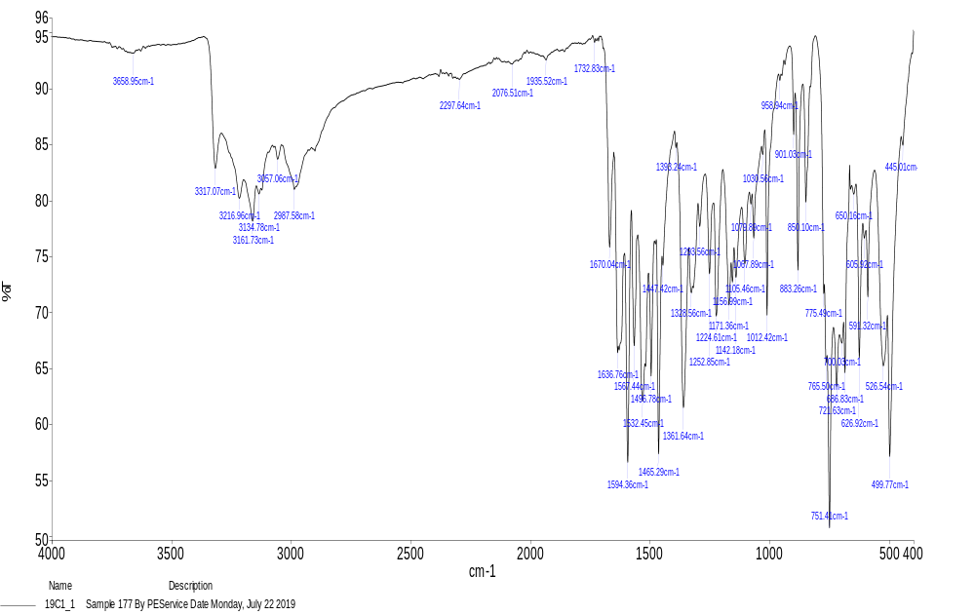
Figure 1. FT-IR spectrum of compound 1
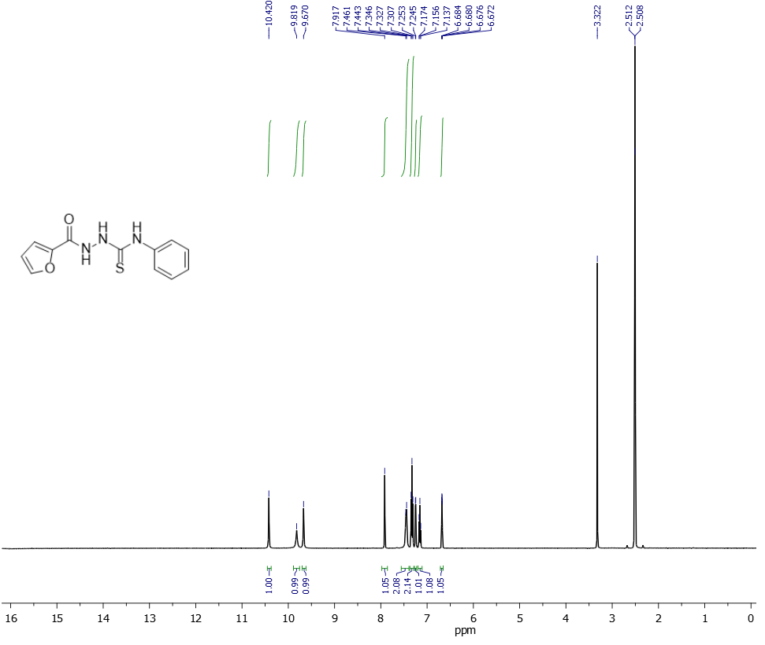
Figure 2. ¹H NMR spectrum of compound 1
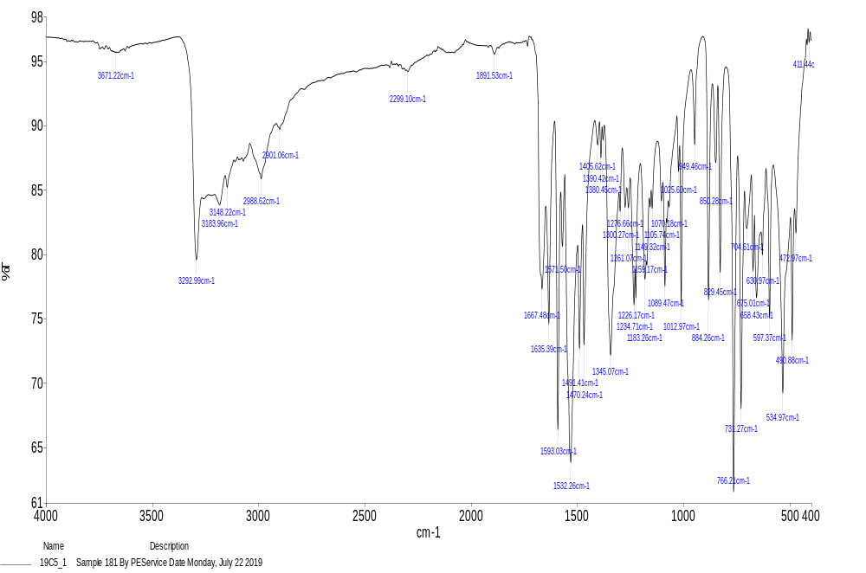
Figure 3. FT-IR spectrum of compound 2
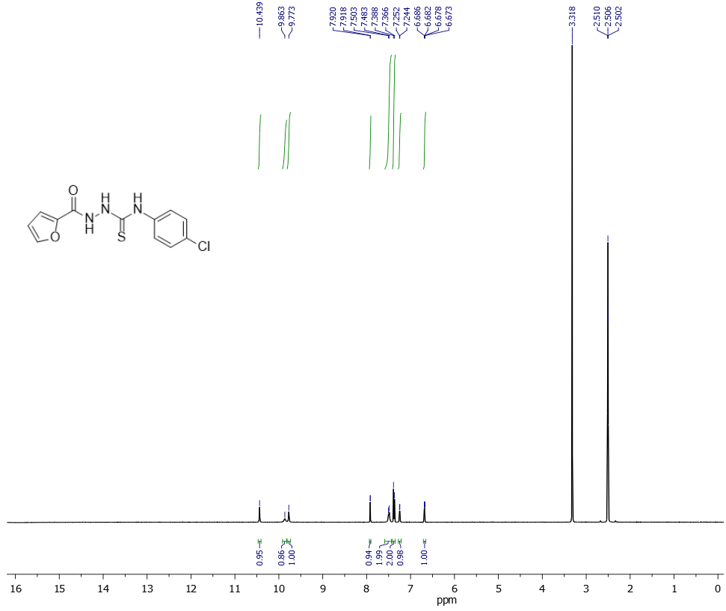
Figure 4. ¹H NMR spectrum of compound 2
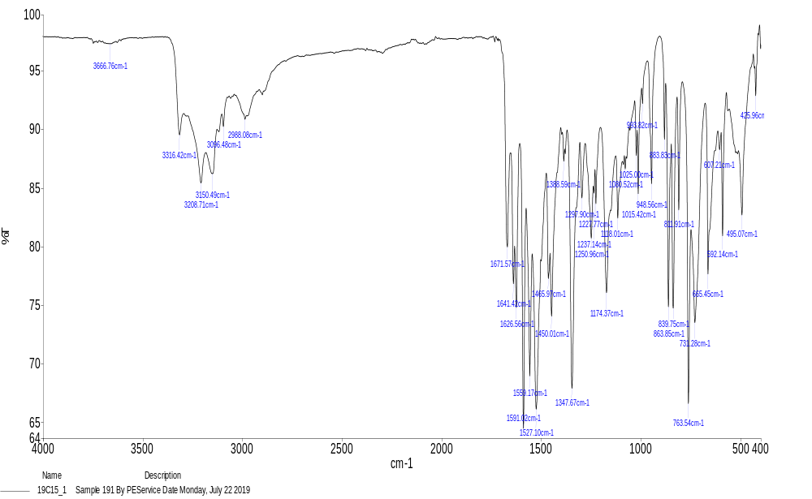
Figure 5. FT-IR spectrum of compound 3
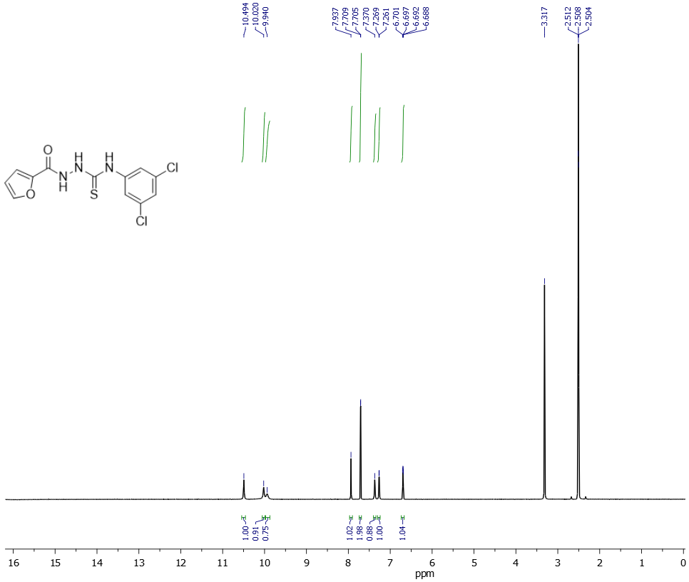
Figure 6. ¹H NMR spectrum of compound 3
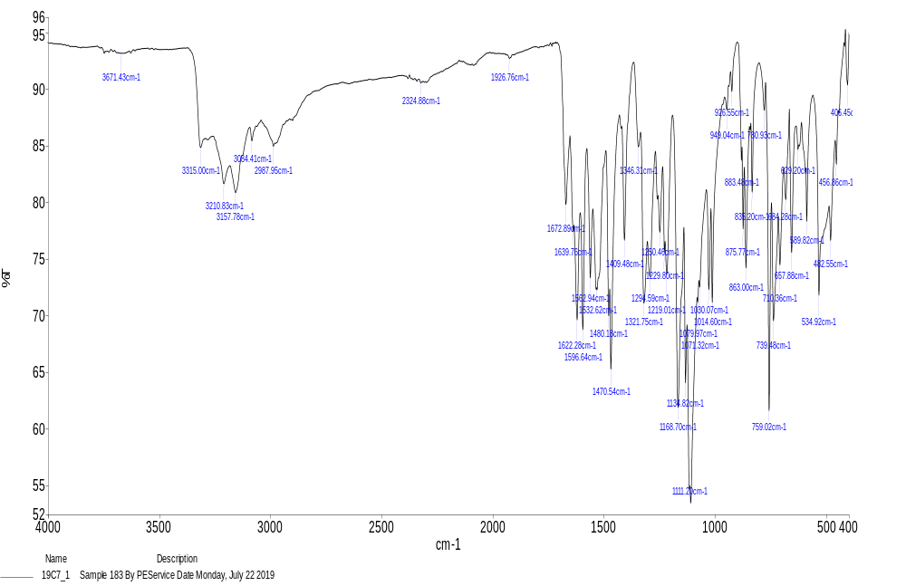
Figure 7. FT-IR spectrum of compound 4
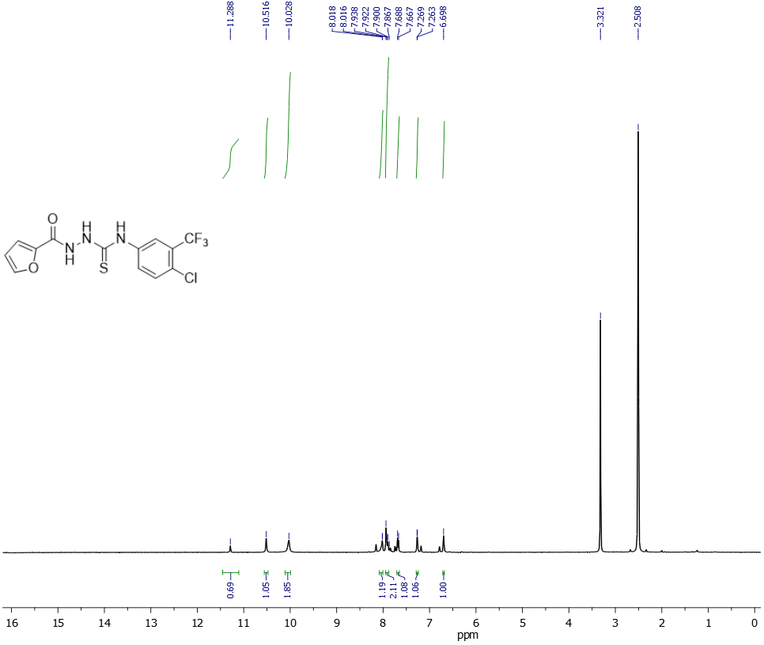 Figure 8. ¹H NMR spectrum of compound 4
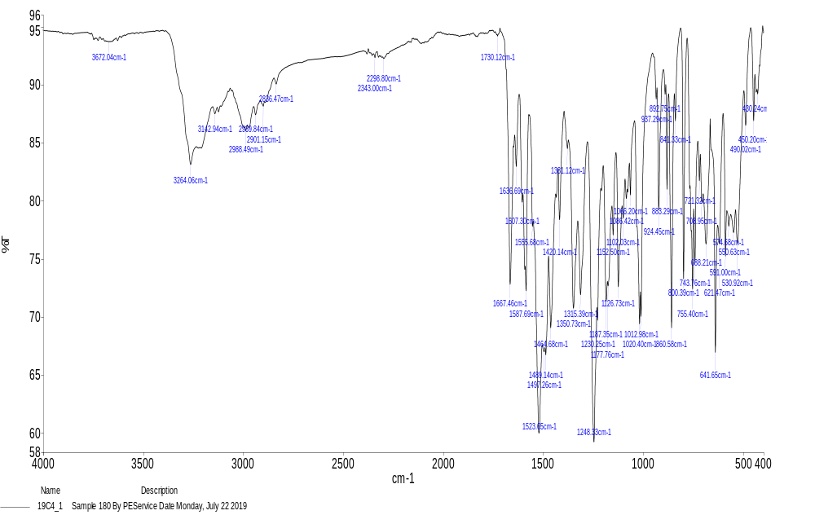
Figure 9. FT-IR spectrum of compound 5
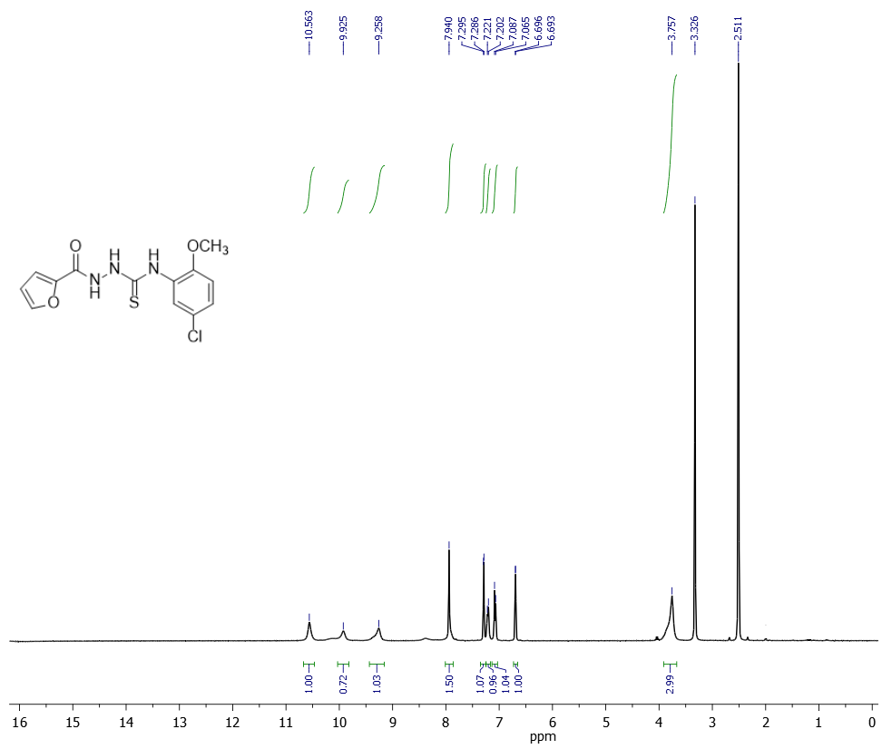
Figure 10. ¹H NMR spectrum of compound 5
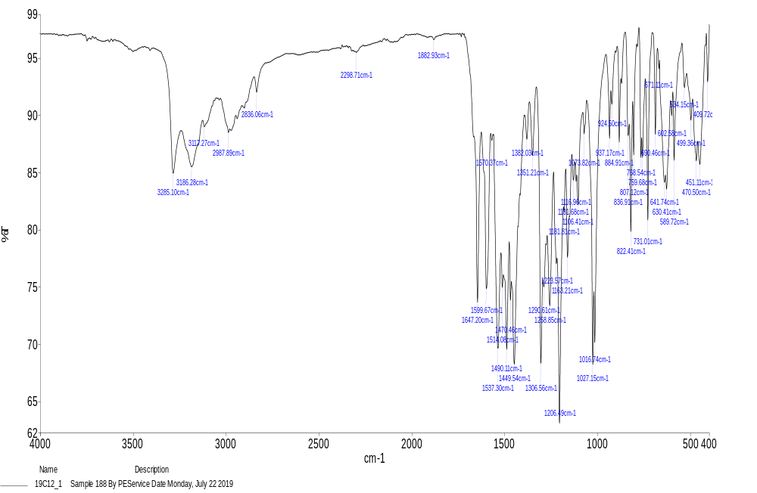
Figure 11. FT-IR spectrum of compound 6
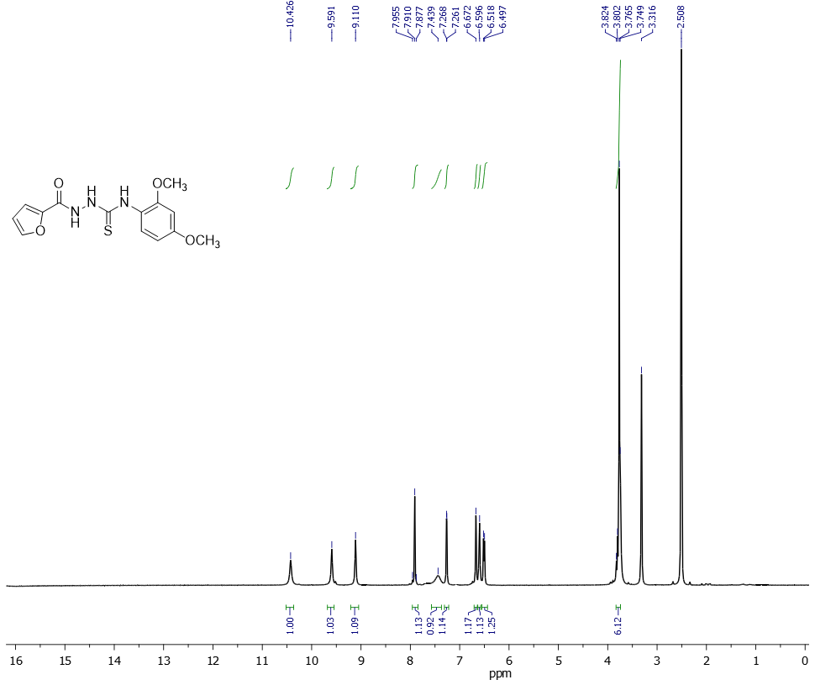
Figure 12. ¹H NMR spectrum of compound 6
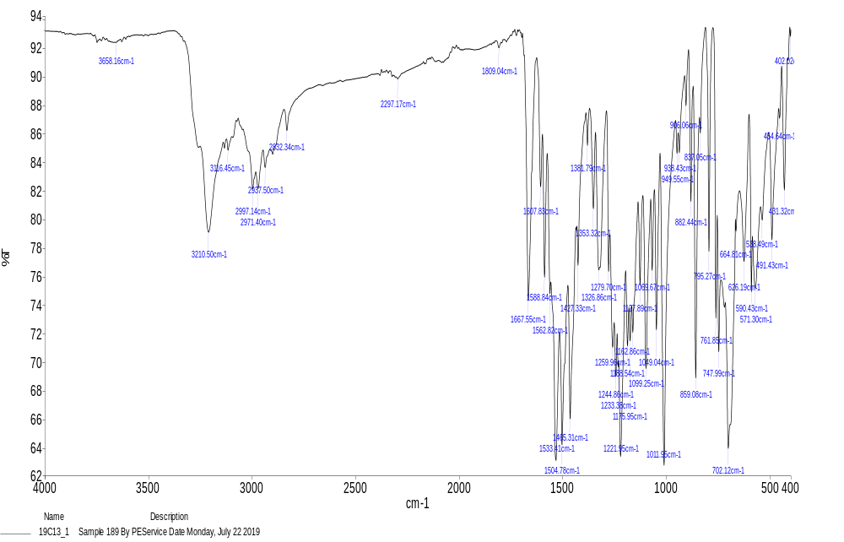
Figure 13. FT-IR spectrum of compound 7
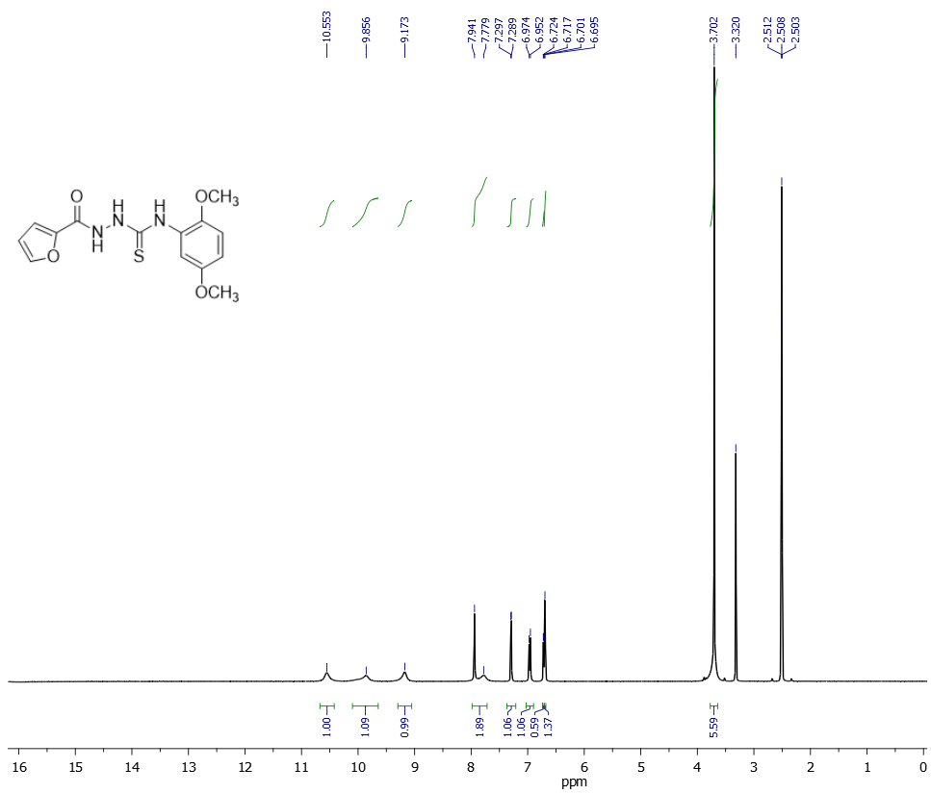
Figure 14. ¹H NMR spectrum of compound 7
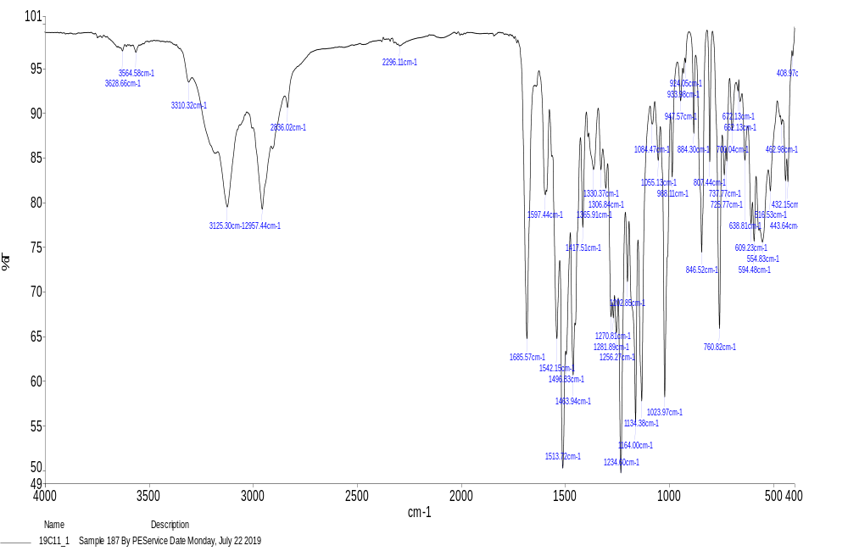
Figure 15. FT-IR spectrum of compound 8
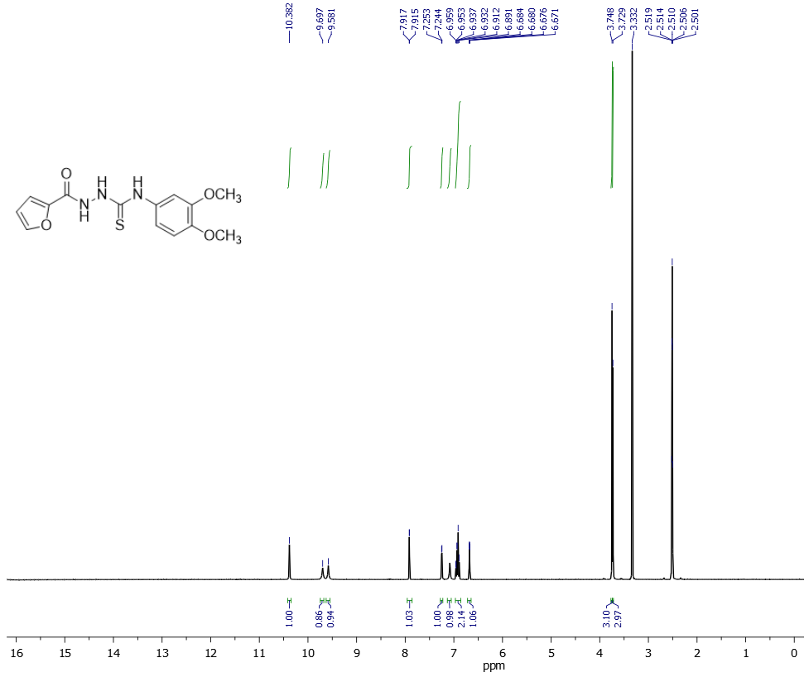
Figure 16. ¹H NMR spectrum of compound 8
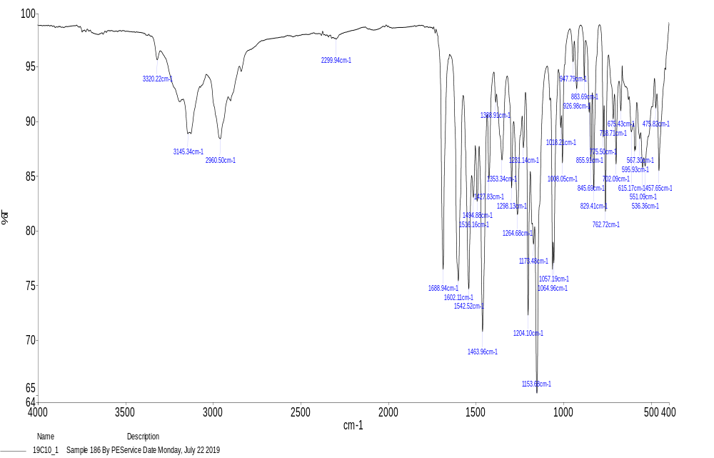
Figure 17. FT-IR spectrum of compound 9
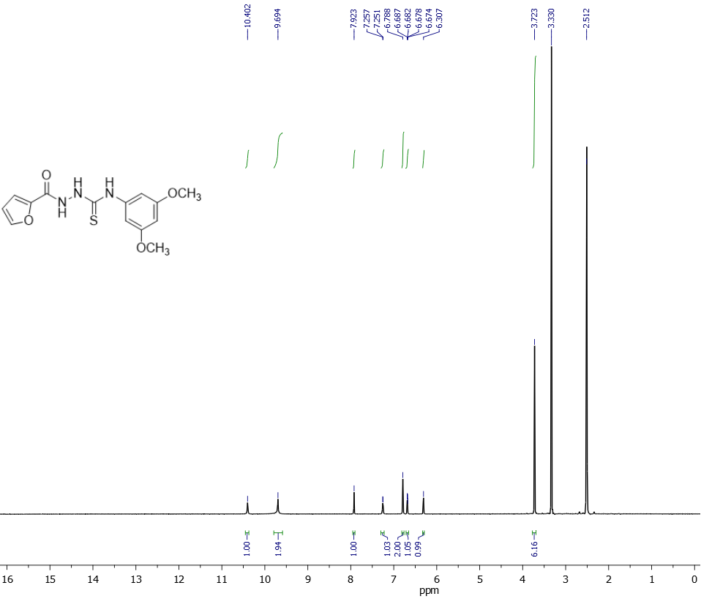
Figure 18. ¹H NMR spectrum of compound 9
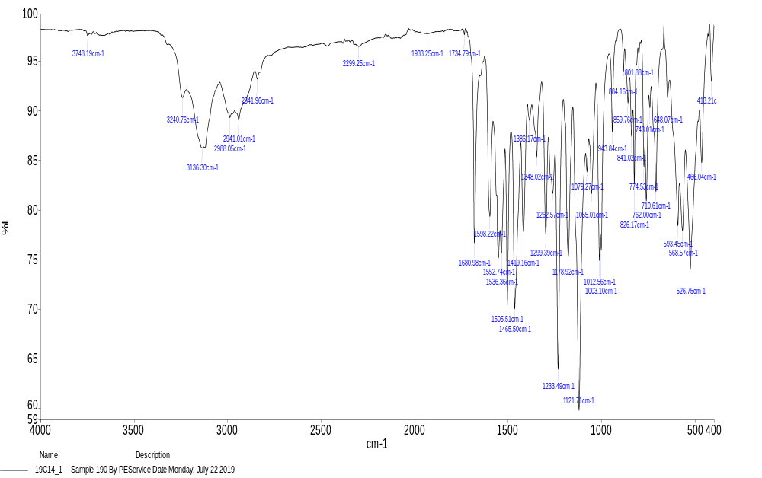
Figure 19. FT-IR spectrum of compound 10
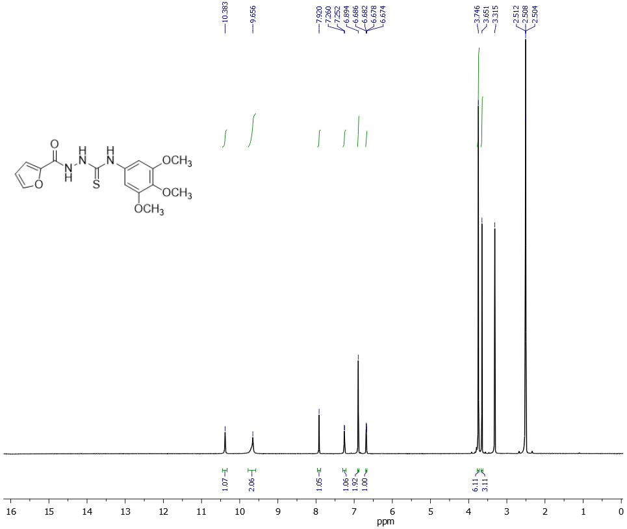
Figure 20. ¹H NMR spectrum of compound 10
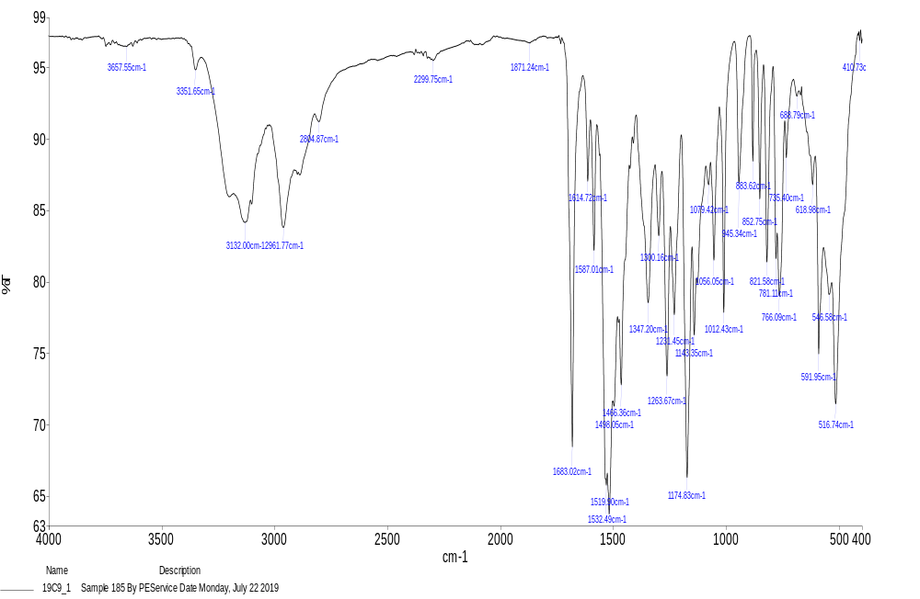
Figure 21. FT-IR spectrum of compound 11
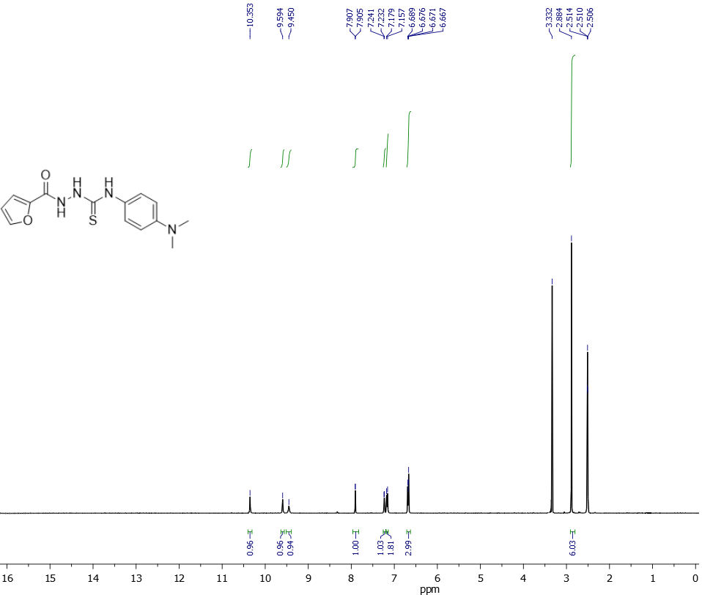
Figure 22. ¹H NMR spectrum of compound 11
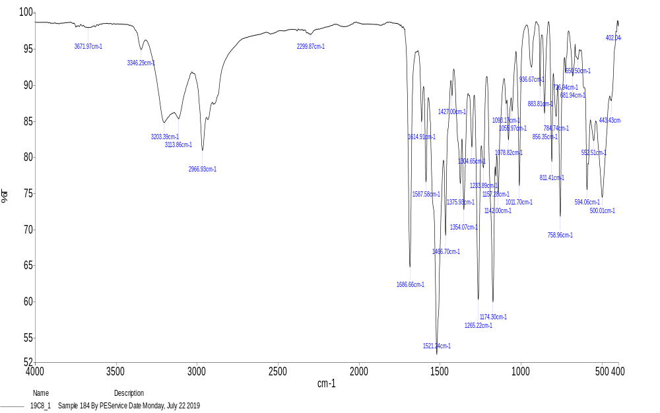
Figure 23. FT-IR spectrum of compound 12
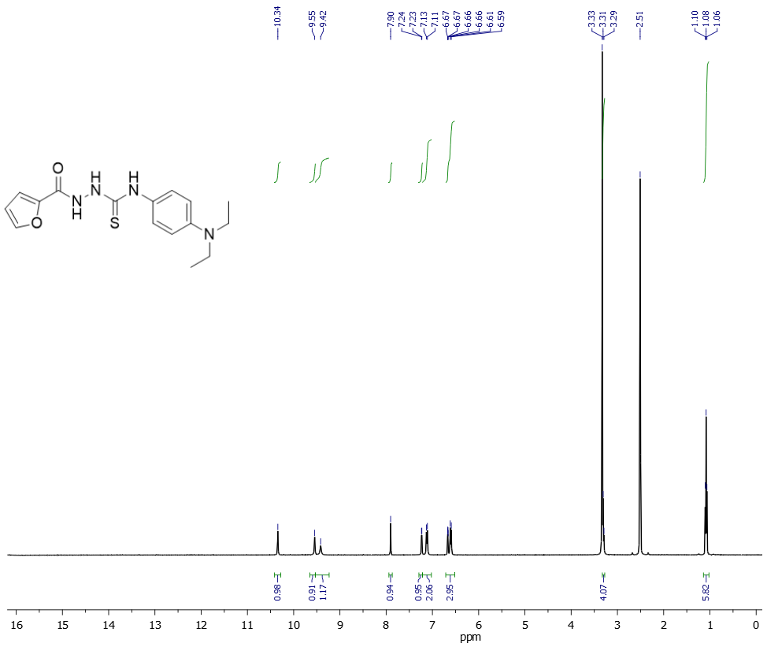
Figure 24. ¹H NMR spectrum of compound 12

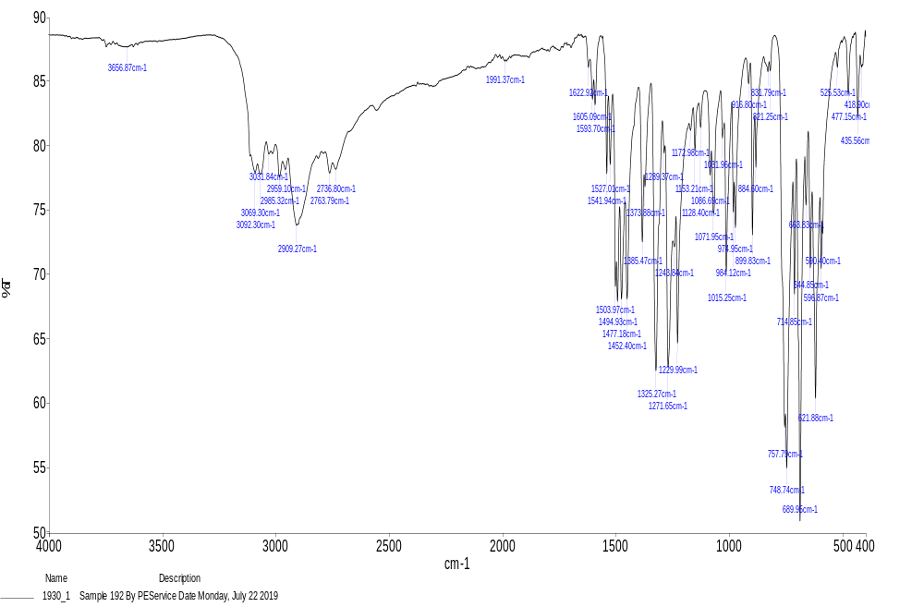
Figure 25. FT-IR spectrum of compound 13
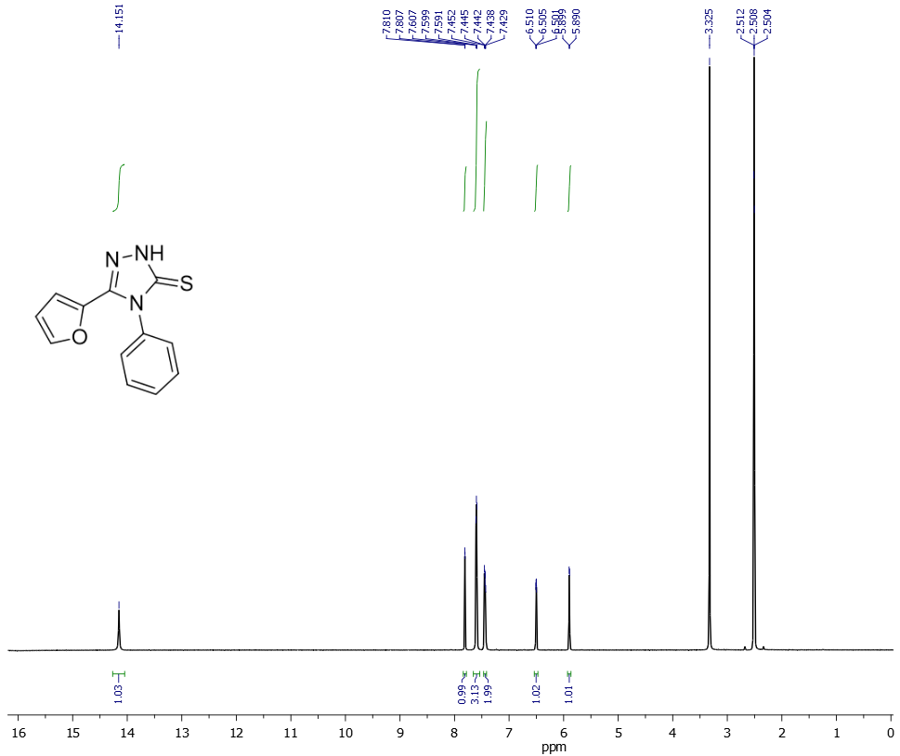
Figure 26. ¹H NMR spectrum of compound 13
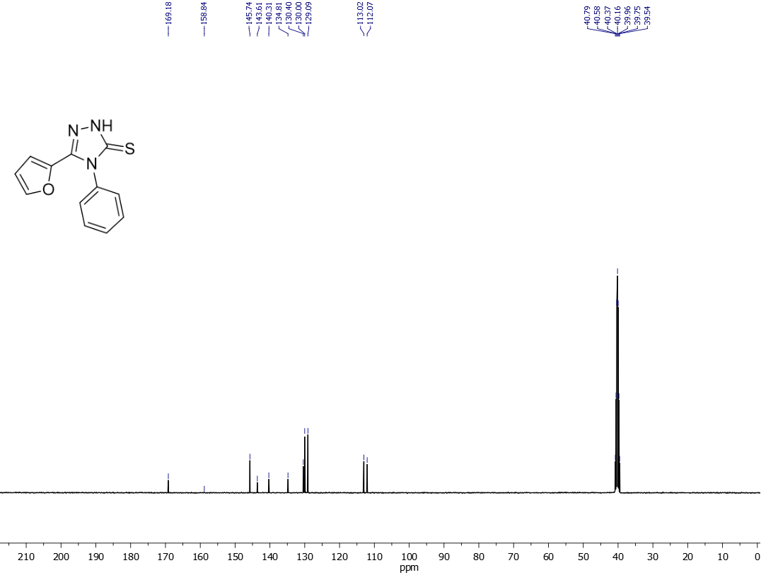
Figure 27. ¹³C NMR spectrum of compound 13

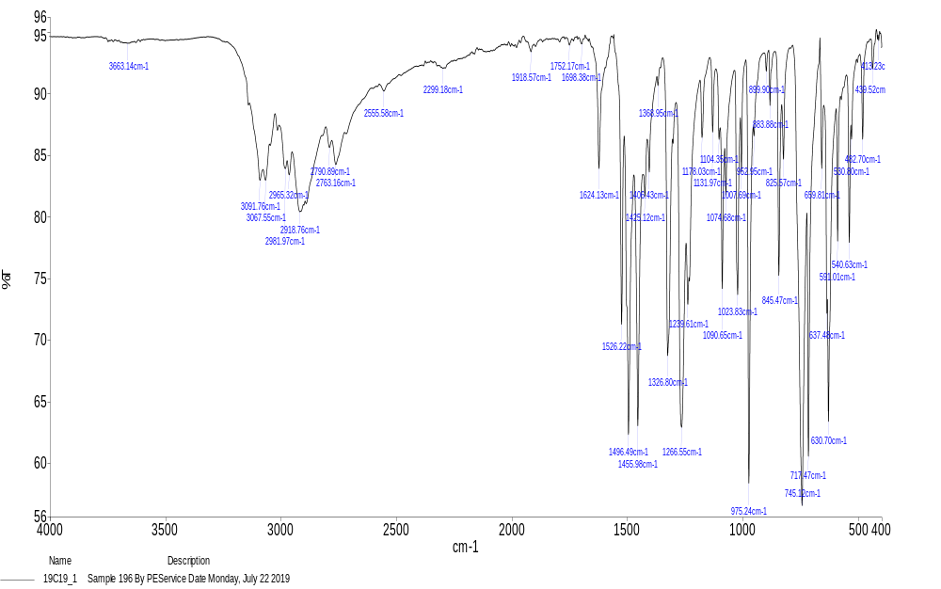
Figure 28. FT-IR spectrum of compound 14
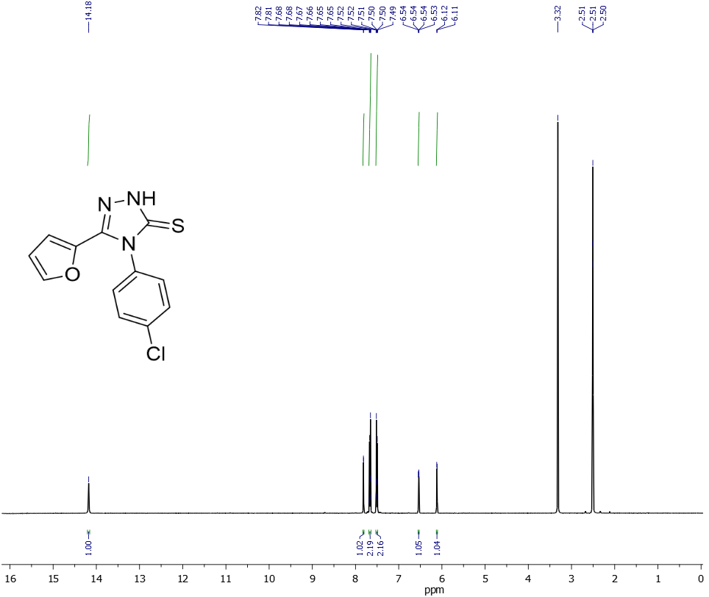
Figure 29. ¹H NMR spectrum of compound 14
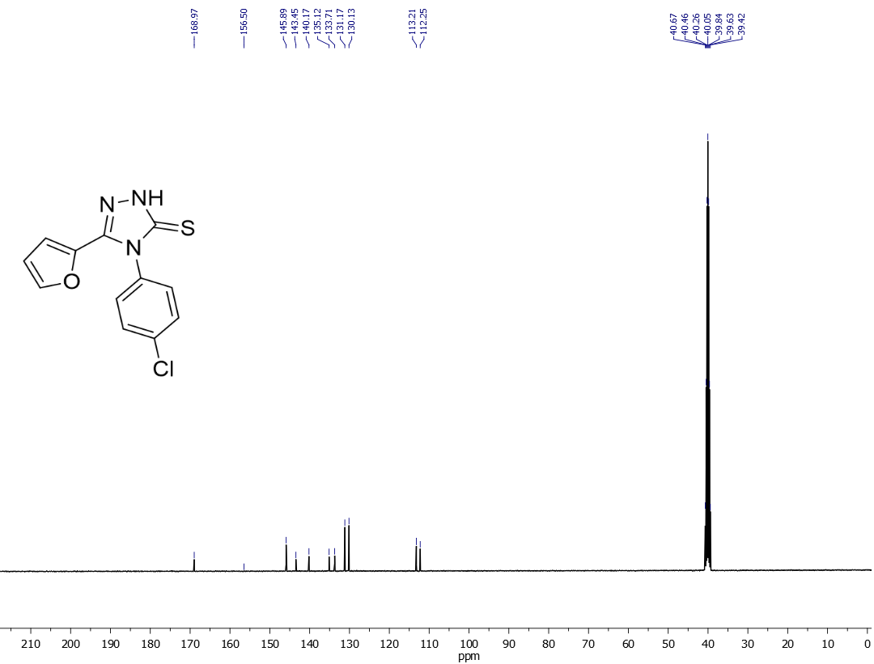
Figure 30. ¹³C NMR spectrum of compound 14
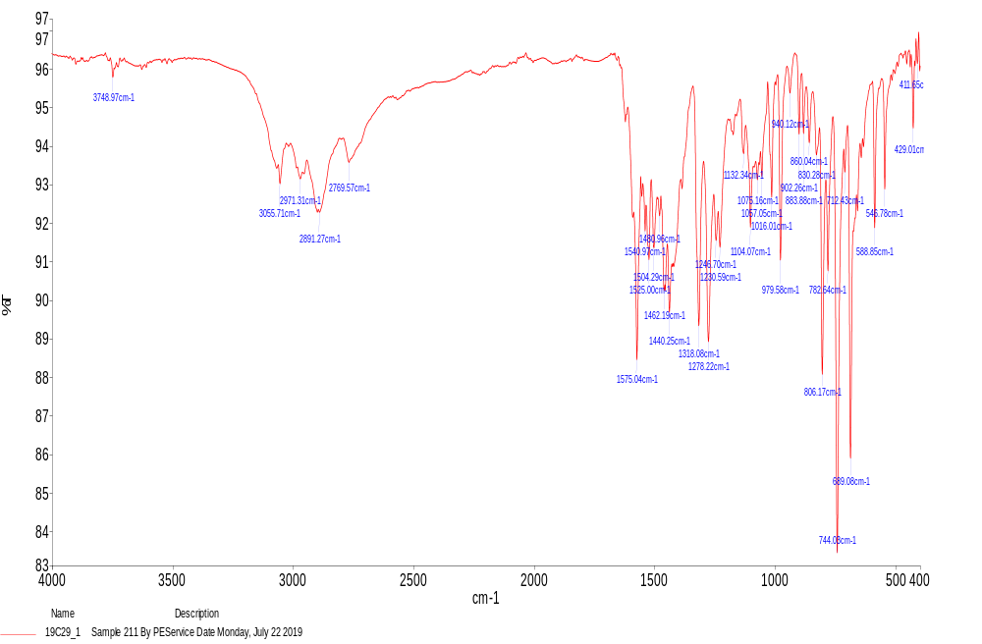
Figure 30. FT-IR spectrum of compound 15
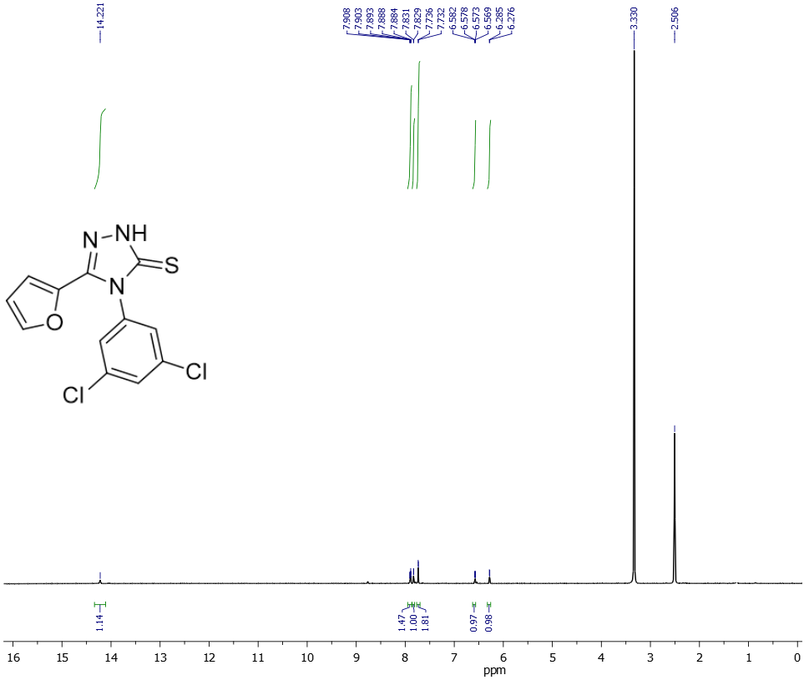
Figure 31. ¹H NMR spectrum of compound 15
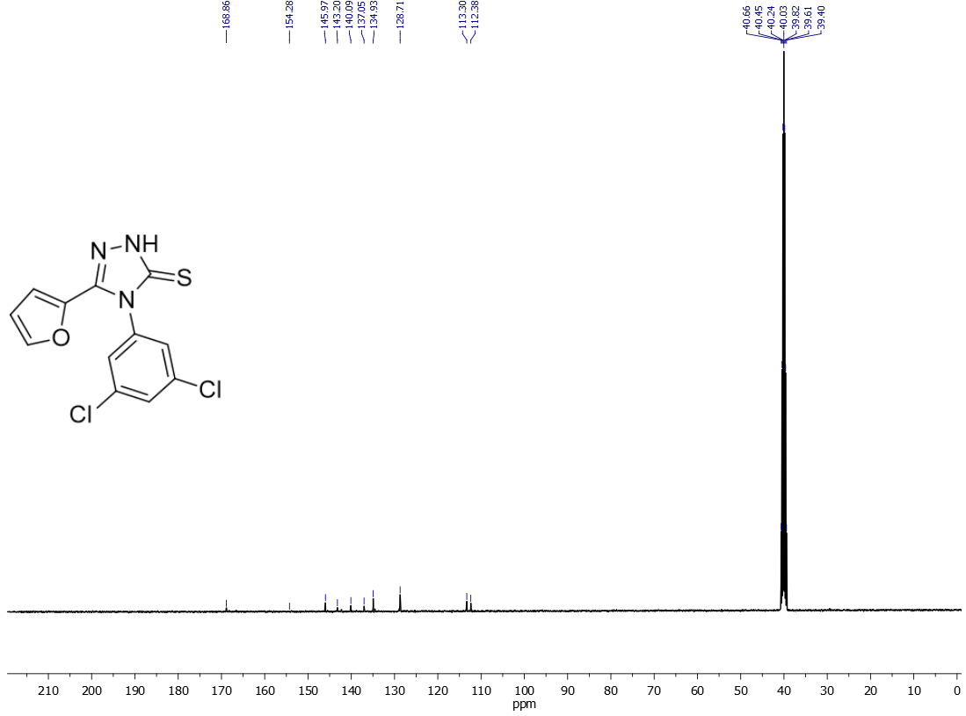
Figure 32. ¹³C NMR spectrum of compound 15

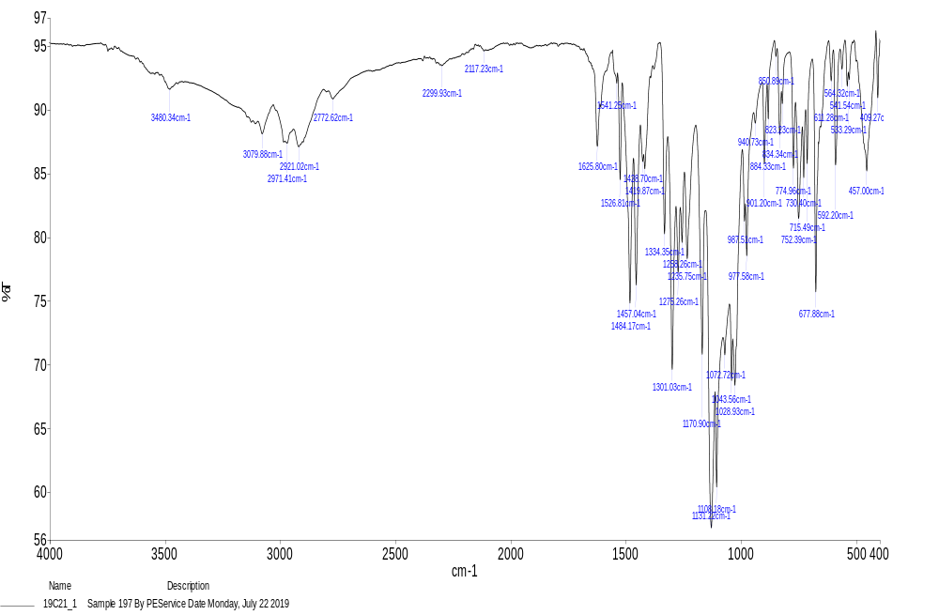
Figure 33. FT-IR spectrum of compound 16
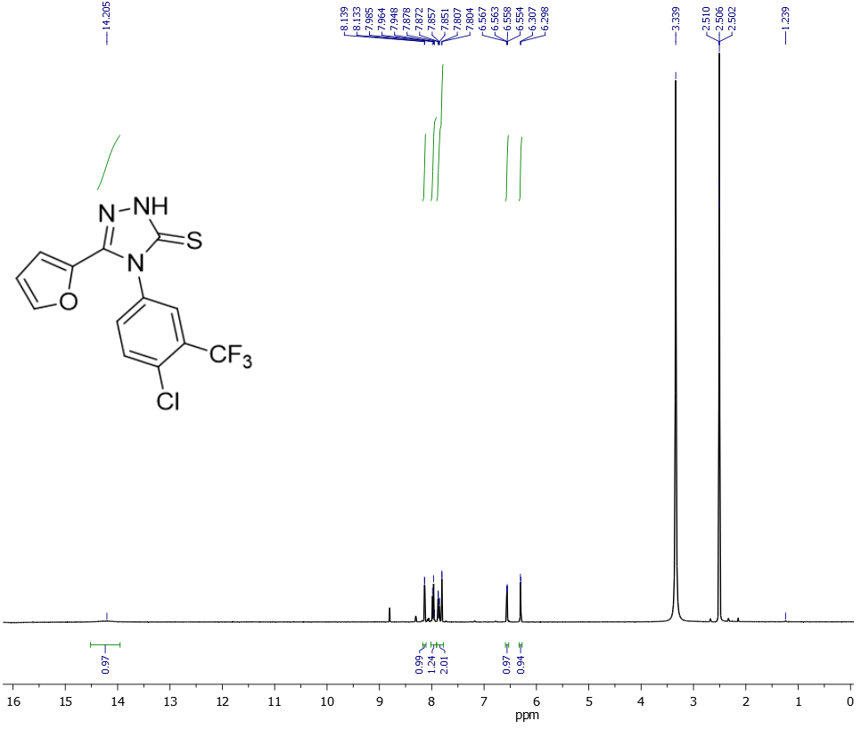
Figure 34. ¹H NMR spectrum of compound 16

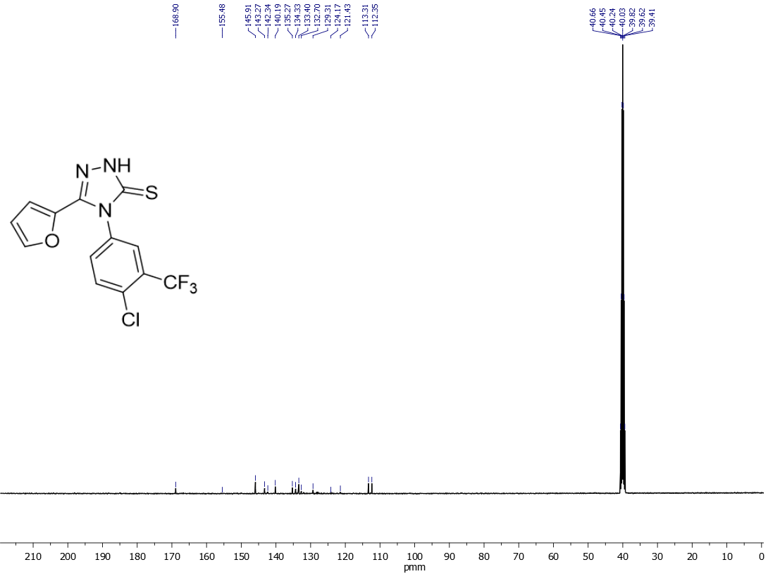
Figure 34. ¹³C NMR spectrum of compound 16
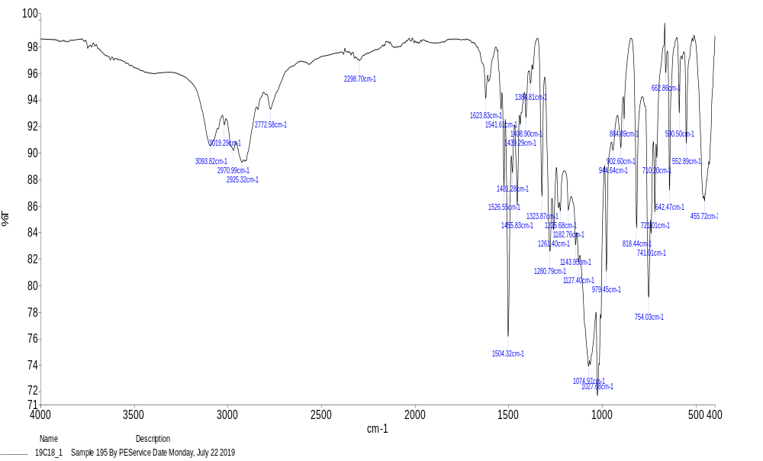
Figure 35. FT-IR spectrum of compound 17

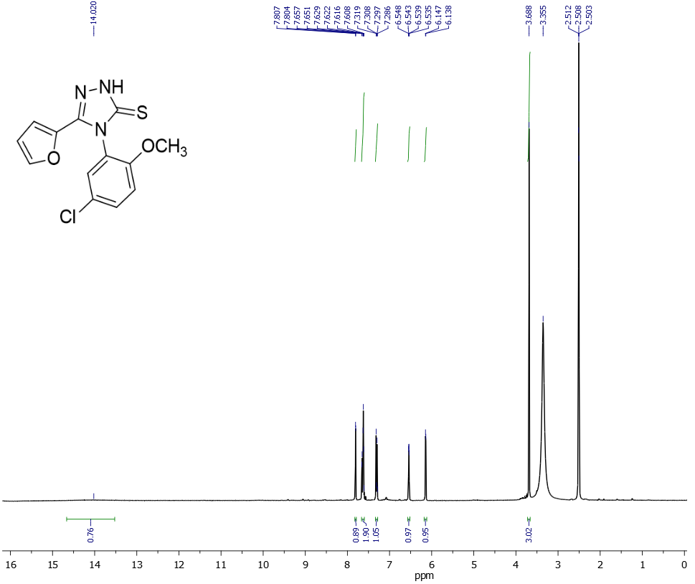
Figure 36. ¹H NMR spectrum of compound 17

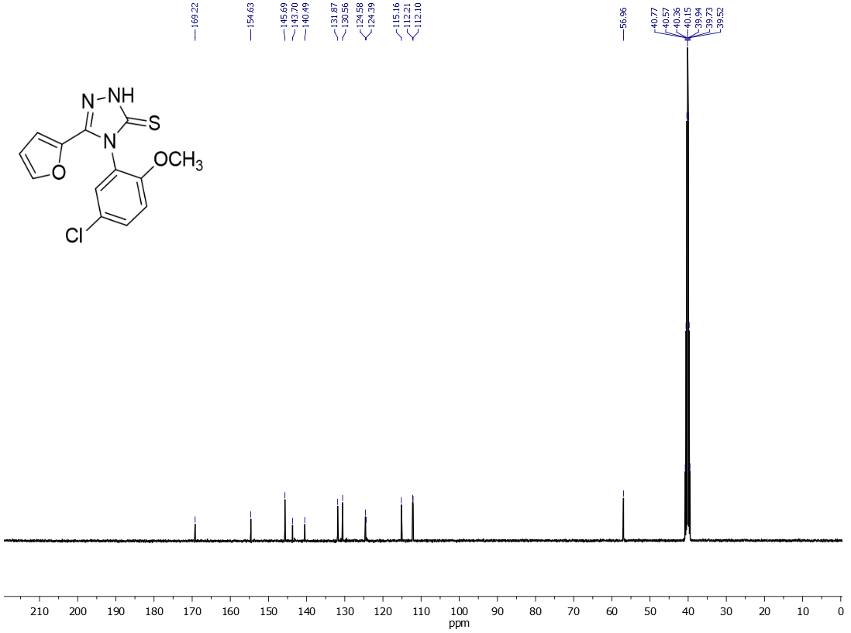
Figure 37. ¹³C NMR spectrum of compound 17

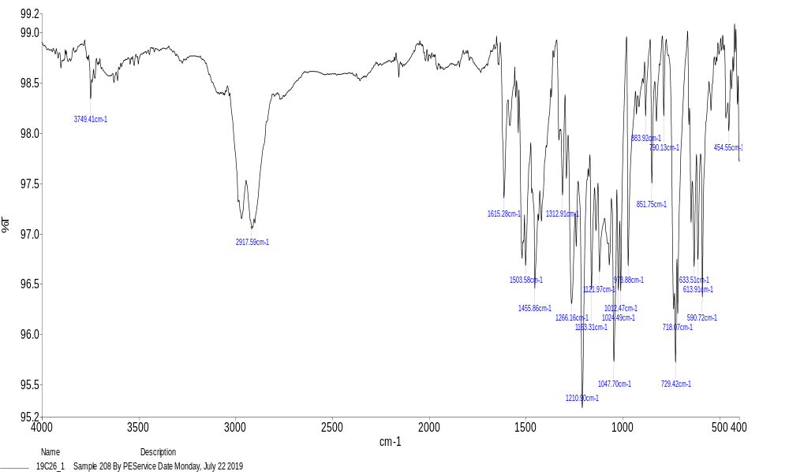
Figure 38. FT-IR spectrum of compound 18
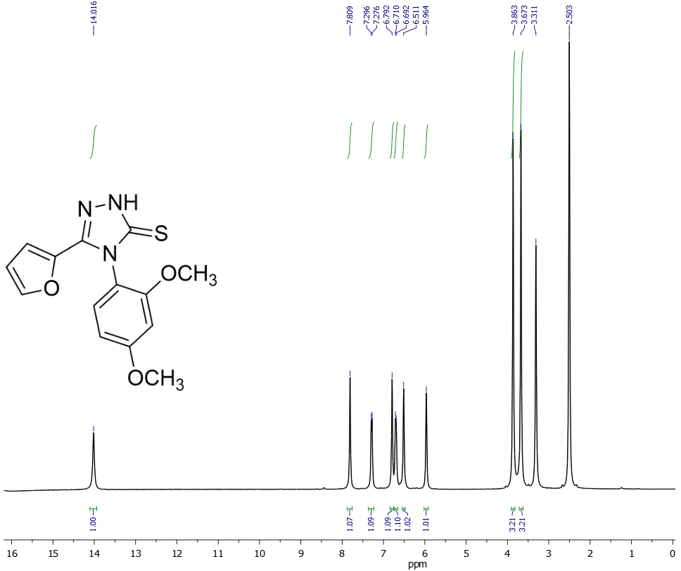
Figure 39. ¹H NMR spectrum of compound 18

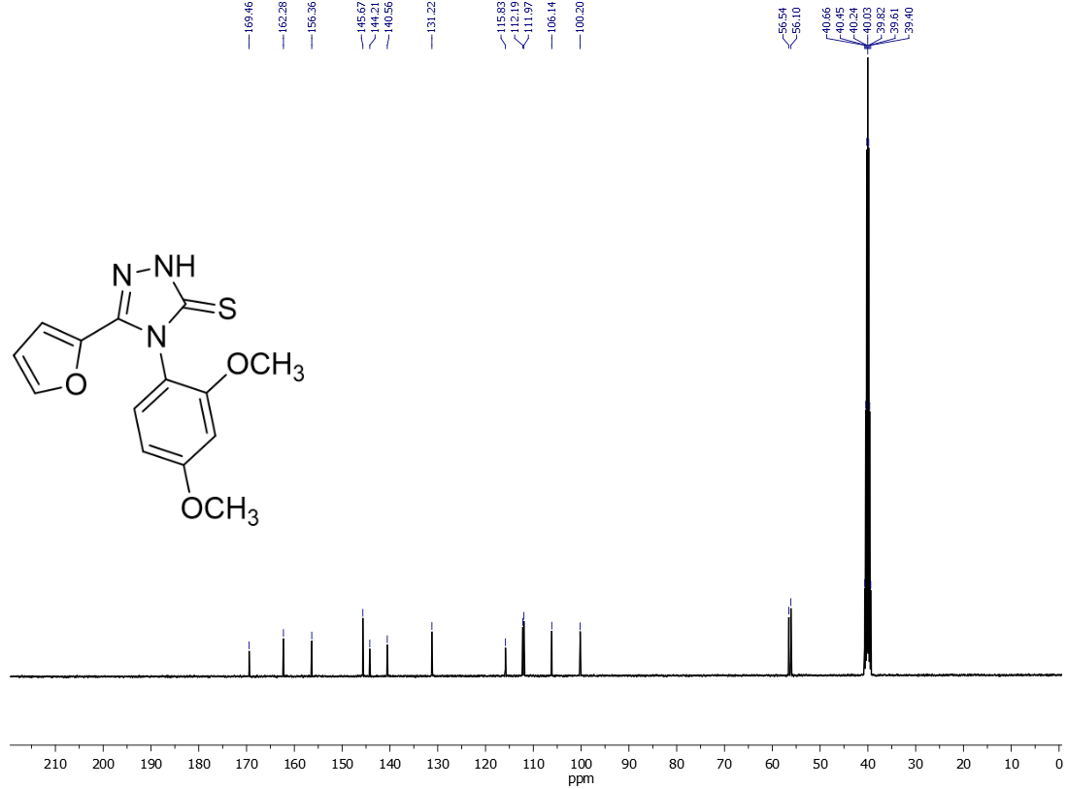
Figure 40. ¹³C NMR spectrum of compound 18
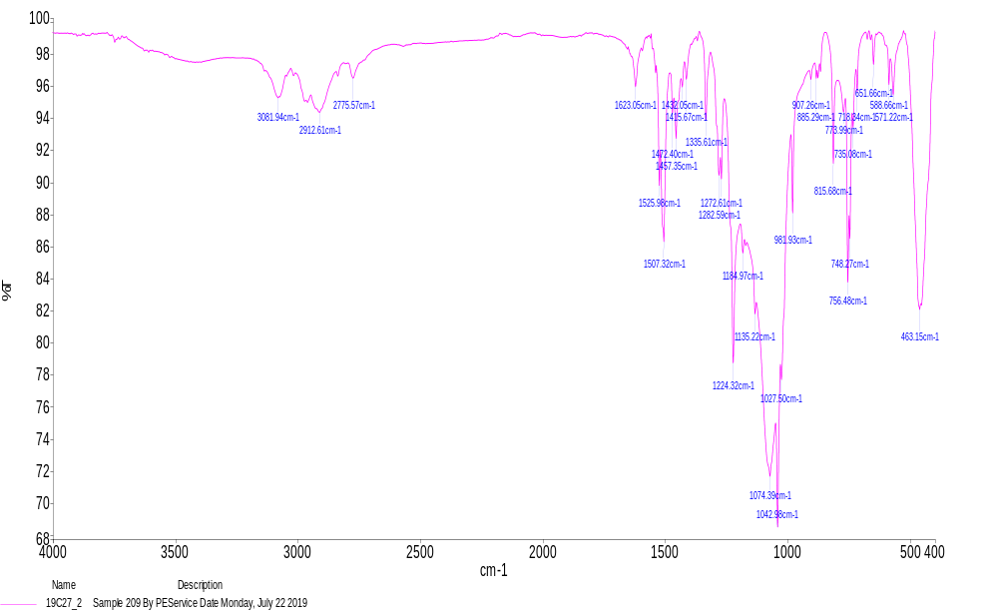
Figure 41. FT-IR spectrum of compound 19
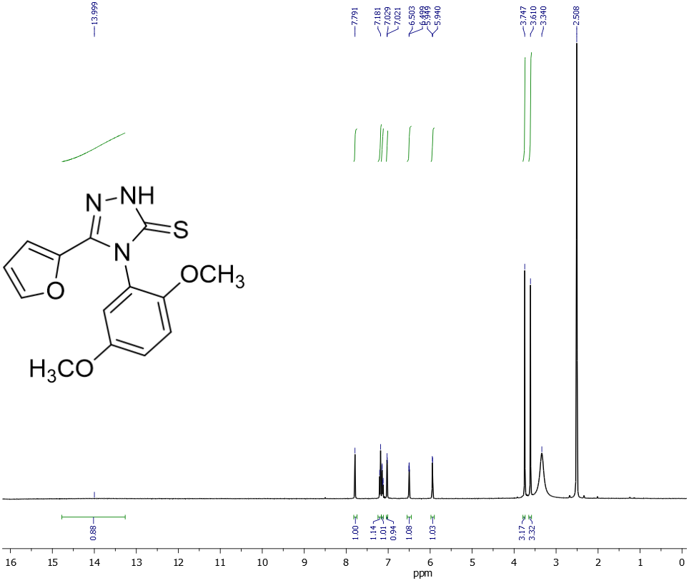
Figure 42. ¹H NMR spectrum of compound 19

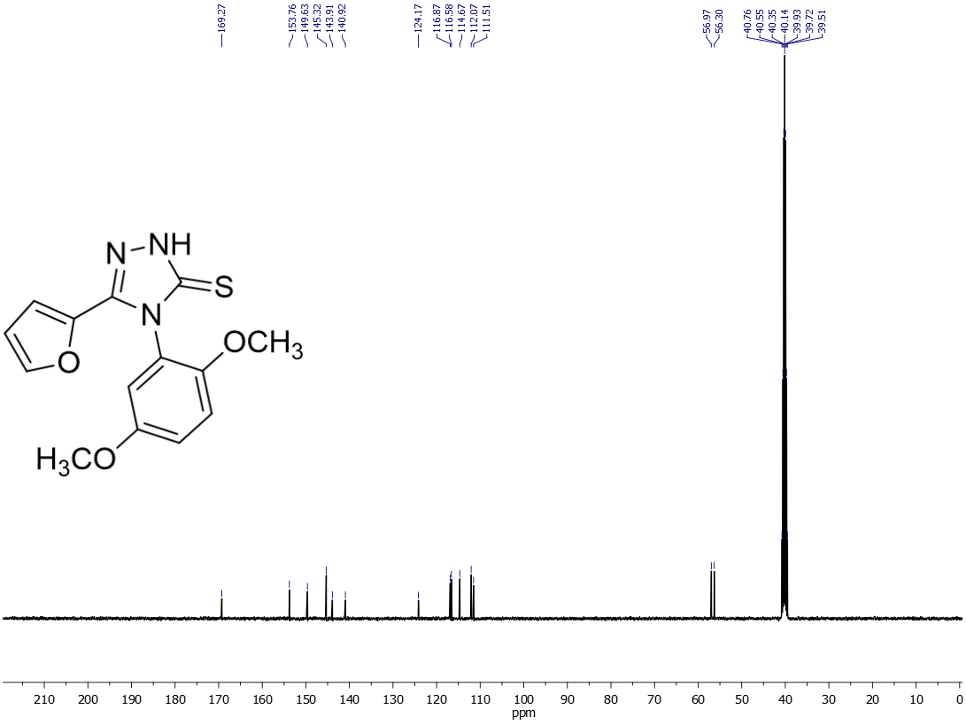
Figure 42. ¹³C NMR spectrum of compound 19

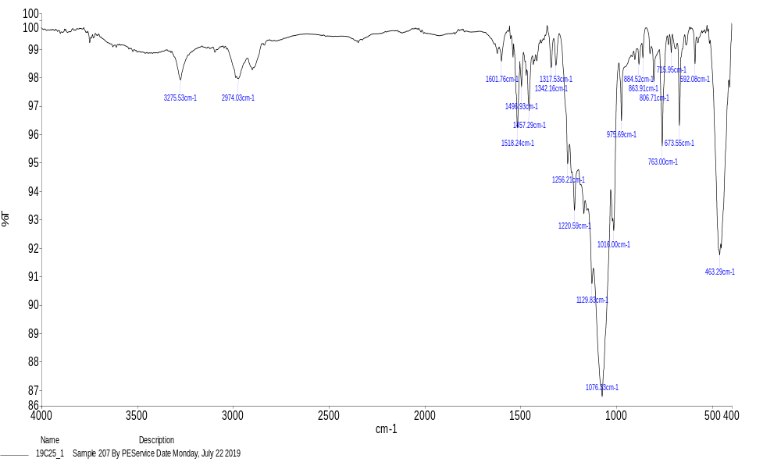
Figure 43. FT-IR spectrum of compound 20
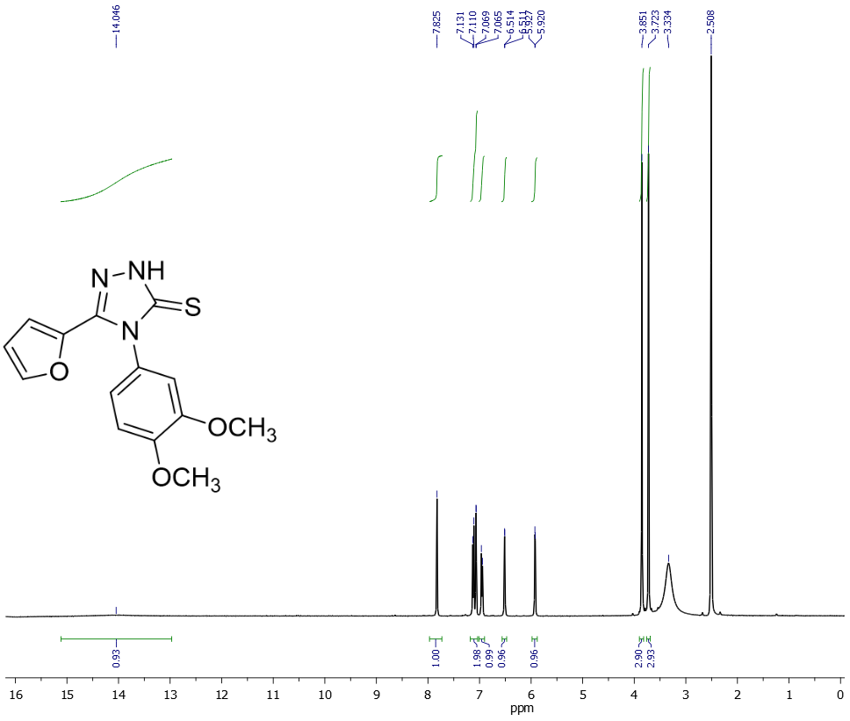
Figure 44. ¹H NMR spectrum of compound 20
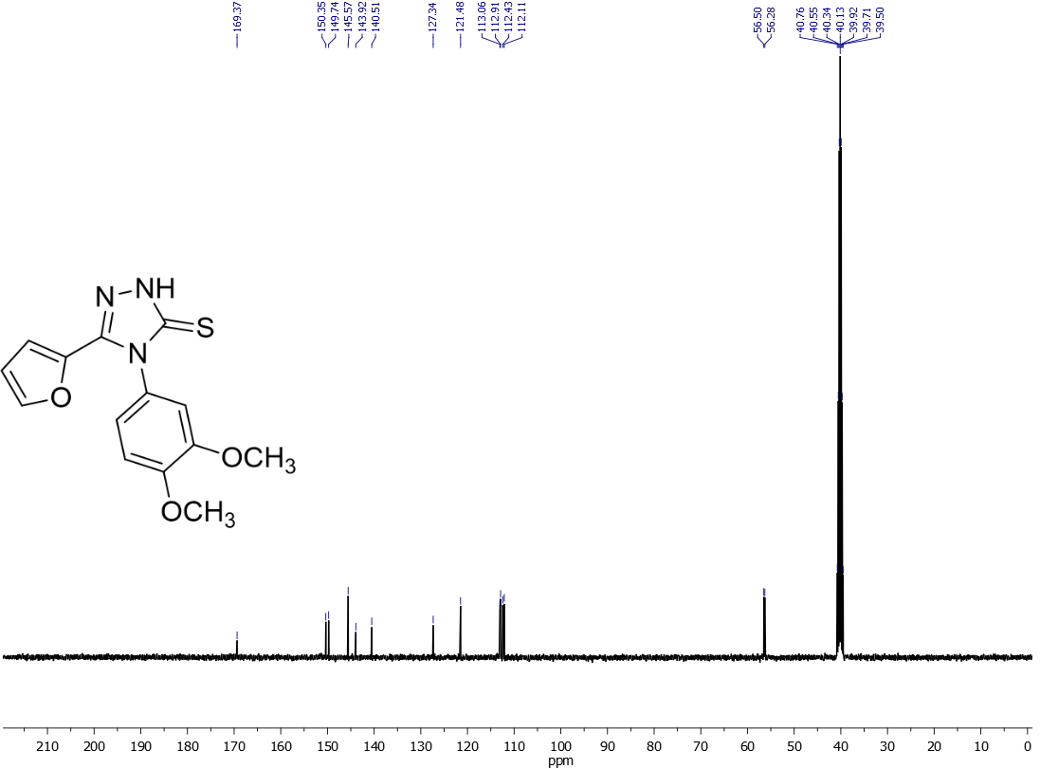
Figure 45. ¹³C NMR spectrum of compound 20
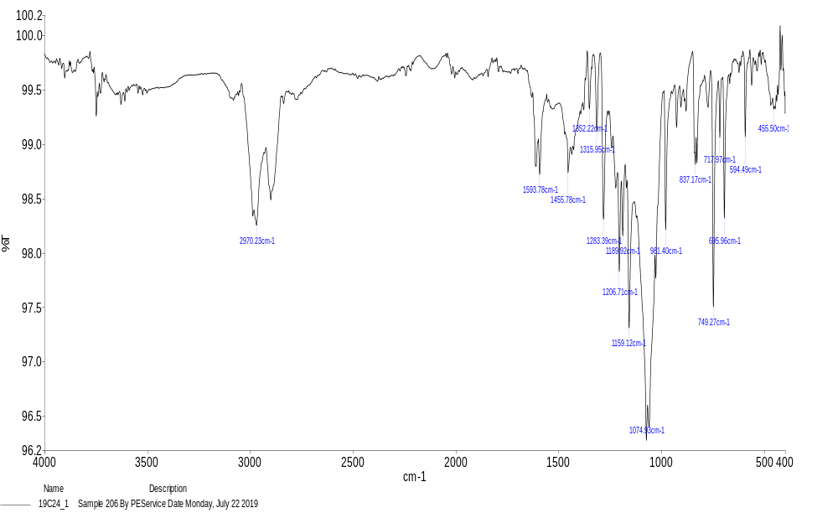
Figure 46. FT-IR spectrum of compound 21
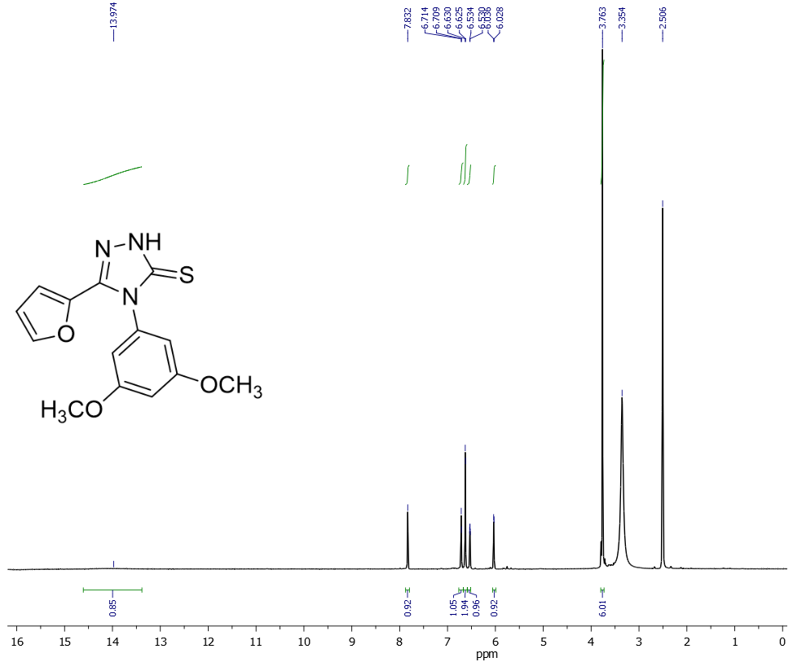
Figure 47. ¹H NMR spectrum of compound 21
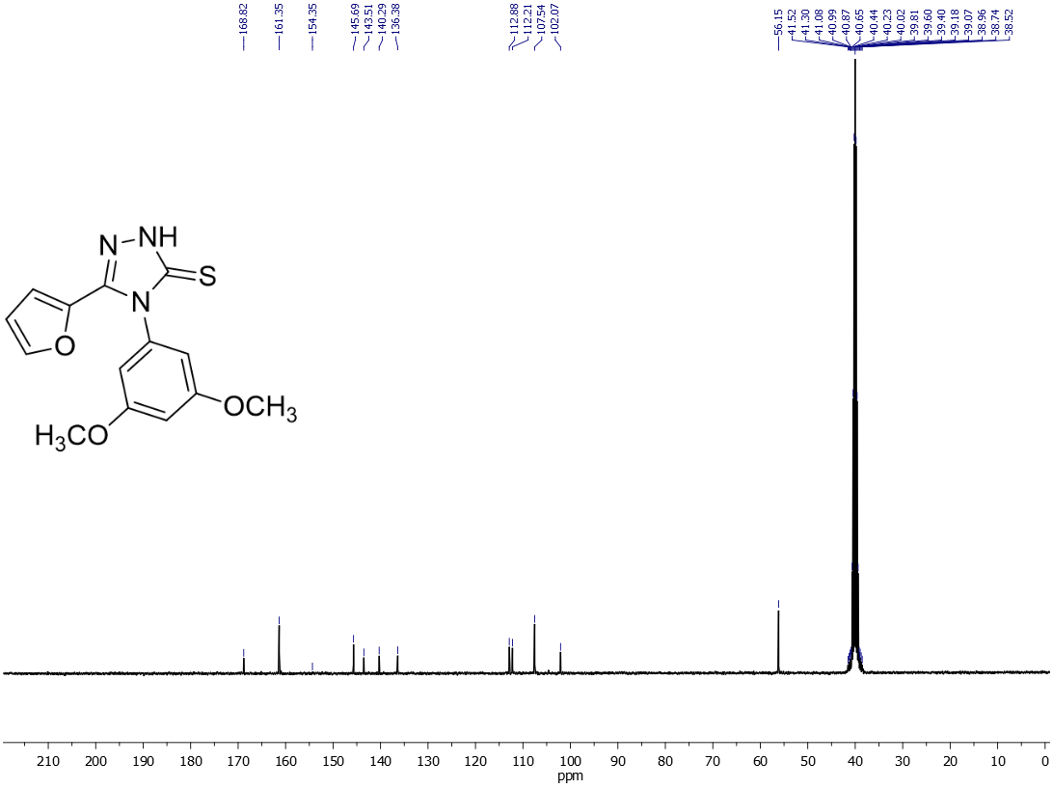
Figure 48. ¹³C NMR spectrum of compound 21

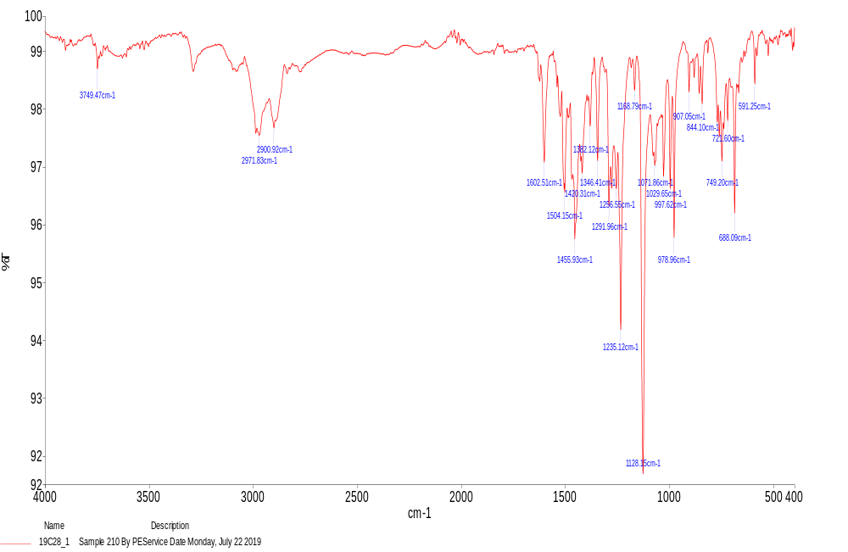
Figure 49. FT-IR spectrum of compound 22
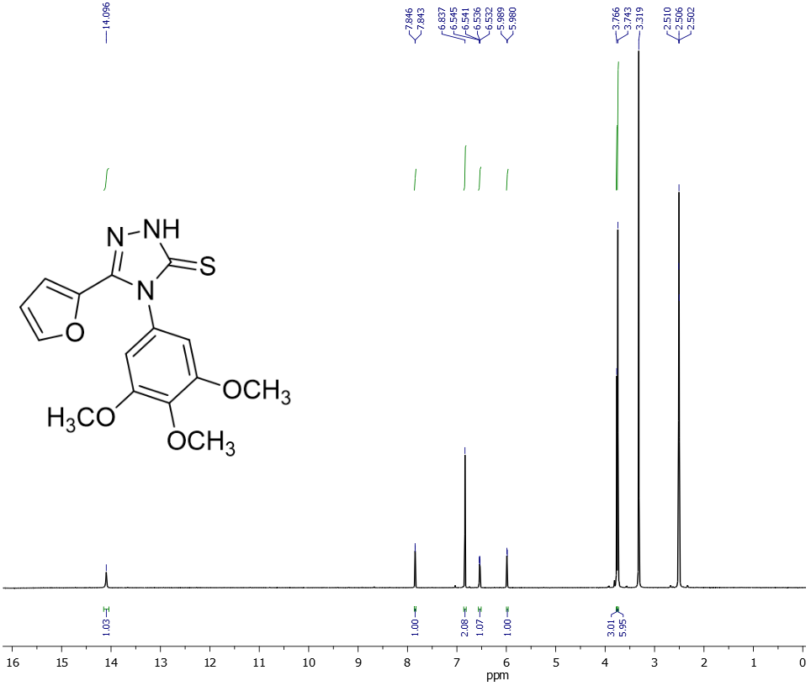
Figure 50. ¹H NMR spectrum of compound 22
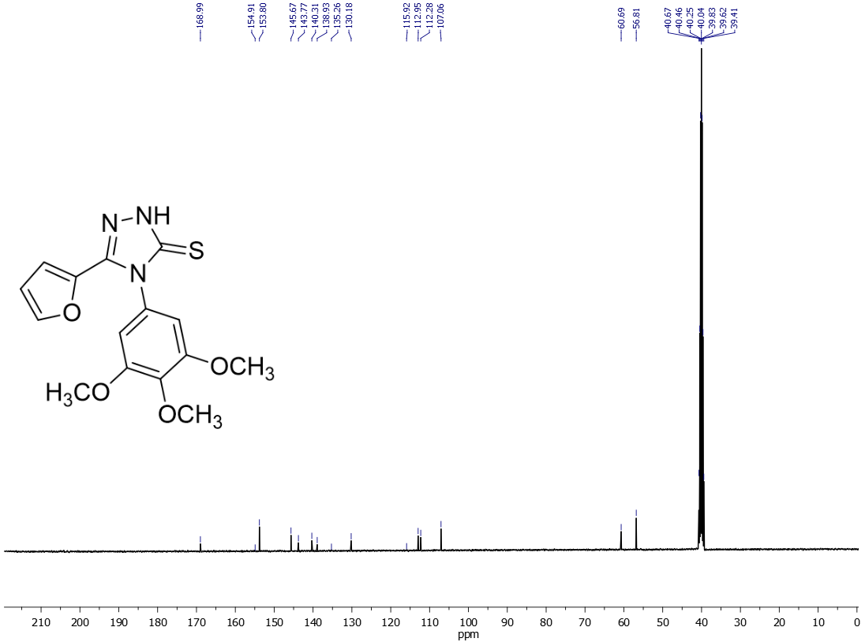
Figure 51. ¹³C NMR spectrum of compound 22
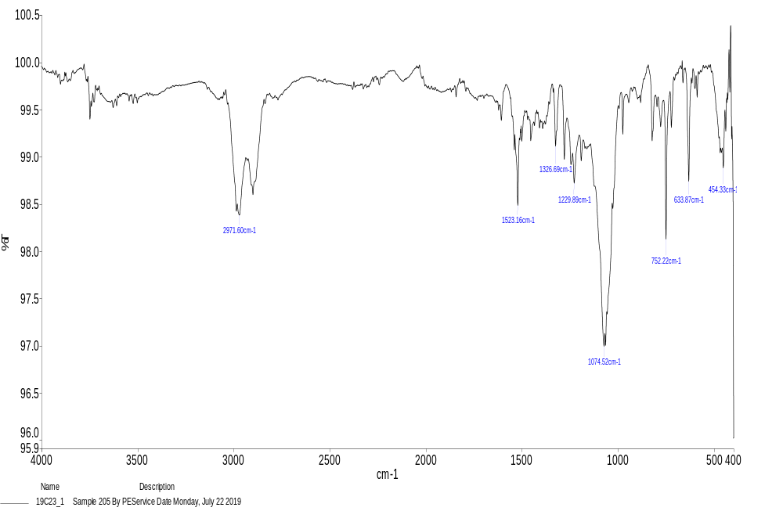
Figure 52. FT-IR spectrum of compound 23

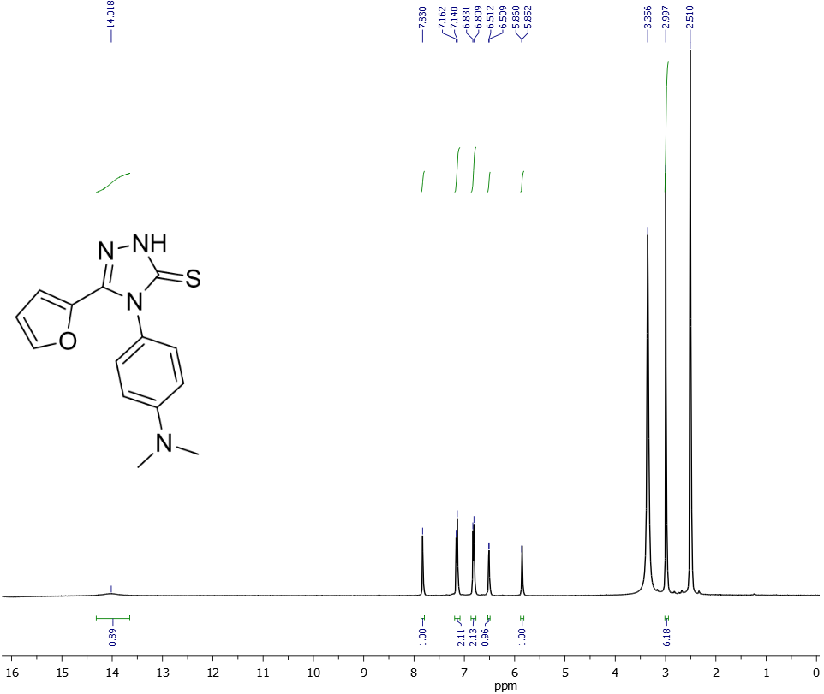
Figure 53. ¹H NMR spectrum of compound 23
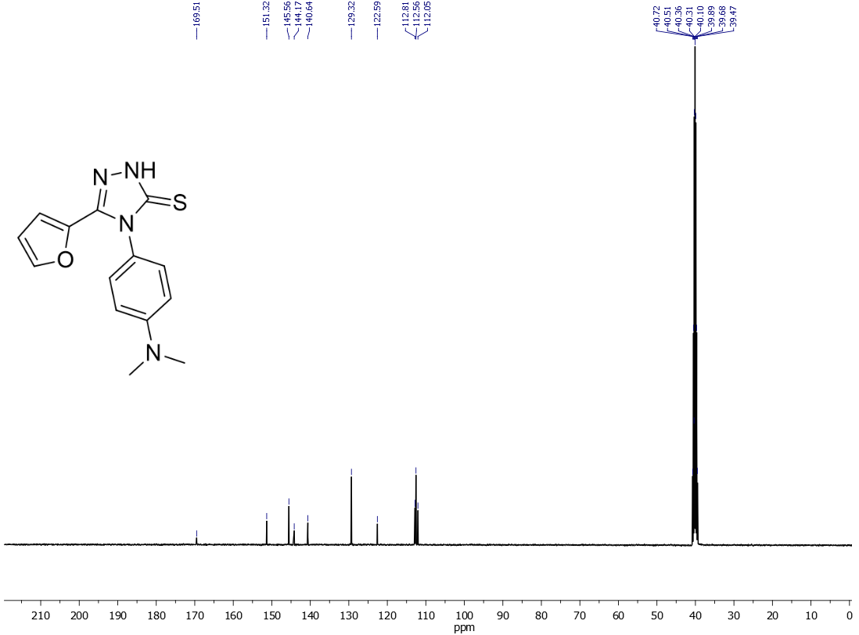
Figure 54. ¹³C NMR spectrum of compound 23

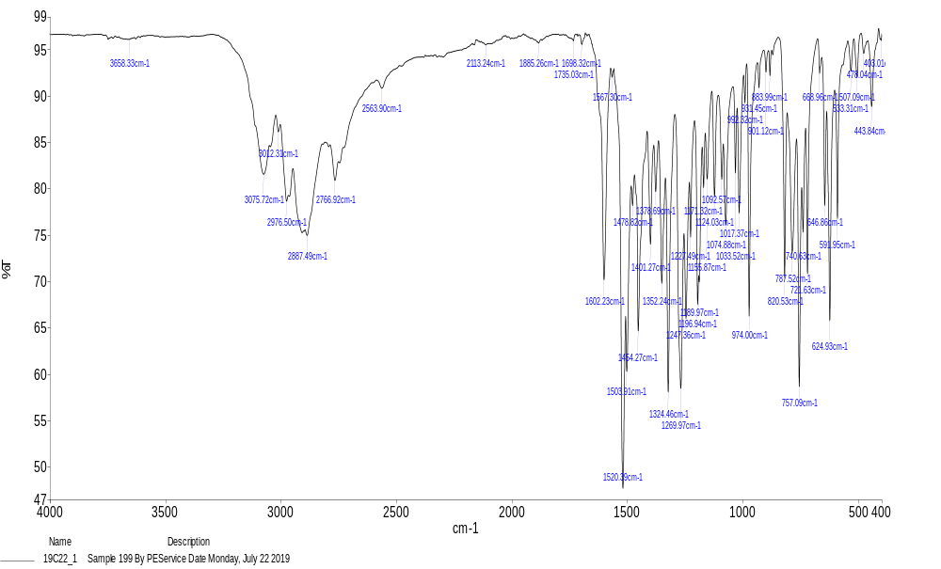
Figure 55. FT-IR spectrum of compound 24
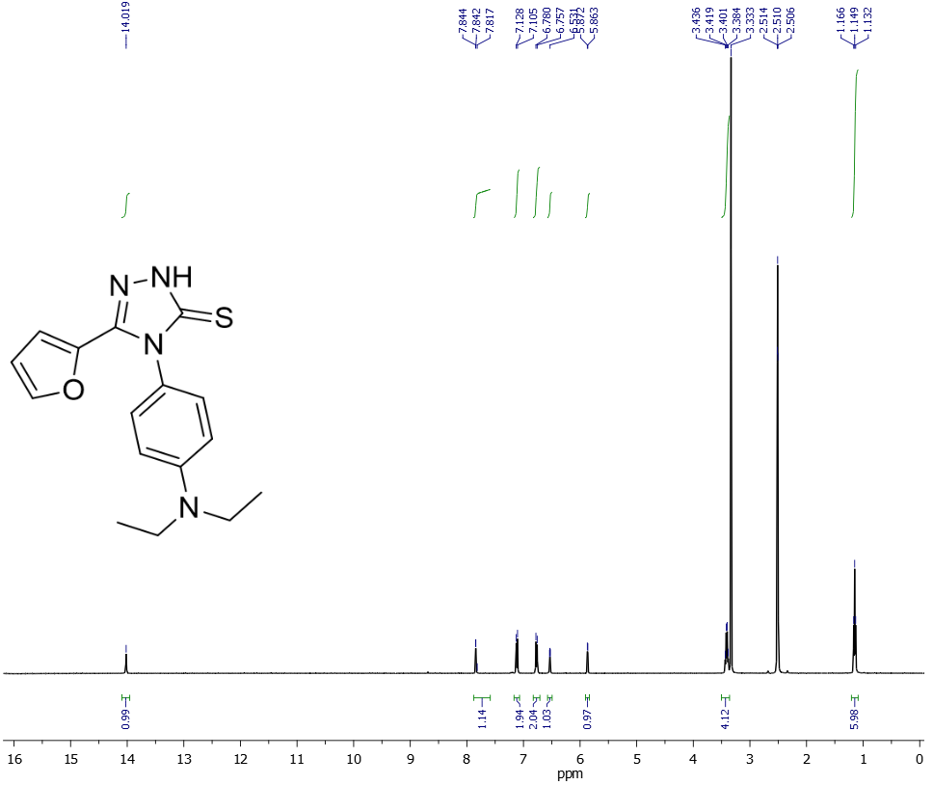
Figure 55. ¹H NMR spectrum of compound 24
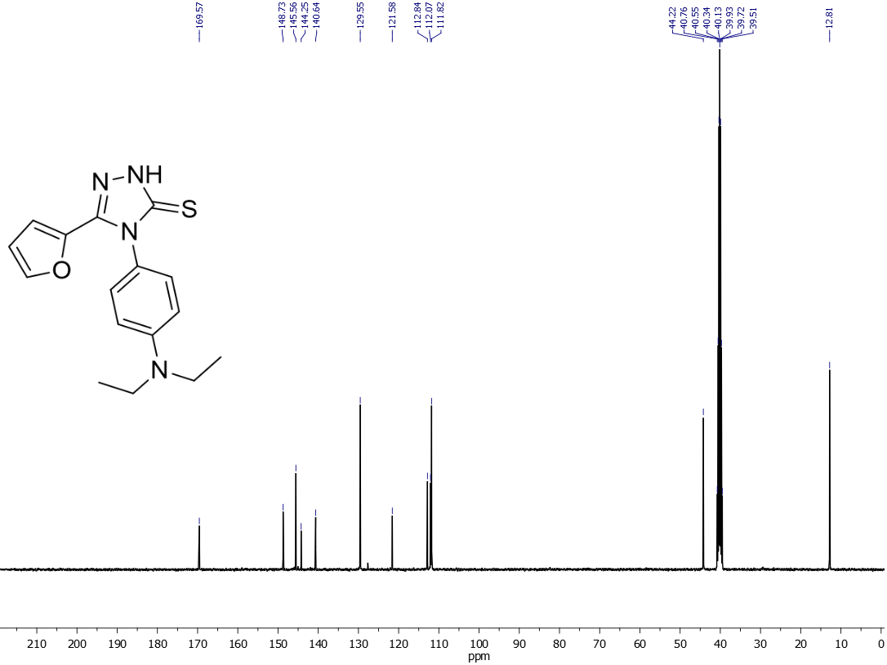
Figure 56. ¹³C NMR spectrum of compound 24

