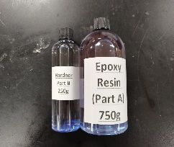

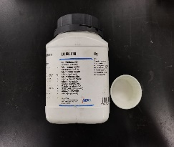
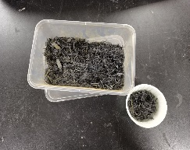
+
Filler (Alumina)
Epoxy Resin
CFW-EP-AL
CFW-EP
EP
Fabricate hybrid composite samples
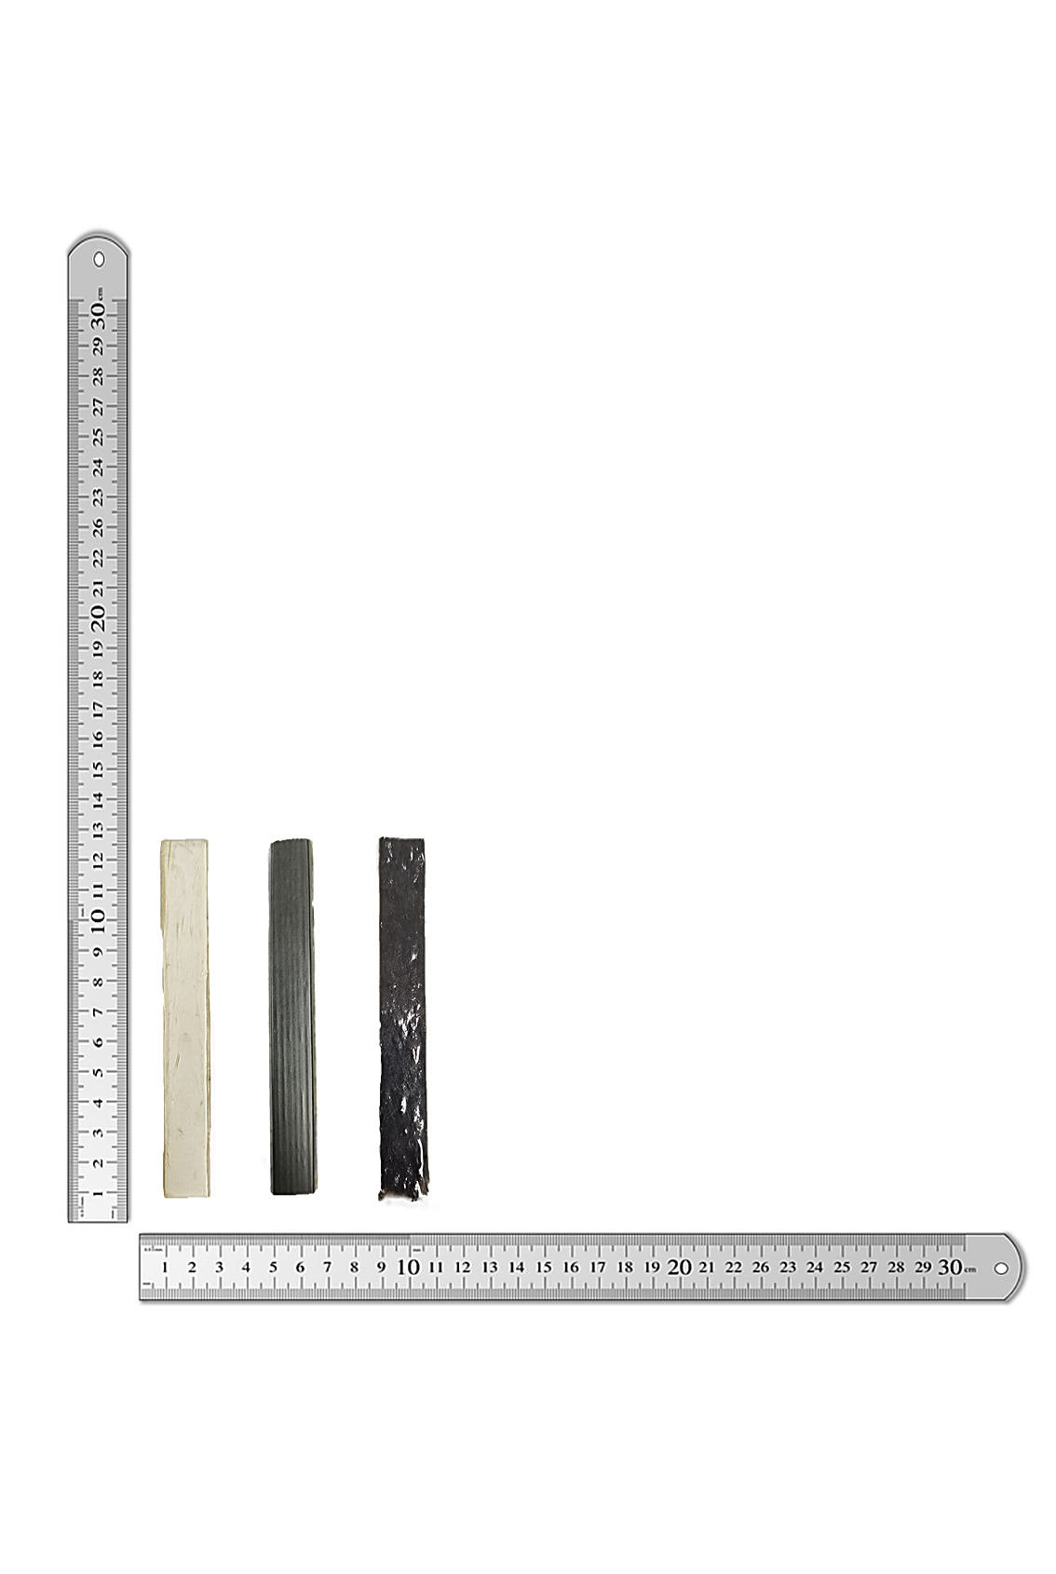
Recycled carbon fibre prepreg waste

Water absorption testing for 168 hours

CFW-EP | Solution | Carbon Fibre Waste (wt%) | Epoxy Resin (wt%) | Flexural Strength (MPa) Fit | Composite Desirability
 | 1 | 2.5 | 97.5 | 91.321 | 1

CFW-EP-AL | Solution | Carbon Fibre Waste (wt%) | Epoxy Resin  (wt%) | Alumina  (wt%) | Flexural Strength (MPa) Fit | Composite Desirability
 | 1 | 2.5 | 95 | 2.5 | 130.161 | 1
Flexural testing before and after immersion in distilled water
Minitab software optimization for composition of CFW-EP and CFW-EP-AL samples

