Introducing monitoring technologies in Chinese cities:
Pollution reduction effects, enforcement strategies, and welfare consequences

Supplementary

Supplementary Note 1: air pollution reduction in China
The air quality of major Chinese cities was once among the worst globally, attributed to three decades of rapid economic growth coupled with lenient environmental regulations. According to the report by the Asia Development Bank, in 2011, less than 1% of the largest Chinese cities met the air quality standards recommended by the World Health Organization (Zhang and Crooks, 2012). The noticeable deterioration in China’s air quality led to a shift in government priorities towards environmental governance. Consequently, China enforced a serious of policies and actions, including the “Two-control Zone (TCZ)” in 1998 and “War on Air Pollution” in 2014.
While China has developed a relatively comprehensive policy framework to tackle air pollution, significant challenges persist at the local level, primarily due to issues related to information asymmetric. The central government has made efforts to strengthen enforcement by introducing mandatory environmental targets and a target responsibility system, aiming to align the interests of central and local authorities. Measures, including recurrent inspections and public appeals, have been cited to enhance the central’s information-gathering capabilities. Nevertheless, these efforts have been less effective as the central government struggled to monitor and verify the environmental performance of local governments. Environmental data is often self-reported by local governments, which are entrusted with collecting, managing, and reporting such data. In situations where environmental targets conflict with local economic interests, local governments have tended to exploit their information advantages, sometimes resorting to data manipulation (Ghanem and Zhang, 2014; Wallace, 2016).

Supplementary Note 2: assignment of AMS as a natural experiment
To effectively monitor local pollution and mitigate information asymmetry between the central and local authorities, China launched a nationwide, real-time air quality auto-monitoring program, which commenced in 2012 and completed in 2014. It marked a crucial milestone in China’s environmental regulation history because these automated monitors stations were top-down decided and directly controlled by the central authorities. The central government also enlisted third-party entities to run these monitoring stations, aiming to prevent local corruption and manipulation, and enhance regulatory effectiveness. Besides, a cross-check mechanism automatically alerts for inconsistent pollution data from nearby AMS, making local conditions more apparent to the central government. Disclosing air quality information empowers the public to oversee local agents, in turn, incentivizes local governments to improve air quality to reduce the risk of social unrest.
The program initiated auto-monitoring of major air pollutants, including PM_{2.5}, PM₁₀, O₃, CO, NO₂, and SO₂, as well as published an Air Quality Index encompassing all pollutants. These stations were set up in three waves. In the first wave, the program was built between May and December 2012 in 74 major cities, representing key population and economic areas such as the Beijing-Tianjin-Hebei Metropolitan Region, the Yangtze River Delta, the Pearl River Delta, direct-administered municipalities, and provincial capitals. The second wave, completed by October 2013, included an additional 116 cities from the list of the Environmental Improvement Priority Cities and the National Environmental Protection Exemplary Cities. In the final wave, achieved by November 2014, the program extended to the remaining 177 cities. By the end of the third waves, over 1, 436 auto-monitoring stations had been installed in 337 cities. Fig.1a plots the roll out of the program.
The setting of large-scale auto-monitoring program can serve as a suitable case for observing the environmental enforcement of local governments. There are several features as follows. First, focus on urban areas. The Chinese auto-monitoring program was primarily designed to assess air quality within city environments. As a result, most of these stations were placed within the built-up areas of prefecture-level cities. By aligning the location of AMS with these built-up areas, we found that 97.6% of the stations are situated within these areas.
Second, central assignment. To avoid any interference from local governments in the selection of AMS locations, the central authority thoroughly planned the setup of AMS details. The Ministry of Environmental Protection (MEP) initially set a basic density of stations, determining the number of stations based on population and built-up areas. Then, the MEP carefully assessed and approved the chosen monitoring station sites, considering the intricate geographical factors like open space, location specifics, and size requirements. Fig.1b and c shows the precise locations of AMS in two cities, demonstrating a dispersed distribution of station locations.
Third, limited monitoring scope. Limited cost constraints, the number of AMS is insufficient to cover the entire urban space. According to technical specifications, the effective monitoring range of a station is about 4 kilometers. Beyond this distance, monitoring stations face challenges in accurately capturing air pollution levels. Therefore, the area within 4 km of AMS locations is likely to be the focus area for local governments’ environmental enforcement actions.

Supplementary Note 3: robustness checks

Alternative Scope of Air pollution Reduction
Our main measurement for annual and monthly cell-level PM_{2.5} is from NASA satellite data. We provide the results for other air pollutants, such as PM₁₀ and NOx. In Column 2 of Supplementary Table 2, we replace the pollutants with PM₁₀, and the results remain consistent. In Column 2 of Supplementary Table 3, we replace the dependent variable with the logarithm of PM_{2.5}, resulting in a significant 0.48% reduction in PM_{2.5} due to place-based pollution reduction effects. In Columns 3-6, we replace the pollutants with PM₁₀ and NO_{X}, and the results remain consistent. Supplementary Figure 4 plots event analysis using the logarithms of PM₁₀, NO_{X}, and PM_{2.5}.

Alternative Sample Selection and Control Group Specification
Because monitoring stations were established in three waves, we change the cities in treatment and control groups to address concerns of sample selection bias. We designate cities in the first wave as the treatment group and those in the second and third waves as the control group. This allows us to estimate AMS-induced pollution reduction effects, resulting in similar decline outcomes (Column 3 in Supplementary Table 2).
Given that a 7 km radius from the monitoring station usually extends beyond most administrative districts within Chinese cities, we set the control group threshold at 4-7 km. However, there may be uncertainties associated with this threshold selection. To address this problem, we test various thresholds for non-technically accessible areas (ranging from 4-5 km to 4-10 km) as the control range in our baseline regression model. Supplementary Table 4 presents diverse results from varying control group thresholds. All baseline regressions consistently show negative coefficients. However, there is a decreasing trend as the control group’s range expands, implying a higher likelihood of pollution transfer from the AMS to more distant areas.

Alternative Estimation Method for Staggered DiD
The AMS program launched in three waves, potentially causing a staggered rollout and varying effects across different units over time. While our baseline model effectively leveraged this staggered rollout for casual identification, recent research has highlighted potential estimation bias of the two-way fixed effects model when treatments exhibit staggered roll-out and heterogeneous effects across units over time (De Chaisemartin and d’Haultfoeuille, 2020; Callaway and Sant’Anna, 2021; Sun and Abraham, 2021). To enhance the robustness of our findings, we use imputation estimation based on a constructed counterfactual group, offering a direct evaluation of dynamic policy effects (Borusyak et al., 2021).
Supplementary Figure 1 presents our staggered DiD regression results for AMS-induced pollution reduction effect. Before the event period, there is no significant difference between launched cities and non-launched cities. However, the coefficient significantly decreases following the rollout of AMS, aligning with our baseline regression results. Supplementary Figure 5 presents our staggered DiD regression results for differential pollution reduction effect. Before the event period, there is no significant difference between the 0-4 km and 4-7 km ranges. However, the coefficient significantly decreases following the rollout of AMS, aligning with our baseline regression results.

Placebo Test of Other Potential Confoundedness
To support the validity of our DiD design for main results, we conduct a placebo test by assigning AMS rollout and cities. Keeping the AMS count constant, we randomly select years and cities to examine potential confounding factors, assuming a false treatment time or the chance presence of other omitted factors. This process is repeated 1000 times. We re-estimate equation (1) and plot the distributions of the coefficients in Supplementary Figure 2. The results indicate that the estimated coefficients are distributed near zero and exhibit a normal distribution. This implies that the effects attributed to AMS are unlikely be caused by any omitted factors: the estimated coefficient of the model (-9.6972) is significantly smaller than the coefficient range obtain from the 1000 times of placebo test conducted nationwide.
Regarding the effects of differential pollution reduction, we also conduct a placebo test by assigning AMS rollout and locations. Keeping the AMS count constant, we randomly select years and locations to examine potential confounding factors, assuming a false treatment time or the chance presence of other omitted factors. This process is repeated 1000 times. Then, we re-estimate equation (1) and plot the distributions of the coefficients in Supplementary Figure 6. The estimated coefficients are distributed near zero and exhibit a normal distribution. The estimated coefficient of the model (-0.3046) is significantly smaller than the coefficient range obtain from the 1000 times of placebo test conducted nationwide. The placebo test provides additional evidence supporting the DiD design’s validity for differential pollution reduction.

Supplementary Note 4: mechanism of spatial planning
Cities with better ventilation and higher air dispersion tend to experience fewer or less intensive urban planning activities carried out by the local government. According to Jacobsen (2002), the air circulation coefficient is determined by multiplying the wind speed by the height of the boundary layer. The European Center for Medium-Range Weather Forecasts provides wind speeds and boundary layer heights at 10 m above ground level for the global 0.75°*0.75° grid. We calculate the Air Ventilation Coefficient (AVC) for each grid cell during the study period. Subsequently, we match each grid cell with cities in the sample based on latitude and longitude to obtain the AVC of each city for each year.
Cities with extensive river networks often face issue of land fragmentation, resulting in diminished land integrity and heightened challenges in altering the spatial layout of a city. The origins of cities in China are closely related to the distribution of rivers, and the development of urban areas often revolve around these rivers. We classify cities into low, medium, and high land fragmentation groups using water system data from the National Basic Geographic Information Database. This classification is determined by the ratio of the river system length to the city’s land area (Bai and Jia, 2016).

Supplementary Reference
Bai, Y., & Jia, R. (2016). Elite recruitment and political stability: the impact of the abolition of China's civil service exam. Econometrica, 84(2), 677-733.
Borusyak, K., Jaravel, X., & Spiess, J. (2021). Revisiting event study designs: Robust and efficient estimation. arXiv preprint arXiv:2108.12419.
Callaway, B., & Sant’Anna, P. H. (2021). Difference-in-differences with multiple time periods. Journal of econometrics, 225(2), 200-230.
De Chaisemartin, C., & d’Haultfoeuille, X. (2020). Two-way fixed effects estimators with heterogeneous treatment effects. American Economic Review, 110(9), 2964-2996.
Jacobson, M. Z. (2002). Atmospheric pollution: history, science, and regulation. Cambridge University Press.
Sun, L., & Abraham, S. (2021). Estimating dynamic treatment effects in event studies with heterogeneous treatment effects. Journal of Econometrics, 225(2), 175-199.
Wallace, J. L. (2016). Juking the stats? Authoritarian information problems in China. British journal of political science, 46(1), 11-29.
Zhang, Q., & Crooks, R. (2012). Toward an environmentally sustainable future: Country environmental analysis of the People’s Republic of China. Asian Development Bank.

Supplementary Figures
Supplementary Figure 1. Staggered DiD estimation for AMS-induced urban pollution reduction effects
Notes: It present the estimation results of the logarithms on PM_{2.5} at the level with the stagger imputation estimation. Standard errors clustered at city level are reported in parentheses below the estimates.
Supplementary Figure 2. Placebo test for AMS-induced urban pollution reduction effects
Notes: This figure plots a placebo test based on randomly generated variables of treatment. We randomly assign the implementation mouth of the monitoring program to cities or randomly assign cities, and estimate the baseline specification in the pre-program period. In the placebo test, we repeat the practice 1000 times and plot the distribution of the estimated coefficients of the placebo double difference term. The gray dashed line at the left is the baseline estimate from the DiD model.

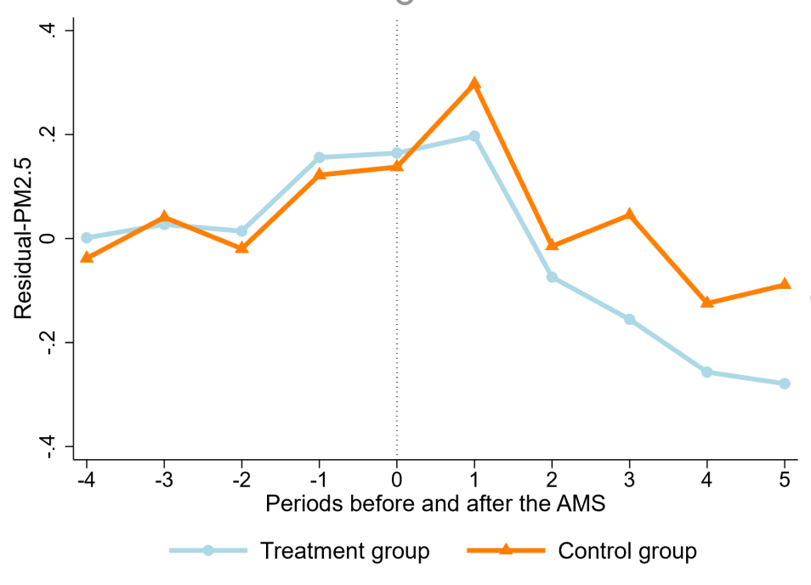
Supplementary Figure 3. Trends in PM_{2.5} in technically accessible and non-accessible areas within cities
Note: The centers of the error area are the values of the coefficients, which represent point estimates from the regressions and indicate the average effects of differential pollution reduction. Their 95% confidence intervals are plotted vertically.

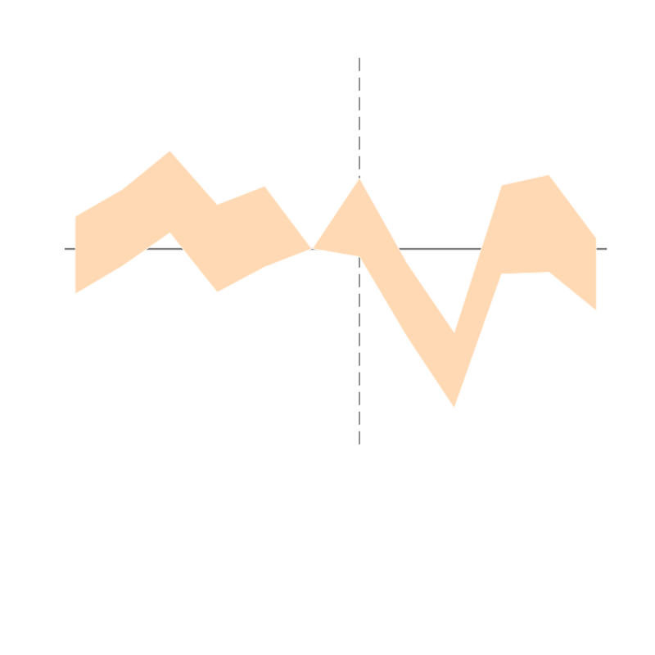
Supplementary Figure 4. Annual dynamic effects of differential pollution reduction of pollutants
Notes: The graph displays the estimated coefficients of the years before and after AMS rollout with their 95% level confidence intervals. The dependent variables are the annual logarithmic of PM_{2.5}, PM_{10,} and NOx at 1km*1km grid cell from 2006 to 2019. Each regression implements the event study model.

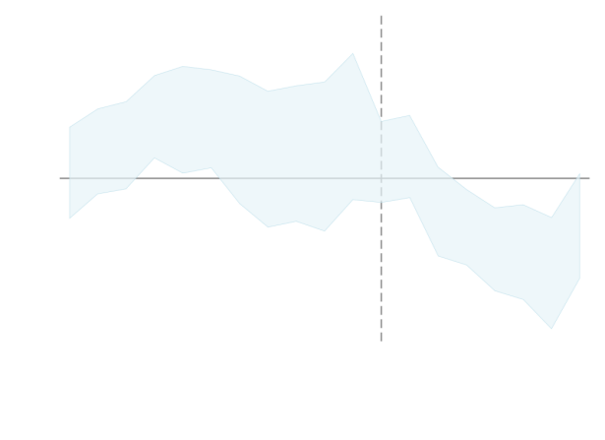  (a) | 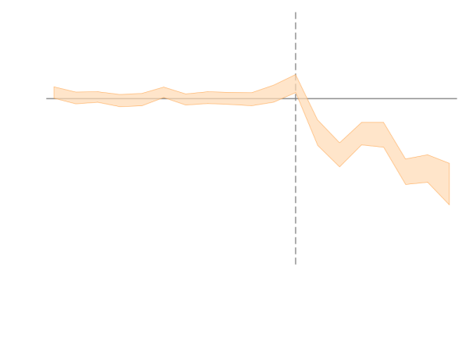  (b)
Supplementary Figure 5. Staggered DiD estimation for differential pollution reduction effects
Notes: (a) and (b) present the estimation results of the logarithms on PM_{2.5} and PM₁₀ at the level with the stagger imputation estimation, respectively. Standard errors clustered at the auto-station level are reported in parentheses below the estimates.

Supplementary Figure 6. Placebo test for differential pollution reduction effects
Notes: This figure plots a placebo test based on randomly generated variables of treatment. We randomly assign the implementation year of the monitoring program to cities or randomly assign the technically accessible area, and estimate the baseline specification in the pre-program period. In the placebo test, we repeat the practice 1000 times and plot the distribution of the estimated coefficients of the placebo double difference term. The gray dashed line at the left is the baseline estimate from the DiD model.
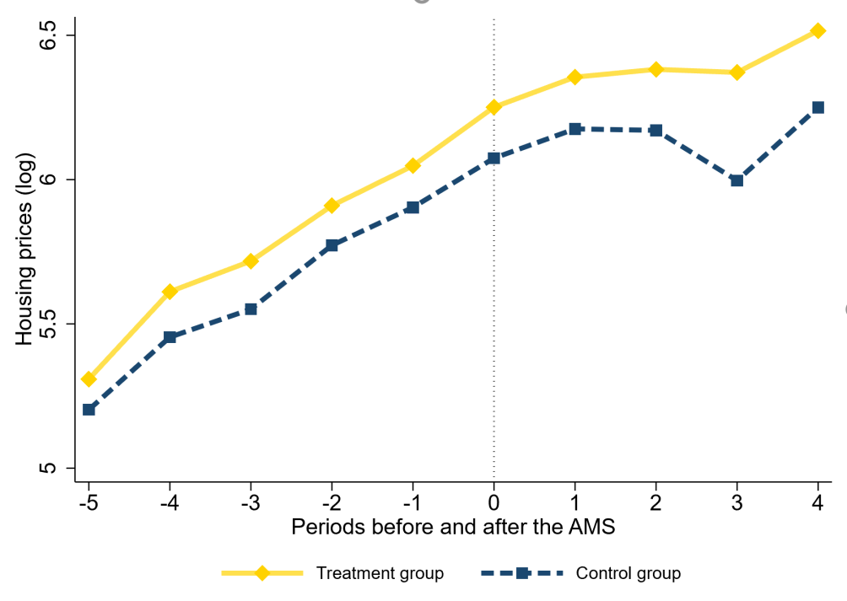
Supplementary Figure 7. Trends in housing price in technically accessible and non-accessible areas within cities
Note: Treatment and control groups had similar trends of housing prices before the AMS started, and diverged afterwards. Their 95% confidence intervals are plotted vertically.

Supplementary Tables
Supplementary Table 1. Summary statistics
 | Measurements | N | Mean | SD | Min | Max | Periods
Panel A: City level
City and air pollution
PM_{2.5} | Concentration of particulate matter less than or equal to 2.5µm³ for each city | 17,868 | 167.61 | 183.51 | 10.37 | 545.64 | 2010-2014
Open | Whether the cell i in city c roll out AMS in wave w and year t | 17,868 | 0.22 | 0.41 | 0 | 1 | 2010-2014
Controls
Wind | Wind speed in each city c (m/s) | 17,706 | 2.08 | 0.59 | 0.63 | 5.51 | 2010-2014
Daylight | Daylight in each city c (w/m²) | 17,706 | 166.62 | 64.07 | 2.72 | 350.73 | 2010-2014
Humi | Humidity in each city c (%) | 17,706 | 67.93 | 12.79 | 18.89 | 92.12 | 2010-2014
Tem | The temperature in each city c (℃) | 17,706 | 13.89 | 10.91 | -28.43 | 41.81 | 2010-2014
Log GDP | GDP per capita in each city c | 17,706 | 10.53 | 0.60 | 8.77 | 13.06 | 2010-2014
Log POPU | The number of population in each city c | 17,706 | 5.90 | 0.70 | 2.97 | 8.12 | 2010-2014
Log Fiscal | Fiscal revenue per capita in each city c | 17,706 | 7.71 | 0.95 | 4.90 | 11.08 | 2010-2014
Panel B: Cell level
Cell and air pollution
PM_{2.5} | Concentration of particulate matter less than or equal to 2.5µm³ for each cell | 2,116,657 | 53.09 | 16.16 | 0 | 380.2 | 2001-2019
Distance | The distance between each cell and its nearest AMS | 2,116,657 | 31.52 | 45.70 | 0.0282 | 500.1 | 2001-2019
Open | Whether the cell i in city c roll out AMS in wave w and year t | 2,116,657 | 0.36 | 0.48 | 0 | 1 | 2001-2019
Focus | Whether the cell i belong to the technically accessible area (0-4 km) of AMS | 632,998 | 0.224 | 0.417 | 0 | 1 | 2001-2019
Impacts
Log industry outputs | The natural logarithm of the industrial outputs in cell i | 738,074 | 10.90 | 4.265 | 0 | 20.24 | 2001-2015
Log industrial plants | The natural logarithm of the number of plants in cell i | 738,074 | 4.162 | 4.829 | 0 | 19.85 | 2001-2019
Log new caterings | The natural logarithm of the number of new caterings in cell i | 1,082,560 | 0.0015 | 0.0339 | 0 | 2.8904 | 2007-2019
Log new parks | The natural logarithm of the number of new parks in cell i | 1,082,560 | 0.0121 | 0.1099 | 0 | 2.5218 | 2007-2019
Log housing price | The natural logarithm of the sales price of each apartment (yuan/m²) | 908,281 | 1.6423 | 0.4261 | 0.0425 | 11.2537 | 2008-2019
Controls
Wind | Wind speed in each cell i (m/s) | 1,963,497 | 2.267 | 0.5743 | 0.530 | 6.796 | 2001-2019
Daylight | Daylight in each cell i (w/m²) | 1,963,497 | 2,120 | 547.4 | 41.8 | 3,904 | 2001-2019
Humi | Humidity in each cell i (%) | 1,963,497 | 67.22 | 9.603 | 28.26 | 90.12 | 2001-2019
Tem | The temperature in each cell i (℃) | 1,963,497 | 14.16 | 4.884 | -3.554 | 26.35 | 2001-2019
Urban | Whether the cell i in each year belongs to urban built-up areas or not | 2,116,657 | 0.361 | 0.334 | 0 | 1 | 2001-2019

Supplementary Table 2. AMS-induced urban pollution reduction effects
 | (1) | (2) | (3) | (4)
 | PM_{2.5} | PM₁₀ | PM_{2.5} | PM_{2.5}
 |  |  | Changing Treatment and Control Group | Using Entropy Balancing
Open | -9.6972*** | -5.2921*** | -12.6392*** | -9.1333***
 | (1.1777) | (1.1274) | (2.7428) | (2.1649)
City FE | Y | Y | Y | Y
Year-month FE | Y | Y | Y | Y
Controls-weather | Y | Y | Y | Y
Controls-socioeconomic | Y | Y | Y | Y
Province-year FE | Y | Y | Y | Y
Observations | 12,173 | 12,173 | 9,502 | 12,012
R-squared | 0.9937 | 0.9862 | 0.9940 | 0.9947
Notes: The estimated of Column 3 is based on DiD model with changing treatment and control group. The estimated of Column 4 is based on DiD model with entropy balancing weight. Standard errors clustered at the city level are reported in parentheses below the estimates. *** p<0.01, ** p<0.05, * p<0.1.

Supplementary Table 3. Differential pollution reduction effects of pollutants
 | (1) | (2) | (3) | (4) | (5) | (6)
 | PM_{2.5} | PM_{2.5} | PM₁₀ | PM₁₀ | NOx | NOx
 | Levels | Log | Levels | Log | Levels | Log
Open*Focus | -0.3046*** | -0.0048*** | -4.5601*** | -0.0103*** | -0.0747*** | -0.0008
 | (0.0451) | (0.0012) | (1.2752) | (0.0011) | (0.0287) | (0.0013)
Individual FE | Y | Y | Y | Y | Y | Y
Year-city FE | Y | Y | Y | Y | Y | Y
Controls-weather | Y | Y | Y | Y | Y | Y
Control-urban | Y | Y | Y | Y | Y | Y
Observations | 645,653 | 645,621 | 645,653 | 645,653 | 457,302 | 457,302
R-squared | 0.9751 | 0.9796 | 0.9999 | 0.9986 | 0.9825 | 0.9929
Notes: Standard errors clustered at the auto-station level are reported in parentheses below the estimates. *** p<0.01, ** p<0.05, * p<0.1.

Supplementary Table 4. Differential pollution reduction effects based on different control group specifications
 | (1) | (2) | (3) | (4) | (5) | (6)
 | 4-5km | 4-6 km | 4-7 km | 4-8 km | 4-9 km | 4-10 km
Open*Focus | -0.2589*** | -0.2992*** | -0.3046*** | -0.3106*** | -0.3147*** | -0.3256***
 | (0.0337) | (0.0361) | (0.0375) | (0.0388) | (0.0393) | (0.0403)
Individual FE | Y | Y | Y | Y | Y | Y
Year-city FE | Y | Y | Y | Y | Y | Y
Controls-weather | Y | Y | Y | Y | Y | Y
Control-urban | Y | Y | Y | Y | Y | Y
Observations | 501,274 | 574,772 | 645,653 | 689,968 | 736,598 | 777,277
R-squared | 0.9768 | 0.9757 | 0.9751 | 0.9744 | 0.9739 | 0.9733
Notes: Standard errors clustered at the auto-station level are reported in parentheses below the estimates. *** p<0.01, ** p<0.05, * p<0.1.

Supplementary Table 5. Differential pollution reduction effects in typical regions
 | (1) | (2) | (3) | (4) | (5) | (6) | (7)
 | PM_{2.5} | PM_{2.5}  JJJ-26 | PM_{2.5}  Fenwei | PM_{2.5}  YRD | PM_{2.5}  PRD | PM_{2.5}  Bottom 50 cities | PM_{2.5}  To 50 cities
Open*Focus | -0.3046*** | -0.3919*** | -0.9189*** | -0.0894 | -0.0362 | -0.3841*** | -0.2535
 | (0.0451) | (0.0897) | (0.3257) | (0.0870) | (0.1941) | (0.0972) | (0.1924)
Individual FE | Y | Y | Y | Y | Y | Y | Y
Year-city FE | Y | Y | Y | Y | Y | Y | Y
Controls-weather | Y | Y | Y | Y | Y | Y | Y
Control-urban | Y | Y | Y | Y | Y | Y | Y
Observations | 645,653 | 109,488 | 21,359 | 88,037 | 29,640 | 148,589 | 23,854
R-squared | 0.9751 | 0.9635 | 0.9362 | 0.8831 | 0.9013 | 0.9780 | 0.9879
Notes: A list of cities in different regions is displayed in Supplementary Table 6. Standard errors clustered at the auto-station level are reported in parentheses below the estimates. *** p<0.01, ** p<0.05, * p<0.1.

Supplementary Table 6. List of cities in different regions
Region | City
BTH region | Beijing, Tianjin, Shijiazhuang, Tangshan, Langfang, Baoding, Cangzhou, Hengshui, Xingtai, Handan, Taiyuan, Yangquan, Changzhi, Jincheng, Jinan, Zibo, Jining, Dezhou, Liaocheng, Binzhou, Heze, Zhengzhou, Kaifeng, Anyang, Hebi, Xinxiang, Jiaozuo, Puyang
YRD region | Shanghai, Nanjing, Wuxi, Xuzhou, Changzhou, Suzhou, Nantong, Lianyungang, Huaian, Yancheng, Yangzhou, Zhenjiang, Taizhou, Suqian, Hangzhou, Ningbo, Wenzhou, Shaoxing, Huzhou, Jiaxing, Jinhua, Quzhou, Zhoushan , Taizhou, Lishui, Hefei, Wuhu, Maanshan, Tongling, Chizhou, Anqing, Xuancheng, Chuzhou, Bengbu, Huaibei, Huainan, Suzhou, Fuyang, Bozhou, Liuan, Huangshan
PRD region | Guangzhou, Shenzhen, Foshan, Zhaoqing, Dongguan, Huizhou, Zhuhai, Zhongshan, Jiangmen
Bottom 50 cities of air quality | Anyang, Baoding, Baoji, Baotou, Bozhou, Canzghou, Changzhi, Dezhou, Fuyang, Handan, Hebi, Hengshui, Heze, Jiaozuo, Jincheng, Jingmen, Jingzhou, Jining, Langfang, Lanzhou, Liaocheng, Linfen, Linyi, Luohe, Luoyang, Nanyang, Pingdingshan, Puyang, Shangqiu, Shijiazhuang, Shuozhou, Taiyuan, Tangshan, Tianjin, Urumqi, Weinan, Xian, Xiangyang, Xiaogan, Xingtai, Xinxiang, Xinzhou, Xuchang, Xuzhou, Yuncheng, Zaozhuang, Zhengzhou, Zhoukou, Zhumadian, Zibo
Top 50 cities of air quality | Beihai, Changdu, Chifeng, Chuxiong, Dali, Danzhou, Daxinganling, Diqing, Enshi, Fuzhou, Gannan, Ganzi, Guilin, Guiyang, Haidong, Haikou, Hami, Heihe, Honghe, Huangshan, Huagshi, Kashi, Kunming, Lasa, Liangshan, Lijiang, Lincang, Linxia, Linzhi, Lishui, Nanning, Quzhou, Rikaze, Shannan, Shenzhen, Shihezi, Suining, Tacheng, Taizhou, Tulufan, Wenshan, Xiamen, Xiangxi, Xiantao, Xingan, Xishuangbanna, Yaan, Yili, Yuxi, Zhoushan
Notes：This table lists the cities in five regions, including the Beijing-Tianjin-Hebei Region (BTH), the Yangtze River Delta Economic Zone (YRD), the Pearl River Delta Metropolitan Region (PRD), the bottom 50 cities of air quality, and the top 50 cities of air quality. The bottom and top 50 cites of air quality are both determined by the monthly air quality bulletin released by the MEP with the period of 2015-2019.

Supplementary Table 7. Mechanism for spatially differential regulation
 | (1) | (2) | (3) | (4)
 | Number of plants | Industrial outputs | Number of new caterings | Number of new parks
Open | -0.6064*** | -0.6290*** | -0.0008*** | 0.0063***
 | (0.0626) | (0.0535) | (0.0003) | (0.0013)
Individual FE | Y | Y | Y | Y
Year-city FE | Y | Y | Y | Y
Controls-weather | Y | Y | Y | Y
Control-urban | Y | Y | Y | Y
Observations | 324,348 | 324,348 | 306,113 | 306,113
R-squared | 0.6703 | 0.5979 | 0.2119 | 0.3069
Notes: Standard errors clustered at the auto-station level are reported in parentheses below the estimates. *** p<0.01, ** p<0.05, * p<0.1. Governments’ regulations mainly target high-polluting industries, as listed in Supplementary Table 8.

Supplementary Table 8. List of high-polluting industries
2-digit Code | Industry Name
06 | Mining and Washing of Coal
08 | Mining and Processing of Ferrous Metal Ores
09 | Mining and Processing of Non-Ferrous Metal Ores
10 | Mining and Processing of Nonmetals
14 | Manufacturing of Foods
15 | Manufacture of Beverages
17 | Manufacture of Textile
19 | Manufacture of Leather, Fur, and Feather
22 | Manufacture of Paper and Paper Products
25 | Processing of Petroleum, Coking, and Fuel
26 | Manufacture of Raw Chemical Materials
27 | Manufacture of Medicines
28 | Manufacture of Chemical Fibers
31 | Manufacture of Non-metallic Mineral goods
32 | Smelting and Pressing of Ferrous Metals
32 | Smelting and Pressing of Non-ferrous Metals
Notes: This table lists the name and 2-digit code of high-polluting industries in the dataset of Chinese industrial enterprises. The industry category is determined in accordance with the Classification of National Economic Industries in China (GB/T 4754-2002) and the polluted industries is classified by the MEP (see http://wfs.mep.gov.cn/gywrfz/hbhc/zcfg/201009/t20100914 194483. htm).

Supplementary Table 9. Heterogeneity analysis of production regulation
 | (1) | (2) | (3) | (4) | (5) | (6)
 | GDP_{PC}-L | GDP_{PC}-M | GDP_{PC}-H | Industri-L | Industri-M | Industri-H
Panel A: Number of plants
Open | -0.0950 | -0.4721*** | -0.6876*** | -0.2955 | -0.6673*** | -0.4315***
 | (0.3347) | (0.1334) | (0.0788) | (0.2183) | (0.0996) | (0.0860)
R-squared | 0.7557 | 0.6683 | 0.6761 | 0.6624 | 0.6912 | 0.7005
Panel B: Industrial outputs
Open | -0.1972 | -0.7311*** | -0.5507** | -0.2173 | -0.5811*** | -0.6043***
 | (0.5487) | (0.0974) | (0.0706) | (0.3191) | (0.0893) | (0.0682)
R-squared | 0.7214 | 0.5896 | 0.5709 | 0.6737 | 0.6202 | 0.6277
Observations | 14,220 | 85,845 | 173,957 | 11,785 | 136,970 | 169,454
Individual FE | Y | Y | Y | Y | Y | Y
Year-city FE | Y | Y | Y | Y | Y | Y
Controls-weather | Y | Y | Y | Y | Y | Y
Control-urban | Y | Y | Y | Y | Y | Y
Notes: Standard errors clustered at the auto-station level are reported in parentheses below the estimates. *** p<0.01, ** p<0.05, * p<0.1.

Supplementary Table 10. Heterogeneity analysis of spatial planning
 | (1) | (2) | (3) | (4)
 | Ventilation-L | Ventilation-H | Land Frag-L | Land Frag-H
Panel A: Number of new caterings
Open | -0.0009*** | -0.0007 | -0.0022*** | -0.0005
 | (0.0003) | (0.0006) | (0.0008) | (0.0003)
R-squared | 0.2204 | 0.4014 | 0.3883 | 0.1227
Panel B: Number of new parks
Open | 0.0061*** | 0.0036 | 0.0073*** | 0.0026
 | (0.0014) | (0.0074) | (0.0015) | (0.0024)
R-squared | 0.3114 | 0.5824 | 0.3188 | 0.2426
Observations | 287,937 | 13,311 | 246,864 | 59,249
Individual FE | Y | Y | Y | Y
Year-city FE | Y | Y | Y | Y
Controls-weather | Y | Y | Y | Y
Control-urban | Y | Y | Y | Y
Notes: Standard errors clustered at the auto-station level are reported in parentheses below the estimates. *** p<0.01, ** p<0.05, * p<0.1.

In the document “Technical Regulation for the Selection of Ambient Air Quality Monitoring Stations”, it’s stated on the first page that “each ambient air quality evaluation city point represents a general radius of 500m to 4km”.

