Table S1 Primers used for qRT-PCR analysis.
Name | Forward primer (5'-3') | Reverse primer (5'-3')
AcDMT1 | GGGATGAAAGAAAAGAGGACACA | GCTCTCAGACTTGCGCTTTTGCT
AcDMT2 | TCCAATGAAACCTTGTGCTGATA | GTTCCATTAGACTCCCCATCAAG
AcDMT3 | GAGCAGGATAGGATAATCACAGTC | TGCCAGAGGAGGAGGGACAG
AcDMT4 | CAAGTGTCAAGTTTGTGTGGAAGC | GATTGTTTTGTACCATGGAGCGT
AcDMT5 | GAAGGGTAAGTTTAAAGAAGGTGG | GTAGCCAGGCGATTTGTAGAAG
AcDMT6 | AATGGAGATGCCTCTGGGGA | GTGGCAAGAACCTGTTGATGAG
AcDMT7 | GCAACATTGACTGGGATACCGA | ATAGCCTGTGCAACCAATTTCTC
AcDMT8 | TGAGGAAGAGAATTCGTCGGGT | CTGATGAGCCCCAATATGCCTT
AcDMT9 | GTCGCCGAGGTTTACCCCAA | GCTTTCAATCTTAGCCAAACAGG
AcDMT10 | TGTGTTATCTTCAATGTGGCTTCA | GCAGGGTTTGTACCGTACGTCT
AcDMT11 | GCCGTCAAAACGCAAGGATTC | CAGTTGTCTTCTCCCTCTTCTTCA
AcDMT12 | CCGTCAAAACGCAAGGATTCG | TGAGGCCATCGCTGTCGTG
AcDMT13 | TGCACTTCATGGGGCACAACTT | CAGAGCTGGTGCACTCAAGGA
AcDMT14 | CCGAAGATGACAATCCTCCAAC | TTGTTTCGGATTCAACGCCCA
AcDMT15 | AGACTCCATTGCCTTTGCCTC | TCAATCGAAGGCATGAGAGGC
AcDMT16 | GAAGTCCAGACCCCAGAAAGA | GATCGAAGGCATGAGAGGCG
ACT | TGCATGAGCGATCAAGTTTCAAG | TGTCCCATGTCTGGTTGATGACT

Figure S1
Fig.S1 Motif analysis of kiwifruit DNMTs.

Figure S2
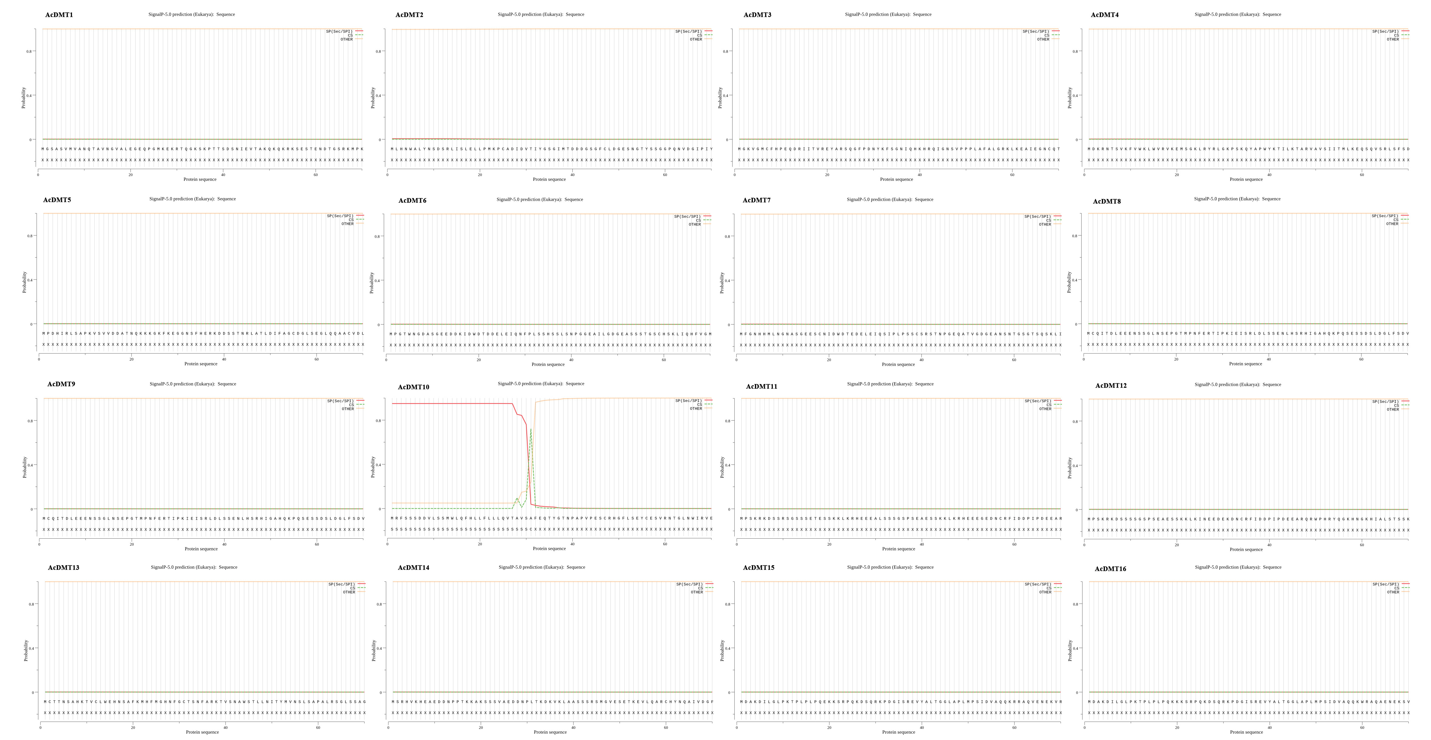
Fig. S2 Prediction of DNMT signal peptide in kiwifruit.
Figure S3
Fig. S3 Hydrophilic analysis of DNMT protein in kiwifruit.
Figure S4
Fig.S4 Prediction of transmembrane structure of kiwifruit DNMTs.

