Supplementary Figures
Figure S1 Diagnostic criteria for chronic endometritis at hysteroscopy: (A) strawberry aspect: large areas of hyperemia with white central points; (B) focal or diffuse endometrial hyperemia; (C) micro-polyps (<1 mm in size with a distinct connective–vascular axis); (D) stromal edema.
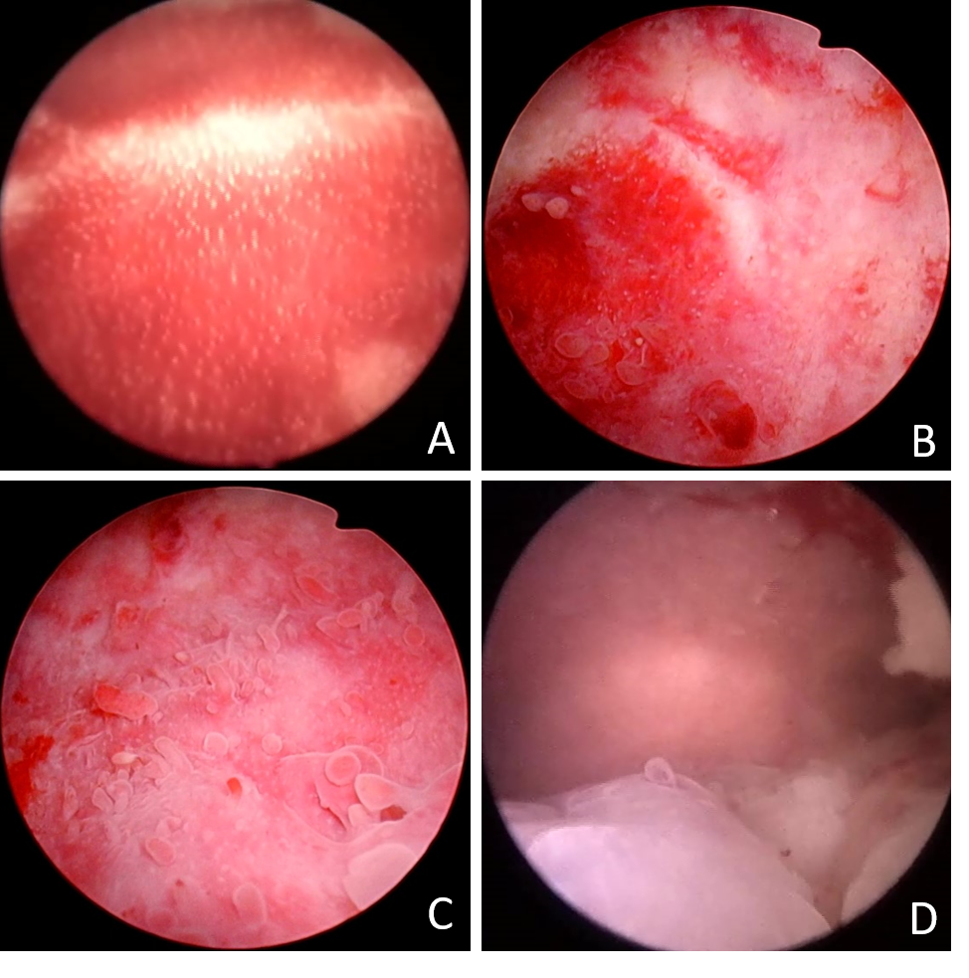

Supplementary Tables
Table S1 General data analysis of patients with only positive hysteroscopy in the antibiotic treatment group and control group.
 | Treatment group | Control group | Z/ꭓ² | P
n | 95 | 38
Age (years) | 31 (29-34) | 31 (28-35) | -0.105 | 0.916
BMI (kg/m²) | 21.0 (19.6-23.5) | 22.1 (19.9-24.9) | -1.151 | 0.250
Gravidity | 0 (0-1)  90-1  ())(( | 1 (0-2) | -1.292 | 0.196
Parity | 0 (0-0) | 0 (0-0)  (( | -0.082 | 0.935
Cause of infertility (%)
Tubal factor | 62.1(59/95) | 68.4 (26/38) | 1.956 | 0.855
Endometriosis | 4.2(4/95) | 2.6 (1/38)
Ovulation disorders | 11.6 (11/95) | 7.9 (3/38)
Male factor | 6.3 (6//95) | 2.6 (1/38)
Unknown | 11.6 (11//95) | 15.8 (6/38)
Other | 4.2 (4//95) | 2.6 (1/38)
Duration of infertility (year) | 2 (2-4) | 2 (1-4) | -0.410 | 0.682
Maternal smoking history (%) | 1.1 (1/95) | 0.0 (0/38) | - | 1.000
No. of embryos transferred (%)
1 | 20.0 (19/95) | 26.3 (10/38) | 0.635 | 0.426
2 | 80.0 (76/95) | 73.7 (28/38)
No. of high-quality embryos | 1 (1-2) | 1 (1-2) | -0.937 | 0.349
Type of embryo transfer (%)
Cleavage-stage embryo | 26.3 (25/95) | 28.9 (11/38) | 0.095 | 0.758
Blastocyst | 73.7 (70/95) | 71.1 (27/38)
Insemination method (%)
IVF | 76.8 (73/95) | 81.6 (31/38) | 0.357 | 0.550
ICSI | 23.2 (22/95) | 18.4 (7/38)
Stimulation (%)
Natural / stimulated | 27.4 (26/95) | 39.5 (15/38) | 1.865 | 0.172
Artificial cycle | 72.6 (69/95) | 60.5 (23/38)
Endometrial thickness (mm) | 9.0 (8.0-10.5) | 9.5 (8.0-11.0) | -0.080 | 0.936

Table S2 Analysis of pregnancy outcomes in the antibiotic treatment group and control group of patients with only positive hysteroscopy.
 | Treatment group | Control group | P
n | 95 | 38
Embryo implantation rate (%) | 44.4 (76/171) | 36.4 (24/66） | 0.259
Clinical pregnancy rate (%) | 54.7 (52/95) | 54.3 (19/35) | 0.963
Miscarriage rate (%) | 11.5 (6/52) | 15.8 (3/19) | 0.693
Early miscarriage rate (%) | 9.6 (5/52) | 15.8 (3/19) | 0.434
Late miscarriage rate (%) | 1.9 (1/52) | 0.0 (0/19) | 1.000
Live birth rate (%) | 48.4 (46/95) | 42.1 (16/38) | 0.510
singleton live birth rate（%） | 32.6 (31/95) | 31.6 (12/38) | 0.907
live birth rate of twins (%) | 15.8 (15/95) | 10.5 (4/38) | 0.433

