95kD
①Fibrin
N PPVL 4W 6W 8W 10W

①GAPDH
N PPVL 4W 6W 8W 10W
37kD

②Fibrin
N PPVL 4W 6W 8W 10W
N PPVL 4W 6W 8W 10W
95kD

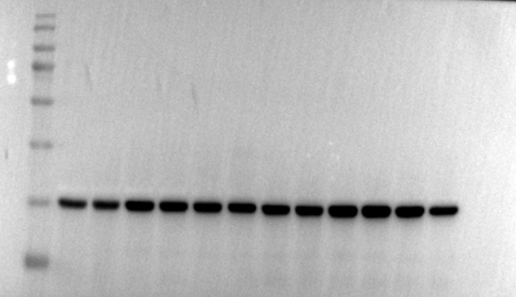
②GAPDH

37kD
N PPVL 4W 6W 8W 10W
N PPVL 4W 6W 8W 10W
①PAI-1
①GAPDH
N PPVL 4W 6W 8W 10W
N PPVL 4W 6W 8W 10W
45kD
37kD

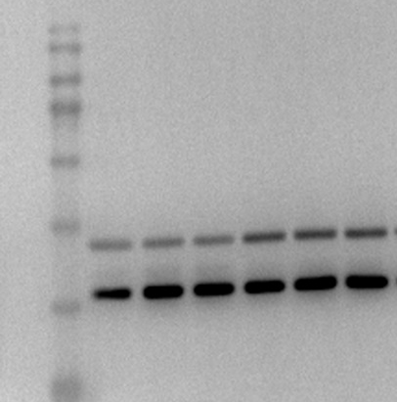
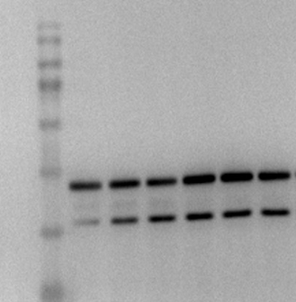

②
PAI-1
②GAPDH

N PPVL 4W 6W 8W 10W
45kD
N PPVL 4W 6W 8W 10W
37kD

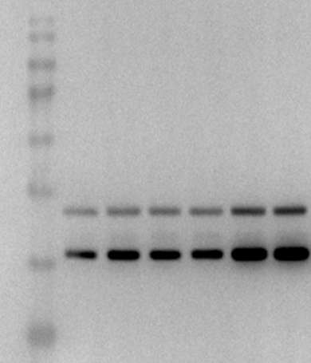
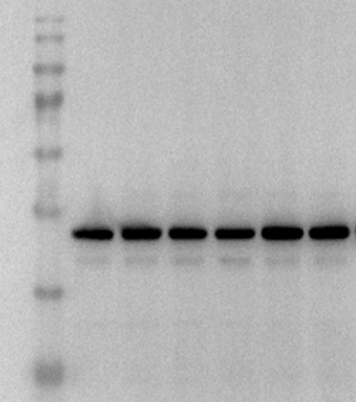

③
PAI-1
③GAPDH

N PPVL 4W 6W 8W 10W
45kD
37kD
N PPVL 4W 6W 8W 10W

