Supporting materials
Superior Energy Storage Performance up to 200°C in a Self-organized Trirelaxor-antiferroelectric Nanocomposite
Jingzhe Xu ^{a,1}, Yongbin Liu ^{a,1}, Dong Wang ^{b,1}, Li He ^{c}, Lisheng Zhong ª, Jinghui Gao ^{a,}*, Ming Wu ª, Ruifeng Yao ª, Nan Zhang ^{d}, Xiaojie Lou ^{b}, Shengtao Li ª, Xiaobing Ren ^{e, f}*

- Scanning electron microscope (SEM) images
Fig. S1 shows the SEM micrographs of the fracture surface of sintered BSTS-xBZN. The specimens are fractured and followed thermally etched at 1150 °C for 30 min to facilitate clear imaging of the grain boundaries. The grain morphology is illustrated respectively, the grain occurs precipitation when the BZN content raises to x=0.12 and the legible grain boundaries become ambiguous with BZN content increasing to x=0.14. Such a feature is regarded as the BZN separating out from grains, causing the decline of the AFE portion.
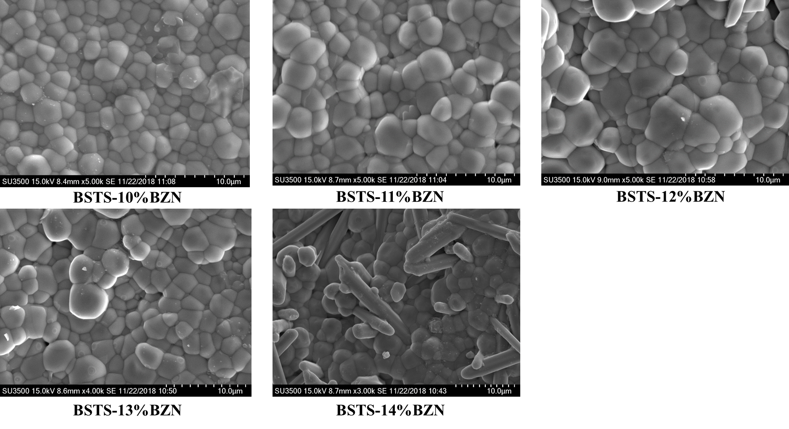 Fig.S1. SEM images of the surface morphology for BSTS-xBZN ceramics (x=10 ~ 14).

- Energy storage performance at high temperature for BSTS-0.11BZN
The specimens can even maintain a performance of about u_{e}=4.3J/cm³ and η=83% at 250℃ as shown in Fig.S2.
Fig.S2 Temperature stability of BSTS-0.11BZN energy storage performance up to 250℃

- Line-scanning convergent beam electron diffraction
Fig.S3 Local crystal symmetry distribution for BSTS-0.11BZN probed by the scanning convergent beam electron diffraction (SCBED) technique, revealing the coexistence of cubic (C), tetragonal (T), orthorhombic (O), and rhombohedral (R) symmetries in the trirelaxor state. (a) TEM bright-field image of BSTS-0.11BZN at room temperature from [001] beam incidence. (b) Schematic diagram for the SCBED method which employs a convergent electron probe to scan point by point across the specimen, obtaining a group of CBED patterns. (c) Distribution of C, T, O, R phase in local area (~100nm) calculated by machine learning (d1)-(d4) Typical categories for the obtained CBED patterns suggest C, T, O and R symmetries, respectively.

- Dielectric permittivity for BSTS-xBZN
The tricritical effect can significantly enhance the dielectric performance. In order to obtain the tricritical effect in BSTS-xBZN, we have fabricated the base tricritical materials Ba_{1-y}Sr_{y}Ti_{0.895}Sn_{0.105} (y=0~0.2), (BSTS) system and measured the dielectric permittivity for Ba_{0.95}Sr_{0.05}Ti_{z}Sn_{1-z}-0.11BZN (z=0~0.155) to demonstrate the tricritical effect remain after BZN doping using LCR impedance analyzer as shown in Figure S4.
Fig.S4 Temperature dependence of dielectric permittivity for BSTSx-11BZN

- Synchrotron XRD
With the aim of detecting the crystal structure for the BSTS-xBZN system, a high-resolution X-ray diffractometer with a powerful synchrotron light source was employed. As shown in Figure S5(a1), the XRD result of BSTS-xBZN suggest that it exhibits a pseudocubic phase with a superlattice peak locating around 2θ=20.7°, and the enlarged figure is shown in Fig.S5(a2).
The relative portion of antiferroelectric phase in BSTS-xBZN calculated from XRD results (Fig.S5(a2)) by JADE software. Firstly, the background was removed and then the intensity was normalized. Then comparing the antiferroelectric phase peak, and intensity in different BZN components as alluded at part D. It should be noticed that the peak achieved to the highest value when x=0.11 and it regard as the effective of the high breakdown strength in these multi-polarization state.
Fig.S5 XRD spectrum and Antiferroelectric-phase portion dependence of BZN content in BSTS-xBZN

- Lattice plane calculation
The crystal lattice planes of BSTS-11BZN were calculated in the diffraction pattern. Firstly, comparing the diffraction pattern with the standard pattern to recognize the crystal orientation index is [013]. Then utilizing the d-spacing distance of the superlattice 1/2(310) plane which was measured by Digital Microscopy software acquire the 1/2(310) lattice plane with 2θ =20.7° in SXRD patterns by Bragg's law as shown in follows:
2dsinθ = nλ

- Reversibility of BSTS-0.11BZN in an electric field cycling

Fig.S6 PFM phase images of BSTS-0.11BZN in an electric field cycling with tip bias voltage ascending from 0 V to 100V and then descending to 0V. The TRE domains and AFE nanoparticles show high reversibility during the electric field loading and unloading.

- Simulation of local tip voltage in PFM
In order to calculate the uneven electric field of the PFM tip, we simulated the electric field of the tip by considering the dimensions of the PFM tip and the sample. The simulation results indicate that when the tip voltage is 50V, the uneven electric field at the tip reaches 600 kV/cm.
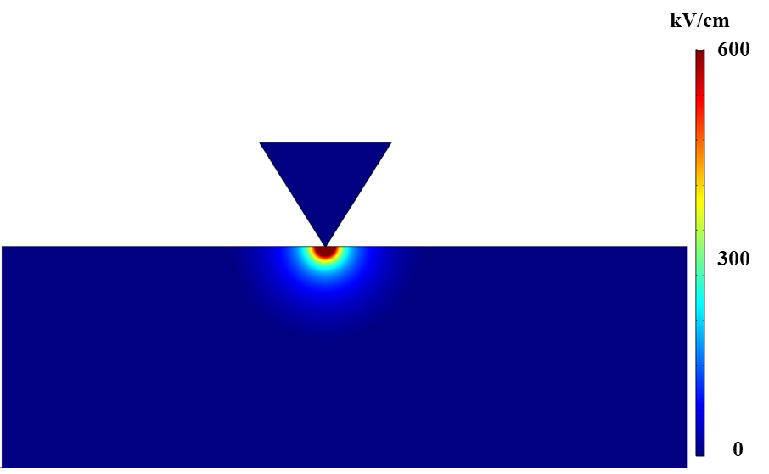
Fig.S7 Simulation of the uneven electric field of the PFM tip at a voltage of 50V.

- Calculation of thermally stimulated depolarization currents (TSDC)
Since the depolarization current originates from electrons and holes, the trap energy level E_{a} and the trapped charge quantity N_{t} can be obtained from TSDC curves according to the halfwidth method given by¹
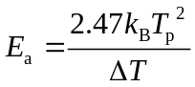 (1)
where k_{B} is the Boltzmann constant, T_{p} is the temperature corresponding to the peak current and T is the peak with at half height.
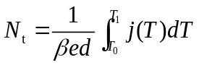 (2)
Where β is the trap density, d is the thickness of sample and e is the elementary charge. T₀ and T₁ represent the starting temperature and ending temperature of peaks, respectively and j(T) describes the depolarization current density.

Reference
1. Christodoulides, C. Determination of activation energies by using the widths of peaks of thermoluminescence and thermally stimulated depolarisation currents. J. Phys. D: Appl. Phys. 18, 1501–1510 (1985).

