Fig. S1 Clustering at 97.0% similarity level, number of outs for each group of overripe fruits and P. okadai at different developmental stages.
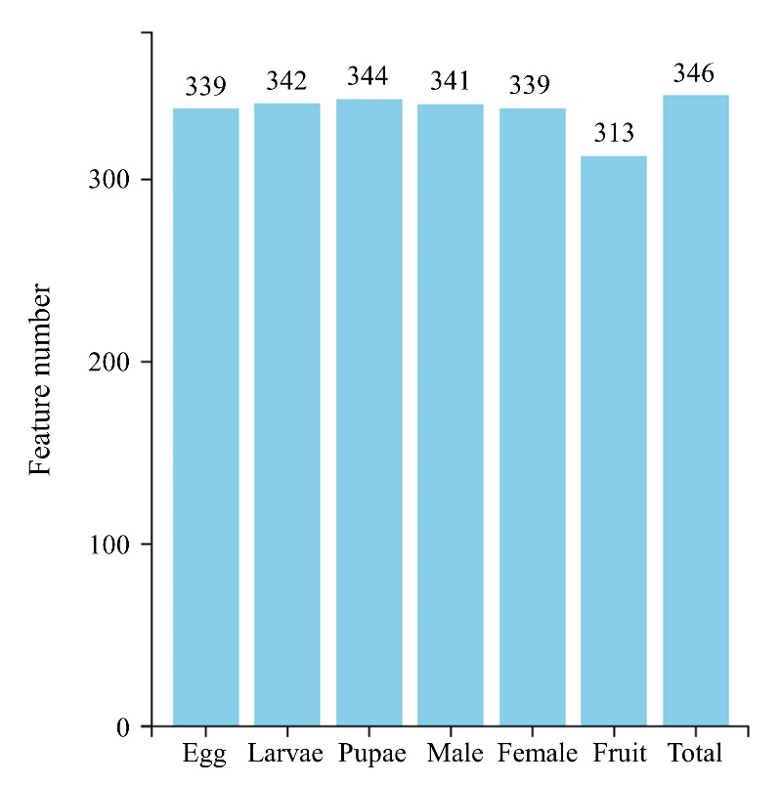

Fig. S2 Rarefaction curves based on OTU numbers with different developmental stages of P. okadai and overripe fruits.
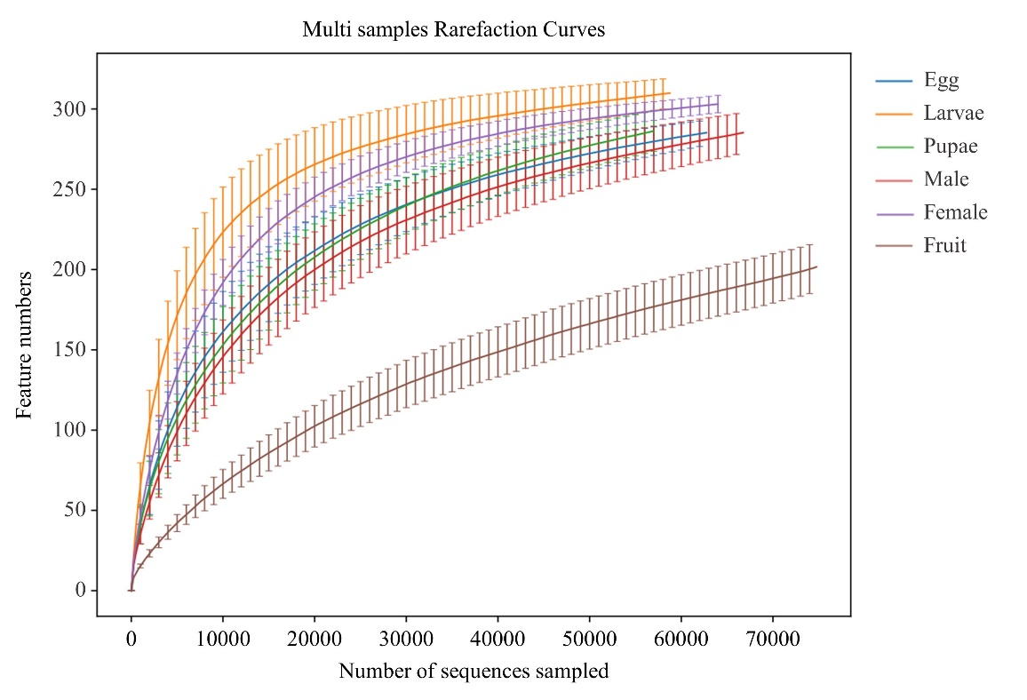

Fig. S3 Taxonomic composition and relative abundance of symbiotic bacteria at the phylum and genus levels between different developmental stages of P. okadai and overripe fruits.
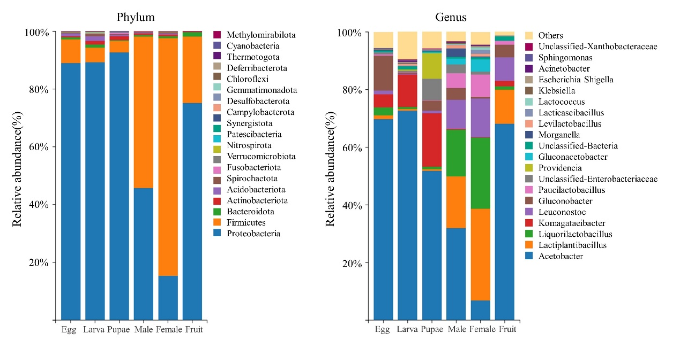
Fig. S4 Differences in microbial community abundance of P. okadai at different developmental stages and overripe fruits using ANOVA (Analysis of Variance, BH-FDR) at the genus level, the figure shows the bacterial genera with the highest abundance percentages.
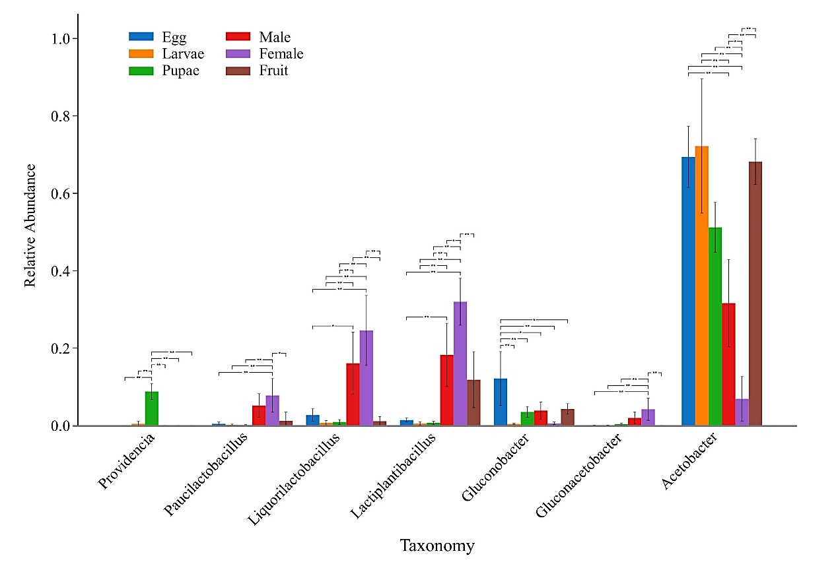

Table S1 The evaluation of sequencing data for overripe fruits and P. okadai at different developmental stages in each sample is shown in the following table: Raw Reads are the number of raw reads obtained from sequencing; Clean Reads is the number of high-quality reads obtained after raw sequence quality control; Effective Reads is the number of effective sequences after Clean Reads by splicing (double-end), filter length and chimeras; AvgLen (bp) is the average sequence length of the sample. (E: Egg, L: Larvae, P: Pupae and M: Male and F: Female midgut, S: overripe pear).
Sample | Raw Reads | Clean Reads | Effective Reads | AvgLen(bp) | Effective(%)
E1 | 80423 | 80152 | 78549 | 407 | 97.67
E2 | 79879 | 79597 | 77947 | 408 | 97.58
E3 | 80071 | 79815 | 77966 | 407 | 97.37
E4 | 79999 | 79742 | 77391 | 410 | 96.74
L1 | 79504 | 79205 | 77546 | 408 | 97.54
L2 | 80029 | 79763 | 77697 | 409 | 97.09
L3 | 79833 | 79563 | 77873 | 408 | 97.54
L4 | 79844 | 79588 | 77411 | 409 | 96.95
P1 | 80089 | 79803 | 76903 | 410 | 96.02
P2 | 80029 | 79724 | 76219 | 411 | 95.24
P3 | 80227 | 79951 | 77666 | 410 | 96.81
P4 | 79932 | 79628 | 73943 | 413 | 92.51
M1 | 80337 | 80039 | 76853 | 420 | 95.66
M2 | 79989 | 79687 | 76909 | 423 | 96.15
M3 | 80295 | 80049 | 77026 | 417 | 95.93
M4 | 80081 | 79819 | 77623 | 417 | 96.93
F1 | 80001 | 79705 | 77255 | 424 | 96.57
F2 | 79801 | 79508 | 76499 | 423 | 95.86
F3 | 79878 | 79594 | 76717 | 428 | 96.04
F4 | 79999 | 79717 | 77091 | 425 | 96.36
S1 | 79766 | 79542 | 78017 | 410 | 97.81
S2 | 79880 | 79597 | 78244 | 413 | 97.95
S3 | 79999 | 79723 | 78156 | 410 | 97.70
S4 | 79939 | 79661 | 78122 | 410 | 97.73

Table S2 54 genera were detected in species with a P.okadai abundance of over 99.9%, of which 11 genus are present at different developmental stages, known as the core microbiota.
OUT ID | Phylum | Class | Order | Family | Genus
OUT 1 | Proteobacteria | Alphaproteobacteria | Acetobacterales | Acetobacteraceae | Acetobacter
OUT 2 | Firmicutes | Bacilli | Lactobacillales | Lactobacillaceae | Lactiplantibacillus
OUT 3 | Proteobacteria | Alphaproteobacteria | Acetobacterales | Acetobacteraceae | Gluconobacter
OUT 4 | Proteobacteria | Alphaproteobacteria | Acetobacterales | Acetobacteraceae | Komagataeibacter
OUT 5 | Firmicutes | Bacilli | Lactobacillales | Lactobacillaceae | Leuconostoc
OUT 6 | Proteobacteria | Gammaproteobacteria | Enterobacterales | Enterobacteriaceae | Uc-Enterobacteriaceae
OUT 7 | Firmicutes | Bacilli | Lactobacillales | Lactobacillaceae | Liquorilactobacillus
OUT 9 | Firmicutes | Bacilli | Lactobacillales | Lactobacillaceae | Paucilactobacillus
OUT 12 | uc-Bacteria | uc-Bacteria | uc-Bacteria | uc-Bacteria | uc-Bacteria
OUT 15 | Firmicutes | Bacilli | Lactobacillales | Lactobacillaceae | Liquorilactobacillus
OUT 110 | Proteobacteria | Gammaproteobacteria | Enterobacterales | Enterobacteriaceae | Klebsiella

Table S3 Relative abundance (%) of taxa overripe fruits and P. okadai at different developmental stages at genus.
Taxa | Egg | Larvae | Pupae | Male | Female | Fruits
Acetobacter | 69.43 | 72.19 | 51.20 | 31.62 | 6.91 | 68.16
Lactiplantibacillus | 1.43 | 0.51 | 0.70 | 18.26 | 31.98 | 11.85
Liquorilactobacillus | 2.72 | 0.68 | 0.92 | 16.09 | 24.57 | 1.14
Komagataeibacter | 4.25 | 11.70 | 18.58 | 0.17 | 0.14 | 1.83
Leuconostoc | 1.38 | 0.23 | 0.89 | 10.25 | 13.10 | 8.29
Gluconobacter | 12.18 | 0.43 | 3.52 | 3.88 | 0.57 | 4.29
Paucilactobacillus | 0.44 | 0.21 | 0.15 | 5.17 | 7.78 | 1.25
Uc_Enterobacteriaceae | 0.74 | 0.35 | 7.55 | 3.23 | 1.11 | 0.14
Providencia | 0.01 | 0.45 | 8.80 | 0.02 | 0.01 | 0.00
Gluconacetobacter | 0.06 | 0.05 | 0.37 | 1.99 | 4.23 | 0.02
Uc_Bacteria | 0.60 | 1.15 | 0.23 | 0.56 | 0.72 | 1.53
Morganella | 0.06 | 0.12 | 0.27 | 2.92 | 0.32 | 0.00
Levilactobacillus | 0.13 | 0.60 | 0.08 | 1.24 | 0.82 | 0.24
Lacticaseibacillus | 0.04 | 0.08 | 0.04 | 0.19 | 1.41 | 0.00
Lactococcus | 0.07 | 0.03 | 0.02 | 0.33 | 1.00 | 0.04
Klebsiella | 0.15 | 0.32 | 0.22 | 0.34 | 0.21 | 0.11
Escherichia_Shigella | 0.12 | 0.29 | 0.19 | 0.08 | 0.15 | 0.03
Acinetobacter | 0.08 | 0.30 | 0.06 | 0.16 | 0.22 | 0.01
Uc_Xanthobacteraceae | 0.12 | 0.33 | 0.08 | 0.11 | 0.16 | 0.02
Sphingomonas | 0.17 | 0.28 | 0.10 | 0.11 | 0.13 | 0.02
Lactobacillus | 0.26 | 0.31 | 0.08 | 0.06 | 0.06 | 0.01
Bacteroides | 0.12 | 0.26 | 0.12 | 0.12 | 0.13 | 0.02
Uc_Muribaculaceae | 0.16 | 0.26 | 0.06 | 0.10 | 0.12 | 0.01
Others | 5.30 | 8.88 | 5.77 | 3.01 | 4.13 | 0.98

Table S4 Alpha-diversity of the gut microbiota of P. okadai at different developmental stages and overripe fruits. The diversity metrics Chao 1 richness estimator, the number of OTUs, the Shannon and the Simpson Indexes were estimated for all the samples (E: eggs, L: larvae, P: Pupae, M: midgut of male, F: midgut of female, S: overripe fruits).
Sample | ACE | Chao 1 | Shannon | Simpson
E1 | 327.46 | 321.71 | 1.60 | 0.38
E2 | 310.92 | 315.29 | 2.05 | 0.56
E3 | 322.95 | 325.98 | 1.70 | 0.45
E4 | 304.00 | 304.00 | 2.85 | 0.59
L1 | 324.30 | 330.13 | 1.43 | 0.25
L2 | 329.20 | 333.25 | 2.47 | 0.43
L3 | 323.19 | 324.00 | 1.85 | 0.37
L4 | 330.41 | 355.00 | 2.86 | 0.66
P1 | 321.26 | 325.67 | 2.34 | 0.65
P2 | 323.75 | 321.43 | 2.56 | 0.68
P3 | 331.26 | 328.53 | 2.40 | 0.66
P4 | 342.43 | 343.50 | 3.46 | 0.77
M1 | 312.83 | 311.44 | 3.12 | 0.83
M2 | 318.94 | 318.75 | 3.49 | 0.84
M3 | 331.62 | 343.50 | 3.38 | 0.80
M4 | 314.77 | 329.44 | 2.86 | 0.77
F1 | 306.47 | 311.61 | 3.05 | 0.79
F2 | 320.19 | 320.24 | 3.68 | 0.84
F3 | 315.04 | 321.52 | 2.74 | 0.74
F4 | 314.61 | 315.95 | 3.05 | 0.78
S1 | 361.63 | 287.77 | 1.60 | 0.47
S2 | 295.40 | 297.73 | 2.04 | 0.59
S3 | 258.54 | 229.93 | 1.57 | 0.46
S4 | 273.71 | 263.46 | 1.71 | 0.49

Table S5 Blast-based alignment of 16S rRNA sequences from the intestinal tract of adult P. okadai.
Kingdom | Phylum | Class | Order | Family | Genus | Species | Top-hit strain | Simillary (%)
Bacteria | Firmicutes | Bacill | Bacillales | Planococcaceae | Metasolibacillus | Lysinibacillus fusiformis | NBRC 15717 | 99.93
Bacteria | Proteobacteria | Alphaproteobacteria | Rhizobiales | Rhizobiaceae | Agrobacterium | Agrobacterium pusense | LMG 25623 | 99.78
Bacteria | Firmicutes | Bacilli | Bacillales | Bacillaceae | Bacillus | Bacillus licheniformis | ATCC 14580 | 99.93
Bacteria | Firmicutes | Bacilli | Bacillales | Bacillaceae | Fictibacillus | Fictibacillus gelatini | LMG 21880 | 99.93
Bacteria | Firmicutes | Bacilli | Lactobacillales | Lactobacillaceae | Levilactobacillus | Levilactobacillus brevis | ATCC 14869 | 99.93
Bacteria | Firmicutes | Bacilli | Lactobacillales | Lactobacillaceae | Leuconostoc | Leuconostoc suionicum | ATCC 8293 | 99.93
Bacteria | Firmicutes | Bacilli | Lactobacillales | Enterococcaceae | Enterococcus | Enterococcus termitis | LMG 8895 | 99.09
Bacteria | Proteobacteria | Alphaproteobacteria | Rhodospirillales | Acetobacteraceae | Acetobacter | Acetobacter ghanensis | 430A | 98.90
Bacteria | Proteobacteria | Gammaproteobacteria | Enterobacterales | Morganellaceae | Morganella | Morganella psychrotolerans | H1r | 99.50
Bacteria | Proteobacteria | Gammaproteobacteria | Pseudomonadales | Pseudomonadaceae | Entomomonas | Entomomonas moraniae | QZS01 | 99.14
Bacteria | Firmicutes | Bacilli | Lactobacillales | Lactobacillaceae | Lactiplantibacillus | Lactiplantibacillus argentoratensis | DSM 16365 | 99.86
Bacteria | Proteobacteria | Alphaproteobacteria | Rhodospirillales | Acetobacteraceae | Acetobacter | Acetobacter tropicalis | NBRC 16470 | 99.71
Bacteria | Proteobacteria | Gammaproteobacteria | Enterobacterales | Enterobacteriaceae | Citrobacter | Citrobacter freundii | DSM 30039 | 98.44
Bacteria | Firmicutes | Bacilli | Lactobacillales | Lactobacillaceae | Leuconostoc | Leuconostoc citreum | ATCC 49370 | 99.79

