Supplementary Materials for
Seed-assisted Formation of Robust Anode Catalysts for Anion Exchange Membrane Water Electrolysis with Industrial-Scale Current density
Zhiheng Li^{1,2 †}, Gaoxin Lin^{1,2 †}, Linqin Wang^{1,2}, Husileng Lee^{1,2}, Jian Du^{1,2}, Tang Tang^{1,2}, Guoheng Ding^{1,2}, Rong Ren^{1,2}, Wenlong Li^{1,2}, Xing Cao^{1,2}, Shiwen Ding^{1,2}, Wentao Ye^{1,2}, Wenxing Yang^{1,2,3} and Licheng Sun^{1,2,3} *
¹Center of Artificial Photosynthesis for Solar Fuels and Department of Chemistry, School of Science and Research Center for Industries of the Future, Westlake University, Hangzhou 310030, Zhejiang Province, China.
²Institute of Natural Sciences, Westlake Institute for Advanced Study, Hangzhou 310024, Zhejiang Province, China.
³ Division of Solar Energy Conversion and Catalysis at Westlake University, Zhejiang Baima Lake Laboratory Co., Ltd., Hangzhou 310000, Zhejiang Province, China.

*Correspondence to:
Licheng Sun: sunlicheng@westlake.edu.cn
† Z. Li and G. Lin contributed equally to this paper.

Supplementary figures
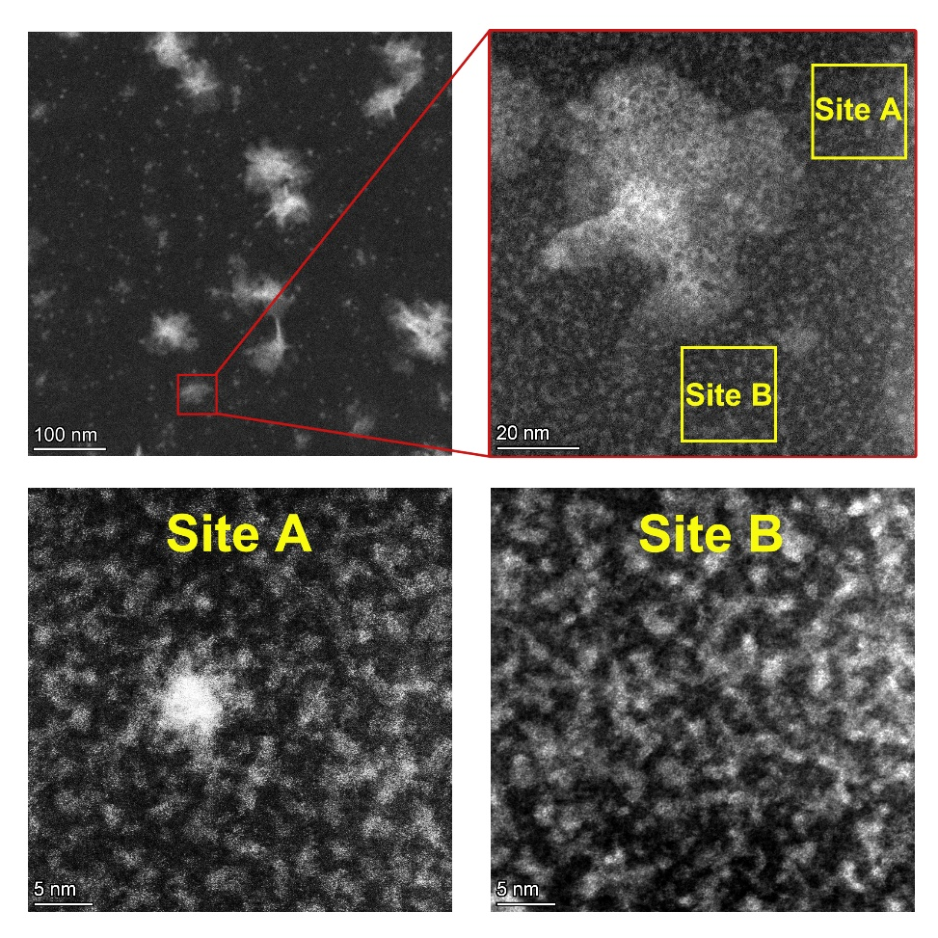
Supplementary Fig. 1 HAADF-STEM of insoluble nanoparticles in the HN liquid.

Supplementary Fig. 2 TEM EDX elemental mapping of the NiFe-nanoparticles in the HN liquid.

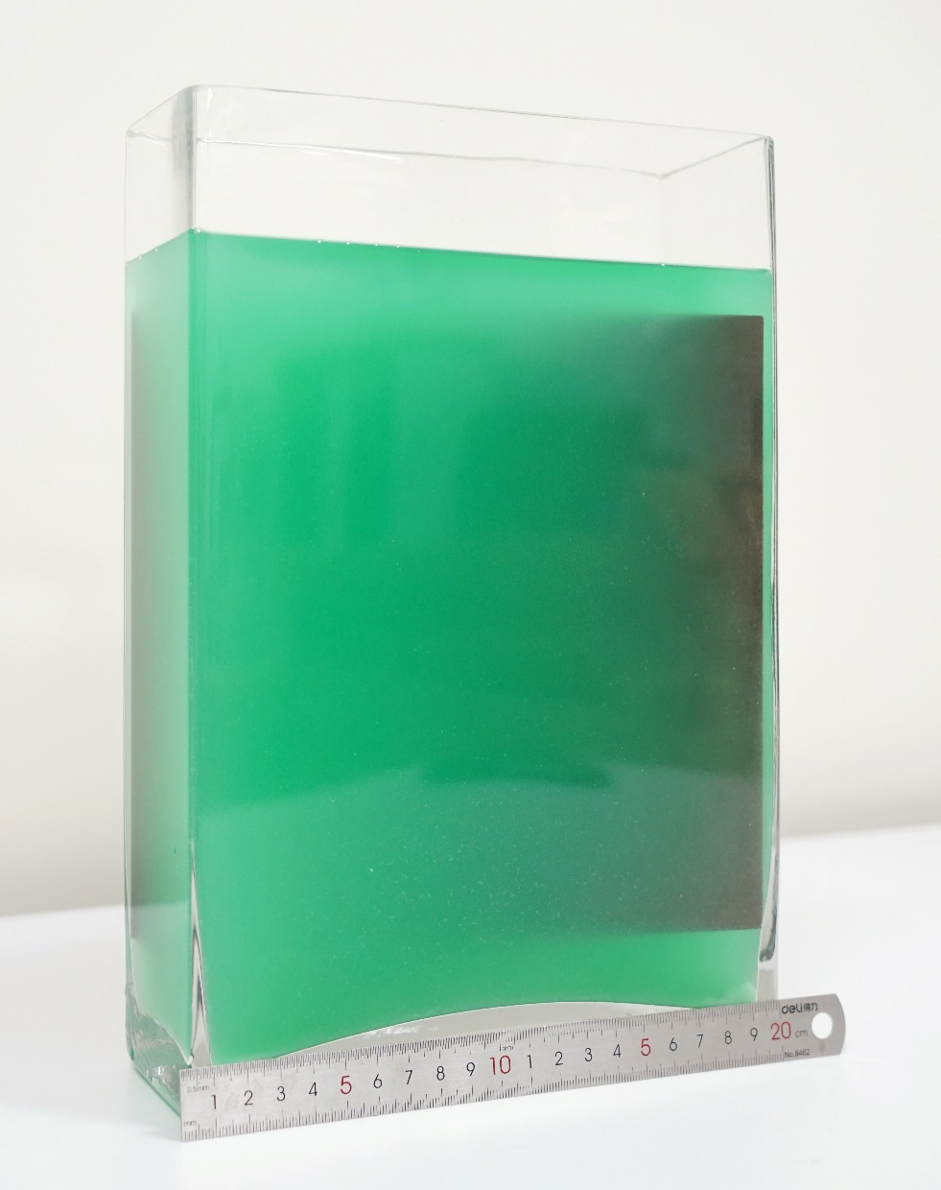
Supplementary Fig. 3 Photo of nickel foam in the HN liquid to prepare CAPist-L1

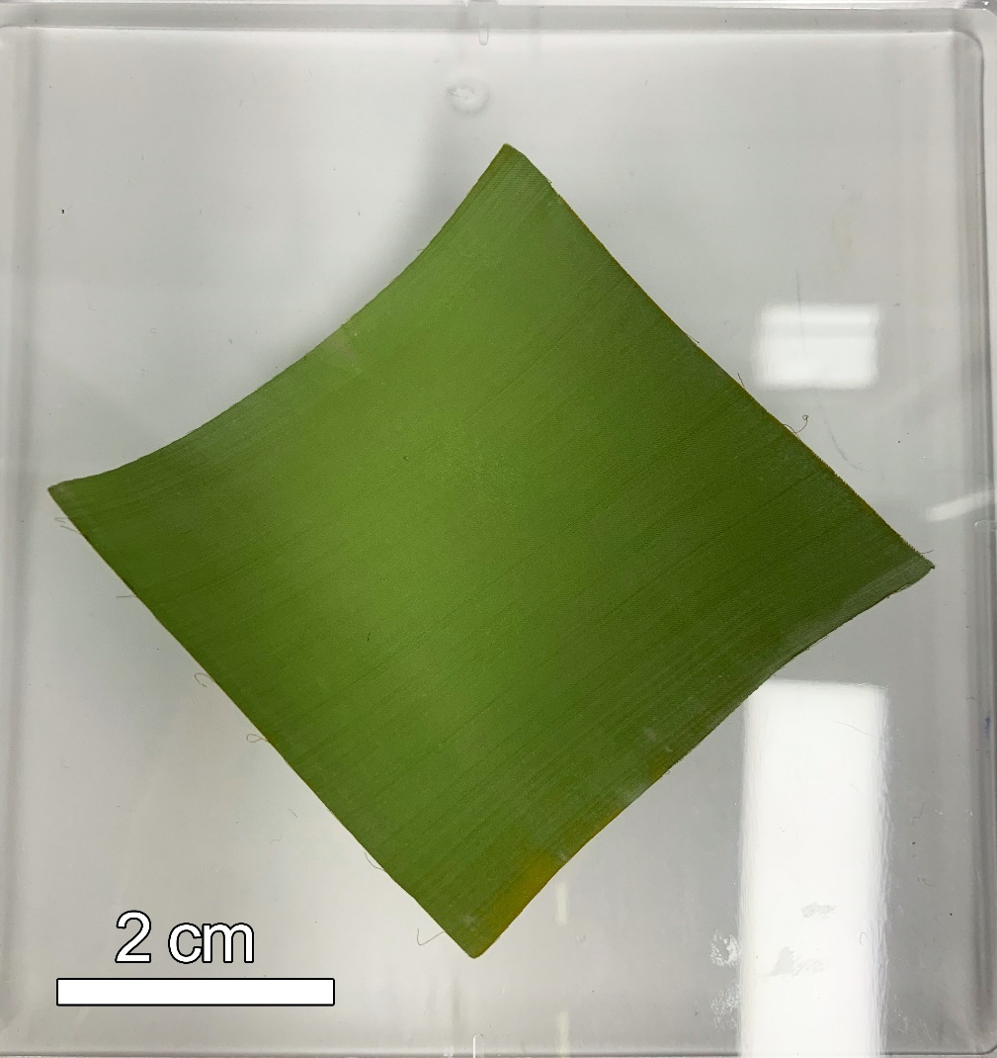
Supplementary Fig. 4 CAPist-L1 catalyst generated on Ni mesh by using the HN method.

Supplementary Fig. 5 Schematic of Ni₂Fe(SO₄)_{0.5}(OH)₆(H₂O)_{3.85}.

Supplementary Fig. 6 Raman analysis of pristine CAPist-L1 and NiFe-LDH

Supplementary Fig. 7 (a) Normalized Fe K-edge XANES spectra of CAPist-L1, NiFe-LDH, and reference samples (e.g., Fe-foil, FeO, and Fe₂O₃). The inset shows a magnified view of the pre-edge peaks. (b) The k²-weighted Fourier transformed EXAFS of pristine CAPist-L1 and NiFe-LDH.

Supplementary Fig. 8 X-ray photoelectron spectroscopy of (a) Fe 2p and (b) Ni 2p for CAPist-L1 and NiFe-LDH catalysts.

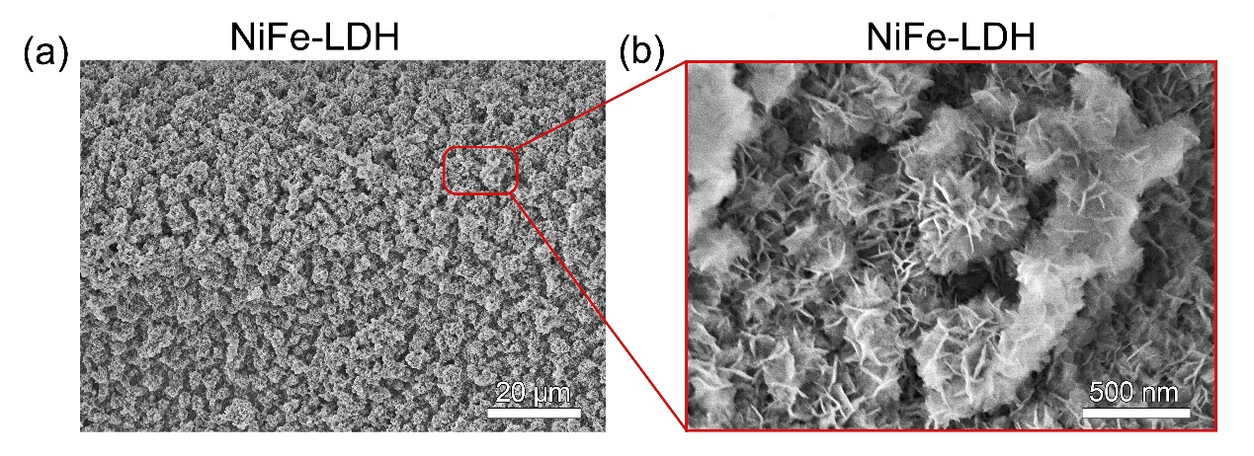
Supplementary Fig. 9 SEM images of NiFe-LDH

Supplementary Fig. 10 TEM-EDX elemental mapping of CAPist-L1.

Supplementary Fig. 11 Comparison of NiFe-LDH synthesized in this work with others from references (Sun et al.¹, Li et al.², Cai et al.³, Wang et al.⁴, Yang et al.⁵, Zhou et al.⁶, Zhai et al.⁷, Du et al.⁸, Li et al.⁹, Wu et al.¹⁰, Lin et al.¹¹, Zhang et al.¹², Dong et al.¹³, Zhao et al.¹⁴).

Notes:
Low overpotential indicates high electrocatalytic performance and low Tafel slope indicates fast OER kinetics. The self-synthesized NiFe-LDH for comparison was one of the best OER catalysts obtained from the hydrothermal method. CAPist-L1 developed in this work exhibited the lowest OER overpotential at 100 mA cm⁻² and one of the lowest Tafel slopes.

Supplementary Fig. 12 (a) CAPist-L1 with a size of 5 cm × 5 cm, with (b) OER activity comparison at different areas. The LSV scan rate is 2 mV s⁻¹.

Supplementary Fig. 13 In-situ Raman analysis of (a) CAPist-L1 and (b) NiFe-LDH catalyst measured in 1 M KOH at an anodic potential range of 1.15-1.50 V.

Supplementary Fig. 14 Photos for bubble attachment over CAPist-L1 at (a) 400 mA cm⁻², (b) 1000 mA cm⁻², and (c) 2000 mA cm⁻², and over with NiFe-LDH at (d) 400 mA cm⁻², (e) 1000 mA cm⁻², and (f) 2000 mA cm⁻². Quartiles organize data of bubble diameter for (g) CAPist-L1 and (h) NiFe-LDH.

Supplementary Fig. 15 Size distribution of O₂ bubbles on the surface of (a) CAPist-L1 and (b) NiFe-LDH.

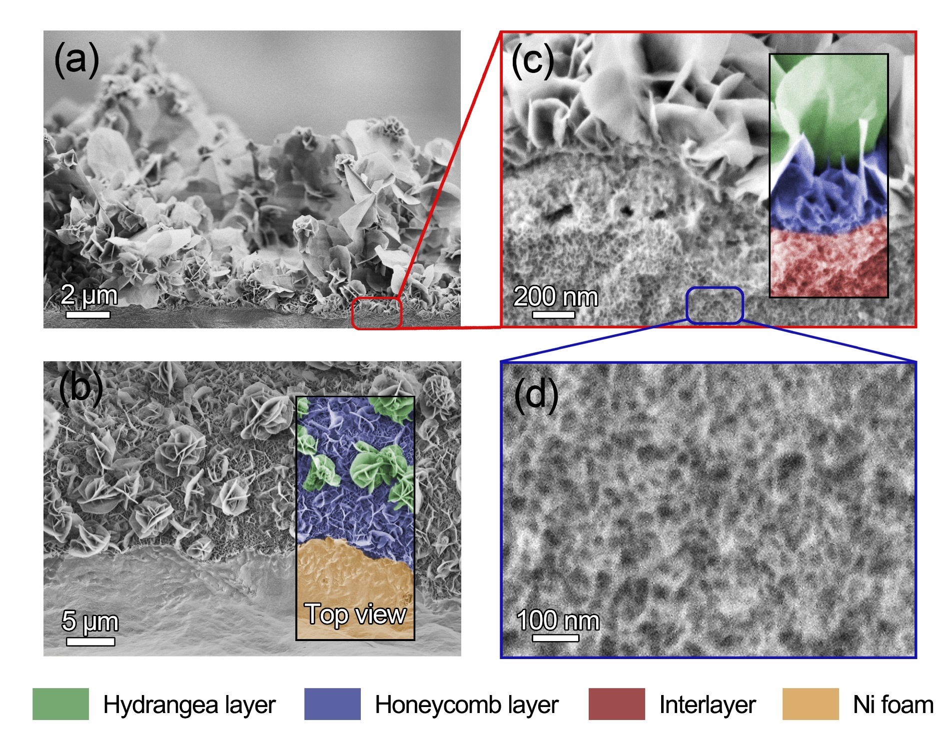
Supplementary Fig. 16 (a) SEM cross-section images of CAPist-L1, with magnified views of (c) catalyst interface and (d) interlayer. (b) Top view of CAPist-L1 SEM image.

Supplementary Fig. 17 (a) SEM images and (b-d) EDS elemental mapping of CAPist-L1. Before the SEM measurement, the CAPist-L1 was pre-treated with vigorous ultrasound for 30 min in EtOH.

Supplementary Fig. 18 (a) Representative nano-scratch photos of CAPist-L1 (top) and NiFe-LDH (bottom) catalyst layers that are in situ formed on Ni-foil. The dashed lines are shown to guide the critical binding force of the catalyst layer. (b) Comparison of the critical binding force of CAPist-L1 and NiFe-LDH. All measurements were conducted three times, independently.

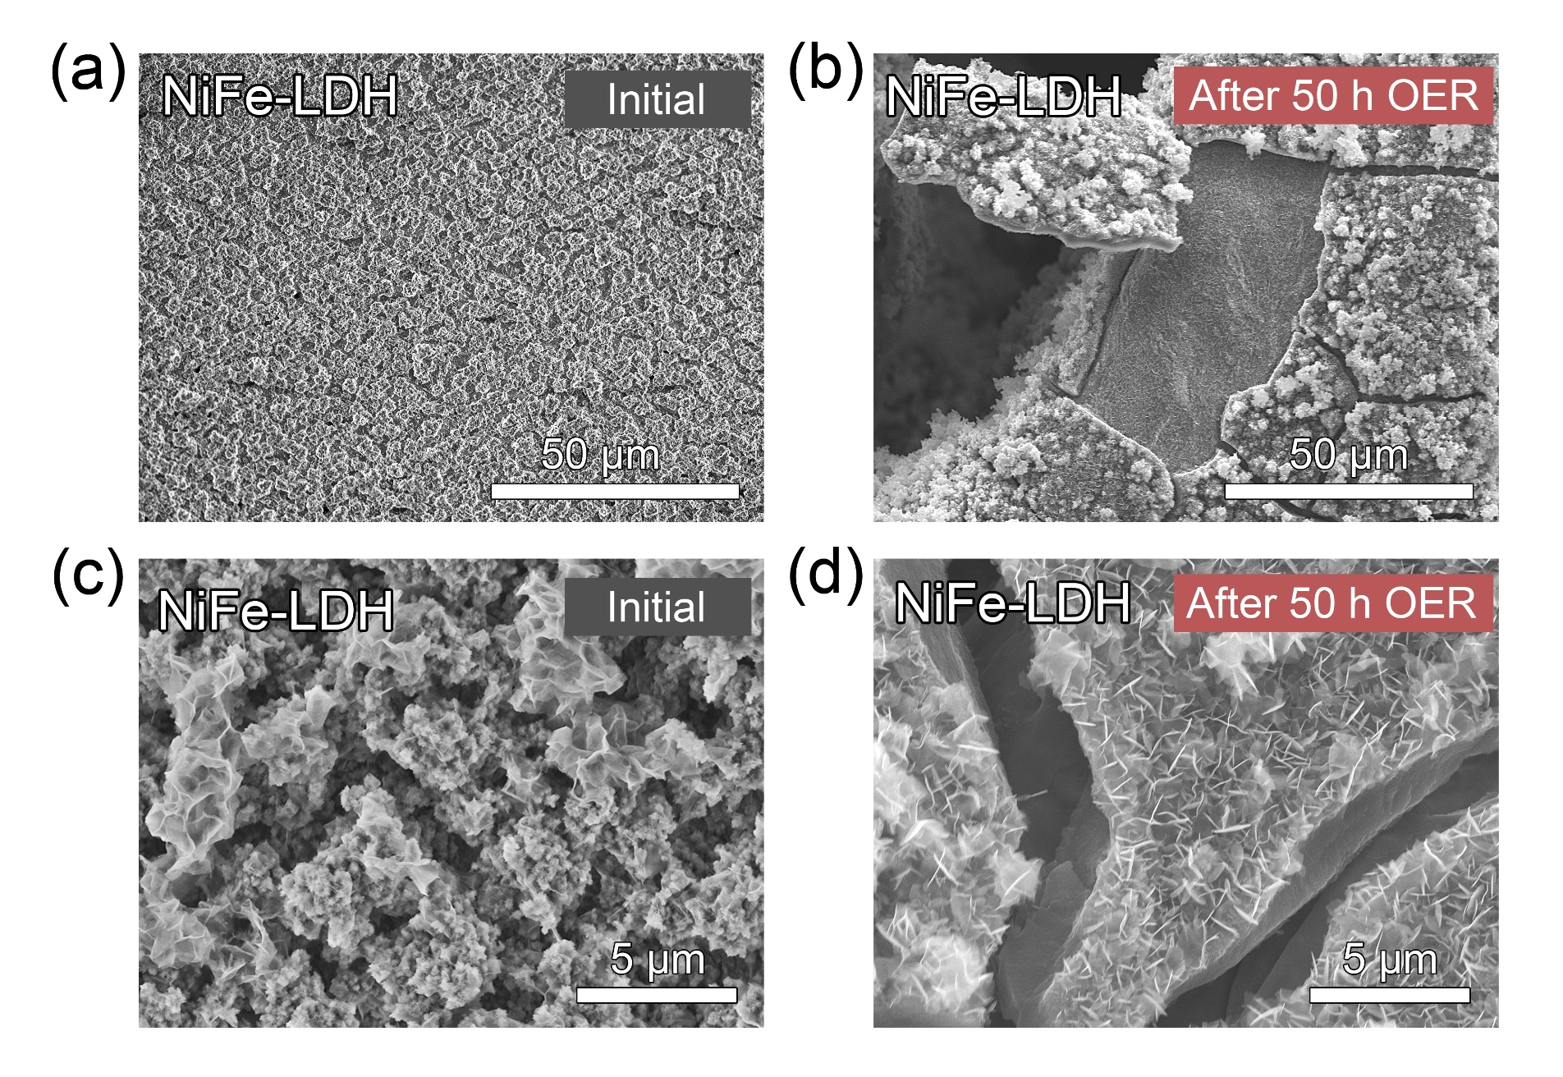
Supplementary Fig. 19 Scanning electron microscopy (SEM) images of NiFe-LDH (a, c) before and (b, d) after 50 h stability test at 500 mA cm⁻².

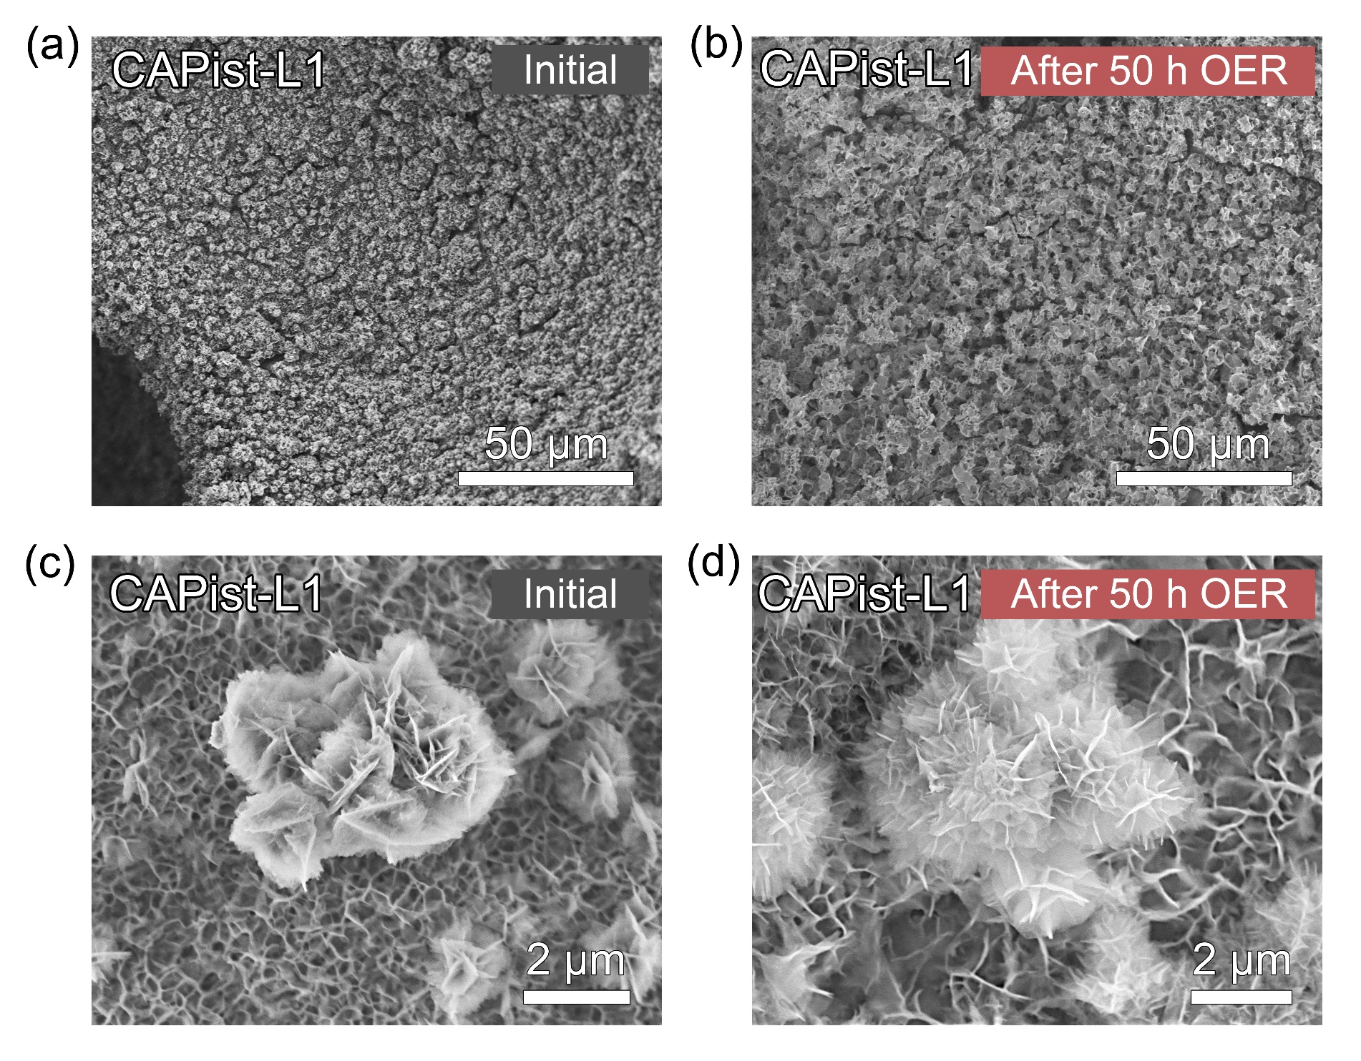
Supplementary Fig. 20 Scanning electron microscopy (SEM) images of CAPist-L1 (a, c) before and (b, d) after 50 h stability test at 500 mA cm⁻².

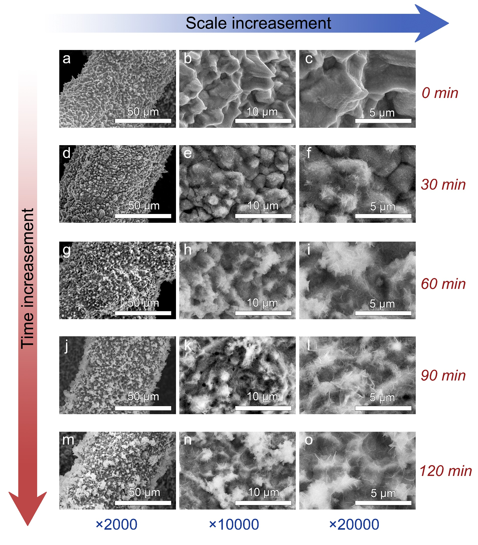
Supplementary Fig. 21 Top view of CAPist-L1 SEM images with different synthesis times of (a-c) 0 min, (d-f) 30 min, (g-i) 60 min, (j-l) 90 min, and (m-o) 120 min.

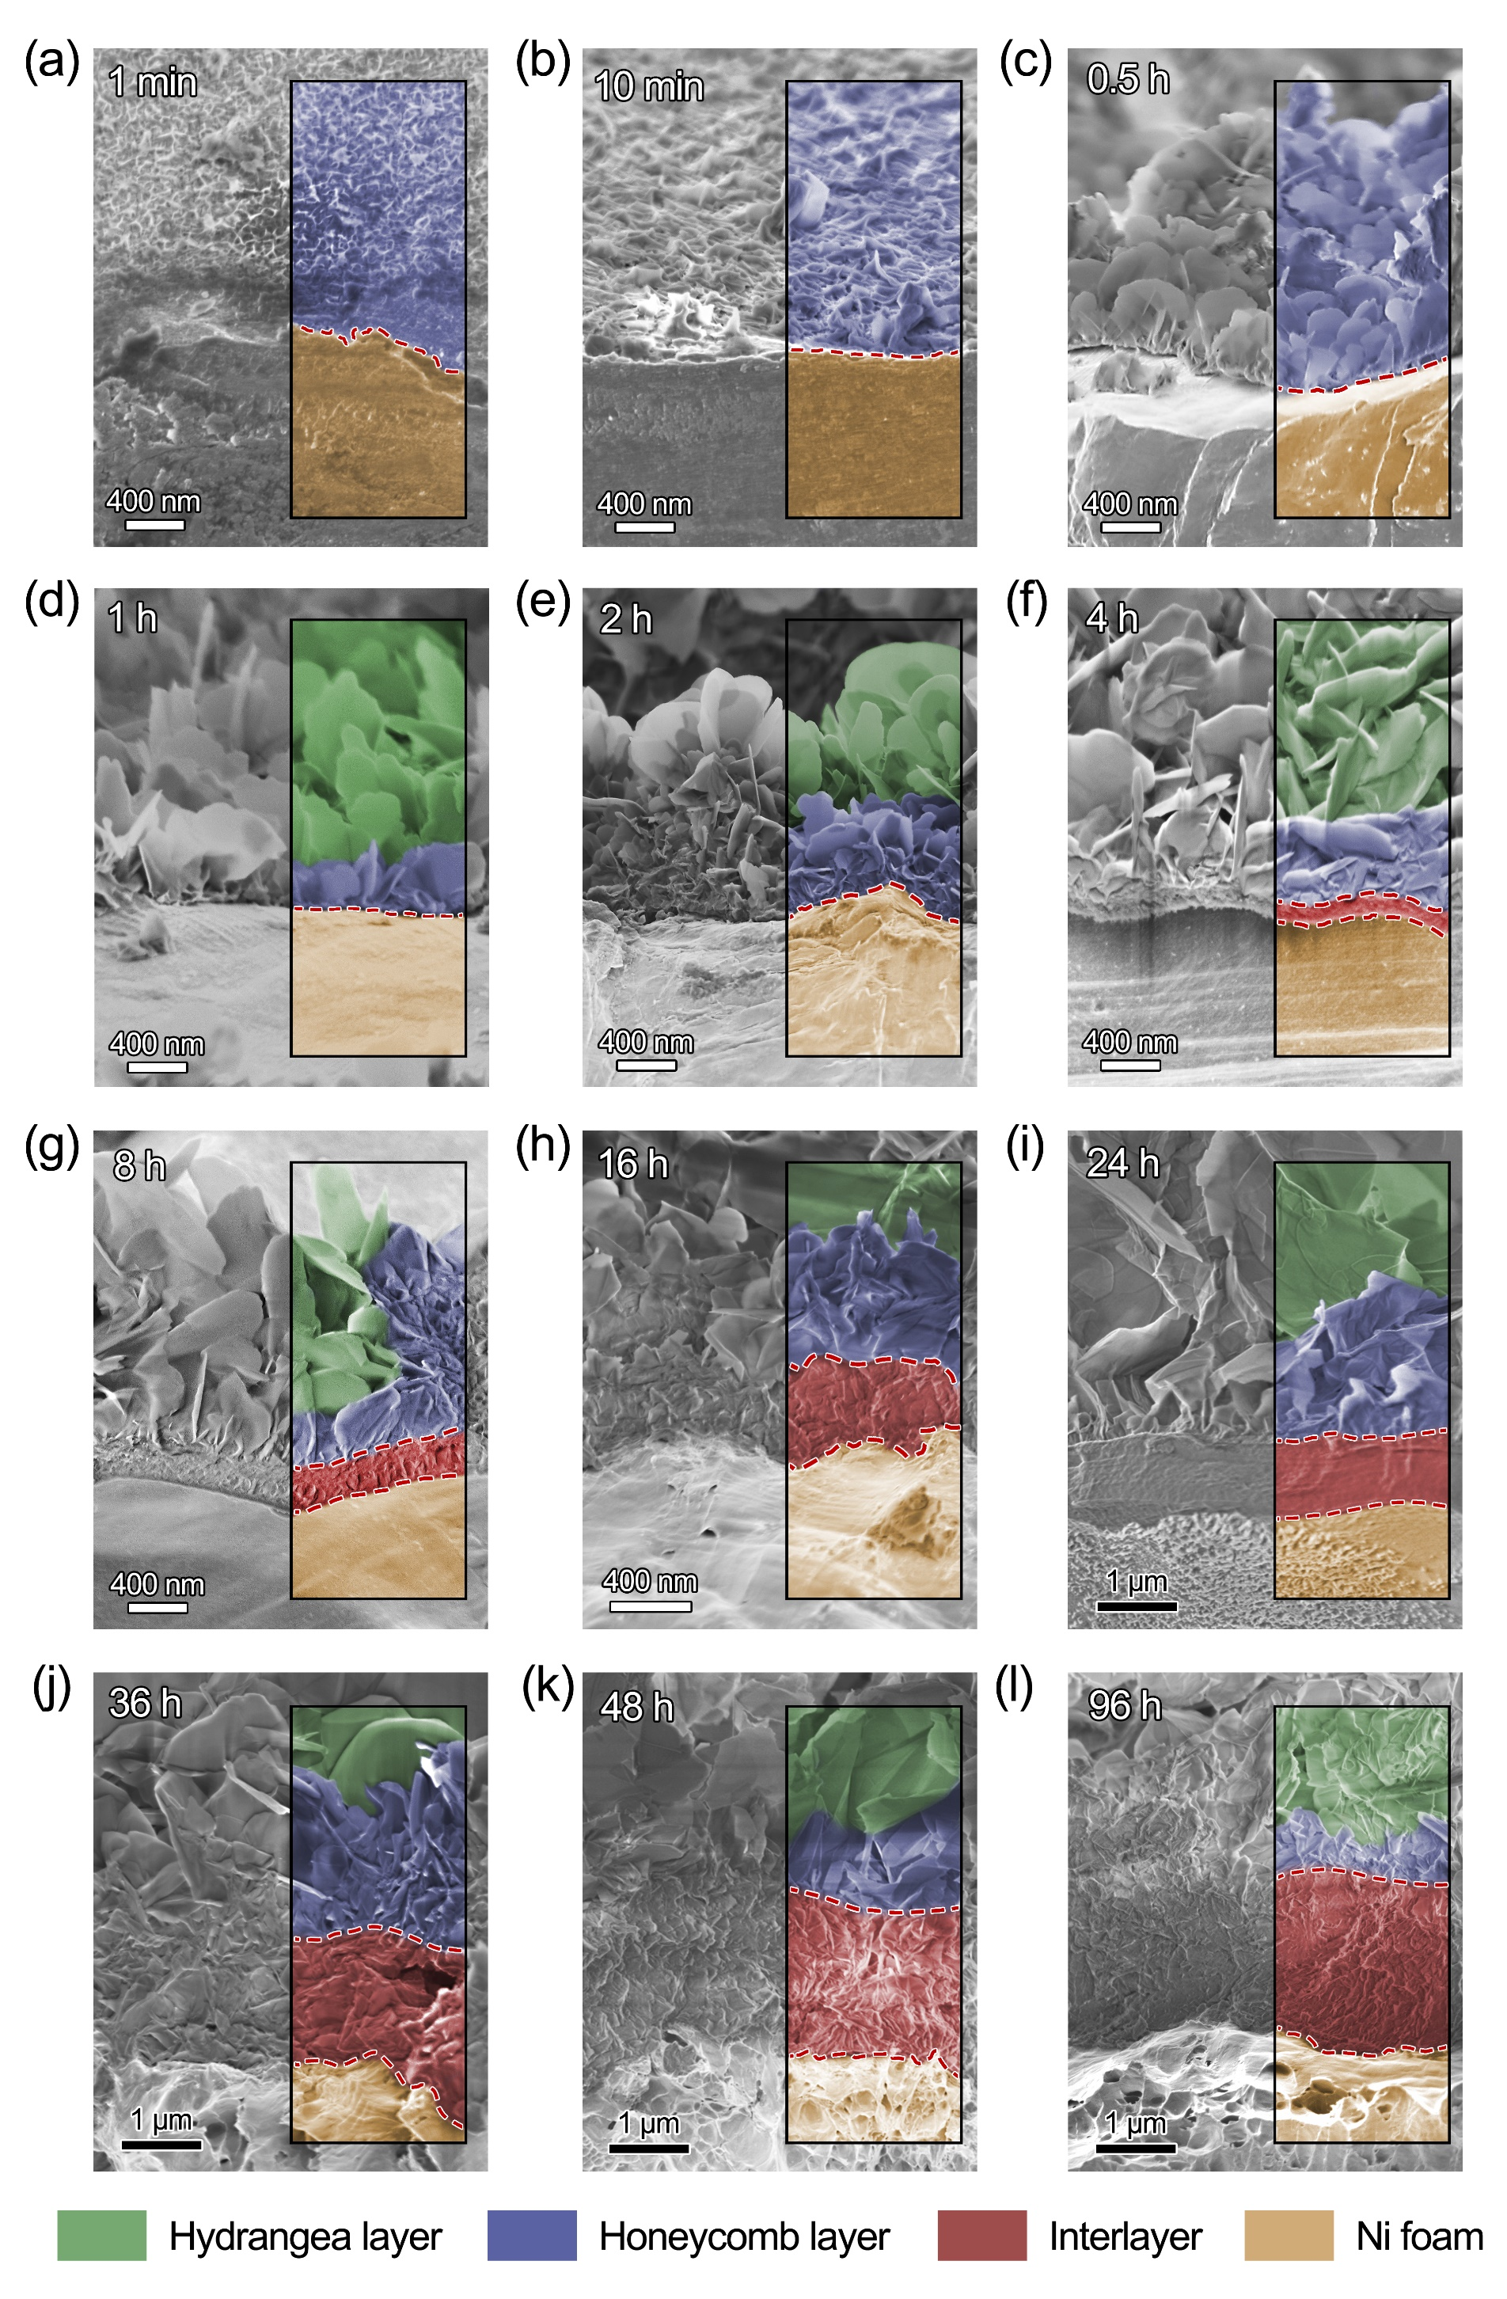
Supplementary Fig. 22 Side view of CAPist-L1 SEM images with different synthesis time of (a) 1 min, (b) 10 min, (c) 0.5 h, (d) 1 h, (e) 2 h, (f) 4 h, (g) 8 h, (h) 16 h, (i) 24 h, (j) 36 h, (k) 48 h, and (l) 96 h. Dashed lines are for guidance of boundaries.

Notes:
During the first two-hour period, a rapid growth of the lamellar structure of the catalyst was observed on the nickel substrate surface. The cross-sectional SEM images even showed obvious catalyst structure in one minute. The fast coverage of the catalyst structure was probably due to the HN process, which could bypass the fundamental nucleation process by utilizing the adsorbed nanoscale NiFe-nanoparticles as the crystal nucleus. In this case, the nucleation energy would be highly reduced to ensure the rapid formation of catalyst layers. As increasing soaking time, the size of the lamellar structure was increased. However, the dense interlayer would not appear until after four hours of soaking due to the slow growth kinetic between the catalyst layer and substrate. The thickness of the interlayer gradually increased from hundreds of nanometers to several micrometers during the soaking. Besides, the growth of the interlayer does not lead to the detachment from the nickel substrate or the fissuration structure of catalyst layers. Therefore, the growth process of the interlayer is believed to arise from substrate etching.

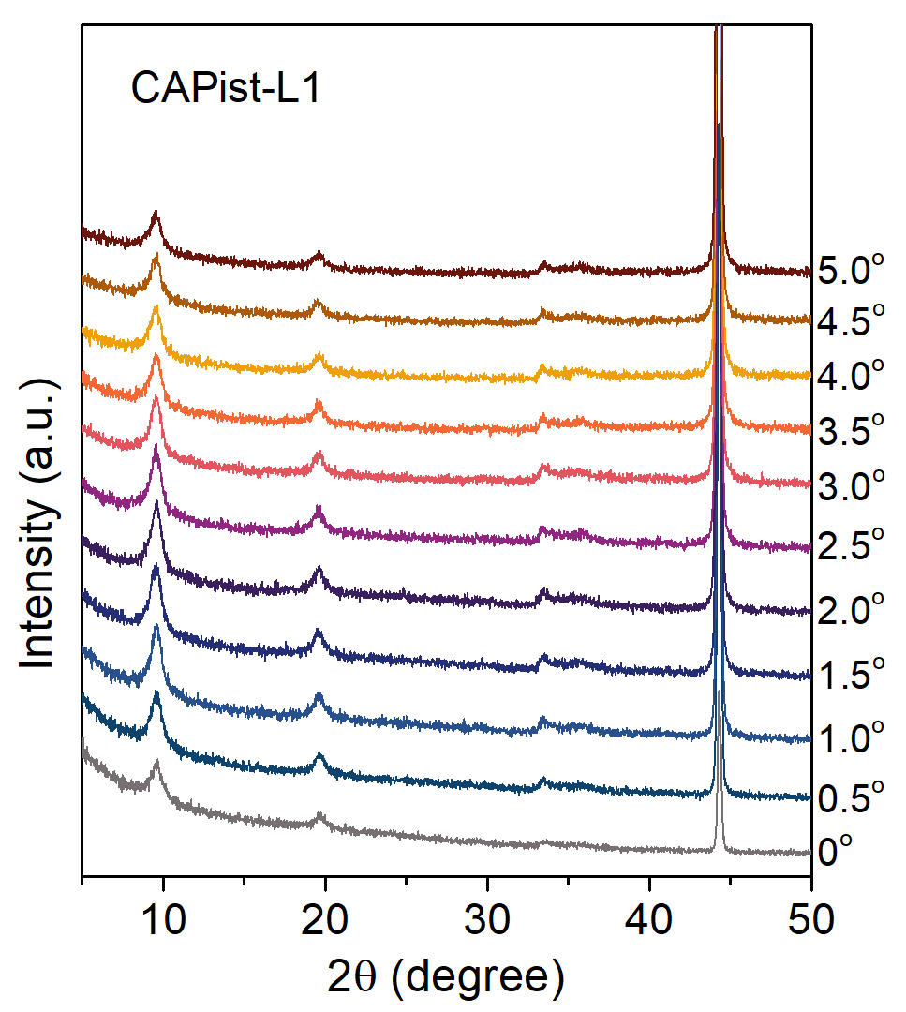
Supplementary Fig. 23 Grazing incidence X-Ray diffraction analysis for CAPist-L1. The CAPist-L1 was prepared via soaking nickel foam in HN liquid at 25 °C for 24 h. Before soaking, the nickel foam was hydro-pressed to ensure a flat surface. The incident angles of the X-ray were 0 - 5 ° to the nickel foam flat.

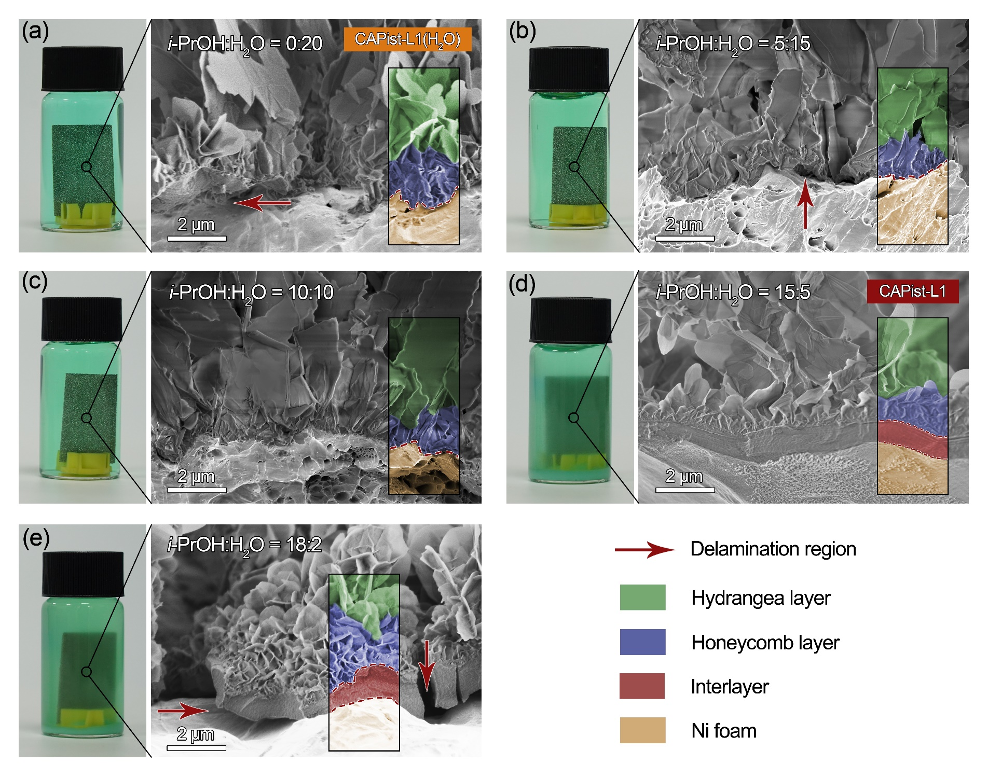
Supplementary Fig. 24 Influence of i-PrOH/H₂O ratios on the soaking systems: (a) i-PrOH/H₂O = 0/20, (b) i-PrOH/H₂O = 5/15, (c) i-PrOH/H₂O = 10/10, (d) i-PrOH/H₂O = 15/5, and (e) i-PrOH/H₂O = 18/2. All experiments were conducted at 25 ºC for 24h. Dashed lines are for guidance of boundaries.
Notes:
Increasing the proportion of water (over 50 vol.%) in the soaking liquid could facilitate the dissolution of NiFe-nanoparticles, making it a homogeneous solution. However, homogeneous solutions were not conducive to the formation of a dense layer. In contrast, the increase of i-PrOH proportion up to > 75 vol.% would obtain insoluble NiFe-nanoparticles, which contributed to the formation of a dense layer. Note that too high i-PrOH proportion (e.g., 90 vol.%) led to the delamination of the catalyst from the nickel substrate.

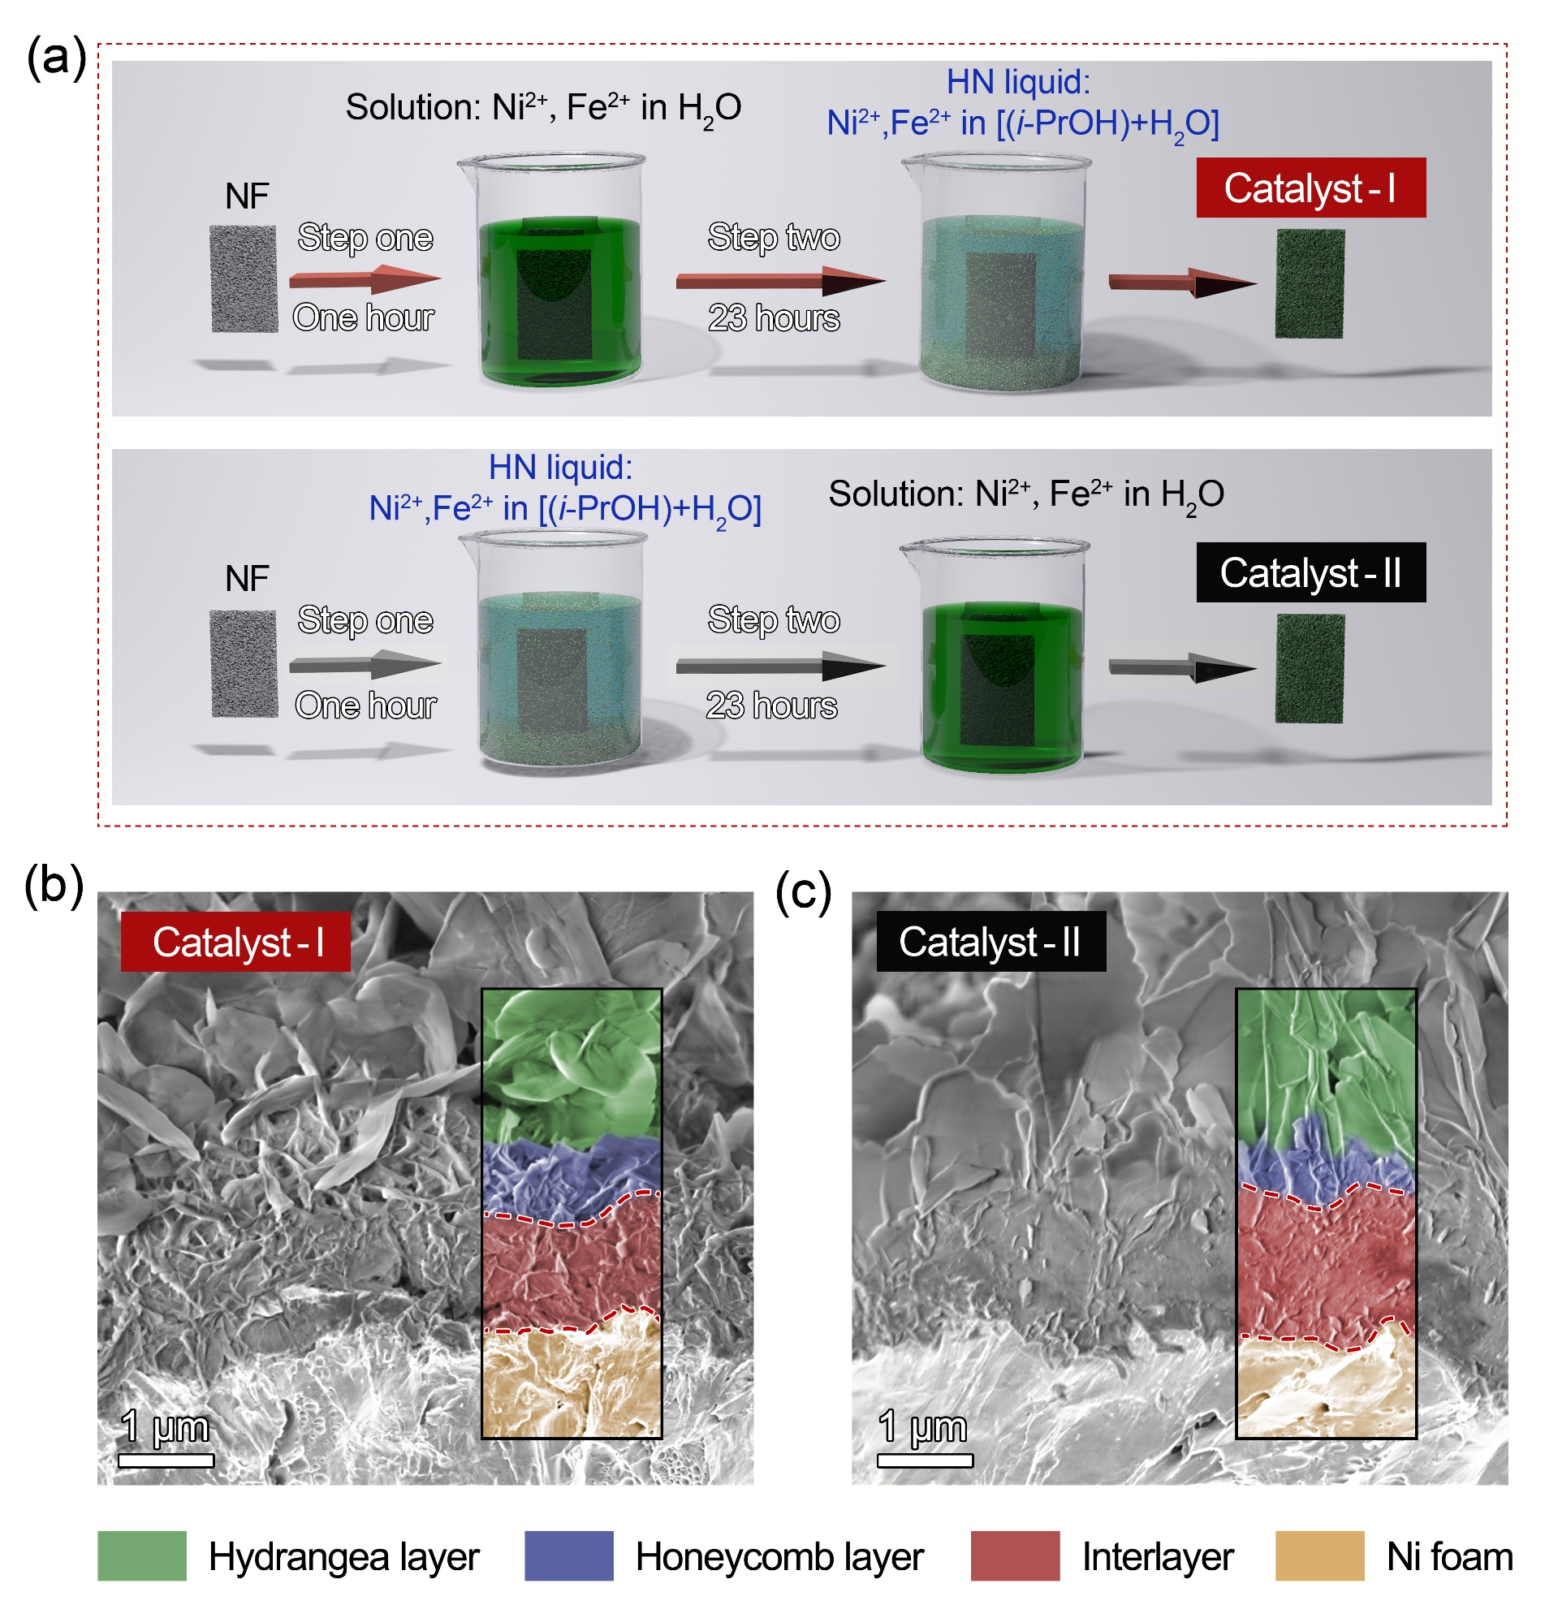
Supplementary Fig. 25 (a) Schematic diagrams for the interchange of soaking systems involving a solution (e.g., nickel and iron ions in water) and HN liquid to obtain Catalyst-I and Catalyst-II. The step one was conducted for one hour and step two was 23 hours. Cross-sectional SEM images for (b) Catalyst-I and (c) Catalyst-II. Dashed lines are for guidance of boundaries.
Notes:
To clarify the role of the amorphous colloform and i-PrOH in interlayer growth, the soaking systems were alternated between water solution and HN liquid. As the interlayer appeared only after two hours, the switching time was set at the initial one hour (step one), followed by another 23 hours soaking process (step two). As shown in Figure S24a, Catalyst-I exhibited a less dense interlayer without the absence of NiFe-nanoparticles at step one. In contrast, Catalyst-II showed a dense interlayer in the presence of NiFe-nanoparticles at step one (Figure S24b). The above results indicate the adsorption of nanoparticles on the NF at the initial soaking stage plays a bigger role in the formation of dense interlayer in comparison to i-PrOH. The Fe²⁺ in the nanoparticles would be slowly oxidized to Fe³⁺ with the assistance of dissolved oxygen during the soaking process. Some of the oxidized Fe³⁺ participated in the nickel substrate corrosion and reduced to Fe²⁺. Other coprecipitated with Ni²⁺ to form the hydroxide, resulting in the dense stacking of nanosheets due to limited space within the catalytic layer and substrate.
Supplementary Fig. 26 In-situ XRD of (a) CAPist-L1 catalyst with corresponding (b) interlayer distance, and (c) NiFe-LDH catalyst. The In-situ XRD was tested in 1M KOH at an anodic potential range of 1.2-1.6 V. Before each test, the potential was maintained for 10 min.

Supplementary Fig. 27 XRD patterns of (a) CAPist-L1 and (b) NiFe-LDH tested in 1 M KOH before and after a short-term stability test (500 mA cm⁻² for 50 h).

Supplementary Fig. 28 (a) Dissolved amount of Ni and Fe from catalyst measured by Inductively Coupled Plasma Mass Spectrometry (ICP-MS). (b) S-number results of CAPist-L1 and NiFe-LDH after 50 h short-term OER stability.

Supplementary Fig. 29 Fitted results of the k²-weighted Fourier transformed EXAFS spectra for (a) CAPist-L1 and (b) NiFe-LDH before and after the short-term OER stability.

Supplementary Fig. 30 Photo for the AEM-WE system. The electrode area is 25 cm² (5 cm × 5 cm).

Supplementary Fig. 31 Electrochemical performance of (a) NiFe-LDH//Ni₄Mo/MoO₂ and (b) IrO₂//Ni₄Mo/MoO₂ electrolyzer. PAP-TP-85 (45.0 ± 0.6 μm) was applied as the membrane.

Supplementary Fig. 32 Faradic efficiency measurements of 1 cm² CAPist-L1//Ni₄Mo/MoO₂ AEW-WE electrolyzer. The short-term durability test was conducted at 1000 mA cm⁻² and 25 °C, and the Faradic efficiencies were measured by gas chromatography method.

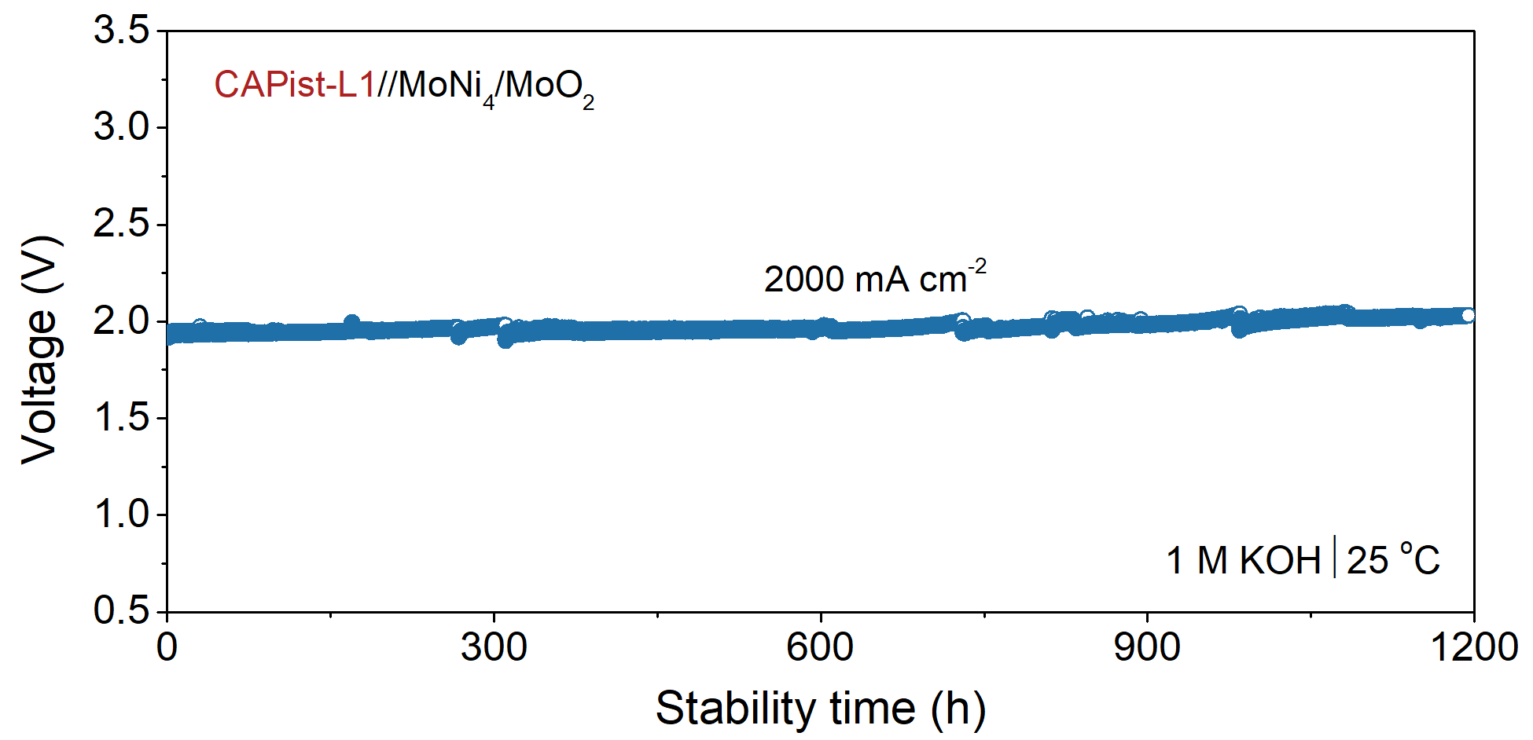
Supplementary Fig. 33 Durability of CAPist-L1//Ni₄Mo/MoO₂ electrolyzer measured in 1 M KOH at 2000 mA cm⁻² and 25 °C.

Supplementary tables
Supplementary Table 1 Faradic efficiency measurements of H₂ and O₂ in three-electrode
systems ª
Time  (min) | Water replacement method |  |  | Time  (h) | Gas chromatography method
Time  (min) | FE_{H2} ^{b} | FE_{O2} ^{c} | M_{H2/O2} ^{d} | Time  (h) | FE_{H2} ^{b} | FE_{O2} ^{c} | M_{H2/O2} ^{d}
30 | 99.75 | 99.24 | 2.01 | 4 | 100.38 | 98.52 | 2.04
60 | 100.26 | 100.26 | 2.00 | 8 | 100.45 | 100.39 | 2.00
90 | 100.52 | 98.73 | 2.04 | 12 | 100.02 | 99.64 | 2.01
120 | 100.01 | 100.77 | 1.99 | 16 | 99.87 | 100.33 | 1.99
150 | 99.24 | 99.75 | 1.99 | 18 | 99.50 | 98.84 | 2.01
180 | 100.26 | 99.75 | 2.01 | 20 | 99.88 | 100.12 | 2.00
210 | 99.75 | 100.77 | 1.98 | 24 | 99.58 | 100.06 | 1.99
240 | 101.28 | 100.26 | 2.02 | 28 | 100.11 | 99.56 | 2.01
Average | 100.13 | 99.94 | 2.00 | Average | 99.97 | 99.68 | 2.01
Errors | 0.61 | 0.72 | 0.02 | Errors | 0.34 | 0.69 | 0.02
ª Three electrodes were settled in an H-cell, in which PAP-TP-85 was used as the membrane.
^{b} Faradic efficiency of H₂ gas production.
^{c} Faradic efficiency of O₂ gas production.
^{d} Molar ratio of H₂/O₂.

For Faradic efficiency measurements, the water replacement method is comparable to that of the gas chromatography method, with a volume H₂/O₂ ratio of approximately 2.0.

Supplementary Table 2 Fitted results from k²-weighted FT-EXAFS spectra for CAPist-L1 and NiFe-LDH
Catalyst |  | Pair | N | R (Å) | σ² (10⁻³Å²) | ∆E₀ (eV)
CAPist-L1 | Pristine | Fe-O | 6.0±0.9 | 2.01±0.02 | 4.6±1 | -1.5±2.5
CAPist-L1 | Pristine | Fe-Fe/Ni | 2.1±0.4 | 2.51±0.03 | 5.3±1 | -1.6±2.8
CAPist-L1 | Pristine | Fe-O-Fe/Ni | 4.4±0.8 | 3.10±0.04 | 5.3±1 | -1.6±2.8
CAPist-L1 | After OER stability ª | Fe-O | 5.7±1 | 2.02±0.04 | 4.9±2 | -1.9±5.0
CAPist-L1 | After OER stability ª | Fe-Fe/Ni | 2.3±0.3 | 2.56±0.04 | 3.4±2 | 1.2±5.3
CAPist-L1 | After OER stability ª | Fe-O-Fe/Ni | 2.9±0.5 | 3.14±0.04 | 3.4±2 | 1.2±5.3
NiFe-LDH | Pristine | Fe-O | 5.9±1.8 | 2.00±0.05 | 6.4±4 | -1.2±4.5
NiFe-LDH | Pristine | Fe-Fe/Ni | 0.9±0.6 | 2.53±0.08 | 4.9±1 | 2.0±6.1
NiFe-LDH | Pristine | Fe-O-Fe/Ni | 4.1±1.9 | 3.11±0.08 | 4.9±1 | 2.0±6.1
NiFe-LDH | After OER stability ª | Fe-O | 5.0±0.8 | 1.95±0.03 | 4.3±1 | -3.1±3.1
NiFe-LDH | After OER stability ª | Fe-Fe/Ni | 0.5±0.3 | 2.50±0.05 | 3.7±3 | 1.2±4.5
NiFe-LDH | After OER stability ª | Fe-O-Fe/Ni | 2.5±1.0 | 3.05±0.05 | 3.7±3 | 1.2±4.5
ª The OER stability was conducted at 500 mA cm⁻² for 50 h.

Supplementary Table 3 Performance and stability comparison of typical AEMWE in 2019-2023.
Anode | Cathode | Membrane |  | Performance |  | Stability |  | References
Anode | Cathode | Membrane | T (ºC) | J (A cm⁻²) | E (V) | J (A cm⁻²) | Hours (h) | References
CAPist-L1 | Ni₄Mo/MoO₂ | PAP-TP-85 | 80 | 7.3 | 2.0 | 1.0  2.0  4.0 | 1750  1150  600 | This work
NiFe | PtRu/C | HTMA-DAPP | 85 | 5.3 | 1.8 | 0.2 | 8 | ¹⁸
IrO₂ | Pt/C | QPC-TMA | 70 | 4.5 | 2.0 | N.A. | N.A. | ¹⁹
NiAlMo | NiAlMo | HMT-PMBI | 60 | 1.65 | 2.0 | 1.0 | 154 | ²⁰
RANEY®-type-Ni | RANEY®-type-NiMo ª | m-PBI | 80 | 1.7 | 1.8 | 0.75 | 2.7 | ²¹
NiMo | Fe-NiMo | Sustainion X37-50 | 80 | 1.0 | 1.57 | 0.5 | 25 | ²²
IrO₂ | 40% Pt/C ^{b} | NPBI | 90 | 2.5 | 2.01 | 0.5 | 298 | ²³
NiFeCo | NiFe | Sustainion X37-50 | 60 | 1.68 | 2.0 | N.A. | N.A. | ²⁴
IrO₂ | PtRu/C | PTP-C1 | 80 | 5.6 | 2.0 | 1A | 210 | ²⁵
NiCoP@rGO | NiCoP@rGO | AIEM | 30 | 0.4 | 1.71 | 0.4 | 70 | ²⁶
IrO₂ | Pt/C | Orion TM1 | 80 | 3.45 | 2.0 | 0.5 | 50 | ²⁷
NiFeV LDH | Pt/C | Sustainion X37-50 | 50 | 2.898 | 1.9 | 0.5 | 100 | ²⁸
Ni₂Fe₈–Ni₃S₂/NF | Ni₄Mo/MoO₂/NF | FAA-3-50 | 80 | 2.0 | 2.0 | 1.0 | 100 | ²⁹
M-NiFe-LDH | Pt/C | Sustainion X37-50 | 50 | 1.0 | 1.69 | 1.0 | 50 | ³⁰
CE-CCO | Pt/C | Sustainion X37-50 | 45 | 2.2 | 1.9 | 0.5 | 64 | ³¹
CCO-11 | Pt/C | Sustainion X37-50 | 45 | 2.0 | 1.9 | 0.4 | 100 | ³²
Ni_{0.75}Fe_{2.25}O₄ | Pt/C | Sustainion X37-50 | N.A. | 2.0 | 1.9 | 0.5 | 21 | ³³
Ir-Ni/Mo5N6 | Ir-Ni/Mo₅N₆ | Sustainion X37-50 | 80 | 2.1 | 2.0 | 0.4 | 30 | ³⁴
Pt/C | Pt/C | 40x-PBB-SEBS | 70 | 1.38 | 1.9 | N.A. | N.A. | ³⁵
Ni-Fe | Ni-Fe | PFTP-13 | 80 | 1.6 | 2.0 | 0.5 | 1100 | ³⁶
IrO₂ | Pt/C | PFTP-13 | 80 | 7.68 | 2.0 | 0.5 | 1100 | ³⁶
IrO₂ | Pt/C | QMter-co-Mpi | 80 | 0.35 | 2.0 | 0.2 | 500 | ³⁷
Ir black | Pt/C | AF1-HNN8-50 | 60 | 2.0 | 1.83 | 0.5 | 1000 | ³⁸
IrO₂ | Pt/C | PFOTFPh-TMA-C6 | 80 | 2.0 | 1.97 | 0.2 | 135 | ³⁹
IrO₂ | PtRu/C | HTMA-DAPP | 60 | 1.75 | 2.0 | N.A. | N.A. | ⁴⁰
VCoP | VCoP | PBI | 60 | 4.2 | 2.0 | 1.0 | 200 | ⁴¹
CoNiS | CoNiS | Sustainion X37-50 | 60 | 2.2 | 2.0 | 1.0 | 600 | ⁴²
Ni-doped FeOOH/NF | Pt/C ^{c} | Sustainion X37-50 | 50 | 0.729 | 1.7 | 0.5 | 15 | ⁴³
IrO₂ | Pt/C | PTP-85 | 55 | 0.62 | 2.0 | 0.4 | 120 | ⁴⁴
IrO₂ | Pt/C | FAA-3-50 | 70 | 3.5 | 2.0 | 1.0 | 3.0 | ⁴⁵
NiFe | Pt/C | FAA-3-50 | 70 | 3.0 | 2.0 | 1.0 | 3.0 | ⁴⁵
IrO_{x} | Pt/C | AF2-HLE7-25-X | 60 | 1.15 | 2.0 | N.A. | N.A. | ⁴⁶
Ni_{0.6}Co_{0.2}Fe_{0.2} | Ni–MoO₂ | Fumapem-3-PE-30 | 50 | 1.12 | 2.0 | 0.5 | 65 | ⁴⁷
CuCoO | NiCoO-NiCo/C | Sustainion X37-50 | 50 | 0.504 | 1.85 | 0.44 | 10 | ⁴⁸
NiFe₂O₄ | NiFeCo | Sustainion X37-50 | 60 | 1.0 | 2.0 | N.A. | N.A. | ⁴⁹
NiMn₂O₄ | Pt/C | FAA3-50 | 50 | 0.5 | 1.85 | 1-1.8 V cycling | 1000 | ⁵⁰
1.8-CuCoO-1000 | Ni-540 | FAA3-50 | 70 | 0.1 | 2.0 | 0.025 | 43 | ⁵¹
Co(OH)_{x}/Ag/Co(OH)₂ | Pt/C/CP | Sustainion X37-50 | 50 | 0.5 | 2.0 | 0.6 | 24 | ⁵²
IrO₂/CP | Ni-Co-S/CP | Nafion 212 | 50 | 1.0 | 2.0 | 0.4 | 78 | ⁵³
IrO₂/C/CP | Ru₂P/CP | Sustainion X37-50 | 50 | 1.5 | 2.0 | 0.5 | 100 | ⁵⁴
Cu_{0.81}Co_{2.19}O4 | 3-Co₃S₄ NS/NF | Sustainion X37-50 | 45 | 0.42 | 2.0 | 0.5 | 11 | ⁵⁵
Ni–Fe–O_{x} | Ni–Fe–Co | PBI | 60 | 0.85 | 2.0 | 1.0 | 100 | ⁵⁶
Ni₂P@FePO_{x}H_{y} | MoNi₄/MoO₂ | Sustainion X37-50 | 60 | 1.0 | 1.85 | 0.5 | 72 | ⁵⁷
CoSb₂O₆ | Pt/C | FAA-3-50 | 60 | 1.0 | 2.0 | N.A. | N.A. | ⁵⁸
Ir black | NiCu MMO | Fumapem-3-PE-30 | 50 | 1.85 | 2.0 | N.A. | N.A. | ⁵⁹
IrO₂/CP | Cu-Co-P | Sustainion X37-50 | 50 | 1.0 | 2.0 | N.A. | N.A. | ⁶⁰
NiFe₂O₄ | Raney Ni | Sustainion Grade T | 60 | 1.0 | 1.85 | 1.0 | 12000 | ⁶¹
CuCoO* | Pt/C | Sustainion X37-50 | 60 | 1.4 | 1.9 | 0.5 | 12 | ⁶²
Co NP | Pt/Ni NW/KB | NREL Gen 2 | 80 | 1.35 | 2.0 | N.A. | N.A. | ⁶³
(NiCo)₃Se₄ | Pt/C | Sustainion X37-50 | 60 | 1.8 | 2.0 | 1 | 95 | ⁶⁴
NiFeOOH | Pt/C | FAA-3-50 | 70 | 4.6 | 2.0 | 0.5 | 100 | ⁶⁵
IrO₂ | Pt black | PiperION | 55 | 1.0 | 1.64 | 0.5 | 180 | ⁶⁶
Ir black | Pt/C | PBI-PVBC-NMPD/Cl | 60 | 0.7 | 2.0 | 0.5 | 3.3 | ⁶⁷
NiFe-LDH | NiMo | PVBC-MPy/35%PEK-cardo | 60 | 0.5 | 2.0 | 0.5 | 42 | ⁶⁸
ª Measured in 24 % KOH,
^{b} Measured in 6 M KOH,
^{c} measured in 1 M KOH + seawater.
N.A.: not available.
The items marked in red are non-noble metal-based AEMWE systems.
Supplementary Table 4 Performance and stability comparison of typical PEMWE in 2019-2023.
Anode | Cathode | Membrane |  | Performance |  | Stability |  | References
Anode | Cathode | Membrane | T (ºC) | J (A cm⁻²) | E (V) | J (A cm⁻²) | Hours (h) | References
Ni-RuO₂ | Pt/C | Nafion 117 | RT | 1.1 | 2.0 | 0.2 | 1000 | ⁶⁹
SnRuO_{x} | Pt/C | Nafion 212 | 50 | 3.0 | 1.735 | 1.0 | 1300 | ⁷⁰
Nb_{0.1}Ru_{0.9}O₂ | Pt/C | Nafion NR117 | 80 | 2.25 | 2.0 | 0.3 | 100 | ⁷¹
DNP-IrNi | DNP-IrNi | Nafion 212 | 90 | 6.5 | 2.0 | 2.0 | 50 | ⁷²
GB-Ta_{x}Tm_{y}Ir_{1-x-y}O_{2-δ} | Pt/C | Nafion 117 | 50 | 2.2 | 1.96 | 1.5 | 500 | ⁷³
IrO_{x}/W-TiO₂ | Pt/C | Nafion 212 | 80 | 1.0 | 1.602 | 1.0 | 450 | ⁷⁴
Sr₂CaIrO₆ | Pt/C | Nafion 212 | 80 | 6.0 | 2.4 | 2.0 | 450 | ⁷⁵
Ir-black | Pt/C | Nafion 212 | 80 | 3.5 | 1.8 | —— | —— | ⁷⁶
Ir-based anode | Pt-based cathode | Nafion 212 | 80 | 4.0 | 1.91 | —— | —— | ⁷⁷
Pt/C | IrO_{x} | Nafion NR 212 | 80 | 4.0 | 1.82 | 2.0 | 150 | ⁷⁸

References
1 Sun, H. et al. Rh-engineered ultrathin NiFe-LDH nanosheets enable highly-efficient overall water splitting and urea electrolysis. Appl. Catal. B-Environ. 284, 119740, (2021).
2 Li, D. et al. Reduced anodic energy depletion in electrolysis by urea and water co-oxidization on NiFe-LDH: Activity origin and plasma functionalized strategy. Appl. Catal. B-Environ. 324, 122240, (2023).
3 Cai, Z. et al. Reinforced Layered Double Hydroxide Oxygen-Evolution Electrocatalysts: A Polyoxometallic Acid Wet-Etching Approach and Synergistic Mechanism. Adv. Mater. 34, 2110696, (2022).
4 Wang, X. et al. Ta-doping triggered electronic structural engineering and strain effect in NiFe LDH for enhanced water oxidation. Chem. Eng. J. 403, 126297, (2021).
5 Yang, Y. et al. Self-supported NiFe-LDH@CoS_{x} nanosheet arrays grown on nickel foam as efficient bifunctional electrocatalysts for overall water splitting. Chem. Eng. J. 419, 129512, (2021).
6 Zhou, H. et al. Water splitting by electrolysis at high current densities under 1.6 volts. Energy Environ. Sci. 11, 2858-2864, (2018).
7 Zhai, P. et al. Engineering single-atomic ruthenium catalytic sites on defective nickel-iron layered double hydroxide for overall water splitting. Nat. Commun. 12, 4587, (2021).
8 Du, S. et al. Controlled Atmosphere Corrosion Engineering toward Inhomogeneous NiFe-LDH for Energetic Oxygen Evolution. ACS Nano 16, 7794-7803, (2022).
9 Li, Z. et al. High-Density Cationic Defects Coupling with Local Alkaline-Enriched Environment for Efficient and Stable Water Oxidation. Angew. Chem. Int. Ed. 62, e202217815, (2023).
10 Wu, Y.-j. et al. Evolution of Cationic Vacancy Defects: A Motif for Surface Restructuration of OER Precatalyst. Angew. Chem. Int. Ed. 60, 26829-26836, (2021).
11 Lin, X. et al. Two Birds with One Stone: Contemporaneously Boosting OER Activity and Kinetics for Layered Double Hydroxide Inspired by Photosystem II. Adv. Funct. Mater. 32, 2202072, (2022).
12 Zhang, Z. et al. Engineering Ultrafine NiFe-LDH into Self-Supporting Nanosheets: Separation-and-Reunion Strategy to Expose Additional Edge Sites for Oxygen Evolution. Small 17, 2103785, (2021).
13 Dong, G. et al. NiFe-layered double hydroxide arrays for oxygen evolution reaction in fresh water and seawater. Mater. Today Energy 22, 100883, (2021).
14 Zhao, W. et al. NiFe Layered Double Hydroxides Grown on a Corrosion-Cell Cathode for Oxygen Evolution Electrocatalysis. Adv. Energy Mater. 12, 2102372, (2022).
15 McCrory, C. C. L., Jung, S., Peters, J. C. & Jaramillo, T. F. Benchmarking Heterogeneous Electrocatalysts for the Oxygen Evolution Reaction. J. Am. Chem. Soc. 135, 16977-16987, (2013).
16 Bediako, D. K. et al. Structure–Activity Correlations in a Nickel–Borate Oxygen Evolution Catalyst. J. Am. Chem. Soc. 134, 6801-6809, (2012).
17 Gourrier, L. et al. Characterization of Unusually Large “Pseudo-Single Crystal” of β-Nickel Hydroxide. The Journal of Physical Chemistry C 115, 15067-15074, (2011).
18 Li, D. et al. Highly quaternized polystyrene ionomers for high performance anion exchange membrane water electrolysers. Nat. Energy 5, 378-385, (2020).
19 Cha, M. S. et al. Poly(carbazole)-based anion-conducting materials with high performance and durability for energy conversion devices. Energy Environ. Sci. 13, 3633-3645, (2020).
20 Wang, L. et al. High Performance Anion Exchange Membrane Electrolysis Using Plasma-Sprayed, Non-Precious-Metal Electrodes. ACS Appl. Energy Mater. 2, 7903-7912, (2019).
21 Kraglund, M. R. et al. Ion-solvating membranes as a new approach towards high rate alkaline electrolyzers. Energy Environ. Sci. 12, 3313-3318, (2019).
22 Chen, P. & Hu, X. High-Efficiency Anion Exchange Membrane Water Electrolysis Employing Non-Noble Metal Catalysts. Adv. Energy Mater. 10, 2002285, (2020).
23 Hu, X., Liu, M., Huang, Y., Liu, L. & Li, N. Sulfonate-functionalized polybenzimidazole as ion-solvating membrane toward high-performance alkaline water electrolysis. J. Membr. Sci. 663, 121005, (2022).
24 Aili, D. et al. Electrode Separators for the Next-Generation Alkaline Water Electrolyzers. ACS Energy Lett., 1900-1910, (2023).
25 Liu, L. et al. Side-chain structural engineering on poly(terphenyl piperidinium) anion exchange membrane for water electrolysers. J. Membr. Sci. 665, 121135, (2023).
26 Mandal, J. R., Singh, K. & Shahi, V. K. Amphoteric Membrane Loaded with a Noble Metal-Free Hollow Spherical NiCoP@rGO Bifunctional Electrocatalyst for Alkaline Water Electrolyzers. ACS Appl. Energy Mater. 5, 8611-8620, (2022).
27 Kang, S. Y. et al. High-performance and durable water electrolysis using a highly conductive and stable anion-exchange membrane. Int. J. Hydrogen Energy 47, 9115-9126, (2022).
28 Lee, J. et al. High-Efficiency Anion-Exchange Membrane Water Electrolyzer Enabled by Ternary Layered Double Hydroxide Anode. Small 17, 2100639, (2021).
29 Ding, G. et al. Highly Efficient and Durable Anion Exchange Membrane Water Electrolyzer Enabled by a Fe–Ni3S2 Anode Catalyst. Adv. Energy Sustainability Res. 4, 2200130, (2023).
30 Jeon, S. S. et al. Design Principles of NiFe-Layered Double Hydroxide Anode Catalysts for Anion Exchange Membrane Water Electrolyzers. ACS Appl. Mater. Interfaces 13, 37179-37186, (2021).
31 Park, Y. S. et al. Superior performance of anion exchange membrane water electrolyzer: Ensemble of producing oxygen vacancies and controlling mass transfer resistance. Appl. Catal. B-Environ. 278, 119276, (2020).
32 Jang, M. J. et al. Superior performance and stability of anion exchange membrane water electrolysis: pH-controlled copper cobalt oxide nanoparticles for the oxygen evolution reaction. J. Mater. Chem. A 8, 4290-4299, (2020).
33 Lee, J. et al. Corrosion-engineered bimetallic oxide electrode as anode for high-efficiency anion exchange membrane water electrolyzer. Chem. Eng. J. 420, 127670, (2021).
34 Wang, H., Tong, Y., Li, K. & Chen, P. Heterostructure engineering of iridium species on nickel/molybdenum nitride for highly-efficient anion exchange membrane water electrolyzer. J. Colloid Interface Sci. 628, 306-314, (2022).
35 Min, K., Lee, Y., Choi, Y., Kwon, O. J. & Kim, T.-H. High-performance anion exchange membranes achieved by crosslinking two aryl ether-free polymers: poly(bibenzyl N-methyl piperidine) and SEBS. J. Membr. Sci. 664, 121071, (2022).
36 Chen, N. et al. High-performance anion exchange membrane water electrolyzers with a current density of 7.68 A cm−2 and a durability of 1000 hours. Energy Environ. Sci. 14, 6338-6348, (2021).
37 Yan, X. et al. Twisted ether-free polymer based alkaline membrane for high-performance water electrolysis. J. Power Sources 480, 228805, (2020).
38 Fortin, P. et al. High-performance alkaline water electrolysis using Aemion™ anion exchange membranes. J. Power Sources 451, 227814, (2020).
39 Soni, R., Miyanishi, S., Kuroki, H. & Yamaguchi, T. Pure Water Solid Alkaline Water Electrolyzer Using Fully Aromatic and High-Molecular-Weight Poly(fluorene-alt-tetrafluorophenylene)-trimethyl Ammonium Anion Exchange Membranes and Ionomers. ACS Appl. Energy Mater. 4, 1053-1058, (2021).
40 Liu, J. et al. Elucidating the Role of Hydroxide Electrolyte on Anion-Exchange-Membrane Water Electrolyzer Performance. J. Electrochem. Soc. 168, 054522, (2021).
41 Wan, L., Xu, Z., Xu, Q., Wang, P. & Wang, B. Overall design of novel 3D-ordered MEA with drastically enhanced mass transport for alkaline electrolyzers. Energy Environ. Sci. 15, 1882-1892, (2022).
42 Wan, L. et al. Oriented intergrowth of the catalyst layer in membrane electrode assembly for alkaline water electrolysis. Nat. Commun. 13, 7956, (2022).
43 Park, Y. S. et al. High-performance anion exchange membrane alkaline seawater electrolysis. J. Mater. Chem. A 9, 9586-9592, (2021).
44 Hu, X. et al. Piperidinium functionalized aryl ether-free polyaromatics as anion exchange membrane for water electrolysers: Performance and durability. J. Membr. Sci. 621, 118964, (2021).
45 Park, J. E. et al. Effect of catalyst layer designs for high-performance and durable anion-exchange membrane water electrolysis. J. Ind. Eng. Chem. 109, 453-460, (2022).
46 Koch, S. et al. The effect of ionomer content in catalyst layers in anion-exchange membrane water electrolyzers prepared with reinforced membranes (Aemion+™). J. Mater. Chem. A 9, 15744-15754, (2021).
47 Faid, A. Y., Barnett, A. O., Seland, F. & Sunde, S. Tuning Ni–MoO₂ Catalyst–Ionomer and Electrolyte Interaction for Water Electrolyzers with Anion Exchange Membranes. ACS Appl. Energy Mater. 4, 3327-3340, (2021).
48 Park, Y. S. et al. Commercial anion exchange membrane water electrolyzer stack through non-precious metal electrocatalysts. Appl. Catal. B-Environ. 292, 120170, (2021).
49 Pushkareva, I. V., Pushkarev, A. S., Grigoriev, S. A., Modisha, P. & Bessarabov, D. G. Comparative study of anion exchange membranes for low-cost water electrolysis. Int. J. Hydrogen Energy 45, 26070-26079, (2020).
50 Carbone, A., Zignani, S. C., Gatto, I., Trocino, S. & Aricò, A. S. Assessment of the FAA3-50 polymer electrolyte in combination with a NiMn2O4 anode catalyst for anion exchange membrane water electrolysis. Int. J. Hydrogen Energy 45, 9285-9292, (2020).
51 López-Fernández, E. et al. Active sites and optimization of mixed copper-cobalt oxide anodes for anion exchange membrane water electrolysis. J. Power Sources 485, 229217, (2021).
52 Guo, W. et al. Sandwich-like Co(OH)_{x}/Ag/Co(OH)₂ nanosheet composites for oxygen evolution reaction in anion exchange membrane water electrolyzer. J. Alloys Compd. 889, 161674, (2021).
53 Guo, W., Kim, J., Kim, H. & Ahn, S. H. Direct electrodeposition of Ni-Co-S on carbon paper as an efficient cathode for anion exchange membrane water electrolysers. Int. J. of Energy Res. 45, 1918-1931, (2021).
54 Kim, J.-C., Kim, J., Park, J. C., Ahn, S. H. & Kim, D.-W. Ru₂P nanofibers for high-performance anion exchange membrane water electrolyzer. Chem. Eng. J. 420, 130491, (2021).
55 Park, Y. S. et al. Co₃S₄ nanosheets on Ni foam via electrodeposition with sulfurization as highly active electrocatalysts for anion exchange membrane electrolyzer. Int. J. Hydrogen Energy 45, 36-45, (2020).
56 Vincent, I., Lee, E.-C. & Kim, H.-M. Highly cost-effective platinum-free anion exchange membrane electrolysis for large scale energy storage and hydrogen production. RSC Advances 10, 37429-37438, (2020).
57 Meena, A. et al. Crystalline-amorphous interface of mesoporous Ni₂P@FePO_{x}H_{y} for oxygen evolution at high current density in alkaline-anion-exchange-membrane water-electrolyzer. Appl. Catal. B-Environ. 306, 121127, (2022).
58 Ham, K., Hong, S., Kang, S., Cho, K. & Lee, J. Extensive Active-Site Formation in Trirutile CoSb₂O₆ by Oxygen Vacancy for Oxygen Evolution Reaction in Anion Exchange Membrane Water Splitting. ACS Energy Lett. 6, 364-370, (2021).
59 Faid, A. Y., Barnett, A. O., Seland, F. & Sunde, S. NiCu mixed metal oxide catalyst for alkaline hydrogen evolution in anion exchange membrane water electrolysis. Electrochim. Acta 371, 137837, (2021).
60 Guo, W., Kim, J., Kim, H. & Ahn, S. H. Cu–Co–P electrodeposited on carbon paper as an efficient electrocatalyst for hydrogen evolution reaction in anion exchange membrane water electrolyzers. Int. J. Hydrogen Energy 46, 19789-19801, (2021).
61 Motealleh, B. et al. Next-generation anion exchange membrane water electrolyzers operating for commercially relevant lifetimes. Int. J. Hydrogen Energy 46, 3379-3386, (2021).
62 Park, Y. S. et al. Hierarchical Chestnut-Burr Like Structure of Copper Cobalt Oxide Electrocatalyst Directly Grown on Ni Foam for Anion Exchange Membrane Water Electrolysis. ACS Sustain. Chem. Eng. 8, 2344-2349, (2020).
63 Alia, S. M. et al. Platinum–Nickel Nanowires with Improved Hydrogen Evolution Performance in Anion Exchange Membrane-Based Electrolysis. ACS Catal. 10, 9953-9966, (2020).
64 Abed, J. et al. In Situ Formation of Nano Ni–Co Oxyhydroxide Enables Water Oxidation Electrocatalysts Durable at High Current Densities. Adv. Mater. 33, 2103812, (2021).
65 Park, J. E. et al. Three-Dimensional Unified Electrode Design Using a NiFeOOH Catalyst for Superior Performance and Durable Anion-Exchange Membrane Water Electrolyzers. ACS Catal. 12, 135-145, (2022).
66 Lindquist, G. A. et al. Performance and Durability of Pure-Water-Fed Anion Exchange Membrane Electrolyzers Using Baseline Materials and Operation. ACS Appl. Mater. Interfaces 13, 51917-51924, (2021).
67 Lu, W. et al. Piperidinium-Functionalized Poly(Vinylbenzyl Chloride) Cross-linked by Polybenzimidazole as an Anion Exchange Membrane with a Continuous Ionic Transport Pathway. Ind. Eng. Chem. Res. 59, 21077-21087, (2020).
68 Li, H. et al. Poly(vinyl benzyl methylpyrrolidinium) hydroxide derived anion exchange membranes for water electrolysis. J. Mater. Chem. A 7, 17914-17922, (2019).
69 Wu, Z.-Y. et al. Non-iridium-based electrocatalyst for durable acidic oxygen evolution reaction in proton exchange membrane water electrolysis. Nat. Mater. 22, 100-108, (2023).
70 Shi, Z. et al. Customized reaction route for ruthenium oxide towards stabilized water oxidation in high-performance PEM electrolyzers. Nat. Commun. 14, 843, (2023).
71 Liu, H. et al. Eliminating over-oxidation of ruthenium oxides by niobium for highly stable electrocatalytic oxygen evolution in acidic media. Joule 7, 558-573, (2023).
72 Yeo, K.-R., Lee, K.-S., Kim, H., Lee, J. & Kim, S.-K. A highly active and stable 3D dandelion spore-structured self-supporting Ir-based electrocatalyst for proton exchange membrane water electrolysis fabricated using structural reconstruction. Energy Environ. Sci. 15, 3449-3461, (2022).
73 Hao, S. et al. Torsion strained iridium oxide for efficient acidic water oxidation in proton exchange membrane electrolyzers. Nat. Nanotechnol. 16, 1371-1377, (2021).
74 Min, X. et al. High performance and cost-effective supported IrO_{x} catalyst for proton exchange membrane water electrolysis. Electrochim. Acta 385, 138391, (2021).
75 Retuerto, M. et al. Highly active and stable OER electrocatalysts derived from Sr₂MIrO₆ for proton exchange membrane water electrolyzers. Nat. Commun. 13, 7935, (2022).
76 Bernt, M., Schröter, J., Möckl, M. & Gasteiger, H. A. Analysis of Gas Permeation Phenomena in a PEM Water Electrolyzer Operated at High Pressure and High Current Density. J. Electrochem. Soc. 167, 124502, (2020).
77 Stiber, S. et al. A high-performance, durable and low-cost proton exchange membrane electrolyser with stainless steel components. Energy Environ. Sci. 15, 109-122, (2022).
78 Hegge, F. et al. Efficient and Stable Low Iridium Loaded Anodes for PEM Water Electrolysis Made Possible by Nanofiber Interlayers. ACS Appl. Energy Mater. 3, 8276-8284, (2020).

