Supplementary material
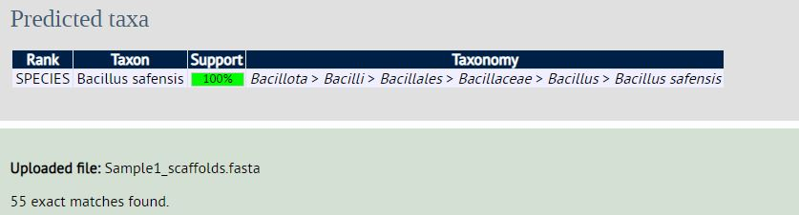
Identity obtained from PubMLST analysis. (A) PubMLST analysis of Ni7
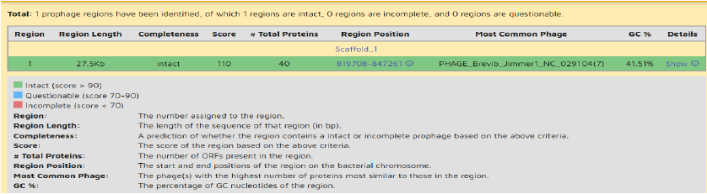
Summary of phage screening. (A) Phage screening of B. safensis Ni7

No. | Sample name | Qubit ng/ul | QC status | Volume (µL)
1 | Ni7 | 67 | Pass | 20
Table-6.1: Quality status of genomic DNA isolated from sample-1 and sample-2

 | Ni7
Contigs | 15
Bases | 3671999
CDS | 3691
rRNA | 7
tRNA | 72
tmrna | 1
No. of hypothetical proteins | 1196
No. of putative proteins | 262
Table-6.3: Gene annotation summary

SUBID BioProject BioSample Accession Organism
SUB13872675 PRJNA1026360 SAMN37738838 JAWJLN000000000 Bacillus safensis Ni7
SUB13891850 PRJNA1026496 SAMN37746240 JAWJLO000000000 Stenotrophomonas sp. C3 (2023) C3

