Ultrathin Aerogel-Structured Micro/Nanofiber Metafabric via Dual Air-Gelation Synthesis for Self-Sustainable Heating

Tian et al.

Supporting Information contains:
Supplementary Figures 1-15

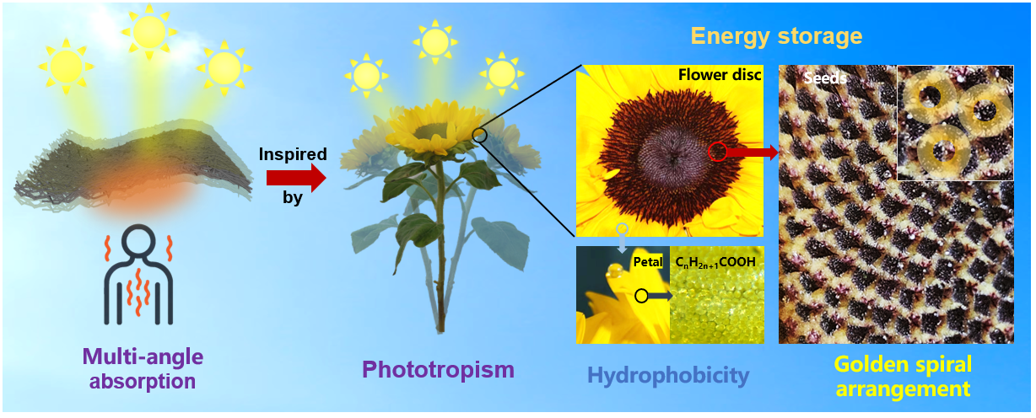
Supplementary Fig. 1 A set of optical photographs showing the natural sunflower and its solar absorption capacity.

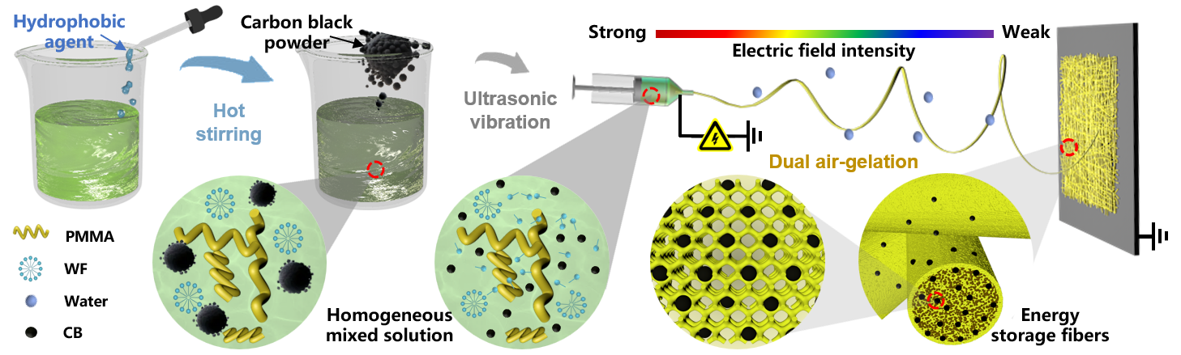
Supplementary Fig. 2 Schematic illustrating the direct synthesis process of PMMA aerogel energy storage fibers.

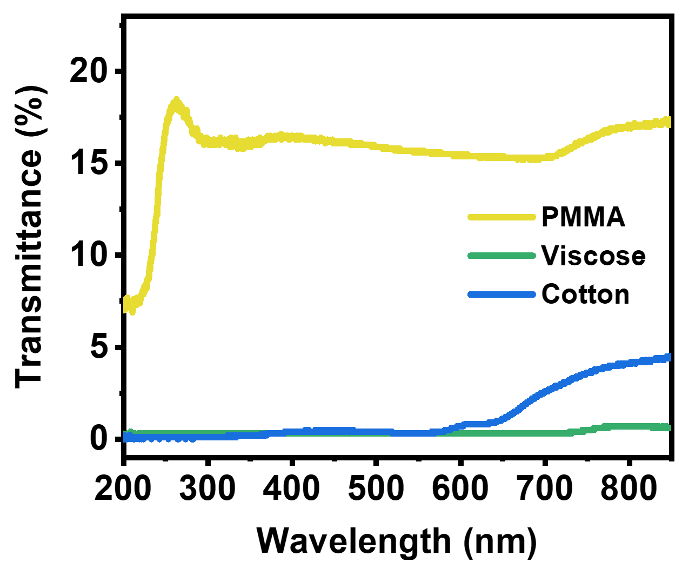
Supplementary Fig. 3 UV-visible light absorption spectra of different fibrous materials.

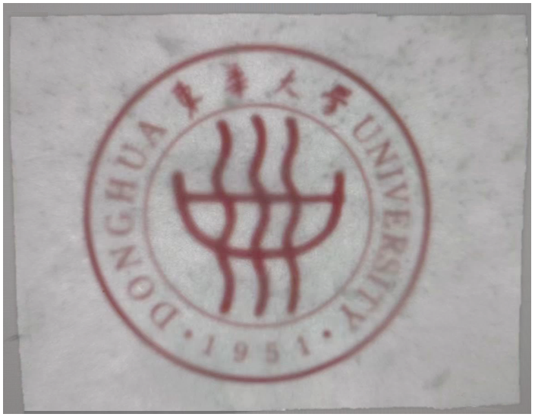
Supplementary Fig. 4 Transparent display of PMMA electrospun fibrous membrane.

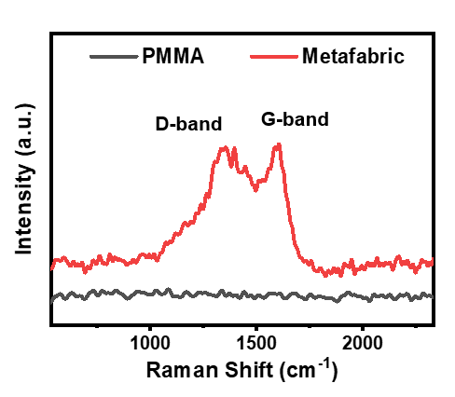
Supplementary Fig. 5 Raman spectra of PMMA AFMs before and after CB doping.

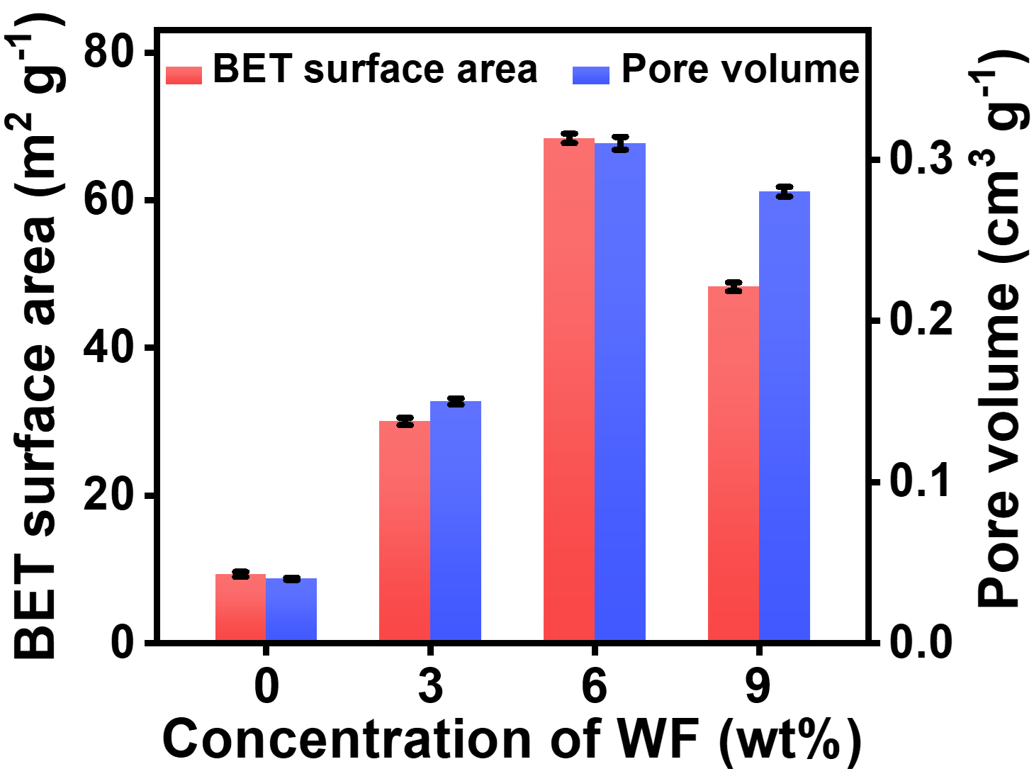
Supplementary Fig. 6 BET surface area and pore volume of the PMMA fibrous membranes with different WF concentrations.

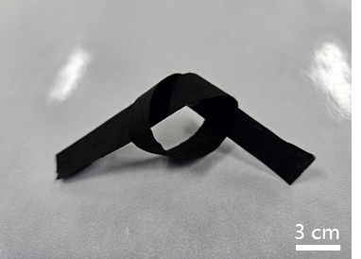
Supplementary Fig. 7 Images showing good flexibility of metafabric.

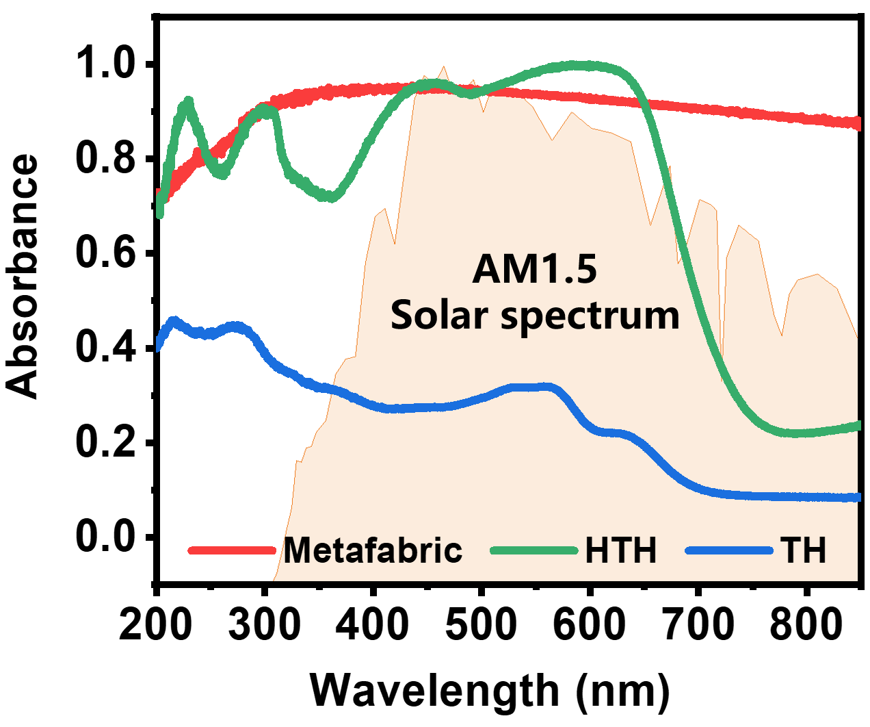
Supplementary Fig. 8 UV-visible light absorption spectra of different thermal management materials.

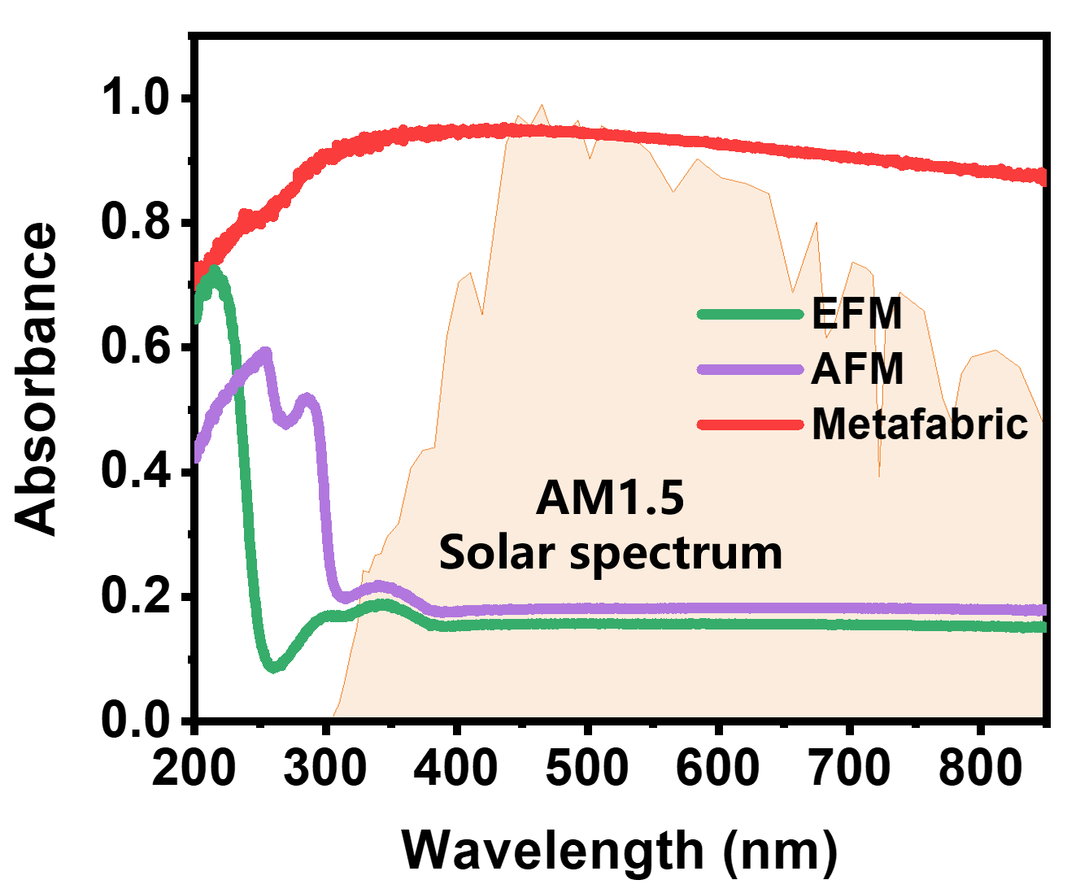
Supplementary Fig. 9 UV-visible light absorption spectra of electrospun fibrous materials with different structures.

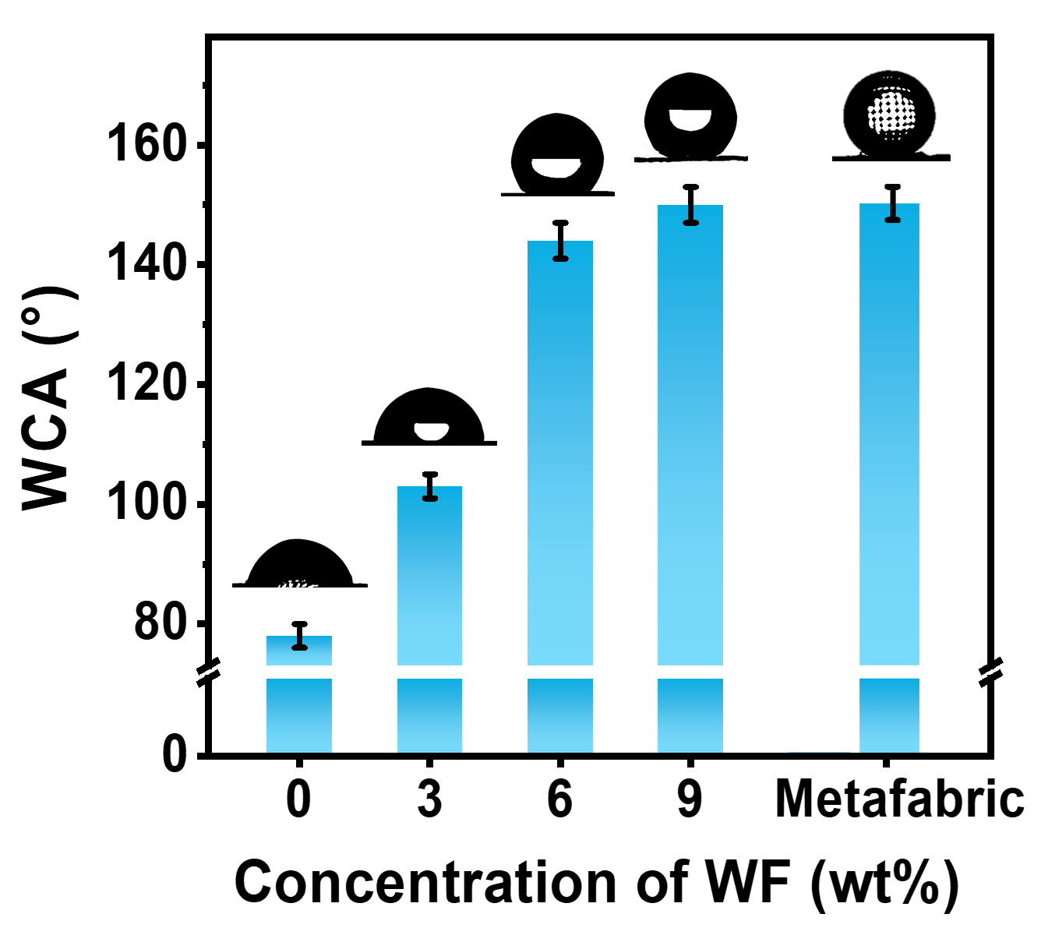
Supplementary Fig. 10 WCA of the PMMA fibrous membranes with various concentrations of WF.

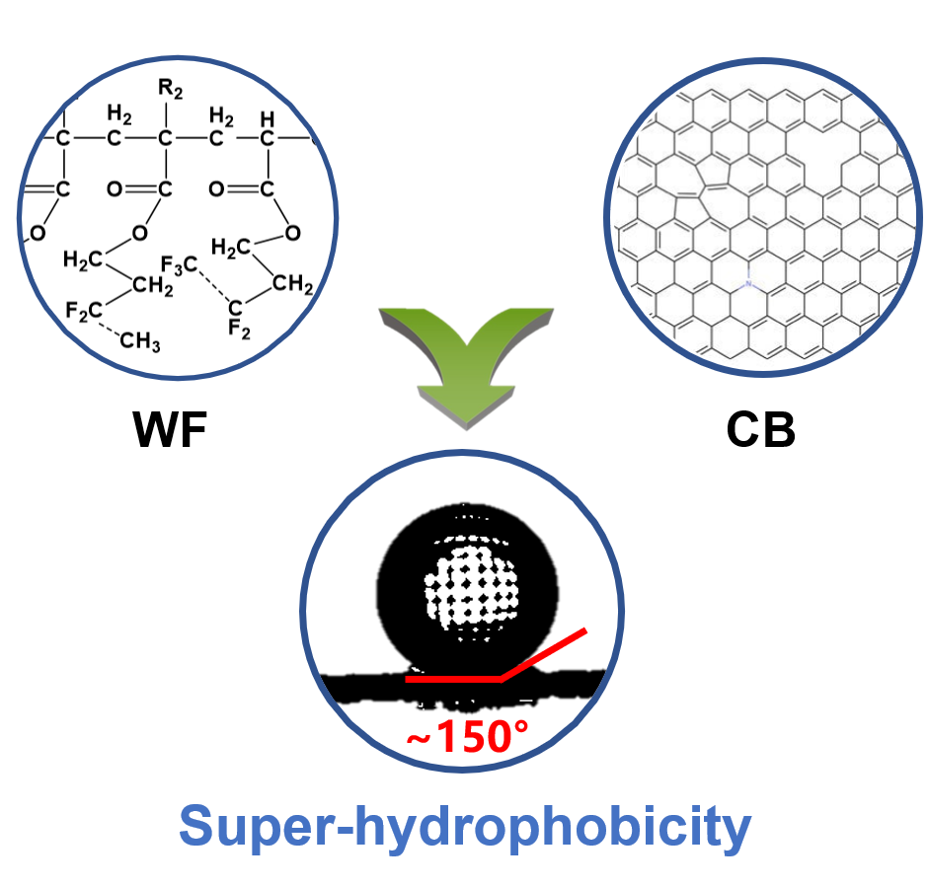
Supplementary Fig. 11 Superhydrophobicity of the metafabric.

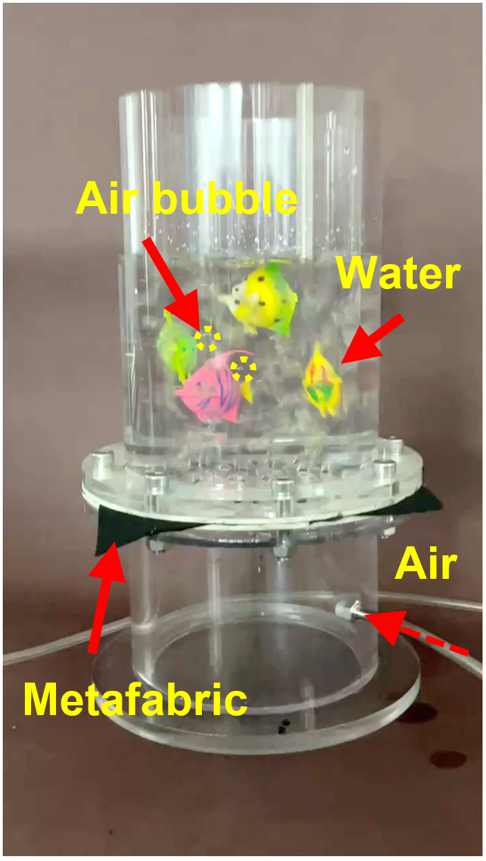
Supplementary Fig. 12 The waterproof and breathable capabilities the metafabric.

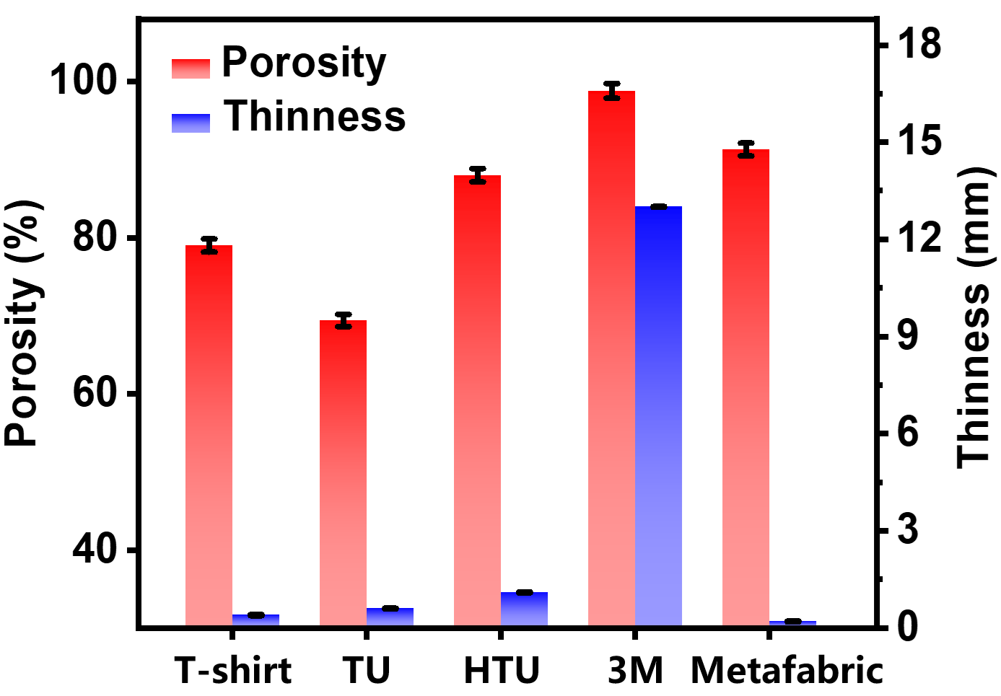
Supplementary Fig. 13 Volume density and porosity of different fibrous thermal management fabrics.

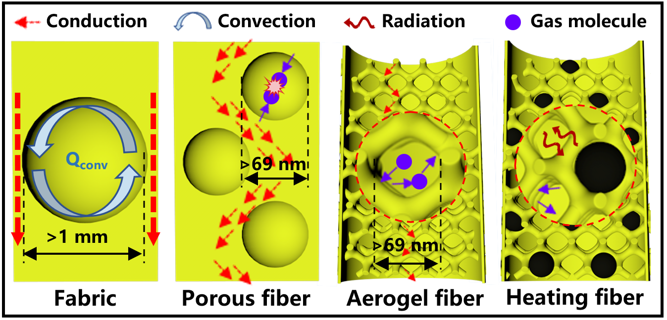
Supplementary Fig. 14 Schematic illustration showing the influence of pore size and structures on heat transport in various porous materials.

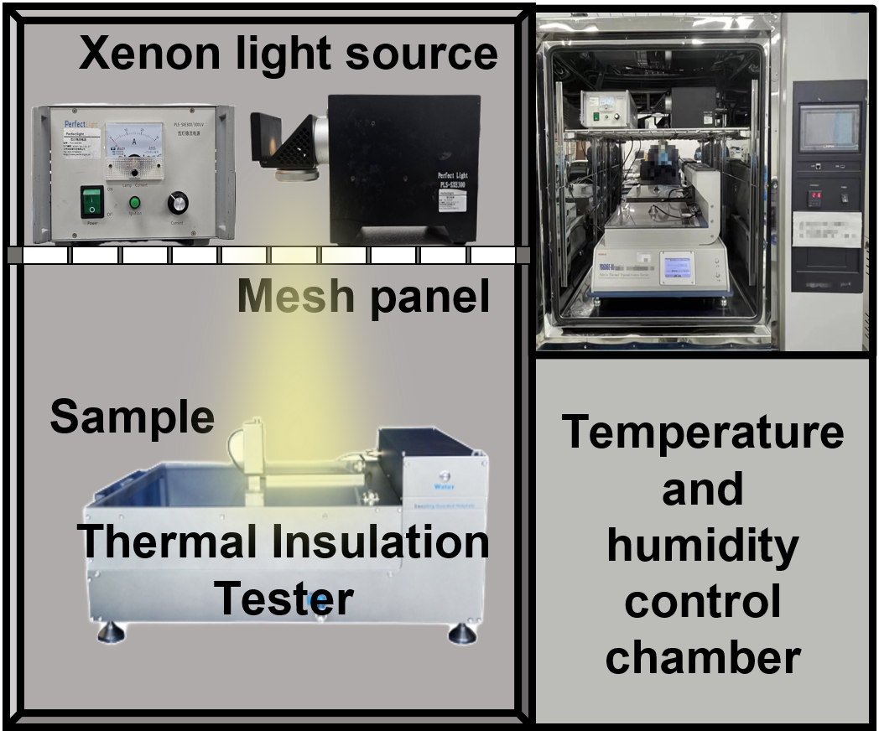
Supplementary Fig. 15 Schematic and photo of the thermal measurement system used to characterize thermal resistance.

