Supplementary Information
Directory
Table 1 - Rasch model analysis of the scale of real CT used by van Prooijen et al. (2018) 2
Table 2 - Rasch model analysis of the scale of fictional CT used by van Prooijen et al. (2018) 2
Table 3 - Rasch model analysis of the GVT12 scale 3
Table 4 - Rasch model analysis of the combined scale of real CT 4
Table 5 - Rasch model analysis of the corrected scale of real CT 5
Table 6 - Rasch model analysis of the corrected scale of fictional CT 5
Figure 1 - Graphic analyses of item responses of the real CT scale used by van Prooijen et al. (2018) 6
Figure 2 - Graphic analyses of item responses of the fictional CT scale used by van Prooijen et al. (2018) 6

Table 1
Rasch model analysis of the scale of real CT used by van Prooijen et al. (2018)
Item | β | SD | z_{DIF} | p_{DIF} | Infit_{MNSQ} | Outfit_{MNSQ}
VT-Rea_01 | 4.11 | 0.24 | -0.41 | .68 | 0.76 | 1.30
VT-Rea_02 | -0.98 | 0.32 | - | - | 0.87 | 0.57
VT-Rea_03 | 0.21 | 0.23 | -0.52 | .61 | 0.84 | 0.58
VT-Rea_04 | 1.60 | 0.20 | -1.46 | .14 | 0.83 | 0.72
VT-Rea_05 | 0.00 | 0.24 | - | - | 0.87 | 0.65
VT-Rea_06 | 1.34 | 0.20 | -0.42 | .68 | 0.94 | 0.83
VT-Rea_07 | -3.16 | 0.70 | - | - | 0.61 | 0.17
VT-Rea_08 | -2.71 | 0.59 | - | - | 0.92 | 0.19
VT-Rea_09 | -0.31 | 0.26 | 0.08 | .94 | 0.87 | 0.69
VT-Ind_01 | 0.26 | 0.23 | 3.09 | .00 | 1.06 | 1.36
VT-Ind_02 | -0.38 | 0.27 | 0.16 | .88 | 0.76 | 0.63
Note. β = item ease parameter; SD = standard deviation; z_{DIF} = standardized z-value of the Wald test; p_{DIF} = probability of observing the estimated effect size, or a more extreme value, under the assumption that the null hypothesis is true. A smaller p-value (≤ 0.05) suggests evidence in favour of the alternative hypothesis; Infit_{MNSQ} = deviation of the residuals of test persons with item and person parameter fit; Outfit_{MNSQ} = deviation of the residuals of test persons with very high/low person parameters; VT-Rea_XX = items describing real conspiracy theories used by van Prooijen et al. (2018); VT-Ind_XX = Agreement to fictional blog texts. n = 242.

Table 2
Rasch model analysis of the scale of fictional CT used by van Prooijen et al. (2018)
Item | β | SD | z_{DIF} | p_{DIF} | Infit_{MNSQ} | Outfit_{MNSQ}
VT-Fik_01 | -0.55 | 0.26 | -0.96 | .34 | 0.81 | 0.74
VT-Fik_02 | -1.87 | 0.40 | 0.09 | .93 | 0.91 | 0.78
VT-Fik_03 | -0.15 | 0.24 | -1.69 | .09 | 0.79 | 0.68
VT-Fik_04 | 1.43 | 0.20 | 0.47 | .64 | 0.91 | 0.90
VT-Fik_05 | -3.72 | 0.90 | - | - | 0.76 | 0.80
VT-Fik_06 | 1.20 | 0.20 | 0.74 | .46 | 1.01 | 1.04
VT-Fik_07 | 0.95 | 0.20 | 1.17 | .24 | 0.99 | 1.00
VT-Fik_08 | 2.97 | 0.22 | 1.87 | .06 | 0.90 | 0.84
VT-Fik_09 | -0.26 | 0.25 | 0.21 | .83 | 0.87 | 0.81
Note. β = item ease parameter; SD = standard deviation; z_{DIF} = standardized z-value of the Wald test; p_{DIF} = probability of observing the estimated effect size, or a more extreme value, under the assumption that the null hypothesis is true. A smaller p-value (≤ 0.05) suggests evidence in favour of the alternative hypothesis Infit_{MNSQ} = deviation of the residuals of test persons with item and person parameter fit; Outfit_{MNSQ} = deviation of the residuals of test persons with very high/low person parameters; VT-Fik_XX = items describing fictional conspiracy theories. n = 242.

Table 3
Rasch model analysis of the GVT12 scale
Item | β | SD | z_{DIF} | p_{DIF} | Infit_{MNSQ} | Outfit_{MNSQ}
GVT_01 | -0.95 | 0.30 | 1.47 | .14 | 1.01 | 1.14
GVT_02 | 0.29 | 0.23 | -0.63 | .53 | 0.83 | 0.79
GVT_03 | -1.65 | 0.38 | -0.39 | .70 | 0.84 | 0.56
GVT_04 | 0.27 | 0.24 | -0.97 | .34 | 1.08 | 1.04
GVT_05 | 2.02 | 0.18 | 1.79 | .07 | 1.03 | 0.99
GVT_06 | -2.09 | 0.55 | 0.06 | .96 | 0.88 | 0.53
GVT_07 | 1.86 | 0.18 | 1.51 | .13 | 1.03 | 0.99
GVT_08 | -1.00 | 0.51 | 0.79 | .43 | 0.82 | 0.90
GVT_09 | -0.32 | 0.25 | -1.47 | .14 | 0.75 | 0.48
GVT_10 | -0.61 | 0.24 | -0.60 | .55 | 0.84 | 0.75
GVT_11 | 0.79 | 0.20 | -1.61 | .11 | 0.88 | 0.75
GVT_12 | 0.83 | 0.20 | 0.04 | .97 | 1.19 | 1.31
Note. β = item ease parameter; SD = standard deviation; z_{DIF} = standardized z-value of the Wald test; p_{DIF} = probability of observing the estimated effect size, or a more extreme value, under the assumption that the null hypothesis is true. A smaller p-value (≤ 0.05) suggests evidence in favour of the alternative hypothesis; Infit_{MNSQ} = deviation of the residuals of test persons with item and person parameter fit; Outfit_{MNSQ} = deviation of the residuals of test persons with very high/low person parameters; GVT_XX = items describing real conspiracy theories. n = 242.

Table 4
Rasch model analysis of the combined scale of real CT
Item | β | SD | z_{DIF} | p_{DIF} | Infit_{MNSQ} | Outfit_{MNSQ}
VT-Rea_01 | 3.91 | 0.19 | -0.16 | .88 | 0.97 | 1.63
VT-Rea_02 | -1.05 | 0.32 | 0.41 | .68 | 1.00 | 0.84
VT-Rea_03 | 0.15 | 0.23 | -1.41 | .16 | 0.86 | 0.52
VT-Rea_04 | 1.52 | 0.17 | -2.42 | .02 | 0.93 | 0.90
VT-Rea_05 | -0.06 | 0.24 | -0.23 | .82 | 0.96 | 0.96
VT-Rea_06 | 1.26 | 0.18 | -0.70 | .48 | 1.01 | 1.01
VT-Rea_07 | -3.18 | 0.72 | 0.31 | .76 | 0.83 | 0.17
VT-Rea_08 | -2.73 | 0.60 | -0.23 | .82 | 0.78 | 0.21
VT-Rea_09 | -0.37 | 0.26 | -0.79 | .43 | 0.89 | 0.44
VT-Ind_01 | 0.20 | 0.22 | 1.49 | .14 | 1.07 | 1.47
VT-Ind_02 | -0.44 | 0.27 | -0.04 | .97 | 0.80 | 0.48
GVT_01 | -0.82 | 0.30 | 2.47 | .01 | 1.11 | 0.96
GVT_02 | 0.37 | 0.23 | 0.58 | .56 | 0.87 | 0.76
GVT_03 | -1.57 | 0.40 | 0.87 | .38 | 0.84 | 0.60
GVT_04 | 0.29 | 0.24 | -1.32 | .19 | 1.10 | 0.98
GVT_05 | 2.06 | 0.17 | 1.77 | .08 | 1.03 | 0.98
GVT_06 | -2.05 | 0.57 | 0.14 | .89 | 0.94 | 0.59
GVT_07 | 1.93 | 0.17 | 0.22 | .82 | 0.96 | 0.87
GVT_08 | -0.98 | 0.51 | -0.30 | .77 | 0.75 | 0.35
GVT_09 | -0.19 | 0.25 | -1.47 | .14 | 0.76 | 0.45
GVT_10 | -0.01 | 0.25 | -1.04 | .30 | 0.85 | 1.03
GVT_11 | 0.85 | 0.20 | -1.04 | .30 | 0.84 | 0.60
GVT_12 | 0.89 | 0.20 | 2.56 | .01 | 1.24 | 1.69
Note. β = item ease parameter; SD = standard deviation; z_{DIF} = standardized z-value of the Wald test; p_{DIF} = probability of observing the estimated effect size, or a more extreme value, under the assumption that the null hypothesis is true. A smaller p-value (≤ 0.05) suggests evidence in favour of the alternative hypothesis; Infit_{MNSQ} = deviation of the residuals of test persons with item and person parameter fit; Outfit_{MNSQ} = deviation of the residuals of test persons with very high/low person parameters; VT-Rea_XX = items describing real conspiracy theories used by van Prooijen et al. (2018); VT-Ind_XX = Agreement to fictional blog texts; GVT_XX = items describing real conspiracy theories. n = 242.

Table 5
Rasch model analysis of the corrected scale of real CT
Item | β | SD | z_{DIF} | p_{DIF} | Infit_{MNSQ} | Outfit_{MNSQ}
VT-Rea_01 | 3.97 | 0.20 | 0.30 | .76 | 0.93 | 1.96
VT-Rea_02 | -1.25 | 0.33 | 0.91 | .36 | 1.03 | 1.03
VT-Rea_03 | -0.01 | 0.23 | -1.12 | .26 | 0.82 | 0.52
VT-Rea_04 | 1.42 | 0.18 | -1.84 | .07 | 0.92 | 0.89
VT-Rea_05 | -0.23 | 0.24 | 0.01 | .99 | 0.98 | 0.93
VT-Rea_06 | 1.15 | 0.18 | -0.22 | .82 | 1.06 | 1.10
VT-Rea_08 | -3.00 | 0.61 | -0.08 | .93 | 0.85 | 0.18
VT-Rea_09 | -0.55 | 0.26 | -0.74 | .46 | 0.90 | 0.53
VT-Ind_02 | -0.62 | 0.27 | 1.17 | .24 | 0.85 | 0.63
GVT_02 | 0.22 | 0.23 | 0.99 | .32 | 0.88 | 0.91
GVT_03 | -1.80 | 0.41 | 1.33 | .18 | 0.83 | 0.86
GVT_04 | 0.12 | 0.24 | 0.04 | .97 | 1.16 | 1.09
GVT_05 | 1.98 | 0.18 | 2.20 | .03 | 1.07 | 1.05
GVT_06 | -2.25 | 0.57 | 0.57 | .57 | 0.94 | 0.80
GVT_07 | 1.86 | 0.18 | 0.98 | .33 | 0.97 | 0.89
GVT_08 | -1.15 | 0.52 | -1.00 | .32 | 0.79 | 0.46
GVT_09 | -0.37 | 0.25 | -1.42 | .15 | 0.79 | 0.55
GVT_10 | -0.20 | 0.25 | -0.40 | .69 | 0.84 | 1.06
GVT_11 | 0.70 | 0.20 | -0.21 | .83 | 0.86 | 0.61
Note. β = item ease parameter; SD = standard deviation; z_{DIF} = standardized z-value of the Wald test; p_{DIF} = probability of observing the estimated effect size, or a more extreme value, under the assumption that the null hypothesis is true. A smaller p-value (≤ 0.05) suggests evidence in favour of the alternative hypothesis; Infit_{MNSQ} = deviation of the residuals of test persons with item and person parameter fit; Outfit_{MNSQ} = deviation of the residuals of test persons with very high/low person parameters; VT-Rea_XX = items describing real conspiracy theories used by van Prooijen et al. (2018); VT-Ind_XX = Agreement to fictional blog texts; GVT_XX = items describing real conspiracy theories. n = 242.

Table 6
Rasch model analysis of the corrected scale of fictional CT
Item | β | SD | z_{DIF} | p_{DIF} | Infit_{MNSQ} | Outfit_{MNSQ}
VT-Fik_01 | -1.02 | 0.24 | -0.96 | .34 | 0.81 | 0.74
VT-Fik_02 | -2.34 | 0.38 | 0.09 | .93 | 0.91 | 0.78
VT-Fik_03 | -0.62 | 0.21 | -1.69 | .09 | 0.79 | 0.68
VT-Fik_04 | 0.97 | 0.17 | 0.47 | .64 | 0.91 | 0.90
VT-Fik_06 | 0.74 | 0.17 | 0.74 | .46 | 1.01 | 1.04
VT-Fik_07 | 0.49 | 0.17 | 1.17 | .24 | 0.99 | 1.00
VT-Fik_08 | 2.50 | 0.19 | 1.87 | .06 | 0.90 | 0.84
VT-Fik_09 | -0.72 | 0.22 | 0.21 | .83 | 0.87 | 0.81
Note. β = item ease parameter; SD = standard deviation; z_{DIF} = standardized z-value of the Wald test; p_{DIF} = probability of observing the estimated effect size, or a more extreme value, under the assumption that the null hypothesis is true. A smaller p-value (≤ 0.05) suggests evidence in favour of the alternative hypothesis; Infit_{MNSQ} = deviation of the residuals of test persons with item and person parameter fit; Outfit_{MNSQ} = deviation of the residuals of test persons with very high/low person parameters; VT-Fik_XX = items describing fictional conspiracy theories. n = 242.

Figure 1
Graphic analyses of item responses of the real CT scale used by van Prooijen et al. (2018)
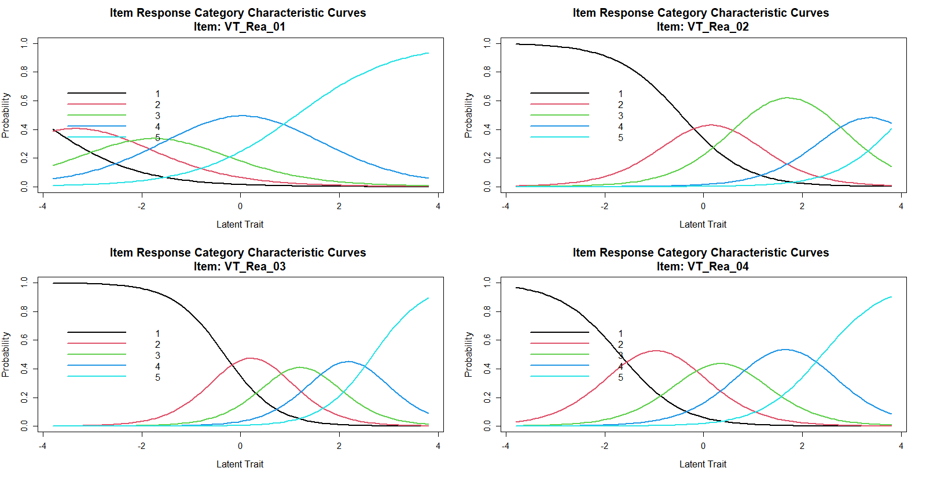
Note. Only the first four out of nine items are presented.

Figure 2
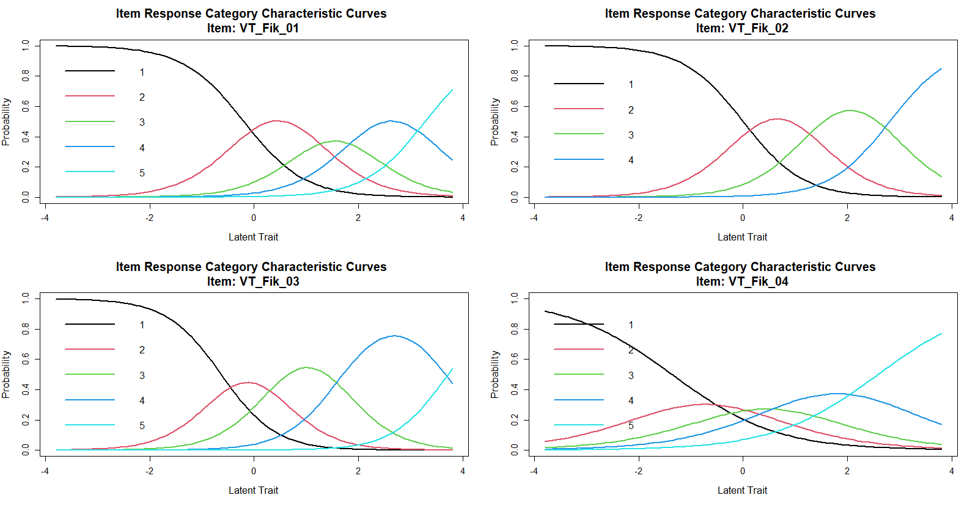
Graphic analyses of item responses of the fictional CT scale used by van Prooijen et al. (2018)
Note. Only the first four out of nine items are presented.

