Supplementary Information
SARS-CoV-2 spike glycoprotein vaccine candidate NVX-CoV2373 elicits immunogenicity in baboons and protection in mice

Authors and Affiliations:
Jing-Hui Tian^{1 #}, Nita Patel^{1 #}, Robert Haupt^{2 #}, Haixia Zhou¹, Stuart Weston², Holly Hammond², James Lague², Alyse D. Portnoff¹, James Norton¹, Mimi Guebre-Xabier¹, Bin Zhou¹, Kelsey Jacobson¹, Sonia Maciejewski¹, Rafia Khatoon¹, Malgorzata Wisniewska¹, Will Moffitt¹, Stefanie Kluepfel-Stahl¹, Betty Ekechukwu¹, James Papin³, Sarathi Boddapati⁴, C. Jason Wong⁴, Pedro A. Piedra⁵, Matthew B. Frieman², Michael J. Massare¹, Louis Fries¹, Karin Lövgren Bengtsson⁶, Linda Stertman⁶, Larry Ellingsworth¹, Gregory Glenn¹, and Gale Smith¹ *

¹Novavax, Inc. 21 Firstfield Road, Gaithersburg, MD, 20878, USA. jhtian@Novavax.com (J.H.T.), npatel@novavax.com (N.P.), hzhou@novavax.com (H.Z.), aportnoff@Novavax.com (A.D.P.), jnorton@Novavax.com (J.M), mguebre-xabier@Novavax.com (M.G.X.), bzhou@Novavax.com (B.Z.), kjacobson@Novavax.com (K.J.), SMaciejewski@Novavax.com (S.M.), rkhatoon@Novavax.com (R.K.), mwisniewska@Novavax.com (M.W.), wmoffitt@Novavax.com (W.M.), skluepfel-stahl@Novavax.com (S.K.S.), bekechukwu@Novavax.com (B.E.), MMassare@Novavax.com (M.J.M.), lfries@Novavax.com (L.F.), lellingsworth@novavax.com (L.E.), gglenn@Novavax.com (G.G.), GSmith@Novavax.com (G.S.)
²University of Maryland, School of Medicine, 685 West Baltimore St, Baltimore, MD 21201, USA. mfrieman@som.umaryland.edu. (M.B.F., R.H., S.W., H.H.)
³University of Oklahoma, Health Sciences Center, Department of Pathology, Division of Comparative Medicine, 940 Stanton L. Young, BMS 203, Oklahoma City, OK, 73104 USA. Email: james-papin@ouhsc.edu (J.P.)
⁴Catalent Paragon Gene Therapy, 801 West Baltimore Street, Baltimore, MD 21201. USA. Sboddapti@catalent.com (S.B.), Chun-Ho.Wong@catalent.com (C.J.W.)
⁵Department of Molecular Virology and Microbiology, and Pediatrics, Baylor College of Medicine, Houston, Texas. ppiedra@bcm.edu (P.A.P.)
⁶Novavax AB, Kungsgatan 109, Uppsala, SE-753 18, SE. KLövgren@Novavax.com (K.L.B.), LStertman@Novavax.com (L.S.)
*Correspondence: GSmith@Novavax.com (G.S.)
#JHT, NP, RH and each contributed equally as co-lead authors.

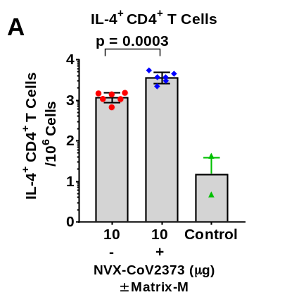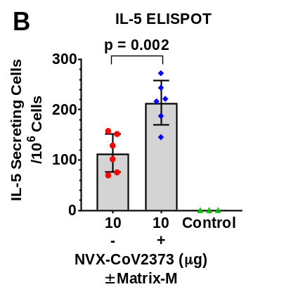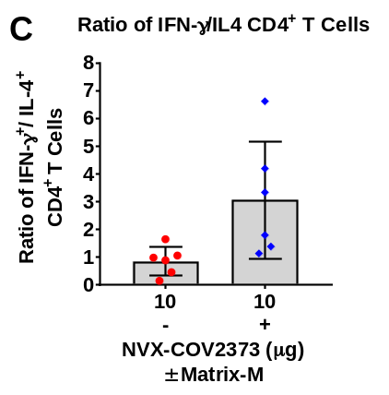
Supplementary Figure 1. Intracellular staining (ICCS) and ELISPOT detection of type 2 cytokines in immunized mice. Groups of mice were immunized with NVX-CoV2373 with and without 5 μg Matrix-M adjuvant with 2-doses spaced 21-days apart and splenocytes collected 7-days after the second immunization and stimulated with NVX-CoV2373 protein. (A) ICCS of IL-4⁺ CD4⁺ T cells. (B) IL-5-secreting splenocytes determined by ELSPOT analysis. Data show the mean ± SD. (C) Ratio of antigen-specific IFN-γ⁺ to IL-4⁺ CD4⁺ T cells in spleens of mice immunized with NVX-CoV2373 with and without Matrix-M adjuvant.

