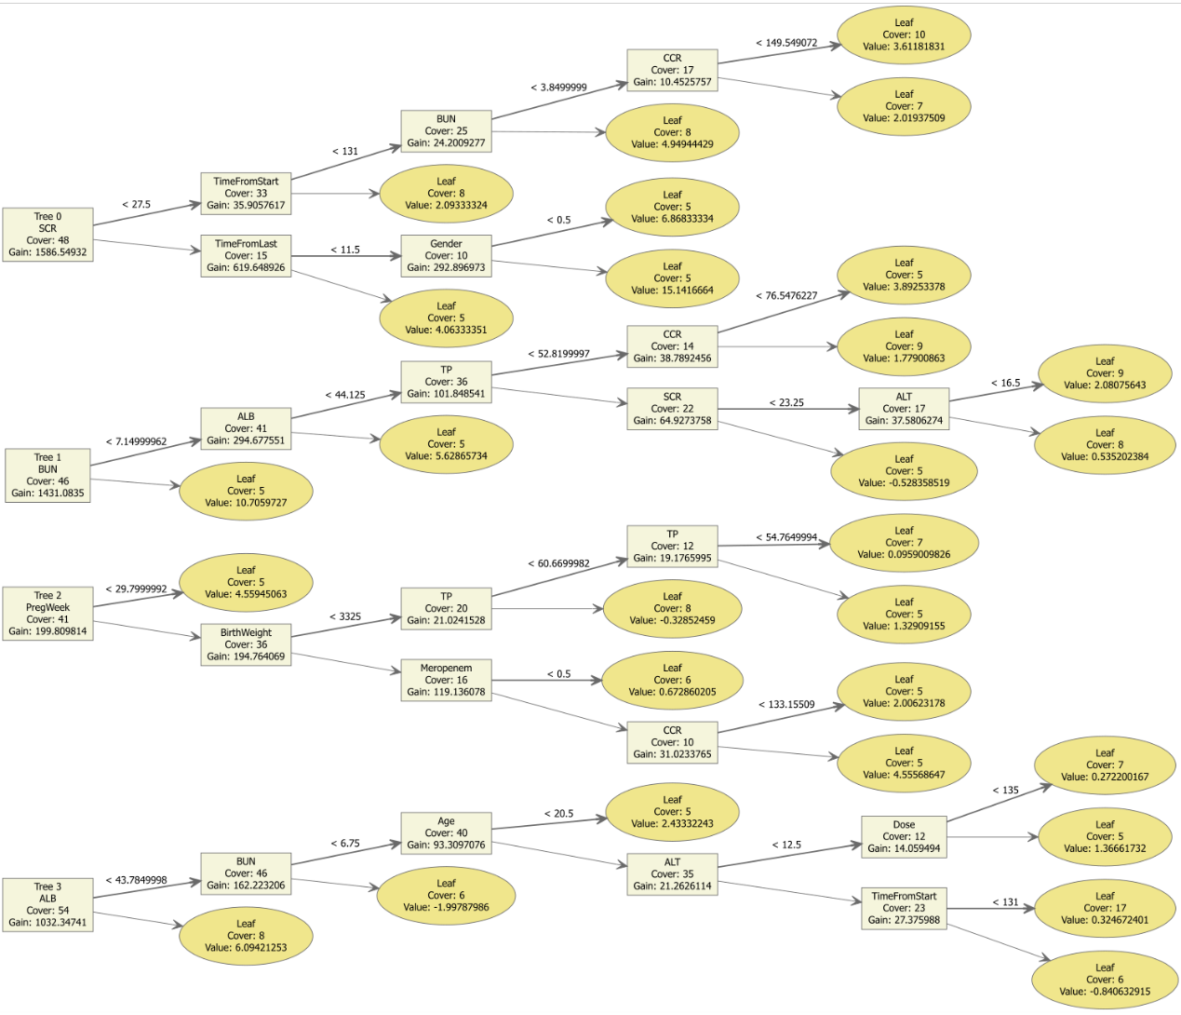
Supplemental Figure 1. Visualization of XGBoost Decision Trees
This figure presents a detailed view of the decision trees generated by the XGBoost algorithm used in our study. It illustrates the complexity and structure of the trees, showcasing how different nodes split based on selected features and their thresholds. This visualization helps in understanding the decision-making process of the XGBoost model, highlighting the paths taken for predicting vancomycin trough concentrations based on patient-specific data such as renal function indicators and other clinical parameters.

