Supplementary material
Appendix S1: Contrasting individual chamois with variable thermal landscapes
We used a hierarchical clustering analysis (HCA) based on individual home ranges’ environmental variables (i.e. % forest, % northern slopes) to identify clusters of individuals sharing similar thermal landscapes. The number of optimal categories was chosen so that differences between chamois in terms of thermal landscape were maximised, i.e. contrasting individuals that had low access to thermal refuges (category 1), access to northern slopes mostly (category 2), access to forest mostly (category 3), or access to both northern slopes and forest (category 4, Appendix S1 & S1bis).
This classification allowed us to specify appropriate values of % forest and northern slopes when testing our predictions. Based on mean values of each cluster (Table 1), we considered that a value of 2.5% for a given thermal refuge, will represent a low individual’s access to this latter, whereas a value of 15% will represent a high access. Thereby, when computing and plotting our models’ predicted values, we specified values of 2.5% forest and 2.5% northern slopes to predict the response of individuals living essentially in open areas and with low access to both thermal refuges. Inversely, we used either a combination of 2.5% forest and 15% northern slopes for predictions concerning individuals which had mostly access to northern slopes, and 15% forest and 2.5% northern slopes for individuals which had access mostly to forest. As very few individuals had access to both thermal refuges in their home range, and as we were more interested in comparing individuals with low access vs individuals with access to thermal refuges, and also in potential differences between individuals with access to forest vs access to northern slopes, we did not use a set of 15% forest and 15% northern slopes in our predictions.
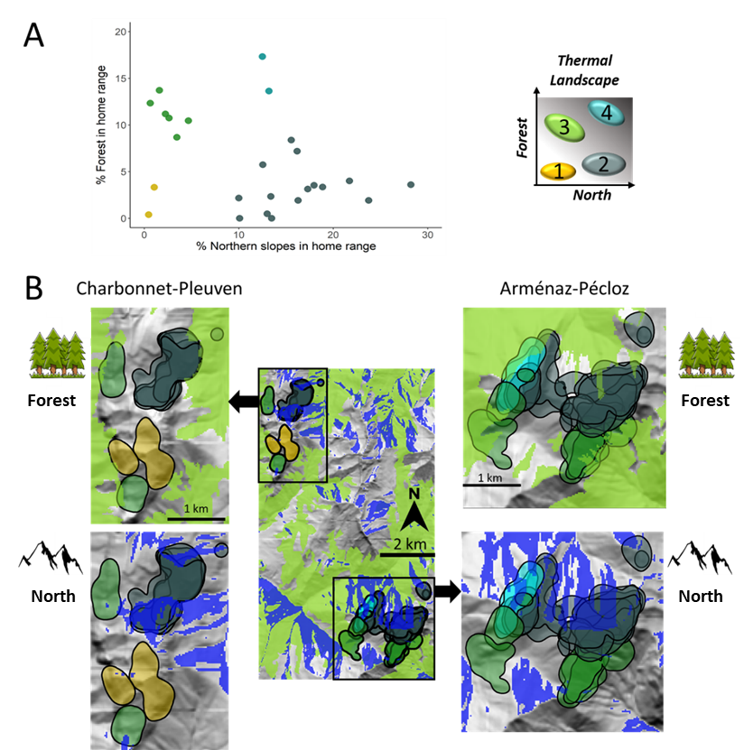
Appendix S1: A) Types of individual thermal landscapes found in the Hierarchical Clustering Analysis, and B) associated individual summer home ranges (coloured by types of thermal landscape). Green areas represent forest habitat type and blue areas represent northern slopes.
Appendix S1 bis: Means and standard deviations (SD) of categories from the hierarchical clustering analysis.
Type of thermal landscape | Number of individuals | Mean % forest [min-max] in home range | Mean % north [min-max] in home range
1: low access to forest & northern slopes | 2 | 1.9 [0.4-3.3] | 0.8 [0.5-1.1]
2: access to northern slopes mostly | 15 | 3.2 [0.0-8.4] | 16.6 [10.0-28.2]
3: access to forest mostly | 7 | 14.2 [8.7-32.6] | 2.18 [0.1-4.7]
4: access to forest & northern slopes | 2 | 15.5 [13.6-17.3] | 12.8 [12.5-13.2]
Appendix S2, S3, S4 & S5. Behavioural adjustments to increasing temperature in relation to the habitat type at each location
At the location scale, the probabilities to forage, rest or relocate varied with temperature, time of the day and the habitat type the individual was currently in (Appendix S2). The two-way interaction between temperature and time of the day was retained in the selected model.
Appendix S2: Candidate Hidden Markov Models to investigate variation in state probabilities in chamois in response to environmental covariates. The top five best ranked models and the null model are presented. The best selected model is in bold. Time of the day: the time of the location (20 min scale) modelled as a circular variable; Habitat: the habitat type under the current location, i.e. open habitat, forest or northern slopes.
Models | N.coefficients | AIC | ΔAIC
Temperature* Time of the day + Habitat | 48 | 487390.7 | 0.0
Temperature* Time of the day * Habitat | 108 | 487399.1 | 8.5
Temperature* Time of the day | 36 | 487459.8 | 69.2
Temperature + Time of the day + Habitat | 36 | 487546.0 | 155.3
Temperature + Time of the day | 24 | 487608.7 | 218.0
Temperature | 12 | 487951.5 | 560.9
Null model | 6 | 488047.5 | 656.8
Accordingly, chamois differentially adjusted their behaviour to increasing temperature depending on the time of the day, notably the probabilities to relocate or rest/ruminate and to a lesser extent, the probability to forage. When temperature increased during the hottest hours of daytime, i.e. at 12:00 UTC, chamois decreased their heat-producing activities: the probability to relocate decreased by 17% while the probability of resting increased by 15% when temperature increased from 10°C to 30°C (Appendix S3A) More importantly, when in thermal refuges, chamois were more prone to forage or relocate than in open areas whatever the temperature. For instance, for a temperature of 20°C at 12:00 UTC, the probability of foraging when an individual was in the forest was 13% higher than in open habitats and 19.0% higher than in northern slopes while the probability of relocating when in northern slopes was 6% higher than in open habitats and 9% higher than in forests (Appendix S3B).
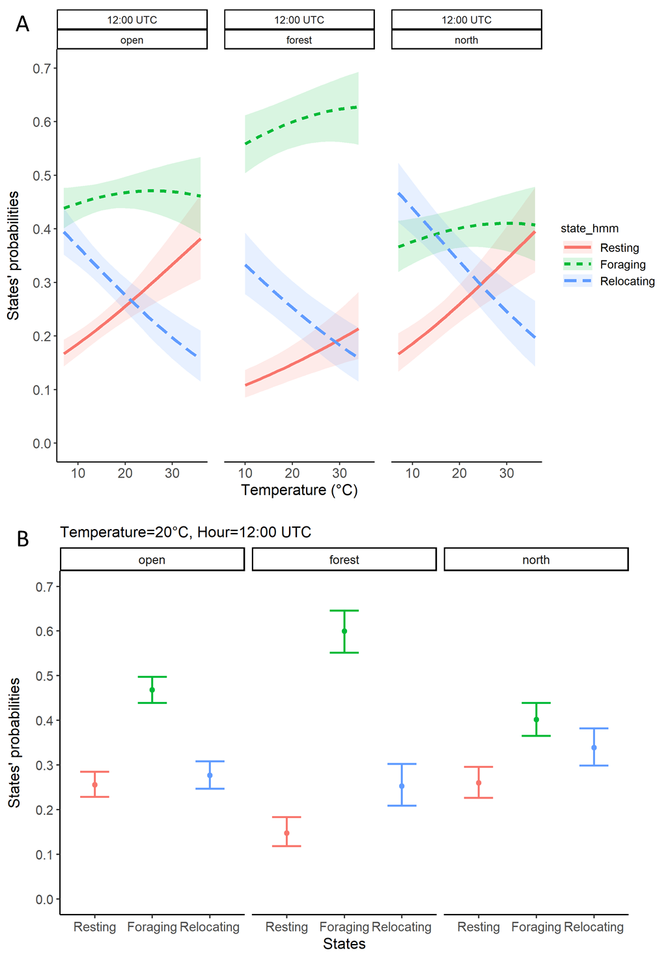
Appendix S3: Stationary state probabilities from the Hidden Markov Model as a function of (A) current study area-ambient temperature at 1810m and (B) current habitat type under each location. Ribbons and error bars correspond to the 95% CI.
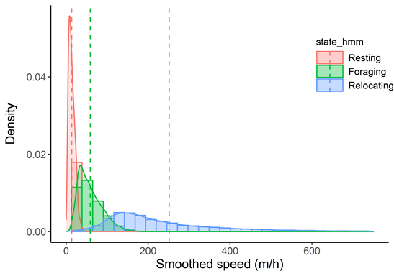
Appendix S4: Density plots of observed smoothed speed for each state specified in the Hidden Markov Model. Dashed vertical lines represent the mean smoothed speed value for each state (resting: 13.6±7.6m/h; foraging: 58.8±29.4m/h; relocating: 251.3±185.8m/h).
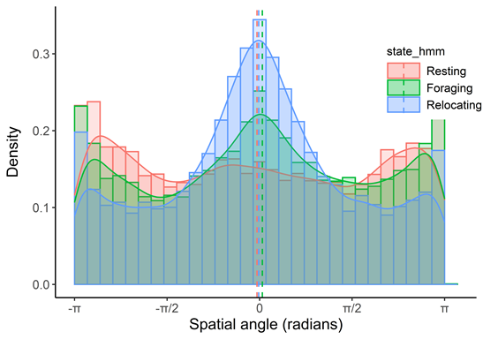
Appendix S5: Density plots of observed spatial angle for each state specified in the Hidden Markov Model. Dashed vertical lines represent the mean spatial angle value for each state (resting: -0.04±1.94; foraging: 0.05±1.84; relocating: 0.02±1.62).

Appendix S6: Summaries of the selected models of daytime and night-time habitat use. Significance codes : [0 ,0.001] : ‘***’, [0.001,0.01] : ‘**’, [0.01,0.05] : ‘*’, [0.05 ,0.1] : ‘.’
Daytime
Equation for forest vs open:
Predictors | Log(odds ratio) β | CI_{95%} | p-value
(Intercept) | -8.939578 | -10.795 — -7.084 | < 2e-16 | ***
Forest | 0.250669 | 0.141 — 0.361 | 7.81E-06 | ***
North.slop | 0.234149 | 0.136 — 0.333 | 3.08E-06 | ***
Temp | 0.197548 | 0.136 — 0.259 | 2.37E-10 | ***
Forest:Temp | 0.002933 | 0 — 0.006 | 0.0909 | .
North.slop:Temp | -0.007128 | -0.01 — -0.004 | 8.71E-07 | ***
Equation for north vs open:
Predictors | Log(odds ratio) β | CI_{95%} | p-value
(Intercept) | -6.996204 | -8.52 — -5.472 | < 2e-16 | ***
Forest | 0.089014 | -0.013 — 0.191 | 0.086231 | .
North.slop | 0.243642 | 0.162 — 0.326 | 6.08E-09 | ***
Temp | 0.122998 | 0.073 — 0.173 | 1.77E-06 | ***
Forest:Temp | -0.005975 | -0.009 — -0.003 | 0.000127 | ***
North.slop:Temp | 0.00262 | 0 — 0.005 | 0.047738 | *
Night-time
Equation for forest vs open:
Predictors | Log(odds ratio) β | CI_{95%} | p-value
(Intercept) | -7.519073 | -9.745 — -5.293 | 3.60E-11 | ***
Forest | 0.12915 | 0.004 — 0.254 | 0.04307 | *
North.slop | 0.180321 | 0.065 — 0.296 | 0.00223 | **
Temp | -0.103649 | -0.136 — -0.071 | 2.72E-10 | ***
Forest:Temp | 0.017014 | 0.015 — 0.019 | < 2e-16 | ***
Equation for north vs open:
Predictors | Log(odds ratio) β | CI_{95%} | p-value
(Intercept) | -7.796648 | -9.112 — -6.481 | < 2e-16 | ***
Forest | -0.053937 | -0.144 — 0.036 | 0.239
North.slop | 0.253278 | 0.182 — 0.324 | 2.95E-12 | ***
Temp | 0.074958 | 0.055 — 0.094 | 4.34E-14 | ***
Forest:Temp | 0.009998 | 0.006 — 0.014 | 2.23E-08 | ***

Appendix S7: Summaries of the selected models of daytime and night-time activity budget. Significance codes: [0 ,0.001] : ‘***’, [0.001,0.01] : ‘**’, [0.01,0.05] : ‘*’, [0.05 ,0.1] : ‘.’
Daytime models
Equation for MM vs LM:
Predictors | Log(odds ratio) β | CI_{95%} | p-value
(Intercept) | 0.4927245 | -0.006 — 0.992 | 0.0529 | .
Forest | -0.0398755 | -0.073 — -0.007 | 0.0184 | *
North.slop | 0.0185161 | -0.01 — 0.047 | 0.2001
Temp | 0.0238902 | -0.004 — 0.052 | 0.0977 | .
Forest:Temp | 0.0042147 | 0.002 — 0.006 | 0.0000441 | ***
North.slop:Temp | -0.0019284 | -0.004 — 0 | 0.0217 | *
Equation for HM vs LM:
Predictors | Log(odds ratio) β | CI_{95%} | p-value
(Intercept) | -0.6336 | -1.312 — 0.045 | 0.067237 | .
Forest | -0.04752 | -0.093 — -0.002 | 0.03975 | *
North.slop | 0.034 | -0.004 — 0.072 | 0.077631 | .
Temp | 0.04717 | 0.015 — 0.079 | 0.003573 | **
Forest:Temp | 0.004309 | 0.002 — 0.007 | 0.000358 | ***
North.slop:Temp | 0.00003405 | -0.002 — 0.002 | 0.969628
Night-time models
Equation for MM vs LM:
Predictors | Log(odds ratio) β | CI_{95%} | p-value
(Intercept) | -0.0909739 | -0.459 — 0.277 | 0.62822
Forest | -0.0417431 | -0.066 — -0.017 | 0.00077 | ***
North.slop | -0.0098594 | -0.031 — 0.011 | 0.35145
Temp | 0.0017304 | -0.017 — 0.02 | 0.85616
Forest:Temp | 0.0043189 | 0.003 — 0.006 | 3.72E-10 | ***
North.slop:Temp | 0.0002964 | -0.001 — 0.001 | 0.58671
Equation for HM vs LM:
Predictors | Log(odds ratio) β | CI_{95%} | p-value
(Intercept) | -1.0548533 | -1.56 — -0.55 | 4.20E-05 | ***
Forest | -0.0378194 | -0.072 — -0.004 | 0.02956 | *
North.slop | -0.0301978 | -0.058 — -0.002 | 0.03404 | *
Temp | 0.0092004 | -0.014 — 0.032 | 0.43777
Forest:Temp | 0.0027973 | 0.001 — 0.005 | 0.00245 | **
North.slop:Temp | 0.0026885 | 0.001 — 0.004 | 2.15E-05 | ***

