Supplementary information
Ascent and attachment in pea plants: a matter of iteration
Silvia Guerra^{1*}, Giovanni Bruno¹, Andrea Spoto¹, Anna Panzieri¹, Qiuran Wang¹, Bianca Bonato¹, Valentina Simonetti^{1,2}, Maria Bulgheroni² & Umberto Castiello¹

¹Department of General Psychology, University of Padova, Padova, Italy
²Ab.Acus company, Milan, Italy
*Corresponding Author: silvia.guerra@unipd.it

The file contains:
- Supplementary Figures S1 – S3
- Supplementary Table S1 – S5

Table S1 A. Mean and standard deviation for the average velocity and acceleration profile of circumnutation, distance from the origin of the plant to the center of circumnutation, and area of circumnutation concerning Experimental condition (‘Support,’ ‘No Support’) and Experimental Phase (‘PRE,’ ‘POST’).

 | Velocity | Acceleration | Distance | Area
Condition: Support  - PRE  - POST | .296 (.258)  .753 (.659) | .0023 (.0040)  .0059 (.0102) | 8.43 (7.52)  18.8 (15.2) | 26.4 (53.3)  210 (457)
Condition: No Support  - PRE  - POST | .210 (.160)  .418 (.387) | .0023 (.0028)  .0036 (.0055) | 5.21 (3.42)  10.7 (7.00) | 7.58 (17.3)  55.9 (131)

Table S1 B. Results from the lmer fitted models (Type III Wald chi-square tests) investigating the interaction between Experimental Condition (‘Support,’ ‘No Support’) and Experimental Phase (‘PRE,’ ‘POST’) for the four kinematical variables considered (scaled). Plant and Experimental Conditions were set as random intercept and random slope variables.

 | χ2 | df | Pr(>χ2) | R²
Velocity ~  (Intercept)  Condition  Phase  Phase*Condition  - Marginal R²  - Conditional R² | 9.688  8.614  730.214  52.055 | 1  1  1  1 | .001**  .003**  <.001***  <.001*** | .186  .479
Acceleration ~  (Intercept)  Condition  Phase  Phase*Condition  - Marginal R²  - Conditional R²  Distance ~  (Intercept)  Condition  Phase  Phase*Condition  - Marginal R²  - Conditional R²  Area ~  (Intercept)  Condition  Phase  Phase*Condition  - Marginal R²  - Conditional R² | 2.804  .008  109.252  9.390  18.725  20.449  478.877  35.519  11.842  17.896  235.725  42.041 | 1  1  1  1  1  1  1  1  1  1  1  1 | .093°  .099°  <.001***  .002**  <.001***  <.001***  <.001***  <.001***  <.001***  <.001***  <.001***  <.001*** | .038  .181  .175  .325  .089  .201
Note. χ² = Chi-squared test; R² = Coefficient of determination; df = Degrees of Freedom. N observations = 3117. ° = p < .100; * = p < .050; ** = p < .010; *** = p < .001.

Table S1 C. Post-hoc analysis (“emmeans” contrast) on the significant interaction effects (Experimental Condition*Experimental Phase) detected in the previous four models.

 | estimate | SE | df | Z ratio | p-value
Velocity ~  Sup PRE – Sup POST  No PRE – No POST  Sup PRE – No PRE  Sup POST – No POST | -.946  -.524  .184  .606 | .206  .049  .209  .206 | Inf  Inf  Inf  Inf | -27.022  -11.185  .881  2.935 | <.001  <.001  .814  .017
Acceleration ~  Sup PRE – Sup POST  No PRE – No POST  Sup PRE – No PRE  Sup POST – No POST  Distance ~  Sup PRE – Sup POST  No PRE – No POST  Sup PRE – No PRE  Sup POST – No POST  Area ~  Sup PRE – Sup POST  No PRE – No POST  Sup PRE – No PRE  Sup POST – No POST | -.450  -.229  .014  .233  -.862  -.470  .259  .651  -.665  -.197  .044  -512 | .142  .043  .057  .142  .039  .052  .149  .144  .043  .058  .128  .121 | Inf  Inf  Inf  Inf  Inf  Inf  Inf  Inf  Inf  Inf  Inf  Inf | -10.452  -3.991  .093  1.646  -21.883  -8.920  1.738  4.522  .  -4.230  -3.417  .346  4.230 | <.001  <.001  .999  .353  <.001  <.001  .304  .<.001  <.001  .003  .986  <.001
Note. Sup PRE = Support, PRE phase; Sup POST = Support, POST phase; No PRE = No Support, PRE phase; No POST = No Support, POST phase. SE = Standard Error, df = Degrees of Freedom.

Fig. S1 A.
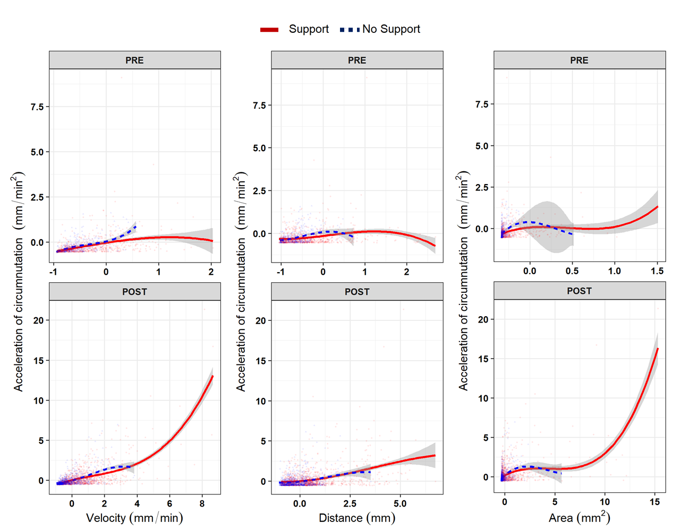
B-spline curves (degrees of freedom = 3) for the non-linear relationship across Experimental Phases (row facets) between the acceleration of circumnutation (as the scaled dependent variable, y axes) and the other three kinematic variables (column facets): the average velocity of circumnutation, distance from the origin of the plant to the center of circumnutation and area of circumnutation. Data represent the sole activity of the apex of the plant. The red solid line represents the ‘Support’ condition, and the blue dashed line represents the ‘No Support’ condition.

Fig. S1 B.
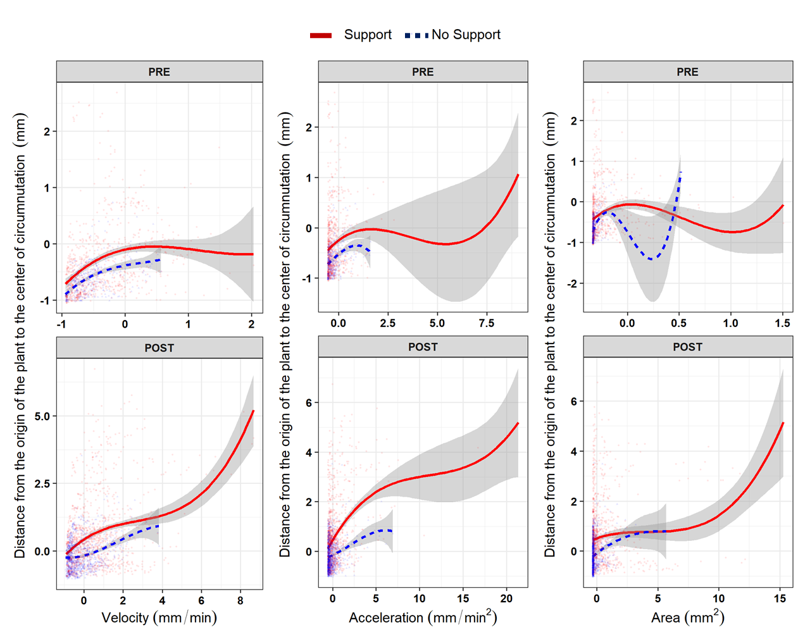
B-spline curves (degrees of freedom = 3) for the non-linear relationship across Experimental Phases (row facets) between the distance from the origin of the plant to the center of circumnutation (as the scaled dependent variable, y axes) and the other three kinematic variables (column facets): the average velocity of circumnutation, acceleration of circumnutation and area of circumnutation. Data represent the sole activity of the apex of the plant. The red solid line represents the ‘Support’ condition, and the blue dashed line represents the ‘No Support’ condition.

Fig. S1 C.
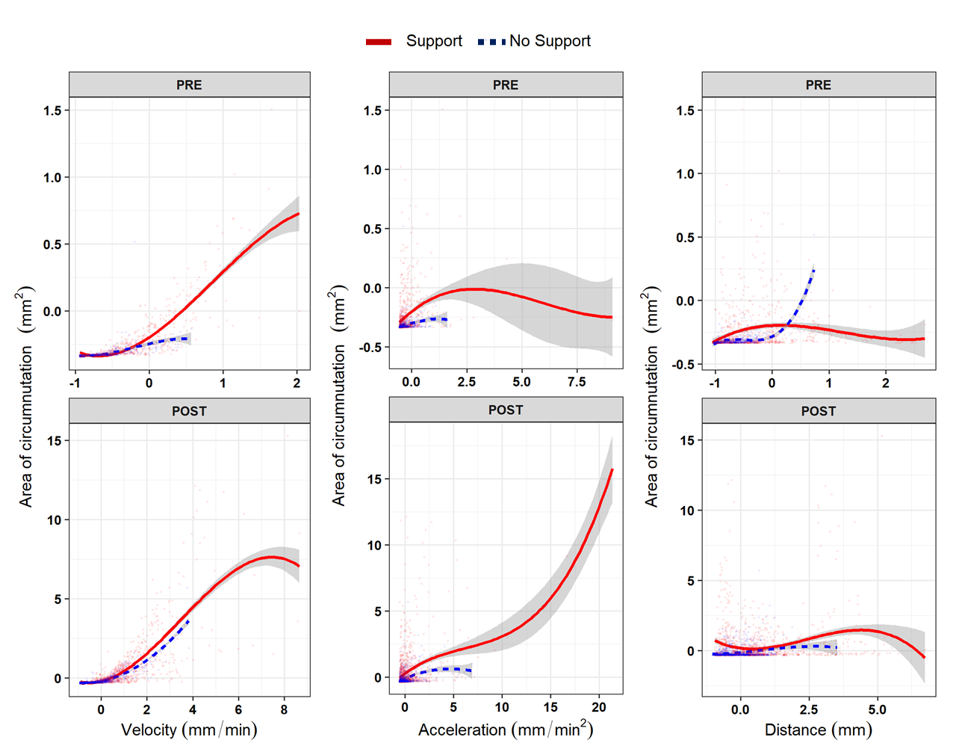
B-spline curves (degrees of freedom = 3) for the non-linear relationship across Experimental Phases (row facets) between an area of circumnutation (as the scaled dependent variable, y axes) and the other three kinematic variables (column facets): the average velocity of circumnutation, acceleration of circumnutation and distance from the origin of the plant to the center of the circumnutation. Data represent the sole activity of the apex of the plant. The red solid line defines the ‘Support’ condition, and the blue dashed line represents the ‘No Support’ condition.

Table S2 A. Results from the generative additive model setting the average velocity of circumnutation as the dependent variable (scaled) and the other three kinematic variables as smoothed terms for the interaction between Experimental Condition (‘Support,’ ‘No Support’) and Experimental Phase (‘PRE,’ ‘POST’). The plant was set as a random smoothed intercept.
Parametric coefficients | Estimate | SE | t value | Pr(>|t|)
(Intercept) | 0.506 | .025 | 20.21 | <.001***
Approximate significance  of smooth terms | edf | Ref.df | F value | p-value
s(Area): Stim PRE  s(Area): Stim POST  s(Area): No PRE  s(Area): No POST  s(Distance): Stim PRE  s(Distance): Stim POST  s(Distance): No PRE  s(Distance): No POST  s(Acceleration): Stim PRE  s(Acceleration): Stim POST  s(Acceleration): No PRE  s(Acceleration): No POST  s (ID Plant) as random effect | 4.701  8.187  2.952  6.001  2.648  1.002  2.718  3.682  3.655  7.961  1.000  2.162  22.045 | 4.919  8.679  2.992  6.304  3.282  1.003  3.114  4.490  4.361  8.625  1.001  2.681  23.00 | 227.758  633.155  36.342  291.224  3.273  219.425  1.380  8.053  11.304  68.015  20.574  31.639  43.919 | <.001***  <.001***  <.001***  <.001***  .021*  <.001***  .368  <.001***  <.001***  <.001***  <.001***  <.001***  <.001***
Adjusted R² = .898
Note. SE = Standard Error, edf = effective degrees of freedom (as an index of smoothness complexity); Ref.df = reference degrees of freedom. Sup PRE = Support, PRE phase; Sup POST = Support, POST phase; No PRE = No Support, PRE phase; No POST = No Support, POST phase. N observations = 3115. ° = p < .100; * = p < .050; ** = p < .010; *** = p < .001.

Table S2 B. Results from the generative additive model setting acceleration of circumnutation as dependent variable (scaled) and the other three kinematic variables as smoothed terms, controlling for the interaction between Experimental Condition (‘Support,’ ‘No Support’) and Experimental Phase (‘PRE,’ ‘POST’). The plant was set as a random smoothed intercept.
Parametric coefficients | Estimate | SE | t value | Pr(>|t|)
(Intercept) | .004 | .001 | 18.8 | <.001***
Approximate significance  of smooth terms | edf | Ref.df | F value | p-value
s(Area): Stim PRE  s(Area): Stim POST  s(Area): No PRE  s(Area): No POST  s(Distance): Stim PRE  s(Distance): Stim POST  s(Distance): No PRE  s(Distance): No POST  s(Speed): Stim PRE  s(Speed): Stim POST  s(Speed): No PRE  s(Speed): No POST  s (ID Plant) as random effect |  |  |  | .014*  <.001***  .040*  <.001***  .571  <.001***  .550  .230  <.001***  <.001***  <.001***  <.001***  <.001***
  2.570
  8.622
  1.002
  1.939
  1.007
  2.112
  1.004
  2.590
  1.460
  7.726
  1.003
  5.200
  14.761
  3.029
  8.952
  1.003
  2.415
  1.014
  2.653
  1.007
  3.237
  1.784
  8.560
  1.006
  6.086
  23.000
  3.524
  43.971
  4.200
  14.509
  0.323
  15.463
  0.362
  1.398
  28.687
  73.285
  24.233
  26.770
  1.906
Adjusted R² = .542
Note. SE = Standard Error, edf = effective degrees of freedom (as an index of smoothness complexity); Ref.df = reference degrees of freedom. Sup PRE = Support & PRE phase; Sup POST = Support & POST phase; No PRE = No Support & PRE phase; No POST = No Support & POST phase. N observations = 3115. ° = p < .100; * = p < .050; ** = p < .010; *** = p < .001.

Table S2 C. Results from the generative additive model setting distance from the origin of the plant to the center of circumnutation as dependent variable (scaled) and the other three kinematic variables as smoothed terms, controlling for the interaction between Experimental Condition (‘Support,’ ‘No Support’) and Experimental Phase (‘PRE,’ ‘POST’). The plant was set as a random smoothed intercept.
Parametric coefficients | Estimate | SE | t value | Pr(>|t|)
(Intercept) | 103.39 | 12.15 | 8.51 | <.001***
Approximate significance  of smooth terms | edf | Ref.df | F value | p-value
s(Speed): Stim PRE  s(Speed): Stim POST  s(Speed): No PRE  s(Speed): No POST  s(Distance): Stim PRE  s(Distance): Stim POST  s(Distance): No PRE  s(Distance): No POST  s(Acceleration): Stim PRE  s(Acceleration): Stim POST  s(Acceleration): No PRE  s(Acceleration): No POST  s (ID Plant) as random effect |  |  |  | <.001***  <.001***  .289  <.001***  <.001***  <.001***  .003**  .279  .611  <.001***  .769  .018*  <.001***
  3.699
  8.846
  1.008
  4.526
  1.003
  8.152
  2.349
  1.011
  1.497
  8.680
  1.006
  1.880
  21.728
  4.486
  8.991
  1.013
  5.430
  1.006
  8.781
  2.848
  1.022
  1.818
  8.966
  1.011
  2.339
  23.000
  28.116
  638.615
  1.131
  83.980
  22.027
  16.965
  4.914
  1.185
  0.377
  85.308
  0.093
  3.783
  17.321
Adjusted R² = .787
Note. SE = Standard Error, edf = effective degrees of freedom (as an index of smoothness complexity); Ref.df = reference degrees of freedom. Sup PRE = Support & PRE phase; Sup POST = Support & POST phase; No PRE = No Support & PRE phase; No POST = No Support & POST phase. N observations = 3115. ° = p < .100; * = p < .050; ** = p < .010; *** = p < .001.

Table S2 D. Results from the generative additive model setting area of circumnutation as dependent variable (scaled) and the other three kinematic variables as smoothed terms, controlling for the interaction between Experimental Condition (‘Support,’ ‘No Support’) and Experimental Phase (‘PRE,’ ‘POST’). The plant was set as a random smoothed intercept.
Parametric coefficients | Estimate | SE | t value | Pr(>|t|)
(Intercept) | 14.033 | 1.051 | 13.35 | <.001***
Approximate significance  of smooth terms | edf | Ref.df | F value | p-value
s(Speed): Stim PRE  s(Speed): Stim POST  s(Speed): No PRE  s(Speed): No POST  s(Area): Stim PRE  s(Area): Stim POST  s(Area): No PRE  s(Area): No POST  s(Acceleration): Stim PRE  s(Acceleration): Stim POST  s(Acceleration): No PRE  s(Acceleration): No POST  s (ID Plant) as random effect |  |  |  | <.001***  <.001***  .280  <.001***  <.001***  <.001***  .012*  .135  .822  <.001***  .789  .141  <.001***
  3.179
  6.825
  2.334
  1.776
  3.294
  8.149
  1.000
  1.684
  1.010
  5.680
  1.002
  1.004
  22.381
  3.864
  7.917
  2.906
  2.252
  3.702
  8.715
  1.001
  2.071
  1.019
  6.731
  1.004
  1.008
  23.000
  24.508
  34.495
  1.043
  11.487
  9.130
  14.546
  6.307
  1.977
  0.057
  8.425
  0.074
  2.152
  33.278
Adjusted R² = .468
Note. SE = Standard Error, edf = effective degrees of freedom (as an index of smoothness complexity); Ref.df = reference degrees of freedom. Sup PRE = Support & PRE phase; Sup POST = Support &POST phase; No PRE = No Support & PRE phase; No POST = No Support & POST phase. N observations = 3115. ° = p < .100; * = p < .050; ** = p < .010; *** = p < .001.

Table S3 A. Results from the lmer fitted models (Type III Wald chi-square tests) investigating the three-parties interaction between Experimental Condition (‘Support,’ ‘No Support’) and anatomical landmark of the plant (‘Apex,’ ‘Tendril’) throughout Leaf (‘Third last,’ ‘Second last,’ ‘Last’) for the four kinematical variables considered (scaled). The plant was set as a random intercept for each model.

 | χ2 | df | Pr(>χ2) | R²
Velocity ~  (Intercept)  Condition: Point: Leaf  - Marginal R²  - Conditional R² | 4.32  4017.53 | 1  11 | .037**  <.001*** | .323  .588
Acceleration ~  (Intercept)  Condition: Point: Leaf  - Marginal R²  - Conditional R²  Distance ~  (Intercept)  Condition: Point: Leaf  - Marginal R²  - Conditional R²  Area ~  (Intercept)  Condition: Point: Leaf  - Marginal R²  - Conditional R² | 7.12  895.68  16.84  1207.36  .051  1302.22 | 1  11  1  11  1  11 | .007*  <.001***  <.001***  <.001***  .821  <.001*** | .125  .260  .166  .320  .164  .406
Note. χ² = Chi-squared test; R²= Coefficient of determination; df = Degrees of Freedom. ° = p < .100; * = p < .050; ** = p < .010; *** = p < .001.

Fig. S2 A.
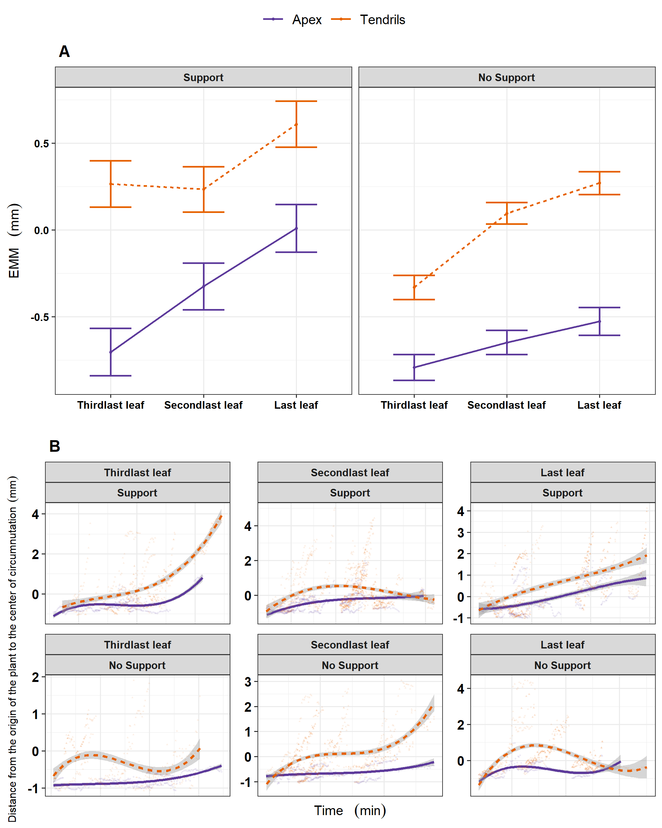
A. Graphical representation of post-hoc analysis for the interaction between Experimental Condition (‘Stimulus,’ ‘No Stimulus’), anatomical landmark of the plant (‘Apex,’ ‘Tendrils’) and Leaf (‘Third last,’ ‘Second last,’ ‘Last’) for the estimation of the distance from the origin of the plant to the center of circumnutation (scaled) in the ‘Third last,’ ‘Second last’ and ‘Last’ leaf. B. For descriptive purposes, the distribution of the same kinematical variable is represented as smoothed across the three last leaves of interest, controlling for the same experimental factors. Tendrils are represented with the orange-dashed line and the apex with the violet-solid line.
Fig. S2 B.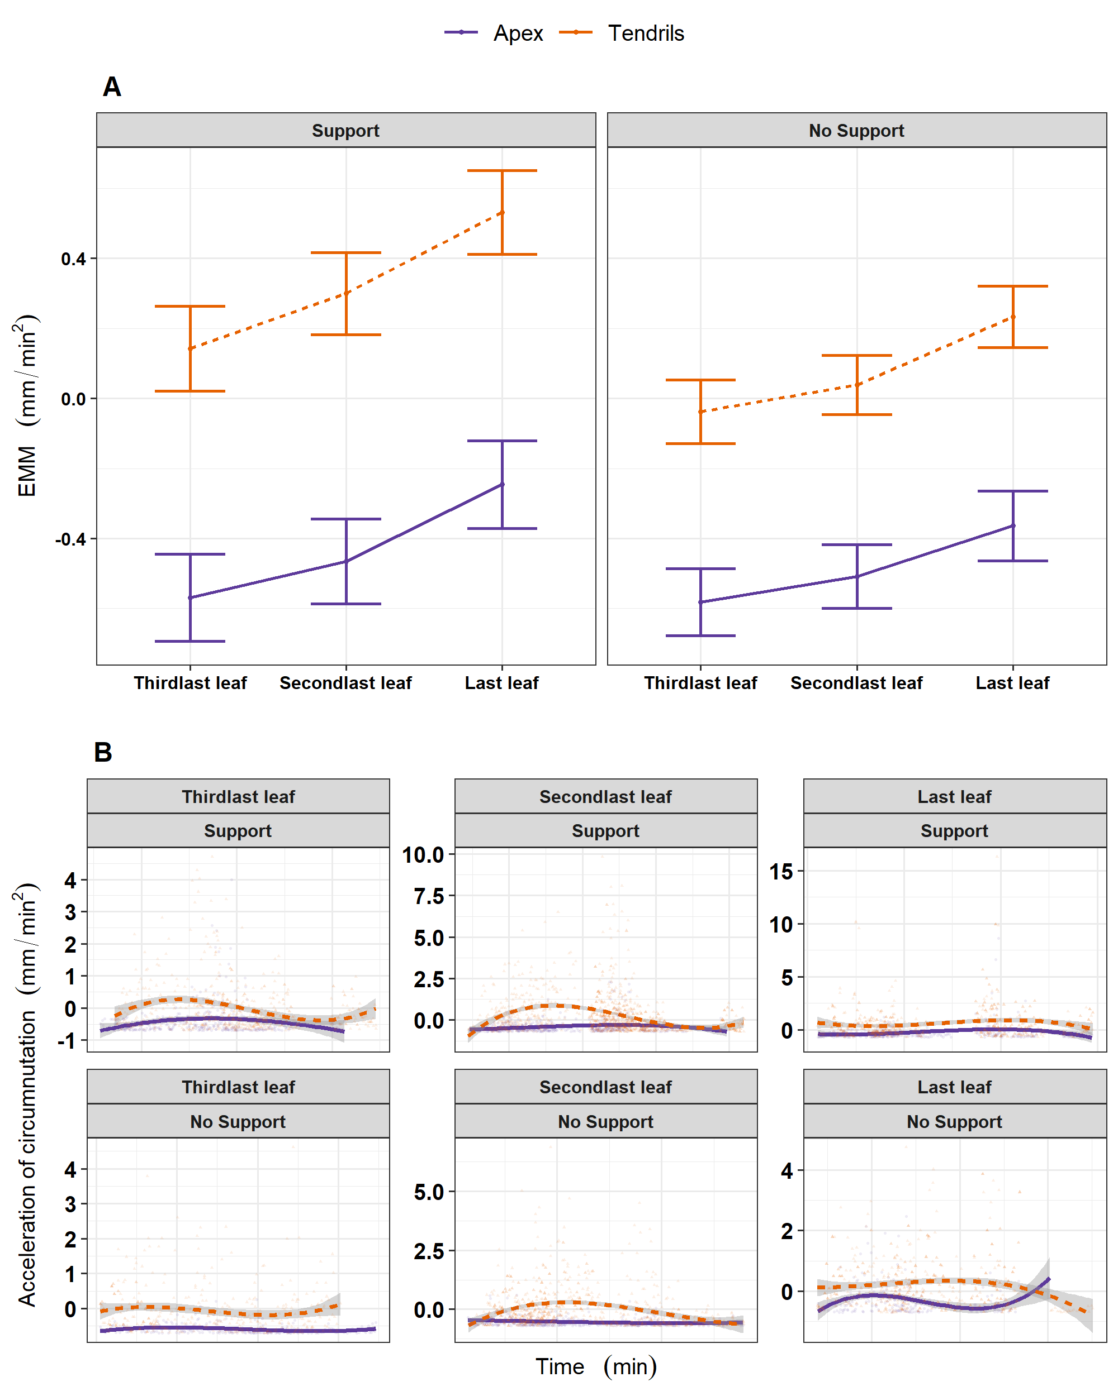
A. Graphical representation of post-hoc analysis for the interaction between Experimental Condition (‘Stimulus,’ ‘No Stimulus’), anatomical landmark of the plant (‘Apex,’ ‘Tendrils’) and Leaf (‘Third last,’ ‘Second last,’ ‘Last’) for the estimation of the acceleration of circumnutation (scaled). B. For descriptive purposes, the distribution of the same kinematical variable is represented as smoothed across the three last leaves of interest, controlling for the same experimental factors. Tendrils are represented with the orange-dashed line. The apex is represented with the violed-solid line.
Fig. S2 C.
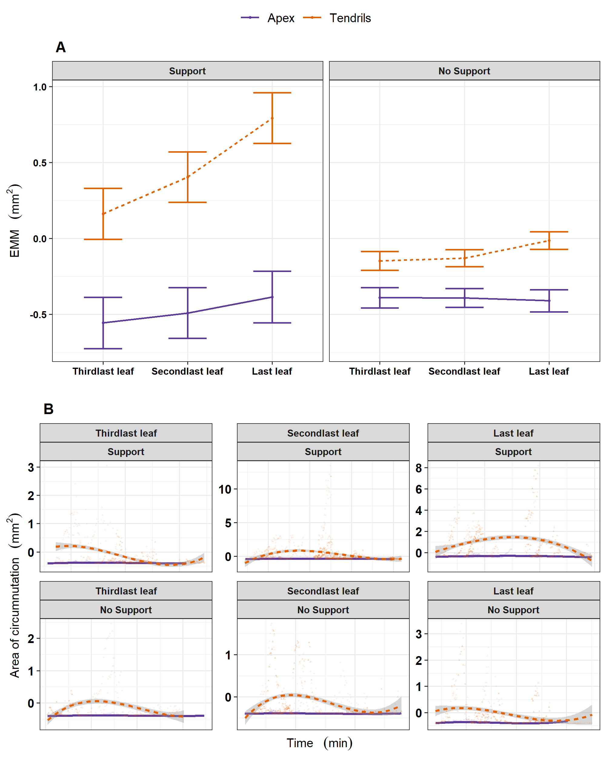
A. Graphical representation of post-hoc analysis for the interaction between Experimental Condition (‘Stimulus,’ ‘No Stimulus’), anatomical landmark of the plant (‘Apex,’ ‘Tendrils’) and Leaf (‘Third last,’ ‘Second last,’ ‘Last’) for the estimation of the area of circumnutation (scaled). B. For descriptive purposes, the distribution of the same kinematical variable is represented as smoothed across the three last leaves of interest, controlling for the same experimental factors. Tendrils are represented with the orange-dashed line and the apex with the violed-solid line.

Table S3 B. Post-hoc analysis (“emmeans” contrast) for the three-parties interaction effects of the models described in Table S3-A.

 | contrast |  |  |  |  |  |  |  |  | est | se | df | z ratio | p-value
Velocity ~
 | Sup | Apex | 3L | - | Sup | Apex | 2L |  |  | -.093 | 050 | Inf | -1.884 | 769
 | Sup | Apex | 2L | - | Sup | Apex | 1L |  |  | -.228 | .050 | Inf | -4.581 | <.001
 | Sup | Tend | 3L | - | Sup | Tend | 2L |  |  | -.255 | .036 | Inf | -7.090 | <.001
 | Sup | Tend | 2L | - | Sup | Tend | 1L |  |  | -.438 | .034 | Inf | -12.668 | <.001
 | No | Apex | 3L | - | No | Apex | 2L |  |  | -.036 | .054 | Inf | -.664 | 1.00
 | No | Apex | 2L | - | No | Apex | 1L |  |  | -.071 | .059 | Inf | -1.206 | .989
 | No | Tend | 3L | - | No | Tend | 2L |  |  | -.107 | .044 | Inf | -2.446 | .374
 | No | Tend | 2L | - | No | Tend | 1L |  |  | -.220 | .040 | Inf | -5.458 | <.001
Acceleration ~ | contrast |  |  |  |  |  |  |  |  | est | se | df | z ratio | p-value
 | Sup | Apex | 3L | - | Sup | Apex | 2L |  |  | -0.104 | 0.065 | Inf | -1.592 | 0.912
 | Sup | Apex | 2L | - | Sup | Apex | 1L |  |  | -0.220 | 0.066 | Inf | -3.349 | 0.039
 | Sup | Tend | 3L | - | Sup | Tend | 2L |  |  | -0.157 | 0.048 | Inf | -3.302 | 0.045
 | Sup | Tend | 2L | - | Sup | Tend | 1L |  |  | -0.231 | 0.046 | Inf | -5.08 | <.001
 | No | Apex | 3L | - | No | Apex | 2L |  |  | -0.074 | 0.071 | Inf | -1.035 | 0.997
 | No | Apex | 2L | - | No | Apex | 1L |  |  | -0.144 | 0.078 | Inf | -1.853 | 0.788
 | No | Tend | 3L | - | No | Tend | 2L |  |  | -0.076 | 0.058 | Inf | -1.323 | 0.976
 | No | Tend | 2L | - | No | Tend | 1L |  |  | -0.195 | 0.053 | Inf | -3.684 | 0.012
Distance ~ | contrast |  |  |  |  |  |  |  |  | est | se | df | z ratio | p-value
 | Sup | Apex | 3L | - | Sup | Apex | 2L |  |  | -0.378 | 0.063 | Inf | -6.003 | <.001
 | Sup | Apex | 2L | - | Sup | Apex | 1L |  |  | -0.335 | 0.063 | Inf | -5.318 | <.001
 | Sup | Tend | 3L | - | Sup | Tend | 2L |  |  | 0.031 | 0.046 | Inf | 0.679 | 1.000
 | Sup | Tend | 2L | - | Sup | Tend | 1L |  |  | -0.374 | 0.044 | Inf | -8.552 | <.001
 | No | Apex | 3L | - | No | Apex | 2L |  |  | -0.144 | 0.068 | Inf | -2.114 | 0.613
 | No | Apex | 2L | - | No | Apex | 1L |  |  | -0.121 | 0.075 | Inf | -1.618 | 0.903
 | No | Tend | 3L | - | No | Tend | 2L |  |  | -0.426 | 0.055 | Inf | -7.716 | <.001
 | No | Tend | 2L | - | No | Tend | 1L |  |  | -0.174 | 0.051 | Inf | -3.432 | 0.030
Area ~ | contrast |  |  |  |  |  |  |  |  | est | se | df | z ratio | p-value
 | Sup | Apex | 3L | - | Sup | Apex | 2L |  |  | -0.066 | 0.059 | Inf | -1.12 | 0.994
 | Sup | Apex | 2L | - | Sup | Apex | 1L |  |  | -0.105 | 0.059 | Inf | -1.78 | 0.829
 | Sup | Tend | 3L | - | Sup | Tend | 2L |  |  | -0.241 | 0.043 | Inf | -5.652 | <.001
 | Sup | Tend | 2L | - | Sup | Tend | 1L |  |  | -0.388 | 0.041 | Inf | -9.48 | <.001
 | No | Apex | 3L | - | No | Apex | 2L |  |  | 0.002 | 0.064 | Inf | 0.03 | 1.000
 | No | Apex | 2L | - | No | Apex | 1L |  |  | 0.018 | 0.070 | Inf | 0.263 | 1.000
 | No | Tend | 3L | - | No | Tend | 2L |  |  | -0.017 | 0.052 | Inf | -0.336 | 1.000
 | No | Tend | 2L | - | No | Tend | 1L |  |  | -0.117 | 0.047 | Inf | -2.468 | 0.360
Note. Sup = Support, No = No Support; Apex = Apex; Tend = Tendril; 3L = Third last Leaf; 2L = Second last Leaf; 1L = Last Leaf. se = Standard Error, df = Degrees of Freedom.

Table S4 A. Mean, standard deviation, and range (min, max) for the total number of circumnutations and switches across the three last leaves developed concerning Experimental Condition.

 | Mean (SD) | Min | Max
Circumnutations (Support)  - Third last leaf  - Second last leaf  - Last leaf | 33 (10.6)  34.1 (10.7)  19.2 (11.6) | 10  6  5 | 51  61  64
Circumnutations (No Support)  - Third last leaf  - Second last leaf  - Last leaf  Switches (Support)  - Third last leaf  - Second last leaf  - Last leaf  Switches (No support)  - Third last leaf  - Second last leaf  - Last leaf | 42.8 (12.1)  48.1 (12.6)  34.8 (14.1)  4.40 (2.90)  2.79 (1.99)  1.38 (1.30)  5.37 (4.05)  6.12 (6.12)  4.31 (2.85) | 11  23  1  0  0  0  0  1  0 | 70  67  59  9  7  4  16  11  9

Table S4 B. Results from the lmer fitted models (Type III Wald chi-square tests) investigating the interaction between Experimental Condition (‘Support,’ ‘No Support’) and Leaf (‘Third last,’ ‘Second last,’ ‘Last’) for the number of switch direction of circumnutations (‘Clockwise’ and ‘Counterclockwise’). The plant was set as a random intercept for the two models.

 | χ2 | df | Pr(>χ2) | R²
Circumnutations ~  (Intercept)  Condition  Leaf  Condition*Leaf  - Marginal R²  - Conditional R²  Switches ~  (Intercept)  Condition  Leaf  Direction  Condition*Leaf  Condition*Direction  Leaf *Direction  Condition*Leaf *Direction  - Marginal delta R²  - Conditional delta R² | 275.958  3.587  191.105  11.335  172.130  1.569  32.173  0.001  13.225  0.058  0.664  0.340 | 1  2  2  2  1  1  2  1  2  1  2  2 | <.001***  .058°  <.001***  .003**  < .001***  .210  < .001***  .970  .001**  .809  .717  .844 | .373  .609  .451  .513
Note. χ² = chi-squared test; R²= Coefficient of determination; df: degree of freedom; ° = p < .100; * = p < .050; ** = p < .010; *** = p < .001.

Table S4 C. Post-hoc analysis (“emmeans” contrast) for the significant interaction effects (Experimental Condition*Leaf) detected on the two models described in Table S4-A and Table S4-B.

 | estimate | SE | df | Z ratio | p-value
Circumnutations ~  Sup 3L – Sup 2L  Sup 2L – Sup 1L  Sup 3L – Sup 1L  No 3L – No 2L  No 2L – No 1L  No 3L – No 1L  Sup 3L – No 3L  Sup 2L – No 2L  Sup 1L – No 1L | 1.589  15.727  17.316  8.689  28.349  8.983  -7.100  -12.622  -15.433 | 1.45  1.270  1.53  3.65  3.54  1.97  3.75  3.53  3.61 | 455.4  452.7  459.5  30.5  27.0  451.7  33.7  26.6  29.1 | 1.098  7.173  11.310  2.378  8.005  4.563  -1.894  -3.577  -4.277 | .882  <.001  <.001  .195  <.001  <.001  .423  .015  .002
Switches ~  Sup 3L – Sup 2L  Sup 2L – Sup 1L  Sup 3L – Sup 1L  No 3L – No 2L  No 2L – No 1L  No 3L – No 1L  Sup 3L – No 3L  Sup 2L – No 2L  Sup 1L – No 1L | .450  .682  1.132  -.188  1.531  1.344  -.211  -.849  -1.095 | .080  .098  .103  .084  .136  .143  .133  .121  .143 | Inf  Inf  Inf  Inf  Inf  Inf  Inf  Inf  Inf | 5.647  6.943  10.956  -2.244  11.278  9.356  -1.584  -6.993  -7.621 | <.001  <.001  <.001  .218  <.001  <.001  .609  <.001  <.001
Note. Sup = Support, No = No Support, 3L = Third last Leaf; 2L = Second last Leaf; 1L = Last Leaf. se = Standard Error, df = Degrees of Freedom.
Fig, S3.

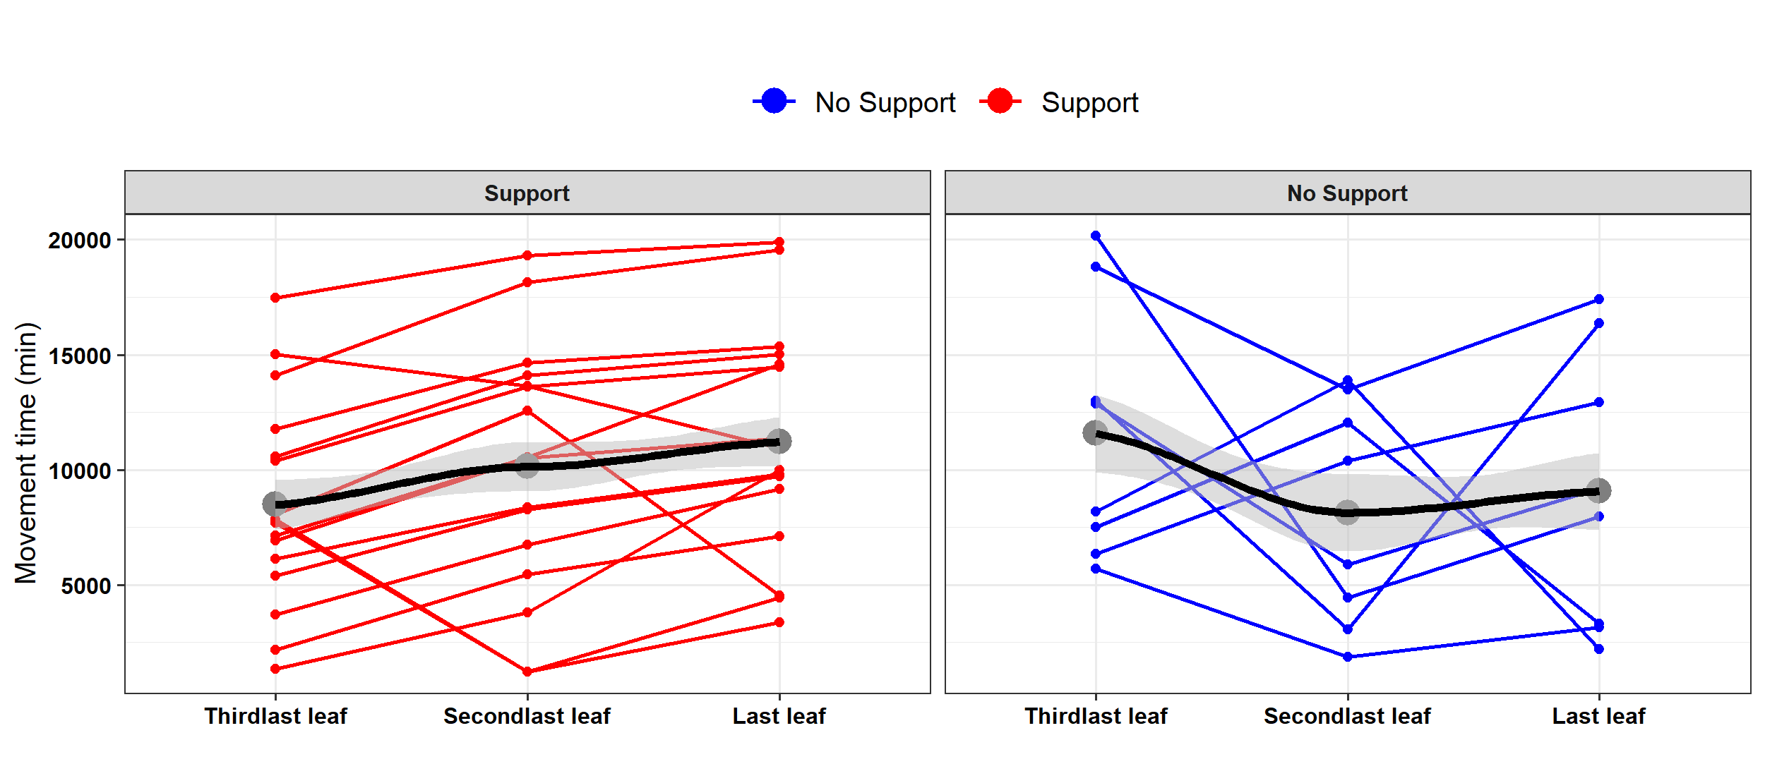
Graphical representation for the variation of the movement time across the last three leaves developed (in columns) per each Experimental Condition (in facets, ‘Support’ and ‘No support’), controlling for individual plants (by line). Per each condition, the black dots represent the mean movement time for each leaf, with the black continuous line representing the mean smoothed variation across leaves. Plants for the ‘Support’ condition are represented with red-solid lines, while those for the ‘No Support’ condition have blue-solid lines.

Table S5 A. Mean, standard deviation, and range (min, max) concerning movement time (min) of leaves, controlling for Experimental Condition (‘Support,’ ‘No Support’) and Leaf (‘Third last,’ ‘Second last,’ ‘Last’).

 | Mean (SD) | Min | Max
Condition: Support  - Third last leaf  - Second last leaf  - Last leaf | 8481.7 (4528.2)  10132.5 (5501.9)  11208 (5016.2) | 1359  1218  3369 | 17466  19299  19902
Condition: No Support  - Third last leaf  - Second last leaf  - Last leaf | 11578.5 (5601.5)  8135.2 (4872.1) 9063 (6029.5) | 5706  1860  2193 | 20169  13884  17412
Note. One day (24h) = 1440 mins, and ten days (240h) = 14400 mins.

Table S5 B. Results from the lmer fitted models (Type III Wald chi-square tests) investigating the interaction between Experimental Condition (‘Support,’ ‘No Support’) and Leaf (‘Third last,’ ‘Second last,’ ‘Last’) for the movement time. The plant was set as a random intercept of the model.

 | χ2 | df | Pr(>χ2) | R²
Leaf movement time ~  (Intercept)  Leaf  Condition  Leaf *Condition  - Marginal R²  - Conditional R² | 24.37  4.054  0.910  7.584 | 1  2  1  1 | <.001***  .131  .168  .022* | .056  .561
Note. χ² = chi-squared test; R²= Coefficient of determination; df: degree of freedom; ° = p < .100; * = p < .050; ** = p < .010; *** = p < .001.

