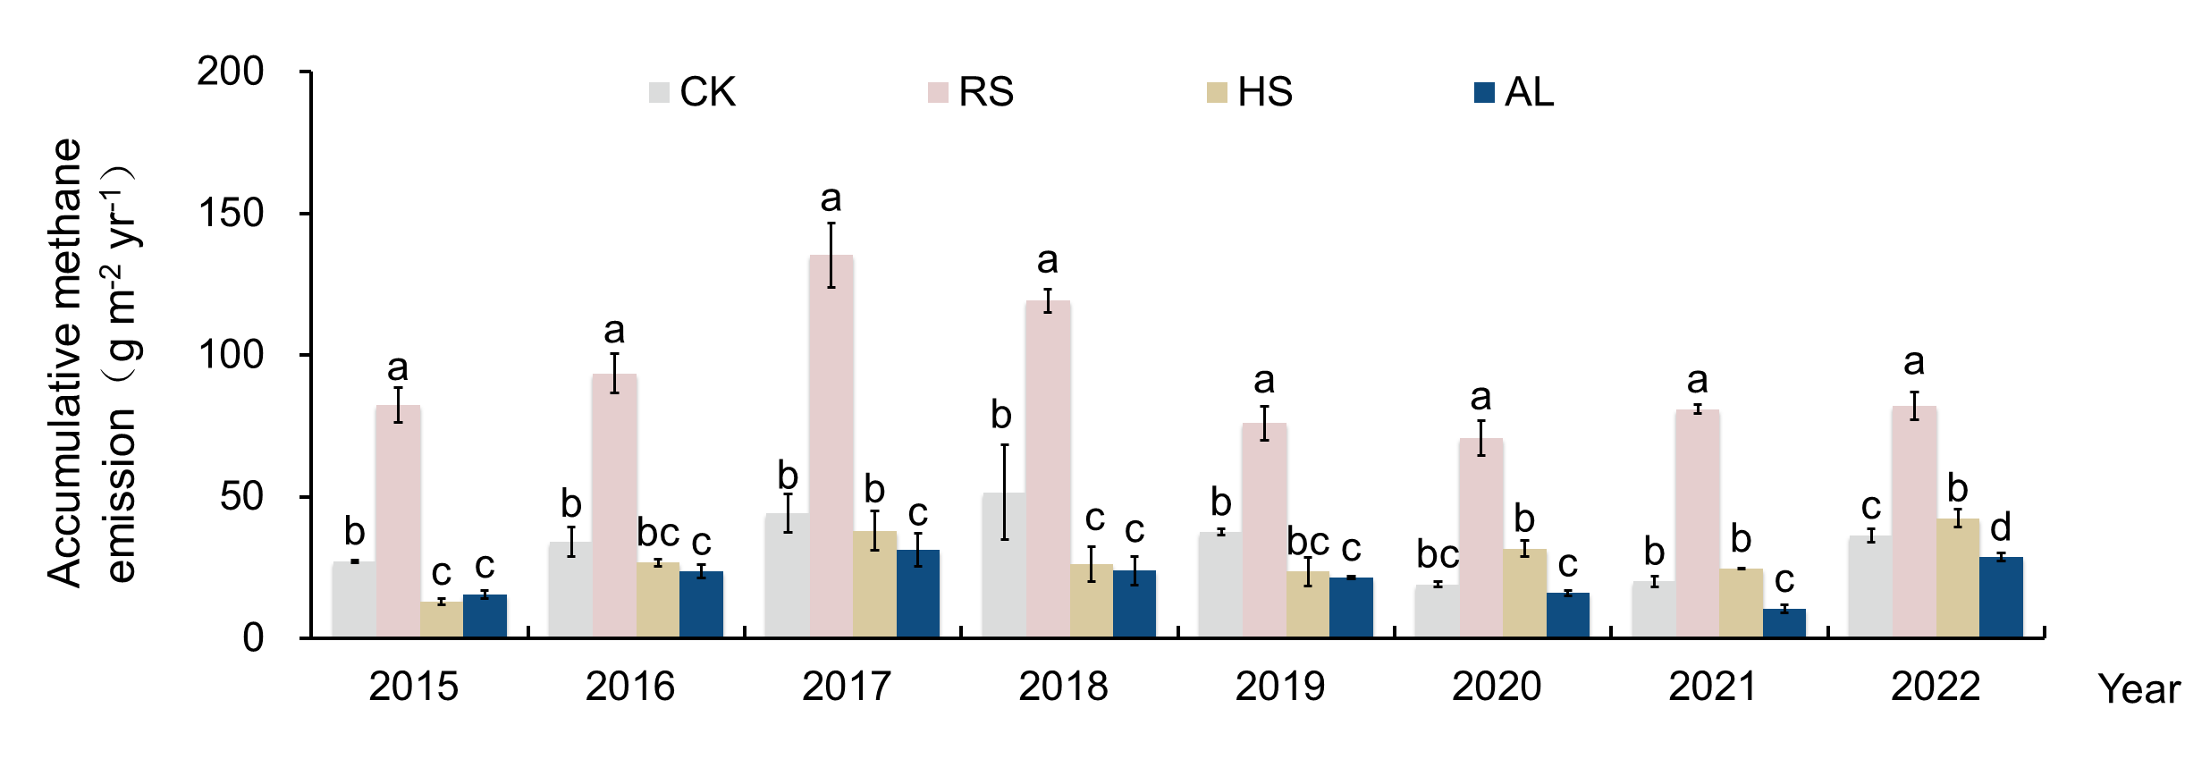
Extended Data Fig. 1 | Cumulative CH₄ emission over 7 years with different amendment strategies. Different letters above the bar present the significant differences among treatment for each year.

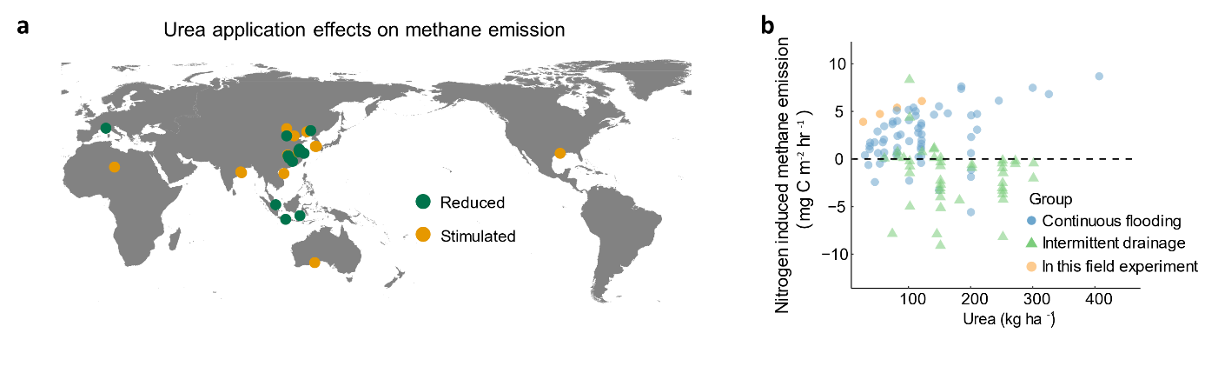
Extended Data Fig. 2 | The effect of urea application on CH₄ emissions in paddy field (a) and its decisive factors (b). The data collected from the long-term field experiment and Banger et al. The reference was listed in the supplementary information.

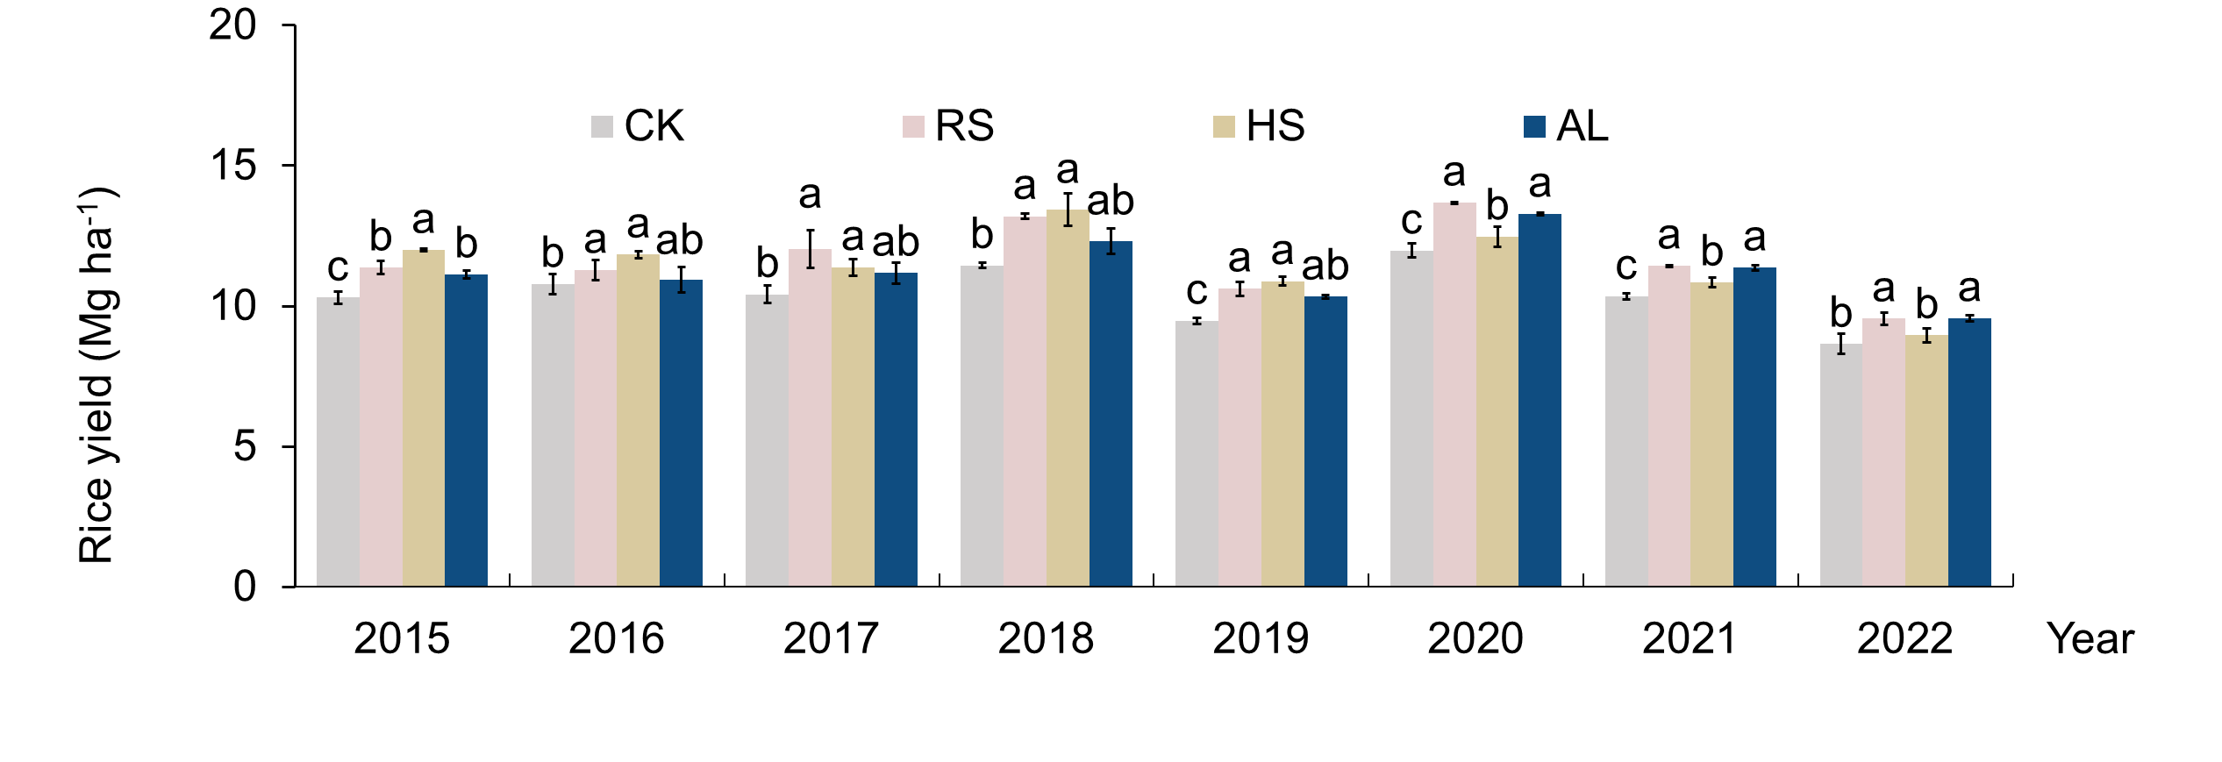
Extended Data Fig. 3 | Rice yield with rice straw and biochar amendments over 8 years. CK, control treatment, no rice straw, and biochar incorporation. RS, rice straw application at 8 Mg ha⁻¹ annually; HS, rice straw biochar application at 22.5 Mg ha⁻¹ only in the first year; AL, rice straw biochar application at 2.8 Mg ha⁻¹ annually. The letters above bars denote significant differences (p ≤ 0.05) between different treatments for each year. The bars show standard error. Mean ± S.E is represented.

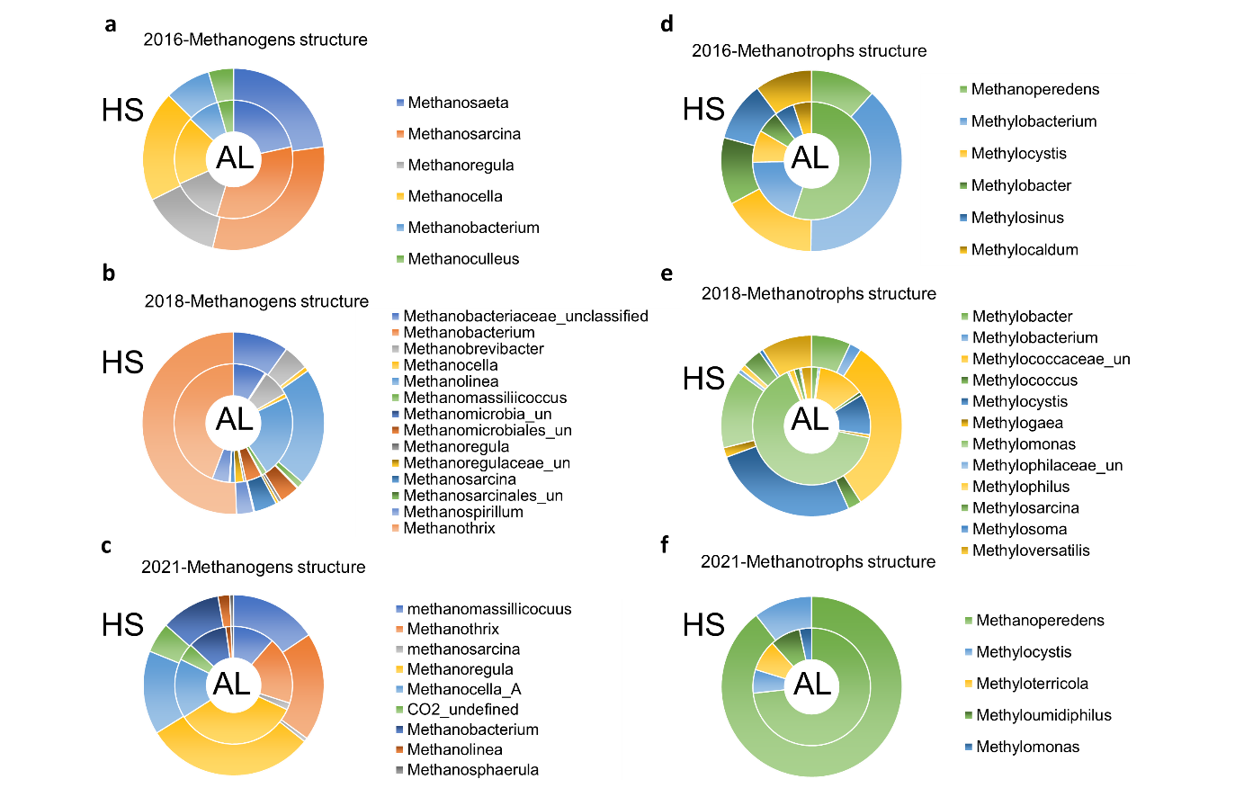
Extended Data Fig. 4 | Methanogens (a-c) and methanotrophs community structure (d-f) variation between AL and HS, observed from years of 2016, 2018, and 2021. The methanogens and methanotrophs abundance were obtained from 16s RNA sequencing (V34 for methanogens and V45 for methanotrophs) in 2016 and 2018, from metagenome sequencing in 2021. Sampling methods was noted in the supplementary information.

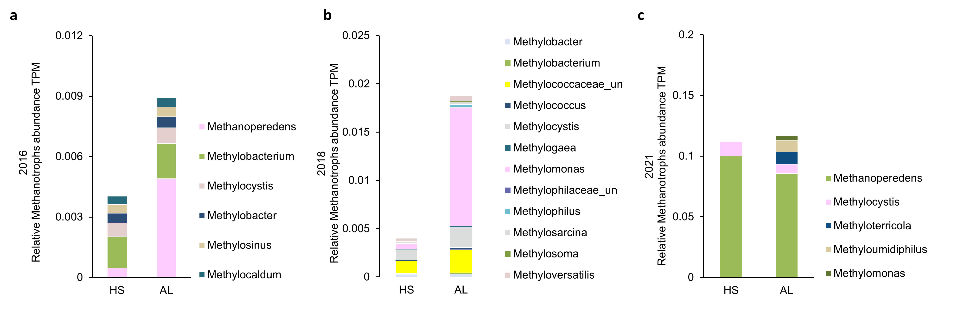
Extended Data Fig. 5 | The relative methanotrophs abundance of between AL and HS, observed from years of 2016 (a), 2018 (b), and 2021 (c).

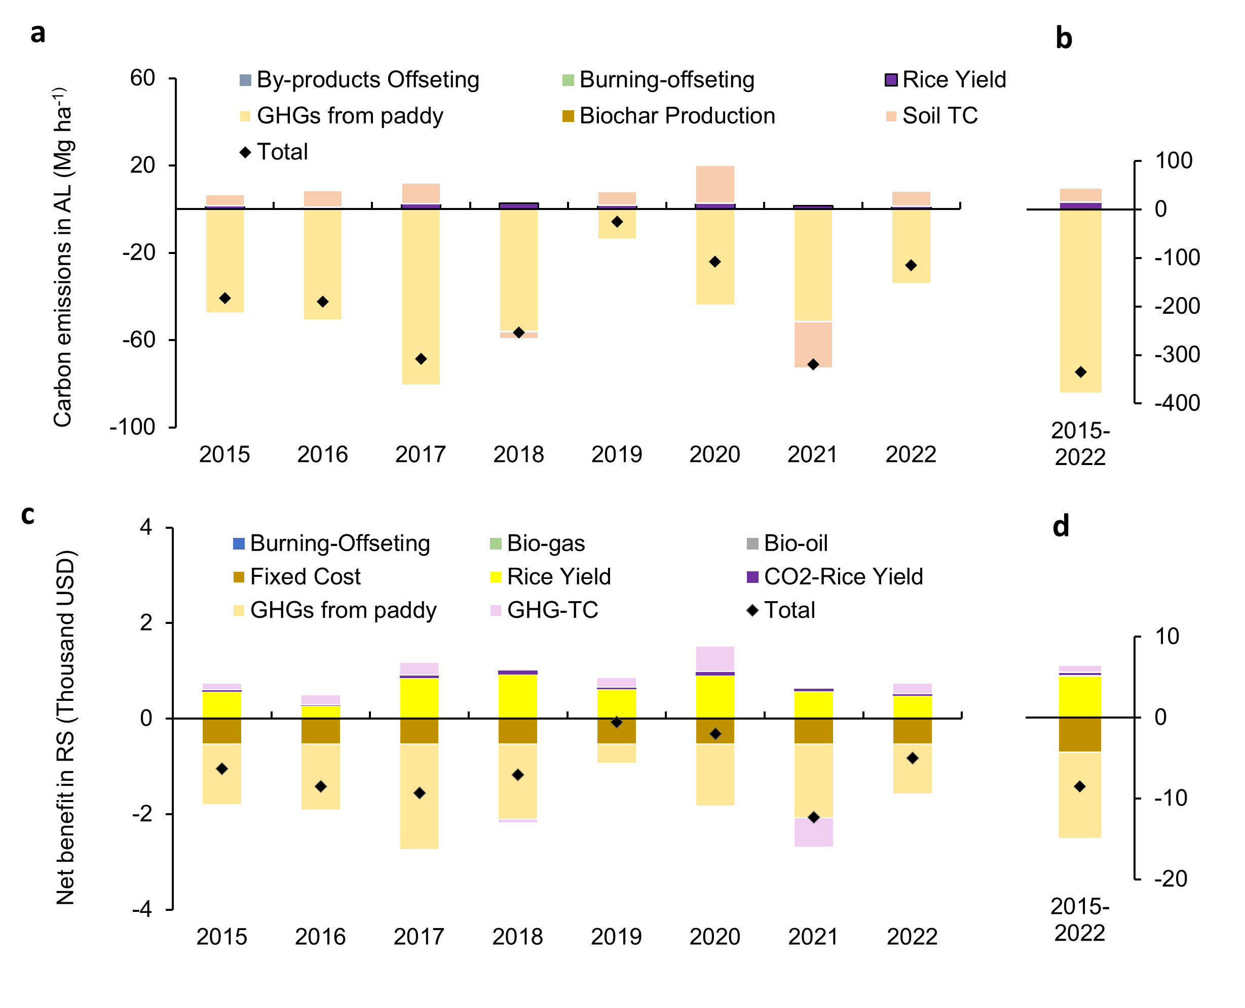
Extended Data Fig. 6 | CO_{2-eq} reduction and the net benefit over 8 experimental years in HS. a, GHG emissions reduction after biochar incorporation at 22.5 Mg ha⁻¹. b, the corresponding net benefits of it.

