Electronic Supplements
The following figures are included in the electronic supplement.
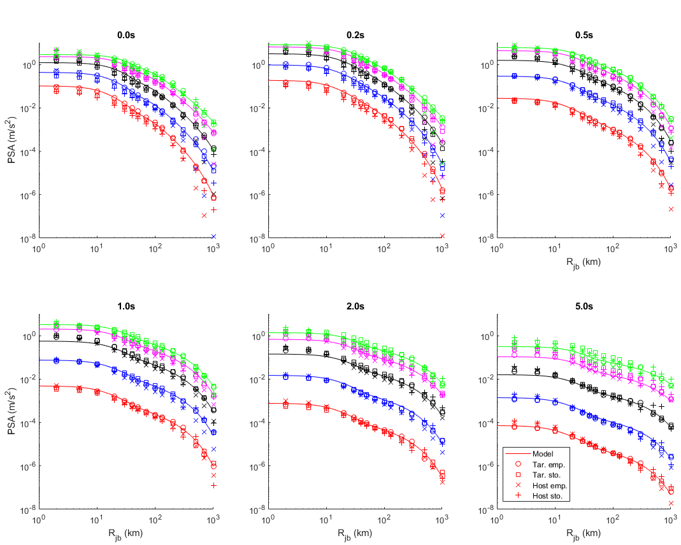
Electronic Supplement Figure 1 Comparison of the raw samples from CHEEP and the fitted functional form for an example branch of the logic tree (80bars, central geometric spreading, central Q model, 0.023s) for M 3.5 (red), 4.5 (blue), 5.5 (black), 6.5 (magenta) and 7.25 (green) and periods of 0.01s (PGA), 0.2s, 0.5s, 1.0s, 2.0s and 5.0s. The close match between the raw samples for the target empirical and the fitted model can be seen.
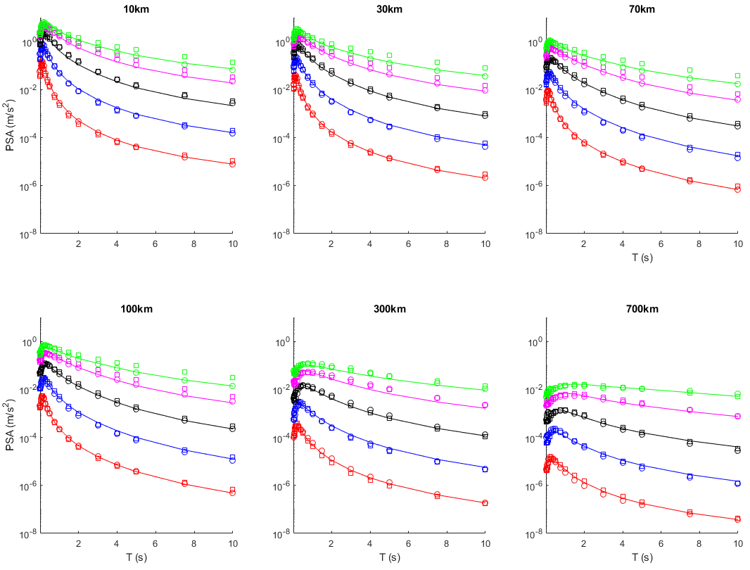
Electronic Supplement Figure 2 Comparison of the raw samples (target empirical=circles, target stochastic=squares) from CHEEP and the fitted functional form for an example branch of the logic tree (80bars, central geometric spreading, central Q model, 0.023s) for M 3.5 (red), 4.5 (blue), 5.5 (black), 6.5 (magenta) and 7.25 (green) and R_{JB} of 10km, 30km, 70km, 100km, 300km and 700km. The close match between the raw samples for the target empirical and the fitted model can be seen. Also this figure shows that the target stochastic has a different spectral shape at large magnitudes because of the assumption of the single corner.

Electronic Supplement Figure 3 Comparisons of three- (red) and five-branch (blue) reweighted models: solid lines is 50th percentile in both cases, dashed-dotted lines are for 5th and 95th percentiles for three-branch version and 3rd and 97th percentile for five-branch version and dashed lines are for 21st and 79th percentile for five-branch version. Predictions are shown for a) M 4 and 7 against R_{JB} and b) R_{JB}=10km and 100km against M, for 0.01s, 0.2s, 0.5s and 1.0s.

Electronic Supplement Figure 4 Comparison of the three-branch models derived using the a priori (blue) and adjusted (red) weights: solid lines is 50th percentile and dashed-dotted lines are for 5th and 95th percentiles. Predictions are shown for a) M 4.5 and 6.5 against R_{JB} and b) R_{JB}=30km and 100km against M, for 0.01s, 0.2s, 0.5s and 1.0s.

- Lower branch | - Central branch | - Upper branch
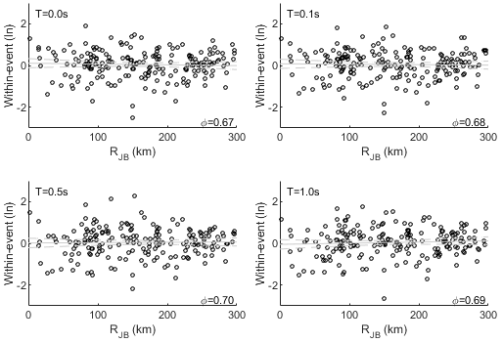 | 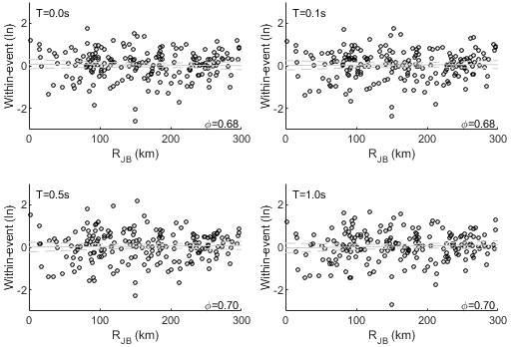 | 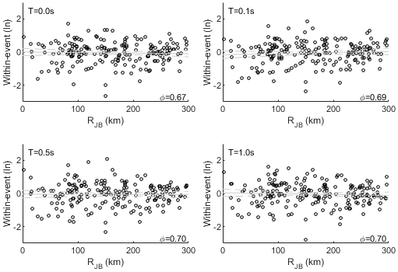

Electronic Supplement Figure 5 Between-event residuals against magnitude and within-event residuals against epicentral distance for the a) lower, b) central and c) upper branches of the three-branch parameterisation of the model. Grey lines are the linear best-fit line and its 95% confidence limits.

a)

b)
Electronic Supplement Figure 6: Contour plots of σ_{lnμ} for the five-branch backbone: a) using the a priori weights and b) using the adjusted weights, for 0.01s, 0.2s, 0.5s and 1.0s.

Electronic Supplement Figure 7: Contour plots of σ_{lnμ} for the complete 162 branch model: a) using the a priori weights and b) using the adjusted weights, for 0.01s, 0.2s, 0.5s and 1.0s.

