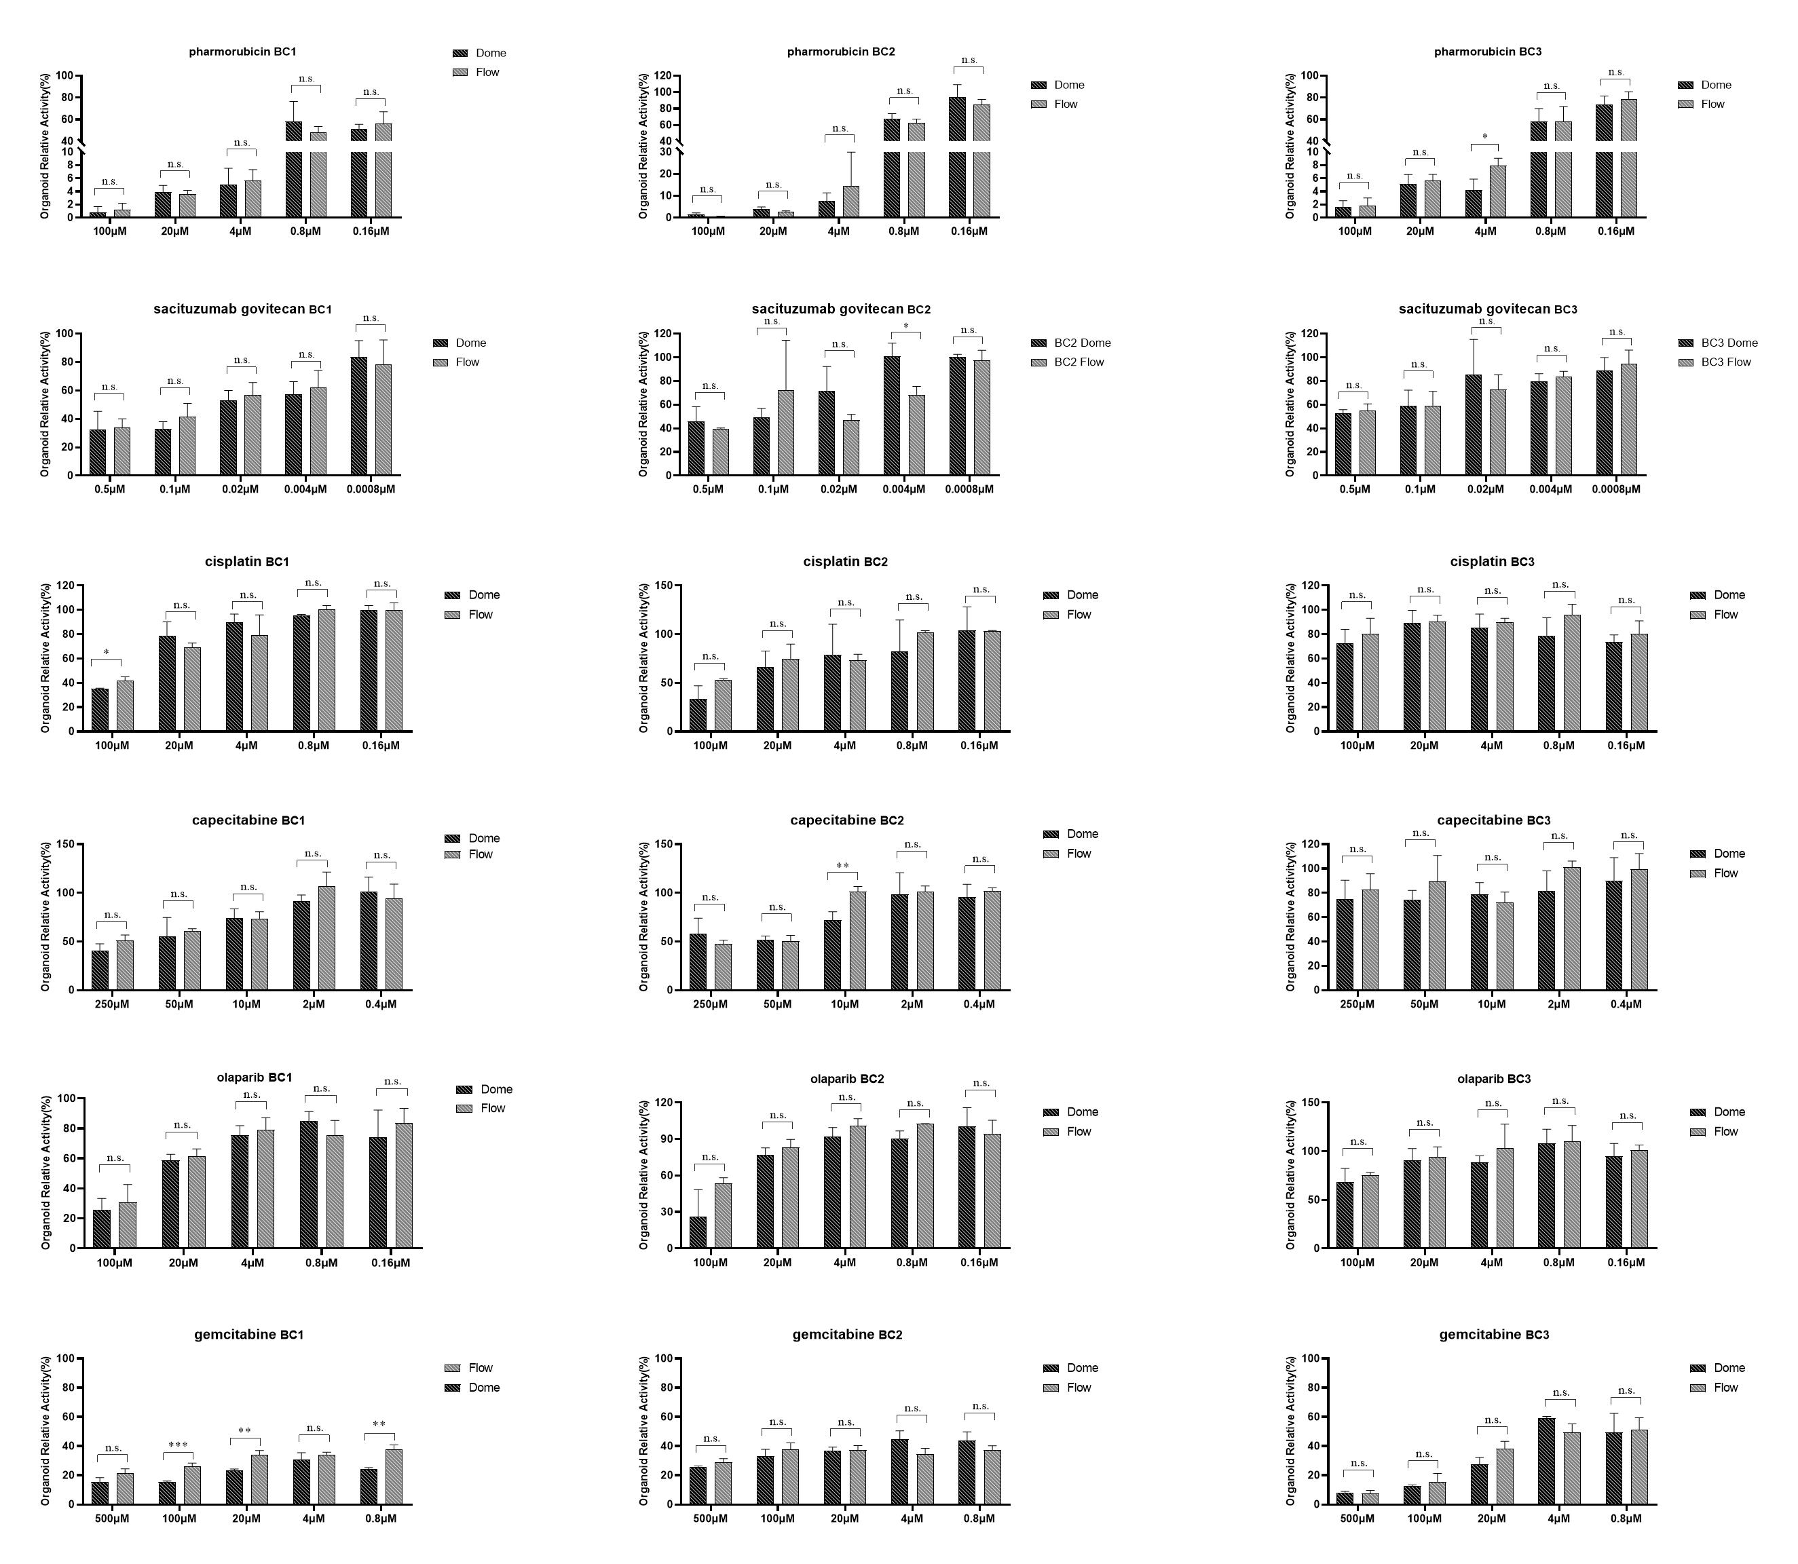
Figure S1:Drug response results for Dome group and Flow group organoids.the results are expressed as the mean ((SD).
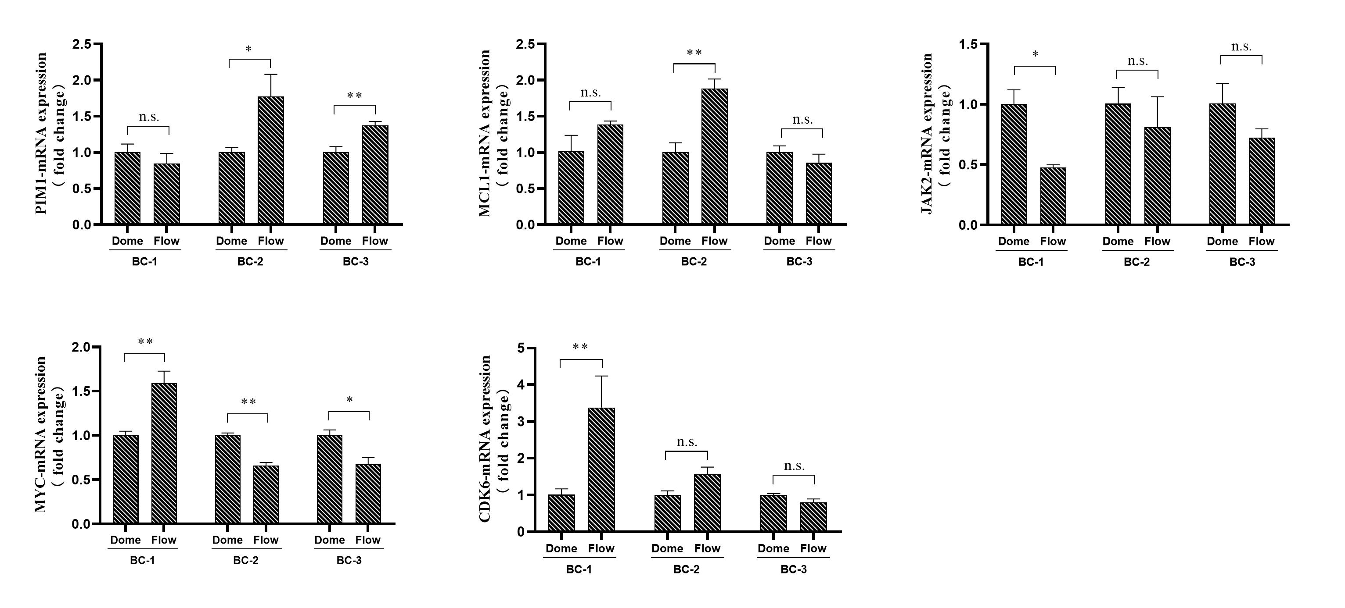
Figure S2:Relative gene expression levels of organoids cultured in Dome group and Flow group on day 15. Normalization was performed using the Dome group data..the results are expressed as the mean (SD).

