Table 1: Baseline study population characteristics (weighted)
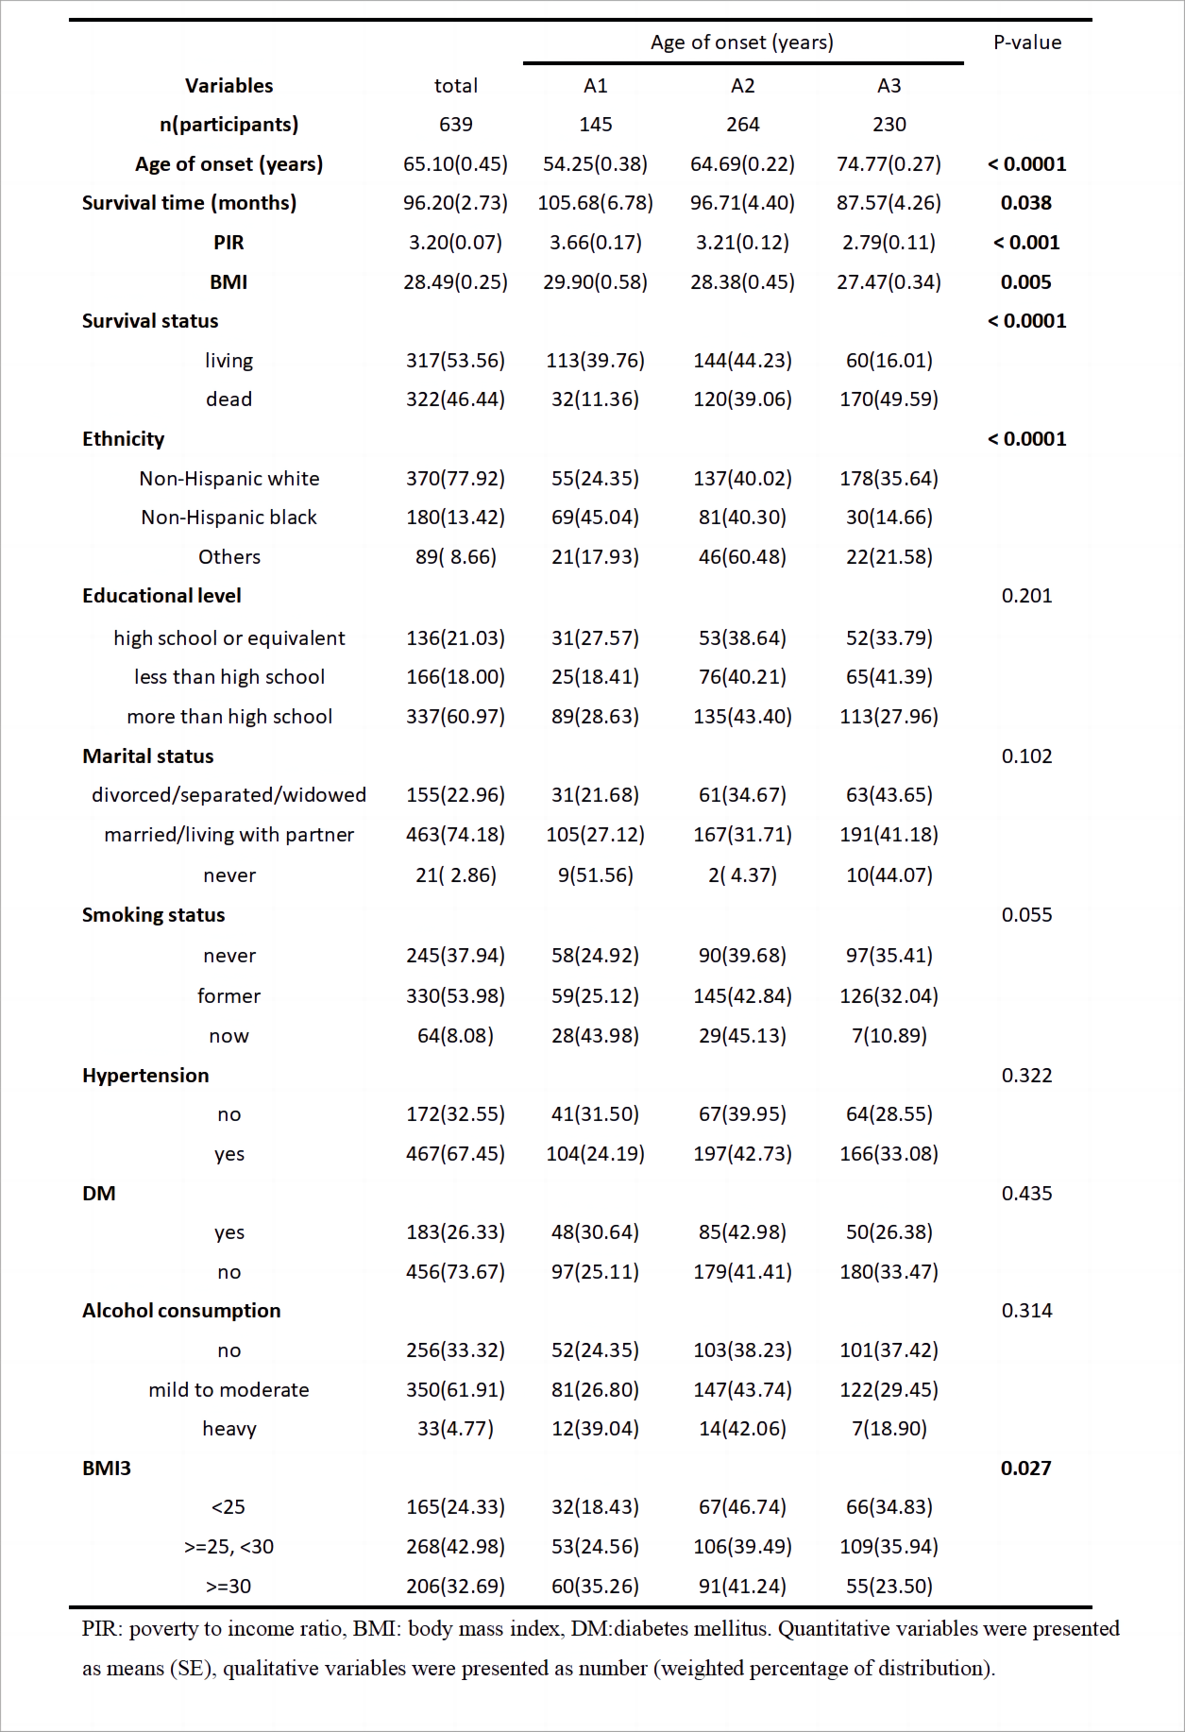

Table 2: Weighted cox regression of the association between the factors and all-cause mortality
