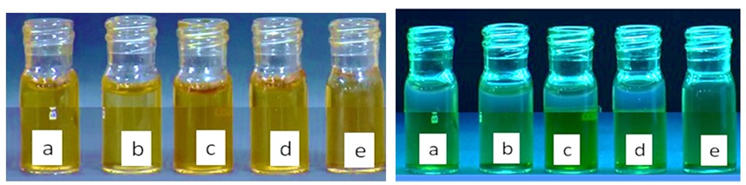
Visual observation of bimetallic transition metal co-doped CQDs

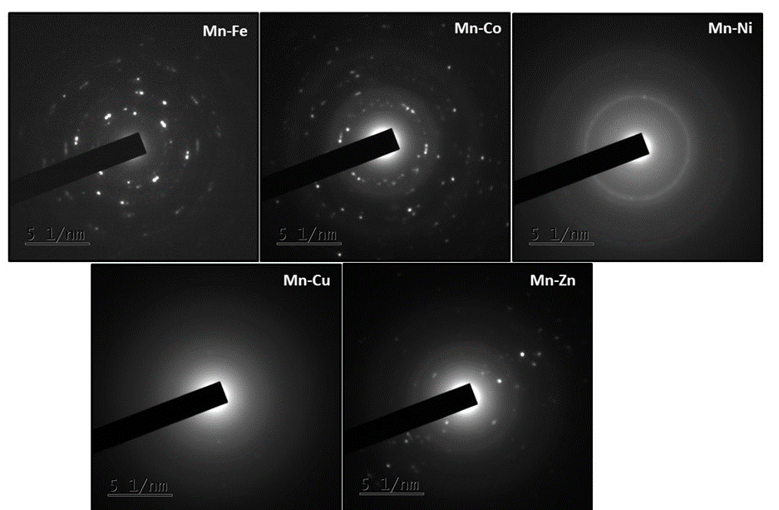
High resolution TEM images of bimetallic transition metal co-doped CQDs

